Lecture 1 : Cheat sheet.

The business environment (climate) is constantly changing, and it is becoming more and more complex. Organizations, private and public, are under pressures that force them to respond quickly to changing conditions and to be innovative in the way they operate.

Such activities require organizations to be agile and to make frequent and quick strategic, tactical, and operational decisions, some of which are very complex.

Making such decisions may require considerable amounts of relevant data, information, and knowledge. Processing these, in the framework of the needed decisions, must be done quickly, frequently in real time, and usually requires some computerized support.

This course is about about using business analytics as computerized support for managerial decision making

It concentrates both on the theoretical and conceptual foundations of decision support, as well as on the commercial tools and techniques that are available.

https://www.youtube.com/watch?v=LFnewuBsYiY

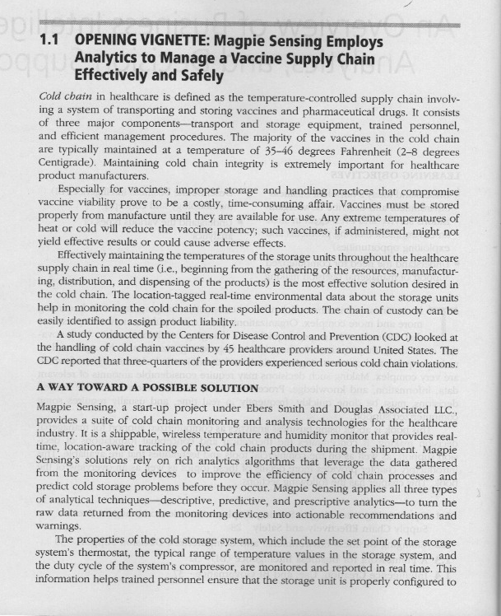
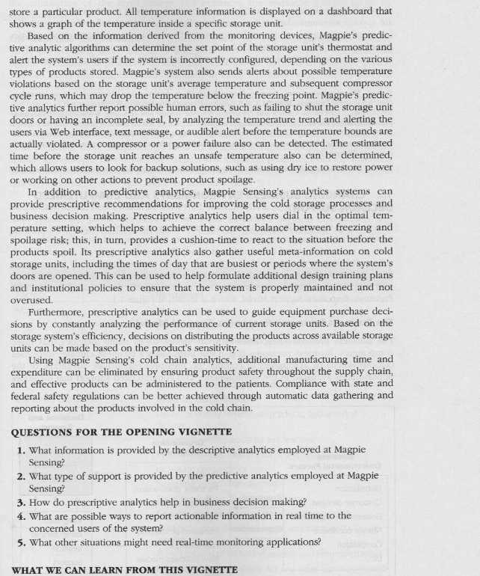
- What information is provided by the descriptive analytics employed at Magpie Sensing?
The descriptive analytics monitor and report the properties of the cold storage system, including the set point of each thermostat, the typical range of temperatures in the system, and the duty cycle of each compressor. These values tell trained personnel whether each storage unit is properly configured for storing particular products.
- What type of support is provided by the predictive analytics employed at Magpie Sensing?
The predictive analytics use the descriptive data to alert users when a unit is not configured properly for storing the products. It also sends an alert when average temperature and compressor cycle runs signal that a temperature may go out of range (for example, after a power failure) or that there may have been a human error, such as failure to shut a door. These analytics tell users about a problem that may occur, giving them time to prevent the problem.
- How does prescriptive analytics help in business decision making?
Prescriptive analytics guides decision makers to the alternative with the greatest benefits. In Magpie’s cold chain system, prescriptive analytics uses data about storage unit performance to help buyers select the best storage units. And based on data about storage system efficiency and product sensitivity, prescriptive analytics guides decisions about where to distribute particular products in the supply chain.
- What are possible ways to report actionable information in real time to the concerned users of the system?
The system uses shippable wireless monitors. These continuously measure temperature, humidity, and location and transmit the data to the computer that analyzes the data.
- What other situations might need real-time monitoring applications?
systems where current performance provides information about changes or decisions that would improve future performance. Examples include monitoring inventory levels at a manufacturing company to determine when to replenish stocks, monitoring sales in a store to identify when and how to adjust the mix of products, and monitoring patient status in a hospital to identify situations where different treatment is required or devices are malfunctioning. (If students have difficulty with this question, it suggests a need to devote some class time to discussing practical applications of data and analytics in business, government, and nonprofit sectors.)

This case illustrates how a company can employ analytics to develop reports on what is happening, predict what is likely to happen, and then to also make decisions to make best use of the situation at hand.

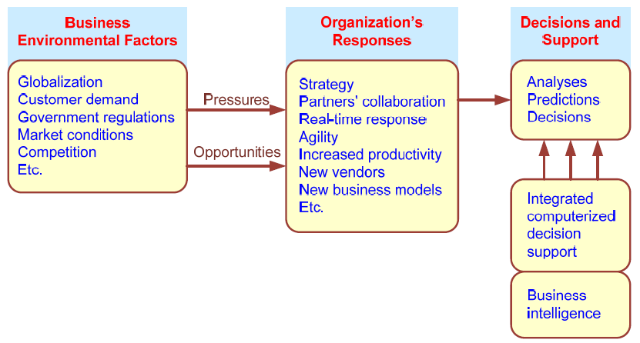
Business Intelligence (BI) is an umbrella term that combines architectures, tools, databases, analytical tools, applications, and methodologies. Its major objective is to enable interactive access (sometimes in real time) to data, enable manipulation of these data, and provide business managers and analysts the ability to conduct appropriate analysis.
2. List and describe the major components of BI.
BI systems have four major components: the data warehouse (with its source data), business analytics (a collection of tools for manipulating, mining, and analyzing the data in the data warehouse), business performance management (for monitoring and analyzing performance), and the user interface (e.g., a dashboard).

What is BI governance?
Some organizations refer to the project prioritization process as a form of BI governance (control and direction). A major governance issue is who should serve as decision makers involved in prioritizing BI projects. The two critical partnerships required for BI governance are: (1) a partnership between functional area heads and/or product/service area leaders, and (2) a partnership between potential customers and providers.

What is intelligence gathering?
Modern companies must ethically and legally organize themselves to glean as much as they can from their customers, their business environment, their stakeholders, their business processes, their competitors, and other such sources of potentially valuable information. But collecting data is just the beginning. Vast amounts of that data need to be cataloged, tagged, analyzed, sorted, filtered, and must undergo a host of other operations to yield usable information that can impact decision making and improve the bottom line.

OLTP.
OLTP (online transaction processing) is a type of computer processing where the computer responds immediately to user requests. Each request is considered to be a transaction, which is a computerized record of a discrete event, such as the receipt of inventory or a customer order. Or a withdrawal from an ATM machine. Or scanning of your groceries.
OLAP.
OLAP (online analytical processing) is processing for end-user ad hoc reports, queries, and analysis. Separating the OLTP from analysis and decision support provided by OLAP enables the benefits of BI that were described earlier and provides for competitive intelligence and advantage as described next. OLAP (online analytical processing) is computer processing that enables a user to easily and selectively extract and view data from different points of view. For example, a user can request that data be analyzed to display a spreadsheet showing all of a company's beach ball products sold in Florida in the month of July, compare revenue figures with those for the same products in September, and then see a comparison of other product sales in Florida in the same time period. To facilitate this kind of analysis, OLAP data is stored in a multidimensional database. Whereas a relational database can be thought of as two-dimensional, a multidimensional database considers each data attribute (such as product, geographic sales region, and time period) as a separate "dimension." OLAP software can locate the intersection of dimensions (all products sold in the Eastern region above a certain price during a certain time period) and display them. Attributes such as time periods can be broken down into subattributes.

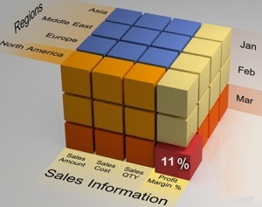

Describe the major types of BI users.
BI may have a larger and more diversified user community. One of the most important aspects of a successful BI is that it must be of benefit to the enterprise as a whole. This implies that there are likely to be a host of users in the enterprise—many of whom should be involved from the outset of a DW investment decision. Not surprisingly, there are likely to be users who focus at the strategic level and those who are more oriented to the tactical level.

Analytics.
is the process of developing actionable decisions or recommendations for actions based upon insights generated from historical data.

descriptive analytics
Descriptive analytics refers to knowing what is happening in the organization and understanding some underlying trends and causes of such occurrences. Tools used in descriptive analytics include data warehouses and visualization applications.

How is descriptive analytics different from traditional reporting?
Descriptive analytics gathers more data, often automatically. It makes results available in real time and allows reports to be customized.

What is a data warehouse? How can data warehousing technology help to enable analytics?
A data warehouse, is the component of a BI system that contains the source data. As described in this section, developing a data warehouse usually includes development of the data infrastructure for descriptive analytics—that is, consolidation of data sources and making relevant data available in a form that enables appropriate reporting and analysis. A data warehouse serves as the basis for developing appropriate reports, queries, alerts, and trends.

https://www.youtube.com/watch?v=KGHbY_Sales

What is predictive analytics? How can organizations employ predictive analytics?
Predictive analytics is the use of statistical techniques and data mining to determine what is likely to happen in the future. Businesses use predictive analytics to forecast whether customers are likely to switch to a competitor, what customers are likely to buy, how likely customers are to respond to a promotion, and whether a customer is creditworthy. Sports teams have used predictive analytics to identify the players most likely to contribute to a team’s success.

What is prescriptive analytics? What kind of problems can be solved by prescriptive analytics?
Prescriptive analytics is a set of techniques that use descriptive data and forecasts to identify the decisions most likely to result in the best performance. Usually, an organization uses prescriptive analytics to identify the decisions or actions that will optimize the performance of a system. Organizations have used prescriptive analytics to set prices, create production plans, and identify the best locations for facilities such as bank branches.

Define modeling from the analytics perspective.
Analytics uses descriptive data to create models of how people, equipment, or other variables operate in the real world. These models can be used in predictive and prescriptive analytics to develop forecasts, recommendations, and decisions.

How can analytics aid in objective decision making?
Problem solving in organizations has tended to be subjective, and decision makers tend to rely on familiar processes. The result is that future decisions are no better than past decisions. Analytics builds on historical data and takes into account changing conditions to arrive at fact-based solutions that decision makers might not have considered.
What is Big Data analytics?
The term Big Data refers to data that cannot be stored in a single storage unit. Typically, the data is arriving in many different forms, be they structured, unstructured, or in a stream. Big Data analytics is analytics on a large enough scale, with fast enough processing, to handle this kind of data.

What are the sources of Big Data?
Major sources include clickstreams from Web sites, postings on social media, and data from traffic, sensors, and the weather.

What are the characteristics of Big Data?
Today Big Data refers to almost any kind of large data that has the characteristics of volume, velocity, and variety. Examples include data about Web searches, such as the billions of Web pages searched by Google; data about financial trading, which operates in the order of microseconds; and data about consumer opinions measured from postings in social media.

https://www.youtube.com/watch?v=1RYKgj-QK4I

Another example of Business Intelligence: Moneyball:
on-base percentage (OBP; sometimes referred to as on-base average/OBA, as the statistic is rarely presented as a true percentage) is a measure of how often a batter reaches base for any reason other than a fielding error, fielder's choice, dropped/uncaught third strike, fielder's obstruction, or catcher's interference

www.youtube.com/watch?v=AiAHlZVgXj

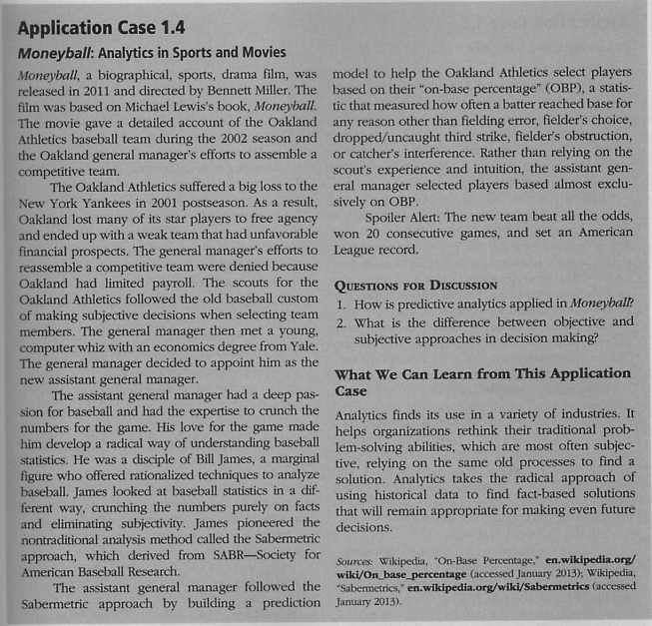

Tutorial
Go to:
Teradatauniversitynetwork:
www.youtube.com/watch?v=NXEL5F4_aKA

