Targets
Targets | How you have worked on this
Target 1  Make explicit links between points suggested in literature and own research decisions. | - Critical analysis of literature  - Weighed arguments and created own decisions
Target 2  Read peer-reviewed journals. | - Got books from the university library  - Wider research of literature and journals

ECAD6013: The Learner: Who am I teaching?
Kaitlyn Done - 2003632

Title: Supporting your discussion with theory, practice and evidence from literature, critically reflect on how you would support an individual learner whose progress is being affected by specific barriers to his/her learning during one particular transition period (horizontal or vertical).
Contents
Part 1 …………………………………………………………………………………… p. 3
Part 2 …………………………………………………………………………………… p. 11
One Page Profile …………………………………………………………………………. p. 11
Support Plan ………………………………………………………………………… pp. 12- 15
Reference List ………………………………………………………………….. pp. 16 - 21
Appendices ……………………………………………………………………... pp. 21 - 24

Word Count: 5,225
Part 1
Confidentiality and anonymity are a key focus in the BERA ethical guidelines. Therefore, throughout this assignment I will adhere to these and ensure that the pupil discussed is protected, (BERA, p.21, 2018). Furthermore, it is important to recognise that ‘Article 16’, the child’s right to privacy, is one of the 42 rights of the child, (UNCRC, n.d), hence the decision to give the pupil a false name, referring to him as ‘Ben’ throughout.
Ben is a 7-year-old boy who was born in Vietnam. Ben and his family have recently moved to a town in Carmarthenshire in Wales, meaning that he will be starting a new school, making new friendships, and learning a new language. This is known as a vertical transition, a significant change to a child’s routine, (Rhondda Cynon Taf, n.d). It is important to manage transitions effectively to ensure that the child’s needs are met. Throughout this process it is salient that both, the child and their parents, experience emotional support throughout the transition process to enhance their well-being and ensure they have a positive experience. Ben’s experience, knowledge, and understanding of the English language is limited, therefore this barrier will have substantial effects on his progress. To support Ben through his vertical transition and English language development, his new class teacher, teaching assistant (TA) and an outside agency translator have met with Ben and his family on three occasions. These meetings have been held in the school, in which Ben and his family were able to explore and familiarise themselves with the new learning environment he will be a part of. This gave the class teacher and the TA the opportunity to get to know Ben and gain an insight into his likes, strengths, and areas of development, which also provided Ben with greater comfort and confidence before joining his new class. During these sessions, Ben and his teacher created a one-page profile, with the help of an outside-agency translator to highlight his strengths and what he would like support with. The information and conclusions following from these encounters have been used to create a support plan for Ben to make his transition a positive and enjoyable experience.

There is very limited information of Ben’s previous education and learning, however through encounters with Ben and his family it is evident that he has a high ability in mathematics. Ben is able to work out complex calculations in his head efficiently and he thrives to challenge himself. As mentioned in the pupil profile (see Part 2) Ben enjoys art and other creative activities. During meetings with Ben, it is clear that he takes pride in his art-work, often sharing drawings and paintings he had created at home and in his previous school. As briefly stated, Ben’s English Language skills are not of the best standard, therefore it is important to develop these skills using his strengths and hobbies to aid.
The Four Purposes are at the heart of the Curriculum in Wales, which should be the aspiration for a school’s curriculum design. Schools should aim to support learners to become: Ambitious, capable learners; Enterprising, creative contributors; Ethical, informed citizens; and Healthy, Confident individuals, (Welsh Government, 2022). The Curriculum for Wales outlines skills that are integral to the four purposes. These include: Creativity and innovation, critical thinking and problem-solving, personal effectiveness, planning and organising, and cross-curricular skills. Cross-curricular skills of literacy, numeracy and digital competence are mandatory skills that pupils need to acquire to enable them to access the curriculum and life-long opportunities, (Welsh Government, 2022). In this case, it is important to focus on literacy being a mandatory skill, meaning that for Ben to experience the breadth of the curriculum and develop key skills, a focus on language development is essential.

In order to support Ben in his development, it is pertinent to understand how children learn language. Chomsky proposes that all children have a ‘language acquisition device’, the innate ability to learn language, also suggesting that they do not need to be taught or guided in a formal way, (Paris, et al. 2021). However, research suggests that children need to hear the language being spoken, emphasising the significance of imitation and positive reinforcement for attempts at language, (Lindon, 2012, pp. 13 -135). Although children can be considered more receptive to learning a new language, this development is not linear, and it can be argued that learning a new language is a skill that is acquired through observation and practice. A teacher must model good English and allow the pupil to hear the language being spoken. However, it is paramount that for a child to make progress, the pupil themselves need to have regular repeated practice and experience of speaking, reading, and writing the language as the teacher observes and guides, (Bright and McGregor,1970, p.4). Although this book is outdated, the process that a child learns remains the same, through experience and repetition. Repetition is fundamental in learning and crucial in Montessori education. It can help strengthen neural processors, teach children to retain knowledge, and is needed to master and succeed a skill, (Montessori Academy, n.d). To strengthen this argument, a case study suggests that learning occurs through first-hand experiences, (ESTYN, 2016), enabling the child to make their own connections between oral and written English. Ofsted offer suggestions about incorporating home languages into the curriculum. These include providing pupils the opportunity to go on trips and visits to practice their home language, creating a provision of a buddy (who speaks the same language if it is possible), visual aids, involving parents into the community, employ EAL specialist teachers and training for staff, (p.16).
Local authorities receive an annual Ethnic Minority Achievement Grant (EMAG) to provide learners with English as an additional language (EAL) extra support to promote their achievement in Wales, (Welsh Government, 2015, pp. 11-12). This funding will be used to employ the translator for the first two weeks of Ben’s school experience to make his transition smoother and more comfortable and give staff in the school the opportunity for training. Children transitioning to a new school can suffer from stress and anxiety as this can be a harrowing experience, (Trautman and Myles, 2010, vii; Symonds, 2015 p.37), in which the anticipation can cause a child to become emotionally vulnerable. It is likely that Ben will be apprehensive about starting the school, especially due to his language barrier. The decision to introduce the Year 2 class to key Vietnamese words and phrases before Ben’s arrival (see Part 2: Support plan) will welcome him and make him feel more relaxed and reassured when he recognises other pupils learning to communicate through the medium of his first language. This will not only aid Ben through his transition but will give the other pupils the opportunity to experience learning another language which directly links to the curriculum for Wales. Languages, Literacy and Communication (LLC) emphasises the importance of exposing pupils to different languages, which means that the pupils will be working towards progression step 2 in the ‘Languages connect us’ description of learning, (Welsh Government, 2019). Although Ben will be developing his English Language skills, it is pertinent that Ben continues to use his home language. A case study has compared two pupils that share the same first language, and are both learning EAL. One of the pupils continued to use his home language and has progressed exceptionally well with reading and writing in English, performing assessments at a similar standard to his English affluent peers. On the other hand, the other EAL pupil is struggling in this aspect of their development, significantly achieving at a slower rate than other pupils in their class. After bringing in more use of their home language in the school, this pupil has become more motivated and enthusiastic to learn English, slowly improving their reading and writing skills with confidence, (Coneth, 2015, p.17). This would suggest that Ben may develop his English language skills at a greater level.

Research would suggest that when an EAL pupil begins to acquire a new language they are often in a period called the ‘silent phase’ in which they develop listening skills and begin to attune to the new language, (Choudry, 2021, pp. 75-76). A person who speaks a language different from one they will be taught in does not mean that they have an additional learning need (ALN), (Welsh Government, 2021, p. 28). Therefore, having a translator in class with Ben for the first two weeks of his transition would be essential to not only support him in his understanding, but to observe and monitor Ben’s individual ability in his learning. This would allow the class teacher to set challenges based on his ability and assess whether he needs additional support in other aspects of his learning. To make the transition less daunting, in advance of Ben’s first day in his new school, the class teacher and TA will prepare a visual learning pack in which he can work through at home with his parents prior to joining the class. Research results have shown that parental involvement at home has positive effects on language competence and wellbeing on children. Therefore, it is crucial to encourage home-based parental involvement to support Ben to work through his visual learning pack and practice key words provided by the teacher. The decision for home-based involvement is due to the worry that too much parental involvement could possibly hinder academic development and have unfavourable impacts on Ben’s transition, (Wong. Et al, 2018, pp. 1544-1555). Appendices B-F share an insight into activities it will consist of to prepare Ben with some key vocabulary he can begin to learn.

The following is a list of strategies the Class Teacher and TA can use to support Ben in the classroom, (UWTSD, 2022, slide 12):
- Make eye contact when speaking to him
- Cue him in by saying his name before asking a question to ensure he has full attention and can listen to the best of his ability
- Help him sequence
- Check for understanding
- Give him time to plan in his head what he is going to say before answering
Giving a child the time to think before answering is significant to ensure that they fully apprehend the question asked and can prepare their response effectively after deep thinking, leading to higher cognitive level achievement, (Rowe, 1986: Tobin, 1987). As Ben is an EAL learner, this ‘wait time’ should be considered to a greater extent. This can give him the opportunity to digest new vocabulary and attempt to make links with his knowledge and understanding, subsequently allowing him to prepare and sequence his answers. Other strategies that a case study suggest to assist the progression of EAL students includes translations, key words, outside classroom support and intense literacy lessons, (Welply. Et al, 2014, p.60). This suggests that one-to-one support with a TA could be beneficial to his progression. The support plan addresses that a TA will work with Ben every Wednesday and Friday afternoon to complete intense phonic activities. Ben has expressed his dislike in reading (see pupil profile – Part 2), however this could be due to his lack of phonetic understanding and confidence. Some critics of phonics programs may argue that introducing phonics to an EAL learner can result in a lower interest in reading, cause difficulty in teaching due to the ‘unphonetic characteristics of the English Language’, lack of spelling ability, and poor development of reading in an adequate speed due to the complex phonetic structure, (Bear, 1964, p. 273). In spite of this, the article is extremely outdated, therefore with changes to phonic teaching programmes and up-to-date, relevant literature, it would seem that there are more advocates for teaching phonics in primary schools. If pupils are taught good pronunciation of English sounds and words, it will enhance their confidence and motivation in learning, (Ren, 2017, pp. 900-901). Understanding phonics is key to learning a language as it can improve listening, speaking, reading, and writing skills. This source also focuses on the effect that bad English pronunciation can have on EAL learners as they fear humiliation, which can cause them to avoid communicating through the medium of English. Thus, the decision to have one-to-one support each week could accelerate Ben’s knowledge and understanding of English and increase his confidence. Some activities Ben will work through with the TA are provided in his visual learning pack, allowing him to continue practicing his English literacy skills to give him the best opportunity to succeed learning EAL. To monitor this, the visual learning pack will be an evident display of Ben’s progress as well as other strategies. One thing that Ben made clear in his pupil profile (see Part 2) is that he would like to be shown pictures to support him in his learning and in conversations with peers, therefore many of the visual aids used will encompass this (See Appendix F). In terms of evaluating his progression, Ben will be working to achieve Progression Step 1 (PS1) of the LLC area of learning, this will include ‘beginning to form letters correctly’ and ‘write using familiar words and phrases’, learning to segment and blend sounds. From this, Ben will begin to learn a ‘range of strategies to read with increasing fluency,’ and use his ‘knowledge of letter sounds and patterns’ to support his spelling and oracy, progressing through PS2, (Welsh Government, 2019).

Vygotsky held the opinion that mental processes derive from socialisation, (Glynn, et al. 2006, p.42), arguing that language is rooted in the experience of socialising with others. His theory of cognitive development is recognised by many, in particular his concept of the Zone of Proximal Development (ZPD). According to Vygotsky, the ZPD is the stage between what the child can do independently and what they cannot do even with support. It is the stage between in which a child can perform a task successfully with the help of a More Knowledgeable Other (MKO), (Psychology Notes HQ, 2021), who can scaffold the learning for a child. In saying this, Parten’s six stages of play contradict this theory that learning begins with social interaction, (Rymanowicz, 2015). For instance, if a child is at the ‘Solitary play’ stage, they are more comfortable entertaining themselves. This would suggest that social interaction may not support cognitive development as a child in this stage may not engage in social interaction. However, Ben’s one page profile (see Part 2) highlights his desire to make new friends indicating that he enjoys social interaction with other children his age. Therefore, the decision to establish ‘Buddies’ in the class, (see support plan - Part 2) may help Ben develop his social skills. As human beings, we need exposure to a language in order to acquire it, (Rowland, 2014, pp.16-17), thus, pairing Ben with a pupil who can model good spoken English will accelerate his vocabulary development and understanding. This will be trialled for the first school half term, with the belief that Ben will develop some confidence in his English language journey and will have established friendships with other peers. As mentioned in the ‘Evaluation/Review’ section in the support plan, regular check ins throughout the day will provide the teacher with an insight into his progress. Ferre Laevers created a 5 point ‘Leuven Scale’ which can be used as an indicator of wellbeing and involvement, (Emotionally Healthy Schools, 2019: Laevers, 2000, pp. 24-25). Through observation, Ben’s social interactions can be assessed to determine whether deep learning is occurring. Laevers believed that with high levels of wellbeing, deep learning and understanding takes place. In terms of putting this into practice, if Ben is operating at a level 4 or 5 on this scale, he is demonstrating signs of satisfaction, smiling, expressive actions, singing and seems generally relaxed and self-confident. Though observation of Ben’s social interactions, if he is showing clear signs of discomfort, avoiding contact and appears withdrawn, it would seem that he is operating at level 1 or 2 on this scale, meaning that further support is needed. If Ben appears to be struggling or needs more support, this ‘buddy programme’ can be ongoing according to his progression. To ensure that Ben experiences socialising in different contexts with different pupils in the class, flexible groupings can ensure that Ben, alongside other pupils, are practicing the development of these skills regularly to build up relationships, (Pollard and Bourne, 1994, p.158). Reflective research has found that group work can raise levels of achievement and help improve pupil attainment in reading and maths, (Baines, 2008, p.2). Baines also discovered that group work can double the levels of active engagement in learning, deep discussions between pupils, and successfully aid class relationships and social inclusion. This indicates that active attempts for group discussions and activities will not only benefit his social development, but his progression in the English language. Afterschool clubs can also contribute to this as Ben has many hobbies and interests (see pupil profile and support plan– Part 2). The pupil profile highlights Ben’s interests, he is particularly passionate about playing football, painting, and drawing. Encouraging Ben to attend the school football club and/or Arts and Crafts club will allow him to socialise with others and give him additional opportunities to strengthen his friendships with those who share similar interests.

To help the development of Ben’s English vocabulary, it is the school administrators’ role to change key signs around the school. Creating bilingual signs with illustrations will help Ben navigate his way around the school, (see example - appendix A) and allow him to ‘experiment with newly-learned vocabulary’, which is progression step 1 (PS1) of the Languages, Literacy and Communication strand: Understanding languages is key to understanding the world around us. (Welsh Government, 2019). Creating posters in the theme of ‘Shrek’ may also be beneficial as this will ignite Ben’s interests (see support plan – Part 2). In terms of progressing through PS1, the information acquired from reading the posters can further support Ben to progress onto PS2, to have the ability to ‘listen to, understand, and communicate the general meaning of what I hear’. From personal experience, I understand that progression is not linear. Regular ‘check ins’ with pupils can be used to evaluate and monitor pupil progress, which has been evident on Professional Teaching Experiences (PTE) I have encountered. This, alongside numerous Assessment for Learning (AfL) strategies can indicate how Ben’s language development has improved throughout the first school term. Donaldson’s ‘Successful Futures’ comprises 12 pedagogical principles, one of which is using ‘AfL to accelerate progress’, (Impact Wales, 2018). This proposes that these strategies will allow practitioners to further support pupils in their individual learning journey, by exploring each child’s understanding, allowing for further development. Ben can receive good quality feedback from his class teacher and TA, involving him in his learning process, gain confidence, and begin to close the gap between what he can currently do and what he would like to achieve. This feedback will equip him with the knowledge and understanding he needs to achieve his aim of improving his language development successfully (Cambridge International Education Teaching and Learning Team, n.d).

Rob Coe’s Great Teaching Toolkit focuses on the importance of creating a supportive environment, motivating Ben to attempt answering in English verbally, encouraging him to attribute his success and ‘failure’. It is vital to build high trust with Ben to ensure that he is willing and feels safe enough to take a risk and try, without the fear of failure, (Coe. Et al, 2020, pp. 24-25). To further add to this argument, research has found that mistakes should be used as a way to aid pupils to check their thinking and understanding, encouraging pupils to take risks in their learning. Pupils should be allowed to try something and experience failure as children learn from mistakes, (Lahey, 2015: Brophy, 2010, p. 213). This indicates that an environment that does not encourage failure, would prove difficult to teach children resilience and having the skills and knowledge to cope and overcome failure when they encounter it.

The one-page pupil profile (See Part 2) also illustrates Ben’s passion for singing and music. The support plan outlines how the use of this will help Ben through his transition and barrier by familiarising him with key vocabulary. In Foundation Learning (FL), songs and music are vital components to learning as it ignites areas of child development and skills such as ‘intellectual, social-emotional, language and literacy’, (Bright Horizons, 2022), assisting the mind and body to work cooperatively. Music exposure aids learning sounds, words and make connections to meanings which implies that having regular times for singing with actions during key parts of the school day will support Ben in identifying and connecting the language he is learning. The following key parts of the day can involve songs: Welcome, Tidy up time, Carpet time and Home time, in which regular reinforcement of these, making them part of the routine can help Ben associate them with his learning.

Taking all into account, the optimum support Ben can receive to ensure he has a positive transition and school experience, is to encourage his language development. To draw on what has been presented throughout, repetition of key vocabulary, phonics activities, and peer support and socialisation are main factors to allow Ben to progress through the Curriculum. The ideas discussed throughout the assignment aim to support and encourage Ben to achieve the four purposes and give him opportunities to develop life-long skills. To make his transition smoother, a focus on using Ben’s home language in the classroom is also essential to ensure that he keeps his identity and flourishes at an accelerated pace in his learning. In terms of a personal professional development, throughout this module and assignment I have done wider research into theories, language development and support for EAL learners which directly links to ‘Professional Learning’ section in the QTS standards, (Welsh Government, 2019, pp. 47-51). To further develop, I will continue my professional learning and development to better prepare myself for situations like Ben’s in the future. Although I have some understanding and experience in working with EAL learners, I wish to develop this and gain more knowledge and first-hand experiences to support my own professional growth and learning.

Part 2

One Page Pupil Profile
What makes me happy?
- Painting and drawing
- Watching Shrek
- Playing football
- Spending time with my family
- Playing outside
- Singing and listening to music.

Name: Ben Age: 7
What do people appreciate about me?
- I am kind and friendly
- I am helpful
- I am hardworking
- I am creative

What is important to me?
- I want to feel understood and listened to.
- I love maths challenges.
- I would like to make new friends.
- I love to be outdoors when I am stressed or need time because I feel calmer when I am surrounded by nature.
- My family are important to me.
- It is important to me to be creative.


What do I dislike?
- Dancing
- Reading

How can you support me?
- I know a little bit of English - please be patient, speak slowly and clearly when talking to me and help me if I am stuck on words.
- I’m nervous to make new friends and be understood by others– please encourage me to play with others.
- Show me pictures to explain things because I am still learning key words.
- Let me get some fresh air when I am stressed.
- I want to be challenged in maths.
- I struggle to understand what is being asked of me so I would like someone who speaks my language to help explain what I need to do in lessons.

Pupil Support Plan – Ben
Background
Ben is 7 years old and has recently moved from Vietnam to Wales and has joined a Year 2 class in the school. Ben’s first language is Vietnamese and is learning English as an additional language. Ben and his family have visited the school 3 times during the before he starts school in the first school term. Their understanding of English is little, therefore all conversations before joining the school have been with an outside-agency translator. Ben is an extremely helpful, kind, and willing pupil who is eager to learn and develop. He has many hobbies and interests, in particular he enjoys playing football and being creative. Ben has a high ability in mathematics and is able to work out complex calculations in his head quickly and efficiently.
Following the discussions had with Ben and his family, he is apprehensive to start this new chapter as his understanding and development of English is very limited. He seems worried that his English language ability will be a barrier to making friendships and communicating with others. However, it is understood that he is an extremely motivated pupil who has a willingness to learn. The following is a support plan that has been created to help Ben with his learning barrier in his transition to his new school. This support plan has been created based on Ben’s one page profile.

First term
Area for support | Intervention/ activity to support – who will be involved? | Links to Curriculum | Evaluation / Review
Settlement  Ben has moved country and is joining a new school, language and culture. In order to support Ben through this transition, it is key to change/ alter | Before Ben’s arrival –  Some members of staff in the school will attend EAL training to ensure they gain a knowledge and experience of how to support EAL learners.  3 members of staff (including Year 2 class teacher and head teacher)  Learn key words and phrases in Vietnamese to support Ben, make him feel more welcome and help him settle into his new school and class.  Whole of Year 2 class  Staff in the school. | Languages, Literacy and Communication (LLC)  PS2  - I can understand that people use different languages  - I am beginning to understand that there are similarities and differences between our languages.  Four Purposes: (Welsh Government, 2022)  Ambitious, capable learners  - Seek and enjoy challenge  - Building up a body of knowledge  - Can communicate effectively in different forms and settings  Enterprising, creative contributors  - Identify and grasp opportunities  - Give off their skills so other people can benefit  Ethical, informed citizens  - Are knowledgeable about culture, community and society  - Respect the needs and rights of others | Ongoing - continue to teach and learn Vietnamese – this will ensure that Ben does not lose his identity. As Ben becomes more confident and comfortable, he can take the ’teacher’ role to teach the class Vietnamese if he wishes to. This is a good experience for all pupils in the class.  Leuven Scale of Wellbeing - To evaluate Ben’s wellbeing throughout the process.
Social Interaction  Ben wants to make new friends. However he is extremely nervous that his language barrier will restrict him. | ‘Buddy’ Programme  Pair Ben up with a child who can model good spoken English. Lev Vygotsky theory – MKO, children learning from others.  Class Teacher and TA will establish buddy pairings for all pupils in the class.  Flexible groupwork activities-  This will help Ben to build friendships with other pupils and build on his language and communication skills.  Class Teacher – 6 pupils to do group activities (this changes every time – ensure the pupils are always grouped in their pairs).  Afterschool club activities – football, crafts (these are some of Ben’s hobbies) – this will allow Ben to connect with pupils with similar interests outside of the school day.  Club leaders  Parents | LLC– PS2  - I can understand that people use different languages.  Health and Wellbeing – PS1  - I can get along with others with and without support.  - I can communicate my needs and feelings in my relationships  Four Purposes:  Ambitious, Capable Learners  - Set themselves high standards and seek and enjoy challenge  - Building up a body of knowledge and have skills to connect and apply knowledge in different contexts  - Can communicate effectively in different forms and settings  Enterprising, Creative Contributors  - Lead and play different roles in teams effectively and responsibly  - Give of their energy and skills so that other people can benefit  Healthy, Confident Individuals  - Are building their mental and emotional wellbeing by developing confidence, resilience and empathy  - Form positive relationships based on trust and mutual respect | By the end of the term, hopefully Ben will be more confident in his development and will have established friendships and peer support groups, socialising with others.  Ben will have regular check ins throughout the first half term to ensure he is supported socially – ongoing if it needs to be.  Parental involvement and support – advise attending afterschool clubs and other activities outside of school (eg football clubs nearby – this will support Ben in developing friendships with those who share the same interests).
Language Development  Ben knows some key words in English however struggles to form sentences correctly. He struggles to understand spoke English in particular due to people speaking too quickly for him. | Visual Learning pack – these will support Ben to identify key words and phrases and make links and connections. Wednesday and Friday afternoons – outside practice with TA to reinforce vocabulary and phonics practice.  - Picture cards  - Key words and phrases  - Matching activities  Class Teacher and TA to prepare  ‘Buddy’ for support.  Outside agency – translator (first 2 weeks)  Songs and Music -  This is one of Ben’s hobbies.  This will be used to familiarise Ben with language and make connections- part of the routine for school day (repetitive).  Class Teacher and TA  Whole Class  Signs around the school –  Bilingual  This will help Ben navigate his way around the school, make him feel more comfortable and make connections between places objects, and new vocabulary.  Posters – Cartoon/Shrek theme  This will spark Ben’s interests and draw him to these posters  - Bilingual  - Fun  - Key words and phrases  This will support Ben to grasp new vocabulary.  School Administrators – change signs around the school. | LLC –  PS1  - I am beginning to form letters correctly  - I am beginning to write using familiar words and phrases.  - I can segment and blend.  - I can experiment with newly-learned vocabulary.  - I am beginning to ask and answer questions  PS2  - I can listen to, understand and communicate the general meaning of what I hear.  Four Purposes:  Ambitious, Capable Learners  - Set themselves high standards and seek and enjoy challenge  - Can communicate effectively in different forms and settings  - Are building up a body of knowledge and have the skills to connect and apply it in different contexts  Enterprising, Creative Contributors  - Connect and apply their knowledge and skills  - Identify and grasp opportunities  Healthy, Confident Individuals  - Are building their mental and emotional wellbeing by developing confidence, resilience and empathy  - Have the skills and knowledge to manage everyday life as independently as they can | Ben’s progression will be monitored throughout.  Formative assessment (AfL) strategies can be used to evaluate his progression and what needs more support.  Other ways of monitoring progress – compare Ben’s written work from the beginning of the term to the end. This will be a good indicator for the class teacher.  Translator – if Ben needs more support in translation and understanding, an outside agency translator can come back to the school to assist if it is necessary.  However, it is understood that Ben’s language development will likely be ongoing and gradual. Therefore, this will be an ongoing focus for Ben and his development.

Reference List
Baines, E. (2008) Promoting Effective Group Work in the Primary Classroom: A handbook for teachers and practitioners. London: Routledge.

Bear, D.E. () ‘Two Methods of Teaching Phonics: A Longitudinal Study’, The Elementary School Journal, 64(5), p. 273. Available at: Two Methods of Teaching Phonics: A Longitudinal Study | The Elementary School Journal: Vol 64, No 5 (uchicago.edu) (Accessed: 1 November 2022).

Bright Horizons, (2022), ‘Children and Music: Benefits of Music in Child Development’, Bright Horizons, 25th February. Available at: Bright Horizons | Children and Music: Benefits of Music in Child Development | Bright Horizons® (Accessed: 25 October 2022).

Bright, J.A. and McGregor, G.P. (1970) Teaching English as a Second Language. London: Longman Group Ltd.

Brophy, J. (2010) Motivating Students to Learn. 3rd edn. New York: Routledge.

British Educational Research Association (BERA). (2018) Ethical Guidelines for Educational Research. Available at: Ethical Guidelines for Educational Research, fourth edition (2018) | BERA (Accessed: 20 October 2022).

Cambridge International Education Teaching and Learning Team (n.d) Getting Started with Assessment for Learning. Available at: https://cambridge-community.org.uk/professional-development/gswafl/index.html (Accessed: 23 October 2022).

Children’s Commissioner for Wales (n.d) United Nations Convention on the rights of the child. Available at: https://www.childcomwales.org.uk/uncrc-childrens-rights/uncrc/ (Accessed: 20 October 2022)

Choudry, S. (2021) Equitable Education: What Everyone Working in Education Should know About Closing the Attainment Gap for All Pupils. St Albans: Critical Publishing.

Coe, R. et al. (2020) Great Teaching Toolkit: Evidence Review. Available at: https://www.cambridgeinternational.org/Images/584543-great-teaching-toolkit-evidence-review.pdf (Accessed: 24 October 2022)

Coneth, J (2015) The EAL Teaching Book: Promoting Success for Multilingual Learners. 2nd edn. London: SAGE Publications Ltd.

Emotionally Healthy Schools (2019) The Leuven Scale. Available at: https://emotionallyhealthyschools.org/primary/the-leuven-scale/ (Accessed: 3 November 2022).

ESTYN (2016) Taking every opportunity to increase literacy. Available at: https://www.estyn.gov.wales/effective-practice/taking-every-opportunity-increase-literacy (Accessed: 20 October 2022)

Glynn, T. Et al. (2006) Supporting Students with Literacy Difficulties. England: Open University Press.

Impact Wales (2018) Donaldson’s 12 Pedagogical Principles. [picture] Available at: https://www.impact.wales/wp-content/uploads/2018/01/12-Pedagogical-Principles-1.pdf (Accessed: 23 October 2022).

Laevers, F. (2000). ‘Forward to Baics! Deep-Level-Learning and the Experiential Approach,’ Early Years, 20(2), pp. 20-29. Available at: https://www.tandfonline.com/doi/pdf/10.1080/0957514000200203?needAccess=true (Accessed: 3 November 2022).

Lahey, J. (2015) The Gift of Failure: How to Step Back and Let Your Child Succeed. London: Short Books.

Lindon, J. (2012) Understanding Child Development 0-8 Years. 3rd edn. London: Pantek Media.

Paris, et al. (2021) Theories of Language Development. Available at: https://socialsci.libretexts.org/Bookshelves/Early_Childhood_Education/Book%3A_Child_Growth_and_Development_(Paris_Ricardo_Rymond_and_Johnson)/11%3A_Middle_Childhood_-_Cognitive__Development/11.10%3A_Theories_of_Language_Development (Accessed: 20 October 2022).

Pollard, A. and Bourne, J. (1994) Teaching and Learning in the Primary School. London: Routledge.

Psychology Notes HQ (2021) Lev Vygotsky’s Sociocultural Theory of Cognitive Development. Available at: https://www.psychologynoteshq.com/vygotsky-theory/ (Accessed: 20 October).

Ren, J. (2017) ‘Reflecting on the Primary Phonetic Learning Based on the Critical Period Hypothesis in Language Acquisition’, Theory & Practice in Language Studies: EBSCOhost, 7(10), pp. 900-906. Available at: Reflecting on the Primary Phonetic Learning Based on the Critical Period Hy...: EBSCOhost (uwtsd.ac.uk) (Accessed: 1 November 2022)

Rhondda Cynon Taf. (n.d) Transition information for Early Years. Available at: https://www.rctcbc.gov.uk/EN/Resident/SchoolsandLearning/AccessandInclusiontoEducation/WorkinginPartnershipwithParents/SchoolTransitionAdvice/TransitioninformationforEarlyYears.aspx#:~:text=Vertical%20transitions%20are%20transitions%20which,may%20affect%20their%20well%2Dbeing. (Accessed: 20 October 2022).

Rowe, M.B. (1986) Wait Time: ‘Slowing Down May Be A Way of Speeding Up!’ Journal of Teacher Education, 37(1), pp. 43–50. Doi: 10.1177/002248718603700110.

Rowland, C (2014) Child Language Acquisition. Oxon: Routledge

Rymanowicz, K (2015) The power pf play – Pat 1: Stages of play. Available at: https://www.canr.msu.edu/news/the_power_of_play_part_1_stages_of_play#:~:text=When%20children%20engage%20in%20solitary,not%20join%20in%20are%20onlookers. (Accessed: 21 October 2022)

Symonds, J (2015) Understanding School Transition: What Happens to Children and How to Help Them. London: Taylor & Francis Group.

Tobin, K (1987) The Role of Wait Time in Higher Cognitive Level Learning. Review of Educational Research, 57(1), pp. 69-95. Doi: 10.3102/00346543057001069.

Trautman, M.L and Myles, B.S. (2010) My New School: A workbook to Help Students Transition to a New School. Kansas: Autism Asperger Publishing Co.

UWTSD (2022), Lecture 7: Barriers to Language Development, lecture notes, Yr Athrofa, University of Wales Trinity Saint David, delivered 11 October 2022.

Welply, O. Et al. (2014) School approaches to the education of EAL students. Available at: https://d1wqtxts1xzle7.cloudfront.net/34695861/Full_Report_FV3_copy-with-cover-page-v2.pdf?Expires=1667322543&Signature=YG0CZ9ZnHcdu1Hq96C-q5hP31kPFIEb-Z4HuoN5R1NkBVF9l3TfuDb3zfX4Ow53nTniM582IZh2OdDz5JhNNQzSGnNIJkEAy1J7q8UhJYnaYnW7Rxt0DGfN9Ju1Qc73~T--Cvf9DaVz~rWXiO0TlnF7ipboDEPGr6aKCMFbtUCLYc~Eyf5ehyePnyhAo-JVPfhDQLhiDIqCzEJMUjd4nuR8Zm6WZ1VX5PCODUDkjLv768Xc4qWVRKfKBYPznlSumoP6WDTHLhHSfJr8lnMFA-S78vgYQj8ARehPtdvdYSQ22MG3l4yH1Z9-wIY-ZeP4V1OvM2sTN404xfOfI5ietHQ__&Key-Pair-Id=APKAJLOHF5GGSLRBV4ZA (Accessed: 24 October 2022).

Welsh Government (2015) Evaluation report on capacity building approaches to support the delivery of English as an additional language in Wales. Available at: https://gov.wales/sites/default/files/publications/2018-11/evaluation-report-on-capacity-building-approaches-to-support-the-delivery-of-english-as-an-additional-language-in-wales.pdf (Accessed: 20 October 2022).

Welsh Government (2019) Languages, Literacy and Communication: Descriptions of learning. Available at: https://hwb.gov.wales/curriculum-for-wales/languages-literacy-and-communication/descriptions-of-learning/ (Accessed: 22 October 2022).

Welsh Government (2019) Professional Standards for Teaching and Leadership. Available at: https://hwb.gov.wales/api/storage/19bc948b-8a3f-41e0-944a-7bf2cadf7d18/professional-standards-for-teaching-and-leadership-interactive-pdf-for-pc.pdf (Accessed: 3 November 2022)

Welsh Government (2021) The Additional Learning Needs Code for Wales 2021. Available at: https://gov.wales/sites/default/files/publications/2021-03/the-additional-learning-needs-code-for-wales-2021.pdf (Accessed: 24 October 2022).

Welsh Government (2022) Developing a vision for curriculum design: Curriculum design and the four purposes. Available at: https://hwb.gov.wales/curriculum-for-wales/designing-your-curriculum/developing-a-vision-for-curriculum-design/#skills-integral-to-the-four-purposes (Accessed: 1 November 2022).

Welsh Government (2022) Developing a vision for curriculum design: Skills integral to the four purposes. Available at: https://hwb.gov.wales/curriculum-for-wales/designing-your-curriculum/developing-a-vision-for-curriculum-design/#skills-integral-to-the-four-purposes (Accessed: 1 November 2022).

Wong, R.S. Et al. (2018) ‘Parental Involvement in Primary School Education: it’s Relationship with Children’s Academic Performance and Psychosocial Competence through Engaging Children with School,’ Journal of Child and Family Studies. 27, pp. 1544-1555. Doi: 10.1007/s10826-017-1011-2

Appendices – Examples of activities (own creation)
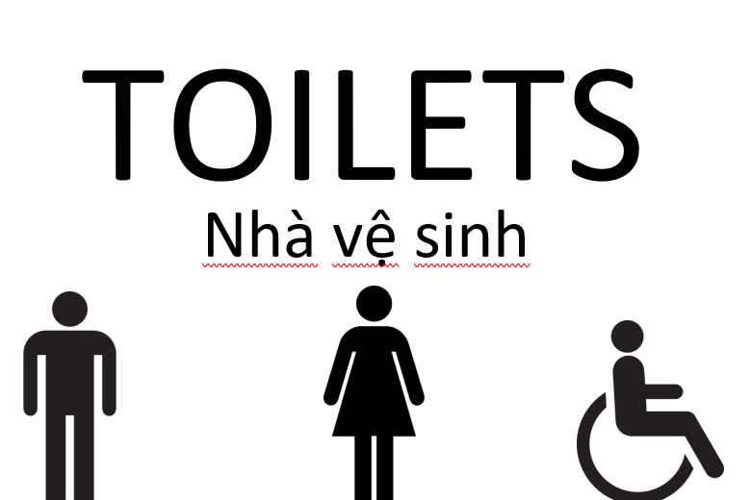
Appendix A

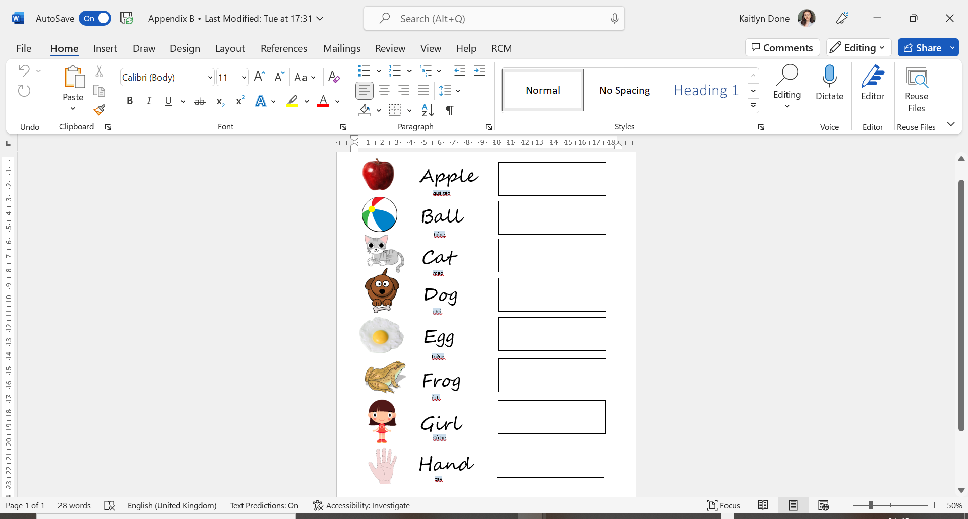
Appendix B

Appendix C
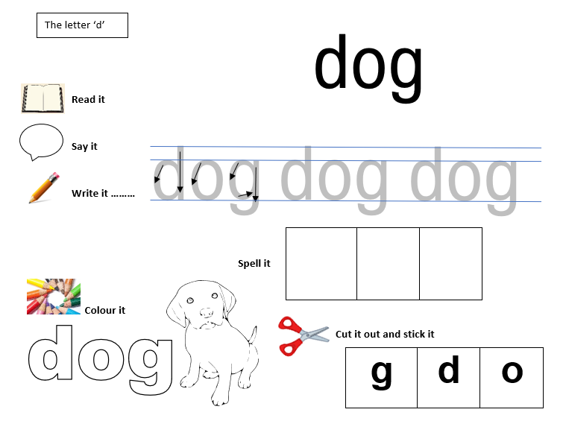
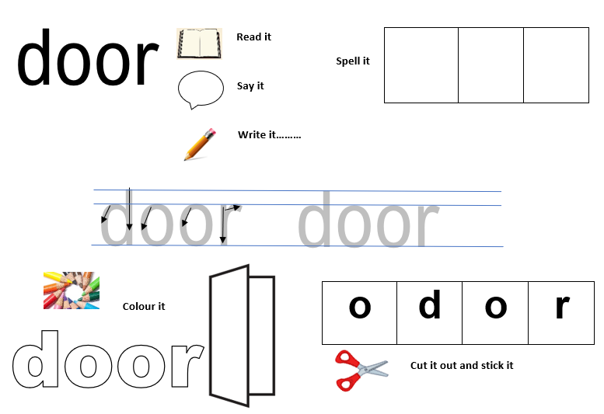

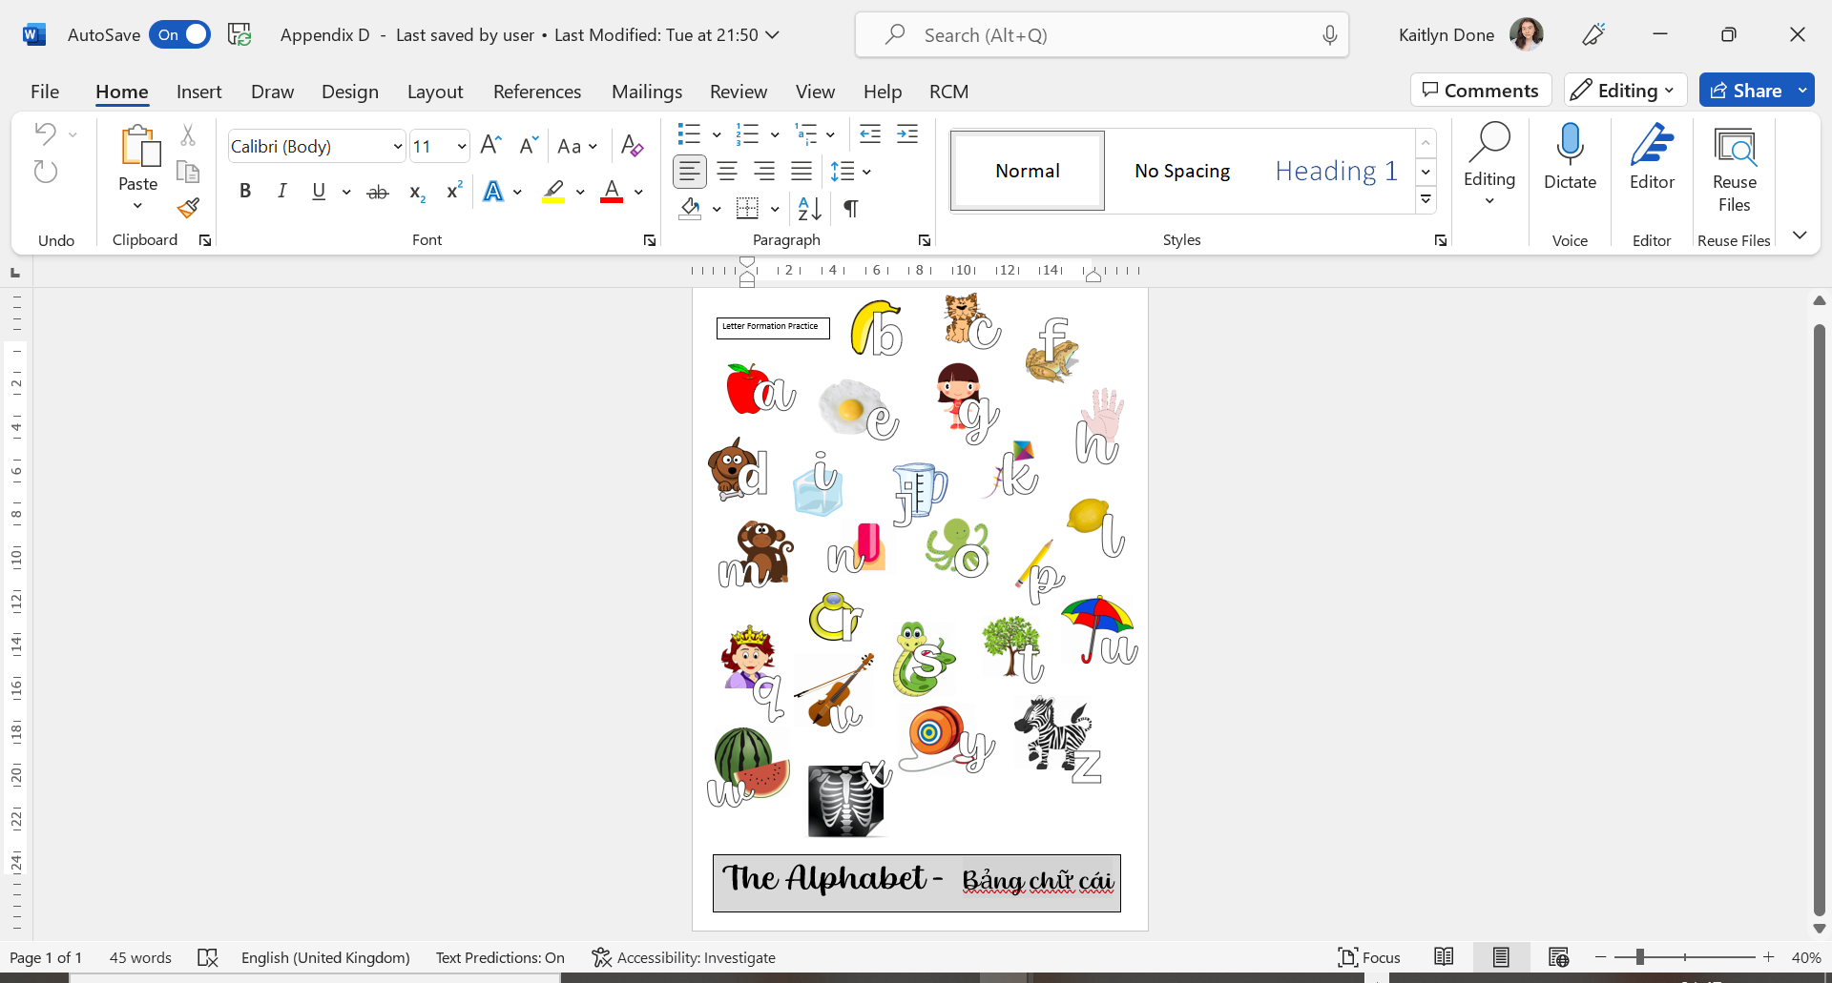
Appendix D

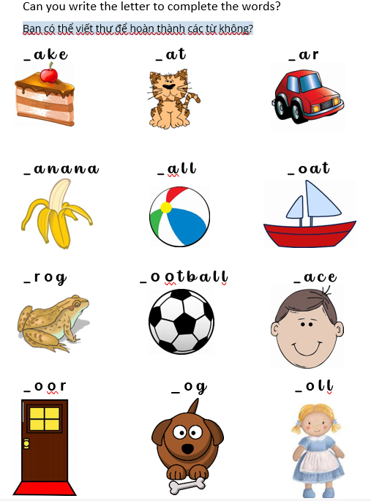
Appendix E

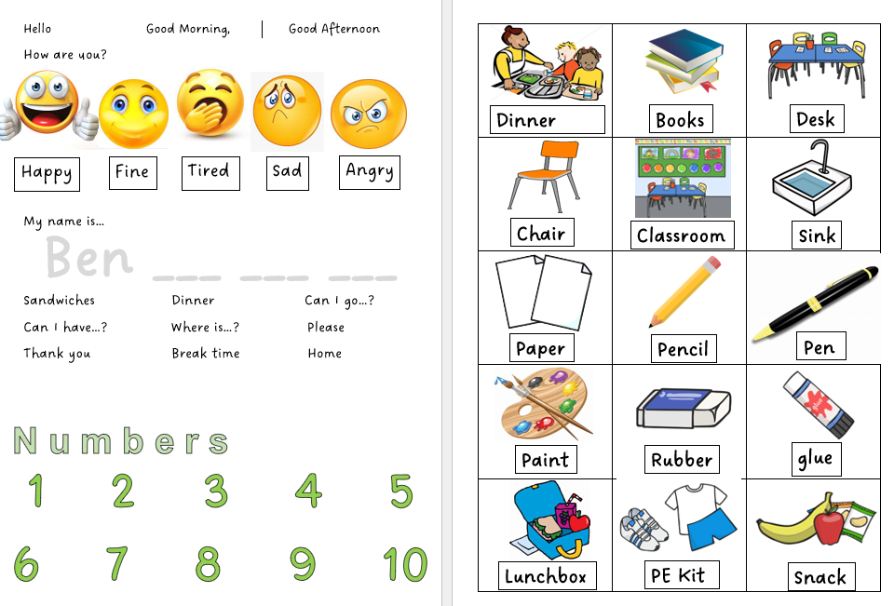
Appendix F

