

MODULE CODE: ECPT6014

ASSESSMENT COMPONENT: A1 Microteach Session

STUDENT NAME: Natalie Emma Male

STUDENT NUMBER:1702161

Use of Generative AI in Assessment

(Lecturer to indicate Yes or No against each element)

RESEARCH | For this assessment, you can use Generative AI to support you in research, including searching for bibliography, using tools to summarise, compare and interrogate materials. | Yes ☒  No ☐
STRUCTURE | For this assessment, you can use Generative AI to support you in structuring your submission, including creating a draft argument structure, identifying parts and headings, etc. | Yes ☒  No ☐
PROOFREADING | For this assessment, you can use Generative AI to check your own text/creation for grammatical and syntactical mistakes, including rephrasing of your own work within specific standards. | Yes ☒  No ☐
WRITING | For this assessment, you can use Generative AI to create text for submission. | Yes ☐  No ☒
CREATIVE | For this assessment, you can use Generative AI to create creative materials, such as images. | Yes ☐  No ☒
PROGRAMING | For this assessment, you can use Generative AI to create and check code. | Yes ☐  No ☒
NONE | For this assessment, you are not allowed to use any type of Generative AI support. This includes research support, structure support, writing/proofreading support and creative support. | Yes ☐  No ☒

AI Acknowledgement

I acknowledge the use of Grammarly https://www.grammarly.com on 07th October 2026 to check my work using the prompt
1. Please check the following text for readability, grammar and syntax.
I confirm that I have not presented any AI generated text as my own work.
I confirm that I have copies of my drafts, notes, and other resources I used before and after the use of AI tools which I may be asked to provide in evidence.

Introduction

This reflection aims to critically analyse my thirty-minute microteach on the subject of Biomimicry. I chose to deliver this topic following a previous negative experience when presenting a similar subject to sixty colleagues at a corporate event. As a new employee, the request came directly from the Chief Officer of the organisation and I did not feel I could decline. However, the staff appeared confused, and feedback indicated they believed the topic was irrelevant to their roles as support workers. The experience deeply upset me and made me apprehensive about future public speaking.
For this assignment, I will use Driscoll’s (1994) Model of Reflection, as it provides a straightforward and effective three-stage framework well-suited to new practitioners. This model offers a clear structure to analyse my experience and support the development of my future practice. Driscoll’s model provides a scaffolded framework for low-stakes, consistent reflection, thereby empowering both educators and students to engage comfortably in substantive self-assessment. (Benedetto & Erickson, 2026).

1: What ?
The microteach I delivered focused on sustainability and the innovative topic of Biomimicry - how we look to solve human problems using examples from nature. I purposely chose this topic as an opportunity to challenge an unfounded belief that the subject matter is unengaging to a new audience. The aims of the lesson were to identify how examples from nature can be applied to solve human problems, introduce learners to a new aspect of sustainability and to promote sustainability in an interesting and positive light.
I immediately faced technical difficulties when the presentation failed to load due to log-on issues. Despite intervention from the tutor and my peers, this could not be fixed; even attempts to email the file were unsuccessful. As a result, my original slot of delivering second became more uncertain as we repeatedly tried to resolve the issue. I had chosen to present second, anticipating that my anxiety would increase the longer I waited. Smollin and Arluke (2014 p. 28) suggest that many new practitioners experience heightened anxiety stemming from a lack of confidence and feelings of unpreparedness.
Whilst waiting for my turn and observing my peers microteaches, I noticed several issues with my own Power-Point presentation. My slides were entirely in capital letters, and my learning aims and objectives were neither defined nor listed. According to Thompson et al. (2024, p 115), Clear learning aims and objectives help learners understand the lesson structure and expectations, thereby increasing motivation. I also realised that my lesson plan lacked sufficient detail to be delivered by someone else in my absence. As a result, I began to feel a little inadequate, exposed and anxious.
Despite this, I felt that my decision to use a physical, paper-based quiz was positive. From a pedagogical perspective my strategy aligned with Dewey’s (1938) principles of experimental education. The theory suggests that hands on tasks can stimulate cognition rather than passive listening. Interestingly none of the observers critiqued the use of paper in a sustainability presentation, perhaps empathising with the technical issues I was experiencing.
During the session, I adapted by sitting with my learners and delivering the material via my laptop, where I had saved a backup copy. I utilised a range of teaching strategies - including a quiz, mini lecture, group discussions and questions & answers- in order to meet my outlined objectives. As a result, learners were able to recognise how biomimicry can support sustainability, identify at least two examples of biomimicry and explain the basic principles in their own words.
Overall, I felt that the session went well although it did run over by several minutes. Initial peer-feedback was positive. Later, I received in-depth peer reviewed feedback and my tutor’s observation form, both of which outlined successful elements and clear recommendations for improvement.

2. So what ?
I was extremely anxious when the presentation would not open, and I could no longer deliver in my chosen slot. However, the situation allowed me to sit with the group and present in a more person-centred way, which changed the dynamic and made me feel more at ease. This contrasted sharply with my previous negative experience delivering to a larger audience. Additionally, by waiting to deliver my session, I had time to identify improvements in my presentation - a luxury that I would not have if I had presented second as planned. Noticing that my aims and objectives were missing, I decided that I would write them on the board while learners completed the pairs quiz.
The combination of technical difficulties and lesson planning issues provided an opportunity engage in what Schön (1983, p 49) describes as ‘reflection in action’ – the process of critically reflecting an adapting practice in real time as events unfold. My ability to adapt during the session was enabled by having outlined potential issues and recommendations in the lesson plan.
Additionally, when I asked the learners to name a public figure they associated to sustainability, I expected them to say Greta Thunberg. I was surprised by the diversity of answers and used this opportunity to record their answers on the whiteboard. Adams et al. (2024, p.45) found that novice teachers decision-making and discourse patterns are often shaped by personal experiences, which in turn inform their reactions to classroom scenarios. I will be mindful in future of how my own assumptions and experiences may influence my teaching practice.
I felt the lesson flowed well and learners appeared to enjoy the topic. Nevertheless, I relied on handwritten notes for key information and dates, as I felt this would maintain accuracy if my nerves took over. Observer one (Appendix E) highlighted in their feedback that I could try to rely less on reading directly from my notes and focus more on making eye contact, which could help my delivery feel more confident and engaging. While the notes helped to reduce my anxiety, for observer one they created a perceived barrier to learner engagement. This clearly demonstrates how past negative experiences heavily influence delivery, fear of repeating a previous failure may cause new practitioners to prioritise phycological safety over natural interaction with the class (Smollin & Arluke, 2014, p. 31).
Despite this, group participation contributed to the session’s success; everyone was present and enthusiastic. The learning strategies appeared to be effective as supported by collective peer feedback. My tutor also identified gaps in the lesson plan (Appendix D) however, they provided encouraging feedback regarding my adherence to a wide range of professional standards. Hattie & Timperley ( 2007, p 81) suggest that feedback from both peers and tutors is critical for ongoing professional development and reflective practice.

3. Now what ?
The ‘Now What?’ stage of Driscoll’s (1994) model requires practitioners to identify actionable steps for future improvement based on reflection and analysis of the experience

3.1 Improved lesson planning
In future sessions I will develop more detailed and robust lesson plans. Ensuring they contain sufficient information, clear structure and precise timing, in order that the session could be delivered by another practitioner if required. However, I will seek feedback prior to lesson delivery to strengthen my planning skills.

3.2 Slide design and implantation
I will improve the quality of my presentation slides by avoiding using capital letters, as this unintentionally creates barriers for learners with additional learning needs. Furthermore, I will ensure that the lesson aims and objectives are clearly displayed from the outset

3.3 Delivery and dependence on notes
I will ensure that my slides contain bullet points to reduce my dependence on notes. Thorough rehearsal in advance will also be a priority, as will seeking more varied teaching opportunities to build my confidence. If prompts are mandatory, I will use concise prompt cards rather than full sentences. This should help maintain learner engagement and increase my overall confidence.

3.4 Time management and pace
My microteach session overran by several minutes. In the future, I will define specific timings for each section to help keep the session within the allotted time. Regular practice will assist in developing this skill, and the use of a timer will support effective time management.

3.5 Rewarding learner responses
I will develop my confidence in consistently recognising and rewarding learners’ responses. Observing colleagues and reflecting on interactions will further support the growth of my emotional intelligence. According to (Niemiec & Ryan, 2009 p.133) Recognising and rewarding learner responses fosters a positive learning environment and supports student motivation.

Conclusion
Overall, the session was successful because I have reframed public speaking from an anxiety-inducing challenge into a positive learning experience, allowing me to prioritise the needs of my learners. Whilst technical difficulties and deficiencies in the lesson plan increased my anxiety, I believe that I demonstrated professionalism, resilience and adaptability throughout the session.
Peer feedback was largely positive and highlighted strengths in my subject knowledge and an ability to adapt to unforeseen technical challenges. However, feedback from both my tutor and peers identified areas for development, particularly in relation to reducing my reliance on notes, consistently recognising and rewarding learners’ contributions and developing more detailed lesson plans.
To conclude, I agree with the collective tutor and peer feedback; this has indeed been a valuable learning experience. Applying Driscoll’s framework has enabled me to critically evaluate my performance, identify areas for development and inform improvements to my future practice.

References

Adams, R., Smith, L. and Jones, T. (2024) 'Navigating instructional discourse and classroom realities', Journal of Educational Development, 42(1), pp. 38–52.
Benedetto, A. and Erickson, K. (2026) Making Learning Visible for Students and Adults Through Reflection. [Online] Getting Smart. Available at: gettingsmart.com (Accessed: 8 October 2026).
Dewey, J. (1938) Experience and Education. New York: Macmillan.
Driscoll, J. (1994) 'Reflective practice for practise', Senior Nurse, 13(4), pp. 47–50.
Driscoll, J. (2007) Practising Clinical Supervision: A Reflective Approach for Healthcare Professionals. 2nd edn. Edinburgh: Elsevier Churchill Livingstone.
Niemiec, C.P. and Ryan, R.M. (2009) 'Autonomy, competence, and relatedness in the classroom: Applying self-determination theory to educational practice', Theory and Research in Education, 7(2), pp. 133–144.
Hattie, J. and Timperley, H. (2007) 'The Power of Feedback', Review of Educational Research, 77(1), pp. 81–112.Schön, D.A. (1983) The Reflective Practitioner: How Professionals Think in Action. New York: Basic Books.
Smollin, L. and Arluke, A. (2014) 'Anxiety dynamics in early career practice', Teaching and Higher Education Journal, 19(2), pp. 22–35.
Thompson, G., Davis, M. and Clark, P. (2024) Foundations of Pedagogical Design. London: Academic Press.

Appendices
Appendix A: Lesson Plan
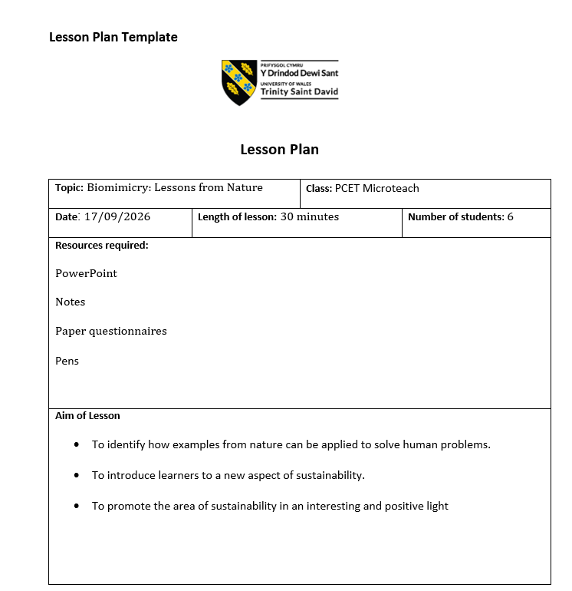

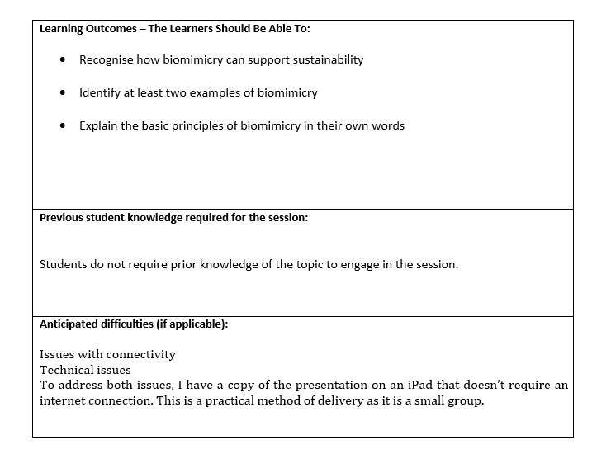
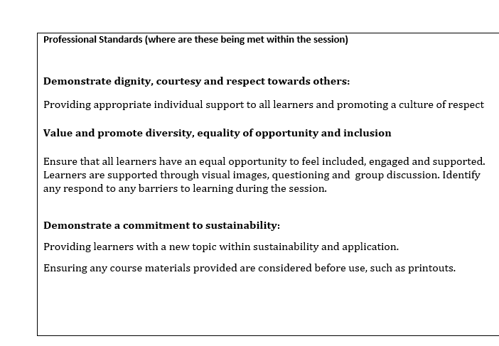

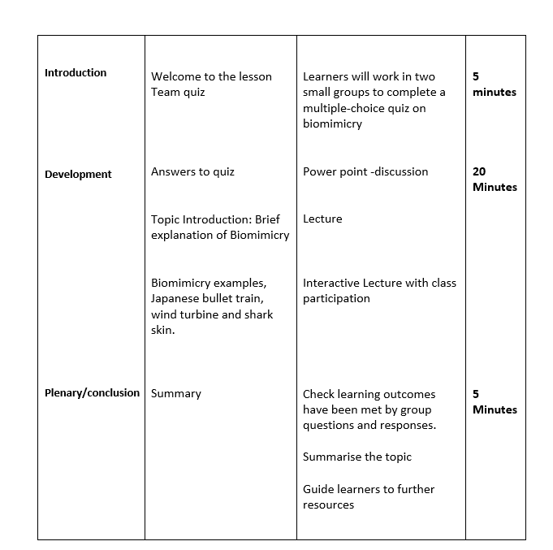

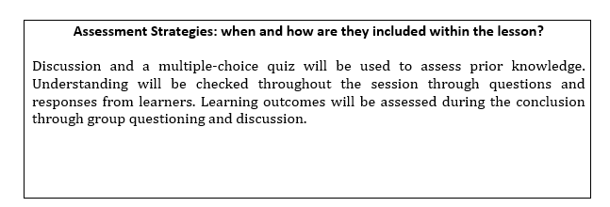

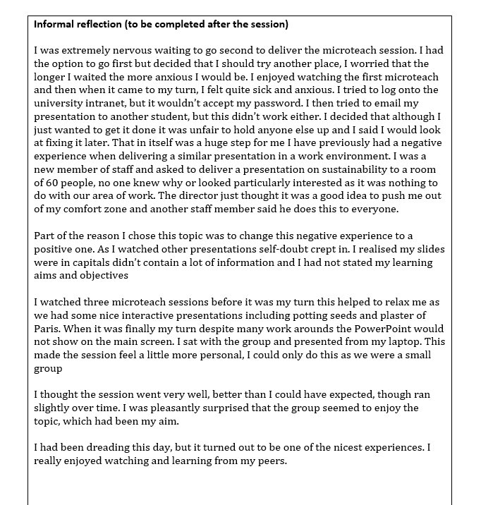

Appendix B: PowerPoint Presentation:
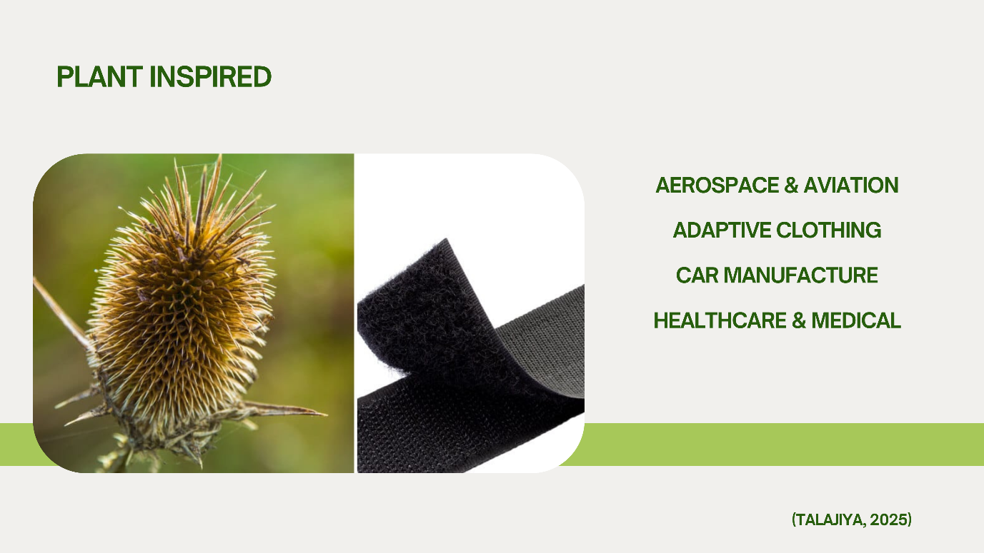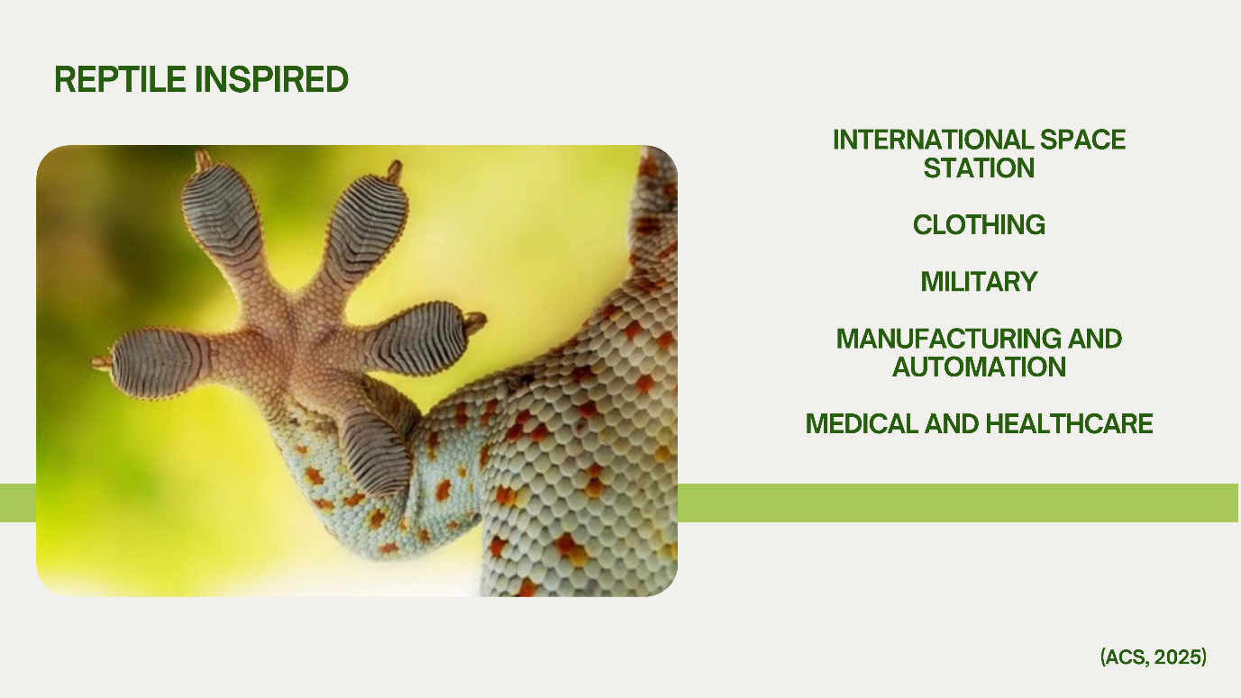

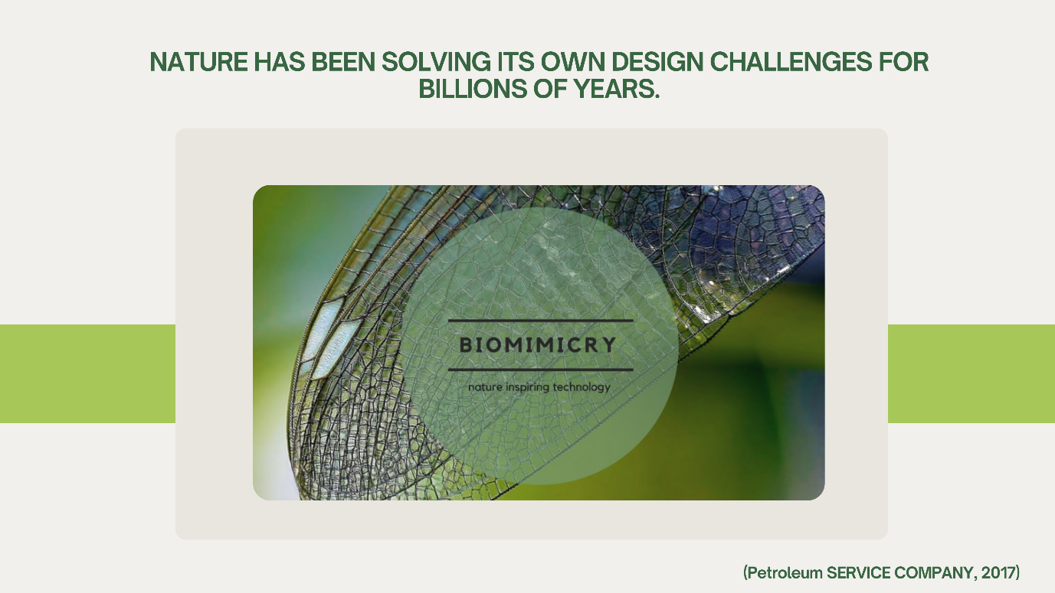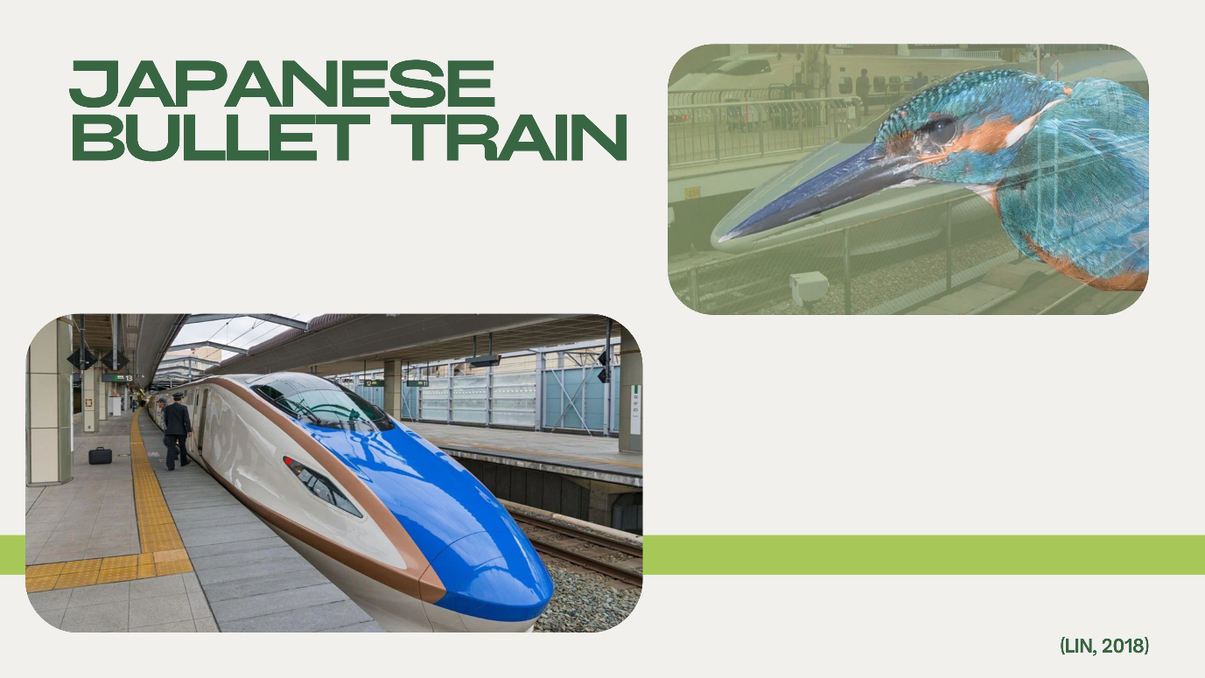
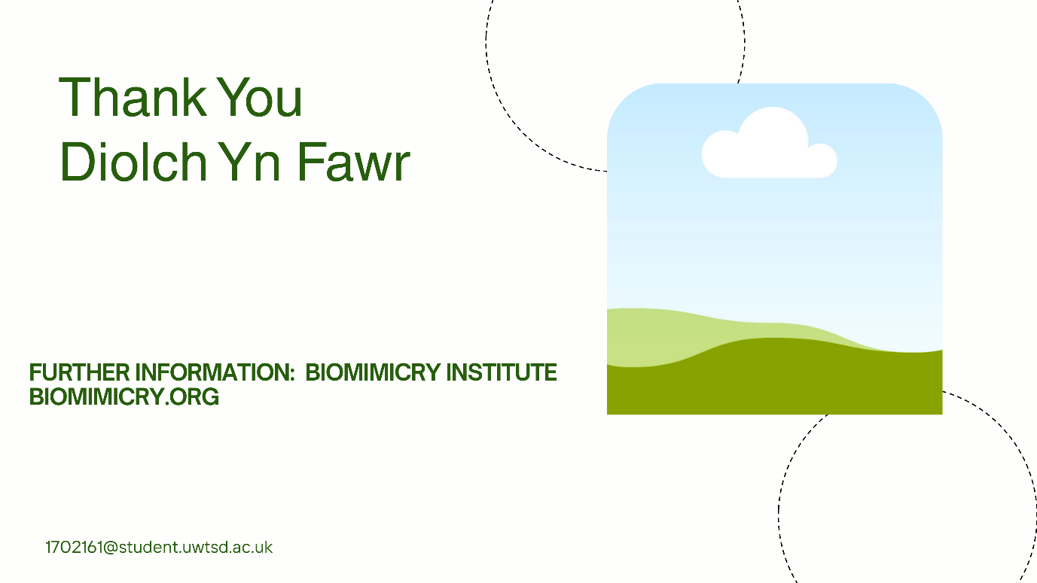

Appendix C: Biomimicry Quiz
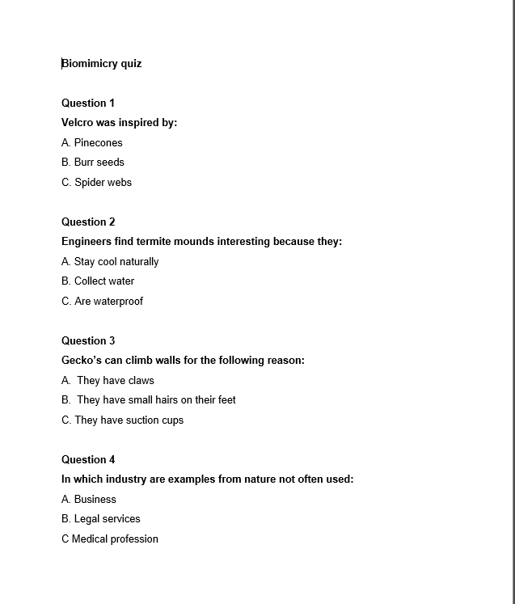

Appendix D: Teacher Observation Form
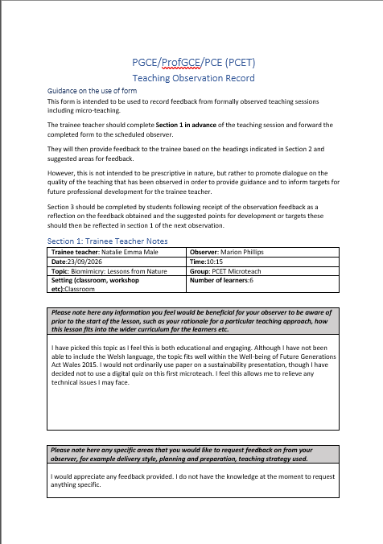

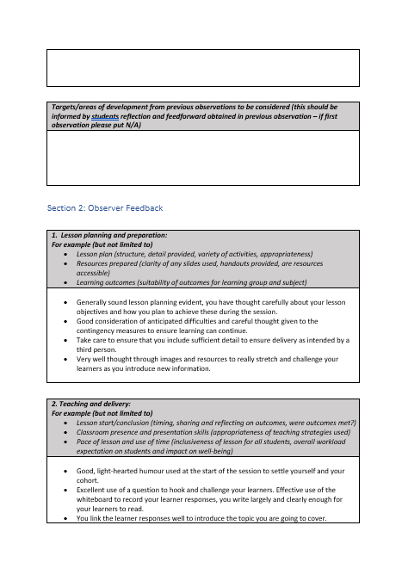
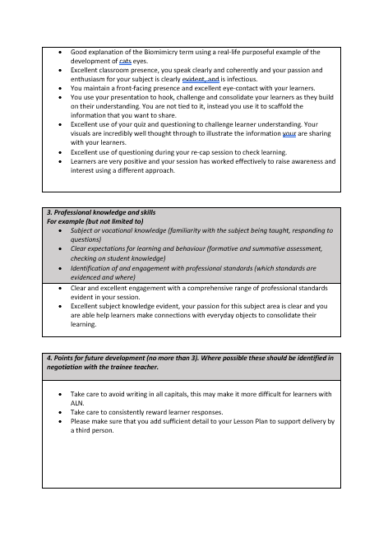

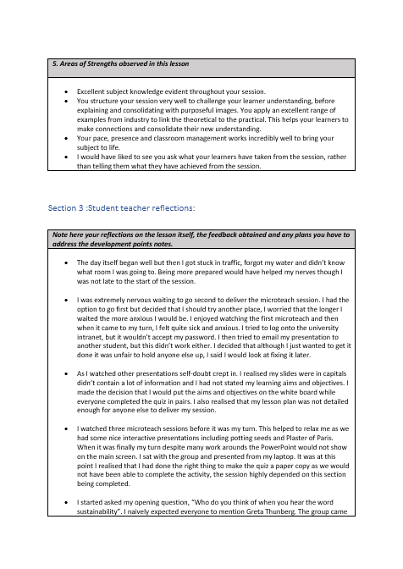



Appendix E: Peer feedback form Observer 1
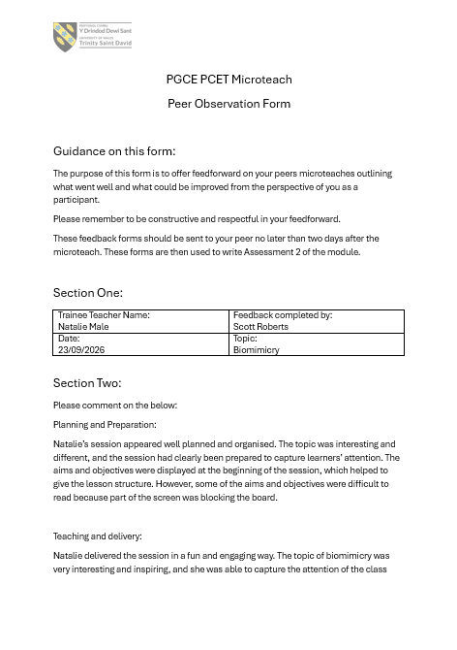

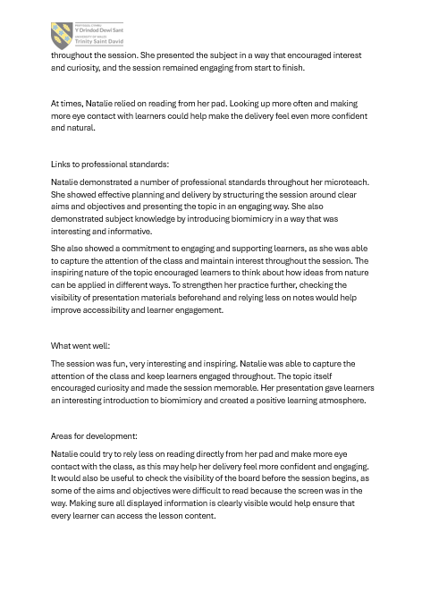

Appendix F: Peer feedback form Observer 2
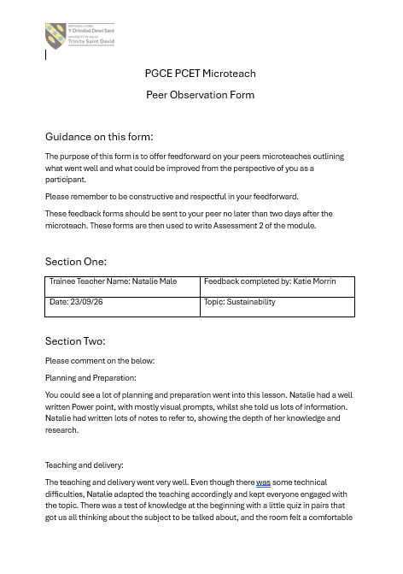

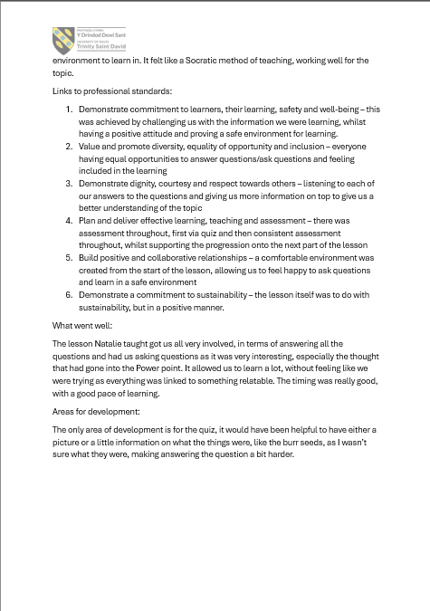
Appendix G: Peer feedback form Observer 3

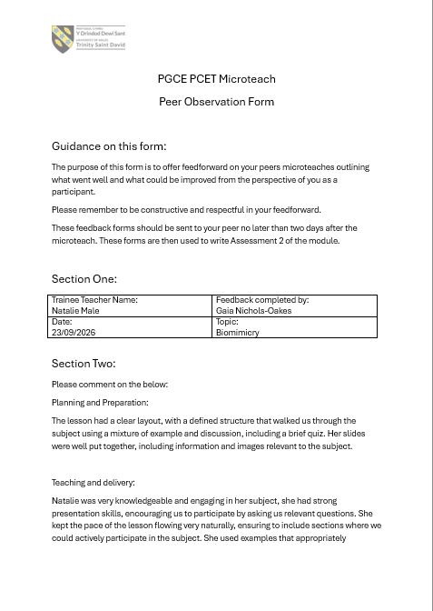
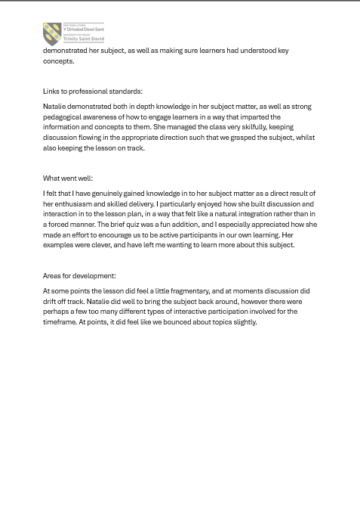

Appendix H: Peer feedback form Observer 4

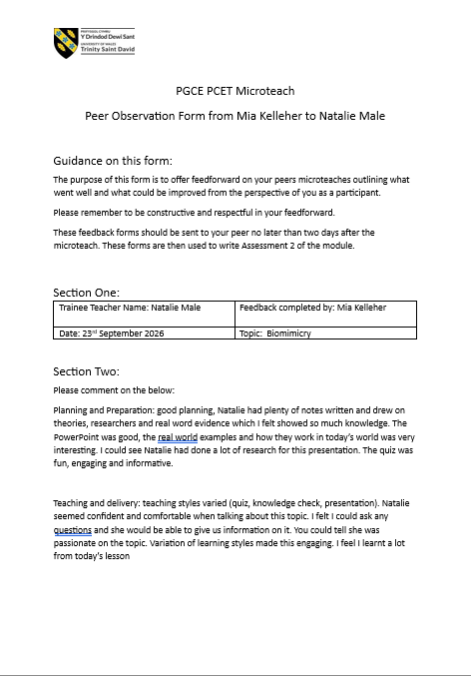
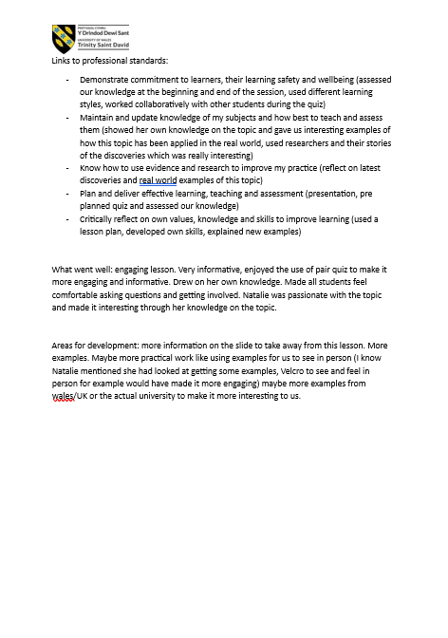
Appendix I: Peer feedback form Observer 5


