INTERNET PROTOCOLS

Prepared for

Dr. Renuga Jayakumar
University of Wales Trinity Saint David

Prepared by

Michele Chiarello
Student ID: 1805745

January 2019
Table of contents

SECTION I

Abstract……………………………………………………………………………………………. 4

Introduction……………………………………………………………………………………... 4

Specifications..…………………………………………………………………………….……. 4

Packets Header………..……………………………………………………………………….. 6

Addressing…………………………………………………………………………………………. 9

Security improvements……………………………………………………………………… 11

Conclusion………………………………………………………………………………………… 12

Appendix………………………………………………………………………………………….. 19

SECTION II

Network design for the School of Management and Engineering…….. 13

List of figures and tables

Figure 1. IPV4 packet header………………………………………………………………. 6

Figure 2. IPv6 packet header………………………………………………………………. 7

Figure 3. Network topology and assumptions……………………………………. 14

Table 1. Initial Fixed length subnet masking addressing scheme…………. 16

Table 2. Addressing scheme for the School of Applied Computing………. 16

Table 3. Addressing scheme for the School of Automotive Engineering. 17

Table 4. Addressing scheme for the School of Engineering…………………. 17

Table 5. Addressing scheme for the Server Room……………………………….. 18

SECTION I

Abstract

This report is related to the knowledges I’ve acquired during my research on the IPV6 protocol.
It aims to introduce the specifications and the real-world application it is used for.

Introduction

During the early 90s, the IETF (Internet Engineering Task force), starts to be concerned about some issues the IPV4 protocol would led due to its limitation in the addressing space.
This led to the study and development of a new protocol that would overcomes this limitation and enhanced the available features present in the old one, to keep up with the times and be ready for the actual and future network needs.
Actually, the old IPV4 protocol is still on use, due to the difficulty of its implementation in the big old infrastructures developed following this standard.
This doesn’t mean that these infrastructures are not updated or less secure, but it’s sure that in the next years they will migrate to the new standard.

Specifications

The IPV6 protocol bring new features to the old IPV4, these are:

- Enhanced addressing space, with 128 bits against the 32 bits used till now.

- Enhanced packets managing by removing some attributes to packet header.

- Eliminated the necessity of the NAT, because with a biggest addressing space it’s not anymore needed a dynamic IP assigned by the ISP to save public IPs.

Moreover, the new protocol defines new types of delivery options. To understand of what we are talking about, we can examine the differences between the IPV4 and IPV6 implementation.

During the delivery of a message we could want to deliver it to only one host, to a group of host or to all the host in the same area.
To achieve this aim, the IPV4 protocol defines 3 types of routing options, or rather:

- Unicast

- Multicast

- Broadcast

The Unicast option aims to deliver the message to only one host. It is a one-to-one delivery type.

Coming through the other types, we have the Multicast option. This one is used when a host needs to deliver the same message to a group of host in the same network simultaneously. This is a one-to-many delivery type.

The last option is the Broadcast, used when a host needs to deliver the same message to all the host in the same network. As mentioned before, this, is a one-to-all delivery option.
Some protocols use a different name for the Broadcast address (multicast), but it works in the same way of the first one.

In the IPV6 protocol, the broadcast address has been removed in favor of the Anycast address.

According to a document written by the Internet Engineering Task force (IETF) [2] “The scalability of multicast routing is improved by adding a "scope" field to multicast addresses. And a new type of address called an "anycast address" is defined; it is used to send a packet to any one of a group of nodes.”

Packets header

As introduced before, one of the most important advantages of the IPV6 protocol is that the handling of the packets header has been simplified.
To understand the differences between the two standards we can compare them in the images below, taken from the Cisco Networking Academy website [1].

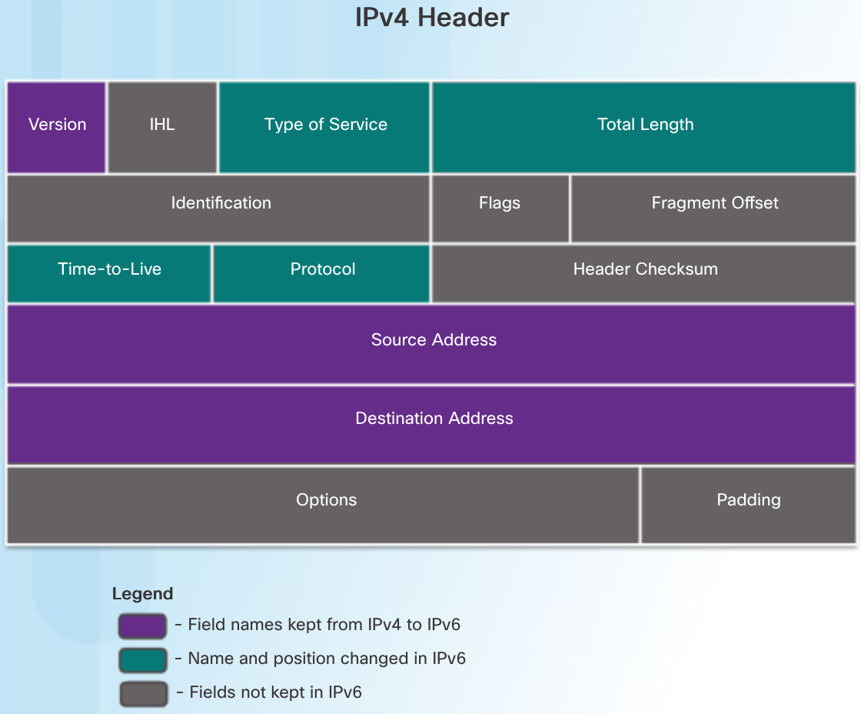

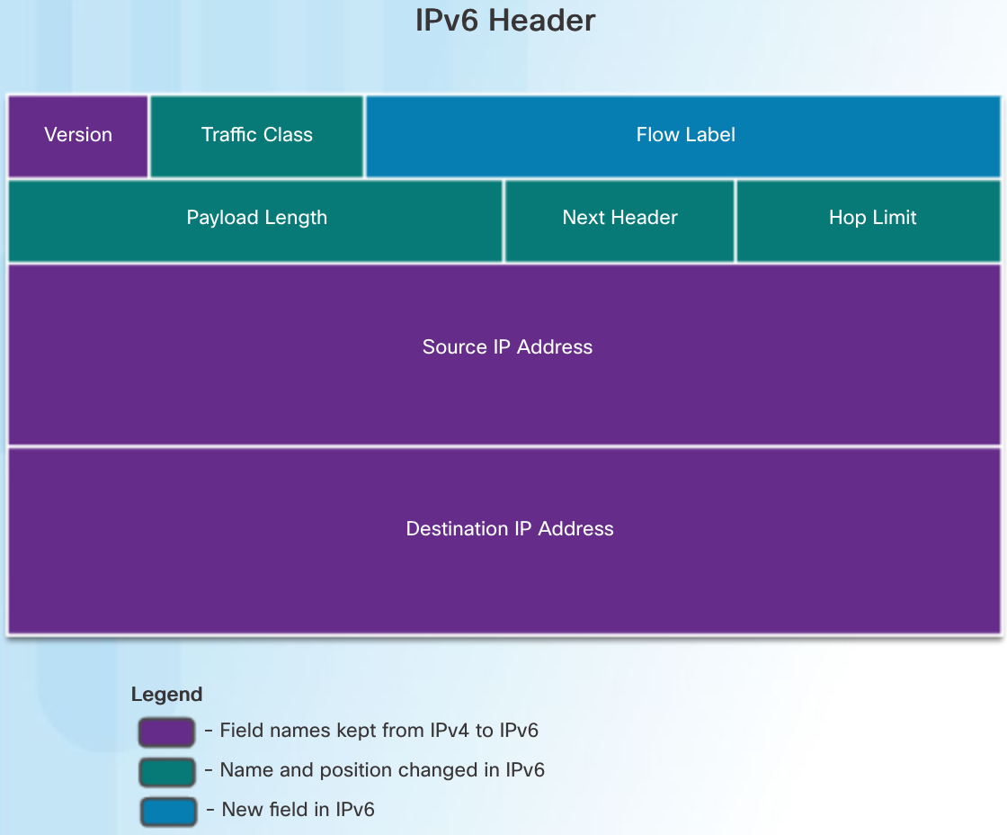

As we can see, various parts of the header, like IHL, Identification, Flags, Fragment offset, Header checksum, Options and Padding have been removed and the new Flow label attribute, has been added.

But, what does it mean in practical terms?

Well, according to the Internet Engineering Task Force (IETF) [2], the reason behind the choice that led to modify the Header Format, is “to reduce the common-case processing cost of packet handling and to limit the bandwidth cost of the IPv6 header.”

Representation

In the IPV6 standard, an address is represented by a group of 8 hexadecimal quartet (16 bits each) and could be imagined in this way:

XXXX : XXXX : XXXX : XXXX : XXXX : XXXX : XXXX : XXXX

Every quartet can be represented by a value from 0000 to FFFF.
We have to keep note of some features while we operate with them, because there are some rules that have to be respected to generate a correct IP.

Every quartet identified by all zero values can be suppressed, and substitute with the symbol “ :: ” .

To have an example of what this means we can inspect this IP address:

2001:0000:3238:DFE1:0063:0000:0000:FEFB

As we can see there are some quartets filled by all zero values.
This address can be represented in various forms.

For example, we can suppress the first 0000 quartet, simplifying the representation in this way:

2001::3238:DFE1:0063:0000:0000:FEFB

Or we can suppress the second part represented by 0000:0000 to making it shorter and more readable, like in this example.

2001:0000:3238:DFE1:0063::FEFB

This is almost the perfect reduction we can have, because we can make one more simplification.
We can suppress the first field represented by 0000, but not using the technique seen before, but simplifying it by transforming it into 0.
As we can see now, the address is shorter than before:

2001:0:3238:DFE1:63::FEFB

With these examples we can understand that:

- A field represented by all zeroes can be suppressed by using the symbol “::”

- All the leading zeroes in a quartet can be suppressed

- After using the :: simplification we can simplify the other all zero fieds by transforming them in just 0

NOTE: The simplification using the symbol “::” can be used only one time in an address. For this reason, we have to use it appropriately.

Addressing

In this standard, we can identify 6 different types of addresses. Each type is used for a different scope.
They are identified by the first quartet and they are:

- Loopback

- Unspecified

- Multicast

- Link-local

- Unique-local

- Global Unicast

- Anycast

According to the Network Working Group [3] “ Anycast addresses are taken from the unicast address spaces (of any scope) and are not syntactically distinguishable from unicast addresses”.

Unicast addresses

A unicast address uniquely identifies an IPV6 enabled and configured device. Comparing the IPV4 and IPV6 standards, we can say that they work in the same way. Particularly, a source IP must be a unicast address, while a destination IP can be both unicast or multicast .

As written in the study material on the Cisco Networking Academy website [1] “The most common types of IPv6 unicast addresses are global unicast addresses (GUA) and link-local unicast addresses”.

Global-Unicast addresses

A Global Unicast address can be compared to a public IPV4 address, because its duty is to make a host in a LAN reachable from the Internet.
They always start with 2001.

Unique-local addresses

Unique Local addresses are another type of addresses that make reachable a device on a network, by a device in another network.
Against the GUA, they don’t let to host with an internet access to reach the device, unless, even a Global Unicast Address is configured.
They are usually used in corporations and Metropolitan Area Networks, where an Intranet network is present.
They can be distinguished by the other types, because they always start with a quartet in the range between FC00 – FDFF.

Link- local addresses

Finally, we have the Link-Local addresses, that are used in a Local Area Network, to let all the host available on it to communicate between each other.
The range between they are allocated is FE80 – FEBF.

Anycast addresses

An Anycast address, is a particular type of address, that leads to the forwarding of a message between all the hosts with the same address.
As mentioned before, an Anycast Address, is undistinguishable from a Unicast Address, even because it’s generated in the same range of any Unicast Address.
To be sure that an address belongs to this typology, in the IPV6 Protocol standard, when a Unicast address is assigned to more than one host, is automatically views as Anycast.

Security improvements

The security improvements brought by the development of the new IPV6 standard are not too many, in fact, comparing it with the IPV4 Protocol, we can notice only a few improved features. We can state that IPV6 is more secure, but not invulnerable to networks attacks.

An example of improved security it’s related to the fact that an improved amount of addressing space makes harder to perform for example a Port scanning attack, where the attacker tries to scan a portion of the network to find a possible vulnerable service on the hosts available for the penetration.

Anyway, there are still some possible attack vectors that could compromise the system, like, as mentioned by Sotillo [4], there are issues related to the Header Manipulation and the Flooding.
Anyway, as learned in various reading, we can state that NO SYSTEM IS SAFE.

Conclusion

To conclude, I would like to say, that during the researches on the IPV6 protocol, I learned that is a huge improvement, respect to the IPV4.
It improves the managing and addressing features as well as the security, but the step to migrate all the actual systems based on the IPV4 protocol, is still far and present some issues.

SECTION II

In this section, I will explain how I designed the hierarchical IP addressing scheme for the Faculty’s network.

To do it, I first sketched out the topology of the network, to understand how all the buildings and labs should be connected and, after, I implemented the use of the fixed length subnet masking to get an idea of the ranges of the IP addresses I had to use for every building.

In this implementation I assumed to use a private CLASS B IP addressing scheme, to be sure that all the structures could support 2000+ hosts.

The range used for this purpose is 172.16.0.0 – 172.31.255.255.

Topology

The image below, shows how I thought to link the buildings, making use of 3 main switches connected to the router of the university.
Every main switch is connected to all the labs present in each building.
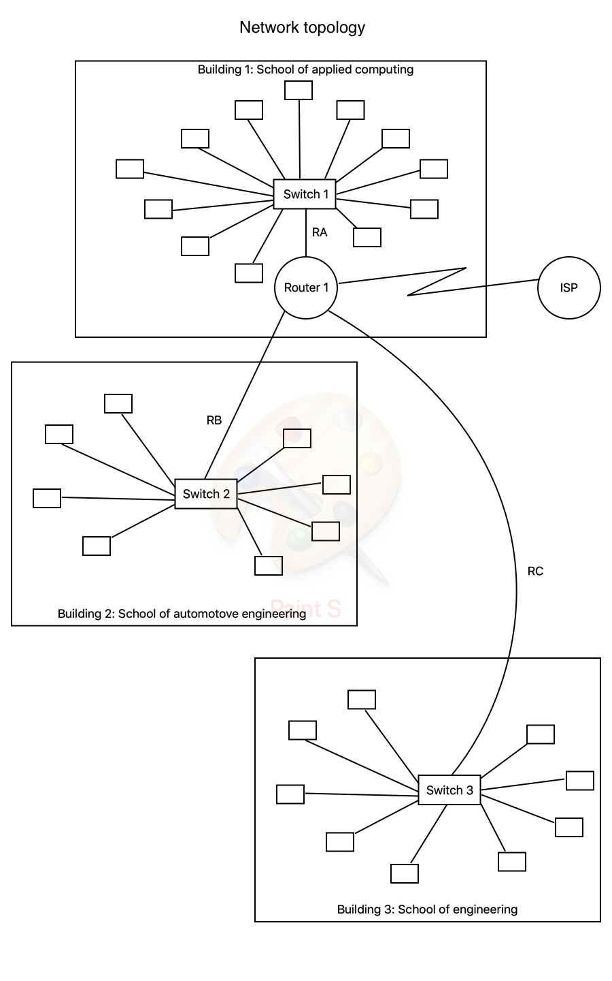

Follows the list of names used for the various connections:

- ROUTER 1: Router used to connect the buildings each other and give the internet connection to the complete structure.

- SWITCH 1: School of Applied Computing main switch, connected to the switches in every lab of this building.

- SWITCH 2: School of Automotive Engineering main switch, connected to the switches in every lab of this building.

- SWITCH 3: School of Engineering main switch, connected to the switches in every lab of this building.

- RA: Link between ROUTER 1 and the SWITCH 1

- RB: Link between ROUTER 1 and the SWITCH 2

- RC: Link between ROUTER 1 and the SWITCH 3

Conventionally I renamed the 3 buildings as:

- Building 1: School of Applied Computing

- Building 2: School of automation Engineering

- Building 3: School of engineering

NOTE: I assumed that TEST CENTRE, OPEN ACCESS LAB (OAL) and the servers which I relocated a Server Room, are in the Building 1.

Initial Fixed length subnet masking addressing scheme

Building | Network | 1st usable address | Last usable address | Broadcast | Subnet mask
Building 1 | 172.16.0.0 | 172.16.0.1 | 172.16.15.254 | 172.16.0.255 | 255.255.240.0
Building 2 | 172.16.16.0 | 172.16.16.1 | 172.16.31.254 | 172.16.31.255 | 255.255.240.0
Building 3 | 172.16.32.0 | 172.16.32.1 | 172.16.47.254 | 172.16.47.255 | 255.255.240.0

Addressing scheme for the Building 1

Building 1 | Network | 1st usable address | Last usable address | Broadcast | Subnet mask
OAL (252) | 172.16.0.0/23 | 172.16.0.1 | 172.16.1.254 | 172.16.1.255 | 255.255.254.0
Lab 308 (142) | 172.16.2.0/24 | 172.16.2.1 | 172.16.2.254 | 172.16.2.255 | 255.255.255.0
Lab 301 (62) | 172.16.3.0/25 | 172.16.3.1 | 172.16.3.126 | 172.16.3.127 | 255.255.255.128
Lab 309 (52) | 172.16.3.128/25 | 172.16.3.129 | 172.16.3.254 | 172.16.3.255 | 255.255.255.128
Lab 304 (47) | 172.16.4.0/25 | 172.16.4.1 | 172.16.4.126 | 172.16.4.127 | 255.255.255.128
Lab 306 (42) | 172.16.4.128/25 | 172.16.4.129 | 172.16.4.254 | 172.16.4.255 | 255.255.255.128
Lab 303 (38) | 172.16.5.0/25 | 172.16.5.1 | 172.16.5.126 | 172.16.5.127 | 255.255.255.128
Lab 302 (32) | 172.16.5.128/26 | 172.16.5.129 | 172.16.5.190 | 172.16.5.191 | 255.255.255.192
Test Center (24) | 172.16.5.192/26 | 172.16.5.193 | 172.16.5.254 | 172.16.5.255 | 255.255.255.192
Staff (22) | 172.16.6.0/26 | 172.16.6.1 | 172.16.6.62 | 172.16.6.63 | 255.255.255.192
Lab 310 (20) | 172.16.6.64/26 | 172.16.6.65 | 172.16.6.126 | 172.16.6.127 | 255.255.255.192
Server Room (8) | 172.16.6.128/28 | 172.16.6.129 | 172.16.6.142 | 172.16.6.143 | 255.255.255.240
N1 (4) | 172.16.6.144/30 | 172.16.6.145 | 172.16.6.146 | 172.16.6.147 | 255.255.255.252
N2 (4) | 172.16.6.148/30 | 172.16.6.149 | 172.16.6.150 | 172.16.6.151 | 255.255.255.252
N3 (4) | 172.16.6.152/30 | 172.16.6.153 | 172.16.6.154 | 172.16.6.155 | 255.255.255.252
N4 (4) | 172.16.6.156/30 | 172.16.6.157 | 172.16.6.158 | 172.16.6.159 | 255.255.255.252
N5 (4) | 172.16.6.160/30 | 172.16.6.161 | 172.16.6.162 | 172.16.6.163 | 255.255.255.252
N6 (4) | 172.16.6.164/30 | 172.16.6.165 | 172.16.6.166 | 172.16.6.167 | 255.255.255.252
N7 (4) | 172.16.6.168/30 | 172.16.6.169 | 172.16.6.170 | 172.16.6.171 | 255.255.255.252
N8 (4) | 172.16.6.172/30 | 172.16.6.173 | 172.16.6.174 | 172.16.6.175 | 255.255.255.252
N9 (4) | 172.16.6.176/30 | 172.16.6.177 | 172.16.6.178 | 172.16.6.179 | 255.255.255.252
N10 (4) | 172.16.6.180/30 | 172.16.6.181 | 172.16.6.182 | 172.16.6.183 | 255.255.255.252
N11 (4) | 172.16.6.184/30 | 172.16.6.185 | 172.16.6.186 | 172.16.6.187 | 255.255.255.252
N12 (4) | 172.16.6.188/30 | 172.16.6.189 | 172.16.6.190 | 172.16.6.191 | 255.255.255.252
RA (4) | 172.16.6.192/30 | 172.16.6.193 | 172.16.6.194 | 172.16.6.195 | 255.255.255.252

Addressing scheme for the Building 2

Building 2 | Network | 1st usable address | Last usable address | Broadcast | Subnet mask
Lab 301 (52) | 172.16.16.0/25 | 172.16.16.1 | 172.16.16.126 | 172.16.16.127 | 255.255.255.128
Lab 206 (50) | 172.16.16.128/25 | 172.16.16.129 | 172.16.16.254 | 172.16.16.255 | 255.255.255.128
Lab 205 (42) | 172.16.17.0/25 | 172.16.17.1 | 172.16.17.126 | 172.16.17.127 | 255.255.255.128
Lab 101 (42) | 172.16.17.128/25 | 172.16.17.129 | 172.16.17.254 | 172.16.17.255 | 255.255.255.128
Lab 103 (37) | 172.16.18.0/25 | 172.16.18.1 | 172.16.18.126 | 172.16.18.127 | 255.255.255.128
Lab 102 (27) | 172.16.18.128/26 | 172.16.18.129 | 172.16.18.190 | 172.16.18.191 | 255.255.255.192
Staff (27) | 172.16.18.192/26 | 172.16.18.193 | 172.16.18.254 | 172.16.18.255 | 255.255.255.192
CAD Lab (22) | 172.16.19.0/26 | 172.16.19.1 | 172.16.19.62 | 172.16.19.63 | 255.255.255.192
N1 (4) | 172.16.19.64/30 | 172.16.19.65 | 172.16.19.66 | 172.16.19.67 | 255.255.255.252
N2 (4) | 172.16.19.68/30 | 172.16.19.69 | 172.16.19.70 | 172.16.19.71 | 255.255.255.252
N3 (4) | 172.16.19.72/30 | 172.16.19.73 | 172.16.19.74 | 172.16.19.75 | 255.255.255.252
N4 (4) | 172.16.19.76/30 | 172.16.19.77 | 172.16.19.78 | 172.16.19.79 | 255.255.255.252
N5 (4) | 172.16.19.80/30 | 172.16.19.81 | 172.16.19.82 | 172.16.19.83 | 255.255.255.252
N6 (4) | 172.16.19.84/30 | 172.16.19.85 | 172.16.19.86 | 172.16.19.87 | 255.255.255.252
N7 (4) | 172.16.19.88/30 | 172.16.19.89 | 172.16.19.90 | 172.16.19.91 | 255.255.255.252
N8 (4) | 172.16.19.92/30 | 172.16.19.93 | 172.16.19.94 | 172.16.19.95 | 255.255.255.252
RB (4) | 172.16.19.96/30 | 172.16.19.97 | 172.16.19.98 | 172.16.19.99 | 255.255.255.252

Addressing scheme for the Building 3

Building 3 | Network | 1st usable address | Last usable address | Broadcast | Subnet mask
Lab 409 (82) | 172.16.32.0/25 | 172.16.32.1 | 172.16.32.126 | 172.16.32.127 | 255.255.255.128
Lab 202 (82) | 172.16.32.128/25 | 172.16.32.129 | 172.16.32.254 | 172.16.32.255 | 255.255.255.128
Lab 203 (67) | 172.16.33.0/25 | 172.16.33.1 | 172.16.33.126 | 172.16.33.127 | 255.255.255.128
Lab 404 (47) | 172.16.33.128/26 | 172.16.33.129 | 172.16.33.190 | 172.16.33.191 | 255.255.255.192
Lab 410 (47) | 172.16.33.192/26 | 172.16.33.193 | 172.16.33.254 | 172.16.33.255 | 255.255.255.192
Lab 408 (30) | 172.16.34.0/26 | 172.16.34.1 | 172.16.34.62 | 172.16.34.63 | 255.255.255.192
Lab 205 (27) | 172.16.34.64/26 | 172.16.34.65 | 172.16.34.126 | 172.16.34.127 | 255.255.255.192
Lab 201 (22) | 172.16.34.128/26 | 172.16.34.129 | 172.16.34.190 | 172.16.34.191 | 255.255.255.192
Staff (20) | 172.16.34.192/26 | 172.16.34.193 | 172.16.34.254 | 172.16.34.255 | 255.255.255.192
N1 (4) | 172.16.35.0/30 | 172.16.35.1 | 172.16.35.2 | 172.16.35.3 | 255.255.255.252
N2 (4) | 172.16.35.4/30 | 172.16.35.5 | 172.16.35.6 | 172.16.35.7 | 255.255.255.252
N3 (4) | 172.16.35.8/30 | 172.16.35.9 | 172.16.35.10 | 172.16.35.11 | 255.255.255.252
N4 (4) | 172.16.35.12/30 | 172.16.35.13 | 172.16.35.14 | 172.16.35.15 | 255.255.255.252
N5 (4) | 172.16.35.16/30 | 172.16.35.17 | 172.16.35.18 | 172.16.35.19 | 255.255.255.252
N6 (4) | 172.16.35.20/30 | 172.16.35.21 | 172.16.35.22 | 172.16.35.23 | 255.255.255.252
N7 (4) | 172.16.35.24/30 | 172.16.35.25 | 172.16.35.26 | 172.16.35.27 | 255.255.255.252
N8 (4) | 172.16.35.28/30 | 172.16.35.29 | 172.16.35.30 | 172.16.35.31 | 255.255.255.252
N9 (4) | 172.16.35.32/30 | 172.16.35.33 | 172.16.35.34 | 172.16.35.35 | 255.255.255.252
RC (4) | 172.16.35.36/30 | 172.16.35.37 | 172.16.35.38 | 172.16.35.39 | 255.255.255.252

IPV6 Addressing scheme for the Server Room

The following table summarizes the IPV6 addresses used for the 6 servers in the Server Room of the Building 1.
As you can see, I didn’t use any Global Unicast address on the Print Server and the Finance Server, because I assumed that they shouldn’t be exposed to the internet, but they only should be used by the internal departments.

Name | Link local | Unic Local | Global Unicast
DNS Server | fe80::aece:45ff:fe00:1322 | fdfd:27ff:4610::8ec:e3f0:90e3 | 2001:ca30:a700:ca01:5bed:c800:67a9::
Email Server | fe80:01ab:42bf:27ff::4610:101a:1001 | fc01:42bf:27ff:ca30:a700:4610::8ec | 2001::3238:dfe1:63:0:0:fefb
Finance Server | fe80:01ab:42bf::27ff:4610 | fc02:42bf:27ff:c01:27ff:4610::1001 | ND
Registry Server | fe80::aece:45ff:27ff:ca30:a700 | fc03:ab1:0:0:4610::10a:abcd | 2001:42bf:27ff::ca01:5bed
File Server | fe80:3238:63:ab1f:df12::300 | fc04::aece:45ff:fe00:1342 | 2001:42bf:27ff::ca01:fafe
Print Server | fe80:63:ab1f:df12:fefb::1ab | fc05:3238::dfe1:63:0:0:fefb | ND
Appendix

References:

[1] Cisco Networking Academy, “Introduction to networks”, accessed 01/09/2019
https://static-course-assets.s3.amazonaws.com/ITN6/en/index.html#6.1.4.3

[2] Internet Engineering task force, “Internet Protocol, Version 6 (IPv6) Specification”, accessed 01/09/2019
http://www.rfc-editor.org/rfc/pdfrfc/rfc8200.txt.pdf

[3] Network Working Group, “Internet Protocol Version 6 (IPv6) Addressing Architecture”, accessed 01/09/2019
https://www.rfc-editor.org/rfc/rfc3513.txt

[4] Samuel Sotillo, “IPv6 Security Issues”, accessed on 01/09/2019
http://iris.nyit.edu/~mcolef/courses/incs810/course_material/IPv6/IPv6_SSotillo.pdf

