HEATHER’S COFFEE SHOP

Contact number: 01934 835555

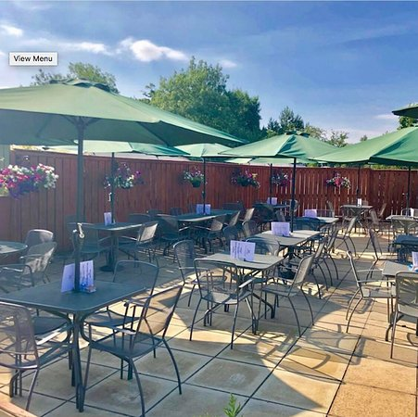

Final Report

Consultancy Project

Assignment 2

Level: 6

Victoria Daws P149271



Contents page

1.0 Executive summary………………………………………………………………..,3
2.0 Introduction………………………………………………………………………….4
2.1 Project Aim…………………………………………………………………..5
2.2 Project Objectives…………………………………………………………..5
3.0 Research Methods………………………………………………………………….6
4.0 Competitor Review…………………………………………………………………7
5.0 Research Findings…………………………………………………………………10
5.1 Question 1…………………………………………………………………..10
5.2 Question 2…………………………………………………………………..11
5.3 Question 3…………………………………………………………………..12
5.4 Question 4…………………………………………………………………..13
5.5 Question 5…………………………………………………………………..14
5.6 Question 6…………………………………………………………………..16
5.7 Question 7…………………………………………………………………..18
6.0 Discussions and Analysis…………………………………………………………19
7.0 Conclusions…………………………………………………………………………20
8.0 Recommendations…………………………………………………………………21
9.0 Appendices………………………………………………………………………….23
10.0 References ………………………………………………………………………..25

1.0 Executive Summary

Heather’s Coffee Shop is a family run café serving traditional English dishes such as jacket potatoes, paninis and full English breakfasts.

It is open all year round and seven days a week. The café has a strong online presence including a Facebook page and TripAdvisor account. The aim of this project is to evaluate the effectiveness of the café’s online marketing strategy. The project objectives are to undertake market research into the café social media use and online presence to evaluate their current strategy. To compare this to what other similar venues are doing in the local area in regard to an online presence and to provide recommendations on how to update and improve Heather’s marketing strategy.

To do this, both primary and secondary research was used to see how much people value an online presence and whether it is worth heathers creating their own website. Primary research, in the form of questionnaires and secondary research, in the form of a content analysis of competitors in the local area was undertaken.

Heather’s have some competitors in the local area. All but one of these establishments have an online presence including websites, Facebook pages and other social media accounts

The strengths of Heather’s café are the friendly staff and the ‘instagramable’ sweet treats along with the rest of the good food provided. Some weaknesses that were found through TripAdvisor comments are that it can sometimes be slow when busy and that the café its self is hard to keep warm. An opportunity for the café would be to create their own website displaying the theme of the café and what they have to offer. A threat to the café is the local competitors.

The consultant concluded from the primary and secondary market research into the café’s social media and online presence, that people would benefit from a simple café website to stand alongside the already strong social media Facebook and TripAdvisor accounts. The content analysis showed that Heather’s competitors have a range of social media accounts such as Pinterest, Twitter and Instagram however, it is not necessary for Heather’s to be on those forms of Social Media. If Heather’s does decide to create a website, the market research shows that it should be easy to use and it should include links to the, already strong, Facebook and TripAdvisor accounts and have pictures of the location and food that it offers.

2.0 Introduction

Heather’s Coffee Shop is a family run café located in the village of Congresbury, they have their contact information on their trip advisor website including their address and a contact phone number;
Smallway
Roundtree Garden Centre
Congresbury
BS49 5AA
North Somerset
England
01934 835555.

The café has great reviews on TripAdvisor, with an average of 4.5/5 from 131 reviews. They are the number 1 of 2 Quick Bites in Congresbury and number 2 of 19 Places to Eat in Congresbury. The café serves British cuisine such as breakfast sandwiches, full English breakfasts and jacket potatoes to name a few dishes.

They are open from:
10:00 - 16:00 on Sundays
09:00 - 16:30 on Mondays
08:00 - 16:30 Tuesday through Friday
09:00 - 16:30 on Saturdays.

Heather’s Coffee Shop has been around for over 20 years and is open all year round. The café is not affected by seasonality as the hours are the same all year. Their online TripAdvisor account has 131 reviews and an overall rating of 4.5/5. The reviews on TripAdvisor show that December through February have the highest rating (with 19 Excellent reviews in total) yet the least number of reviews, whereas March through May have the greatest number of reviews but are mixed (with 35 Excellent, 5 Very Good, 4 Average and 3 Terrible reviews). This shows that the café preformed best during the winter season.

“Social platforms help you connect with your customers, increase awareness about your brand, and boost your leads and sales” (Marketing Insider Group, 2019). Many studies have shown that a strong online presence is crucial to the success of a business. “45% of the total world population are using social networks” (Hootsuite Social Media Management, 2019) so it is important for small businesses to keep up with these trends. Heather’s has taken this into consideration and has a strong Facebook and TripAdvisor page but no unique website. This is what the consultant is looking into throughout this report, is there a need for Heather’s Coffee Shop to create a website?

2.1 Project Aim

To evaluate the effectiveness of the café’s online marketing strategy. This will entail looking at what online platforms are already in place and how effective they are.

2.2 Project Objectives

To undertake market research into the café’s social media use and online presence to evaluate their current strategy. To do this, the use of secondary research will help analyse the effectiveness of the current strategy. Primary research will then determine whether the current strategy is working.

To compare Heather’s to similar venues in the local area in regard to online presence. Identify the local competitors and what their online presence is.

Provide recommendations on how to update and improve Heather’s marketing plan. Make recommendations on how Heather’s could have a stronger online presence.

3.0 Research Methods

This research will take an epistemological, interpretivism approach which is the study of knowledge. It examined the relationship between the researcher and the research being undertaken (Löfgren, 2013). The research is very subjective with no specific answer looking to be proven. It is looking at attitudes, ideas and opinions of those who visit Heather’s and whether a stronger online presence would improve the café’s image or bring more people in. The need to understand why people think the way they do and why they make the decisions that they do about their business (Saunders, 2009).

To get the most reliable and in-depth quality of research the consultant will collect a mixed method set of data. This is important as both figures and opinions are needed to get a clear picture of how well Heather’s is doing.

Questionnaires are a method of primary data that will be a useful tool to collect both quantitative and qualitative data. Questions can be asked to get the results that are needed to provide a conclusion. The same questionnaire will be filled out both in the café and online via Facebook. This way data can be collected from the location in question and from a wider range of potential customers. It is important to get a range of different individuals to complete the questionnaire, which is what the consultant did, as the younger generation will have a different outlook on how important social media and a strong online presence is, compared to the older generation.

Alongside the primary data collection, secondary data collection methods will also be used to collect information for this project. Secondary research was done first to see what competitors were doing online and with this information, the consultant completed a content analysis of the competitor’s online material. Following this research, the questionnaire was created based on what was found and how Heather’s could use this information to their advantage.

4.0 Competitor review
 | Website | TripAdvisor | Facebook | Twitter | Instagram | Pintrest | Rating
The Strawberry Line Café  The Strawberry line Café is located next to Yatton train station, so it attracts both locals and people traveling to the small village by train. The café is open every day serving breakfasts, lunches, tasty treats and snacks, and hot and cold beverages. |  |  |  |  |  |  | 4.5 stars
Cottage Tea Rooms  The Cottage Tea Rooms is a café located on the High Street in Yatton village so attracts locals and people driving through Yatton. |  |  |  |  |  |  | No rating on Google
that coffee place  that coffee place is located in the precinct in the village centre and attracts locals and people who are doing their shopping in the Coop that is located in the same precinct. |  |  |  |  |  |  | 4.6 stars
Poppies  Poppies is located in Claverham which is further away from Heather’s than its other competitors but is still considered a competitor as it offers similar amenities to Heather’s. |  |  |  |  |  |  | 4.5 stars
Costa Coffee  Costa Coffee is located in Cadbury Carden Centre which is next to Heather’s. | There is a website and various social media pages but not the Congresbury location specifically, only Costa Coffee’s general social media accounts. |  |  |  |  |  | 3.1 stars
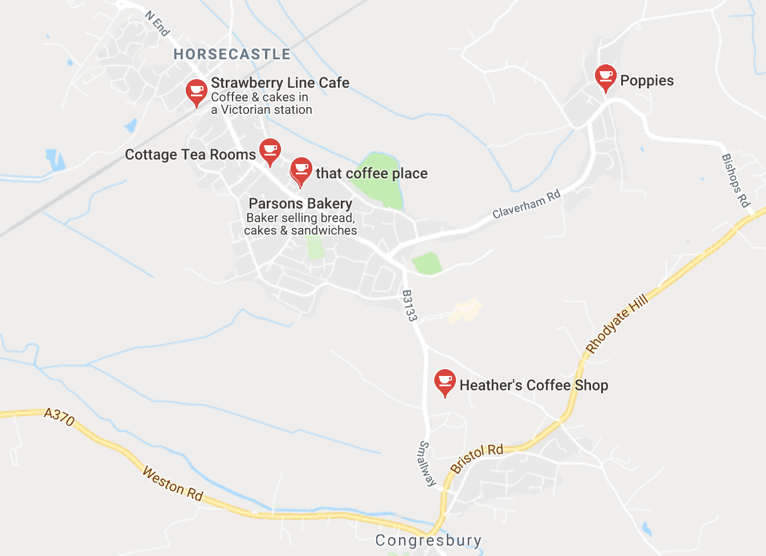
(Google Maps, 2019)

Heather’s café has some competitors in the local area. The Strawberry Line Café, Cottage Tea Rooms, that coffee place, Poppies and despite not showing up on google maps, a costa coffee is located in the garden centre next to Heather’s. Each of these venues offer similar services to Heather’s, such as teas, coffees and food.

Heather’s has a 4.5-star rating, so based on a brief google search, Heather’s main competitors are that coffee place with 4.6 google stars, Poppies with a rating of 4.5 google stars and the Strawberry Line Café with 4.5 google stars. However, there are many other factors that affect people’s decision to visit a café and that Heather’s are having to compete with, such as menu options like gluten or dairy free options, distance to travel or the physical café environment.

From the table, it is clear that 4 out of 5 competitors have a Facebook account but only 3 out of 5 have their own website. This may show that an up-to-date social media page is enough for the local community to keep informed about the café options in the area. The ratings do not seem to correlate with the amount of online presence. The Cottage Tea Rooms are the only clear sign that no online presence means no reviews and therefore no rating for customers to go on.

5.0 Research Findings

The results of this questionnaire may not be 100% accurate as each questionnaire could’ve been filled out between a group of people rather than strictly one person to each questionnaire. This means the number of people who took part in the survey is undetermined however, in total, 50 questionnaires were completed, and this is what the results showed:

5.1 Question 1

How often do you visit Heather’s?

The consultant decided to ask participants how often they had visited Heather’s to see if the majority were regular visitors and therefore would not need to look up the café online. If a large majority had only visited once or less than once a week then there would be a need to have a clear online presence to show what Heather’s has to offer so that potential customers could see all the great things the café has to offer when comparing it with other cafes in the local area. The results show that 35% of the interviewees visit Heather’s once a week or more, meaning they could be considered regular customers of the café. This is good for the café as they have a loyal customer base.

5.2 Question 2

Where do you live?

This question is important as it shows the distance people are willing to travel to visit the café. People are only going to travel if the café has something great to offer. The results also show that the majority of customers are local, from Yatton, however, one participant travelled over 100 miles and visited the café when they come to Yatton.

As 72% of the participants are local, traveling within a 6-mile radius, the need for an informative website may not be so apparent as customers already know what their local coffee shop has to offer. However, this is not enough information to determine if Heather’s would benefit from a website.
5.3 Question 3

Age?

The consultant decided to collect the age of Heather’s customers to show the demographic of the café. If the majority of the customers are over 66 then maybe there is not such an urgent need for a website to market the café as, typically, the older generation do not use computers. But this information cannot be gathered without further questioning. The results show, the 72% of Heather’s customers are between 47 and 66. 13 out of the 17 questionnaires that were filled out by customers that are 66+ said they didn’t use any social media or online platforms. This supports the hypothesis that the older generation do not use the internet in their everyday lives.

5.4 Question 4

What forms of social media do you use in your everyday life?

The consultant then went on to ask customers about their online activity to see if a website would be something worthwhile for the café. This information shows that 32% of the questionnaire participants do not use social media at all and that Facebook is the most used form of social media. This is good news for Heather’s as the café already have a Facebook page to market themselves. The data collected for this question may not be 100% accurate as the consultant posed the question in an open-ended format rather than giving participants options. For example, WhatsApp may not be considered as a form of social media to some people and therefore would not have written it down even if they do in fact use it.

The results of Question 3 and Question 4 together show that age relates to social media use. As Heather’s main clientele is over the age of 47, it is not surprising that a large number of interviewees do not use Social Media at all. This is something for the café to think about as they might need to think of other forms of marketing to reach the older generation that don’t use computers.

5.5 Question 5

Have you ever used TripAdvisor?

This is important information to collect as Heather’s is on TripAdvisor as well as Facebook. The consultant wanted to know if customers used this website to see if the cafe is putting their resources into the right places. Despite the older clientele of the café, the results show that 58% of the customers have used TripAdvisor. This shows that customers do appreciate a TripAdvisor page to inform them about what a café has to offer.

Following the broad question of whether customers look at TripAdvisor, the consultant collected information on what people look at when visiting the website. Ratings and Reviews is the main reason people look on TripAdvisor and Heather’s TripAdvisor page has plenty of Ratings and Reviews for potential customers to look at. If there are both good and bad reviews from other customers on TripAdvisor, potential customers are going to get a broader opinion of the café than if there are just ‘self-made’ comments on the companies own page. Customers also like to see that the establishment in question has taken the time to reply to comments, this shows that the café is interested in the feedback and is willing to take it on board (Davies, 2019). If the comments are left blank, then it doesn’t give the impression that the online platforms are being taken seriously by the café. This is why it is important for Heather’s to keep their already strong pages, up-to-date.

5.6 Question 6

Do you look at a restaurant/cafes website before visiting?

This question is finding out if there is a need for Heather’s to create a website. If the café spent time and money on creating a detailed website and the data showed that people do not look at websites, then it would be wasted resources for Heather’s. The results of the market research show that 68% of people do look at a café or restaurants website before visiting, meaning it would be a valuable resource for Heather’s to create a website to market to potential customers, but also to make their online presence stronger. As the content analysis table of Heather’s competitors shows, the establishment with more online content has a stronger online presence and therefore more for customers to use as research when looking for somewhere to dine.

This set of results looks further into the quality of a website. It can be interpreted from these results that people would rather have no website than a poor website as the majority of customers said that a poorly presented and hard to use website would discourage them from visiting the café or restaurant. So, if Heather’s is going to create a website it needs to be of good quality.

On reflection, this follow up question could have been worded differently to not include a double negative. This may have been confusing to participants completing the questionnaire. However, the consultant found the results useful as clear recommendations can be made with the information that people would be more likely to be put off a café or a restaurant if the website was poor.

5.7 Question 7

Have you ever looked up Heather’s online?

The final question the consultant asked Heather’s customers is whether people had ever looked online to find information about the café. 82% of the interviewees said they had never looked up the café online, this could be because many are so local, they know about the café.

This question was the only opportunity for interviewees to provide some qualitative data when asked “What did you find when you searched?” The consultant was surprised to receive very few answers, even when interviewees said they had searched the café online. Some responses included;

“LOTS OF VIDEOS ABOUT THE CAFÉ”

“VERY NICE CAFÉ THAT WE ENJOY COMING TO, FIRST HEARD OF FROM WORD OF MOUTH”

“WENT ONLINE TO WRITE A GOOD REVIEW!”

6.0 Discussion and Analysis

SWOT Analysis of Heather’s Coffee Shop

Strengths  Heather’s is a small independent business located in the centre of Congresbury. As it is a small business it has the luxury to change what they want when they want. If something isn’t working out such as the pricing strategy or what food they have on offer, then the café does not have to adhere to any rules set by higher management.  A great quality of Heather’s is their friendly staff, “Food and drinks are good value and staff are friendly” (TripAdvisor, 2019). As question 1 shows, 69% of the customers asked had visited more than once and some had travelled a distance to dine there as question 2 shows. Many of the staff members have been part of the cafés team for many years and get to know the locals so can give personalised service, such as knowing orders and knowing personal details about regular customers. This gives a friendly, homely feeling when dining at Heather’s.  The café has been using the same sweet treat suppliers for many years. This shows that the café management recognise what works and what to keep constant to keep their customers happy. A phrase that is becoming more frequent with today’s society is “instagramable” meaning “Worth putting into Instagram/social media” (Urban Dictionary, 2019) by having the same consistent and delicious looking treats, the café will collect a data base online of the recognisable dishes and people will want to come and eat at Heather’s to find out how the good looking food pictures taste. | Weaknesses  Although the café has very few, there are some weaknesses like with all companies. As the sandwiches and savoury dishes are made fresh, they take time to put together. Some TripAdvisor comments show that when it is busy, on a weekend or holiday, the staff can’t keep up with demand and therefor it takes longer to get the fresh meals out to customers than it does on a quieter day: “Slow. Nice cake but slow.” (TripAdvisor, 2017)  Another weakness of the café is that it is situated in a conservatory building. This has its positives and negatives. The conservatory building helps create the warm, homely atmosphere the café is striving for and allows light to flow in, meaning the room isn’t dark and depressing as some café buildings are. However, the glass structure is hard to keep warm in the winter and can get hot and humid in the summer. There is a spacious outdoor seating area to tackle the heat in the summer, but the winter can get cold and cost a lot to keep warm 7 days a week.  Despite these negative comments, it has not put customers off the café, and all said they would visit again.
Opportunities  One of the biggest opportunities Heather’s have is the option to create a website that displays what the café has to offer. The colour scheme, image choice, font and positioning all have an important part to play in how user friendly the website is. As the research shows (especially the results of question 6, part 2) people value the effectiveness of a website. If it doesn’t work or achieve the aim and is not easy to use, then customers implied they would rather not have a website at all. So, the opportunity is there for the café to create a website, however there has to be enough resources put into the creation of said website to make it worth wile. | Threats  Competitors of Heather’s are a threat to the café. As analysed in the competitor analysis section of this report, Heather’s has some competitors in the local area that offer similar amenities to them. But Heather’s has been around longer than any of the establishments mentioned and has its great reputation to separate it from these competitors.

7.0 Conclusions

The aim of this report was to undertake market research into Heather’s Coffee Shop’s social media use and online presence to evaluate their current strategy. This was done with 3 specific objectives:

To undertake both primary and secondary market research into the café’s social media use and online presence. This involved looking into what the café already has in place, which is a Facebook page and a TripAdvisor page but no website. Both of the social media platforms are detailed with information on what the café serves, opening times and location. With the use of primary research, the consultant can conclude that people would benefit from a simple café website to stand alongside the social media pages as question 6 shows that 69% of customers do look at a café or restaurants website before going.

To compare Heather’s to what other similar venues are doing in the local area in regard to online presence. When looking at what Heather’s Coffee Shop’s competitors are doing online, the majority had a strong online presence with Facebook pages, some Instagram accounts, Twitter pages, Pinterest accounts and café websites. Those without any online information do not give as good of an impression as customers do not have anything to go by when looking online.

Provide recommendations on how to update and improve Heather’s marketing plan. Based on market research, Heather’s Coffee Shop would benefit from creating a website that has all the information that is on Facebook and TripAdvisor. The website should also have the links to both social media sites as the questionnaire showed that customers value both a website and a social media presence. The website should be easy to use, have a clear colour scheme that matches the look and feel of the café itself and pictures of the food they serve to show potential customers what they offer. Information such as special events or seasonal changes should also be on the website.

The sample of people who filled out each questionnaire may have narrowed the results, those who answered the questionnaire online would have different answers to those who filled it out on paper in the café as the online survey was sent out on Facebook, therefore, all those who completed it online would’ve answered question 4, the question asking if the interviewee used social media, yes and that they used Facebook. This could be why the Facebook column is considerably larger than any other answer.

On reflection, the questionnaire was potentially too quantitative. The consultant could have asked more questions to express an opinion from each customer rather than purely facts and figures, gathering qualitative data.

8.0 Recommendations

The results from the questionnaire show that certain forms of social media are good for the community. As 40% of the people who were interviewed are local, there may not be a need for a complex website and many people already know what there is on offer. However, the other 60% have travelled further to the café and would benefit from a simple website that provides information on menu updates, holiday hours and small events run by Heather’s.

Question 6 shows that 69% of customers do look at a café or restaurant’s website before going and following that, customers would rather have no website than a bad website. If Heather’s chooses to create a unique website, it should be simple and easy to use. It is also important to keep the current Facebook and TripAdvisor pages up-to-date as the results of the questionnaire show that people do look at them and value the content.

The next phase of the project would be to implement these suggestions.

9.0 Appendices

- Blank questionnaire

QUESTIONNAIRE

My name is Victoria Daws and I am completing my university dissertation on Social Media Presence at Heather’s Café. I would appreciate you taking a few minutes to complete this short questionnaire. Thank you very much.

- How often do you visit Heather’s?

Once…………………..
Less than once a week……………..
Once a week…………….
More than once a week………………

- Do you live locally?

Yes No

Where are you from?…………………………………

- Age?

0 – 16………………
17 – 26………………
27 – 46………………
47 – 66 ………………
66+ ……………
Would rather not say………………

- Do you use social media in your everyday life?

Yes No

If yes, which forms of social media do you use? ..................................

- Have you ever used TripAdvisor?

Yes No

If yes, have you used it to look up cafes and restaurants?

Yes No

If yes, what were you looking for (tick all that apply)

Ratings and reviews…………………………………………...
Location…………………………………………………………
Type of establishment (what food they offer) ………………
Price……………………………………………………………..
Other…………………………………………………………….

- Do you look at a restaurant/cafe website before visiting?

Yes No

If yes, on a scale of 1 – 5 with 5 being it would affect your decision and I being it would not affect your decision how much would a poorly presented and hard to use website detract you from visiting a restaurant/café?

1……..
2……..
3……..
4……..
5……..

- Have you ever looked up Heather’s online?

Yes No

What did you find when you searched? ..........................................

THANK YOU
PLEASE HAND THE COMPLETED QUESTIONNAIRE TO HEATHER’S STAFF

- Minutes of meetings

March 13, 2019, 10:30am: Initial contact was made with the Heather’s Coffee Shop on potentially doing this project with the café.

March 25, 2019, 4:30pm: Café responded and agreed to let the consultant work with them.

April 9, 2019, 12:50pm: First meeting with Café owner to finalise project details.

April 13, 2019, 3:45pm: Questionnaire questions agreed.

April 14 – 20, 2019: Questionnaires filled out and collected for analysis.

May 10, 2019, 5:00pm: Finished report sent to client.

10.0 References
Costa.co.uk. (2019). The Nation's Favourite Coffee Shop | Costa Coffee. [online] Available at: https://www.costa.co.uk/ [Accessed 17 Apr. 2019].
Davies, M. (2019).
Facebook.com. (2019). Heathers Coffee Shop. [online] Available at: https://www.facebook.com/Heatherscoffeeshop/ [Accessed 15 Mar. 2019].
Foodhygienerating.me.uk. (2019). Food Hygiene Rating of Cottage Tea Rooms 102 High Street, Yatton, Bristol, BS49 4DW. [online] Available at: http://foodhygienerating.me.uk/council/North-Somerset/food-hygiene-ratings/?place=516821-102-The-Bistro-102-High-Street-Yatton-Bristol-BS49-4DW [Accessed 17 Apr. 2019].
Google.com. (2019). yatton cafes - Google Search. [online] Available at: https://www.google.com/search?sa=X&rlz=1C5CHFA_enUS739US739&biw=633&bih=665&q=yatton+cafes&npsic=0&rflfq=1&rlha=0&rllag=51388942,-2823522,341&tbm=lcl&ved=2ahUKEwiwkKu409bhAhXEKewKHfYpAZEQjGp6BAgJEDU&tbs=lrf:!2m1!1e2!2m1!1e3!3sIAE,lf:1,lf_ui:9&rldoc=1#rlfi=hd:;si:,51.38279067823448,-2.7971021771396636;mv:!1m2!1d51.39720036367101!2d-2.794308715731404!2m2!1d51.36934521476122!2d-2.8281260069911696!4m2!1d51.38327490844528!2d-2.8112173613612867!5i14 [Accessed 7 Apr. 2019].
Hootsuite Social Media Management. (2019). 130+ Social Media Statistics that Matter to Marketers in 2019. [online] Available at: https://blog.hootsuite.com/social-media-statistics-for-social-media-managers/ [Accessed 8 May 2019].
Löfgren, K. (2013). What is epistemology? Introduction to the word and the concept. [video] Available at: https://www.youtube.com/watch?v=lI9-YgSzsEQ [Accessed 11 Mar. 2019].
Marketing Insider Group. (2019). Why Social Media Is Important for Business Marketing | Marketing Insider Group. [online] Available at: https://marketinginsidergroup.com/content-marketing/why-social-media-is-important-for-business-marketing/ [Accessed 8 May 2019].
Saunders, M., Thornhill, A. and Lewis, P. (2008). Research methods for business students. 5th ed. Pearson Education M.U.A.
Strawberry Line Cafe. (2019). The Strawberry Line Cafe - About Our Cafe. [online] Available at: http://www.strawberrylinecafe.co.uk/2010/01/our-cafe [Accessed 13 Apr. 2019].
that coffee place. (2019). Coffee, Cakes - That Coffee Place - Yatton, England. [online] Available at: https://thatcoffee.place/ [Accessed 17 Apr. 2019].
TripAdvisor. (2019). Heather's coffee shop, Congresbury - Restaurant Reviews, Phone Number & Photos - TripAdvisor. [online] Available at: https://www.tripadvisor.co.uk/Restaurant_Review-g1761798-d8107397-Reviews-Heather_s_coffee_shop-Congresbury_Somerset_England.html [Accessed 11 Mar. 2019].
Urban Dictionary. (2019). Urban Dictionary: Instagramable. [online] Available at: https://www.urbandictionary.com/define.php?term=Instagramable [Accessed 9 May 2019].

