Module: Strategic Management and Sustainability
Module code: LCBB6004

University Of Wales Trinity Saint David

Student ID: 2024157
Student name: Maria Hagiu

August 2023

Table of Contents
Introduction 3
Important business strategies of Volkswagen over the last five years 3
Resources and capabilities of Volkswagen in the last five years and its alignment to the current business strategies 5
The strategy Volkswagen is currently using to become more competitive by taking sustainability and the environment into consideration 5
Sustainability practices that Volkswagen can develop for competitive advantage in the future 7
Conclusion 9
References 10
Appendices 12
Appendix 1: SWOT analysis of Volkswagen 12
Appendix 2: Porter’s five force 13

Introduction
This report will discuss the important business strategies that Volkswagen has been following for the last five years (Volkswagen, 2022). Also, the resources that the company has been using to align with the current business strategy will also be discussed. The capabilities of Volkswagen to recover from the negative impacts will also be discussed in this report. Furthermore, the strategies the organisation has been using to sustain the business in the current situation will also be explained in the report. Apart from this, the strategies that Volkswagen can use in future to improve the sustainability of business will also be explained in the report (Volkswagen, 2022).

Important business strategies of Volkswagen over the last five years
Volkswagen has followed many business strategies for growth over the last five years. The main aim of Volkswagen is to move ahead with pace. Also, it has been following the strategy to sharpen the focus of the strategic projects and implement the projects in a more systematic manner (Volkswagen, 2022). The organisation has worked to make the future of the organisation more sustainable for present and future generations. Furthermore, Volkswagen has been very efficient, innovative, sustainable and customer oriented. It has systematically focused towards making the growth of the company profitable (Volkswagen, 2022). The goal of the organisation is to help its customers meet their diverse needs by creating an attractive portfolio of their products. The organisation has also been working on sharpening the focus and increasing the momentum to achieve the targets. The core product of the company has been more emotive which gives a completely new driving experience to the customers (annual report, 2020). The organisation has also been using digital technology effectively for cleaning automobiles to make them safer to use. Moreover, the organisation has also been working on transforming to e- mobility. It has been found that many Volkswagen cars that have been sold had a defeat device inside the diesel engine. This device was used to check the level of emissions made by the car (Volkswagen Group, 2023). The organisation has been accused by the Environmental Protection Agency of modifying the software fitted in the Volkswagen models but the organisation has denied the claim (annual report, 2020). It has been found that when the cars were moving under controlled laboratory supervision, the device that was installed inside the diesel engine made the car operate under some kind of safety mode due to which the engine of the car was operating below the normal performance. As a result, diesel engines produced nitrogen oxide pollutants more than the maximum level the organisation was heavily fined (Volkswagen Group, 2023). This made the customers lose trust in the organisation and the need to win back the trust of the customers has risen.
The organisation has used strategies to win back the trust of the customers. The Lewin change model was one such strategy used. This model is a very simple and easy-to-understand framework (Volkswagen Group, 2023). There are three stages present in this model such as “unfreeze, change and refreeze”. The unfreezing stage prepared Volkswagen to accept the necessity to change. This involves breaking the current status of the organisation before building up new ways of operation. The Unfreezing stage explains why the existing strategy cannot be continued. In this stage, the change has been done by conducting a survey to understand the current situation of Volkswagen (Volkswagen Group, 2023). The next stage of this model is the change stage. In this stage, the uncertainties are resolved and new ways of doing things are explored (Irvin et al., 2019). It is very important to make clear communication and plan the changes in the implementation. The employees of Volkswagen have been empowered in this stage (Volkswagen Group, 2023). The third stage is the refreeze stage. This is the stage where the changes are embraced and new ways of working have been developed. The practical explanation of refreeze is setting up consistent job descriptions, stable organisational charts, training ethical dilemmas and many other factors (annual report, 2020).
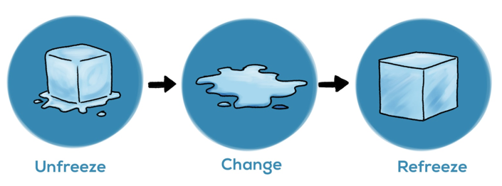
Figure 1: Lewin change management model
(Source: Ratana, 2020)

Resources and capabilities of Volkswagen in the last five years and its alignment to the current business strategies
There are many resources that Volkswagen has been using for the success of the organisation (Dattée et al., 2022). One of the main resources is the employees. The employees of Volkswagen are the true assets of the company. The organisation always looks for ways to retain employees. There are some strategies followed by Volkswagen to retain its employees. The salaries paid to the employees of the organisation have been more than average the average salary. This encourages the employees to stick around and work more. The employees have been always allowed to speak their minds because it helps Volkswagen to get new ideas. The portfolio of the organisation is the widest because it always searches for opportunities to diversify. Moreover, Volkswagen has also been planning to innovate and create a self-driven car by the year 2026. The organisation will launch automated electric vehicles to market the scalable product (Dattée et al., 2022). Volkswagen also has the capability to bounce back after receiving negative publicity. It has effectively used the change model to combat the negative effect of the Diesel gate scandal. Also, the organisation has the capability to grow its market in the United States of America.

The strategy Volkswagen is currently using to become more competitive by taking sustainability and the environment into consideration
There are many practices by which Volkswagen is gaining a competitive advantage and trying to sustain itself in the future (Wei, 2023). The organisation offers attractive pricing to its customers to stay ahead of the market. The automobile companies like Bentley and Jaguar are using this strategy to stay ahead in the market. Volkswagen also concentrates more on its branding to differentiate itself from other companies. The strategy of differentiation helps the organisation to find the core talent that separates Volkswagen from other organisations (Wei, 2023). Also, the innovation strategy helps Volkswagen to get a competitive advantage over others. The organisation also does very good financial planning. It uses the effective use of information systems to get a report on the functional performance when compared to the target related to the budget (Setyani et al., 2022). The quality of financial planning is mostly dependent on the CEO of the organisation because they have a very good idea about the products and services of the company. As Volkswagen has knowledge of the cost structure of the organisation, it is very easy for them to estimate the impact of a product change on the organisation as well as on their distribution system.
Volkswagen also identifies the qualities related to the demographics of its customer base. It helps the organisation to understand its customers on a personal level that is it helps the organisation to know about the customer's hobby, the aspects of the business that attracts the customers and many other factors (Setyani et al., 2022). The demographic information is collected by Volkswagen through various surveys, interaction with the customers and analysis of the customer information. Volkswagen also has many connections with companies that have specialisation in providing information related to the business. Getting detailed knowledge about the customers helps Volkswagen to get more knowledge about its competitors (Bašová, 2022). The organisation also maximises its revenue potential by getting in-depth insights about the customers. Furthermore, the organisation also believes in retaining customers and also boosts prospective customers. Volkswagen is also taking steps in moving towards the electrical future which means it is moving towards making electric cars to reduce carbon emissions. The organisation has been on the road to success for a couple of years and the revenue growth of the company has been tremendous. Moreover, Volkswagen has also been working to acquire companies. Recently, the organisation acquired a German-based automobile company. Volkswagen has also gained success by getting 100% company shares of Porsche (Pacces, 2023). Volkswagen has also launched “Strategy 2025” which is the electrification strategy. The main aim of this strategy is to launch electric vehicles which include battery and also the fuel cell vehicles. Volkswagen has also made an agreement with Hino Motors to introduce e-mobility products in the market. Volkswagen has tried its best to get the title of Rolls-Royce but it was not able to do so. The thought of getting the title counts. Volkswagen has also been investing in brand names and it is one of the most important strategies of the organisation. The organisation has seized the auto union control and became the owner of Audi. Volkswagen has also acquired Lamborghini which has added a popular brand name to the portfolio of the organisation (Pacces, 2023). Also, Volkswagen has allowed the brands to retain their original names instead of micing the brands. With this, the sale of products of Volkswagen has become easy in the market. The organisation is also updated according to the needs and wants of the customers. Volkswagen also understands the importance of the present climate apart from investing in the brand names that are popular. Volkswagen was also able to rebuild its reputation after getting caught in the scandal by introducing electric vehicles. This shows that Volkswagen is committed to maintaining sustainability. The company also has a good digital transformation strategy. It has decided to transform into a tech group in the year 2021 (Bist et al., 2022). With the high production of electric cars, the company did not struggle much to orient itself into the market related to technology. Digitisation also helps the organisation to strengthen its security and reduce the risk of policy breaches. The organisation was also able to introduce new business models which have created higher levels of efficiency inside the organisations (Bist et al., 2022). Volkswagen has shown exponential growth in recent years with the help of the cloud. The cloud is used by the organisation to effectively analyse all the data in the organisation. The organisation also uses Porter’s five force analysis to analyse the strength and weaknesses of the competitors (Budiharso et al., 2022). It is an effective tool to identify the competition in the automobile industry. Also, this tool is used by the organisation to analyse the potential of new entrants in the automobile industry. Volkswagen also uses Porter’s five force analysis to analyse the power of the people who supply the products related to automobiles (Budiharso et al., 2022). The power of customers is also analysed by the organisation with the help of this tool. The analysis of the competitors is also done very easily with the help of this tool.

Sustainability practices that Volkswagen can develop for competitive advantage in the future
There are many ways by which Volkswagen can use to gain a competitive advantage in the future (Nuryakin and Maryati, 2022). Volkswagen can work on creating cars that are environmentally friendly. Cost leadership is another competitive advantage that Volkswagen can gain. The advantage of cost leadership can be gained when Volkswagen offers the same quality of automobile products as its competitors provide. The organisation can find various ways to offer the lowest price of cars to its customers. For doing this, the company can explore many ways to create its product at a low price through the perfect production methods. It can also utilise its resources in a more efficient manner compared to its competitors (Nuryakin and Maryati, 2022). The cost leadership strategy is sometimes called an offensive strategy because it drives the competitors out of the market. Volkswagen can also make an attempt to work on making different products with different attributes. It will help the organisation to stay apart from the competitors. In this strategy, the low cost is the only possible factor that sets the business aside. Organisations that differentiate themselves mainly look for more than one marketable attribute (van Bavel, 2022). Volkswagen can explore the markets that give importance to the attributes. Volkswagen can also use a defensive strategy to gain a competitive advantage in the future. The advantage that can be gained by following this type of strategy is it can distance itself from the competition that may occur in the future. It will help the organisation to maintain the competitive advantage it has gained. This strategy is closely related to the differentiation strategy and helps business organisations to retain a competitive advantage (Gartner et al, 2022). Volkswagen can make an attempt to get resources through strategic alliances with other business organisations. This can be done within the same industry or related industries. Volkswagen can be careful about not amalgamating alliances and collusion. Collusion occurs when organisations belonging to the same industry work together. Strategic alliances are joint ventures that are used by business organisations to pool resources and gain exposure (Gartner et al, 2022).
Volkswagen can also use the process of biodegradable packaging because as soon the customers extract the contents, the product packaging becomes useless (Alvoittu, 2022). Plastic waste is not biodegradable and if it is not recycled it remains permanently on the earth. Also, plastic is not recyclable. So, if Volkswagen switches to using biodegradable materials it will be a sustainable business practice of the organisation. Furthermore, Volkswagen can make the best use of digitisation to eliminate the usage of paper. The sustainable business practice of keeping the records in digital format makes the use of paper redundant. If the organisation cannot avoid the use of paper, then it can make use of recyclable materials. This will save the trees and will also help to reduce global warming. The conservation of water is also most important for Volkswagen while it is creating its products related to automobiles. Using more water will involve high-cost implications for the organisation. There are many organisations that are cutting down the usage of water in their office premises to save water. Volkswagen also can also make an attempt to eliminate carbon footprints in the future by making the best use of renewable energy. The usage of renewable energy will give long-term benefits to the organisation like creating a green environment and saving money. The sources of renewable energy are wind, solar and geothermal sources. Volkswagen can also gain some special grants from the local government to get access to renewable energy sources (Van der Waldt and Fourie, 2022). Volkswagen can also improve its supply chain management to gain a competitive advantage in the future. The organisation can reassess the supply chain. Material sourcing can be done by the organisation to avoid any kind of wastage. Also, while doing this, the organisation can make sure that the natural resources are not exploited. Renewable energy sources can also be saved by the organisation by reducing unnecessary usage of energy sources. All the strategies related to sustainability will be put into practice by the employees of Volkswagen. So, it is very important to educate employees about sustainability (Karatepe et al., 2022). The roles and responsibilities can be assigned to the employees in such a way that they feel involved in performing the responsibilities. Furthermore, proper training can be given to the employees to maintain a positive work culture inside the organisation.

Conclusion
The digital technology is used effectively by Volkswagen to improve hygiene inside the organisation. Volkswagen has been caught in the diesel gate scandal and was successfully able to recover from it by regaining the trust of the customers again. Volkswagen has worked very hard to gain the trust of the customers again by working on creating electric vehicles. Furthermore, the organisation Volkswagen is also planning to produce cars that can be self-driven in the future. Porter’s five force analysis is used by Volkswagen for properly analysing the competitors and it has been found to be the best tool.

References
Alvoittu, A., 2022. The Effects of Greenwashing on Consumer Behavior.
Aman-Ullah, A., Aziz, A. and Ibrahim, H., 2020. A systematic review of employee retention: what’s next in Pakistan?. Journal of Contemporary Issues and Thought, 10, pp.36-45.
annualreport 2020. Volkswagen Konzern - AR 20 - Goals and Strategies. [online] Available at: https://annualreport2020.volkswagenag.com/group-management-report/goals-and-strategies.html [Accessed 12 Jul. 2023].
Bašová, A., 2022, October. Digitalisation and the company's competitive advantage. In IAI ACADEMIC CONFERENCE PROCEEDINGS (p. 76).
Bist, A.S., Agarwal, V., Aini, Q. and Khofifah, N., 2022. Managing Digital Transformation in Marketing:" Fusion of Traditional Marketing and Digital Marketing". International Transactions on Artificial Intelligence, 1(1), pp.18-27.
Budiharso, T., Makruf, I. and Mujahid, I., 2022. Porter’s Five Forces: Evaluating Education Management Practices in the Postgraduate Program of UIN RM Said Surakarta, Indonesia. Journal of Social Studies Education Research, 13(1), pp.164-192.
Dattée, B., Arrègle, J.L., Barbieri, P., Lawton, T.C. and Angwin, D.N., 2022. The dynamics of organizational autonomy: Oscillations at Automobili Lamborghini. Administrative science quarterly, 67(3), pp.721-768.
Gartner, J., Maresch, D. and Tierney, R., 2022. The key to scaling in the digital era: Simultaneous automation, individualization and interdisciplinarity. Journal of Small Business Management, pp.1-28.
Irvin, J., Rajpurkar, P., Ko, M., Yu, Y., Ciurea-Ilcus, S., Chute, C., Marklund, H., Haghgoo, B., Ball, R., Shpanskaya, K. and Seekins, J., 2019, July. Chexpert: A large chest radiograph dataset with uncertainty labels and expert comparison. In Proceedings of the AAAI conference on artificial intelligence (Vol. 33, No. 01, pp. 590-597).
Javed, A.R., Shahzad, F., ur Rehman, S., Zikria, Y.B., Razzak, I., Jalil, Z. and Xu, G., 2022. Future smart cities: Requirements, emerging technologies, applications, challenges, and future aspects. Cities, 129, p.103794.
Karatepe, T., Ozturen, A., Karatepe, O.M., Uner, M.M. and Kim, T.T., 2022. Management commitment to the ecological environment, green work engagement and their effects on hotel employees’ green work outcomes. International Journal of Contemporary Hospitality Management, 34(8), pp.3084-3112.
Nuryakin, N. and Maryati, T., 2022. Do green innovation and green competitive advantage mediate the effect of green marketing orientation on SMEs’ green marketing performance?. Cogent Business & Management, 9(1), p.2065948.
Pacces, A.M., 2023. Controlling Shareholders and Sustainable Corporate Governance: The Role of Dual-Class Shares. European Corporate Governance Institute-Law Working Paper, (700).
Ratana, S., Raksmey, C. and Danut, D., 2020. Conceptualizing a framework: A critical review of the development of change management theories. Studies in Business and Economics, 15(2), pp.205-214.
Setyani, S., Hanifah, I.A. and Ismawati, I.I., 2022. The role of budget decision making as a mediation of accounting information systems and organizational culture on the performance of government agencies. Journal of Applied Business, Taxation and Economics Research, 1(3), pp.311-324.
van Bavel, B., 2022. Wealth inequality in pre‐industrial Europe: What role did associational organizations have?. The Economic History Review, 75(3), pp.643-666.
Van der Waldt, G. and Fourie, D., 2022. Ease of Doing Business in Local Government: Push and Pull Factors for Business Investment in Selected South African Municipalities. World, 3(3), pp.470-486.
Volkswagen 2022. BBC News. [online] 25 May. Available at: https://www.bbc.com/news/business-61581251 [Accessed 12 Jul. 2023].
Volkswagen Group 2023. Strategy. [online] Available at: https://www.volkswagen-group.com/en/strategy-15955 [Accessed 12 Jul. 2023].
Wei, W.A.N.G., 2023. Independent Final Report.

Appendices

Appendix 1: SWOT analysis of Volkswagen
Strengths | Weaknesses
- Employee retention (Aman-Ullah et al., 2020)  - Widest portfolio of the brand  - Effective strategies to diversify  - Innovation in the products | - The negative publicity has made the brand weak  - The market share of the organisation is the lowest in the USA
Opportunities | Threats
- A rise in fuel prices can be seen in future for the purpose of creating automated cars in the future.  - The demand for autonomous vehicles will increase in the future  - High focus on increasing the sustainability policy | - Increased competition in the future  - The regulations of government can be strict in future (Javed et al., 2022)
(Source: Created by the learner)

Appendix 2: Porter’s five force
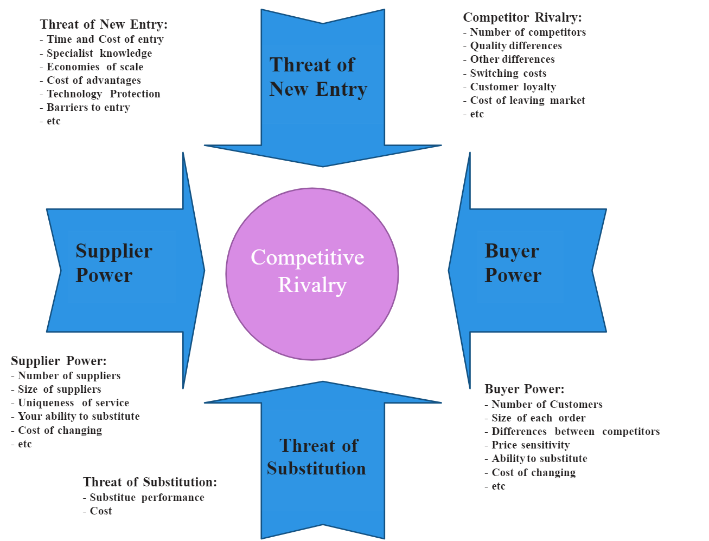
(Source: Volkswagen Group, 2023)

