

Cloud Computing Technologies (ACCC5000_LON)

London Bikes Ltd /Overview of Cloud Computing /

Student: Sonya Kyuchukova
ID 1818665
B.Sc Cloud Computing

Lecturer: Anupam Mazumdar

CONTENT:

1.Abstract……………………………………………………….3
2. Introduction………………………………………………….3
3.Benefits of Cloud Computing…………………………….10
4.Disadvantages of Cloud Computing…………………….11
5.Characteristics of Cloud Computing…………………….12
6.Security of information in Cloud Services………..........14
7.Virtualization………………………………………………….17
8.Migration strategies…………………………………………18
9.Cloud Computing solution for London Bike……………19
10.Reference…………………………………………………….21

1.Abstract
Today, small and medium-sized enterprises face many challenges such as globalization, competitiveness, adaptability, speed of change, growth and therefore they increasingly need new technologies.
To successfully address these challenges, London Bike is considering using cloud computing in their business, and applying them can be an essential tool for developing the potential of their future.
2. Introduction
"Cloud computing" is a term that refers to the idea of ​​combining the computing power of many computer devices in a system as users use computer resources in a network environment.
Cloud Computing provides us with a tool through which we can access applications as utilities through Internet.
It permits us to make, tack and customise applications on-line.
Simply put, cloud computing is that the provision of computing services - together with servers, storage, databases, networks, software, analytics and intelligence - over the Internet to offer faster innovation, flexible resources and savings from scale. We usually only pay for the cloud services we use, which helps reduce operating costs, manage infrastructure more efficiently, and scale when businesses change.
What is Cloud?
Cloud can provide services over the network or the Internet, present in a remote location - WAN, LAN or VPN.
What is Cloud Computing?
Cloud Computing is the way to manipulate, configure and access applications online by offering online data storage, infrastructure and application.
Cloud computing will make London Bikes business application mobile and collaborative by not having to install some of the software on the local computer and thus cloud computing overcomes the problems of platform dependency.

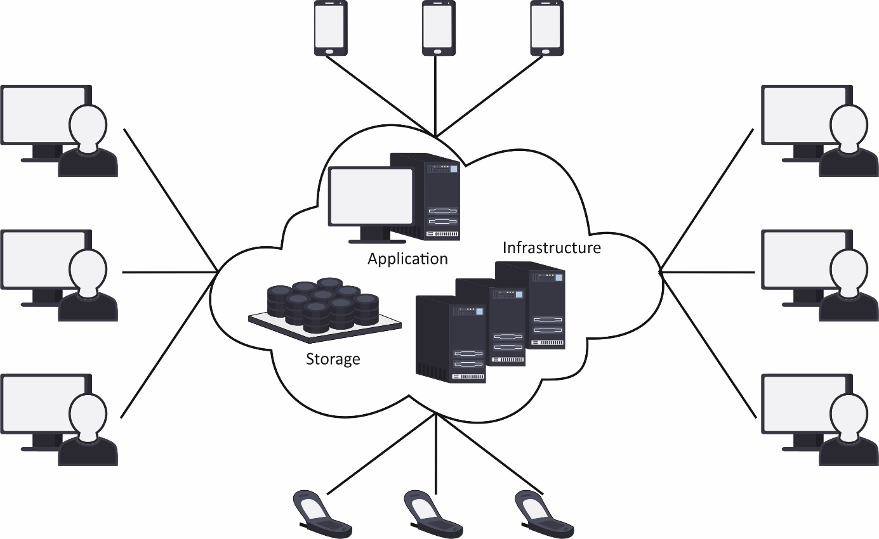
Basic Concepts

Behind the scene there are bound services and models operating creating the cloud computing possible and accessible to finish users such following:
- Deployment Models
- Service Models

DEPLOYMENT MODELS
Deployment models define the type of access to the cloud, how the cloud is located? Cloud will have any of the four varieties of access: Public, Private, Hybrid and Community.
P U B L I C CLOUD
The Public Cloud allows systems and services to be easily accessible to the general public but less The Hybrid Cloud is most suitable for London Bike .The critical activities as payments are performed using private cloud while the non-critical activities as map, are performed using public cloud.as payments are performed using private cloud while the non-critical activities as map, are performed using public cloud. because of its openness.
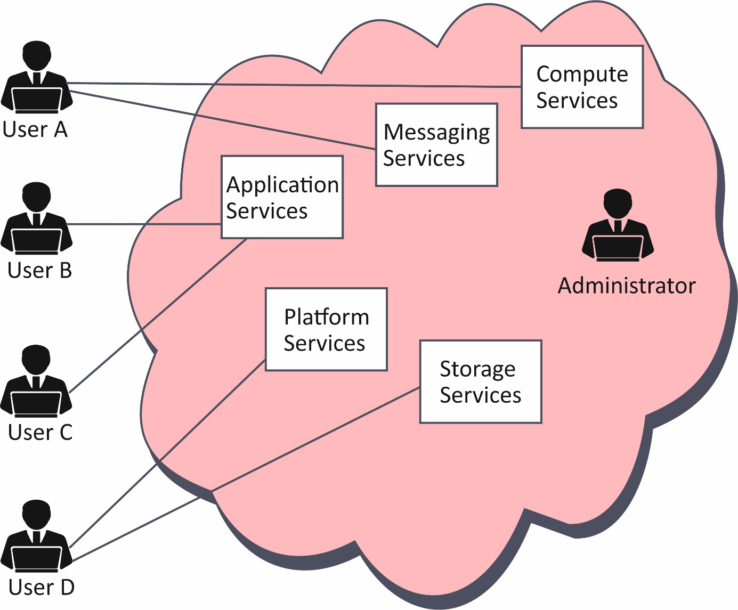

P R I V A T E C L O U D
The Private Cloud allows systems and services to be accessible within an organization The Hybrid Cloud is most suitable for London Bike . The essential activities as payments are performed exploitation personal cloud whereas the non-critical activitiesas map, are performed using public cloud is increased because of its private nature.
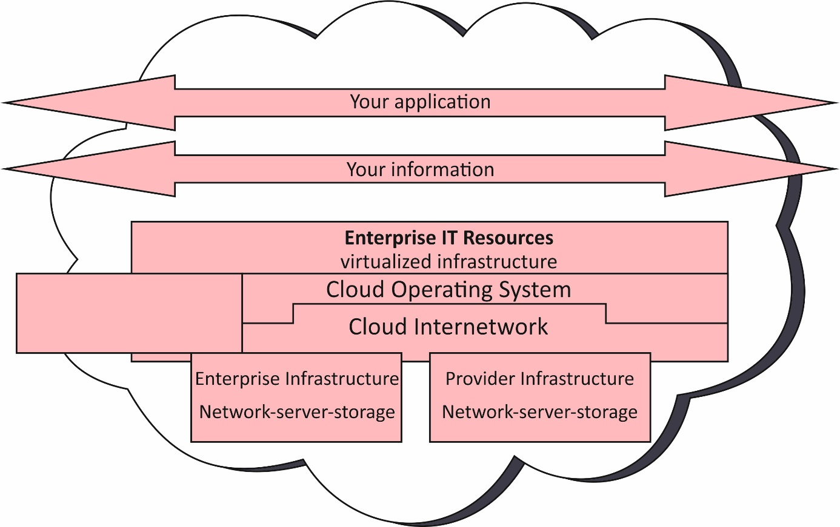
C O M M UN I T Y C L O U D
The Community Cloud allows systems and services to be accessible by group of organizations.

H Y B R I D C L O U D
The Hybrid Cloud is mixture of public and personal cloud. but, the vital activities are performed victimization personal cloud whereas the non-critical activities are performed using public cloud.
The Hybrid Cloud is most suitable for London Bike .The critical activities as payments are performed using private cloud while the non-critical activities as map, are performed using public cloud.

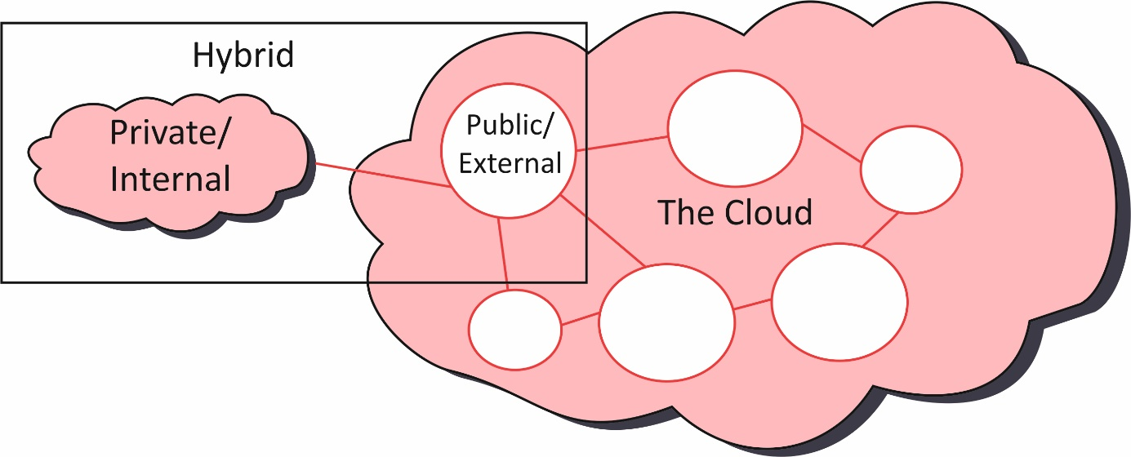

SERVICE MODELS
The reference models on which the Cloud Computing is based are Service Models.These may be labeled into 3 fundamental carrier models:

1. Infrastructure as a Service (IaaS)
IaaS affords get entry to essential assets which include bodily machines, digital machines, digital storage, etc.
2. Platform as a Service (PaaS)
PaaS provides the runtime environment for applications, development & deployment tools, etc.
3. Software as a Service (SaaS)
SaaS version permits to apply software program programs as a carrier to quit users.

There are many other service models, such as:
- Network as a service
- Business as a service
- Identity as a service
- Database as a service
- Strategy as a service
- Backup as a Service

Infrastructure as a service (IaaS) is the most basic level of service. Each service model uses the basic model of the service, each inherits the security and management mechanism from the base.
- Identity as a service
- Database as a service
- Strategy as a service
- Backup as a Service

Infrastructure as a service (IaaS) is the most basic level of service. Each service model uses the basic model of the service, each inherits the security and management mechanism from the base.

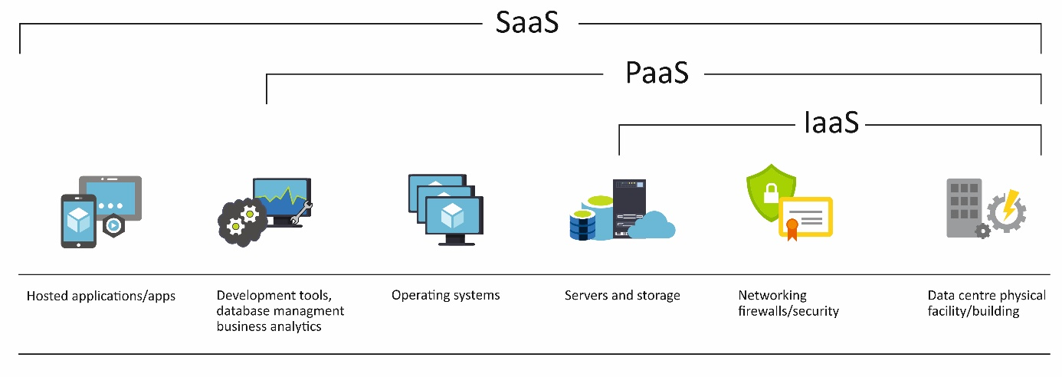

London Bikes is seeking to learn about Cloud Computing and implementation their business process such as Software as a Service.

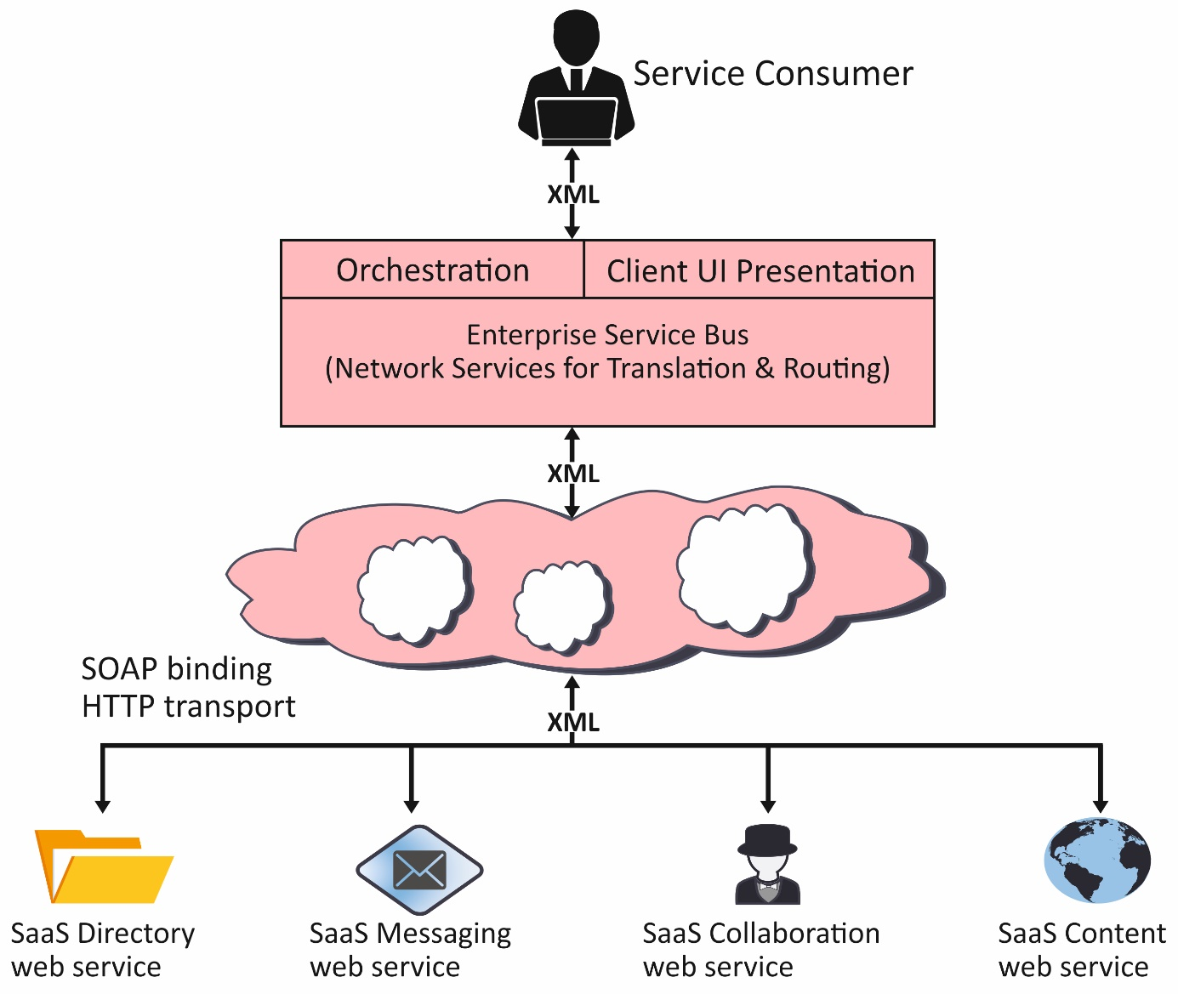
Software as a service (SaaS) lets in customers to connect with and use cloud-primarily based totally apps over the Internet such email, calendaring and workplace tools.
SaaS presents a whole software program answer which you buy on a pay-as-you-move foundation from a cloud provider provider. You lease the usage of an app to your organization and your customers connect with it over the Internet, normally with an internet browser. All of the underlying infrastructure, middleware, app software program and app records are placed with inside the carrier provider’s records center. The provider issuer manages the hardware and software, and with the correct provider agreement, will make certain the provision and the safety of the app and your facts as SaaS permits your corporation to stand up and jogging fast with an app, at minimum in advance cost.
For organisational use, you could lease productiveness apps, which include email, collaboration and calendaring apps; and sophisticated commercial enterprise packages including purchaser courting control (CRM), agency useful resource planning (ERP) and report control You pay for using those apps via way of means of subscription or in line with the extent of use.
Advantages of SaaS
Gain get right of entry to to state-of-the-art applications. To offer SaaS apps to users, you don’t want to purchase, install, replace or keep any hardware, middleware or software. SaaS makes even state-of-the-art company applications, consisting of ERP and CRM, low cost for firms that lack the assets to buy, set up and control the specified infrastructure and software program themselves.
Only pay for what you use. You additionally store cash due to the fact the SaaS provider routinely scales up and down in keeping with the extent of usage.
Use loose consumer software.Users can run maximum SaaS apps at once from their internet browser with no need to down load and set up any software, even though a few apps require plug-ins. This manner which you don’t want to buy and set up unique software program in your users.
Mobilise your personnel easily. SaaS makes it smooth to “mobilise” your staff due to the fact customers can get admission to SaaS apps and facts from any Internet-related laptop or cell device. You don’t want to fear approximately growing apps to run on exceptional kinds of computer systems and gadgets due to the fact the carrier company has already carried out so. In addition, you don’t want to carry unique information onboard to control the safety troubles inherent in cell computing. A cautiously selected carrier company will make sure the safety of your data, irrespective of the sort of tool eating it.
Access app to data from anywhere with records saved with inside the cloud, customers can get admission to their statistics from any Internet-related laptop or cell device. And whilst app facts is saved with inside the cloud, no facts is misplaced if a user’s pc or tool fails.
Backup as a Service (BaaS)
Backup as a Service (BaaS) could allow London Bike to back up company files, folders and entire data warehouses in a single data center.
Archiving as a provider is less complicated to manipulate than different off-web website online services. Instead of worrying about rotating and managing tapes or hard drives elsewhere, storage administrators can unload the maintenance and management of their archives.
London Bike can protect your company's data and information by reducing the risk of data loss due to human error, hacking or cyberattack.

Advantages
London Bike would have more access to your files anytime and anywhere you have an internet connection.
Better protection
The data would be isolated from local device damage, malicious attacks or natural disasters
Less stay
If a problem occurs, the system can be restored at any time to continue operating.
3.Benefits of Cloud Computing

Cost
Cloud computing removes the capital price of purchasing hardware and software program and putting in place and jogging on-webweb page statistics center – The racks of servers, the round the clock strength for energy and cooling and the IT specialists for coping with the infrastructure.
Speed
Most cloud computing offerings are furnished as self provider and on demand, so even giant quantities of computing sources may be provisioned in Minutes, commonly with only some mouse clicks, giving companies quite a few flexibility and taking the stress off potential planning.
Global scale
The blessings of cloud computing offerings encompass the cappotential to scale elastically. In cloud speak, which means turning in the proper quantity of IT resources – for example, extra or much less computing power, storage, bandwidth – proper whilst they’re needed, and from the proper
Productivity
On-web website online facts centers usually require plenty of “racking and stacking” – hardware setup, software program patching and different time-eating IT management Cloud computing gets rid of the want for a lot of those tasks, so IT groups can spend time on attaining greater crucial commercial enterprise goals.
Performance
The largest cloud computing offerings run on a international community of stable information centers, which Are frequently upgraded to the ultra-modern era of speedy and green computing hardware. This gives numerous advantages over a unmarried company records middle which include decreased community latency for packages and extra economies of scale.
Reliability
Cloud computing makes information backup,catastrophe healing and enterprise continuity less complicated and much less luxurious due to the fact information may be reflected at a couple of redundant webweb sites at the cloud provider’s network.
Security
Many cloud vendors provide a large set of policies, technology and controls that enhance your safety posture overall, supporting to defend your data, apps and infrastructure from capacity threats.
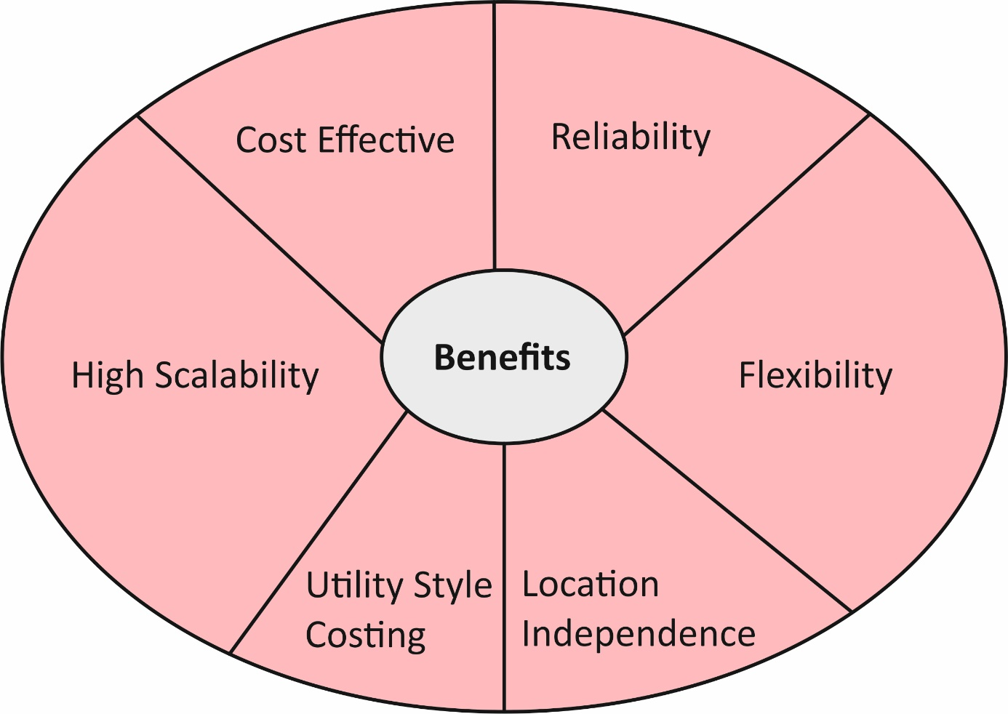
4.Disadvantages of Cloud Computing
SECURITY & PRIVACY
The biggest concern about cloud computing is the security.The facts control and infrastructure control in cloud is supplied through third-party. It is continually a hazard to handover the touchy data to such providers.The cloud computing companies make sure greater steady password covered bills any signal of safety breach could bring about lack of customers and businesses.
LOCK-IN
It may be very tough for the clients to replace from one Cloud Service Provider (CSP) to another. It consequences in dependency on a specific CSP for service.
ISOLATION FAILURE
This hazard entails the failure of isolation mechanism that separates storage, memory, routing among the distinct tenants.
INSECURE OR INCOMPLETE DATA DELETION
It is feasible that the statistics asked for deletion might not get deleted. It occurs both due to the fact greater copies of information are saved however aren't to be had or disk destroyed additionally shops information from different tenants.

5.Characteristics of Cloud Computing

For a London bike, the benefits can be maximized given the characteristics of cloud computing
On-demand self-service
Cloud computing resources can be provided without human interaction by the service provider. A manufacturing corporation can offer extra computing assets if wanted with out going thru the cloud carrier provider. This can be storage space, virtual machine instances database.
Manufacturing companies can use a self-provider internet portal as an interface to get admission to their cloud accounts to see their cloud services, their use, and to provide and remove services when needed.
Broad network access
Cloud computing resources are available on the network and can be accessed from different client platforms high-speed communication connection - such as the Internet, or in the case of a private cloud network (LAN).
Network bandwidth and latency are very crucial components of cloud computing and huge region community access, as they relate to the first-class of community service. This is especially important for time-sensitive service applications.
Multi-tenancy and resource pooling
Cloud computing resources are designed to support a multi-client model.Multi-hiring permits a couple of clients to percentage the identical packages or the identical bodily infrastructure at the same time as keeping the confidentiality and safety of their information.
Pooling assets manner that more than one clients are served with the aid of using the identical bodily assets. The resource of suppliers must be very large and flexible enough to serve multiple customer requirements and provide economies of scale. As far as pooling of resources is concerned, the allocation of resources must not affect the efficiency of critical production applications.
Rapid elasticity and scalability
One of the incredible matters approximately cloud computing is the ability to quickly provide resources to the cloud, as manufacturing organizations needs them. And then remove them when you don't need them. Resources in cloud computing can increase or decrease rapidly and, in some cases, automatically, in response to business requirements. This is a key feature of cloud computing. Utilization, capacity and therefore costs can be increased or decreased without additional contract or penalties
Measured service
Cloud Computing assets utilization is metered and production corporations pay therefore for what they've used. Resource usage may be optimized with the aid of using leveraging charge-per-use capabilities. This way that cloud aid usage—whether or not digital server times which are walking or garage withinside the cloud—receives monitored, measured and mentioned through the cloud provider provider. The fee version is primarily based totally on “pay for what you use”—the charge is variable primarily based totally at the real intake through the producing organization.
Elasticity is a benchmark in cloud computing and suggests that manufacturing organizations can quickly provide and remove the provision of some of the cloud computing resources. Quick provisioning and removal of reserves can apply to repositories or virtual machines or client applications.
With the scalability of cloud computing, there is less capital cost on the part of customers in the cloud. This is because the client in the cloud needs additional computing resources, it can simply provide them when needed and they are available immediately.Scalability is extra deliberate and gradual. For example, scalability approach that production companies are regularly making plans for greater capacity, and of direction the cloud can take care of this boom or decrease.

6. Security of information in Cloud Services

Three parties are involved in ensuring the information security of cloud services: developer, provider and user. Each of them has its contribution to the protection of the service and customer data. The main workload in this case is with the cloud service provider. Accept the services that are provided on the basis of the database of your own or rented (fully or partially) data processing center (DPC).

Therefore, the choice of cloud provider is similar to the choice of hosting and is related to the choice of data center. In this way, in order to assess the safety of the service for one or another provider, it is obligatory to ask the question "In which data center is its equipment located?" The center must be protected both physically and accidentally actions of staff or by actions of malicious people.

In the SaaS cloud service delivery model, the provider assumes full responsibility for implementing and managing the control mechanisms. This is a model that does not impose serious regulatory and legislative requirements on the organization that uses cloud services.

It is important when using cloud services to provide protection of information used to identify payment and use possible solutions for providing information security of data and applications
Users in a cloud-based targeting gain to overcome them in specific directions.

- user authorization
- separation of user data
- data encryption
- hyper jacks
- physical safety
- harmful traffic
- fake service
- inactive VMs
- carrying personal belongings
- Internet of Things

User authorization
When using cloud services the most common way to authorization is password protected. Providers provide consumers with higher reliability by applying means such as certificates and electronic signatures that ensure the provider’s interaction with the identification of users and determination of the given powers. Thanks to this provider has up-to-date information for authorized users. When using cloud services, users can connect to data or applications from anywhere there is internet. Instead of a stationary workplace with a precision a specific set of software and location (IP), the user can connect to a virtual workstation via IaaS, using devices. The identification information transmitted over the network for general use can be easily intercepted. Access rules must not be linked to the physical topology, for example to the IP address of the user or services. Therefore, safe identification, differentiation, the separation of duties and control of all events is very important because in addition to direct data corruption, there may be data theft. The administrator manages the service and the data is under the control of the user organization.

Separation of user data
A problem with cloud technologies is the separation of data and applications from consumers. The best option is when each user uses an individual virtual machine (VM) and virtual network. The division of VM between users are provided by hypervisors (hypervisor or monitor of virtual machines is computer software, firmware or hardware that creates and manages virtual machines), and the separation between virtual networks is ensured through the application of standard technologies such as VLAN (Virtual Local Area Network), VPLS (Virtual Private LAN Service) and VPN (Virtual Private Network).Some providers dispose of all users' data in a single cloud environment and through additional applications isolate the data of different users. Such an approach does not is suitable and unreliable, as on the one hand a hackers break in additional applications, and on the other hand there may be errors in which given user accidentally sees another's data

Data encryption
Most users think that the communication channels and data of the premises in the cloud are similar to expand. When exchanging data over the network, there are usually no problems, such as delivery in this case provides access to HTTPS data. When controlling data in the cloud, however, there are problems connecting to using encrypt all accounts with one key and the hacker gaining access to a key could get access to all data. There is a problem encrypting the data keyword distribution. Such technology would be good to be flexible and not supported by specific service provider in which special technology is used allows to check the server, to controls access to closed data to remove unnecessary information without possibility of recovery. In the event of a change of service provider, all data is contained portable without any problems and are supported by Amazon EC2, Eucalyptus and VCloud.

Hyper jacking
When providing additional services with cloud technology server can be to be easy to imagine or to have the wrong mood. Unauthorized access to hypervisors allows you to control all systems running in virtual data machines, avoiding numerous system protections. One of the specific hacker attacks is received the name "hyper jacking", which means replacing hypervisors with those that allows unregulated access to the offered services.
Fake service
In order to attract and increase revenue and attract confidential information incorrect suppliers create the so-called "False clouds" - Exploits as a Service (EaaS), which is why organizations need to be trusted when choosing a supplier only on verified ones. The terms “false cloud” or “cloud washing” are also used when the service provider tries to sell in the form of a cloud service that on its own in essence, they are not cloud-based, but rather outsourced or virtualized. However, when the user has paid only for the use of resources and not for the license there is greater opportunities for cloud service management and optimization of the main ones automation operations, it can reach the required level of scaling the service.

Inactive VM
On a broken virtual machine it is impossible to install and install in operation of security software applications, which is why it is necessary to be realized protection at the level of the hypervisor.

Harmful traffic
The provision of services to the provider complicates the task of providing security in the traffic between applications and virtual machine. Many antivirus developers systems offer their own versions of products to protect virtual environments.

Ensuring security in the application of cloud services is related to both the provider and the organizations using these services. Usually organizations almost fully trust the supplier, but this is not always enough and possible. It is important to be defined the limit of responsibility of each, which largely depends on the safety model used. For example, the IaaS provider would not could be responsible for applications located on the virtual network, and the SaaS provider for the correctness of access by the user. However, the supplier is in all cases obliged to ensure trouble-free operation of the service, protection, monitoring of the system security, the separation of powers, and the fact that user data is protected and will not fall into the wrong hands, incl. and in other users or contributors to supplier.

7.Virtualization

Virtualization is a method that lets in you to proportion a bodily example of an software or useful resource from a couple of groups or tenants by assigning a logical name to a physical resource and providing a directory of this physical resource upon request.
The architecture of Multitenant
Offers virtual isolation between many tenants and therefore organizations they can use and customize the app as if they each have their own instance, and my advice to London Bike is that this way of visualization is best for them.

Service Oriented Architecture (SOA)
The service-oriented architecture helps to use applications as a service for other applications, regardless of type supplier, product or technology. It is consequently feasible to trade statistics among distinctive programs companies with out extra programming or making modifications to the services.
Computing networks
Grid Computing refers to distributed computing that includes a group of computers from multiple locations interconnected to achieve a common goal. These computer resources are diverse and geographically dispersed. Grid Computing breaks the complicated venture into smaller pieces. These smaller pieces are distributed in the located processors in the network.
Auxiliary calculations
Additional calculations are based on the Pay per Use model. It offers computing resources on demand, measured service. Cloud computing, network computing and managed IT services are based on the concept of utility computing.

8.Migration strategies

In order to satisfy the strategic parameters of London Bike, I suggest that the following steps be considered as a migration solution:

The first step of the iterative migration process is basic and is an assessment of the existing IT structure, topology, applications, databases, their connections and dependencies at all levels development of variants of concepts or prototypes of the migration project in details with specific parameters and scope of appropriate solutions for implementation.

The next step is to determine all the dependencies and relationships of the hardware topology, processes, applications, components of individual systems operating in the environment of the organization.

The third step is to generate a map of the architecture and structure of the cloud during migration and what will be the advantages over the existing architecture and structure.

The fourth step in which the architecture and structure are redesigned, as well as the implementation of the missed functionalities in order to achieve the full original functionality of the organization. During migration, it is possible to lose some, albeit small, insignificant functionalities.

The fifth step is to achieve the essential and significant characteristics of the cloud, which increases the possibilities for achieving integration, flexibility, as well as all the advantages of using the cloud, such as architecture.

The sixth step is to implement, validate, and test the new form of enterprise applications with a rich set of test tools that include testing components of enterprise cloud applications, as these results can be positive or mixed.

The seventh step the required number of iterations to optimize to achieve the desired results.

9.Cloud Computing solution for London Bike

Cloud Computing is giving access of London Bike to technologies that were previously beyond their reach and allow them to grow their business at a relatively lower cost.

One of the biggest benefits for London Bike from switching to cloud services is saving money. The cloud provides a variety of services at affordable prices. Server and application virtualization expands the possibilities for optimal use of physical equipment, which means that cloud service providers can provide much more with less. Therefore, an organization using this type of service can achieve a significant reduction in maintenance costs, energy consumption, space for IT equipment and even eliminate its costs for maintenance, installation and upgrading of hardware equipment. This is especially important for small and medium-sized businesses, where these savings are essential.

Better flexibility

With cloud services, you can access applications, data, and files from anywhere, from any device type, and at any time. All you need is an internet connection. Thus, the work becomes a flexible and remote work process.

More secure data

Improved data security is another asset of cloud computing. Traditional storage systems can be easily stolen or damaged. They also have a better chance of cyberattacks such as viruses, malware and hacking. Human errors and power outages can also affect data security.

If they use Cloud computing, they will benefit from improved data security. In the cloud, data is protected in various ways, such as antivirus, encryption methods and increasingly popular next-generation firewalls. In addition, to reduce the likelihood of data loss, cloud services help you stay compliant with information security standards and regulations.

Greater integration

Cloud-based business solutions can create a variety of simplified opportunities for integration with multiple cloud-based providers. They can also benefit from specialized services that integrate with systems such as human resources, accounting and marketing.

Higher scalability

One of the most important aspects of the London Bike service is their scalability. Cloud-based, as future needs increase, cloud solutions can accept all the sudden and increased demands of the organization
Cloud-based services have the flexibility to increase or decrease. This ensures that all requirements are served according to their needs and budget.

London Bikes would like to start using Cloud Computing first by backing up their data and making sure their data is protected.

Cloud backup will create copies of their important files in the cloud. This means that if one of the computers breaks down or the cloud service in use does not work for some reason, they will still have access to a copy of their important files. Cloud archiving is an automatic process. All the latest versions of important files are automatically uploaded to the servers of the service they use and can access the archived files at any time and from any device.
With cloud archiving, it is not possible to share files with other people and give them the ability to edit those files.

10.REFERENCE

- Alboaie, L., & Vaida, M. F. (2011). Trust and Reputation Model for Various Online Communities.

- Anderson, T. E., Culler, D. E., & Patterson, D. A. (1995). A case for NOW (networks of workstations).
- Antonescu, A.–F., & Braun, T. (2014). Modeling and Simulation of Concurrent Workload Processing
- in Cloud-Distributed Enterprise Information Systems. ACM

- Benkler, Y. (2006). The wealth of networks: How social production transforms markets andfreedom. Londra: Yale University Press.

- Alshamaila, Y. Y. (2013). An empirical investigation of factors affecting Cloud Computing adoption among SMEs in the North East of England. Newcastle University Business School, Newcastle upon Tyne.

- Apulu, I., & Latham, A. (2009). Information and communication technology adoption: Challenges for Nigerian SMEs, TMC Academic Journal

- Aravind, R. G., Sampath, M. K., & Venkatesh, V. G. (2013). Opportunities for Cloud based Software as a Service (SaaS) Warehouse Management System: An Indian Industry Insight. SIBM

- Banerjee, P. (2017). An intelligent IT infrastructure for the future‖, Proceedings of 15th International Symposium on High-performance Computer Architecture, HPCA, Raleigh, NC, USA.

- Berman, S., Marshall, A., & Srivathsa, R. (2012). The power of cloud-Driving business model innovation, IBM Institute for Business Value.

- Buyya, R., Broberg, J., & Goscinski, M. A. (2011). Cloud Computing: Principles and Paradigms. Hoboken, New Jersey: John Wiley and Sons.

- Cafaro, M., & Aloisio, G. (2010). Grids, clouds and virtualization. Springer Publishing Company, Incorporated, 1st edition.

- Dillon, T., Chen, W., & Chang, E. (2010). Advanced Information Networking and Applications (AINA), 2010 24th IEEE International Conference on. 20-23 April 2010

- Ghaffari, K., Delgosha, S. M., & Abdolvand, N. (2014). Towards Cloud Computing: A SWOT Analysis on its adoption in SMEs. International Journal of Information Technology Convergence and Services (IJITCS)

