Ella Williams
1707424
Human Resource Profession
Diversity of the LPR in the Construction Industry
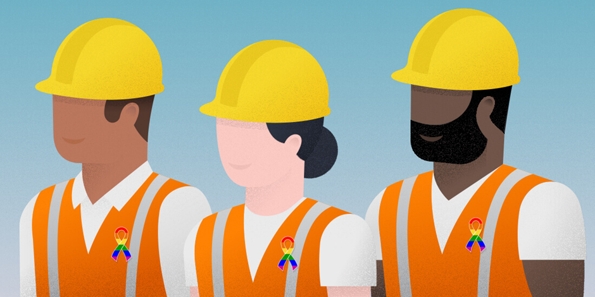
Executive Summary
This report gives the reader the knowledge and awareness of how improving the inclusivity and diversity of their organisation will contribute to their success. In the modern days we live in laws and regulations are now put in place for organisations to follow so people are equal and not discriminated against. Three main issues of diversity will be investigated throughout the literature review which are; gender diversity, employment by ethnicity and how the construction industry is improving employment for disabled people.
The purpose of this report is to show the stakeholders of the LPR that it is extremely important to improve the diversity and inclusivity of the workforce.
The reader will find how simple it is to improve the diversity and inclusivity of their workplace and how beneficial it will be for their organisation. Throughout the report you will find three topics which are affected the most when organisations are not diverse. Firstly, this report shows how construction organisations do not employ many women which is causing a huge concern and effect within the organisation. However, studies and reports have shown that organisations who have women within an organisation benefit a lot. Also, statistics have shown how in the UK the construction industry is not diverse as they do not employ many people from different backgrounds and ethnicity groups. By employing people from all over the world organisations benefit as more ideas and experiences can be shared. Lastly, the report explains how health and safety is not allowed to be used as an excuse to employ someone who is disabled as it is a form of discrimination, even if it was not intended. This shows how the construction industry cannot discriminate against disabled people.
This report concludes by stating how the construction industry has many improvements to make as the diversity and inclusivity is appalling. However, the secondary research has shown that the construction industry is now taking responsibility and trying to improve. This will benefit the success of the organisation.

Contents Page
- Introduction……………………………………………………………………3-4
  - Report Remit
  - Background of LPR
  - Rationale
- Literature Review……………..……………………………………………….5-13
  - What is diversity and inclusion in the workplace?
  - Gender diversity in the construction industry
  - Employment by ethnicity
  - Construction industry improving employment for disabled people
- Conclusion…………………………………………………………………………14
- Recommendations…………………………..…………………………..……14-15

Table of Figures
Figure 2.2.1: Graphs showing a bad gender balance in the construction industry………………………………………………………………………………8
Figure 2.2.2: Bad for women, bad for business…………………………………9
Figure 2.2.3: Women in Construction……………………………………………10
Figure 2.3.4: Percentage of people aged 16 to 64 years in employment within each ethnic group…………………………………………………………………11
Figure 2.3.5: Percentage of workers in each ethnic group employed within different sectors……………………………………………………………………12

- Introduction

  - Report Remit
This report critically reviews how the human resource (HR) department in the construction industry manage a diverse work force. Secondary research will be undertaken throughout to support the information and studies found about the diversity in the construction industry. Primary research will not be included as this project does not have the time to undertake the research.
This report is written for the stakeholders of the LPR; the CEO and top management team. These stakeholders have a huge impact on the organisation as they have a lot of power to make decisions and need to keep the organisation up-to-date with laws and regulations.
The aims of this report are to show how improving the diversity and inclusivity will contribute to the organisation (LPR’s) success. To do this the report will include a lot of secondary research to show how the diversity and inclusivity of the construction industry has been over the years, now and how it needs to change.

  - Background of LPR
LPR is a private engineering enterprise with incredible high standard capabilities. The organisation operates a united business model containing the full range of construction, engineering and asset management services which deliver simple solutions for some of the world’s most important public and private organisations (Laning-O'Rourke, 2019).
LPR is dedicated to developing the organisation on a culture-based on “Excellence Plus” performance. Targets are set in all their operations world-wide. Excellence Plus performance is made up of four elements; People development, Responsible Behaviour, Client Focus, and Innovation. The performance is set to achieve their vision which is to be the organisation that every stakeholder chooses first, able to change and challenge poor practices synonymously with the construction industry, and to complete this together with world-leading businesses (Laning-O'Rourke, 2019).

  - Rationale
The LPR should make sure that they are aware of the consequences if they do not improve their diversity within the workplace. It is extremely important they act upon this as it could have a negative impact on the organisation, as employees may not want to work for the organisation if they are not treated fairly. This could also put people off applying for jobs as they will not want to work somewhere which does not care about diversity and inclusivity.
Caring about diversity and inclusivity will mean employees will feel happy where they work and appreciated. This will promote the workplace, helping jobs fill up fast and give the organisation a great image.

- Literature Review

  - What is diversity and inclusion in the workplace?
Diversity is about an organisation recognising difference and employs individuals who have different genders, abilities, backgrounds, ethnicity, religion beliefs, age, skills and experiences. Not everyone is the same and organisations cannot discriminate a person due to one of those characteristics (Diversity, 2000). Also, diversity is about becoming aware of the benefits to having a range of viewpoints when making decisions and the workforce (CIPD, 2018).
If an organisation employs applicants who have different genders, age, religion beliefs, etc, they would then show how they are not discriminating anyone and are obeying the Equality Act 2010 (GOV.UK, 2015).
However, inclusion is where difference is seen as a benefit to the organisation. Employees will be able to share their experiences and have different perspectives. This helps the organisation to make better decisions. Every employee feels valued in an inclusive working environment, helping their performance rise to their full potential as they will feel their contribution to the workplace matters. It does not matter if employees are from different backgrounds as in diverse workplace, every employee should feel welcomed and valued (CIPD, 2018).
Just like every organisation, LPR’s HR department has an important role to undertake as they must promote diversity. The main role in diversity management is to create an organisational culture that respects every employee within the organisation, making everyone feel equal. This is proven to contribute to the organisation’s success as employees will enjoy working with the organisation and feel respected (Changeboard, 2010).
According to Lozano and Escrich (2016, p. 679), “Managing cultural diversity in organisations is of prime importance as it involves harmonising different values, beliefs, credos and customs, and in essence human identity”. This shows how HR departments need to consider diversity and cultural diversity as it is a human rights issue.
Having a diverse workforce is very beneficial for the LPR as it makes the working environment a positive place to work in, increasing employee satisfaction. This will make employees want to come back again and work more hours. If employees are happy where they work and are treated fairly it will improve the employer brand and reputation externally. A diverse workforce can make an organisation look more attractive to stakeholders, creating a great public image. There would also be opportunities for employees to grow and develop if the workforce is diverse. This is because employees are more challenged when they are exposed to new ideas and if personal growth is encouraged by employers and HR department (Morley, 2018).
Another benefit would be increasing their market share as it allows organisations to successfully market more, communicating better with consumer groups who are from different cultures, religious backgrounds, and races. This could lead to an increase in profits and sales and create a more diverse market (Morley, 2018).
However, if the LPR does not have a diverse workforce people will not want to work in the organisation. Having a bad name in the public eye could lead to consumers not using their services. This could mean the organisation might struggle to stay open and may be forced to shut-down. Also, if the organisation does not obey the laws and legislations, they might have to pay a fine and would be in trouble with the law.

  - Gender diversity in the construction industry
In the construction industry, gender diversity is a huge problem. In the UK one in five construction organisations have no women senior roles. Industry professions believe that ‘there is a fixed prejudice against women in the construction industry, and there is still an inequality of opportunity for women” (Nifty-Lift, 2018).
According to Construction News (2018), “half of all the construction firms claim they have never had a female manager within their business”. This is a worrying figure when equality and gender diversity is a huge issue. Not only is that alarming, but when women who do work in the construction industry are asked if they have experienced gender discrimination 48% of them claimed they had. 28% of the woman gave the same example of how there is inappropriate comments from male colleagues, or behaviour. This shows how the industry need to apply more regulations to change the way women are treated. This will hopefully encourage equality (Nifty-Lift, 2018).
The LPR would need to make sure the women within the organisation do not feel this way, and male workers should act professional around women. Doing this will show the organisation is able to obey the law’s and regulations set in place and the organisation would not get bad publicity about gender diversity.
Also, the gender pay gap is a huge issue within the construction industry. 42% of organisations do not monitor the equal pay between genders (Nifty-Lift, 2018). This shows how HR and accountants departments need to be more aware and up-to-date with the job roles and how much individuals should be earning, whether it is minimum wage or a set wage the organisation is paying (which is above minimum wage).
Figure 2.2.3 shows how by the year 2020 the average annual salary for a woman in the construction industry is supposed to be £39,200. That would be an increase of 60% from the year 2005 with only £24,500. This shows how although the construction industry is not fully diverse, it is trying to improve over the years (Ranstad, 2016).

Another online source written by academics and researchers supports this evidence. According to The Conversation (2018), “the construction sector has the worst gender balance of any, with the UK struggling behind the rest of Europe”. Less than 1% of the 800,000 construction workers are women. However, if planners, surveyors and architects are added to this percentage it only rises to 18% (The-Converstaion, 2018).
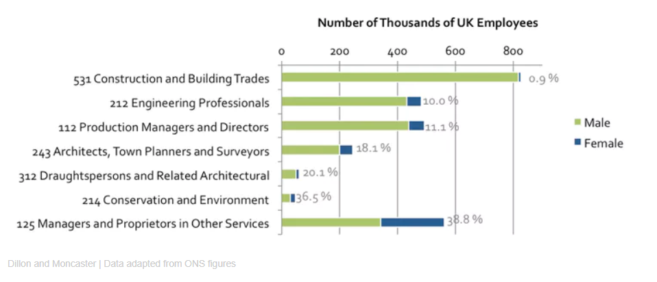
Figure 2.2.1: Graphs showing a bad gender balance in the construction industry

Figure 2.2.1 shows how there is more male workers in the construction industry than females. For example, there is 0.9% of women who work in the construction and building trades within the 99.1% of men, which is an extreme example. However, there is 38.8% of women who work in the ‘Managers and Proprietors in Other Services’, although there is still a higher percentage of male workers with 61.2% (The-Converstaion, 2018).
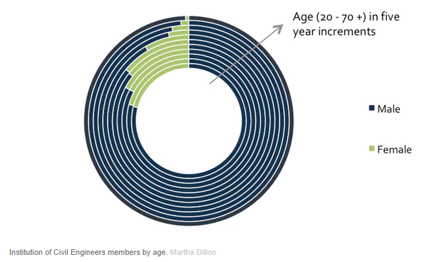
Figure 2.2.2: Bad for women, bad for business

Figure 2.2.2 is a pie chart showing the difference between male and female workers aged 20 to 70+ in five-year increments. A group of senior women in the industry believe that gender equality and diversity is not only bad for women but business too. The group set up a network called “The Equilibrium” and undertook a lot of research to support their belief (The-Equilibrium-Network, 2017). The network analysed main international industry studies which all showed a clear correlation when there was a lot of women working with the industry and the organisations financial performance (The-Converstaion, 2018).
When women are at senior levels it reduces the ‘leaky pipeline’ effect. According to McDonagh and Fitzsimons (2017), “Senior women act as great role models to many junior women and help them succeed”. This creates a positive working environment, giving young women a confidence boost when working in an environment full of male employees. This would benefit the LPR as the organisation would be diverse as men and women would work there and would benefit young women who would like to work in the construction industry. This would also promote teenage girls to feel like they are able to work in the construction industry.
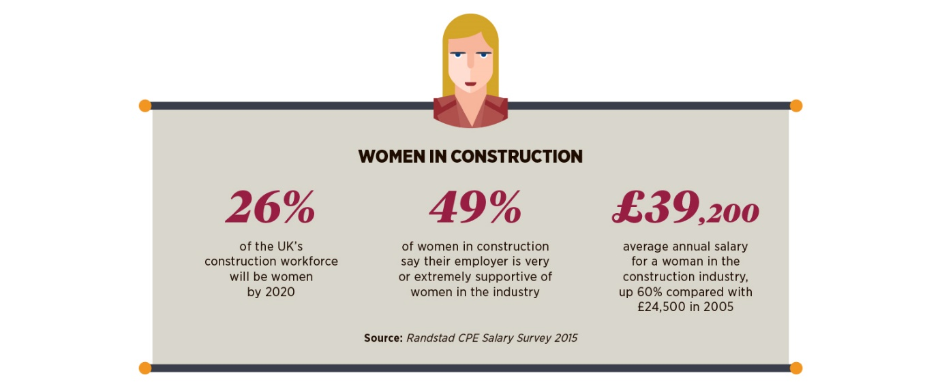
The Boston Consulting Group undertook a study which included 1,700 organisations in 8 different countries. This study found out that if the diversity of leadership teams is increased it will create better financial performance and lead to better innovation. Also, the organisations who had a more diverse management team had a 19% higher revenue due to the innovation (Powers, 2018).
Figure 2.2.3: Women in Construction

The UK Industry Performance Report (2015) shows how most of the employees under the age of 24 years-old have decreased, along with the number of women who work in the construction industry. This shows how the industry is struggling with engaging young people to work in the industry which is worrying as they will not have many people to replace the people who retire. Women only make up 11% of the British people who are employed within the construction industry (Boles, et al., 2015).
Figure 2.2.3 shows estimated percentages for the women in construction in the year 2020. This information is sourced from ‘The Randstad CPE Salary Survey’ (2016). By the year 2020, it is estimated that 26% of the UK’s construction workforce will be made of women which is more than half of what it was in 2015. By 2020, it is forecasted that 49% of women in the construction industry say, “their employer is extremely supportive of women in the industry”. This shows how from the years 2015 to 2020, it is forecasted for the diversity and inclusivity to improve rapidly (Ranstad, 2016).
If the LPR does not consider in improving the gender diversity of their organisation they will not succeed in the future as laws and regulations are changing and adapting to the modern day we live in. This would give the organisation a bad image.

  - Employment by ethnicity
Not only is gender diversity a problem in the construction workforce, but the employment by ethnicity is a huge problem too. The total working age (16 to 64 years) population in Wales, England and Scotland was just under 40 million. However, just over 34 million people were White (GOV.UK, 2019).

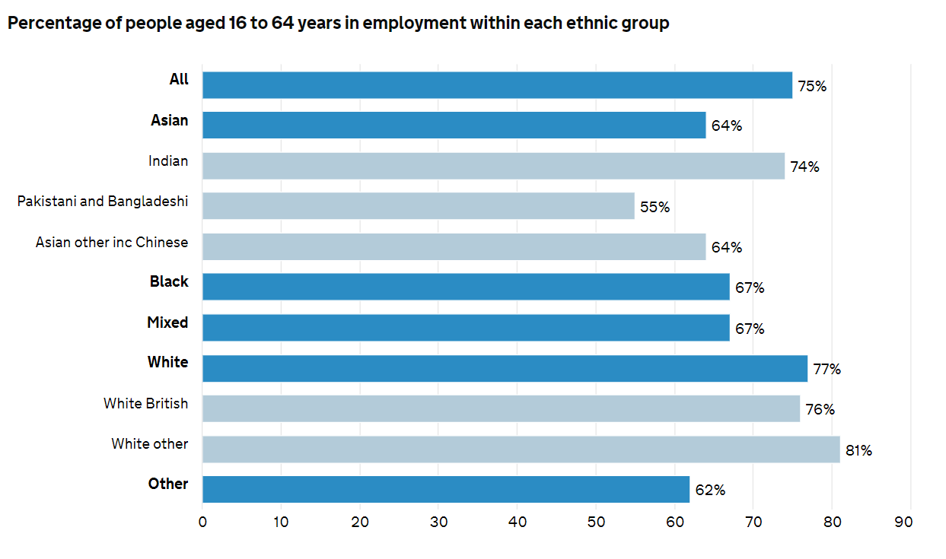
Figure 2.3.4: Percentage of people aged 16 to 64 years in employment within each ethnic group

Figure 2.3.4 shows in the year 2017 the ‘White Other’ ethnic group was the group with the highest employment rate totalling to 81%, with the ‘Pakistani and Bangladeshi’ group being the lowest with 55% (GOV.UK, 2019).
Figure 2.3.5: Percentage of workers in each ethnic group employed within different sectors

However, Figure 2.3.5 shows how the sector with the highest percentage of white workers was construction with 7.9%. The ‘Mixed’ ethnicity group was the second highest with 4.4%, ‘Indian’ had 3.8%, with ‘Black’ and ‘Other’ with 3.6%. Pakistani and Bangladeshi was the lowest ethnicity group with 2.2.% in the UK (GOV.UK, 2018). This shows how in the UK the construction industry is not diverse as they do not employ many people from different backgrounds and ethnicity groups.

The LPR need to make sure that they employ people from every ethnicity group, so they have a diverse working environment. This will benefit the organisation as people will be able to work together from different backgrounds and more ideas and past experiences will be shared. If the LPR do not employ people from different countries, they will look like they are discriminating as they have not chosen to employ anyone who is not British and mainly white.

2.4. Construction industry improving employment for disabled people
According to Go Construct (2019), “in the construction industry, disabled people cannot be discriminated against” and they believe “a job in construction can provide a greater career for life”.
Disabled people do not have to reveal their disability to employers. However, this can cause a problem as employers would not be able to make any adjustments to make sure the disabled workers do not get hurt when they are working. When it comes to construction, adjustments can be made by controlling a piece of machinery to insure the disabled employee is able to handle it and will not get hurt. This still gives them the same advantage to someone who is non-disabled person (Go-Construct, 2019).
Health and Safety is not allowed to be used as an excuse to employ someone who is disabled as it is a form of discrimination, even if it was not intended. The HR department should be aware of what is a form of discrimination as this could have a huge impact on the organisation (Go-Construct, 2019).

The LPR organisation need to know there is always a potential job for everyone, whether they are disabled or not. The construction industry has never promoted the workforce to be suitable for people who are disabled until a decayed ago. It is also the law for organisations to not discriminate against anyone, especially not a disabled person. If the organisation did not employ a disabled person, they might feel they were being discriminated against and report or even sue to organisation. This would have a huge impact on the organisation.

- Conclusion
To conclude, the construction industry has improvements to undertake as the diversity and inclusivity is very low. However, secondary research has shown that the construction industry is taking responsibility and action on their own organisations and are now trying to improve the diversity and inclusivity within the workforce. If the LPR undertook the responsibilities, they would become a successful diverse organisation.

- Recommendations
To improve on the LPR’s diversity and inclusivity, I would like to recommend some improvements to help the organisation continue to succeed.
Firstly, I would recommend the LPR to become up-to-date on what diversity and inclusivity mean. This would include having the knowledge and understanding of the laws and regulations they need to obey so they do not break the laws. If the organisation has the understanding and are aware of what diversity and inclusivity mean, it would help the organisation know exactly what they must do when they employ people and how they would be expected to treat their employees.
Secondly, I would recommend the LPR to employ women as secondary research shows a lot of construction firms have never had a woman work for their organisation before and this needs to change. Employing a senior woman into the organisation would act as a role model to all the young woman wanting to work in construction. This creates a positive working environment and gives junior women a confidence boost.
Thirdly, I would recommend the LPR to create their own equality, diversity and inclusion policy. A big international engineering enterprise called ‘Laing O’Rourke’ created their own policy by stating how “they are committed to be an equal opportunities employer”. The organisation has their own programme which is set up to attract people from different backgrounds, promoting a working environment that is cultural (Laning-O'Rourke, 2019). This shows how committed Laing O’Rourke is to becoming equal, diverse and inclusive and I would recommend the LPR organisation to commit too by creating their own policy.
Overall, these recommendations would benefit and improve the LPR.

References

Boles, N., Bryer, L. & Crane, T., 2015. UK Industry Performance Report, Watford, Herts: Glenigan.
Changeboard, 2010. Diversity in the workplace - what's the role of HR?. [Online]
Available at: https://www.changeboard.com/article-details/13720/diversity-in-the-workplace-what-s-the-role-of-hr-/
[Accessed 10 April 2019].
CIPD, 2018. Diversity and inclusion in the workplace. [Online]
Available at: https://www.cipd.co.uk/knowledge/fundamentals/relations/diversity/factsheet
[Accessed 15 April 2019].
Diversity, 2000. What is Diversity?. [Online]
Available at: https://www.diversity.com/page/What-is-Diversity
[Accessed 10 April 2019].
Go-Construct, 2019. Construction and Disability. [Online]
Available at: https://www.goconstruct.org/construction-today/diversity-in-construction/construction-and-disability/
[Accessed 17 April 2019].
GOV.UK, 2015. Equality Act 2010: guidance. [Online]
Available at: https://www.gov.uk/guidance/equality-act-2010-guidance
[Accessed 15 April 2019].
GOV.UK, 2018. Employment by sector. [Online]
Available at: https://www.ethnicity-facts-figures.service.gov.uk/work-pay-and-benefits/employment/employment-by-sector/latest
[Accessed 17 April 2019].
GOV.UK, 2019. Employment. [Online]
Available at: https://www.ethnicity-facts-figures.service.gov.uk/work-pay-and-benefits/employment/employment/latest
[Accessed 17 April 2019].
Laning-O'Rourke, 2019. Laning O'Rourke. [Online]
Available at: http://www.laingorourke.com/who-we-are/about-us.aspx
[Accessed 15 April 2019].
Lozano, J. F. & Escrich, T., 2016. Abstract. Cultural Diversity in Business: A Critical Reflection on the Ideology of Tolerance, p. 679.
McDonagh, M. & Fitzsimons, L., 2017. Women Count, London: The Pipeline.
Morley, T., 2018. Making the business case for diversity and inclusion, United Kingdom, Bingley: Emerald Group Publishing Limited.
Nifty-Lift, 2018. Gender diversity in the construction industry. [Online]
Available at: https://www.constructionglobal.com/mission-critical/gender-diversity-construction-industry
[Accessed 16 April 2019].
Powers, A., 2018. A Study Finds That Diverse Companies Produce 19% More Revenue. [Online]
Available at: https://www.forbes.com/sites/annapowers/2018/06/27/a-study-finds-that-diverse-companies-produce-19-more-revenue/#271b9a42506f
[Accessed April 18 2019].
Ranstad, 2016. The Randstad CPE Salary Survey, Bedfordshire: Randstad.
The-Converstaion, 2018. How gender equality can help fix the construction industry. [Online]
Available at: https://theconversation.com/how-gender-equality-can-help-fix-the-construction-industry-90413
[Accessed 25 January 2019].
The-Equilibrium-Network, 2017. Reserach and Information. [Online]
Available at: https://equilibrium-network.com/research-and-information/
[Accessed 16 April 2019].

