
LCLM5006: Developing Emotional Intelligence Skills
Component 2 - Individual written report
Student Name: Luis Chisaguano
Student ID: 2332661

Executive Summary
This report has examined the significance of emotional intelligence and generational diversity in modern organisations and their impact on organisational performance, communication, leadership and teamwork. It has discussed key emotional intelligence models, including Goleman's Mixed Model, Mayer-Salovey Ability Model and Bar-On Model, and has highlighted components like self-awareness, self-regulation, empathy, social skills and emotional management. The report has also analysed the characteristics of different generations of employees and their workplace expectations. It has been concluded that organisations should develop emotional intelligence training, flexibility in leadership styles, mentoring programs and flexible work arrangements for effectively managing generational diversity.

Table of Contents
Introduction 4
Emotional Intelligence Components with Relevant EI models 5
Self-awareness in Workplace Behaviour 6
Self-regulation and Managing Workplace Stress 6
Empathy and Workplace Relationships 7
Social Skills and Teamwork 7
Emotional Perception - Mayer and Salovey Ability Model 8
Emotional Understanding and Decision-Making 8
Emotional Management and Conflict Resolution 9
Adaptability and Well-Being-Bar on Emotional Intelligence Model 9
Critical Evaluation of Emotional Intelligence in the Workplace 9
Research Unique Characteristics that Managers Need to Be Aware of (Generation X, Y and Z) 10
Generation X Employees in the Workplace 10
Generation Y (Millennials) in the Workplace 12
Generation Z in the Workplace 13
Recommendations 15
Conclusion 16
References 17

Introduction
Emotional intelligence and generational diversity are two significant aspects that have an influence on organisational performance and workplace relationships in modern organisations. Emotional intelligence mainly refers to the ability to understand, manage and use emotions efficiently in oneself and others (Craig, 2022). This helps the employees improve communication, teamwork, leadership and conflict management. Emotional intelligence models like Goleman's Mixed Model, Mayer-Salovey Ability Model and Bar-On Model explain different levels of emotional intelligence components, including self-awareness, self-regulation, empathy, social skills, emotional perception and emotional management. At the very same time, organisations now employ a multi-generational workforce that consists of Generation X, Generation Y and Generation Z employees, who have different sets of values, expectations, communication styles and career goals. Managers should understand both emotional intelligence and generational differences in order to recruit effectively, manage the employees efficiently and create a positive work environment that supports teamwork, productivity and employee well-being across different generations.

Emotional Intelligence Components with Relevant EI models
Emotional intelligence is known to be one of the important capabilities in modern organisations, and that is particularly so in environments that require teamwork, communication, leadership and customer interaction. Emotional intelligence refers to the ability to understand, manage, and use emotions quite effectively in oneself and others. According to Daniel Goleman's quote, understanding one's own emotions is quite important for understanding others. In the workplace, employees make use of emotional intelligence for managing stress, resolving conflict and also improving performance. Emotional intelligence is explained below with the help of various models, including Daniel Goleman's Mixed Model, Mayer-Salovey Ability Model and Bar-On Emotional Intelligence Model (Kubala and Williams, 2022). This section is quite important since it will critically evaluate the ways employees make use of emotional intelligence components in the workplace with reference to these models.
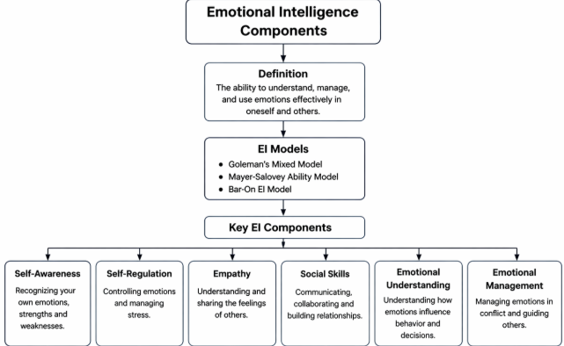
Figure: Components of Emotional Intelligence
Source: (Self-Developed)

Self-awareness in Workplace Behaviour
Self-awareness is termed as the ability to recognise and also understand one's own emotions, their strengths, weaknesses and behaviour. In Daniel Goleman's Emotional Intelligence Model, self-awareness is the very core aspect of emotional intelligence. Employees who are generally self-aware can identify when they can feel stressed, frustrated, motivated or also overwhelmed. This also allows them to control their reactions and make better decisions.
For instance, it could be stated that an employee who recognises that they become impatient during the tighter deadlines might take short breaks or plan their work earlier to avoid any kind of emotional reactions. Self-aware employees are also more open to feedback since they can understand their individual strengths and areas for improvement (Brackett, Delaney and Salovey, 2025). This could help in improving any kind of professional as well as personal performance.
However, self-awareness alone does not guarantee any kind of effective workplace behaviour. An employee might be aware they are under stress, but they could still react negatively towards their colleagues. Therefore, self-awareness should be combined with self-regulation as well as social skills to become quite effective. This shows that emotional intelligence components are quite interrelated and cannot work effectively in isolation.

Self-regulation and Managing Workplace Stress
Self-regulation refers to the ability to control one's own emotions, impulses, and behaviours in difficult situations. This is another important component in Goleman's Emotional Intelligence Model. In the workplace, employees might face pressure from any kind of deadlines, customer complaints, workload, and organisational changes. Employees who have strong self-regulation remain quite calm and professional even when the situations are quite stressful.
For example, if a customer complains quite aggressively, an emotionally intelligent employee will respond quite calmly and also try to solve the problem instead of reacting emotionally. This also helps them in maintaining professional relationships and organisational reputation (Winter, 2023).
Critically speaking, excessive self-regulation might also create certain problems. Employees who have been constantly suppressing their emotions could be experiencing stress, emotional exhaustion or burnout. This means organisations should not only expect the employees to regulate their emotions, but they can also create a supportive environment in which employees can express their concerns and receive support. Hence, emotional intelligence should be supported by organisational culture and leadership.

Empathy and Workplace Relationships
Empathy is the ability to understand and share the feelings of others. Empathy is one of the most important emotional intelligence components in the workplace since the organisations mainly rely on teamwork, collaboration and customer service.
Employees who demonstrate empathy could understand the problems of colleagues, support team members and also communicate more effectively. For instance, a manager who understands that an employee is struggling with the workload or personal issues could offer flexible deadlines or additional support. This kind of builds trust, improves teamwork and also increases the satisfaction of the employees (Gentry, 2024).
Empathy is also quite important in customer service roles. Employees who have a better understanding of customer emotions could respond appropriately and improve the satisfaction level of the customers.
Yet, empathy also has its own limitations. Too much empathy might be affecting the decision-making process, especially for the managers who are required to make difficult decisions like performance management, layoffs or disciplinary actions. Managers should be balancing empathy with the organisational goals and fairness. Hence, empathy should be used carefully and professionally in the workplace.

Social Skills and Teamwork
Social skills generally refer to communication, teamwork, conflict management, leadership and relationship building. According to Goleman's model, social skills are important for leadership and teamwork effectiveness. Employees who have strong social skills could be communicating clearly, collaborating effectively and also resolving conflicts professionally. For instance, during the team project, employees with good social skills can help in motivating the members, share their ideas and also ensure that everyone is participating in discussions. This improves the productivity of the teams and organisational performance (Taplow Group, 2025).
Social skills are also very important for leadership roles. Leaders with strong emotional intelligence could have an influence on the employees, motivate the teams and also manage the organisational changes quite effectively. Yet, social skills could also be misused. Some of the individuals might be using their interpersonal skills to manipulate others or influence decisions for their personal benefit. This highlights the ethical concerns linked with emotional intelligence. Hence, emotional intelligence should be used ethically and responsibly for the organisational and team benefits rather than any kind of personal advantage.

Emotional Perception - Mayer and Salovey Ability Model
The Mayer-Salovey Ability Mode of emotional intelligence is focused on emotional perception, emotional understanding, emotional facilitation, and emotional management. Emotional perception is the ability to recognise emotions in others through their facial expressions, body language, and tone of voice.
In the workplace, employees generally make use of emotional perception during meetings, teamwork and negotiations. For instance, an employee might notice that a colleague looks quite anxious or confused during a meeting and might be explaining the task again or offer support. This helps in improving communication and teamwork (exploresel, 2022).
Yet, emotional perception is not always accurate. There are some of the cultural differences, personal bias and also communication styles that could be leading to some of the misinterpretations of emotions. For instance, silence in a meeting might be interpreted as disagreement, but it could actually be indicating respect or careful thinking, depending on the cultural background.

Emotional Understanding and Decision-Making
Emotional understanding refers to the ability to understand emotional changes and how emotions influence behaviour and decision-making. Employees who understand emotions could also predict how people might react in some situations. For instance, if an organisation introduces a new policy, emotionally intelligent employees and managers could understand that employees might be feeling uncertain or also resistant to change. Hence, they might be communicating clearly, providing training and introducing changes gradually for the reduction of stress and resistance (hibob, 2023). Critically, it could be stated that emotional understanding requires experience and emotional maturity. Employees with limited experience could also struggle to interpret emotional situations accurately. This suggests that emotional intelligence could be developed through training, coaching and workplace experience.

Emotional Management and Conflict Resolution
Emotional management refers to the ability to manage emotions in oneself and others. This is particularly important in conflict situations. Conflict is also quite common in certain workplaces due to the differences in opinions, workload distribution or communication problems.
Employees with emotional intelligence could manage the conflicts quite calmly by listening to the different perspectives, controlling emotions and focusing on solutions rather than blame. For instance, a team leader might organise a meeting that could allow both employees to express their concerns and then find a compromise solution (Segal, Robinson and Smith, 2023).
However, emotional management could also be used quite strategically for influencing others. Some of the employees might make use of emotional intelligence to persuade or manipulate colleagues. This kind of raises ethical issues regarding the use of emotional intelligence in organisations. Hence, organisations should be promoting ethical behaviour alongside emotional intelligence development.

Adaptability and Well-Being-Bar on Emotional Intelligence Model
The Bar-On Emotional Intelligence Model is focused on emotional and social competencies like adaptability, stress management, interpersonal skills and emotional well-being. This model emphasises that emotional intelligence is linked with mental health and workplace well-being.
Employees with high emotional intelligence are more adaptable to organisational change, new technology, new roles, as well as workplace challenges (Mutongi, 2024). For instance, when organisations introduce new systems or undergo restructuring, emotionally intelligent employees are more likely to remain positive and also adapt quickly.
Emotionally intelligent employees also manage stress better and maintain a work-life balance. This improves the satisfaction with the job and also reduces the rate of absenteeism.

Critical Evaluation of Emotional Intelligence in the Workplace
Emotional intelligence provides different benefits in the workplace, including improved teamwork, leadership, communication, conflict management and customer service. Employees with emotional intelligence are more likely to perform better, build strong relationships and also adapt to organisational changes (Forbes Councils, 2025). Yet, emotional intelligence also has some limitations. Firstly, emotional intelligence is quite difficult to measure accurately compared to technical skills. Further, emotional intelligence could be influenced by personality and cultural differences. Therefore, emotional intelligence should not be viewed as a solution to workplace problems. Instead of this, it should be combined well with the technical skills, organisational support and effective management practices.

Research Unique Characteristics that Managers Need to Be Aware of (Generation X, Y and Z)
Modern organisations generally consist of a multi-generational workforce where employees from Generation X, Generation Y (Millennials), and Generation Z work together. Each generation has different sets of values, work expectations, communication styles and career goals. At the time of recruitment, managers should understand these generational differences to create an effective work environment, improve employee satisfaction, and increase organisational performance. In case managers fail in understanding the generational differences, it might lead to communication problems, conflicts and low employee engagement.

Generation X Employees in the Workplace
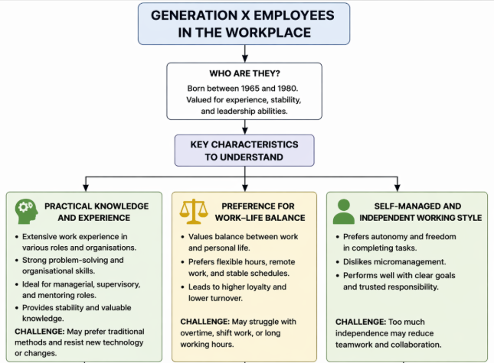
Figure: Characteristics of Generation X employees
Source: (Self-Developed)
These are the employees who include individuals born between 1965 and 1980. Most of the organisations relied on the Generation X employees for their experience, stability and leadership abilities. Managers are required to understand their work values and expectations during recruitment.
Practical Knowledge and Experience: Generation X employees mainly have a significant level of work experience since most of them have worked in different organisations and roles throughout their careers. They bring practical knowledge, problem-solving skills and organisational understanding. During recruitment, managers often value Generation X employees for their managerial roles, supervisory roles and mentoring positions. Their experience allows the organisation to remain stable (Marshmellow, 2024). Yet, some Generation X employees might prefer traditional working methods and could also resist the new technology or new management styles.
Preference for Work–Life Balance: Generation X employees strongly value work-life balance. Most of the employees in this generation have family responsibilities and also prefer flexibility in their working hours, remote work options and stable working schedules. During the recruitment, organisations that offer flexible working conditions are more likely to attract the employees of Generation X. Yet, their strong preference for work-life balance might be creating challenges in organisations that could require overtime, shift work or long working hours. Hence, managers should clearly communicate the job expectations, working hours and organisational culture.
Self-Managed and Independent Working Style: Generation X employees mainly prefer autonomy and independence in their work. They do not like being micromanaged and prefer managers who trust them and give them responsibility. During the recruitment, managers should clearly define their job roles and performance expectations while allowing flexibility in how the employees complete tasks (themuse, 2024). Yet, too much independence might reduce teamwork and collaboration. Some Generation X employees might prefer working individually rather than in teams. Hence, managers should be encouraging teamwork while also respecting their independent working style.

Generation Y (Millennials) in the Workplace
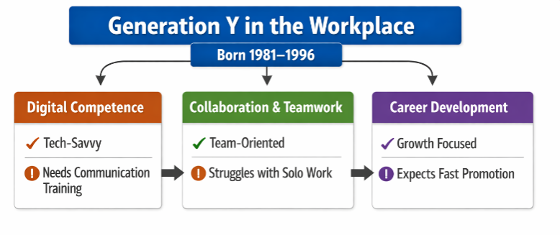
Figure: Characteristics of Generation Y employees
Source: (Self-Developed)
Generation Y is also known as Millennials, and they include individuals born between 1981 and 1996. This generation forms a large portion of the modern workforce, and managers should understand their expectations during recruitment. Some of the important characteristics of this group of employees are demonstrated below:
Digital Competence: Generation Y employees are highly familiar with the use of digital technology, the internet and social media. They are quite comfortable in using digital tools, online platforms and communication software in the workplace. Organisations mainly benefit from their technological knowledge since they can improve the efficiency of the organisation, innovation and digital transformation (learnenglish, 2023). Yet, their reliance on technology could sometimes reduce face-to-face communication skills. Managers should be providing training in communication, teamwork and interpersonal skills for maintaining a balanced work environment.
Collaboration and Teamwork: Generation Y employees mainly prefer teamwork and collaboration rather than working alone. They basically like sharing ideas, participating in discussions and working in groups for solving problems. They also believe teamwork improves the level of creativity and decision-making. During the process of recruitment, managers should emphasise the team-based work environments, collaborative projects and open communication culture for attracting Millennials. Yet, they could sometimes depend too much on teamwork and also struggle while working independently. Managers must ensure that employees can develop both teamwork and independent working skills.
Career Development and Learning Opportunities: Career development is quite important for Generation Y employees. They are quite interested in learning new skills, training programs, promotions and career progression opportunities (PeopleHum, 2024). During the process of recruitment, managers should be highlighting training programs, promoting opportunities and career growth paths for attracting Millennials. Employees who view career growth opportunities are more motivated and also productive. Organisations which invest in employee development often have higher levels of retention rate and job satisfaction. Yet, Millennials are sometimes criticised for expecting fast promotions and quick career growth. Hence, managers should clearly explain the career progression timelines and performance expectations.

Generation Z in the Workplace
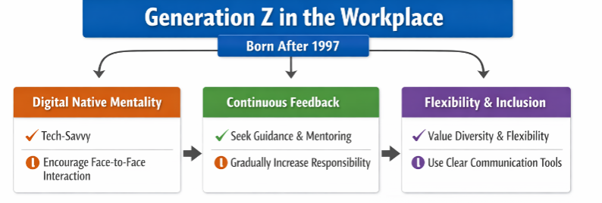
Figure: Characteristics of Generation Z employees
Source: (Self-Developed)
These sets of employees are the ones who were born after 1997. This generation has recently entered the workforce, and managers are required to understand their expectations for creating a positive work environment.
Digital Native Mentality: Generation Z employees are digital natives. They have grown up with smartphones, social media, artificial intelligence and online communication. They are quite comfortable using technology and learning new digital systems quite quickly. Organisations mainly benefit from Generation Z employees since they improve digital communication, innovation and technology adoption in the workplace (Benítez-Márquez et al., 2022). Yet, these employees might sometimes prefer digital communication over face-to-face communication, which could have an impact on teamwork and workplace relationships. Managers should encourage interpersonal communication and teamwork activities.
Desire for Continuous Feedback and Guidance: Generation Z employees mainly prefer constant feedback, mentoring and guidance from managers. They also want to learn quickly and improve their skills. Managers should be providing structured training programs, mentoring and performance feedback systems during recruitment and onboarding. This improves communication between managers and employees and could create a supportive work environment. Employees often feel valued and motivated when they receive guidance. Yet, too much supervision could reduce their independence and problem-solving skills. Managers should gradually give more responsibility as employees gain experience (Benítez-Márquez et al., 2022).
Focus on Flexibility, Diversity and Personal Identity: Generation Z employees value flexibility, diversity, equality and inclusion in the workplace. They mainly prefer organisations which support diversity, flexible working hours, hybrid working and inclusive work environments (Bellinder, 2024). During the process of recruitment, organisations that promote diversity, employee well-being and flexible working arrangements are also more likely to attract Generation Z employees. It also improves the organisational culture and innovation since diversified teams generate creative ideas. Yet, flexible working environments might sometimes reduce direct supervision and communication. Managers should be using efficient communication tools and performance management systems for maintaining productivity (PeopleHum, 2024).

Recommendations
Organisations should be implementing some of the significant strategies for improving emotional intelligence and also managing the diversity amongst generations in the workplace. Some of these strategies are demonstrated in the following section:
Emotional Intelligence training programs: It is recommended that different emotional intelligence training programs be provided to the employees and managers. This will help in improving self-awareness, empathy, communication skills and conflict management. It can also allow the employees to work better in teams and improve workplace relationships (PeopleHum, 2024).
Adopting flexible leadership styles: It is recommended that managers adopt flexible leadership styles since different generations have different expectations (Baša et al., 2023). For instance, Generation X employees prefer independence, Generation Y employees prefer teamwork and feedback, while Generation Z employees mainly prefer guidance and flexibility. Managers should also be adjusting their leadership and communication style accordingly.
Flexible working arrangements: The organisation should be providing flexible working arrangements like hybrid working, flexible working hours and work-life balance policies for attracting and retaining employees from different generations (PeopleHum, 2024).
Creating mentoring programs: Companies must create mentoring programs where experienced Generation X employees could be mentoring younger Generation Y and Generation Z employees. This could encourage knowledge sharing and also teamwork. This could also become much more effective in understanding the process and enhancing the activities (Benítez-Márquez et al., 2022).

Conclusion
Emotional intelligence and generational diversity play a significant role in modern organisational success. Emotional intelligence allows employees to manage emotions, communicate effectively, resolve conflicts and also build stronger workplace relationships. Emotional intelligence models like Goleman's model, Mayer-Salovey Ability Model and Bar-On Model have explained different emotional intelligence components that employees use in the workplace. At the same time, managers should understand the unique characteristics of different generations of employees during recruitment as well as workforce management. Each generation has a different level of strengths, expectations and working styles that could be influencing the teamwork and organisational culture. In case managers must also understand these differences and apply emotional intelligence in leadership and communication, organisations could create a positive and productive work environment. Hence, organisations have also focused on developing emotional intelligence and managing generational diversity for improving organisational performance, employee satisfaction and long-term organisational success.

References
Baša, K., Machova, R., Baša, P. and Doležaiová, V. (2023). Comparative analysis of the workplace expectations of generations Y and Z. Acta Polytechnica Hungarica, 20(3), pp.211-230.
Bellinder, M. (2024). Generation Z and workplace values: determining a Generation Z hierarchy of workplace values that influence workplace preferences (Doctoral dissertation).
Benítez-Márquez, M.D., Sánchez-Teba, E.M., Bermúdez-González, G. and Núñez-Rydman, E.S., (2022). Generation Z within the workforce and in the workplace: A bibliometric analysis. Frontiers in psychology, 12, p.736820.
Brackett, M., Delaney, S. and Salovey, P. (2025). Emotional Intelligence. [online] Noba. Available at: https://nobaproject.com/modules/emotional-intelligence [Accessed 2 Apr. 2026].
Craig, H. (2022). The Theories of Emotional Intelligence Explained. [online] PositivePsychology.com. Available at: https://positivepsychology.com/emotional-intelligence-theories/ [Accessed 1 Apr. 2026].
exploresel (2022). Explore SEL. [online] exploresel.gse.harvard.edu. Available at: http://exploresel.gse.harvard.edu/frameworks/4/ [Accessed 3 Apr. 2026].
Forbes Councils (2025). Conflict Resolution Made Simple: The Power of Emotional Intelligence & Empathy. [online] Forbes.com. Available at: https://councils.forbes.com/blog/the-power-of-emotional-intelligence-in-conflict-resolution [Accessed 2 Apr. 2026].
Gentry, B. (2024). The importance of empathy in the workplace. [online] Centre for Creative Leadership. Available at: https://www.ccl.org/articles/leading-effectively-articles/empathy-in-the-workplace-a-tool-for-effective-leadership/ [Accessed 3 Apr. 2026].
hibob (2023). What is empathy in the workplace? [online] HiBob. Available at: https://www.hibob.com/hr-glossary/empathy-in-the-workplace/ [Accessed 2 Apr. 2026].
Kubala, K. and Williams, F. (2022). Emotional intelligence: Components, importance, and examples. [online] www.medicalnewstoday.com. Available at: https://www.medicalnewstoday.com/articles/components-of-emotional-intelligence [Accessed 3 Apr. 2026].
learnenglish (2023). Millennials in the workplace. [online] LearnEnglish. Available at: https://learnenglish.britishcouncil.org/free-resources/reading/b2/millennials-workplace [Accessed 3 Apr. 2026].
marshmma (2024). Gen X in the workplace 2024 | MMA. [online] www.marshmma.com. Available at: https://www.marshmma.com/us/insights/details/gen-x-in-the-workplace.html [Accessed 3 Apr. 2026].
Mutongi, C. (2024). The Role of Emotional Intelligence in Conflict Management - International Journal of Research and Scientific Innovation (IJRSI). [online] International Journal of Research and Scientific Innovation (IJRSI). Available at: https://rsisinternational.org/journals/ijrsi/articles/the-role-of-emotional-intelligence-in-conflict-management/ [Accessed 2 Apr. 2026].
peoplehum (2024). Generation Y: Navigating the Workforce of Millennials. [online] peoplehum. Available at: https://www.peoplehum.com/glossary/generation-y [Accessed 2 Apr. 2026].
Segal, J., Robinson, L. and Smith, M. (2023). Conflict Resolution Skills. [online] HelpGuide.org. Available at: https://www.helpguide.org/relationships/communication/conflict-resolution-skills [Accessed 3 Apr. 2026].
taplowgroup (2025). The Role of Empathy in Workplace: Benefits, Importance & Beyond. [online] www.Taplowgroup.com. Available at: https://www.taplowgroup.com/insights/blogs/the-role-of-empathy-in-workplace-benefits-importance-beyond [Accessed 2 Apr. 2026].
themuse (2024). 10 Characteristics of Gen X at Work. [online] The Muse. Available at: https://www.themuse.com/advice/gen-x-characteristics [Accessed 3 Apr. 2026].
Winter, T. (2023). Models of Emotional Intelligence. [online] blog.hptbydts.com. Available at: https://blog.hptbydts.com/models-of-emotional-intelligence [Accessed 3 Apr. 2026].

