

Graduate Diploma in Professional Police Practice

LEVEL 6 - 40 Credits

Workbook title: Competency Based Workbook 1 (DHEP)

6,500 Words

(SOUTH WALES POLICE, GWENT POLICE AND UWTSD)

Learner name: ____Matthew James __________________________

Learner’s University Registration Number:
_________2246021______________________

FACULTY OF BUSINESS AND MANAGEMENT
PUBLIC SERVICE PROGRAMME

Module title: Policing in the Workplace 3 (DHEP)
Workbook Guidance

Please read these notes carefully; they provide essential information.

What is the workbook for?

The purpose of this workbook is to enable learners to demonstrate and provide evidence of how they meet the learning outcomes set by the College of Policing, for the Graduate Diploma programme. Essentially, you are being asked to outline your experiential learning based upon your theoretical understanding in a range of operational situations.

Area of Professional Practice covered, (called elements in your module descriptor):

- Wellbeing and Resilience
- Communication Skills
- Managing Conflict
- Valuing Difference and Inclusion
- Criminal Justice
- Decision making, discretion
- Conducting Investigations
- Criminal Justice (Managing offenders)
- Problem Solving
- Evidence Based Policing
- Maintaining Professional Standards
- Public Protection.

You may wish to use the same incidents as you’ve outlined in the Occupational Competence Portfolio.

How should the workbook be presented?

Blank electronic copies can be found on Moodle of this workbook. You must submit this document electronically therefore it is important that you save your work regularly and upload the final typed version through Turnitin on Moodle.

Word count policy can be found in chapter 7 of the Academic Quality under section 7.7 (this applies to presenting work above and under the specified word count).
(https://www.uwtsd.ac.uk/media/uwtsd-website/content-assets/documents/academic-office/aqh-chapters/chapters---en/Chapter_07_Assessment_Taught_Programmes_Pages_72-79-UPDATED-05-11-2019.pdf)

Reflective practice is a core aspect for your workbooks and although there is a variety of useful resources on Moodle, there is one particular book, that is specifically based on reflective practice in policing, here is a link to one chapter from Selina Copley’s Reflective Practice for Policing Students:
https://moodle.uwtsd.ac.uk/pluginfile.php/298870/mod_resource/content/1/Reflective%20Practice%20for%20Policing%20Students%20-%20Selina%20Copley%20Chapter5.pdf

How is the workbook assessed?

Advice and support about the completion of this workbook will be provided by university staff as part of your initial training day. Your tutor constable and in-force training staff will not be involved in assessing or marking your workbook after it has been submitted.

Dates of workbook submission will be made available during the initial training day and posted on Moodle.

Once submitted your workbook will be assessed and marked independently.

Confidentiality

It is important that no individual can be identified either directly or indirectly from the information in the workbook. Therefore, you must:

- adhere to guidance in the Student Handbook about unfair practice and plagiarism;
- not identify individuals including witnesses, victims or offenders by name;
- not write information that enables any individual to be identified indirectly through the description you provide. This includes references to names, colleagues, places (including hospitals, schools, town, villages, streets) specific incidents which were high profile and could be identified due to past publicity, other professionals or any other personal information including medical or other conditions.
- take personal responsibility for adhering to confidentiality rules.
- not include any dates of any incidents or anything that specifically identifies an actual incident.

The content of this workbook should be your own work. Do not allow anyone else to see your work or use your work for their own submissions.

Please be aware that any content that is deemed to be inappropriate, disrespectful, or abusive will not be tolerated. Following review of any content of this nature the information will be shared with the employer of the student responsible.

Should any health and wellbeing concerns be raised because of disclosures made by the student within this workbook, the employer of the student will be informed.

NOTE

Your workbook will be submitted electronically via Turnitin on Moodle. Guidance on this is in the Student Handbook.

Remember that the workbook is YOUR responsibility you must not rely on the assessor or anyone else to pick up any confidentiality breaches as this is your work and you must accept full responsibility for confidentiality. Meeting all the confidentiality requirements is very important.

Dyslexia and other special circumstances

If you have any condition that you feel may affect your ability to deal with any part of the programme, please see the Student Handbook for further guidance. The University has a Student Services Unit that may be able to help but it is the learner’s individual responsibility to contact them.

Guidance:

- Your workbook must contain the items specified in the table below (clearly identified and in the order given);
- You should use this document to insert your text / answer within each section of this workbook;
- You should upload your completed document as a saved pdf file of this workbook; if this is not possible then a Worddoc file is acceptable. Do not send a scanned file from a photocopier, an apple.dot file or a Microsoft publisher file as Turnitin will not be able to assess them, despite you being able to upload them.

Contents

Workbook | Area of Professional Practice | Word count
Task 1 | Wellbeing and Resilience | 1000
Task 2 | Communication Skills, Managing Conflict, Valuing Difference and Inclusion | 2000
Task 3 | Criminal Justice, Valuing difference and inclusion | 1750
Task 4 | Decision making and discretion, Conducting Investigations and Criminal Justice (managing offenders) | 1750
 | Bibliography
Task 5 | Independent Patrol Status Confirmation | Equivalent 1,500words
Confirmation of Confidentiality and Plagiarism
Confirmed by submission through `Turnitin

Task 1

Relevant areas of the National Policing Curriculum:
Understanding the role of a constable.

Guidance:

Focussing on your initial 6 months of learning and since being attested as a Police Constable, discuss and compare the coping strategies you have applied to develop resilience and minimise stress.

1000 words (+/- 10%: include your actual word count at the end of each section)

ANSWER:

This essay will discuss and compare the coping strategies that I applied during my initial six months training and how I managed stress during the period of my first examination, while reflecting on how I can develop resilience improve in the future. Using Borton’s Model of Reflection (Borton, 1970) I will structure the essay using the tools 3 main stages; “What?”, “So What?”, and “Now What?”. Firstly, “what?” will outline my experience, and what strategies I applied initially. Secondly, “So What?” will analyse the experience and discuss how my strategies affected the outcome with supporting theory. Thirdly, “Now What?” is where I will reflect and synthesise what I have learned to deepen my understanding of developing resilience for the future.

- What?

The initial six months of being a newly attested Police Constable are incredibly intense. Subjected to high volumes of literature and laws, alongside various operational policies and procedures that is then tested through two examinations. The first examination was within the first three months training, followed by another exam within the next two months. It was necessary to pass these assessments to progress through the training period and move on to the tutorship period.

As a group, we were anxious about the examinations, I particularly felt overwhelmed. My early preparations for the first exam consisted of revising in solitary and rewriting the material in a more visual manner to remember the information. Toward the end, I found the most effective revision tactics involved meeting in groups with my peers to discuss questions and answers, run through flash cards, and record definitions to listen to on my commute.

During the main revision period, my routine completely changed. I cancelled my usual commitments, for example, going to the gym and taking part in martial arts classes. I do not believe this was beneficial to my mental health during an already stressful period.

- So What?
Although a passed my first exam, I was hoping to have achieved a better mark. Tutors and I believed that was due to test anxiety or stress (Warner, 2018), as opposed to a lack of knowledge or understanding. Upon reflection there were very few coping strategies implemented throughout preparations for my first exam.

McKenzie Health System (2023) outlines 5 reasons why stress may beneficial, these include: boosting mental performance, improving memory, giving you more energy, boosting the immune system, and resiliency. However, too much stress can become overwhelming and have an adverse effect. Martin (2013) explains “individual academic buoyancy” which alludes to an individuals’ resilience when “setbacks, challenges, and difficulties” occur within academic life. It is stated that some stress may be good, as it can boost performance due to connections between neurons in your brain being strengthened, which increases your mental performance and improves productivity.

Being part of a cohort added to my stress, as I was not the only person feeling overwhelmed by the volume of information we had to study. This collective stress may have induced second-hand stress because of the pressure that everyone was feeling (Kaplan, 2015). Making use of social support networks has a direct positive effect on psychosocial adjustment and helps overcome stress by utilising appropriate coping methods (Jang & Kim, 2018).

As the outcome of these exams had such a great impact on my ability to progress in my career, the exams where perceived as a threat which likely inhibited my overall performance (Hughes et al, 2019). Towards the end of my revision preparations for the first exam I noted that certain revision techniques were not working and adapt this accordingly. However, I was not able to see that I should have been implementing strategies for the stress itself. I will now analyse my experience by looking at possible reasons that could explain the stress I was feeling.

Physical exercise has linked to mental health (Kern, 2016) reducing anxiety, depression, and negative mood. Due to the changes in my routine, I was unable to spend as much time taking part in physical activity as usual. Endorphins are released when completing physical exercise,
which help relieve pain and reduce stress (Cleveland Clinic, 2022), which was also observed by Kern (2016), along with other benefits including reduction in tiredness that can increase mental alertness. Not taking part in my usual activities my have affected ability to cope with stress, while also introducing new stressors.

Hughes et al (2019) outlines the importance of quality over quantity. Maintaining a social life while revising would have provided balance. Maintaining somewhat of my usual routine and adding quality revision around my other priorities would have helped better manage my stress and performance (Wanna et al, 2015). In the future, I will fit preparations into my schedule. This may involve cancelling some social events but should not interfere with routine tasks that are beneficial to my mental health and help cope with stress, such as exercise commitments and group revision meetings.

- Now What?

From these experiences, I can outline the strategies that worked and what to implement for my second exam period. Exercise is associated with benefits that enable individuals to cope with stress effectively and is an integral part of my daily life that is essential for ensuring that my mental health well balanced. For the first exam, I would prioritise revision over exercise. This negatively impacted me and impaired my ability to deal with stress. Moving forward I will fit exam preparation alongside physical activity to maintain endorphins (Cleveland Clinic, 2022) which will help with stress levels, and reduce general feelings of anxiety (Kern, 2016).

During the first exam, I spent a significant amount of time revising alone without clear revision tactics, meaning a lot of time was spent being unproductive. I found it very useful when revising as part of a team, this helped to ease stress for myself, and others included which is supported by Jang & Kim (2018). For the upcoming exam, I will use Using flash cards with my peers and take part in group revision sessions which I hope will address the test anxiety (Martin, 2013; Warner & Budd, 2018) and also help with second-hand-stress (Kaplan, 2015).

Proactive coping is when an individual tries to create resources that they can use to ease challenges, which promotes personal growth (Schwarzer & Taubert, 2002; Aspinwall & Taylor, 1997). Some stress can be beneficial (McKenzie Health System, 2023), but I will introduce strategies that prevent so much stress that I feel overwhelmed. Using what I have learned from using Borton’s Model of Reflection and the coping strategies mentioned previously, I hope to feel more control develop my resilience.

Word count - 1098

Task 2

Relevant areas of the National Policing Curriculum:
Communication Skills, Managing Conflict, Valuing Difference and Inclusion

You must choose a policing incident involving conflict in which you played a significant role with an offender/service user/victim and reflect on what happened.

Critically assess the incident including social and legislative contexts and any relevant cultural, ethnicity and language issues.

Consider the use of effective communication skills that you used within the incident.

Reflecting upon your incident, critically evaluate any theories or models underpinning the causes of conflict within policing interventions. (Examples would include, Betaris Box, The Drama Triangle).

2000 words (+/- 10%: include your actual word count at the end of each section)

This essay I will be discussing my involvement in an incident that took place involving a fight with an armed individual. I was on mobile patrol in the company of my mentor as we were conducting patrols in the area. One afternoon we came across a fight where a male was seen pushing another male into the road with one of these men appearing to be brandishing a hammer.

The male was shouting and waving his arms in an aggressive manner and pointing at the other male. As we observed from the vehicle it became apparent that we were going to have to act. We began by radioing in and asking for any taser carrying units to attend as the male was carrying a weapon. During this time the male with the weapon was becoming increasingly agitated and was starting to cause concern for the members of the public. It was at this time we decided to get out of the car and attempt to engage with both individuals.

Social aspect
Policing within the Welsh Valleys presents its own set of challenges, crime and violent behaviour is inherent in these areas, and anti-police views are not uncommon. The Welsh Valleys notably have similar socio-economic backgrounds to other small, disused industrial towns throughout the UK. Since the collapse of the mining industry areas such as Merthyr Tydfil, Rhondda Cynon Taf, and Blaenau Gwent have been neglected and have seen an increase in unemployment, drug use and crime. These areas are often considered to be of a lower socio-economic demographic which have often been linked to lower household income, higher rates of unemployment and lower levels of education which in-turn produce higher crime levels.

Demographics
Areas such as Merthyr Tydfil, Rhondda Cynon Taf and Blaenau Gwent were once busy industrial areas that attracted the masses with the concept of employment. Since the closure of the coal mining industry these areas have suffered from a lack of regeneration and employment opportunities. As a result, over half (54.1%) of the households in Wales in 2021 were considered deprived, with the second highest proportion of those considered deprived being within the Merthyr Tydfil valley (59.8%) (Census, 2021).
Income
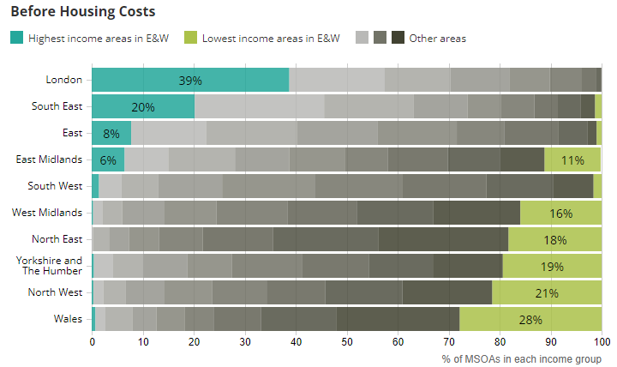
Figure 1 - graph showing the areas with the highest income vs the areas with the lowest income (Office for National Statistics, 2020)
The graph above outlines the most affluent areas throughout the United Kingdom in comparison to the areas with the lowest income. Clearly this demonstrates that Wales as a whole is considered one of the most deprived areas throughout the entirety of the UK with the lowest income reported, and one of the areas where highest income was the lowest (Office for National Statistics, 2020).

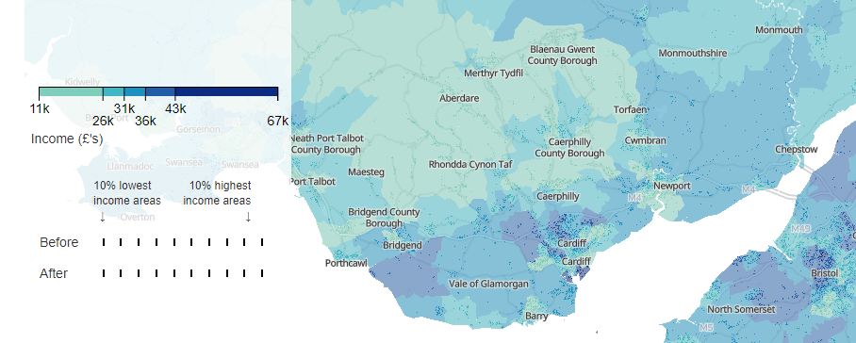
Figure 2 -Average disposable income throughout South Wales (Census, 2023)

The map above outlines the mean disposable income for houses throughout South Wales. The areas lighter in colour show the lowest income. Around 54% of people live in an area where more than 175 people per 1,000 of the working age population are receiving benefits.

Unemployment and Education
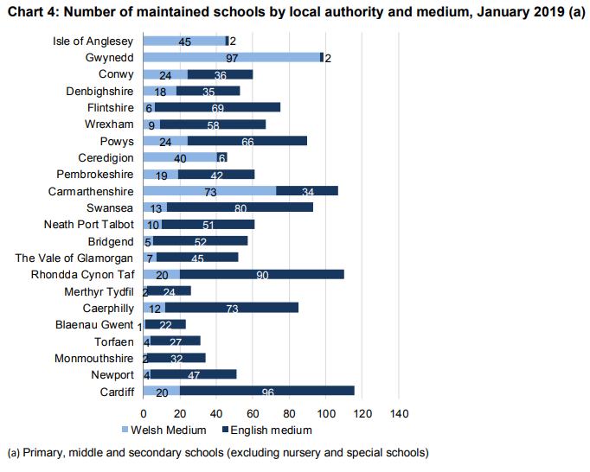
Figure 3 - Number of maintained schools throughout Wales (Gov.Wales, 2023)
Education in the valleys tends to be of a lower quality than other areas in Wales. More than 29% of adults have no qualifications in areas such as Blaenau Gwent (Gov.Wales, 2017). The graph above shows that the number of schools throughout Merthyr Tydfil are amongst the lowest throughout Wales (Gov.Wales, 2023).

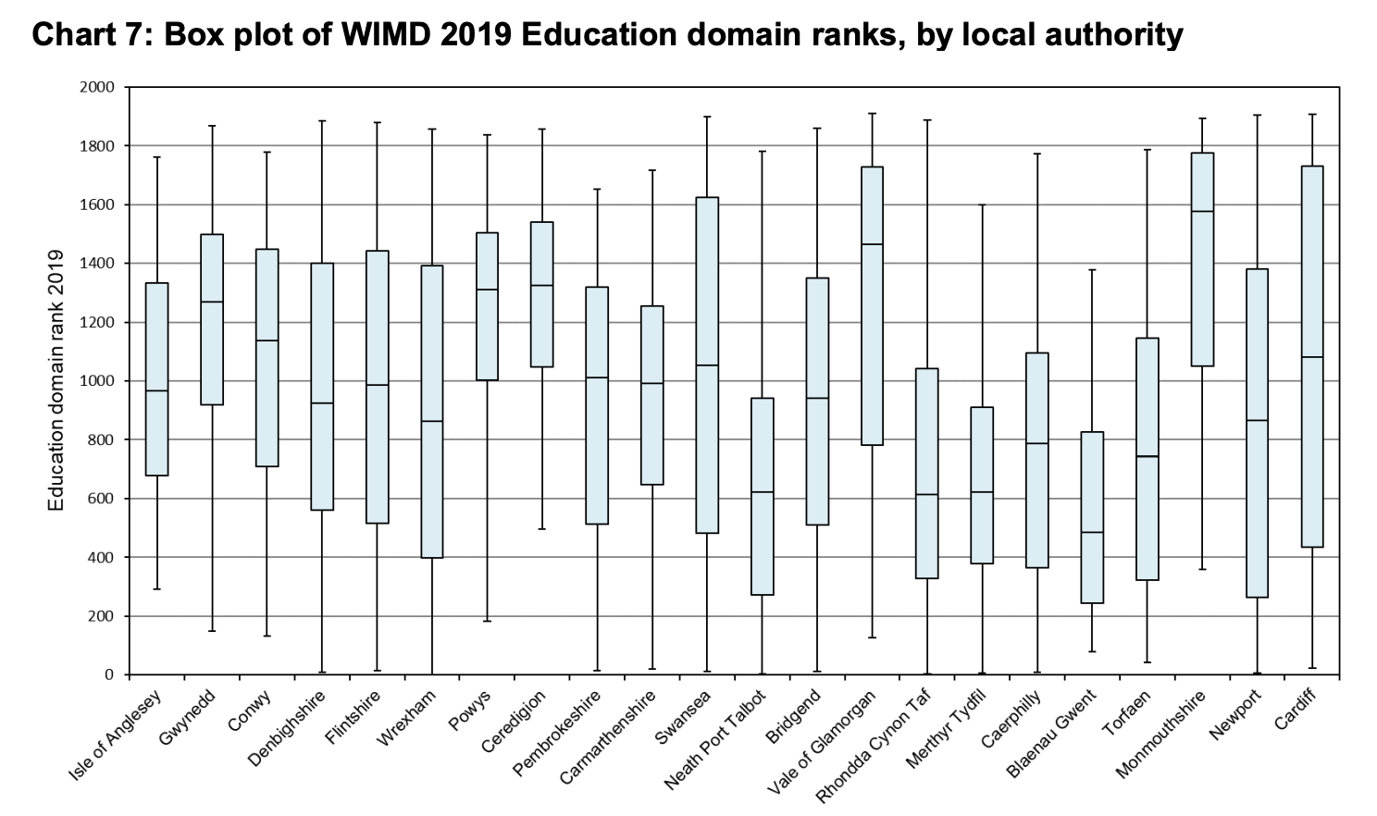
Figure 4 - rank of local authorities in Wales

This graph shows that the Valleys (Merthyr Tydfil, Rhondda and Blaenau Gwent) suffer from low levels education which is used as a factor to determine how deprived an area is by the Welsh Government.
"Deprivation" refers to more than just poverty. It alludes to unfulfilled needs that results from a deficiency of resources. It may entail having less access to chances and resources than we may anticipate in our society, for instance, in the areas of education and health. (Welsh Government, 2019).

Why education is important for reducing crimes
Links show that lower educational levels often produce a wide range of negative outcomes such as poverty, unemployment, and poor health. These factors are linked to crime and antisocial behaviour (Leicestershire Villages, 2021).

Studies suggest that lower education levels often result in higher levels of crime. The Chief Constable of Merseyside Police, Andy Cooke, stated that “The best crime prevention is increased opportunity and reduced poverty” (Dodd, 2021).

Bell et al. (2018) outline the link between education and the probability of offending. They state that this is potentially due to large proportions of the day students are incapacitated and unable to commit offences, however they also state that higher quality education is likely to substantially reduce the probability of individuals offending in the future by raising their human capital, wages and employment and reduces the probability of committing crime in the future.

Given the demographics of the valleys, naturally we can expect the volume of crime to be higher than some of the more affluent areas of Wales. As the graph below outlines, South Wales is the densest in relation to crime rates.

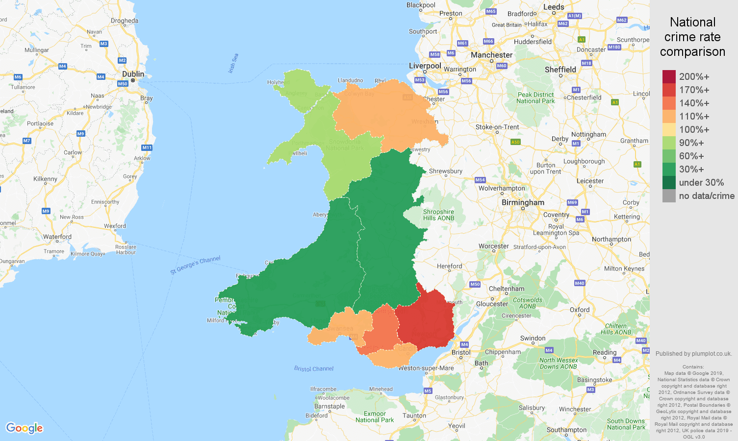
Figure 5 - Crime figures Wales Comparison (Plumplot, Wales Public Order Crime Statistics 2023)
According to recent news, in 2022 Merthyr Tydfil was ranked 7th for volume of calls per 1000 residents (Thomas, 2022). Aberdare have seen 28 public order offences and a further 28 Violent offences in September 2023 (South Wales Police, 2023) and are the most common types of offences.

Legislative Implications
The fight unfolded very quickly and there were several potential offences being committed. It became evident that we were dealing with an affray which is an offence under Section 3 of the Public Order Act 1986. This can include scenarios such as fighting in public, violent protests and as in our case, an individual wielding a weapon in a manner likely to cause fear to the public. The threat of unlawful force must be imminent, and the accused must have the intention to use and threaten violence or be aware that their behaviour is violent in nature. The offence of an affray must include at least three persons, a person (a) who is making threats, a second person (b) who is the recipient of the threats and is present at the time and a third person (c), who observes the violence and fears for person b’s personal safety (Bryant & Bryant, 2018).

Reflecting on the experience, I felt calm when approaching the incident as I was confident that this issue could be resolved. My experience working as a Police Community Support Officer with Gwent Police meant that I was often exposed to hostile situations.
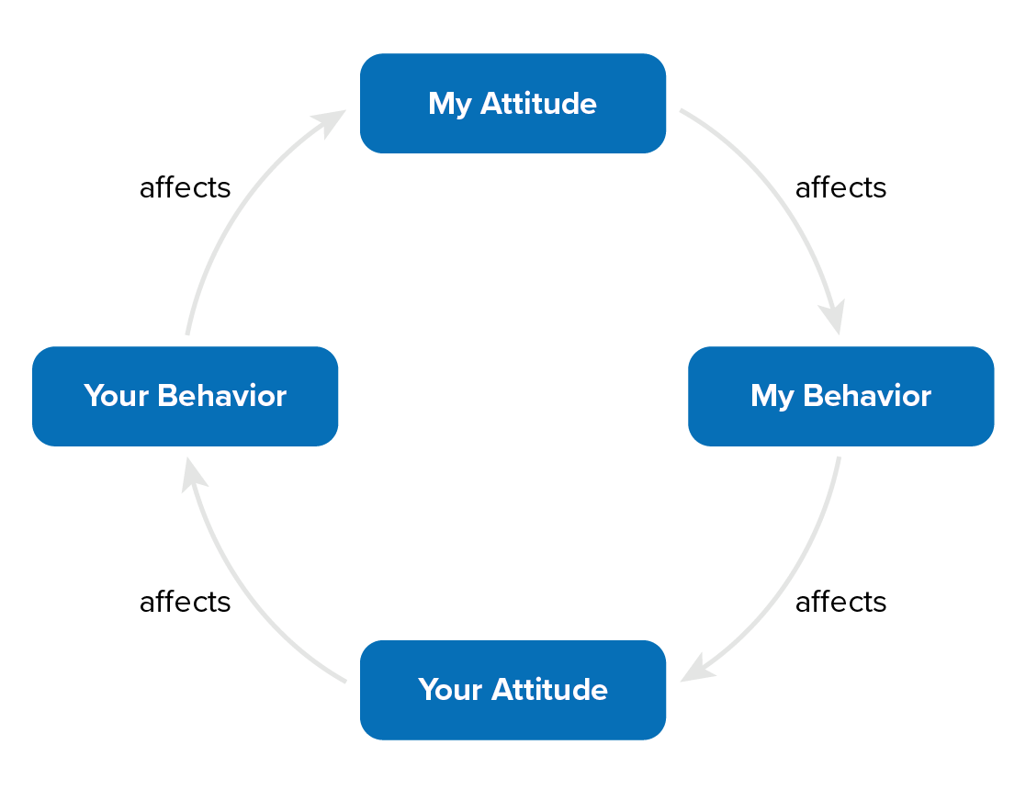
Batari Figure 6 - Batari's Box Model
Betari’s box is a model that outlines how our actions impact our own attitudes and behaviours and how this in turn impacts the attitude and behaviours of those we are communicating with (Wall, 2019). It is often the case that when we are negative or aggressive, these actions are mimicked, worsening the conflict. Maintaining a calm and relaxed demeanour, I hoped that this would be reflected by the offender where we would be able to open a dialogue. I felt that it was appropriate to attempt to engage with the subject verbally rather than using force. The police use a mnemonic ‘BUGEE’ (College of Policing, 2020) to allow officers to create time and space to assess risk and decide on the most appropriate course of action (College of Policing, 2023). The mnemonic stands for:
- Be prepared to back off
- Use of effective cover
- Give space and time if possible
- Early negotiation
- Evacuate immediate area.

As stated, the immediate area had been evacuated as people were avoiding the scene. There was plenty of space between me and the offender which provided sufficient cover, space, and the ability to back off if needed. The male’s behaviour profile was that of a compliant person, displaying some verbal resistance. I felt that early negotiation was a feasible option.

The type of conflict often dictates how best to manage the situation. The Thomas-Kilmann Conflict Mode Instrument discusses the ways we might deal with conflict (Trippe, 2015); our reaction may be assertive or cooperative. Being assertive relates to the extent to which an individual is required to meet demands, in a policing context this relates to taking control of a situation by giving lawful orders. In this scenario we demanded that the individual handed over the weapon.

Cooperativeness refers to the degree to which an individual will try to satisfy the concerns of another person. This can be a useful technique when policing as it is often much easier and safer to have an individual work with you rather than be met by resistance. Once the weapon had been removed, so had the threat so it was easier to work with the male.

Effective communication is vital as an officers’ verbal and nonverbal cues may propel a routine situation into an escalating conflict (Shea,L. and Harpool, D, 1988). By using the leaps model (College of Policing, 2020), we took time to listen to his counter allegation where he stated that he was initially assaulted and that his actions were a result of self-defence. While remaining empathetic, the male was informed that he was going to have to be handcuffed and searched to ensure he wasn’t in possession of any further weapons. Using non-threatening body language, we were able to move in closer and restrain the male. He remained compliant throughout, and we were able to provide him with the platform to air his emotions, he outlined that he felt agitated and was being aggressive as an act of self-defence. Once the situation calmed and we gained some clarity on the situation, we understood that he was the victim of the initial affray and asked if he would like to make a complaint. He had still committed the offence of possession of an offensive weapon in a public place, which was dealt with by a voluntary attendance to interview, and out of court disposal.

Conclusion
This call was a great example of the importance of having the ability to effectively communicate with potentially hostile people and defuse the situation. Working in an area that is inherently anti police and with high levels of violent crime such as the Welsh Valley’s officer safety is paramount. The deprived areas mean that the residents often turn to a life of crime and this becomes a way of life. Within this culture violence becomes more commonplace and often result in issues with public order. As this case outlined, much of the time these individuals are either a victim of crime themselves or have had negative experiences with the police prior. Having the ability to empathetically listen to everyone involved and provide them with basic dignity and fairness allowed officers to gain.

I feel that the outcome of this call was the best possible result. It transpired that the male was actually initially the aggrieved and was in fact assaulted first. Given the fact that there were weapons involved, using force in this scenario would have been justified. However, I felt that with the circumstances the risk of injury to the subject and officers was unnecessary as this would have likely been met with resistance. Upon reflection, I would potentially have to consider using force in future. In this scenario we were lucky that the male remained complaint and the situation could have easily gotten out of hand, making use of cuffs at the earliest convenience should be considered in future. I will use this scenario as a positive point of reference for effective communication in future events.

Word Count - 1943

Task 3

Relevant areas of the National Policing Curriculum:
Criminal Justice, Valuing difference and inclusion

You must choose a policing incident in which you played a significant role with an offender/ service user/victim and reflect on what happened

Critically explore a policing incident that you have attended and examine how you dealt with competing issues such as legalisation, social issues, culture and language.

Consider the victims code of practice and how it was used to support your victim/witness through the criminal justice system.

Your reflection must illustrate your understanding and application of core principles of ethics, equality, diversity and human rights.

1750 words (+/- 10%: include your actual word count at the end of each section)

ANSWER:

- Critically explore a policing incident that you have attended and examine how you dealt with competing issues such as legalisation, social issues, culture and language.

- Consider the victims code of practice and how it was used to support your victim/witness through the criminal justice system.

Your reflection must illustrate your understanding and application of core principles of ethics, equality, diversity and human rights.

Recent changes in government policies have attempted to address the ways in which the Criminal Justice System (CJS) treats victims and service users to ensure that victims of crime are receiving the same basic standards of service. This resulted in the victims’ code of practice which outlines 12 basic rights that all victims are entitled to. All rights must be met when dealing with a crime but in certain cases some are more significant than others.

In this essay I will discuss a recent incident where the victims’ code of practice played a significant role as the case progressed throughout the CJS. I will reflect on my responsibilities to date and discuss what I can do to further support the victim throughout the process.

This incident refers to a complaint received in relation to homophobic comments aimed towards the victim through Facebook comments. The victim had employed the defendant to undertake painting and decorating in his grandparent’s house and required a £150 deposit. The victim sent this and organised a date with the defendant for the work to be completed. This was then rearranged twice and on the third occasion the defendant did not show up to complete the work or attempt to contact the victim. As a result of this, the victim made an awareness post on Facebook warning people not to employ the defendant, at this point the defendant engaged with the victim and various others in the comment section and made homophobic comments towards the victim who is gay.

The offence is malicious communications as the defendant had made comments via the Facebook post that are considered electronic communication (True Vision, no date). The intention was indecent and meant to cause the victim, and others able to see the post, distress or anxiety (UK Public General Acts, 1988). This offence was aggravated by these communications being driven by homophobic comments about the victim’s sexuality. A hate crime is defined as any act that is motivated by prejudice or hate towards another race, religion, sexual orientation or disability (Chakraborti, 2009).

Hate crimes continue to rise in England and Wales, a report by the BBC outlined a 29% increase of reported crimes between 2016 and 2017 (Kelly, 2017) and they continue to remain a concern for UK police forces. The college of policing has recently provided new guidance on how to manage hate crimes driven by an inquiry regarding the murder of Stephen Lawrence and how the police are not accurately recording hate crimes (COP, 2020). Hate crimes are particularly harmful as they do not only have an impact on the individual, but also impact the wider community (Walters et al., 2018).

For several years there has been a lack of reliable data on homophobic hate crimes which meant the CJS lacked a true understanding of the extent and nature of these crimes (Dick, 2009). This could be due to the tumultuous relationship between the LQBTQ+ community and the police throughout history. Members of the LGBTQ+ community are not known for having great confidence in the police service (Chakraborti, 2009) and research shows that the community have less favourable views of the CJS than heterosexuals (Nadal et al., 2015). Wellock & Tarpey, (2023) outline that there are underpinning feelings of distrust among gay and queer people towards the police which has an impact on the community accessing help. This makes policing homophobic hate crimes more difficult with only one fifth of those experiencing hate crimes reporting this for fear of homophobic reactions from the police (Girardi, 2021). Generally, members of the LGBTQ+ community live in greater levels of fear that they will be the recipient of a hate crime and feel more vulnerable to being a victim of crimes in general.

The victim has likely already been exposed to negative feelings towards the police, and given the nature of the complaint, they are considered vulnerable. This had the biggest implication on how the Victims Codes of Practice (VCOP) related to this case. VCOP is a statutory document that outlines the information, support and services available to victims of crime (The Supreme Court, no date). The College of Policing has released an updated VCOP that outlines the minimum standards that victims of crime should expect to receive (College of Policing, 2021). The VCOP states that additional support should be provided for those who are vulnerable or intimidated (South Wales Police, no date), therefore it was pertinent that consideration was given to additional support for the victim.

Under VCOP, a victim has a right for the crime to be recorded at the earliest opportunity. This is not only critical for encouraging diversity, but also essential for accurate recording of hate crimes. The victim was encouraged to make a formal complaint as this is considered a proactive approach and is outlined in the code of ethics as a means of addressing discrimination, by supporting victims and encouraging reporting to prevent future incidents (COP, 2014). Once this crime was reported I was able to undertake a victim needs assessment as part of the initial updates on the occurrence. This assessment outlined that due to the victims' vulnerabilities they were entitled to enhanced services, such as more frequent updates and special measures at court which will be discussed in more detail shortly. The vulnerability of the victim also resulted in the submission of a Public Protection Notice (PPN) on their behalf. A PPN takes the information of an individual and the case and disseminates it to relevant third parties so that the victim can receive appropriate support from the relevant agencies. Any victim of a hate crime is assigned a Hate Crime Officer (HCO) who monitor all hate crimes, offer regular updates with the victims to offer support and safeguarding advice throughout the process (Three Rivers District Council, 2022).

Another right under VCOP that needed consideration was Right 3 - To be provided with information when reporting the crime. Although the victim was supported in his wish to make a formal complaint, he was still advised about out of court disposals which are sometimes less strenuous on the victims’ welfare. This includes community resolutions or conditional cautions, which allow victims’ views to be considered and offers them the opportunity to have their say in the decision-making process.

It is sometimes difficult to manage the expectations of the victim when dealing with crimes. Often the desired outcome is arrest, but sometimes this is not practical. The police must remain impartial and treat the defendant fairly, not imposing on his basic human rights. For example, as per Article 6 of the Human Rights Act (HRA) the defendant has the right to a fair and public hearing. Any person accused of an offence is to be presumed innocent until proven guilty (HRA, 1998). The role of the police is to remain impartial while gathering evidence to present to the courts. This can be difficult while also attempting to support the victim. As part of the process of providing the defendant with a fair trial, another consideration is the right to liberty and security. Arresting an individual and removing this right requires a necessity and should be justified, proportionate, legal, accountable, necessary and ethical (Bryant & Bryant, 2018). In this case there was no requirement for arrest and the defendant was invited for a voluntary interview before considering arrest.

When the offence goes to court, the victim will be supported through the process and has the right to be given information about the trial process. This is where special measures may be introduced for intimidated or vulnerable victims. Part II of the Youth Justice and Criminal Evidence Act (YJCEA, 1999) outlines categories of witnesses and measures designed to make the process easier for those with different vulnerabilities to provide evidence. Our victim was a witness that “suffered from fear or distress” in relation to testifying in the case (South Wales Police, no date). Special measures have been applied for as this case goes to court. To achieve the best evidence, the victim has requested that they provide evidence via video link.

Finally, one of the most relevant rights under the VCOP is the right to provide a Victim Impact Statement (VPS). This statement allows the victim to explain in their own words how a crime has affected them, emotionally or in any other way (South Wales Police, no date c). A VPS provides information for judges but also helps to provide therapeutic benefits for victims and allows the defendant to understand the harm they have caused (Hungerford-Welch et al., 2011).

This offence was driven by homophobic comments with the intention of causing the victim to feel harassed and alarmed. When interviewed the defendant stated he “didn’t mean anything” by his comments. Although the defendant showed sincere remorse for his actions, it was clear he had little understanding of the impact caused. Allowing the victim to provide a VPS which will be read out loud in public court will provide the victim, who was left to feel anxious and vulnerable with a voice.

The victim suffered a crime that has been aggravated by hate and showed signs of anxiety towards the CJS. The VCOP ensured that the victim was receiving the tailored support they required from the point of initial reporting to where the case progressed through the CJS. I ensured that the victim was able to provide evidence needed in court by applying for special measures making them feel at ease. Historically police forces have struggled to maintain positive relationships with diverse communities as policies, operational norms and officer attitudes often result in suspicion and mistrust (Bullock & Johnson, 2017). The relationship between the CJS and the LGBTQ+ community has been biased against the LGBTQ+ community (Wellock & Tarpey, 2023). This was a vital opportunity to provide the victim positive engagement with the police, therefore making it more likely that this individual, and those around them would engage with the services in the future. Evidence has indicated that public confidence improves when local people are involved in decisions about issues that concern them, and effective community engagement can increase confidence and trust in community perceptions of the police (College of Policing, 2013).

I feel that this case resulted in an overall positive outcome for the victim. I offered enhanced rights and additional support with the complaint, which would then introduce the need for a Hate Crime Officer (HCO) to be used on the case. The victim was provided with alternative routes of disposal and supported as the case progressed to court. To ensure that the best evidence is delivered at court special measures have been applied to ease the victim. They have also had the opportunity to provide a VPS outlining how this event has negatively impacted on their lives. I feel that as an officer I have delivered the best service possible and that this is reflected given that the victim has not used right 12 of the VCOP, the right to make a complaint.

Word Count - 1828

Task 4

Relevant areas of the National Policing Curriculum:
Decision making and discretion, Conducting Investigations and Criminal Justice (Managing offenders)

You must choose a policing incident in which you played a significant role with an offender/service user/victim and reflect on what happened.

Critically assess a policing incident that you have attended, where you played a significant role with an offender/victim and reflect upon what happened.

Reflect upon your use of the National Decision-Making Model and the Code of Ethics and review this impacted upon your decision making and use of discretion within the incident.

Critically review your responsibilities regarding the provision of CPIA when conducting this investigation.

1750 words (+/- 10%: include your actual word count at the end of each section)

ANSWER:

In this essay I will be discussing an incident where I played a significant role and had the opportunity to utilise the National Decision-Making model (NDM) and my discretion. I will also talk about the responsibilities I had regarding the provision of CPIA when developing the case file.

An offender was arrested on two counts of shoplifting and further arrested for possession of a class A drug and sleeping pill and taken to custody and interviewed by myself the following morning.

The morning after the individual was arrested, I was tasked with taking over the investigation, specifically taking the lead in gathering further information on the defendant, conducting interviews and developing the case file. The defendant was seen stealing washing capsules from Savers on two separate occasions. There was CCTV footage from both offences that clearly showed the defendant taking the products from the shelf and placing them into a bag for life. The defendant proceeded to leave the store without paying for the items, contrary to section 1 of the Theft Act 1968. The defendant was arrested some days later after being detained by a member of the public after acting suspiciously in a car park. Upon arrest she was searched, and a small yellow tablet and heroin was found in her possession contrary to section 5(2) of and Schedule 4 to the Misuse of Drugs Act 1971.

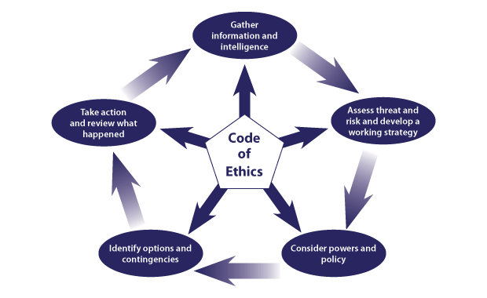

Figure 1 - National Decision-Making Model

The NDM is used nationally throughout UK police forces as a risk assessment tool to aid the decision-making process and as a means of reflection post event (College of Policing, 2013). The NDM allows officers to make informed and rational decisions, while taking into consideration all information and policies, and enables officers to weigh the desired outcome while balancing resources with demand threat and risk (Coxhead, J. 2017).

As officers we are encouraged to act in accordance with the code of ethics while utilising the NDM. The Code of Ethics, includes ethical policing principles and guidance for ethical and professional behaviour. It encourages personal responsibility to act in a professional manner, with the hoped outcome of the public having more confidence to trust the police to be fair, ethical and acting within their best interest (College of Policing, 2014).

Information

The NDM begins with the information gathering stage of the cycle. During this stage we define the situation (what is happening or has happened), look at what we know and don’t yet know, and what further information or intelligence we need to gain at this point in time (College of Policing, 2014).

Evidence is any information obtained and presented with the intent to conclude whether a crime has been committed. The CPIA 1996 outlines the different categories of information and how to manage each of them. The categories are evidence, unused material, and non-relevant material. These elements had the biggest influence on my responsibilities in this case, specifically the roles of interviewing and charging the defendant. I conducted the interview and preparations to the fullest extent which required me to complete an interview booklet disclosing the evidence obtained to the defendant and solicitor.
As the initial arrest was dealt with I had more time to gather information around the case. The individual was unknown to me prior to my involvement, and I was unaware of the offences beforehand. I began by familiarising myself with the offences in question, there were three in total ranging over a three-month period. I began by looking at the oldest offence of shoplifting utilising NICHE. I began by reading the Occurrence Enquiry Log updates to understand what enquiries had been conducted so far.

I found there were still some outstanding enquiries needed before I could progress this case. For the first offence CCTV footage of the offence had been collected, but a witness statement was still outstanding. For the second offence we had a witness statement from the reporting person, but the CCTV was yet to be collected. The third offence was for possession of drugs that were found on the person as a result of her being searched prior to arrest. The defendant was found in possession of a non-prescribed sleeping tablet and half a gram of heroin. Body worn video and an arrest statement provided all the information needed to interview the offender.

Assessment

Assessing the circumstances, including any particular threats, the likelihood of harm, and the possibility of rewards, are all part of this analytical stage. First I assessed whether I needed to take action immediately, and whether I needed to seek any more information. The custody clock was running as the defendant had already been arrested, I only had 24 hours to collate all of my evidence. Before the interview, I considered what could go wrong and what could go well. We were anticipating a guilty plea, but if she plead not guilty in interview this would result in insufficient evidence and the defendant could be released with no further action. When assessing risk, I decided that the only probable risk of harm would be risk of loss for the shop in which the theft occurred. This would increase demand on the police, as the defendant would continue to commit the offences.
As mentioned, the individual was found in possession of two controlled substances, heroin and a sleeping pill known as Quetiapine. Upon questioning during the interview, it was discovered that the sleeping pill was provided by a family member who is prescribed the drug. We decided that the sleeping pill was not in the public interest to pursue prosecution for, therefore this was unused material.

I hoped to achieve a reduction in demand for this individual. This impacted the decisions I made in relation to whether the defendant would be released on bail, or remanded into prison where she can no longer offend.

Using a controlled substance that is not prescribed to you unless you have authorisation in the form of a licence (eg. prescription) is an offence under Section 5 of the Misuse of Drugs Act 1971. It could be argued that the individual should also face prosecution for this.

However, I decided to use discretion in this case. This allows officers the ability to use their decision-making skills to utilise a different method of disposal for this offence. When making decisions about discretion we must consider what we are trying to achieve, and the potential effects of our decisions (College of Policing, 2014). To build a solid case to prosecute we would have to undertake costly forensic analysis, where there would likely be no further sanctions as it is a Class C drug.

It was clear the individual was eager to be released from custody. After providing us with a full and frank confession to each of the offences, we decided to release the individual on police bail for three months. In respect of the NDM and code of ethics, as we had no further lines of enquiry to conduct this decision was fair.

Powers and Policy

The powers and policies section takes into consideration what legislation and options we have at our disposal. The Theft Act 1968 would apply to this case. This act outlines the basic definition of theft, and states “a person is guilty of theft if he dishonestly appropriates property belonging to another with the intention of permanently depriving the other of it” (UK Public General Acts, 1968).
The purpose of Criminal investigations is to ensure those suspected of committing an offence are brought to justice through a professional, ethical, and vigorous investigation (College of Policing, 2023). How these investigations are conducted are regulated by the Criminal Procedure and Investigations Act introduced in 1996. This governs the investigatory process and to protect citizens from unlawful convictions (Polykarpou, 2022). Everyone involved in the criminal justice process has a duty to disclose evidence, regardless of whether it assists the defence case or undermines the prosecutions. A series of high-profile rape cases highlighted concerns that evidence is not being disclosed effectively and that CPIA compliance is not being met. 2018 saw a 70% increase in the collapse of prosecution cases due to failures to disclose evidence (Cowling, 2018).

In this case, the evidence being presented by the prosecution to charge the accused had the biggest implication. This included witness statements for all three offences, forensic evidence which included drugs seized by the arresting officer, a positive test for heroin, and accompanying statement. Multiple digital exhibits including CCTV of the two shoplifting offences and body worn video of the arrest were also collected, along with supporting statements from an eyewitness.

Unused material is material which has been obtained in the process of an investigation but is not being used as evidence. For this case it includes the redacted occurrence enquiry logs from the NICHE system, the defendant’s custody records, Police National Computer print outs of the defendants’ previous convictions, and interview notes. As the individual is being charged and the case file has been compiled, each of the above has been added and disclosed for the occurrence.

Options

The options stage involves consideration of different options for disposal. During this stage, I considered various options on how to deal with the defendant as the case progressed through the courts. The options were as follows:

Remand - As the defendant has previously shoplifted, she could be placed under remand to prevent further loss while evidence is collected until they are expected in court. This was considered as we entered the build up to the festive period.

Release on Police Bail - This would involve allowing the defendant back into the community but imposing conditions that must be followed by the defendant. If these conditions are breached they are then arrestable.

Release under investigation - The defendant would be released with no conditions/implications and would then receive a notice to attend court.

No Further Action (NFA) - They are released from custody and no formal action is taken against them. This was not an option as the aggrieved wish to make a complaint.

Action and Review

The Action and Review stage of the cycle has two distinct steps. The first is ‘Action’, where decision makers need to make and implement appropriate decisions. Secondly ‘Review’, where the decision maker reflects on what happened following the incident.

After interviewing the defendant and obtaining a full and frank confession, out of the options and contingencies, it was decided she should be released on bail with conditions to not enter Savers. There were concerns around this as it was nearing Christmas, where shoplifting often increases (The Mirror, 2023). Since this time, we have not received any further calls and the individual has not been arrested for any further shoplifting offences. In respect of the NDM and code of ethics, as we had no further lines of enquiry to conduct, this decision was fair. Having access to personal information, including offending history and evidence can cause you to be bias and change your behaviour or attitude toward them while collecting evidence, so we remained open-minded and gained information on the current offence.

We have however seen the individual while conducting patrols within the area. Having treated the individual fairly and with integrity, we were able to build rapport and our interactions since have been positive. She is now happy to engage with officers which often leads to the development of quality intelligence relating to drugs, shoplifting offenders and the addresses and acquaintances of others recent offenders, which is a positive outcome.

Word count 1908

Task 5

Independent Patrol Staus confirmation – equivalent to 1,500

This completion of this task shall be confirmed by the employer once independent patrol status is achieved.

Bibliography
The bibliography should only include sources referenced within the workbook using the Harvard referencing system. Information about referencing in written assignments and how to avoid plagiarism can be found on Moodle. It is important that you are aware of the importance of ensuring that the work submitted is your original work.
Bell, B., Costa, R. and Machin, S.J. (2018) ‘Why does education reduce crime?’, SSRN Electronic Journal [Preprint]. doi:10.2139/ssrn.3253463.
Borton, T. (1970) Reach, touch, and teach. New York Mcgraw-Hill.
Bryant, R. and Bryant, S. (eds.) (2017) Blackstone’s Handbook for Policing Students . 12th edn. Oxford: Oxford.
Bryant, R. and Bryant, S. (eds.) (2018) ‘Roles, Responsibilities, and Support’, in Blackstone’s Handbook for Policing Students. Oxford: Oxford University Press.
Bullock, K. and Johnson, P. (2017) ‘Police engagement with Muslim communities: Breaking out, breaking in, and breaking through’, Policing and Society, 28(8), pp. 879–897. doi:10.1080/10439463.2017.1339706.

Chakraborti, N. (2009) ‘A glass half full? assessing progress in the policing of hate crime’, Policing, 3(2), pp. 121–128. doi:10.1093/police/pap003.

Cleveland Clinic (2022) Endorphins: What they are and how to boost them, Cleveland Clinic. Available at: https://my.clevelandclinic.org/health/body/23040-endorphins (Accessed: 29 December 2023).

Cowling, P. (2018) Hundreds of cases dropped over evidence disclosure failings, BBC News. Available at: https://www.bbc.co.uk/news/uk-42795058 (Accessed: 22 November 2023).
College of Policing (2014) Code of ethics - college of policing, College of Policing. Available at: https://assets.college.police.uk/s3fs-public/2021-02/code_of_ethics.pdf (Accessed: 30 December 2023).
College of Policing (2013) Engagement, College of Policing. Available at: https://www.college.police.uk/app/engagement-and-communication/engagement (Accessed: 31 December 2023).
College of Policing (2023) Investigation process, College of Policing. Available at: https://www.college.police.uk/app/investigation/investigation-process (Accessed: 22 November 2023).
College of Policing (2013) National decision model, College of Policing. Available at: https://www.college.police.uk/app/national-decision-model/national-decision-model (Accessed: 09 November 2023).
College of Policing (2020) New National Hate Crime Guidance published, College of Policing. Available at: https://www.college.police.uk/article/new-national-hate-crime-guidance-published (Accessed: 29 December 2023).

College of Policing (2021) Victims’ code for policing, College of Policing. Available at: https://www.college.police.uk/guidance/victims-code/victims-rights-policing (Accessed: 29 December 2023).

Coxhead, J. (2017) Interoperability of the National Decision Making Model, EMPAC home page. Available at: https://www.empac.org.uk/interoperability-national-decision-making-model/ (Accessed: 07 December 2023).

Dick, S. (2009) ‘Homophobic hate crime — findings from the gay British crime survey 2008’, Safer Communities, 8(4), pp. 35–42. doi:10.1108/17578043200900036.
Dodd, V. (2021) ‘Tackle poverty and inequality to reduce crime, says police chief’, The Guardian, 18 April. Available at: https://www.theguardian.com/uk-news/2021/apr/18/tackle-poverty-and-inequality-to-reduce-says-police-chief (Accessed: 25 November 2023).

Flavin, B. (2019) Different types of learners: What college students should know, Rasmussen University. Available at: https://www.rasmussen.edu/student-experience/college-life/most-common-types-of-learners/ (Accessed: 08 December 2023).

Girardi, R. (2021) ‘“it’s easy to mistrust police when they keep on killing us”: A queer exploration of police violence and LGBTQ+ victimization’, Journal of Gender Studies, 31(7), pp. 852–862. doi:10.1080/09589236.2021.1979481.
Gov.Wales (2023) Schools’ census results: As at January 2019, GOV.WALES. Available at: https://www.gov.wales/schools-census-results-january-2019 (Accessed: 09 December 2023).
Gov.Wales (2017) Valleys Taskforce: Summary of evidence, GOV.WALES. Available at: https://www.gov.wales/valleys-taskforce-summary-evidence (Accessed: 09 December 2023).

Hughes, R., Kinder, A. and Cooper, C.L. (2019) The wellbeing workout: How to manage stress and develop resilience. Cham, Switzerland: Palgrave Macmillan.

Hungerford-Welch, P. et al. (2011) ‘Victim personal statements: Should they affect the sentencing process?’, Criminal Justice Matters, 85(1), pp. 36–38. doi:10.1080/09627251.2011.599687.

Jang, M. and Kim, J. (2018) ‘A structural model for stress, coping, and Psychosocial Adjustment: A multi-group analysis by stages of survivorship in Korean women with breast cancer’, European Journal of Oncology Nursing, 33, pp. 41–48. doi:10.1016/j.ejon.2018.01.004.

Kaplan , B. (2015) Secondhand stress: How people around you can increase your anxiety - orlando health - one of Central Florida’s most comprehensive healthcare networks, Secondhand Stress: How People Around You Can Increase Your Anxiety. Available at: https://www.orlandohealth.com/content-hub/secondhand-stress-how-people-around-you-can-increase-your-anxiety#:~:text=It%27s%20true%E2%80%94stress%20from%20others,an%20impact%20on%20your%20health. (Accessed: 03 December 2023).

Kelly, J. (2017) Rise in hate crime in England and Wales, BBC News. Available at: https://www.bbc.co.uk/news/uk-41648865 (Accessed: 29 December 2023).

Kern, M.L. (2016) ‘Exercise, physical activity, and Mental Health’, Encyclopedia of Mental Health, pp. 175–180. doi:10.1016/b978-0-12-397045-9.00064-1.

Leicestershire Villages (2021) The relationship between crime and education, Leicestershire Villages. Available at: https://www.leicestershirevillages.com/how-does-lack-of-education-cause-crime/ (Accessed: 02 December 2023).

Martin, A.J. (2013) ‘Academic buoyancy and academic resilience: Exploring “everyday” and “classic” resilience in the face of academic adversity’, School Psychology International, 34(5), pp. 488–500. doi:10.1177/0143034312472759.

McKenzie Health System (2023) 5 reasons stress is good for you, McKenzie Health System. Available at: https://www.mckenziehealth.org/news-blog/2023/march/5-reasons-stress-is-good-for-you/#:~:text=That%20may%20be%20one%20reason,up%20and%20get%20you%20pumped. (Accessed: 29 December 2023).

Mareeswaran, N ; Gopalakrishnan, S Arad: "Vasile Goldis" Western University Arad, Romania; Annals of the Romanian society for cell biology, 2021, Vol.25 (1), p.2792-2801

McRae, I. (2023) ‘Would you prosecute a child for stealing baby formula? Shoplifting’s rise amid cost of living crisis’, Big Issue, 15 September. Available at: https://www.bigissue.com/news/social-justice/shoplifting-rise-cost-of-living-children-poverty/ (Accessed: 15 November 2023).
Office for National Statistics (2020) Income estimates for small areas, England and Wales: Financial year ending 2018, Income estimates for small areas, England and Wales - Office for National Statistics. Available at: https://www.ons.gov.uk/peoplepopulationandcommunity/personalandhouseholdfinances/incomeandwealth/bulletins/smallareamodelbasedincomeestimates/financialyearending2018 (Accessed: 09 December 2023).
Plumplot (2023a) Gwent Violent Crime Statistics, Gwent violent crime statistics in maps and graphs. Available at: https://www.plumplot.co.uk/Gwent-violent-crime-statistics.html (Accessed: 02 December 2023).
Plumplot (2023b) Wales Public Order Crime Statistics, Wales public order crime statistics in maps and graphs. Available at: https://www.plumplot.co.uk/Wales-public-order-crime-statistics.html (Accessed: 02 December 2023).

Polykarpou, M. (2022) ‘Prosecutorial and police disclosure ethics in criminal evidence review in the UK and the US. A comparative account’, Criminal Justice Ethics, 41(1), pp. 45–61. doi:10.1080/0731129x.2022.2056352.

Putwain, D.W. et al. (2015) ‘“‘sink or swim’: Buoyancy and coping in the cognitive test anxiety – academic performance relationship”’, Educational Psychology, 36(10), pp. 1807–1825. doi:10.1080/01443410.2015.1066493.

Shane, J.M. (2021) Stress inside police departments: How the organization creates stress and performance problems in police officers. New York: Routledge.

Stein, S. and Bartone, P.T. (2020) Hardiness: Making stress work for you to achieve your life goals. Hoboken, NJ: John Wiley & Sons, Inc.
The Mirror (2023) ‘Fears of shoplifting chaos this Christmas as firms beef up security for festive period’, 7 November. Available at: https://www.mirror.co.uk/news/uk-news/fears-shoplifting-chaos-christmas-firms-31384838 (Accessed: 20 November 2023).
Thomas, E. (2022) ‘The Welsh neighbourhoods where the most crimes are committed’, Wales Online, 4 April. Available at: https://www.walesonline.co.uk/news/wales-news/worst-crime-areas-wales-cardiff-23585100 (Accessed: 20 November 2023).
Trippe, B. and Baumoel, D. (2015) ‘Beyond the Thomas–Kilmann Model: Into Extreme Conflict’, Negotiation Journal, 31(2), pp. 89–103. doi:10.1111/nejo.12084.
UK Public General Acts (1968) Theft act 1968, Legislation.gov.uk. Available at: https://www.legislation.gov.uk/ukpga/1968/60 (Accessed: 01 January 2024).
Wall, I. rua (2019) ‘Policing atmospheres: Crowds, protest and “atmotechnics”’, Theory, Culture &amp; Society, 36(4), pp. 143–162. doi:10.1177/0263276419829200.
Wanna, J., Lee, H.-A. and Yates, S. (2015) Managing under austerity, delivering under pressure performance and productivity in Public Service. Acton, A.C.T.: ANU Press.
Warner, N. and Budd, M.-J. (2018) ‘The impact of peer-to-peer coaching on self-esteem, test anxiety and perceived stress in adolescents’, The Coaching Psychologist, 14(2), pp. 69–79. doi:10.53841/bpstcp.2018.14.2.69.
Welsh Government (2022) Demography and migration in Wales (census 2021), GOV.WALES. Available at: https://www.gov.wales/demography-and-migration-wales-census-2021-html (Accessed: 02 December 2023).
Welsh Government (2019) Welsh index of multiple deprivation (WIMD) 2019: Results report - GOV.WALES, GOV.wales . Available at: https://www.gov.wales/sites/default/files/statistics-and-research/2019-11/welsh-index-multiple-deprivation-2019-results-report-024.pdf (Accessed: 31 December 2023).

CONFIDENTIALITY and PLAGIARISM – confirmed by submission through Turnitin

Please sign to confirm the work submitted is your own work and has not been copied from another.

Signed: M. James …...................

Date: 02/01/2024….......................

