Assignment 1
An Analysis of Effective Leadership for the Future of Work



MODULE NAME: LEADERSHIP & MANAGEMENT THEORY & PRACTICE (M6X00882)
Student Name: Emma-Lisa Beaumont (1804423)

Table of Contents
Executive Summary 3
1.0 Report Remit 4
2.0 Complexity 4
2.1 Cynefin Framework 5
Figure 1: The Cynefin Framework (Source: Snowden, 1999) 6
2.2 Mega-trends 8
2.2.1 Technological Breakthrough 8
2.2.2 Shifting Economic Power 9
2.2.3 Climate Change and Resource Scarcity 9
2.2.4 Rapid Urbanisation 9
2.2.5 Demographics and Social Change 10
2.3 The VUCA Environment 10
3.0 Leadership for Innovation 13
3.1 Servant Leadership 13
3.2 Authentic Leadership 15
4.0 Leadership Skills for Innovation 17
4.1 Emotional intelligence 17
4.2 Learning Agility 18
6.0 Conclusion 21
7.0 Recommended Micro-experiment 21
8.0 References 22
Table of Figures
Figure 1: The Cynefin Framework (Source: Snowden, 1999) 6
Figure 2: An outline of current mega-trends (Source: Hartley, 2019) 8
Figure 3: A diagram of the VUCA environment (Source: Macpherson, 2019) 11
Figure 4: Model of Authentic Leadership (Source: Beddoes-Jones and Swales, 2015). 16
Figure 5: High Learning-Agile Individual traits according to the Learning Agility Initiative (Source: Mitchenson and Morris, 2014) 20

Executive Summary

This report has been commissioned in order to explore the leadership approaches, which can be implemented in order to help an international technology company achieve its strategic goal to “become the world’s leader in innovation and excellence in the sector”.
In the modern world of leadership, organisations must be willing to acknowledge that they are no longer operating as single entities within a business environment. Current research suggests that organisations should now consider themselves, and others, as complex systems. These systems comprise of interrelating parts which can learn, adapt and evolve together.
The report goes on to examine a number of leadership topics including complex environments, servant leadership, emotional intelligence and VUCA. It uses these points to understand how the company can better reach it’s strategic goals and future-proof their workforce to successfully navigate complex environments.
The report makes recommendation for the company to conduct a number of micro-experiments including project teams created with the aim of examining servant leadership, and using the Genos Assement tools to identify strengths and development opportunities within the emotional intelligence of the workforce.

1.0 Report Remit
This report has been commissioned in order to explore the leadership approaches, which can be implemented in order to help an international technology company achieve its strategic goal to “become the world’s leader in innovation and excellence in the sector”.
In the modern world of leadership, organisations must be willing to acknowledge that they are no longer operating as single entities within a business environment. Current research suggests that organisations should now consider themselves, and others, as complex systems. These systems comprise of interrelating parts which can learn, adapt and evolve together. Natural systems must be examined in order to fundamentally understand the complex and evolutionary way in which organisations need to promote innovation. Only by doing this, can organisations begin to understand how to successfully adapt to change within a dynamic, rapidly changing environment.

2.0 Complexity
In order to fully understand how leadership can be influenced and affected by the environment in which it is operating, it is important to understand the concept of complexity and Complex Adaptive Systems.
Complex Adaptive Systems are characterised by McDaniel (2008) as:
- Diverse agents that learn
- That interact with each other in non-linear ways, and therefore
- Self-organise
- Have emergent properties and
- Co-evolve with the environment
At the core of complex adaptive system theory is the knowledge that even perfect understanding of each part of a complex adaptive system, does not necessarily mean an understanding of the system as a whole. The system therefore may mutate, change and self organise, even with the parts remaining the same (Gupta, 2008)
The concept of complex adaptive systems has been noted long before modern business texts. As Gestalt psychologist Kurt Koffka once said, “the whole is more than the sum of its parts” which is a succinct example of the understanding of complex systems.

2.1 Cynefin Framework
The Cynefin Framework is a conceptual framework developed by Dave Snowden in 1999. The framework is described as a “sense-making device” (Kurtz, Snowden, 2003). It is designed to signify factors both in our dynamic environment and in our own, or collective life experience which influence us.

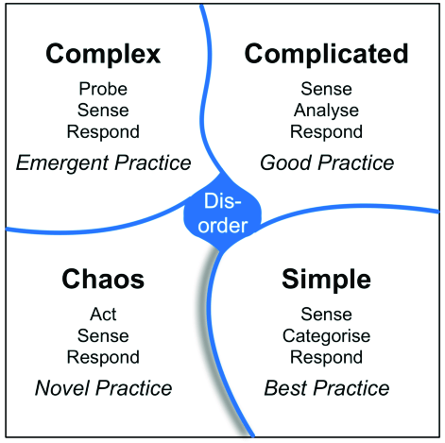Figure 1: The Cynefin Framework (Source: Snowden, 1999)
In practice within the technology industry, the framework is used in the process of software development in order to structure and lead development teams. O’Connor and Lepmets (2015) argue that using the Cynefin framework for this process assists in choosing correctly for the situational context at hand.
An example of this in practice became perceptible when a small innovative technology company was acquisitioned by a major telecommunications company. Once the larger company imposed its corporate personnel and practice onto it’s company, the innovation and creativity they believed they had acquired stopped. Hasan and Kazlauaskas (2013) suggest that had the Cynefin Framework been implemented in this instance, they would have successfully led the smaller company in a way more suited to complexity. This would have fostered the innovation and creativity of the company, while allowing them to fit into a more corporate environment.

2.2 Mega-trends
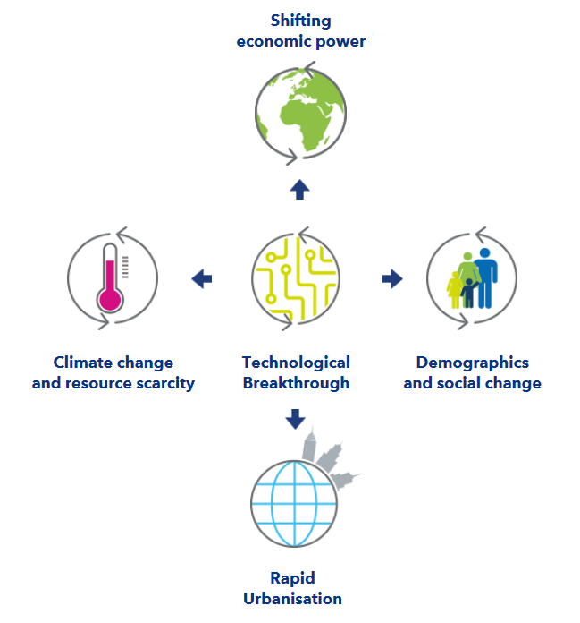Figure 2: An outline of current mega-trends (Source: Hartley, 2019)

2.2.1 Technological Breakthrough
Legislation will force change combined with technological advances. Zero-carbon targets will mean that companies need to invest in clean technology in order not to become outdated – or outlawed. For example, in the next two decades, governments will phase out fossil-fuel engines (BBC, 2020).
One of the biggest technological shifts will be the rapid introduction of artificial intelligence (AI) and the increased analysis of big data. AI will eliminate large segments of the job market and in turn create new positions currently not in existence. This means that companies will need to reskill their staff in order to protect their skilled workforce (Taulli, 2019; Press, 2019).
The ‘internet of things’ will mean that all new devices will be connected in some way. This level of connectivity means not only will information be more easily accessible, but also will require a much higher level of cyber security measures in order to protect business systems, and individuals alike (Thomas et al., 2017).

2.2.2 Shifting Economic Power
As economic activity continues to grow in the developing world. By 2040, E7 economics are predicted to be double the size of the G7 – an international intergovernmental economic organisation that consist of the 7 most economically advanced countries in the world (Sydney Business Insights, 2018).

2.2.3 Climate Change and Resource Scarcity
Businesses need to become increasingly more adaptable and innovative, as resources become scarcer. In order to be able to keep using natural resources such as metals, water and other virgin materials, recycling and remanufacturing must be increased (Winston, 2019). Businesses must be prepared to show their commitments to environmental sustainability and corporate social responsibility in order to appease consumers in an increasingly eco-conscious world (Thomas et al., 2017).

2.2.4 Rapid Urbanisation
Due to the rapid growth in urbanisation, megacities and metropolises will be more prevalent in the near future (Thornton, 2019; Winston, 2019). This is likely to cause a steep increase in the cost of living in desirable urbanised areas. In turn, this will create demand for bigger buildings, more sophisticated management technology and greater connectivity to supply essentials such as food.

2.2.5 Demographics and Social Change
According to the United Nations (2015), the world population will reach at least 8.5 billion by 2030. This will largely be the growth of the aging population, with 8.5% of the population over 65 in 2015 – projected to grow to almost 17% by 2050 (NIH, 2016). This will mean that businesses will need to ensure that they are prepared to retain employees for a longer time and that retraining, and upskilling, is deployed to keep workforces relevant. Business should be mindful that marketing is adapted to an aging population, as to exclude those over 65 would be to ignore nearly 20% of consumers in 2050. Conversely, businesses must be prepared to change their strategic management and business models in order to recruit and retain a generation of digital focused millennials (Thomas et al., 2017).

2.3 The VUCA Environment
The VUCA environment combines both the knowledge obtained from the Cynefin Framework and Mega-trends and can be used to form a strategic assessment tool.
In order to successfully understand how to manage the complex systems which businesses have become; it is important to understand the VUCA environment in which businesses operate. VUCA stands for Volatility, uncertainty, complexity and ambiguity and is a military-derived strategic insight method (Johansen, 2007 pp. 51-53). This is particularly important to note, as it provides a backdrop into VUCA effectiveness into dynamic strategic assessment - especially important in a military setting but equally as effective within a business environment (Bennett and Lemoine, 2014).
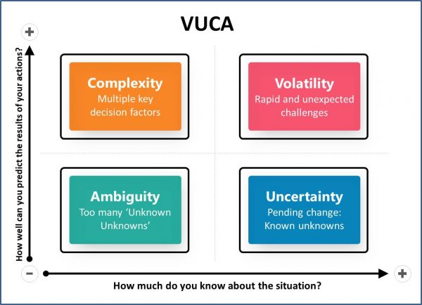Figure 3: A diagram of the VUCA environment (Source: Macpherson, 2019)

For the purpose of business application, VUCA can be applied to the business and economic environment as follows:
Businesses should be aware that volatility – unexpected or unstable challenges – may arise and should use this aforethought in order to prepare for such situations. This is often applicable where natural disaster, such as flood or epidemic affect daily operations. A very recent example of this would be the 2020 Coronavirus outbreak, which has had a significant impact on manufacturing in China (Stevenson, 2020). To combat this, preparation such as inventory stockpiling should be employed - however the extent of this investment should match the risk expected (Bennett and Lemoine, 2014).
Uncertainty should be regarded as the extent to which we can be confident we have an accurate prediction of future events. An example of uncertainty could be a competitor launching a product, which leaves the business uncertain as to the impact on their sales (Emerging World, 2019). To prepare for uncertainty, ongoing collection and analysis of market data should be standard practice.
Complexity can be described as a situation with many variables or intertwined issues. This can make this a situation more time consuming or overwhelming to process. Complexity often occurs in multi-national business operations, where trading occurs under many different trade laws, legal environments and cultures (Bennett and Lemoine, 2014). An example of complexity is currently developing within the European Union and United Kingdom, as trade agreements are currently unclear and means companies operating between the two will have to understand and implement much new legislation and regulation (UK Government, 2020).
Ambiguity relates to a developing situation with a lack of clarity (Kraaijenbrink, 2018). In a business context it may mean that there are simply too many options to choose from that make proceeding with confidence difficult (Hines, 2016).
In order for a company to successfully apply the lessons that can be learnt from the VUCA model, they must be willing to implement the model as a strategic tool. This requires them to become adaptable, and responsive to changes in their macro-environment.
Millar, Groth and Mahon (2018) make suggestions for executives to successfully navigate VUCA environments:
- Put emphasis upon agility, dexterity, flexibility and resilience.
- Treat innovation as an ongoing process, and not a one-off activity.
- Acceptance of VUCA environments as an inevitable part of organisations.
- Learning opportunities should be taken across borders and experienced gained from places which are not typically seen as leaders in management, such as India and Africa.

3.0 Leadership for Innovation
In order to develop a leadership style which fosters innovation in a complex business environment, it is important to first understand the backgrounds and intended outcome of the theory. Rafiee and Mohammadi (2012) investigated the potential relationship between leadership style and self-esteem. They found that there was a strongly positive relationship style between participative leadership style and positive influence on self-esteem. As shown in research by Jamshidi et. Al (2012), there is a definite link between self-esteem and creativity, and therefore innovation.
Here we can examine 2 of the most applicable leadership styles for this industry with innovation and creativity in mind.

3.1 Servant Leadership
The hierarchy of servant leadership is the opposite of traditional ‘top-down’ models (Tarallo, 2018; Farnen, 2020). This form of leadership was originally coined in the writing of Robert Greenleaf, a management researcher, in 1977. Greenleaf defined his concept of servant leadership as first foremost being a natural feeling of wanting to serve others and making sure the highest priority needs of teammates are being met. Greenleaf also described success within a servant leadership system as being achieved when those served are happier, healthier, freer and wiser and as a result become servants themselves (Greenleaf, 1977). In more modern academia, Spears (2004) stressed the importance of a servant leader being an active listener, and earnestly seeking to enrich those they serve.
In a test of servant leadership efficacy carried out by the Servant Leadership Institute, a telecommunications company found:
- Voluntary turnover between 2011-2016 averaged 5%
- In the 5 years since implementing servant leadership, trust in leadership increased 17%
- Between 2008 and 2016, the company saved over $500,000 due to improvements suggested and implemented by employees (Servant Leadership Insititute, 2012).
Van Dierendonck and Rook (2010) describe servant leadership as being specifically suited to the management of innovative and creative teams, as it is primarily employee-focused in nature. This aims at enhancing the inherent drive of employees and fosters a creative environment.
Servant leadership is very compatible in terms of the technology industry. As servant leadership first aims to empower individuals to become independent and free-thinking, this allows for greater communication and discussion. A freedom of this kind is likely to spark creativity and innovation within teams, which is ideal for forward-thinking industry such as that of the technology industry (Hollis, 2017; Yang et al., 2019).

3.2 Authentic Leadership
Authentic leadership is a leadership approach which is based upon open communication, honesty and ethical foundations (Gardner et al., 2011). Lopez and Snyder (2002) described authenticity as being self-aware, and as a result acting genuinely.
The purpose of authentic leadership is to evolve purpose and self-belief within leadership, in order for others to have confidence to follow. There are a number of ways to measure levels of authentic leadership. The Leader Authenticity Scale, developed by Henderson and Hoy (1982) and aimed to measure the leader’s intrinsic ability to act genuinely, regardless of job title given (also known as salience of self over role). However, this method has since been criticised and subsequently updated due to small sample size in development (Gardner et al, 2011).
In 2015, Beddoes-Jones constructed a ‘three-pillar’ model of authentic leadership. The researcher argues that since this theory is tested on leaders of experience, and not students as other models largely are studied on, that this model has greater validity and relevance (Beddoes-Jones and Swailes, 2015).
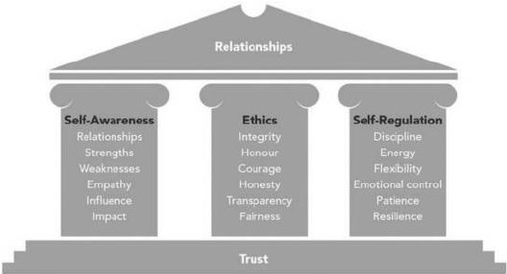Figure 4: Model of Authentic Leadership (Source: Beddoes-Jones and Swales, 2015).
Authentic leadership places focus up recognising positive achievements in place of highlighting flaws, which nurtures trust and therefore increases feeling of emotional safety (Avolio et al, 2010). Černe et al. (2013) conducted research into the potential influence that authentic leadership has on creativity and innovation. The researchers found that authentic behaviour from leaders lead to enhanced positive outcomes regarding creativity, as opposed to those who self-assessed themselves as authentic leaders.
This leadership style has been adopted by the likes of Satya Nadella, current CEO of Microsoft. It is therefore clear that this type of leadership can be adopted within the technology sector as it drives clarity, purpose, effective use of resources, innovation and strong goal-driven behaviour (Kassa, 2018).

4.0 Leadership Skills for Innovation
Aside from theoretical forms of leadership styles, there are several key skills which are imperative in navigating complex environments, as well as encouraging creativity and innovation.

4.1 Emotional intelligence
The idea of emotional intelligence as a desirable skill for leadership was first popularised by Goleman (1995), who claimed that emotional intelligence mattered more to leadership than IQ (Intelligence Quotient). A popular definition of emotional intelligence was created by Salovey and Mayer (1990) as "the ability to monitor one's own and other people's emotions, to discriminate between different emotions and label them appropriately, and to use emotional information to guide thinking and behaviour".
The Genos Emotional Intelligence Model is an example of one emotional intelligence assessment tool, which is used in talent management and leadership theory. (Genos International, 2020). It is used to understand an individual’s level in each of the following areas:
- Recognising and expressing emotions
- Understanding emotions of others
- Making decisions
- Managing emotions
- Controlling emotions (Moore, 2020).
The model has been trialled by research through Swinburne University of Technology, Australia. Through this research, employees who were deemed more emotionally intelligent were described by their supervisors as being:
- Innovative and creative at work
- Effective team players
- Exhibit stronger customer service skills
- Show higher organisational loyalty
- Better performance in sales (Gardner, 2005).
Emotional intelligence holds a more important place than ever in a technological age with a rapid rise of artificial intelligence. Beck and Libert (2017) discuss the limitations of technology in terms of social and emotional understanding and intelligence. The knowledge that artificial intelligence cannot easily replicate these very human skills should be at the forefront of leader’s minds in order to maintain competitive advantage (Humphrey et al. 2017). Investing in developing emotional intelligence within a company is critical in order to successfully work alongside rapid technological progress; in order to successfully navigate complex environments (Meall, 2018).

4.2 Learning Agility
Described by De Meuse et al (2010), a critical effect of the complex, dynamic and ambiguous business environments operating today is that leadership skills are susceptible to becoming outdated and obsolete. Therefore, to be efficient in a leadership role, those in such positions must be willing and capable to adapt their behaviour as dynamics change.
The term learning agility, as highlighted by Lombardo and Eichinger (2000), describes an employee's ability to adapt to new situations and make decisions quickly by aggregating important information from new documentation or situations as they arise.

Amato and Molokhia (2016) describe the direct correlation between the VUCA environment and the need to cultivate agile learners. Leaders who are motivated, adaptable and can quickly analyse and synthesize information arising from complexity are the leaders which organisations need to find and nurture in order to succeed in a VUCA environment.

According to research conducted by the Learning Agility Initiative, there are a number of characteristics of high learning-agile individuals, which are shown in Figure 5:

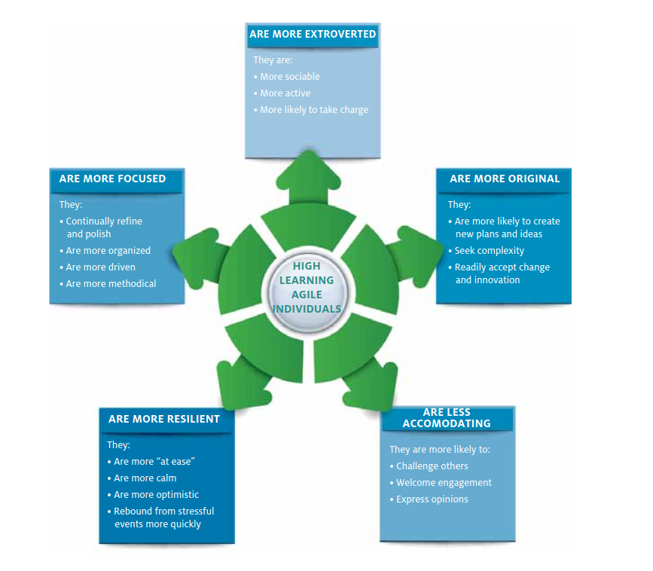Figure 5: High Learning-Agile Individual traits according to the Learning Agility Initiative (Source: Mitchenson and Morris, 2014)
Once these leaders have been identified it is important to set and maintain goals in order to keep learning-agile individuals fulfilled and up to date in their roles (Siddiqui, 2018). In current highly complex business environments, learning agility is becoming more important than experience. Knegtmans (2018) anticipates that in the imminent future recruitment will shift from selecting talent based upon current skill and experience, and will instead be imperative to select candidates that organisations feel can be future-proofed. This confirms the need for the ability to identify learning-agile leaders not only within an organisation, but from selection onwards.

6.0 Conclusion
From the literature reviewed within this report, it is clear that a holistic approach to leadership must be taken in order to successfully navigate complexity within the technology industry, as per the initial aim of the company.
Attention must be paid not only to the Complex Adaptive Systems that businesses have become, but also to the leaders and individuals within it, to not only become successful in the present moment but also to future-proof the companies strategic movements going forward with adaptable and agile learners in the driving seat.

7.0 Recommended Micro-experiment
Based upon research carried out for this report, the researcher recommends a micro-experiment be conducted in order to test the company’s preparedness for a future within a dynamic industry such as technology.
The first recommendation is the creation of a new project team focused around servant leadership. A leader should be picked for this experimental based upon their compatible personality traits, and being noticeably motivated to drive team morale from a servant perspective. It is recommended that this project is heavily statistically analysed for productivity and key performance indicators which can be effectively compared to other aspects of the organisation, and in future other experimental teams based on research within this report. This will not only identify potential leaders of the future, but also allow for analysis of leadership types within the organisation, and industry.
A second recommendation is that of team analysis which could be examined following the Genos Emotional Intelligence Model. By using Genos Development Assessment tools such as the Emotional Intelligence Workplace Behaviour Self Report and Leadership Feedback Reports, talent within the organisation can be analysed from both their own perspective and from their leader’s perspectives in order to identify potentially useful skill-sets and identify opportunities for development (Genos International, 2020).
These micro-experiments can be replicated and extended to test different theories and adapted to test many leadership methods and team combinations to determine the best way forward to maintain competitive advantage and meet, and perhaps exceed the goal of “becom[ing] the world’s leader in innovation and excellence in the sector”.

8.0 References
- Amato, M. A. and Molokhia, D. (2018) ‘Organizations need leaders with learning agility in order to move ahead successfully in volatile times. But can you teach someone to be a more agile learner? We say yes and have identified the elements that will help someone increase learning agility. Explore our proven practices, and see how leading organizations are making it happen.’, p. 12.
- Avolio, B. (2010) ‘Pursuing Authentic Leadership Development’, Handbook of leadership theory and practice.
- Basu, C. (2019) Definition of Complexity in Business. Available at: https://smallbusiness.chron.com/definition-complexity-business-21640.html (Accessed: 13 April 2020).
- BBC News (2020) ‘How will the petrol and diesel car ban work?’, BBC News, 4 February. Available at: https://www.bbc.com/news/uk-40726868 (Accessed: 12 April 2020).
- Beck, M. and Libert, B. (2017) ‘The Rise of AI Makes Emotional Intelligence More Important’, Harvard Business Review, 15 February. Available at: https://hbr.org/2017/02/the-rise-of-ai-makes-emotional-intelligence-more-important (Accessed: 12 April 2020).
- Beddoes-Jones, F. and Swailes, S. (2015) ‘Authentic leadership: development of a new three pillar model’, Strategic HR Review, 14(3), pp. 94–99. doi: 10.1108/SHR-04-2015-0032.
- Bennett, N. and Lemoine, G. J. (2014) ‘What VUCA Really Means for You’, Harvard Business Review, 1 January. Available at: https://hbr.org/2014/01/what-vuca-really-means-for-you (Accessed: 12 April 2020).
- Černe, M., Jaklič, M. and Škerlavaj, M. (2013) ‘Authentic leadership, creativity, and innovation: A multilevel perspective’, Leadership. SAGE Publications, 9(1), pp. 63–85. doi: 10.1177/1742715012455130.
- De Meuse, K., Dai, G. and Hallenbeck, G. (2010) ‘Learning agility: A construct whose time has come’, Consulting Psychology Journal: Practice and Research, 62, pp. 119–130. doi: 10.1037/a0019988.
- van Dierendonck, D. and Rook, L. (2010) ‘Enhancing Innovation and Creativity through Servant Leadership’, in, pp. 155–165. doi: 10.1057/9780230299184_13.
- Emerging World (2019) ‘What the VUCA!’, Emerging World, 5 April. Available at: https://www.emergingworld.com/blog/what-the-vuca/ (Accessed: 12 April 2020).
- Farnen, K. (2020) Four Elements of Servant Leadership. Available at: https://work.chron.com/four-elements-servant-leadership-4919.html (Accessed: 12 April 2020).
- Gardner, L. (2005) ‘Emotional Intelligence and Occupational Stress’, p. 282.
- Gardner, L. and Stough, C. (2002) ‘Examining the relationship between leadership and emotional intelligence in senior level managers’, Leadership & Organization Development Journal, 23, pp. 68–78. doi: 10.1108/01437730210419198.
- Gardner, W. et al. (2011) ‘Authentic Leadership: A review of the literature and research agenda’, The Leadership Quarterly, 22, pp. 1120–1145. doi: 10.1016/j.leaqua.2011.09.007.
- Genos International (2020a) ‘Emotional Intelligence Development Assessments’, Genos International. Available at: https://www.genosinternational.com/assessments/ (Accessed: 13 April 2020).
- Genos International (2020b) ‘Emotional Intelligence (EI) Model’, Genos International. Available at: https://www.genosinternational.com/emotional-intelligence/ (Accessed: 12 April 2020).
- Genos International (2020c) ‘Workplace Behaviour - Emotional Intelligence in The Workplace’, Genos International. Available at: https://www.genosinternational.com/workplace-behaviour/ (Accessed: 13 April 2020).
- Goleman, D. (1995) Emotional intelligence. New York: Bantam Books.
- Greenleaf, R. K. (1977) Servant leadership: a journey into the nature of legitimate power and greatness. New York: Paulist Press.
- Gupta, A. (2008) Tejas Article : Insights from Complexity Theory: Understanding Organizations Better. Available at: https://tejas.iimb.ac.in/articles/12.php (Accessed: 13 April 2020).
- Hartley, N. (2019) How the 5 Megatrends Impact Health and Safety | Banyard Solutions Ltd. Available at: https://www.banyardsolutions.co.uk/how-the-5-megatrends-impact-health-and-safety/ (Accessed: 13 April 2020).
- Hasan, H. and Kazlauskas, A. (2013) ‘The Cynefin framework: putting complexity into perspective’, p. 5.
- Henderson, J. E. and Hoy, W. K. (1982) Leader Authenticity: The Development and Test of an Operational Measure. Available at: https://eric.ed.gov/?id=ED219408 (Accessed: 12 April 2020).
- Hines, A. (2016) ‘Can I Get a Job as a Futurist?’, World Futures Review. SAGE Publications Inc, 8(1), pp. 46–53. doi: 10.1177/1946756715627368.
- Hollis, N. (2017) ‘Why We Need Authentic Leaders - Norma Hollis’, Integrated Growth System and Peer Groups, 7 June. Available at: https://executiveforumsidaho.com/2017/06/07/need-authentic-leaders-norma-hollis/ (Accessed: 12 April 2020).
- Jamshidi, S., Akbari, B. and Mehregan, B. (2012) INVESTIGATION OF THE RELATIONSHIP BETWEEN CREATIVITY AND SELF-ESTEEM AND THE RELATIONSHIP BETWEEN CREATIVITY AND ACADEMIC ACHIEVEMENT. Available at: https://www.semanticscholar.org/paper/INVESTIGATION-OF-THE-RELATIONSHIP-BETWEEN-AND-AND-Jamshidi-Akbari/b5d0cceead82c100310db5fa8964da588a525457#paper-header (Accessed: 12 April 2020).
- Johansen, R. (2007a) Get there early: sensing the future to compete in the present. Concordville, Pa.]; [Norwood, Mass.: Soundview Executive Book Summaries ; [Distributed by Books24x7.com. Available at: http://www.books24x7.com/marc.asp?bookid=23554 (Accessed: 12 April 2020).
- Johansen, R. (2007b) ‘Or How I Learned to Stop Worrying and Love Business Dilemmas—Pt.’, World Business Academy Viewpoint, 21(6), p. 10.
- Johansen, R. and Soundview Executive Book Summaries (2007) Get there early: sensing the future to compete in the present. Concordville, Pa.]; [Norwood, Mass.: Soundview Executive Book Summaries ; [Distributed by Books24x7.com. Available at: http://www.books24x7.com/marc.asp?bookid=23554 (Accessed: 12 April 2020).
- Kassa, M. (2018) Uncovering a Leadership Style: Satya Nadella. Available at: https://www.linkedin.com/pulse/uncovering-leadership-style-satya-nadella-mekonnen-kassa (Accessed: 12 April 2020).
- Knegtmans, R. (2018) Learning Agility Can be More Important than Experience, Cornerstone International Group. Available at: https://www.cornerstone-group.com/2018/08/23/learning-agility/ (Accessed: 13 April 2020).
- Kraaijenbrink, J. (2018) What Does VUCA Really Mean?, Forbes. Available at: https://www.forbes.com/sites/jeroenkraaijenbrink/2018/12/19/what-does-vuca-really-mean/ (Accessed: 12 April 2020).
- Kurtz, C. F. and Snowden, D. J. (2003) ‘The new dynamics of strategy: Sense-making in a complex and complicated world’, IBM SYSTEMS JOURNAL, 42(3), p. 22.
- Lombardo, M. M. and Eichinger, R. W. (2000) ‘High potentials as high learners’, Human Resource Management, 39(4), p. 9.
- Lopez, S. J. and Snyder, C. R. (eds) (2009) The Oxford Handbook of Positive Psychology. 2nd edn. Oxford University Press. doi: 10.1093/oxfordhb/9780195187243.001.0001.
- Macpherson, C. (2019) ‘Leading in a post-Brexit VUCA world’, Change & Strategy - Campbell Macpherson, 16 December. Available at: https://www.changeandstrategy.com/leading-in-a-post-brexit-vuca-world/ (Accessed: 12 April 2020).
- McDaniel, R. R., Lanham, H. J. and Anderson, R. A. (2009) ‘Implications of complex adaptive systems theory for the design of research on health care organizations’, Health care management review, 34(2), pp. 191–199. doi: 10.1097/HMR.0b013e31819c8b38.
- Meall, L. (2018) Technology will make emotional intelligence your superpower | ACCA Global. Available at: https://www.accaglobal.com/gb/en/member/member/accounting-business/2018/11/insights/emotional-intelligence.html (Accessed: 12 April 2020).
- Millar, C. C. J. M., Groth, O. and Mahon, J. F. (2018) ‘Management Innovation in a VUCA World: Challenges and Recommendations’, California Management Review, 61(1), pp. 5–14. doi: 10.1177/0008125618805111.
- Mitchinson, A. and Morris, R. (2015) ‘Learning About Learning Agility’, p. 20.
- Moore, R. (2020) Emotional Intelligence Skills and How to Develop Them. Available at: https://positivepsychology.com/emotional-intelligence-skills/ (Accessed: 12 April 2020).
- NIH (2016) World’s older population grows dramatically, National Institutes of Health (NIH). Available at: https://www.nih.gov/news-events/news-releases/worlds-older-population-grows-dramatically (Accessed: 12 April 2020).
- O’Connor, R. V. and Lepmets, M. (2015) ‘Exploring the use of the cynefin framework to inform software development approach decisions’, in Proceedings of the 2015 International Conference on Software and System Process - ICSSP 2015. the 2015 International Conference, Tallinn, Estonia: ACM Press, pp. 97–101. doi: 10.1145/2785592.2785608.
- Press, G. (2019) Is AI Going To Be A Jobs Killer? New Reports About The Future Of Work, Forbes. Available at: https://www.forbes.com/sites/gilpress/2019/07/15/is-ai-going-to-be-a-jobs-killer-new-reports-about-the-future-of-work/ (Accessed: 12 April 2020).
- Rafiee, S. and Mohammadi, M. (2012) ‘Leadership styles and its relationship with subordinates’ self-esteem’, Management Science Letters, 2(7), pp. 2457–2462. doi: 10.5267/j.msl.2012.07.021.
- Salovey, P., Brackett, M. A. and Mayer, J. D. (1990) Emotional Intelligence: Key Readings on the Mayer and Salovey Model. National Professional Resources Inc./Dude Publishing.
- Servant Leadership Insitute (2012) Servant Leadership Institute- What is Servant Leadership, Servant Leadership Institute. Available at: https://www.servantleadershipinstitute.com/servant-leadership (Accessed: 12 April 2020).
- Siddiqui, N. (2018) ‘Learning Agility – Why This is Important in Such a Volatile World | Research Staff Community’. Available at: https://blogs.kcl.ac.uk/researchstaff/2018/05/11/learning-agility-why-this-is-important-in-such-a-volatile-world/ (Accessed: 13 April 2020).
- Snowden, D. (2002) ‘Complex acts of knowing: paradox and descriptive self‐awareness’, Journal of Knowledge Management, 6(2), pp. 100–111. doi: 10.1108/13673270210424639.
- Spears, L. C. (2004) ‘Practicing servant-leadership’, Leader to Leader, 2004(34), pp. 7–11. doi: 10.1002/ltl.94.
- Stevenson, A. (2020) ‘Coronavirus Outbreak Tests World’s Dependence on China’, The New York Times, 29 January. Available at: https://www.nytimes.com/2020/01/29/business/china-coronavirus-economy.html (Accessed: 12 April 2020).
- Sydney Business Insights (2020) Economic power shift, Sydney Business Insights. Available at: https://sbi.sydney.edu.au/megatrends/economic-power-shift/ (Accessed: 12 April 2020).
- Tarallo, M. (2018) The Art of Servant Leadership. Available at: https://www.shrm.org/resourcesandtools/hr-topics/organizational-and-employee-development/pages/the-art-of-servant-leadership.aspx (Accessed: 12 April 2020).
- Taulli, T. (2019) How To Reskill Your Workforce For AI (Artificial Intelligence), Forbes. Available at: https://www.forbes.com/sites/tomtaulli/2019/05/04/how-to-reskill-your-workforce-for-ai-artificial-intelligence/ (Accessed: 12 April 2020).
- Thomas, R., Preetha, D. and Khan, A. (2018) Deloitte Insights: The Internet of Things. Available at: https://www2.deloitte.com/content/dam/insights/us/articles/4420_IoT-primer/DI_IoT-Primer.pdf (Accessed: 12 April 2020).
- Thornton, A. (2019) 10 cities are predicted to gain megacity status by 2030, World Economic Forum. Available at: https://www.weforum.org/agenda/2019/02/10-cities-are-predicted-to-gain-megacity-status-by-2030/ (Accessed: 12 April 2020).
- UK Government (2020) Existing UK trade agreements with non-EU countries, GOV.UK. Available at: https://www.gov.uk/guidance/uk-trade-agreements-with-non-eu-countries (Accessed: 12 April 2020).
- United Nations (2015) ‘UN projects world population to reach 8.5 billion by 2030, driven by growth in developing countries’, United Nations Sustainable Development, 29 July. Available at: https://www.un.org/sustainabledevelopment/blog/2015/07/un-projects-world-population-to-reach-8-5-billion-by-2030-driven-by-growth-in-developing-countries/ (Accessed: 12 April 2020).
- Winston, A. (2019) ‘Business in the Age of Mass Extinction’, Harvard Business Review, 9 May. Available at: https://hbr.org/2019/05/business-in-the-age-of-mass-extinction (Accessed: 12 April 2020).
- Yang, J., Gu, J. and Liu, H. (2019) ‘Servant leadership and employee creativity: The roles of psychological empowerment and work–family conflict’, Current Psychology, 38(6), pp. 1417–1427. doi: 10.1007/s12144-019-0161-3.

