
Name | Patel MeetkumrSureshbhai
Id Number | 2241855
Module Name | Marketing Management – Assessment 2 (25%)
Module Code | LCMB7001
Lecturer(s) | TusharaBalendran

HSBC HOLDINGS PLC MACRO AND MICRO ENVIRONMENTAL ANALYSIS
Table of Contents
Introduction 4
Company Background 4
Mission and Vision Statement of HSBC HLDGS Plc 4
PESTLE analysis of HSBC HLDGS Plc 4
Advantages and Disadvantages of PESTLE analysis 6
Porter’s Five Forces Analysis of HSBC HLDGS Plc 7
SWOT analysis of HSBC HLDGS Plc 8
STP analysis of HSBC HLDGS Plc 10
4P’s of the Marketing mix 11
Conclusion 12
Recommendations 12
Defensive Strategies for Pioneers in the Growth Stage of PLC: 12
Attack Strategies for Pioneers in the Growth Stage of PLC: 13
References 14

Introduction
Marketing is essential since it raises brand recognition, stimulates interest in a product or service, and ultimately leads to increased sales. It entails knowing who you're selling to, where they hang out online, and how to best market your products or services to them. Brand recognition, consumer dedication, and an upper hand in the marketplace are all outcomes of effective marketing. It links items with customers via surveys, commercials, websites, and other means of communication to shape consumer preferences and ultimately sales (Yasaet al., 2020). When done well, marketing may increase income and solidify a company's position in the market, both of which are essential to the company's continued success and development.

Company Background
HSBC Holdings Plc, or simply HSBC, is a British multinational financial services and banking corporation with headquarters in London. Since its inception in 1865, the Hong Kong and Shanghai Banking Corporation (HSBC) has expanded to become a global powerhouse in the banking industry. Retail banking, commercial banking, investment banking, and wealth management are just a few of the many services offered by HSBC, a global financial institution present in more than 60 countries and territories (Huhtamäki, 2020). The company's global presence, wide range of customers, and dedication to innovation and sustainability have earned it a stellar reputation. The worldwide financial sector relies heavily on HSBC because of the company's long history, global reach, and suite of services.

Mission and Vision Statement of HSBC HLDGS Plc
Mission:The goal of HSBC Holdings Plc is to be the preeminent bank in the world by providing exceptional service, helping to expand the global economy, and maintaining the highest ethical standards (Colombo, 2020).
Vision:Their mission is to be a leading global provider of ethical and innovative financial services, delivering excellent client experiences and advancing society (Colombo, 2020).

PESTLE analysis of HSBC HLDGS Plc
Political Factors
Favorable: HSBC's global presence benefits from stable political environments in many countries, allowing smooth operations and growth (Barik and Kumar, 2018).
Unfavorable: Political instability in certain regions can lead to economic uncertainties, affecting HSBC's profitability and risk management.
Economic Factors
Favorable: HSBC thrives in a stable and growing global economy, as it's a key player in the financial industry. Economic growth supports consumer spending, lending, and investment activities, boosting the bank's revenues(fernfortuniversity.com, 2021).
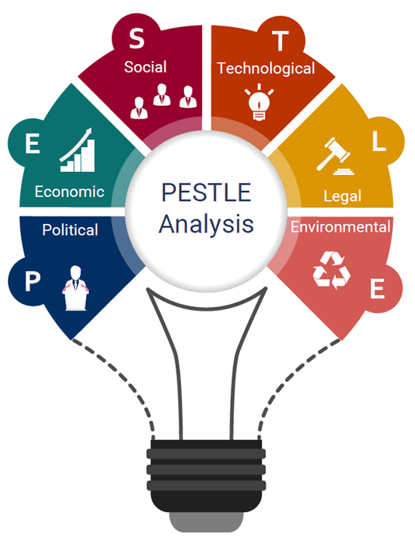
Figure 1: Pestle Analysis
Source: (fernfortuniversity.com, 2021)
Social Factors
Favorable: HSBC's international scope allows it to cater to diverse social trends and consumer preferences. It can tailor its services to various cultural norms, enhancing customer satisfaction(fernfortuniversity.com, 2021).
Technological Factors
Favorable: Technological advancements offer opportunities for HSBC to innovate in digital banking. Online and mobile banking, AI-driven customer service, and cybersecurity measures improve customer experience and operational efficiency(fernfortuniversity.com, 2021).
Environmental Factors
Favorable: HSBC is committed to sustainability, reducing its environmental impact. This aligns with societal expectations and enhances its reputation among environmentally conscious consumers(fernfortuniversity.com, 2021).
Unfavorable: Environmental risks such as climate change can impact the bank's loan portfolios. Businesses in industries vulnerable to climate change might default on loans, affecting HSBC's financial stability.
Legal Factors
Favorable: A favorable legal environment supports transparent financial operations, protecting customers and shareholders. HSBC benefits from regulatory frameworks that promote ethical practices(fernfortuniversity.com, 2021).
Unfavorable: Stringent regulations can increase compliance costs and administrative burdens. Legal issues, like fines for non-compliance with anti-money laundering regulations, can damage HSBC's reputation.

Advantages and Disadvantages of PESTLE analysis
Advantages
Comprehensive View: PESTLE provides a holistic view of the external environment, enabling businesses to recognize potential opportunities and threats.
Proactive Decision Making: Helps businesses anticipate changes and adapt strategies proactively.
Strategic Alignment: Enables organizations to align their strategies with external trends, ensuring relevancy.
Risk Management: Assists in identifying potential risks in the international market, especially beneficial for businesses planning to expand globally.
Disadvantages
Data Overload: Gathering data for all six factors can lead to information overload, complicating decision-making.
Rapid Changes: The external environment can change rapidly, making the analysis obsolete if not frequently updated.
Subjectivity: Interpretations of external factors can be subjective, leading to potential biases.
Lacks Specificity: While PESTLE offers a broad overview, it might not delve deep enough into industry-specific issues or micro-environmental factors.

Porter’s Five Forces Analysis of HSBC HLDGS Plc
Threat of New Entrants (Medium)
HSBC has little competition thanks to the stringent rules governing its business. Large sums of money, specialized knowledge, and adherence to rules and regulations are essential in the financial industry. However, developments in technology have lowered entry barriers, opening the market to fintech entrepreneurs. Due to high barriers to entry brought about by complexity and regulation, competition in this sector is very low(portersfiveforces.org, 2020).
Bargaining Power of Suppliers (Low)
The majority of HSBC's supply chain consists of companies that offer either technology, real estate, or human resources. Since these vendors have little effect on HSBC's business, they have little sway in negotiations. Because of its scale and worldwide reach, the bank can negotiate advantageous terms with its suppliers and spread the risk of any one supplier going out of business(portersfiveforces.org, 2020).
Bargaining Power of Buyers (Medium)
Many different types of people, organizations, and governments are among HSBC's many clients. Despite consumers' freedom of choice, the banking industry often has substantial switching costs owing to customers' investments in accounts, relationships, and related operations. However, clients are in a stronger negotiating position now that they can easily evaluate services on other web platforms. Buyer power is moderate, and methods that emphasize distinctiveness and the needs of individual customers are important(portersfiveforces.org, 2020).
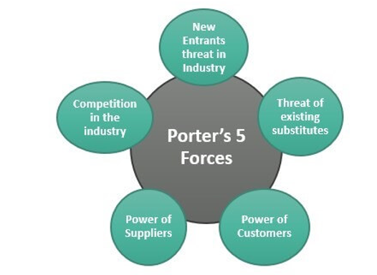
Figure 2: Porter’s Five Forces
Source:(portersfiveforces.org, 2020)
Threat of Substitutes (Medium)
Substitutes for HSBC's core banking services provide a manageable amount of competition. Traditional banks like HSBC provide a broad variety of financial goods and services, despite the rise of digital banking and fintech. The danger of alternatives is always there, but it may grow as time goes on and new choices emerge that better meet consumers' requirements and tastes(portersfiveforces.org, 2020).
The Intensity of Competitive Rivalry (High)
There are several international and domestic banks competing for customers' business. HSBC competes with major international banks, as well as local credit unions, online lenders, and fintech firms. Keeping ahead of the competition requires constant attention to differentiation, service, and new ideas. Constant attempts to win over new customers and increase market share are essential in the face of intense competition(portersfiveforces.org, 2020).

SWOT analysis of HSBC HLDGS Plc
Strengths
- With a presence in more than 64 countries, HSBC has a substantial worldwide footprint and access to a wide variety of markets.
- The HSBC name is instantly recognizable and reliable all across the world, which helps retain current customers and draws in new ones.
- The bank provides a full suite of banking services to both consumer and business customers(mbaskool.com, 2020).
- To improve both the client experience and the bank's bottom line, HSBC is putting money into digital banking products.
- Even in bad economic times, it remains stable because of its solid risk management structure.
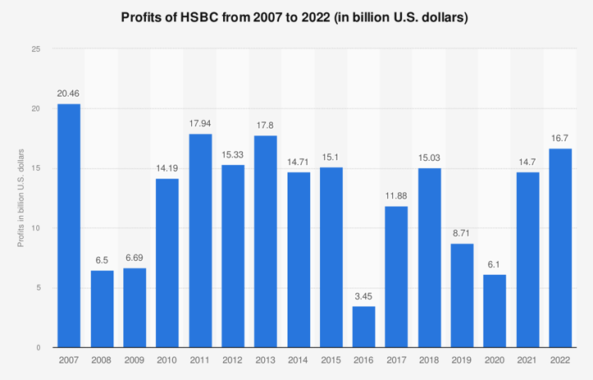
Figure 3: Profit of HSBC
Source: (mbaskool.com, 2020)
- Weaknesses
- Due to its size and worldwide reach, HSBC might experience increased bureaucracy and longer decision-making times.
- Since HSBC operates in so many different countries, it must meet a wide variety of regulations and pay higher compliance expenses as a result(mbaskool.com, 2020).
- HSBC, like other international financial institutions, is vulnerable to operational risks such as system failures and cyberattacks.
- Controversies of the past may have a lasting effect on a company's public reputation and the confidence of its target audience.
Opportunities
- Fintech companies can help HSBC improve its digital services and stay competitive in a market that is always changing.
- There are growing possibilities in Asia, Africa, and Latin America, where there are still open areas.
- HSBC has a chance to be a leader in environmental and social duty because there is more demand for sustainable banking(mbaskool.com, 2020).
- Growing wealth around the world gives HSBC's wealth management and private banking services more possibilities.
- Putting more money into digital change can improve how customers are treated and how well businesses run.
Threats
- Regulations, particularly post-BREXIT, might affect HSBC's cross-border operations and compliance expenses.
- HSBC faces fierce competition from global, regional, and technology banks.
- Financial performance, loan quality, and capital reserves may suffer during economic downturns(mbaskool.com, 2020).
- HSBC faces cybersecurity dangers that might damage client data and trust in the digital age.
- Political conflicts, trade disputes, and geopolitical developments might affect HSBC's overseas operations.

STP analysis of HSBC HLDGS Plc
Segmentation
Geographic and demographic targeting are both used by HSBC. Its target audience includes people, companies, and organizations with different financial requirements and goals. HSBC has a global presence, with regional offices that cater to customers' needs wherever they may be. For instance, the company caters to several types of clients depending on their financial objectives, including high-net-worth individuals, retail consumers, and corporate clients (Trudeau and McLarney, 2017).
Targeting
HSBC's approach is to cater to diverse clients, from individual bank clients to large organizations. Given its worldwide reach, the bank aims to build relationships with international clients and provides special services to expats and students who need access to foreign currency (Trudeau and McLarney, 2017).
Positioning
HSBC markets itself as a globally integrated financial services provider that can adapt its offerings to the varying needs of its clientele. Through its global connections and knowledge, the bank promotes itself as a conduit between different cultures and economies. It markets itself as providing clients with services that are safe, cutting-edge, and always available via a variety of digital channels (Trudeau and McLarney, 2017).

4P’s of the Marketing mix
Product:HSBC caters to a wide variety of customers by providing them with a wide variety of financial services. A few examples include insurance policies, business banking services, investment opportunities, credit card and loan programs, and retail banking services. The bank is dedicated to improving the client experience and convenience by delivering cutting-edge technologies such as online banking and mobile applications (Jackson and Ahuja, 2016).
Price: When setting prices, HSBC takes into account the market, the competitors, and the value it offers its clients. The bank's pricing structures ensure that each client pays a reasonable price for the services they need. Although HSBC is known for its low fees for its regular banking clients, the bank may charge a premium for its specialist financial services aimed at high-net-worth people (Jackson and Ahuja, 2016).
Place: HSBC has an extensive international branch and ATM network. Customers may access their accounts and make transactions from any location thanks to the bank's large physical presence and the reliability of its online and mobile banking services. HSBC makes its services available to a large audience by facilitating easy entry points and streamlined digital platforms (Jackson and Ahuja, 2016).
Promotion:When advertising its products and services, HSBC takes a holistic approach, using a variety of channels and methods. Advertising both online and off, event sponsorship, and working with other companies all contribute to raising its profile. The worldwide scope, dependability, and focus on customers are common themes in HSBC's advertising campaigns. The bank's social responsibility efforts are consistent with its brand image and appeal to the bank's target demographic of socially minded customers (Jackson and Ahuja, 2016).

Conclusion
Understanding the competitive environment, external variables, and internal strengths and weaknesses of HSBC is made possible by an analysis employing Porter's Five Forces, PESTLE, and the SWOT frameworks. The sector is very competitive, according to Porter's Five Forces, thus HSBC must work hard to differentiate itself. The PESTLE study shows both positive and negative aspects, demonstrating HSBC's flexibility in the face of economic and regulatory change. HSBC's worldwide reach and product variety are highlighted as assets in the SWOT analysis, alongside the problems of high levels of competition and cyberattacks. The necessity of HSBC's strategic agility and customer-centric strategy to successfully navigate the current difficult financial environment is highlighted by these findings.

Recommendations

Defensive Strategies for Pioneers in the Growth Stage of PLC:
Enhanced Customer Engagement: HSBC should focus on strengthening customer relationships through personalized services, innovative digital experiences, and proactive communication. This can help retain existing customers and foster loyalty in a competitive market.
Diversification of Product Offerings: To mitigate risks and capitalize on changing customer preferences, HSBC can introduce new financial products and services that align with evolving market trends. This strategy can also attract new customer segments and enhance the bank's competitive edge.
Market Expansion: While being a pioneer, HSBC can explore new geographical markets to tap into emerging economies. This diversification can reduce dependence on a single market and provide additional growth avenues.
Strategic Partnerships: Collaborating with fintech startups and technology providers can help HSBC stay at the forefront of digital innovation. These partnerships can enable the bank to offer cutting-edge solutions and attract tech-savvy customers.

Attack Strategies for Pioneers in the Growth Stage of PLC:
Differentiation through Innovation: HSBC should invest in research and development to develop unique and innovative financial products, services, and features that set it apart from competitors. Being a pioneer, this approach can attract early adopters and tech enthusiasts.
Aggressive Marketing Campaigns: Aggressive and creative marketing campaigns can help HSBC increase brand awareness and attract attention. Promoting its innovative offerings, exceptional customer service, and global reach can resonate with customers seeking something different.
Leverage Data Analytics: HSBC can leverage data analytics to gain insights into customer behavior and preferences. This information can be used to tailor products and services to specific segments, enhancing customer satisfaction and loyalty.
Competitive Pricing: Aggressively pricing its offerings can attract price-sensitive customers while still delivering high-quality services. Offering competitive interest rates, reduced fees, or attractive promotions can sway customers from competitors.

References
Barik, B. and Kumar, S., 2018. Macro Environment of Indian Life Insurance Business: A PESTLE Analysis. Bimaquest, 18(3).
Colombo, N., 2020. HSBC Holdings and Others v Commission: Fining Methods Under the Spotlight (T-105/17 HSBC Holdings). Eur. Competition & Reg. L. Rev., 4, p.40.
Huhtamäki, M.J., 2020. HSBC Holdings and Others v Commission: Reasoning is Everything When It comes to Fines. Journal of European Competition Law & Practice, 11(1-2), pp.50-52.
Jackson, G. and Ahuja, V., 2016. Dawn of the digital age and the evolution of the marketing mix. Journal of Direct, Data and Digital Marketing Practice, 17, pp.170-186.
Trudeau, C. and McLarney, C., 2017. How Can Banks Enhance International Connectivity with Business Customers?: A Study of HSBC. IUP Journal of Business Strategy, 14(2).
Yasa, N., Giantari, I.G.A.K., Setini, M. and Rahmayanti, P.J.M.S.L., 2020. The role of competitive advantage in mediating the effect of promotional strategy on marketing performance. Management Science Letters, 10(12), pp.2845-2848.
fernfortuniversity.com, 2021. Hsbc Holdings Plc PESTEL & Environment Analysis. [Online]
Available at: http://fernfortuniversity.com/term-papers/pestel/nyse4/7247-hsbc-holdings-plc.php
mbaskool.com, 2020. HSBC SWOT Analysis. [Online]
Available at: https://www.mbaskool.com/brandguide/banking-and-financial-services/615-hsbc.html
portersfiveforces.org, 2020. HSBC Porter’s 5 Five Forces: 2022 Detailed Overview. [Online]
Available at: https://www.portersfiveforces.org/hsbc-porters-5-five-forces/

