Effects of Stress: The Link Between Pressure and Performance
1st August 2018 in Employee Well-being, Peak Performance, Resilience, Stress Management
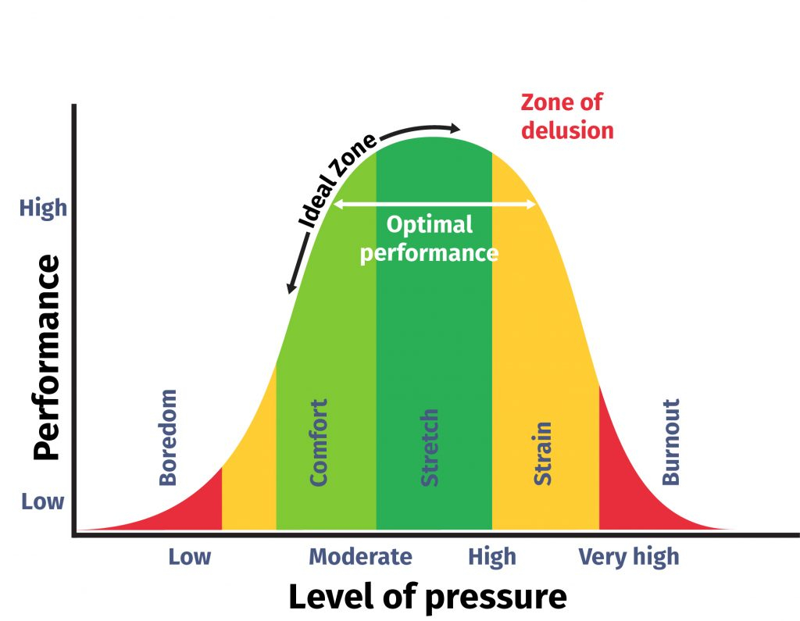
We’ve all been there. A job we should we should find easy becomes difficult because we are under too much pressure. To understand why, we look at the effects of stress in the workplace and the link between performance and pressure.

The stress curve
Stress is a continuum. It takes the shape of a bell curve and this usefully shows how our performance is affected by pressure. Managers need to understand the stress curve to ensure pressure is kept at the correct level to minimise the harmful effects of stress to both employees and the business.
We are rarely either completely stressed or unstressed, but often somewhere in the middle. And our position on the continuum can change day-to-day, minute by minute or even in seconds. You can probably point to where you exist on the continuum right now. You could even trace your movement along it over the last week, month or year. And you could probably say what caused you to shift along in either direction. What we’re concerned with here though, is how well you can perform at each point on the stress curve.
Stress curve/performance and pressure graph showing effect of work related stress on performance.
Take a look at the graph above. As pressure increases, our performance increases. But at a certain level, we feel stretched and we reach our peak performance. After a certain point however, the pressure becomes too much we start to feel the effects of stress. We do not cope as well and our performance declines.
Eventually, stress symptoms become extreme and our performance rapidly deteriorates. The ‘flight or flight’ response takes over, our minds are in survival mode, we can’t think clearly and concentrating on the task is impossible.

Long term effects of stress
Whilst it is clearly no good for an organisation to have a stressed workforce who cannot concentrate on their jobs, the effects of stress take a terrible toll on the human body. If stress is experienced in the long term, the symptoms become more serious. Physical illnesses such as gastrointestinal disorders, heart disease and immunosuppression can arise as well as mental health conditions. Absence, turnover and presenteeism are the results – costing organisations incredible amounts of money.
So let’s take a look how managers can help by examining each section of the stress curve more closely.

Stress curve: Boredom
Imagine for a moment that your job is incredibly simple. Too simple in fact. And all you have to do is perform the same basic action repeatedly. All day, everyday. Pick your own example, but I’m imagining being sat at a conveyor belt, putting the lids on an endless stream of pens.
This might sound like a nice break from your rather more hectic job, but for how long could you put up with this? Not long I would think.
This is because you are in the boredom zone of the stress curve. We need a minimum amount of pressure to motivate good performance. If a task is too easy, or if there are no targets, deadlines or consequence of working poorly, then people tend to perform poorly. It’s not laziness. It’s being thoroughly bored with your job and having no challenge that generates a sense of apathy. Can you really feel valued as an employee if your job demands nothing of you? Would you really try hard if you don’t believe your employer thinks you capable of something more?
Managers need to provide a level of challenge for their employees that moves them out of the boredom zone to achieve a higher level of performance. If your staff appear to be languishing in the boredom zone, you need to consider how you can help them progress, learn new skills and feel more challenged. What can you do to make the job more interesting and rewarding? Can their role become more varied, perhaps? Or could you set challenges with rewards that will truly motivate them?

Stress curve: Comfort
When a certain level of pressure is applied, a good level of performance is achieved. Employees usually respond well to a moderately high level of demand or workload. You should also set high, but realistic expectations to help drive performance.
The comfort zone is clearly a good place for employees to be ensure they are not experiencing the negative effects of stress. Life isn’t always comfortable though and there may (and almost certainly will) be times the pressure increases and moves us on to the next point on the stress curve.

Stress curve: Stretch
If the pressure increases, we enter the stretch zone. Our performance increases here as a response to the higher workload, expectation or level challenge that has generated pressure. However, whilst we can perform well in this zone for a while, we can’t keep going like this forever. If we are continually stretched then the effects of stress take over and negatively impact on our health and our performance.
It’s important if you’re in this zone to take breaks and give yourself chance to move back down towards the comfort zone. This can be difficult to do as the source of pressure will be demanding you crack on and do the job. But remember, if you or your staff are in this zone too long, performance will decrease and less work will get done. It seems counter-intuitive, but you can get more done by doing less. It’s your level of performance when you are working that counts.

Stress curve: Strain
So, you’ve been in the stretch zone too long, the pressure’s increased and you’ve had no time to recover. What happens? You enter the strain zone.
When pressure is too high, performance decreases. For a while it will exceed that of the comfort zone but soon the effects of stress take over, fatigue sets in and errors are made. Stress symptoms will begin to develop. Frustration, anxiety, poor concentration and shame about not being able to cope begin to take over. Performance plummets.
It’s easy to focus too much on the task at hand and not on yourself or your staff. Getting the job done is the priority, but we fail to see that we are not getting the job done because we are stressed. If you look back at the stress curve above, you will see that hovering above the strain zone is the Zone of Delusion.
The Zone of Delusion is where we falsely believe our performance is heading if we keep working at full capacity. We think we just keep getting better and better, not realising our performance is really decreasing. Managers should be aware of their own tendency to enter the zone of delusion, but also look out for it in their staff. Staff may say they are working effectively, but actually have declining performance. Managers should step in and ensure they take measures to reduce the pressure where possible. They should ensure staff are taking breaks and holidays and doing so themselves to act as positive role model.

Stress curve: Burnout
When the pressure is very high and sustained, we might enter the dangerous, burnout zone. In crisis, we experience exhaustion and the stress response is triggered. Our bodies draw on survival mechanisms as it believes it is in physical danger and the ‘fight or flight’ response takes over. Adrenaline and cortisol are now running the show and we have little chance of focussing on complex mental tasks or making good decisions. We need immediate rest.
In the short term the symptoms may not cause lasting harm, but prolonged stress has serious effects on mental and physical health. Immunosuppression, raised blood pressure, gastrointestinal problems and cardiovascular disease can all result from the prolonged effects of stress.
If you find you or your staff are habitually in the burnout zone then immediately take steps to reduce the sources of pressure. It is no good to demand more and more of yourself or staff when performance and health are suffering.

Learn more
Given that employees perform best when the level of pressure is just right, it makes sense to train managers so they know how to manage pressure in the right way.
Delphis offers face-to-face workshops and online courses delivered and developed by highly educated business managers, academics and teachers. We are committed to guiding companies along the path to creating healthy, productive and rewarding working environments for their staff. The financial argument is compelling and caring for your employees is the right thing to do.
Feedback from our workshops:
“Very relevant and informative… engaging and inclusive style. Worth spending a whole day on… need to roll out to whole company… loved the takeaway workbook… pretty much perfect.”
Please get in touch to discuss how we can provide customised mental health training for

