Title page
The full title, written in all capital letters- appears halfway through the page.
My name – three lines from the title
Course name, lecturer name, university and due date – four lines down

Illustration List
Figure 1: Dali, S., (1931). The Persistence of Memory. Available at: https://www.moma.org/collection/works/79018 (Accessed: May 10, 2023).
Figure 2: Ray, M., (1935). Space Writing. Available at: https://research.bowdoin.edu/surrealist-photography/2014/02/06/man-ray-space-writing-self-portrait-1935/ (Accessed: May 10, 2023)
Figure 3:
Figure 4: Parke, T., (2001). Dream/Life. Available at: https://www.magnumphotos.com/arts-culture/society-arts-culture/trent-parke-dreamlife/ (Accessed: May 11, 2023)

Introduction

In order to identify a study area, I will explore three key words in my essay: photo manipulation, surrealism, and shadow. I will then come to a conclusion with a research question that I will use to start my independent inquiry at level 6.

Photo Manipulation (650 words approx.)
Images have been manipulated for centuries before photo manipulation software such as Photoshop software was created. When Calvert Richard Jones took a picture of five capuchin monks inside a building in Malta in 1846, it was the first instance of photo editing (National Science and Media Museum, 2021). The fifth monk was a few steps behind the other four monks who had gathered together. Jones used Indian Ink to paint over the fifth monk on the negative because he thought that the monk had damaged the scene’s integrity. Stalin was notoriously known for having people removed from his photographs as well as small things like blemishes. The most famous instance of this is from 1926, when Nikolai Yezhov was selected to be on Stalin’s right, but he was later erased from the picture, denounced, arrested, and executed (Blakemore, 2022).
Before Photoshop, you had to make sure everything was flawless before taking a picture. For instance, “Models had to spend hours in the makeup room and studios had to be well-lit” (Gutierrez, 2015). In contrast, with Photoshop this is not necessary since the lighting can be adjusted to achieve the desired effect. With the development of Photoshop, any photograph can now be more easily changed. Due to how simple it is to alter how we appear by erasing minor flaws, Photoshop has transformed how we perceive people and what the ideal person should look like. This can have a significant impact on consumers, particularly younger ones who may find it difficult to distinguish whether what they are seeing is authentic or has been altered (Gann, 2011). This may lead to people developing a negative perception of their bodies or perhaps developing body dysmorphia (Gann, 2011). Since Photoshop is so widely used in the fashion industry and on social media, it has gained a bad reputation because it is mostly known for being used to alter how people look. However, photoshop is much more than just this, as other photographers use it to create unique or stunning images with either subtle or very obvious alterations, as “Photoshop has allowed top photographers to expand their abilities and stretch the bounds of photography” (Cortigiano, 2019). According to photographer Lindsay Adler “how do I make [these grand ideas] become a reality? […] I become resourceful with Photoshop.” Without this software, photographers like Adler would not be able to create the images they would like to unless they had a large budget for the project, which could lead to a decrease in the number of photographers creating new and exciting images as they do not have the funding to support them (Cortigiano, 2019).
Artificial Intelligence (AI) has a substantial influence on photography because it can be applied to so many distinct aspects of creating or editing an image. Software such as Adobe Lightroom or Skylum Luminar, which employ algorithms to evaluate images and make automatic adjustments to exposure, colour, and other characteristics of the image, make it simpler and faster for photographers to edit their photos (Adorama, 2023). The majority of current cameras now use AI technology, which enables features like facial recognition, an autofocus system that instantly recognises the subject’s face and can detect red eyes, among other things. It can also correctly expose their shot, allowing photographers to concentrate more on composition and less on setting adjustments, or it can help novice photographers ensure they always achieve the ideal exposure (Adorama, 2023). Even though AI technology has many positive effects for photographers, it also has some drawbacks. For example, it is possible to create backgrounds or even people that are not real and add them to your photographs. As a result of how realistic they appear, it is difficult to tell what is real and what is not, which can deceive many people. The fact that AI algorithms will decide how to treat your image implies that photographers will have less influence over the end result, which is another disadvantage. AI algorithms also have a tendency to favour particular aesthetics, which makes it probable that many photographs produced with this software will seem very similar (xphotography, 2023). This can restrict photographers’ originality and make their work less distinctive than it formerly was (xphotography, 2023).

Surrealism
The literary and creative movement known as surrealism got started in Europe in the late 1910s and early 1920s. Through the nonsensical juxtaposition of images, the avant-garde movement of surrealism aimed to unleash the creative potential of the unconscious mind (Oxford Reference, 2023). Guillaume Apollinaire, a French avant-garde poet, first used the term “surrealist” in the introduction to a play that was performed in 1917, but André Breton, a leader of a new generation of poets and artists in Paris, is credited with giving it its modern definition as “pure psychic automatism, by which one proposes to express, either verbally, in writing, or by any other manner, the real functioning of though. Dictation of thought in the absence of all control exercised by reason, outside of all aesthetic and moral preoccupation” (Tate, 2023). The Dadaist movement, which was an artistic movement that emerged during the First World War and produced works defined by absurdity, travesty, and contradiction, is also where the movement’s roots may be found. Unlike Dadaism, Surrealism was influenced by Freudian theories, aims to express the workings of the subconscious, and is illustrated by the juxtaposition of a subject (Leike, 2019). The Surrealist photographers Man Ray, Lee Miller, and André Kertész employed double exposure, solarisation, and photogram to produce photographs that were frequently unusual, surreal, and unearthly in the 1920s and 1930s. They used photography as a tool to access the unconscious as they Investigated the darkest corners of the human psyche (Victoria and Albert Museum, 2023).
Born in Spain in 1904, Salvador Dali was a surrealist printmaker and painter. He was influenced by Sigmund Freud’s teachings on the erotic relevance of subconscious images and his association with the surrealists in Paris (Dali Paintings, 2023). Dali started utilising a technique he called “paranoiac critical” to put himself into hallucinogenic states (MoMA, 2023). From 1929 until 1937, Dali produced works that established him as the most well-known surrealist artist in the world (Encyclopedia Britannica, 2023a).
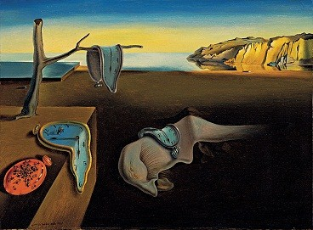
Figure 1: The Persistence of Memory, (Dali, 1931)
One of Salvador Dali’s most well-known works, The Persistence of Memory, was inspired by Hieronymus Bosch’s Garden of Earthly Delights and was created in 1931 (Dali Paintings, 2023). The setting of the Catalonia coast at Cape Creus that can be seen in this painting serves as the backdrop for many of Dali’s images. A profile of a distorted human face, which also appears in one of Dali’s early works, The Great Masturbator, can be seen in the painting’s centre underneath one of the watches (Gromley, 2023). The melting clocks that are recurring throughout this image were motivated by Dali eating Camembert cheese whilst during an hallucination (Gromley, 2023). Time may not be moving as it should, which may indicate that civilization is running out of time and the world as we know it is changing more quickly than we realise. This could be symbolised by the clocks, which lack the firm circular shape that we are used to observing and having a cheese-like softness instead. The placement of the seashore which is advancing towards the sky rather than the front of the picture can also be used to corroborate this. As the water recedes towards the back of the image, it might represent drought.
Man Ray, also referred to as Emmanuel Radnitzky, was born in Pennsylvania in 1890. The Dada and surrealism movements both benefited greatly from the contributions of the photographer, painter, and filmmaker Man Ray. The New York Dada artists were founded in 1915 when Ray first met the French artist, Marcel Duchamp (Encyclopedia Britannica, 2023b). In 1921, Ray relocated to Paris and began to engage with the Dada and Surrealist writers and painters there (National Portrait Gallery, 2023). Ray experimented with a variety of mediums. How to make photograms, also known as “rayographs,” these are a type of photograph taken without the assistance of a lens or camera, was one of his photography-related discoveries. After placing objects on light-sensitive paper, the paper is exposed to light, developed, and then fixed. Where items have rested on the paper and prevented the light from exposing the paper, there are light spots in the print (Victoria and Albert Museum, 2009). He later pursued portrait and fashion photography, and many of his photographers had their work featured in publications including Vouge and Harper’s Bazaar (Encyclopedia Britannica, 2023b).
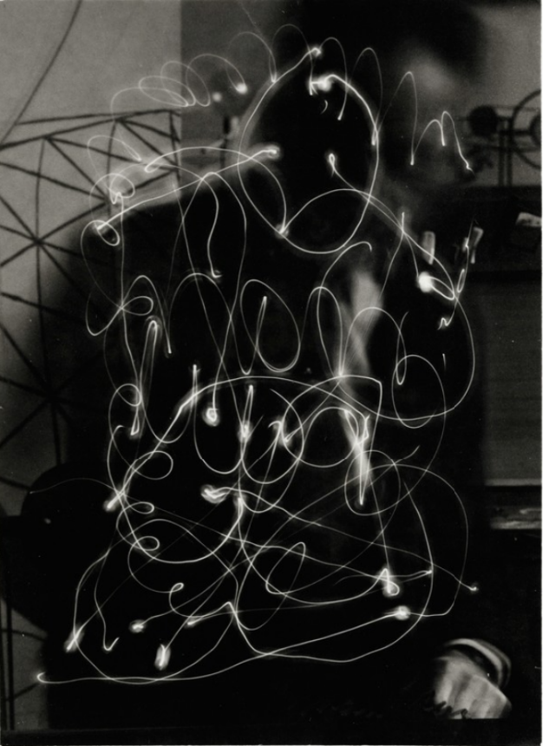
Figure 2: Space Writing, (Ray, 1935)
Ray produced a photograph in 1935 called Space Writing. He used a penlight to draw what appears to be his signature backwards in this artwork by opening the shutter of his camera for a long exposure (Artsy, 2023). Since the light was captured with a long exposure, Ray was out of focus since a long exposure documents everything that is moving in the frame, including the artist’s face, which is hidden behind the white lines made by the penlight. In this situation, if he were perfectly still, you could see him clearly, but we would be unable to use the pen to sketch. Since the viewer can only make out the artist’s shadow, they might be intrigued and desire to learn more about the mysterious figure. The only way the spectator can connect to the man in the picture is through his signature, and by doing so, it makes the picture more memorable because the viewer will keep thinking about the man and speculate on his identity.

Shadow
Every photograph in photography depends on light and shadows since without them, the pictures would not have an adequate balance. A photograph’s contrast can be strengthened and given more dimension by having a good balance of light and shadow. Both light and shadows enhance an image in separate ways. For example, although light makes an image appear brighter, shadows can give drama to a particular area of the composition of the image (Adobe, 2023).
A group of computer scientists from MIT, Google, and the University of California have developed a new AI tool that can eliminate harsh shadows from photographs while preserving the organic shadows (Cade, 2020). However, one problem with this software is that some of the images lose contrast, which is important in photography, but with some of the images, a viewer would not be able to tell any.
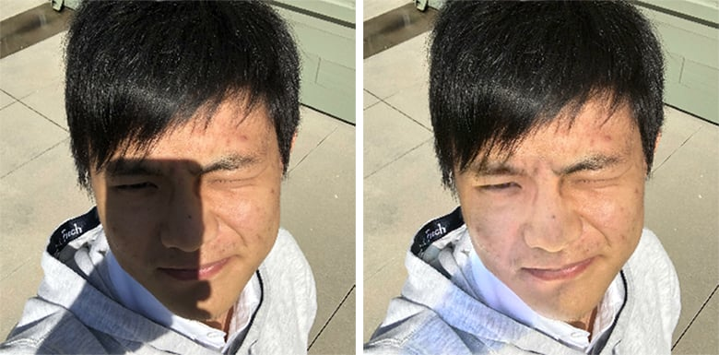
Figure 3:
The term “chiaroscuro,” which dates back to the Renaissance and derives from the Italian words which are “chiaro, meaning bright or light, and oscuro, which means dark” is used by artists to create “photorealistic paintings with value and depth” (Virtual Art Academy, 2023). It is Alleged that artists like Caravaggio, Rafael and Leonardo da Vinci developed this technique.
Australian photographer Trent Parke was born in Newcastle, New South Wales, in 1971, and currently resides in Adelaide. Themes of identity, locality, and family life are explored in Parke’s work, which occupies a space between fiction and reality. Parke began his career as a press photojournalist and also has roots in documentary photography (Reid, 2022). His “poetic, often darkly humorous photography that offers an emotional and psychological portrait of his home country Australia” is what he is best known for (Parke, 2023a).
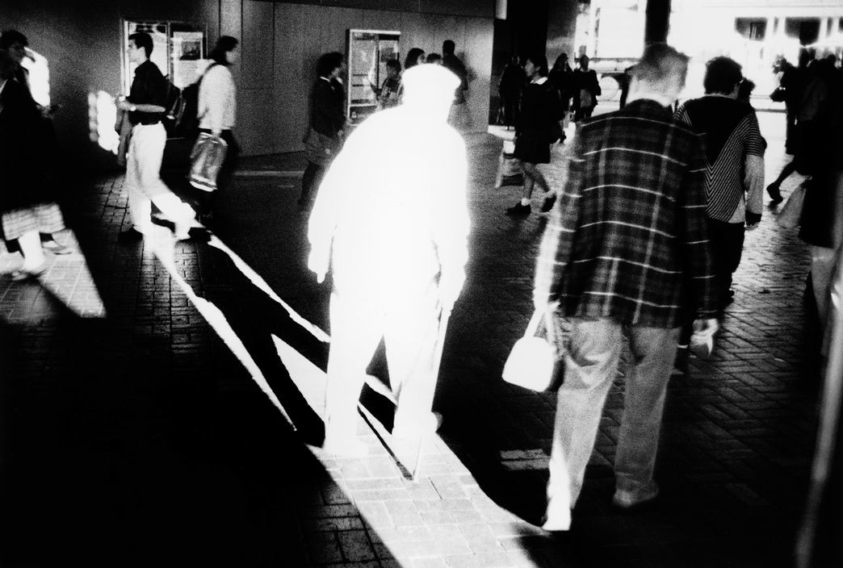
Figure 4: Dream/Life, Trent Parke, 2001
Dream/Life is a collection of photos that Parke created in 2001. The image "An elderly man dressed in white walks into harsh sunlight in a tunnel under Circular Quay railway station" was one of the distinctive pictures in this collection (Parke, 2023b). Due to the intense light, the viewer might not realise that the figure in the picture is an "elderly man" if the picture's description did not describe what it was displaying. The utilisation of light and shadows is more apparent and produces greater contrast in this black and white shot. Parke's technique for capturing this image and the intense light that resulted in the white figure show that this figure is the main focal point of the picture and that this is what the photographer wants the audience to devote their attention to. The manner in which the "elderly man" or figure has been highlighted may imply that they are a divine being, connecting this image to a religious context. The fact that no one is paying attention to this figure could either further reinforce the idea that he is a divine being that humanity cannot see or that by him heading into the light could suggest that his time has come and that he is going to cross over into the afterlife.

Discussion
In surrealism, photo manipulation is extremely prevalent since, without it, an image would lack its unorthodox and remarkable quality, making it difficult to produce pictures that are otherwise impossible to capture. Light and shadows are frequently used in surrealism and photo manipulation because without them, an image would the lack contrast. However, in a surrealist image, an unbalanced use of light and shadows could contribute to the image appearing more bizarre.
One thing I have discovered so far from completing this research is just how prevalent AI is in the photography industry. Prior to conducting my research, I was aware that certain cameras had Artificial Intelligence (AI) characteristics built in, but I was unaware of how widespread it had become. The history of surrealism was another thing I was unaware of, and I now know more about the artists that created it throughout this period.
Surrealism, photo manipulation, and shadows are three subjects that I find fascinating because when I make my work, I like to try to make it peculiar so that the viewer has never witnessed it before. To do this, I make surrealist photographs, and without the use of photo manipulation or shadows, it would be difficult for me to make the pictures I desire.
In regard to these topics I'd like to learn more about photograms, sometimes known as "rayographs," as I know very little about them and have only tried them a few times. More research on this subject will have an impact on my practise since I intend on experimenting with this technique to see what pictures I can create without a lens or camera, and I want to explore how various textures would appear while utilising this technique. Given that I have never tried it before and that it would be interesting to see what kinds of images I could make, I would like to try incorporating AI into my practice.
What question could you suggest to frame your research?

What can photographers learn from…
What can photographers learn from older photography techniques?

How does AI/photo manipulation affect…
How does AI affect the future of photography?
How does photo manipulation affect young people and what they believe to be true?

How can photographers utilise technology to…
How can photographers utilise technology to improve their work?

Reference List
Adobe (2023) The principles of light and shadow in photography, Adobe. Available at: https://www.adobe.com/creativecloud/photography/hub/guides/understanding-light-and-shadow-photography (Accessed: May 10, 2023).
Adorama (2023) Ai in photography: How photographers can use Artificial Intelligence, Adorama. Available at: https://www.adorama.com/alc/ai-in-photography/ (Accessed: May 3, 2023).
Artsy (2023) Man ray: Space writing (self-portrait) (1935), Artsy. Available at: https://www.artsy.net/artwork/man-ray-space-writing-self-portrait#:~:text=Man%20Ray%20drew%20with%20a,of%20lines%20by%20lengthening%20his%20%E2%80%A6&text=Man%20Ray%20was%20a%20key,Americans%20associated%20with%20either%20movement (Accessed: May 10, 2023).
Blakemore, E. (2022) How photos became a weapon in Stalin's great purge, History.com. A&E Television Networks. Available at: https://www.history.com/news/josef-stalin-great-purge-photo-retouching (Accessed: April 26, 2023).
Cade, D. (2020) This ai automatically removes harsh shadows from your portraits, PetaPixel. Available at: https://petapixel.com/2020/08/24/this-ai-automatically-removes-harsh-shadows-from-your-portraits/ (Accessed: May 10, 2023).
Cortigiano, K. (2019) Why We Use Photoshop: Top Photographers Explain, CreativeLive Blog. Available at: https://www.creativelive.com/blog/why-photographers-use-photoshop/ (Accessed: May 9, 2023).
Dali Paintings (2023) Persistence of memory, 1931 by Salvador Dali, Dali Paintings. Available at: https://www.dalipaintings.com/persistence-of-memory.jsp (Accessed: May 10, 2023).
Encyclopedia Britannica (2023a) Surrealist techniques, Encyclopedia Britannica. Available at: https://www.britannica.com/art/Surrealism/Surrealist-techniques (Accessed: May 9, 2023).
Encyclopedia Britannica (2023b) Man ray, Encyclopedia Britannica. Available at: https://www.britannica.com/biography/Man-Ray (Accessed: May 10, 2023).
Gann, C. (2011) Parents Should Tell Kids Picture-Perfect Celebs Aren’t Real, Psychologists Say, ABC News. Available at: https://abcnews.go.com/Health/photoshopped-images-carry-warning-labels/story?id=15060113 (Accessed: May 9, 2023).
Gromley, J. (2023) The persistence of memory, Encyclopædia Britannica. Available at: https://www.britannica.com/topic/The-Persistence-of-Memory (Accessed: May 10, 2023).
Gutierrez, C. (2015) Photoshop has changed the history of digital photography., Adobe Education Exchange. Available at https://edex.adobe.com/community/discussion/f425c84-#:~:text=It%20definitely%20changed%20the%20way,of%20photoshop%20is%20erasing%20blemishes (Accessed: April 26, 2023).
Johansson, E. (2023) About, ERIK JOHANSSON. Available at: https://www.erikjo.com/about (Accessed: May 10, 2023).
Leike (2019) Surrealism in photography and film, Photography with leilion. Available at: https://photoleilion.wordpress.com/2019/07/14/surrealism-in-photography/ (Accessed: May 3, 2023).
MoMA, (2023) The Persistence of Memory, The Museum of Modern Art. Available at: https://www.moma.org/collection/works/79018 (Accessed: May 10, 2023.
National Portrait Gallery (2023) Man Ray, National Portrait Gallery. Available at: https://www.npg.org.uk/collections/search/person/mp07924/man-ray-emmanuel-radnitzky (Accessed: May 15, 2023)
National Science and Media Museum (2021) The time-travelling camera: A short history of digital photo manipulation, National Science and Media Museum. Available at: https://www.scienceandmediamuseum.org.uk/objects-and-stories/digital-photo-manipulation-history (Accessed: March 30, 2023).
Oxford Reference (2023) Surrealism, Oxford Reference. Available at: https://www.oxfordreference.com/display/10.1093/oi/authority.20110803100543634;jsessionid=A21B751E19C12C4075EED2D8AC5263E0#:~:text=A%2020th%2Dcentury%20avant%2Dgarde,the%20irrational%20juxtaposition%20of%20images (Accessed: May 9, 2023).
Parke, T. (2023a) Trent Parke, Photographer Profile, Magnum Photos. Available at: https://www.magnumphotos.com/photographer/trent-parke/ (Accessed: May 11, 2023).
Parke, T. (2023b) Dream/ Life, Magnum Photos. Available at: https://www.magnumphotos.com/arts-culture/society-arts-culture/trent-parke-dreamlife/ (Accessed: May 15, 2023)
Reid, M. (2022) Trent Parke, Michael Reid. Available at: https://michaelreid.com.au/artist/trent-parke/ (Accessed: May 11, 2023).
Tate (2023) Surrealism, Tate. Available at: https://www.tate.org.uk/art/art-terms/s/surrealism#:~:text=The%20word%20'surrealist'%20(suggesting,a%20play%20performed%20in%201917 (Accessed: May 3, 2023).
Victoria and Albert Museum (2023) Surrealist photography, Victoria and Albert Museum. Available at: https://www.vam.ac.uk/articles/surrealist-photography (Accessed: May 9, 2023).
Victoria and Albert Museum (2009) Rayograph, Victoria and Albert Museum. Available at: https://collections.vam.ac.uk/item/O191523/rayograph-photogram-man-ray/#:~:text=A%20rayograph%20(or%20photogram)%20is,stopped%20light%20exposing%20the%20paper (Accessed: May 15, 2023)
Virtual Art Academy (2023) The History of Art: Chiaroscuro. Available at: https://www.virtualartacademy.com/chiaroscuro/ (Accessed: May 16, 2023)
xphotography (2023) Ai in photography: Pros & cons, XPhotography. Available at: https://xphotography.ca/product-photography-blog-montreal/ai-in-photography-pros-cons/#:~:text=AI%20in%20photography%20is%20a%20double%2Dedged%20sword.,and%20the%20potential%20for%20mistakes (Accessed: May 9, 2023).

