Student name: Morgan Hall
Programme: Manufacturing Systems Engineering Operations
Module: ACEA4000
Assignment: Plant Flow Diagrams and P&ID Diagrams

Dust suppression system
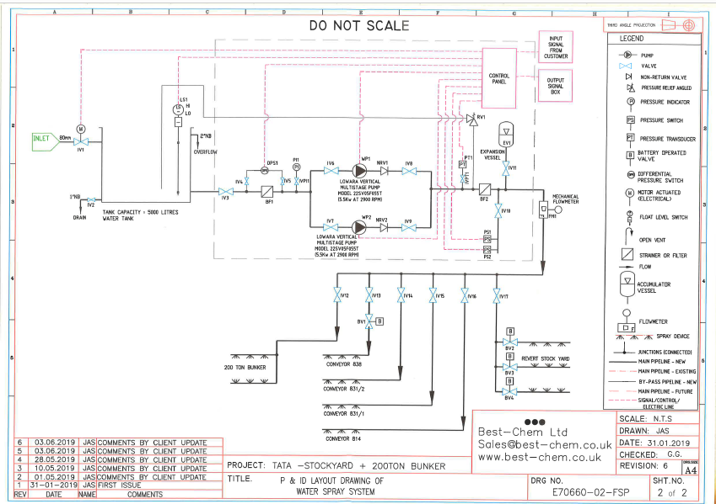

Dust Suppression System, Harbour and Blending Area.

Due to Iron and Burdening being a very important step in the steelmaking process and having the largest plant coverage, there are many steps that go into what helps to produce the finished product of molten iron. Examples of these steps are the harbour area, the sinter plant, the granulated coal injection plant, stockyards and ferrous stock houses, and then finally to the furnaces. In the harbour area, the raw materials come in from around the world. The unloaders work as fast as possible to unload all the goods off the boat in the fastest time possible. After being unloaded the material moves along the conveyor, through magnets to clean the material of any scrap metal or rubbish. The material is then either taken to the coke ovens, or to the stock yards for use in other parts of the site. The harbour and blending plant have 5 stockyards in which they control. The majority of this material is fines which are laid on the fines bed for the sinter plant to use in production meaning it is a finer size compared to some of the lump material. Due to this there can sometimes be a lot of dust that is taken off the pile due to wind or the use of mobile plant etc. This can lead to a large cloud starting to form over the works, which is not only bad for the environment, but may cause complaints from the nearby community, possibly leading to damage to the businesses reputation. The main solution to this problem was to use a water system in order to spray some of the stockpiles that are very fine and are subject to dust clouds with water in order to wet the material and stop the dust from being taken off the top of the material. This would then lower the risk of any dust clouds forming from a fines stockpile. For this to happen however, a complex network of pipes and valves etc. must be created in order to cover the area and the different components of the plant that must be reached. An example of these plant components would be the 200 ton bunker and the conveyors that have to be reached.
Spraying the 200 ton bunker is key in ensuring that dust level are kept down as all material from the yards (apart from the direct charge yards) will end up going into the bunker, making it a key part of the process and also a key area that needs to be targeted as large dust clouds can form from the bunker due to the high amounts of fines going through on a daily basis. The other components that need to be sprayed would be the conveyors as they are the components that carry the material from point A to point B, e.g. from the Harbour into the blending plant stockyards. Also due to the conveyor’s motion dust clouds may be more likely to occur when moving the fine materials.
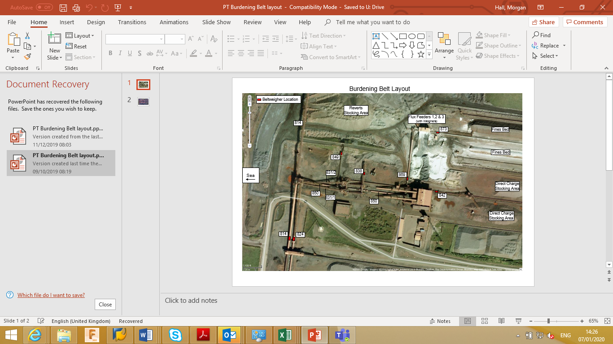

= 200 Ton Bunker location

The system itself is a complex network of different components like valves, pumps and spraying devices that are all linked to have a continuous flow of water for the spraying devices. These obviously would need commissioning before the process is being carried out to check whether the system is safe to have out on site. Also, from a commissioning standpoint it is important that the system itself actually works to lower the risk of dust clouds entering the local community. The system starts off with a water inlet, this is the source of the water to the system. After this, the water is the transferred through a pipe of size 80mm into a tank with an overall capacity of 5000 litres. The water is then taken through a series of valves, a filer and a differential pressure switch, until it reaches a pipes in a parallel shape including; a valve, a pump (Lowara Vertical Multistage Pump Model 22SV05F055T which operates at 5.5 Kw at 2900 RPM), a non-return valve and then another regular valve. After this stage in the system, the water in the system the goes through another filter and then past an accumulator vessel which is used to dampen spikes in the water pressure through the system then through a mechanical flowmeter which measures the flow within the system using a turbine etc. After this the water is then ready to be distributed into the area in which the water is needed to reduce the dust levels. IV12 valve takes water to the 200 ton bunker which has two spray devices due to the high levels of dust that can accumulate.
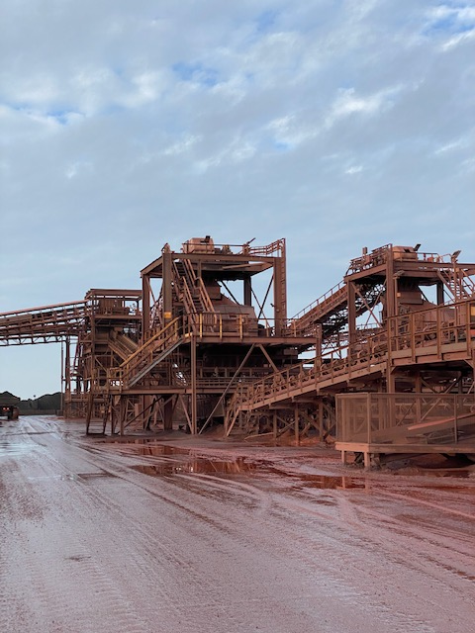

IV13 valve takes water through another valve and then onto 838 conveyor which takes material from the power screens into the kumba pile which can also accumulate high levels of dust. IV14 valve takes the water to 831/2 conveyor which is the conveyor before the power screen. IV15 takes the water to 831/1 conveyor which is a symmetrical conveyor to 831/2 and also takes material to a symmetrical power screen. The power screens screen out the fines from the lump so a large amount of dust can form.
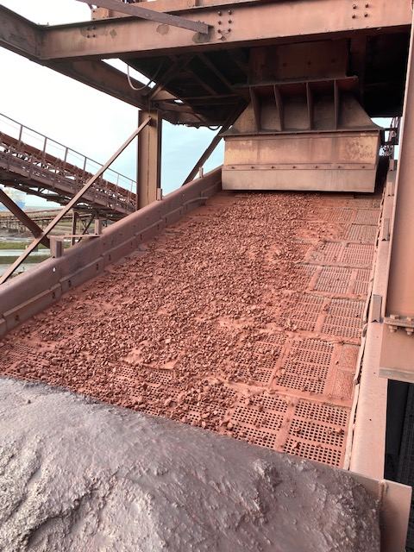
IV16 valve takes the water to conveyor 814 where the water is sprayed onto the conveyor, this is important as 814 is one of the main conveyors that takes the material from the ship into the stockyard so has a large amount of material moving along it on a daily basis when a vessel is unloading.

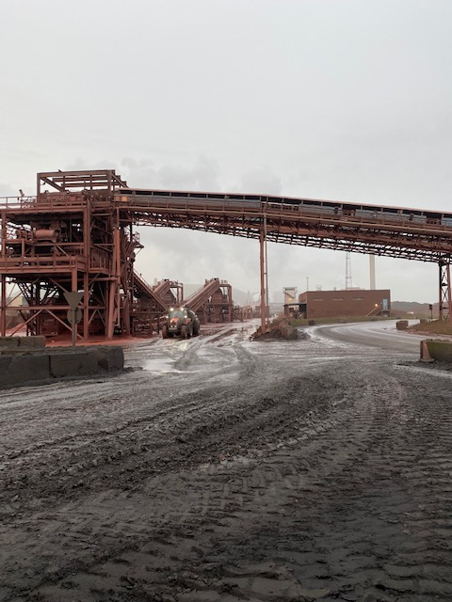

Finally, IV17 valve takes the water to a set of 3 valves that will control water into the revert stock yards. The revert stock yards are the yards for all the waste materials and recycled materials from around the plant. This is important as some of the revert beds can become very large and if the material is of a finer size, then it is at risk of becoming dust clouds, also, due to some of the materials being recycled from other processes, they may be seen as more worrying if turned into a dust cloud etc. due to their consistency and colour.
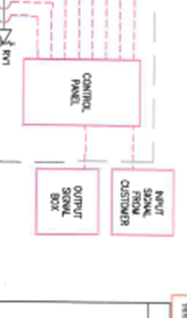
As shown below, the whole system is controlled via the control box in the system, which works off the input signal from the customer, giving instructions to the system on where the water is needed. The control panel is then linked up through the use of an electric line (shown above with the dotted red line) within the system to parts like the differential pressure switch, the pumps and the pressure indicators.

