Blwyddyn / Year:  Year 5/6 (Progression step 3). | Maes Dysgu a Phrofiad / Area of Learning and Experience:  Languages, Literacy and Communication. | Amcan y wers / Aims of the lesson:  - To understand and use the question “Sut wyt ti’n teimlo?” in a conversation.  - To respond to “Sut wyt ti’n teimlo?” using a range of appropriate Welsh emotional vocabulary.  - To use the sentence structures “Dw i’n...”, “Dw i ddim yn...” with “achos” and “ond” to give more detailed responses.  - To play vocabulary games (e.g., dice game, Blooket and walk and talk) to reinforce emotional language and sentence patterns.  - To create and present a bilingual poster showing different emotions with clear and accurate Welsh labels.
Gwybodaeth flaenorol / Previous knowledge:  Learners were familiar with the question “Sut wyt ti?” and could use it to ask how someone is. They knew how to give basic responses using simple emotions such as hapus and trist. They know “Dw i’n” confidently and some are aware of “Dw i ddim yn”. | Geirfa allweddol / Key vocabulary:  - Sut wyt ti’n teimlo? = How are you feeling?  - Dw i’n… = I am…  - Dw i ddim yn… = I am not…  - Achos = Because  - Ond = But  - Emotions: hapus (happy), trist (sad), grac (angry), wedi blino (tired), cyffrous (excited), nerfus (nervous).  Ffocws iaith / Language focus:  - Forming and responding to the question “Sut wyt ti’n teimlo?”.  - Expanding sentence stems with conjunctions such as “achos” and “ond”.  - Understanding and using emotional vocabulary correctly.  - Using positive and negative forms (e.g., "dw i'n..." / "dw i ddim yn...") in the same sentence. | Gweithgareddau addysgu a dysgu / Teaching and Learning Activities:  Input (10 minutes):  The lesson will begin with a whole-class introduction to the question “Sut wyt ti’n teimlo?”, building on learners’ prior understanding of “Sut wyt ti?”. The teacher will display the phrase on the board and model its pronunciation and use. A large dice featuring pictures of different emotions will be introduced as a game to spark interest and recall prior vocabulary. The teacher will roll the dice to a learner and ask “Sut wyt ti’n teimlo?”, and the learner must respond with the correct Welsh word for the emotion shown. That learner will then pass the dice to another learner while asking the same question, continuing the activity until confidence is displayed. To support language development, learners will be given thinking time, the option to call a friend for help, and examples of emotions in Welsh will be displayed on the whiteboard. The teacher will encourage the use of sentence structures like “Dw i’n...” and “Dw i ddim yn...”, and once confidence is evident, will demonstrate how to extend answers using conjunctions such as “achos” and “ond” to say what they are and are not feeling. To embed these structures, learners will take part in a “Walk and Talk” activity, moving around the classroom until the teacher signals them to stop. At that point, each learner must ask the nearest peer “Sut wyt ti’n teimlo?” and receive a response that includes both what they are and are not feeling, encouraging fuller sentence structures. Following this, the teacher will introduce the main task: creating a poster titled “Sut wyt ti’n teimlo?”  Main Body (50 minutes):  In the main part of the lesson, learners will begin by completing a creative task: designing a poster titled “Sut wyt ti’n teimlo?” which includes drawings of different emotions, each labelled in both Welsh and English. They will split their poster into four equal sections and draw something that makes them feel that emotion, for example, playing football for hapus. They will then write the corresponding emotion underneath each drawing. This task promotes creativity and provides a visual way to reinforce the emotions vocabulary. As an extension activity, learners will work in pairs to write a short dialogue using the target sentence structures with conjunctions. They will practise reading it aloud and then record their conversation on Seesaw, developing their confidence in their speaking and listening skills.  Plenary (15 minutes):  To consolidate learning at the end of the lesson, learners will have a final opportunity to engage with the vocabulary through a short, timed round of Blooket on the class iPads working in pairs. This will act as a fun way to revisit the key emotional vocabulary and sentence patterns in an engaging and competitive format. As learners begin to finish and prepare for dismissal, the teacher will carry out a quick-fire speaking activity, posing one final question to each table using “Sut wyt ti’n teimlo?” and prompting a response from a chosen learner. Learners will be encouraged to respond using both positive and negative forms with conjunctions. This provides a final opportunity to reinforce sentence structures and pronunciation while ending the session on an active, focused note.
Adnoddau / Resources:
- 30x A4 white paper.
- 10x Packs of coloured pencils.
- 30 x Normal drawing pencils.
- 15 x iPads with Seesaw and Google on them.
- 30 x Rulers.
- My pre-made Welsh presentation, access to interactive whiteboard and laptop.
- Dice with 6 inserts.
- 6 x Pictures of emotions for the dice.



Emotion pictures for the dice:




Blooket questions:
- Sut wyt ti'n teimlo?
- How are you feeling? (Right)
- What is the weather today?
- How old are you?
- What have you been doing?
- Dw i’n….
- You are….
- I am…. (Right)
- We are….
- They are….’
- Dw i ddim yn…..
- We are not….
- They are not….
- I am not….(Right)
- Bob is not….
- Gyffrous
- Angry
- Excited (Right)
- Amazing
- Bored
- Wedi blino
- Excited
- Angry
- Happy
- Tired (Right)
- Ofnadwy
- Excited
- Happy
- Awful (Right)
- Tired
- Eisiau bwyd
- Hungry (Right)
- Bored
- Excited
- Sad
- Achos…
- Because….(Right)
- And….
- Sad….
- Happy…
- Ond
- Why
- Because
- But (Right)
- Where
- Dw i’n……ond dw I ddim……
- I am...but I am not...(Right)
- He is....but he is not...
- She is....but she is not...
- I am not....but I am...

Presentation slides:
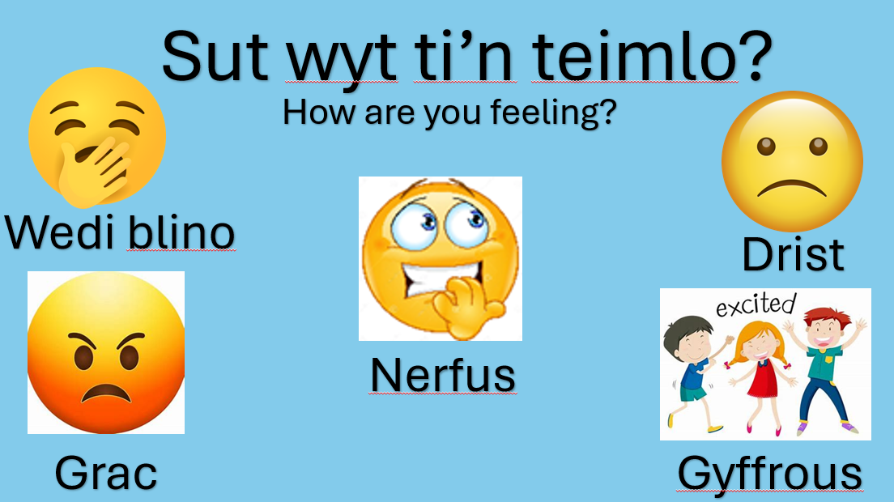
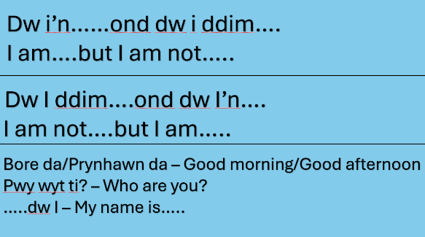

Reflection and Evaluation:
Overall, this was a successful and well-paced lesson that used a variety of pedagogical strategies to support learners' development in spoken Welsh. Learners were engaged throughout, and the activities helped to strengthen their understanding and confidence in using the language. A key strength was the use of active learning techniques, such as language drilling and group repetition in different voices, which reinforced sentence structures in a dynamic, engaging way. These strategies align with constructivist principles, where learners build knowledge through active engagement with content. The “pass the dice” activity encouraged full-class participation, allowing for scaffolding and peer support, where learners supported each other, making the learning process more collaborative. Sandwiching (English–Welsh–English) was also an effective method to support scaffolding, helping to bridge the gap for learners struggling with new vocabulary. The creative poster activity was in line with the constructivist approach, encouraging learners to link emotions with personal experiences, creating a meaningful and authentic context for the vocabulary. The task allowed learners to engage with the content in a way that connected to their lives, increasing intrinsic motivation. The final Blooket game offered a fun way to consolidate learning while allowing me to assess pupils' understanding in real-time. This aligns with formative assessment principles, which suggest that assessment should be embedded into learning, not something that occurs at the end. One area for improvement is the use of individual Assessment for Learning (AfL). While I used techniques like think–pair–share, call a friend, and thumbs up/down, the feedback was often group-based. Moving forward, I would like to incorporate more individual AfL strategies, i.e. mini whiteboards and targeted questioning. This would help me gather more accurate data on each learner’s progress.

