Hand rendered draft - block repeat tile
This example has been drafted in a scattered format, repeated out side by side as a straight block.
Draft: the first version of a design (not finished, but has the bones to become a finished outcome)

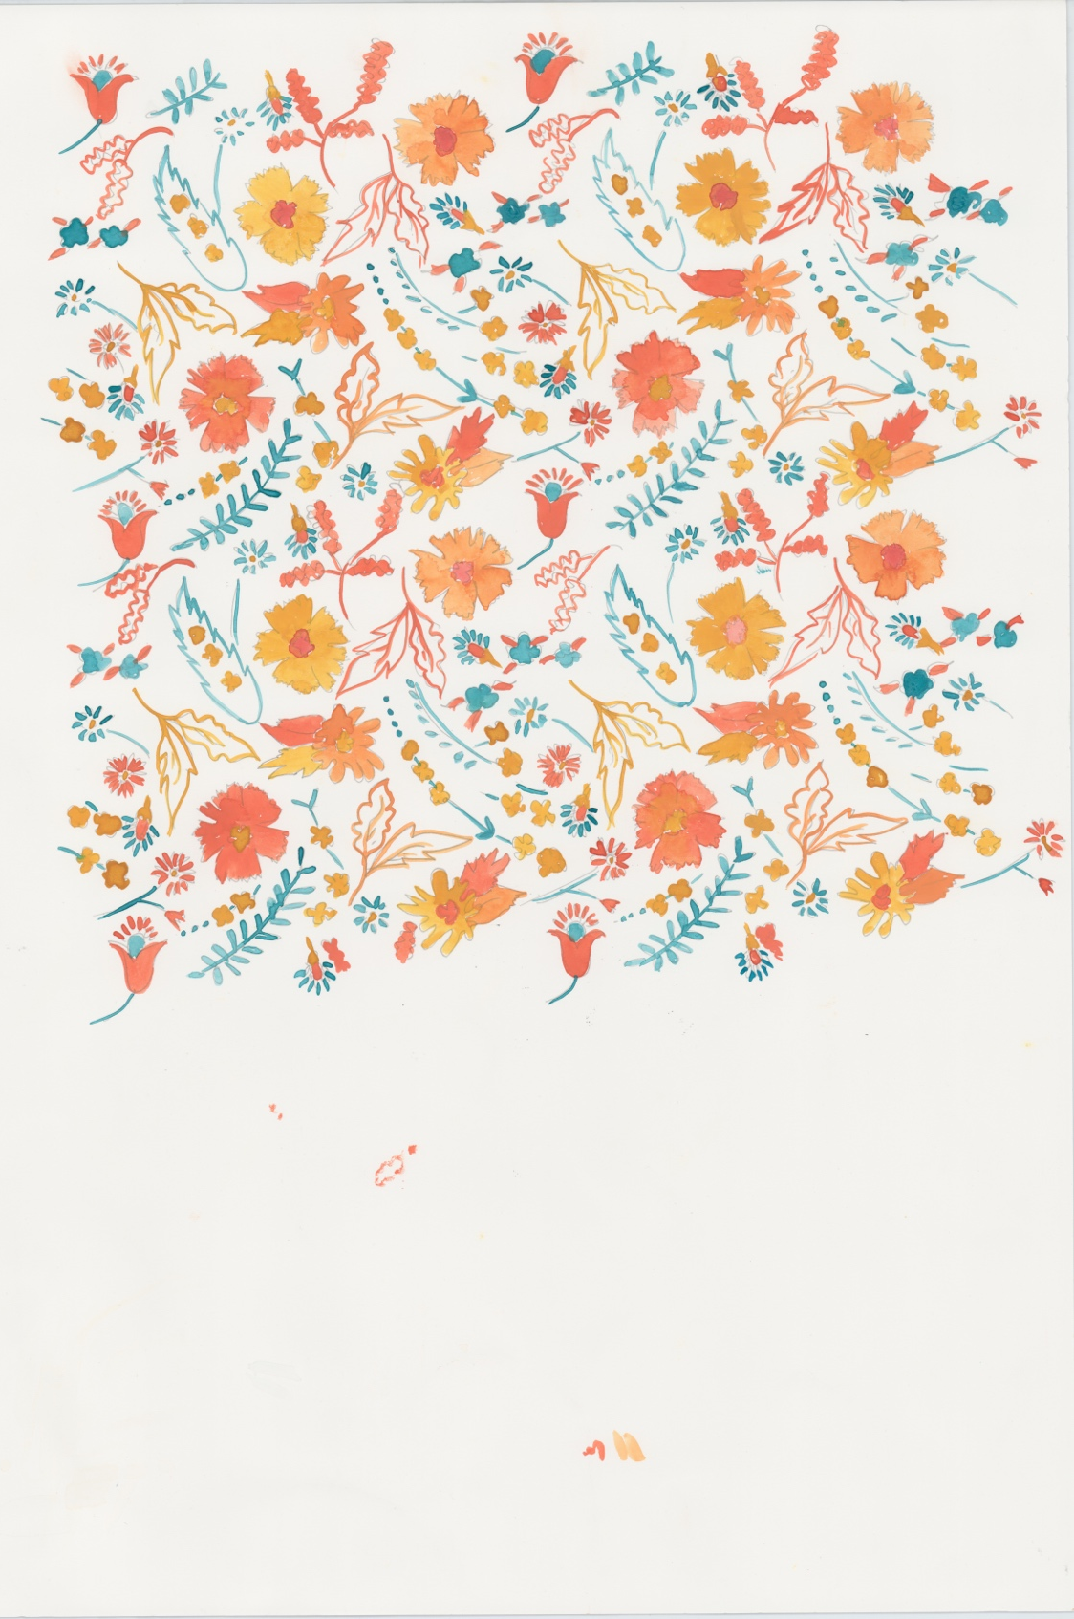
Original artwork gouache

These pattern types can work well in a block repeat system, but are not limited to this method of repeat. Abstract, Check, Chevron, Ditsy, Floral, Geometric, Ogee, Scattered, Spot, Stripe, Trellis.

You can draft out a block repeat within the framework of a square or rectangle, something like this…

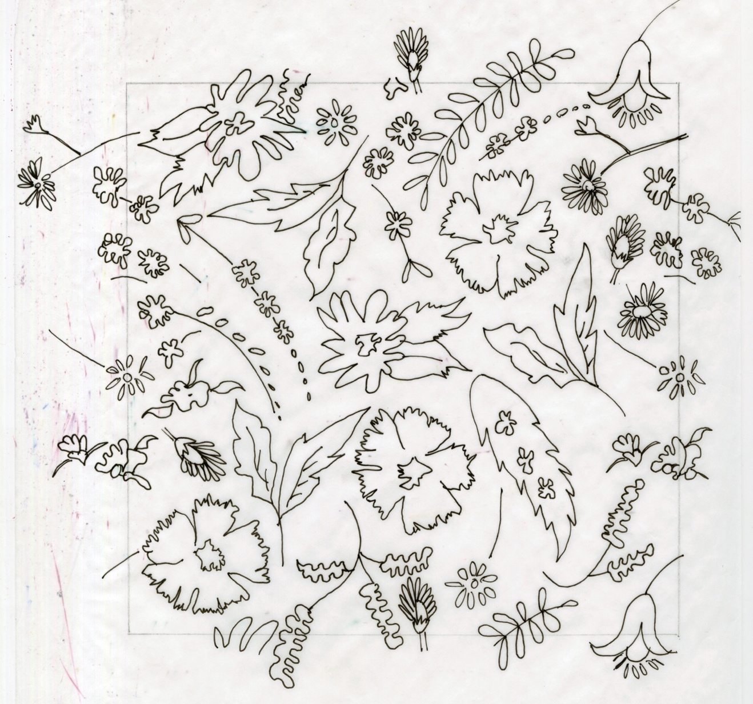
Hand rendered scattered tile (draft) (Motifs have been placed in multiple directions as if scattered or tossed, elements that fall outside of the tile have been drawn on either side of the tile to allow for whole elements and no harsh edges)

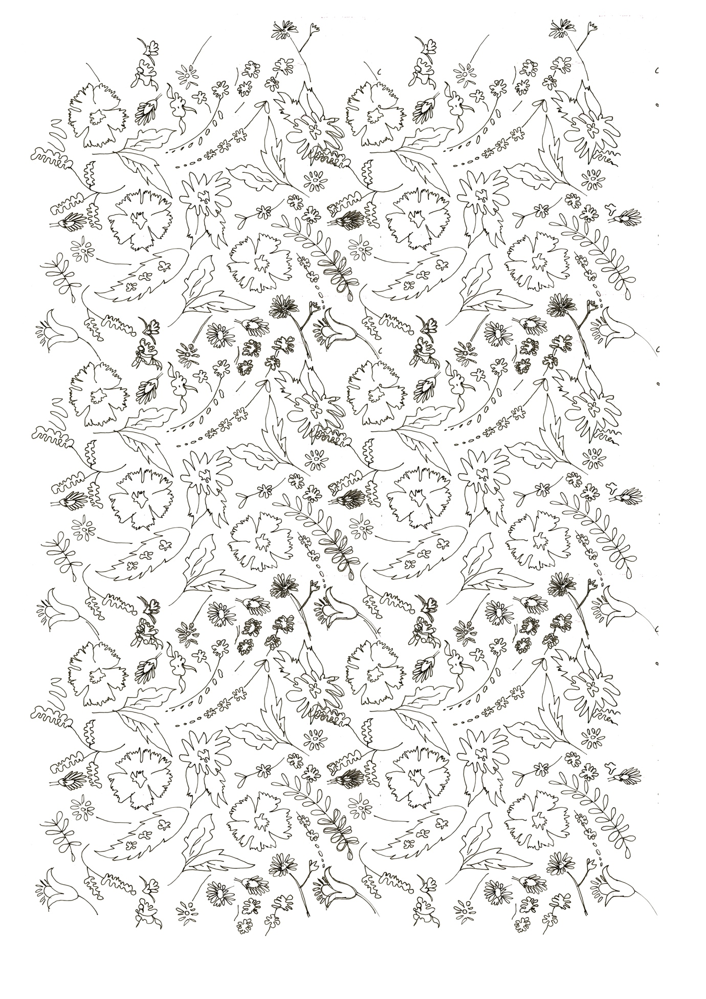

Hand rendered scattered tile (draft) showing the block repeat

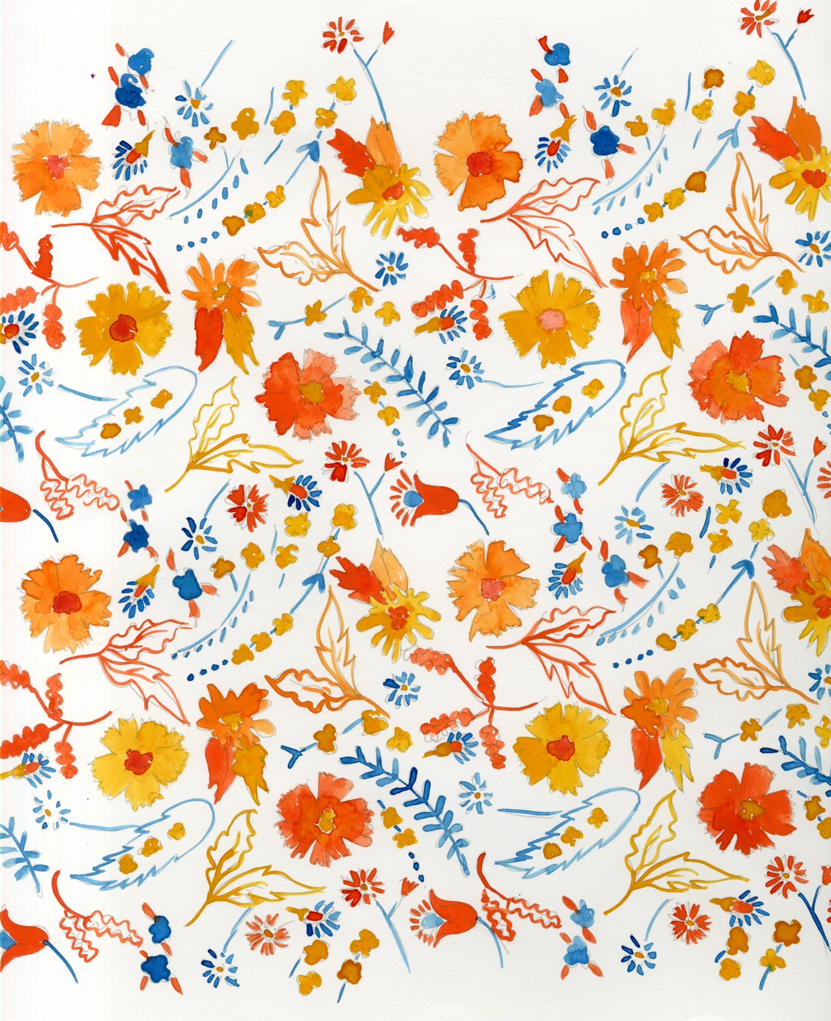
Hand rendered scattered tile drawn out and painted in gouache

