

Assessment 1 – Reading Task Template
PART 1: Upload your photo of your A3 in-class notes here:
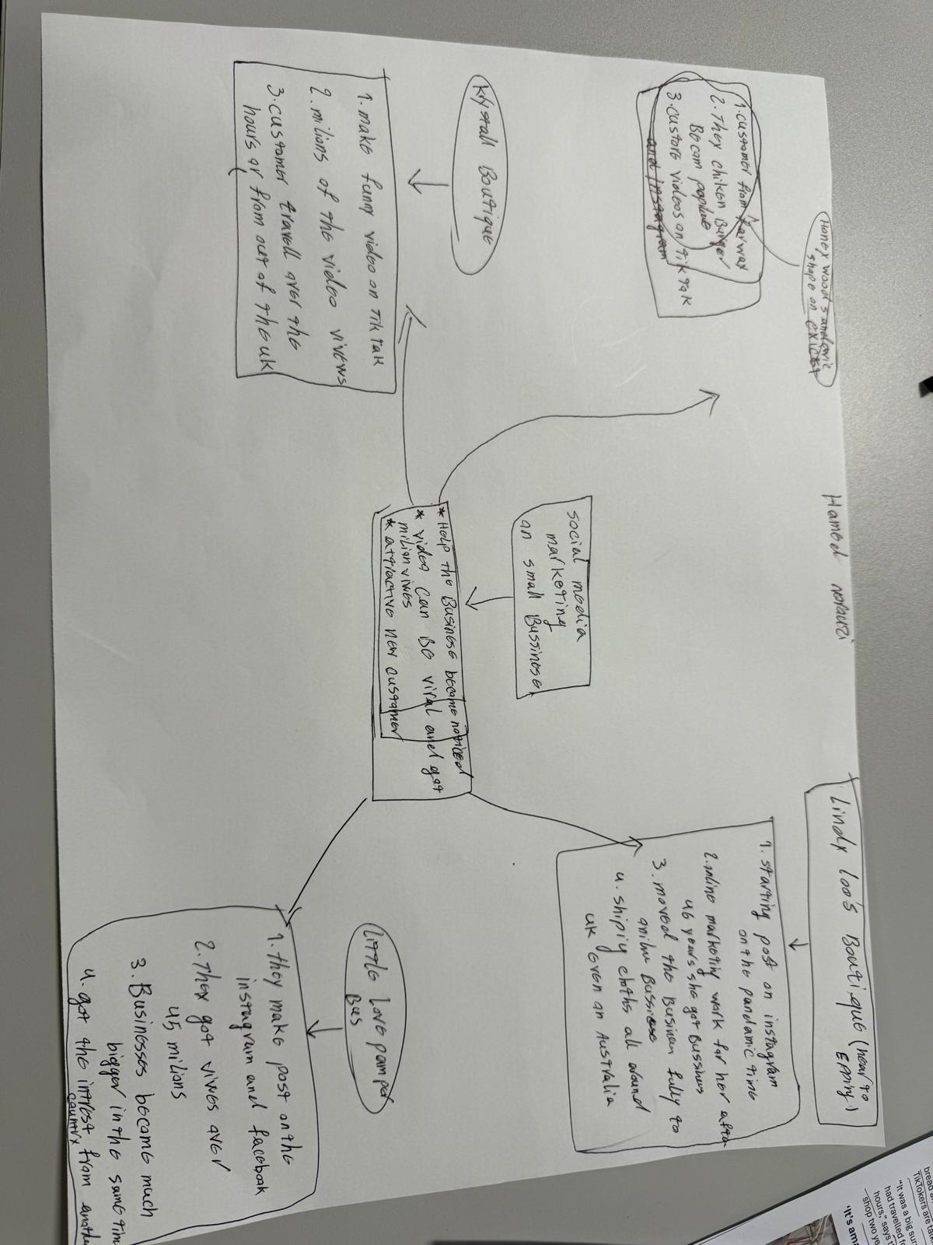

PART 2:
- Answer every question below in 1-3full sentences.
- Use your own words. Do not use generative AI to answer these questions.
- Include a specific detail from the text when asked.
REMINDER
- The main idea is the overall message of the whole text.
- A key point helps to explain the main idea.
- A specific detail or example from the text shows that the key point is true.

- What is the main idea of the whole text?
The main idea is how social media platform like TIK TOK or INSTAGRAM can help the small businesses to grow and grab more customers from around the world and expand the reach

- What is one key point that supports the main idea, and which specific example from the text shows this?
The key point supporting the main idea is the development and growth of individual small businesses.
For example some small businesses like the HONYWOOD SANDEWICH SHOP become a famous from the TIKTOK and got customers drive three hours for the chicken burger

- What is a different key point that supports the main idea, and which specificexample from the text shows this?
Another key point is the role of social media platform like INSTAGRAM in building and sustaining a business.
LINDA HUNTERs business faced difficulties during the pandemic, by recording videos and posting them on INSTAGRAM her business not only survived but also grew reaching new customers even from AUSTRALIA

- Which part of the text do you think is most important, and why?
I think the most important point of the text is presenting social media as a helpful tool especially for small businesses.
By Advertising your product you are able to get the customers from different places that will more interested what you have to offer to.

Reflection:
- What did you find difficult in this task (including in-class components), and why was it difficult?
It was a bit difficult at the begging for me to how start and explain social media can be helpful in the short way for growing the businesses
The key point was a bit confusing me but after some try and writing and deleting I found out how to start.

- What helped you with this difficulty, and how did it help you?
After having some conversation with the different group and some other student I find out how to making some note and marking some important key point helped me to understand and writing more with confidence

