Charlie Williams (2235685)
Computing (Networks and Cyber Security)
Computer Forensics

Computer Forensics

Table of Contents
- Introduction
- Digital Forensics and Computer Forensics
- Brief History of Digital Forensics
- Fundamental Concepts
- Analysis of Digital Evidence
- Pre-analysis
- Tools
- Chain of Custody
- Analysis
- Discovered Evidence
- Timeline
- Post-analysis- what happened?
- Conclusion
- Reference List

Introduction
Good morning or afternoon! I hope you are doing well. Welcome to my report on Computer Forensics and Digital Forensics. Herein, I intend to discuss the history, fundamental concepts, and some computer forensic tools that are used in the field. Above is a table of contents containing the full list of sections of this report.

Digital Forensics and Computer Forensics

Brief History of Digital Forensics
The original computer forensic technicians were law enforcement officers with an interest in computers, which is a good fit for the field [1]. This included the FBI’s Computer Analysis and Response Team, started in the US in 1984. A year later, the Metropolitan Police in the UK set up a similar unit dubbed the Fraud Squad [2].
The existence of these forensic groups went unregulated for some time, until in 1998 the “Good Practice Guide for Digital Evidence” (Association of Police Officers, 2012) was published. It essentially detailed guidelines, standard techniques, protocols, and procedures to be employed by forensic technicians [2]. These guidelines have gradually developed into industrial standards and the field is now regulated by the Forensic Science Regular in the UK. [3]

Fundamental concepts
Contrary to what a vast number of online resources suggest, computer forensics and digital forensics are different, and do not refer to the same thing. Computer forensics refers specifically to digital forensics performed on computers, such as personal computers and laptops. Digital forensics refers to the wider umbrella of forensics performed on digital devices, including but not limited to phones, tablets, IOT devices, smart/home devices (Amazon Alexa, Google Home etc.) and printers. It includes anything that operates on binary [4]. This means that computer forensics a is part of digital forensics, and not the other way around. They are not interchangeable.

The main scope/applications of Digital Forensics are as follows:
- Criminal investigation- Digital Forensics is employed as a response to both physical and digital crime [5]. This is likely the most common use for digital forensics. Hardware seized by the police is forensically analysed, during which they look for potentially incriminating evidence using techniques such as reverse steganography, cross drive analysis, live analysis, and file carving [6].
- Security Incident response- security professionals responding to a security incident will investigate and attempt to work out the method used by attackers to illegally access systems to prevent it in future.
- Data recovery- Digital Forensic techniques can be employed for the purpose of recovering important data from physical drives.
- Network Forensics- network forensics involves the active monitoring of network traffic [7]. This has a very wide range of uses from monitoring for security purposes or to look for information that may assist with trouble shooting in an IT environment.
- Legal evidence- Usually as a follow-up to crime investigations, findings from digital forensics can be used as legal evidence for both criminal and civil cases [7].

Analysis of Digital Evidence
The next section of my report is attributed to my research, preparation and forensic analysis of digital evidence related to a cyberbullying investigation. Before I dive into the analysis itself, it is vitally important for me to cover some of the pre-requisites for my investigation.

Pre-analysis
To help me frame my analysis, I will be referring to a pair of existing, real world forensic reports. They can be found in the references section below, [8] and [9].

Tools
As I do not have a budget and lack experience with forensics work, I have decided to utilise open-source tools only. There are a few advantages with open-source tools, one of which is that there is a considerable amount of free support available online that I can utilise. As a baseline for my investigation, I’ve identified that there are three types of tools that I will need. These are categorised as disk analysis, network analysis, and steganography. These are the types of tools that I think will most beneficial during my investigation. Below are the tools I will be using for my investigation:

- Autopsy – Autopsy is an open-source tool used for disk analysis. It is designed to be used directly after installation with no major setup required.
- Wireshark- Wireshark is a network/packet analyser. It has a very useful feature which tracks connections going out with a live feed. This is useful as I will be using a fresh Windows image, which will have a limited number of outgoing connections. This means I can easily spot suspicious connections, such as the creation of command-and-control beacons.
- OpenStego- OpenStego is an open-source steganography tool that will enable me to unpack data hidden inside other files. This is very important for my investigation as malicious threat actors or those attempting to hide data will often use steganography to hide data inside innocent looking files, especially on previously mobile storage devices like this one.
- WinRAR- WinRAR is necessary for extracting files from the .zip files containing the evidence later.

Chain of Custody
My chain of custody will be formatted similar to a real-world report I sourced online [8].

SanDisk Cruzer Switch USB Device

Description of Evidence
Item | Quantity | Description of Item
1 | 1 | SanDisk Cruzer Switch USB Device
 |  | Serial number: 4C530499930102110561

Chain of Custody
Item | Date/Time | Released by |  |  | Received by | Comments/Location
1 | 8/3 | Nitheesh |  |  | Jon | Digital Image taken by Jon to pursue cyberbullying investigation. Contains large amounts of artifacts and metadata.  Location: IQ Building  Image: CASE1-FLASH.E01  14939 MB  SHA256: 08f0c7d5dc6b5f3fbf5e2997c29efe6eb0a458cb  Image acquisition completed at: Mon Mar 11 17:22:59 2024
1 | 8/3 | Jon |  |  | Nitheesh | Digital Image Sent to Nitheesh
1 | 3/22 | Nitheesh |  |  | Charlie | Digital Image sent to Charlie

Analysis
This section of my report will detail the process in which I conducted the analysis itself and will also document my findings. It is my aim to present my findings in a clear and understandable manner. This will include annotations for what I discover and a breakdown of what it represents. I have also created a timeline so the incident can be seen in what I believe to be chronological order, in context.

Acquisition of Data
I was not present for the acquisition of the data, and so I cannot account the details of how the image was obtained, so instead I will list general guidelines for what should be done regarding data acquisitions.

While the image is being taken, a write blocker should be used. This essentially creates a one-way channel between the imager and the evidence which only allows data to be read and prevents data from being written. This is important for preserving the integrity of the evidence.
Investigation should be done inside a virtual machine to prevent possible damage to assets and minimize potential costs.
My investigation will be conducted in a virtual machine created using Oracle VirtualBox, on a Windows OS.
Chain of Custody needs to be tracked to ensure the evidence is not tampered with and to assure the court of law that the evidence is authentic [10].

Discovered Evidence
The drive itself contains large amounts of artifacts and deleted files. This can be retrieved using Autopsy.

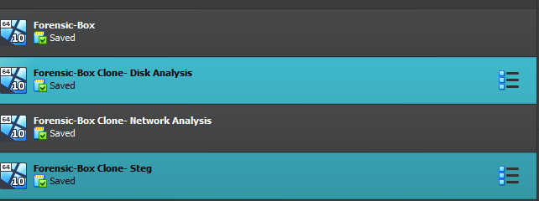
First, I created several copies of my original Forensic machine. This means I can analyse the image without compromising the original file and means I can create different boxes with different configurations. I’ve included a screenshot that displays the different boxes I created. I will also be including my notes from the time of capture and a timestamp.

One issue I had with creating multiple virtual machines like this was storage. The forensic image itself is pretty large, and creating up to 4 instances of it at once takes up a lot of space on my computer. Thankfully, I had a spare external drive I could use to house the files needed for each machine, but in future I need to plan ahead for this issue.
02/05/2024 21:03: Creating a clone of my existing forensic box for disk analysis. As I am doing only disk analysis, I can turn off the network adapter.
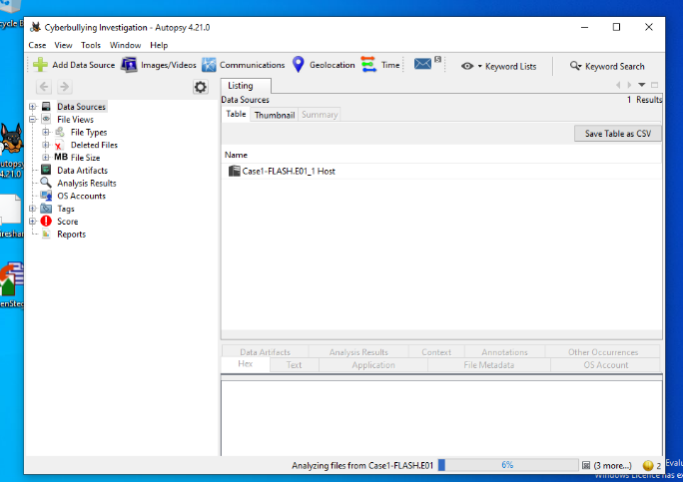
From my investigation, I have uncovered several screenshots of conversations ongoing between two individuals. One is a person who’s name I believe to be Emmy James, who will be referred to as EM, and the other is another user who’s username is Seer Musta. Seer Musta, who henceforth I will refer to as SM, utilises several accounts across different social media platforms, along with basic credential harvesting techniques, and social engineering to coerce information from a user who I believe to be EM, and then attempts to use this information to initiate a romantic relationship with them, which eventually turns into SM attempting to intimidate and threaten EM into meeting them.
21:50, beginning of investigation using Autopsy

A large majority of the evidence is screenshots of conversations from a recipient’s point of view, which leads me to believe that this drive originally belonged to either EM themselves, or a family member/partner/other close acquaintance. I will be documenting my evidence in the order I processed them, and in my post-anaylsis section I will construct a timeline in which I will present my findings on what I believe happened.

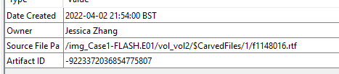
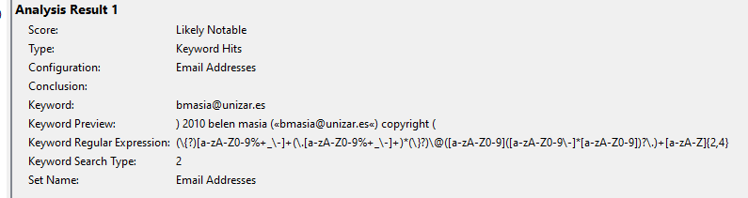
This drive contains a lot of files from what seems to be a corporate environment, including an .mp4 of a Zoom meeting, a spreadsheet containing details of employees and finance information about those employees. I don’t believe these are especially relevant to the investigation.
22:03. No notes for this one, but this artifact caused me initially to believe the drive belonged to (or was at least associated with) Jessica Zhang

02/05/2024, 21:59: autopsy notifies me of a likely notable file containing several email addresses some of which are: mihaklov@de.ibm.com, viktor mihailov, drepper@gmail.com ulrich drepper, sam.verschueren@gmail.com

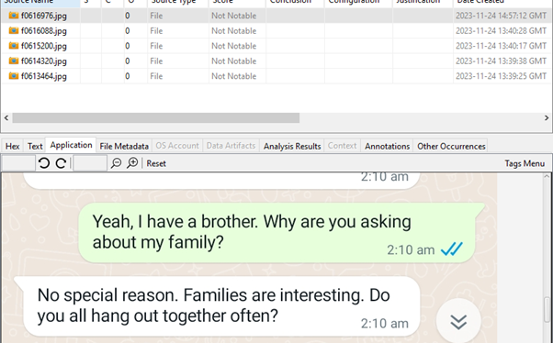
If the aforementioned screenshots were from the sender’s side of the conversation I think that those files could be used to possibly try and piece together the real identity of the criminal who participated in cyberbullying, however as the messages are captured from a recipient’s point of view I do not think it is the case. It is possible that the criminal could have obtained these files and saved them to a drive, but I do not consider this to be a logical conclusion to come to, and I have seen no evidence that could suggest this possibility. With this in mind, I will of course continue to analyse these files of an organizational nature, but I will not be considering them as crucial evidence towards the potential identity of the perperator.
There are lots of screenshots of these messages between these two users, some of which are innocent, and some of which seem to be conducted with the intention of gathering information, such as this one on the right.
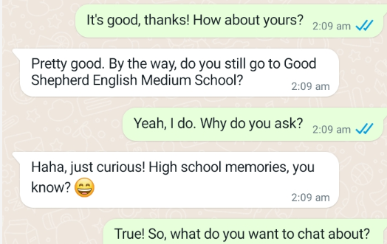
The reason I suspect SM of messaging EM as multiple different accounts is due to the fact that inbetween separate conversations with people that EM does not know, SM continually references information obtained through other conversations. This indicates two major possibilities, either SM is part of a group of individuals harassing this user, or SM is using multiple accounts to message EM. I think given the context of SM’s goal, the latter is the logical conclusion. (Timestamp for image on the right is 22:18)
22:15, same as previous, exif metadata, from android, carved. Below is another screenshot from the same conversation where SM brings up personal information that was never provided to them (it was given in a different conversation with a different user)
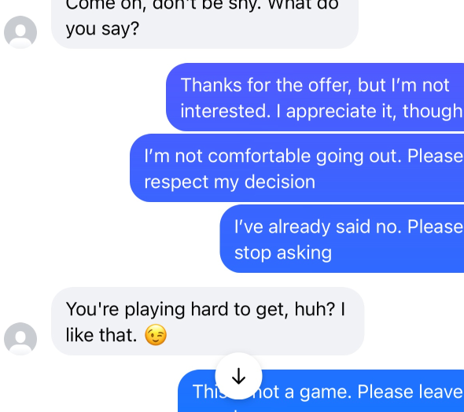
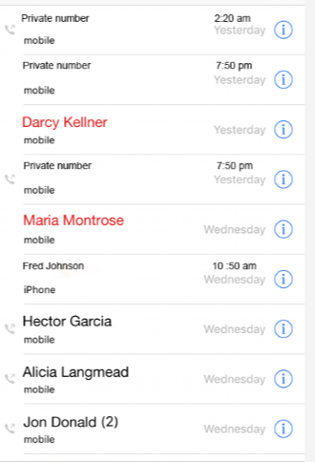
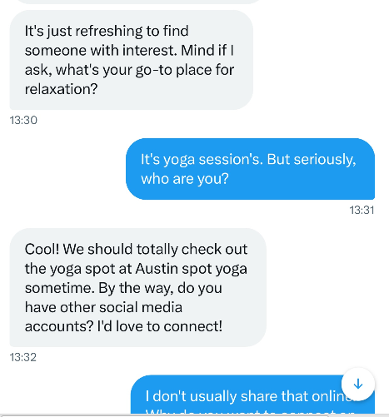
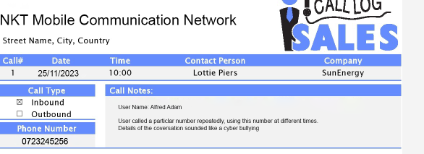
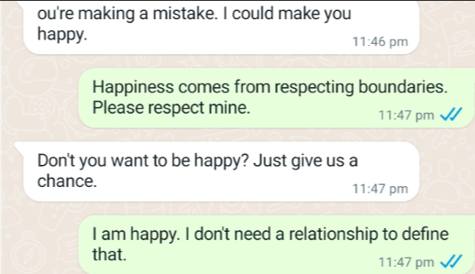
22:20, Next is to Justine elias (a likely alias of SM) which is someone turning down romantic advances, probably same device

22:23, screenshot of call logs involving cyberbullying. This will be relevant soon as the phone number for EM is obtained by SM using phishing. There are two other names associated with this call log report, Lottie Piers and Alfread Ada

22:25, unprompted harassment from another user called Lee Saint, asking the user to go for coffee. This may be related to the fact that EM told SM they liked coffee in a prior conversation
22:24, SM pushing for information from EM

22:24, Screenshot of calls from a private number, possibly related to call logs from before
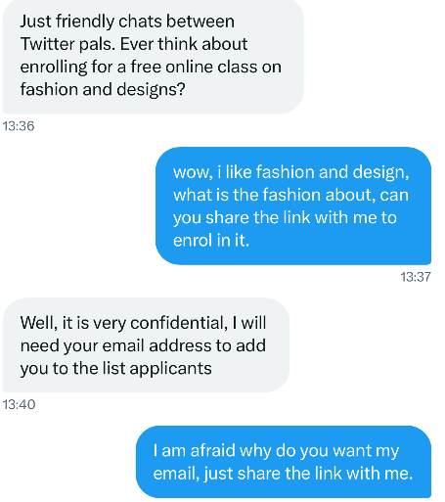
The next piece of evidence [fig.1] is very important to the investigation. This is the leadup of a conversation that leads to SM sending what I am certain is a phishing link leading to a credential harvesting site. The user openly voices concerns with sharing details with SM, to which SM gives ambiguous answers in response. When the user continues to refuse to provide an email, SM likely creates a fake page for a fashion course, to which EM enters various details including email and phone number [fig.2].

22:25, fig.1
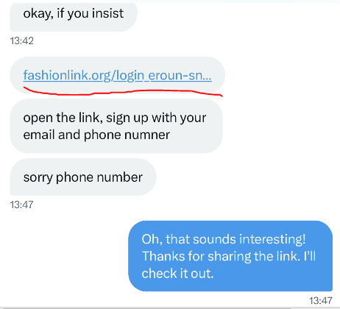
Credential harvesting is a common tactic used by attackers to gain usually essential information on victims. In this case, it was used by SM to gather the user’s email and phone number, at the very least. It is likely that more details were obtained, and this may be prevalent later on.
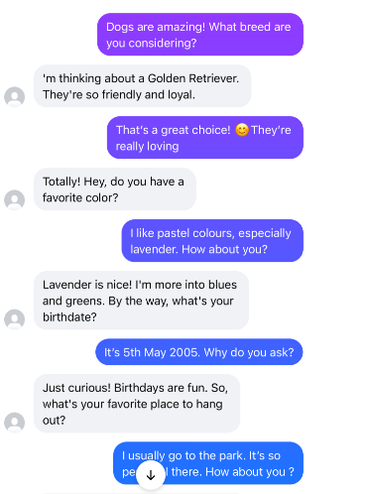
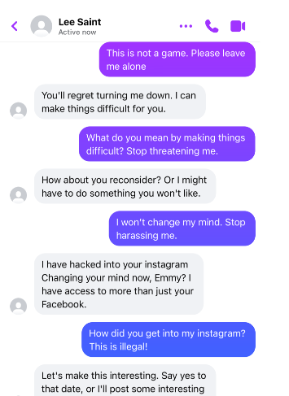
22:25, fig.2

22:28, this is a conversation with Fred William, in which the user gives some information about themselves. They provide their favourite pet, colour, and importantly, favourite place to go, and their date of birth.

22:27. This is a further conversation with Lee Saint. Lee manages to compromise EM’s instagram account, referring EM as “Emmy” which is where I have gleaned their name from.

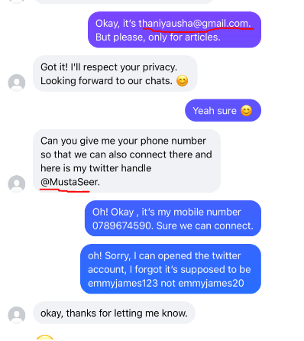
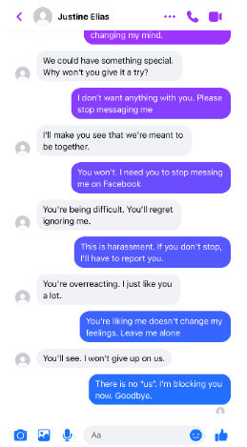
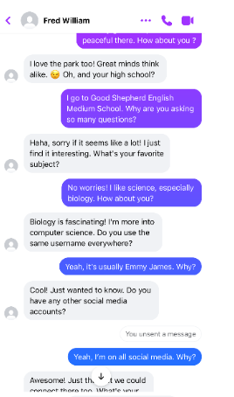
22:30, Fred, who we can now see is Musta Seer, has obtained EM’s email and phone number
22:31, the user is harassed again by Justine, who makes vague threats, and is then blocked by EM
22:29, Screenshot of the user providing information to Fred such as their full name, school, favourite subjects, and usernames for other social media platforms.
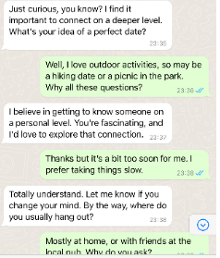
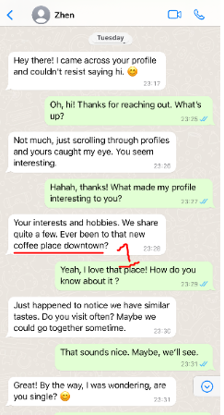
22:32

The user is messaged by another new account on Whatsapp, saying that they came across the user’s profile and wanted to say hi. During the conversation they refer to information given in prior conversations again, which is a common pattern during this investigation, which I have marked with 1.
22:33, Zhen attempts to discover information about where they are likely to encounter the user, and later expresses interest in finding them there.
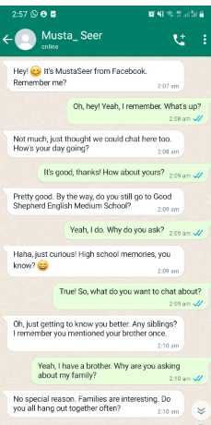
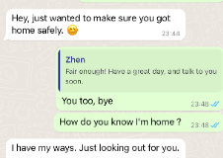
Following this, they pivot the conversation towards a potential romantic interest.

Tentative Evidence
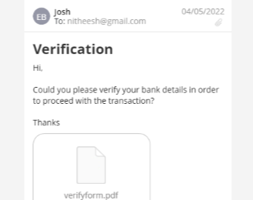
Present on the drive is a file containing lots of card details for several people, including “Damon Haley”, “Bayley Messner”, “Conley Tijernia”, “Cypress Kain” and “Vinh Casiano”. This, although suspicious, does not seem to be relevant to my investigation. It is likely related to poor information governance from the organizational side of this drive.
22:38
22:33, Zhen intentionally being vague and attempting to intimidate the user.
22:34, this is important because it links Musta_Seer with the other accounts definitively as he has information that was only provided to those accounts, and not to SM.

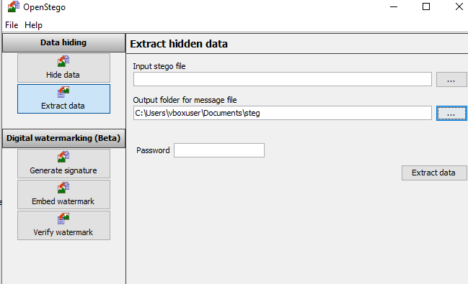
There are a couple of very suspicious looking .bmp and .png files present on the drive, which I initially suspected to be hiding data inside using steganography. However, I have been unable unpack them. I had another look at the file and compared the file size of both files to the dimensions of the images themselves, and although they do seem to be prime targets for steganography, the file size does line up with the actual dimensions for the images. I unfortunately cannot get OpenStego to work, it continually returns this error message:
03/05/2024, 18:26, attempting to use Open Stego and getting below error message.
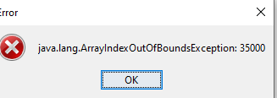
I also tried some of the extracted texts from the file itself as passwords for reverse steganography, but this also did not return any results.

Timeline
Ideally, I would have liked to added timestamps to the various events occurring in the timeline, but unfortunately, the text messages only contain information about the time of day, and do not have timestamps for the date. This means that it is more difficult to build a timeline.

I could have used the screenshot file timestamps, but I found this to be inconsistent with the times that the messages themselves were sent.

I can, however, find when the timeline ends. The call logs report captured previously is taken from the 25/11/2023, so I can conclude that is when the phone harassment was taking place.
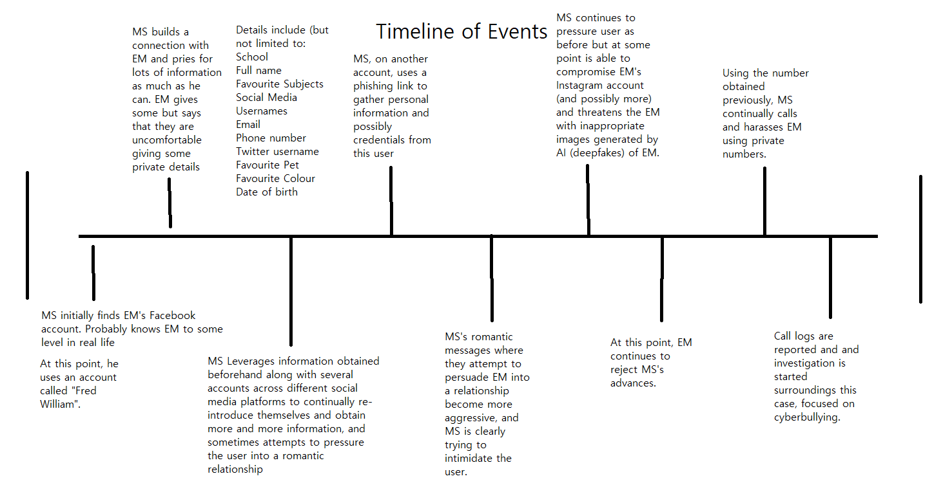
25/11/2023

Conclusion
EM, or Emmy James, was harassed and cyberbullied by SM, AKA Musta Seer. Although SM’s intentions may have initially seemed innocent, I believe it was always his intention to utilise social engineering and phishing techniques to gain access to personal information on EM without their knowledge/consent.
SM utilised several accounts, along with fake websites used as credential harvesting for SM’s motives. SM sought to harass and threaten EM into beginning a romantic relationship with him, and when he was continually rejected despite his efforts he resorted to cyberbullying and directly harassing EM with phone calls.
I believe I chose a good array of tools. Autopsy, which was the main software I used was invaluable throughout every stage of this investigation. I would use it again given the chance, however I would also like try commercial tools, like FTK.
I think my time management with this investigation and report could be better, I invested a lot of my time in the wrong places, which has led to some aspects of my investigation being hastily done. An example of this would be the steganography aspect of my report, in which I could have spent considerably more time. I likely missed something which may have been able to tie together a lot of other miscellaneous evidence from the investigation.
Reference List
- https://online.champlain.edu/blog/evolution-digital-forensics
- https://www.open.edu/openlearn/science-maths-technology/digital-forensics/content-section-4.2
- https://www.gov.uk/government/organisations/forensic-science-regulator
- https://www.quora.com/Is-digital-forensics-the-same-as-computer-forensics-Why [Pujan Shah’s reply is what I am using as a reference here. The reply is 7 years old but I have sense checked it and believe it to be a valid reference in this instance]
- https://www.cameraforensics.com/blog/2020/02/21/digital-forensics-what-you-need-to-know
- https://www.bluevoyant.com/knowledge-center/understanding-digital-forensics-process-techniques-and-tools
- https://www.quora.com/What-is-digital-forensics-and-what-are-its-scopes [sense checked]
- https://online.fliphtml5.com/rllbc/zdmn/#p=3
- https://ora.ox.ac.uk/objects/uuid:6d1260fd-b8ee-4a11-8a5f-e7708d543651/files/m0e5334ee23f2b6390f1a69c5d791e618
- https://www.ncbi.nlm.nih.gov/books/NBK551677/

