FIRNN

FACIAL IMAGE RECOGNITION NEURAL NETWORK

Samia Assebab

Contents
Product Information Document 3
Objectives 3
Scope 4
IN THE SCOPE 4
OUT OF SCOPE 5
Constraints 5
Staff 5
Budget 5
Ethics 5
Time 5
Authority 6
Resources 6
References 7

Table of figures
Figure 1 3
Figure 2 4
Figure 3 6

Project Initiation Document

The purpose of this document is to define the necessary processes taken to advance the FIRNN project into a commercialised product. The document will briefly outline and clarify the objectives, scope, constraints, authority structure and recourses. It is designed to assess the progress and success of the project and highlight areas of weakness.

Objectives

Facial image recognition neural network (FIRNN), is a functional prototype which aims to completely replace all manual attendance registers with an automated virtual facial recognition service. The traditional method of physically writing attendance sheets [1], relies on physical input into multiple systems, making it prone to human error [2] as well as being a paper heavy task.
The production of functional code is the most important aspect of the project [3]. As project objectives are highly reliant on functional software, thus the focal point is the software development within a realistic time scale, as well as:
- Development of a basic model

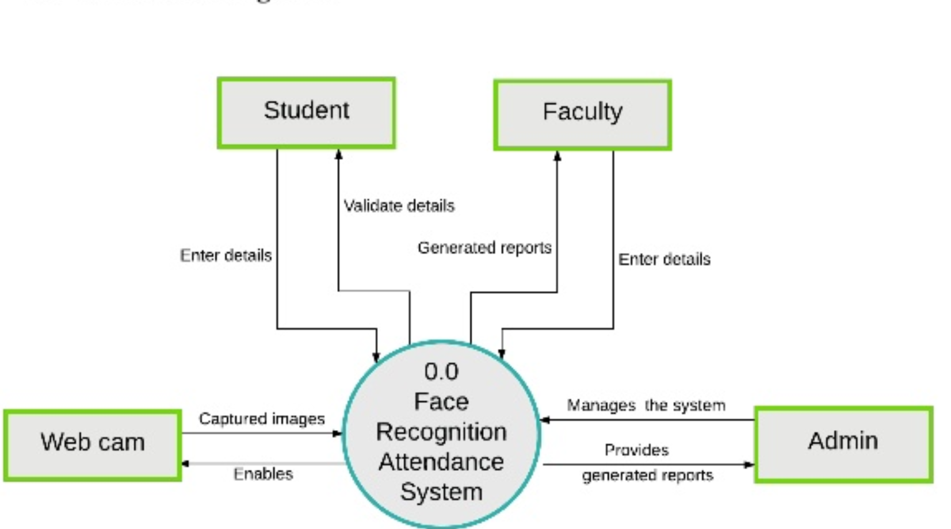
Figure 1- Context level diagram of FIRNN model
- Identification of benefits and development in line with market demand
- An estimation of product cost at both manufacturing and distribution level [4]
- Development of long-term strategies for sustaining FIRNN [5]
- The engagement of all stakeholders in the development of FIRNN

Scope

The scope will assess the expectations of the project and the expected model at different stages.

In the Scope
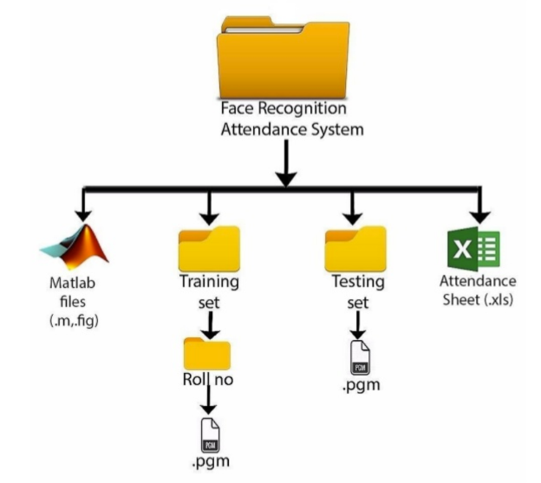
- Introduce and embed FIRNN as an interactive platform between client and user, FIRNN will enable the client to view attendance as well as duration in class, and patterns in attendance.
Figure 2 – An example of how user will view the data.
- Both client and user can view attendance in percentage as well as prompts for when they have missed classes consistently, and ways in which to improve performance.
- The program will send automated reports to the client about data capacity
- Hosting can be provided by the FIRNN organisation for extra subscription fees
- FIRNN will provide all necessary equipment to install and run as well as a client policy
- FIRNN will continue maintaining and updating the system when necessary

Out of Scope
- FIRNN will not facilitate the consumer with data storage or the appropriate specifications for installing the service
- A user interface is not included in the program, nor is a user policy
- Recovery and maintenance are not included in the program
- Contact points are not available
- Technical support is not available

Constraints

Staff
There are many limitations upon the project, as the lack of advanced software developers available restricts the model to a very basic prototype. For the project to reach completion within the projected timeframe, many functions are removed or reduced to a basic level.
The average start-up tech company employs no less than 40 people, according to the business insider [6] with the project only having one lead developer, this means full potential cannot possibly be reached.

Budget
Another constraint is the budget, as the project is in its early stages an appropriate projection of expenditure has been unsuccessful, this poses the threat of preparing a project which is fiscally unattainable.

Ethics
The ethical dilemmas of the system, means creating a software which takes that into account, establishing a secure system is highly important. However, the lack of security specialists on the team means the probability of a security breach is greatly heightened [7].
Both time and staff shortage mean there is an increased workload on the existing team members to learn alternative methods to satisfy security and data legislations [8]

Time
The projected time frame poses many disadvantages as already highlighted. Another disadvantage is conflict of interest between group members, the lack of staff means a higher workload for each member. Creativity is also affected as there are too many basic tasks to complete before any creative input can be implemented [9].

Authority

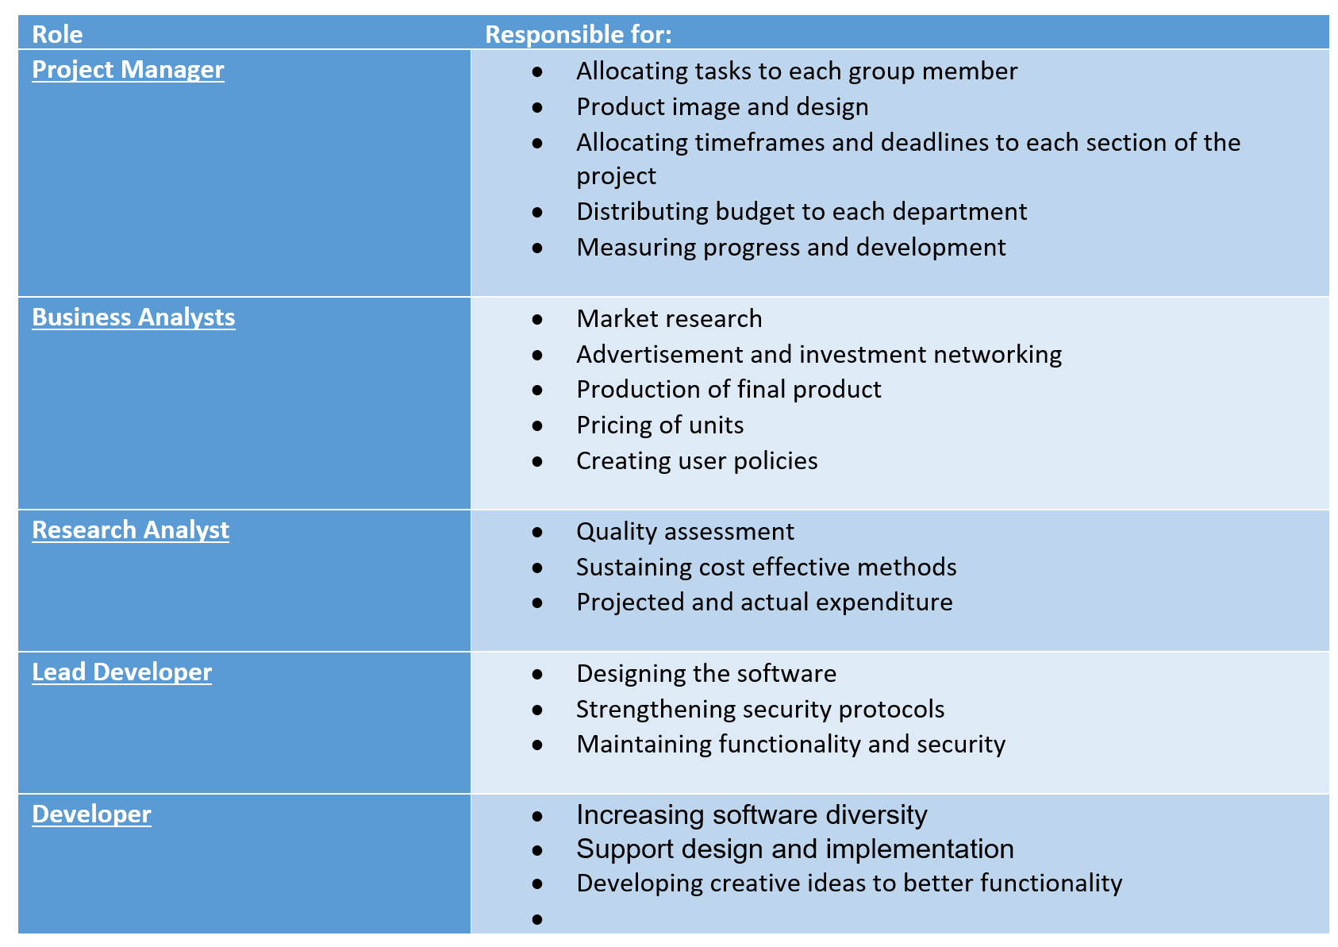
Figure 3- Authority structure

Resources

The complexities of this project mean that it is difficult to compile an accurate list of requisite resources at this stage. However, we speculate that it might include the following:
- Biometric cameras
- 32 GB ram processors
- 4 software developers
- Consistent cashflow via investors

References

[1] | A legal requirement and ISI standards for day and boarding schools and EYFS providers, “PROCEDURES FOR MAINTAINING ADMISSION AND ATTENDANCE REGISTERS,” EYFS, 2017.
[2] | K. A. Barchard, “The impact of data entry methods on data accuracy and statistical results,” in preventing human error, Amsterdam, 2011, pp. 1834-1839.
[3] | J. Hughes, “Research Topics in Functional Programming,” Addison-Wesley, 1990.
[4] | PROJECT MANAGEMENT FOR DEVELOPMENT ORGANIZATIONS, “Project Budget Management,” pm4dev, 2015.
[5] | G. B. D. &. S. A. S. Rajiv D. Banker, “ Software Development Practices, Software Complexity, and maintanace,” University of Minnesota, 2018.
[6] | M. L. Libes, “Business Insider,” University of Washington Center for Commercialization, 14 Decemeber 2011. [Online]. Available: https://www.businessinsider.com/heres-what-the-average-tech-startup-looks-like-2011-12?r=US&IR=T. [Accessed 03 December 2019].
[7] | R. C. Joseph, “Data Breaches: Public Sector Perspective,” IT Professional, 2018, pp. 57-64.
[8] | Privacy Interantional, “The Keys to Data Protection,” in A Guide for Policy Engagement, London, Privacy International , 2018, pp. 9-11.
[9] | P. &. N. T. &. P. V. Paulus, “Some rules for the road to innovation,” Group brainstorming and teamwork: Some rules for the road to innovation, pp. 69-86, 2006.

