
Master of Business Administration
Human Capital Management

LCMB7023
Assessment component 1:
Individual report – HR strategy

Chosen option 1: Re-Engineering Performance & Job Design
Application on Aether Innovations

Student Name: Chaklashiya Dhruviben Mukeshbhai
Student ID: 2431413

Words: 2662
Submission date: 20th March 2026

Table of Contents
Part 1: Option 1: Re-Engineering Performance & Job Design 3
1.1 Examination of current practices in performance appraisal and job design approach in the company 3
1.2 Propose a modern and growth-focused system of performance appraisal: 360 Degree feedback 5
1.3 Job analysis and propose the job description and specifications for six key positions 7
1.4 Explanation of how these two systems connect to create a performance-driven culture. 10
Part 2: Reflection 11
2.1 Learning journey 11
2.1.1. Concrete Experience 11
2.1.2. Reflective Observation 12
2.1.3. Abstract Conceptualization 12
2.1.4. Active Experimentation 13
2.2 Plan to stay relevant 13
Reference List 15

Part 1: Option 1: Re-Engineering Performance & Job Design

1.1 Examination of current practices in performance appraisal and job design approach in the company
Performance appraisal practices of Aether Innovation
OKRs (Objectives and Key Results) as a new performance appraisal tool is extensively used by SME technology companies such as Aether Innovations. According to Silva and Souza (2023), this method focuses on goal alignment, ongoing feedback and measurable results and helps firms to be dynamic in the competitive markets. Silva and Santos, (2024) also stated that the employees are evaluated according to well set targets, which are usually reviewed after every quarter, which increases transparency and accountability. For example, Intel is a large-scale tech organisation, using the strategy for performance appraisal.
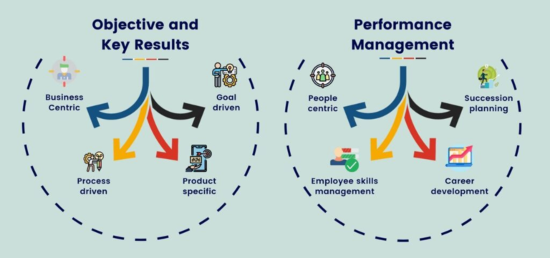
Figure 1: OKR appraisal management process applied by Aether Innovation
(Source: Datallifence AI, 2025)
OKRs can be used to foster motivation mainly using the Ability-Motivation-Opportunity (AMO) Model because individual efforts are correlated with organisational performance and rewarded (Vuong and Nguyen, 2022). They also endorse ability by determining gaps in performance and directing the development of the skills through feedback. In contrast, Vskill (2026) argued that the organisation faces some kind of bias and subjectivity in the appraisal of performance. Poorly designed OKRs or overambitious goals of the organisation, make people demoralised, leading to stress and dissatisfaction. Also, the lack of equal feedback in a firm can undermine the ability dimension since the employees lack sufficient support in terms of development (Vuong and Nguyen, 2022). Also, there is a limited opportunity for employees, so they lack adequate freedom or resources to meet their goals, and this restricts the performance effectiveness.
Job Design Practices analysis using the AMO model
The job design in the SME tech companies like Aether Innovation is flexible, autonomous, with multi-functions. Employees are supposed to work on different tasks, work in teams and they should be fast in adapting to the changing project needs (Gibb’s 2022). This is an adaptable design that facilitates innovation and quick problem-solving which is critical in a high-growth setting.

Figure 2: AMO model
(Source: self-developed and idea taken from Vuong and Nguyen, 2022)
According to AMO, flexibility in job design is beneficial in terms of opportunity as it provides more involvement in the decision-making process and motivates involvement among employees (Vuong and Nguyen, 2022). It is also able to enhance competence by exposing an individual to diverse activities, which promote lifelong learning. For example, Google and Amazon use the AMO model in their job design to attract applicants. However, John Doerr (2018) stated that in the organisation, the roles are not well defined, and this usually creates role ambiguity and work overload, which has a detrimental impact on motivation. Workers can experience stress or a lack of expectations, which diminishes productivity and increases turnover.

1.2 Propose a modern and growth-focused system of performance appraisal: 360 Degree feedback
As per Vuong and Nguyen, (2022) 360-degree feedback is a modern and growth-focused performance appraisal approach which can measure the limitations of the OKR approach and improve performance appraisal. The implementation is done using the following stages.
Goal setting
Observation and documentation
Multi-source feedback collection
- Peer
- Subordinates
- Supervisors
- self
Structured and standard evaluation
- Competency frameworks
- Rating scales
Feedback discussion
Anonymous feedback
Action plan
HR monitoring
Development Planning
Feedforward approach
Figure 3: 360-degree performance appraisal proposed model's blueprint
(Source: self-created)

Goal alignment and planning:
Employees have set objectives and key results (OKRs) that are in line with organisational goals. This will make sure that performance can be measured and strategically applicable at the start of the appraisal cycle (Meynhardt et al., 2024).
Multi-source feedback collection
Supervisor, peer, subordinate and self-assessment are used to collect the feedback. This offers a comprehensive perspective of employee performance, which will minimise bias in a single-rater perspective and enhance more accurate evaluation.
Organised and standardised assessment system
Employ similar rating scales and competency frameworks, such as teamwork, communication, and innovation. This will be fair and comparable among teams in the organisation.
Anonymous continuous feedback
Feedback by peers and subordinates must be anonymous to promote honesty (Vuong and Nguyen, 2022). The reviews are to be done quarterly in order to aid continuous improvement as opposed to annual appraisal.
Planning for development after the feedback discussion
Managers hold individual meetings on which they discuss the feedback results. Productive insights are provided to the employees, and they also develop individualised development plans in cooperation.
Feedforward approach
Concentrate on future performance enhancement instead of concentrating on mistakes. This develops a growth culture and increases employee motivation.

HR monitoring
HR makes sure that there is proper training on how to give feedback, manages bias, and ensures consistency in the process. This enhances the effectiveness and trust of the system.

1.3 Job analysis and propose the job description and specifications for six key positions
By application of the Job Characteristic Model, the job analysis method of Aethan Innovation has been designed. As per the model identified, the skill variety, task identity and task significance impact the work meaningfulness (Meynhardt et al., 2024). Similarly, autonomy improves responsibility, and feedback improves knowledge of results, and these improve motivation, employee performance and satisfaction level. Each role focuses on transferable skills such as leadership, digital literacy and innovative mindset. One of the important skills is the communication and collaboration skills among each of the departments (Meynhardt et al., 2024). The job description consists of a combination of skill utilisation, autonomy and feedback based.
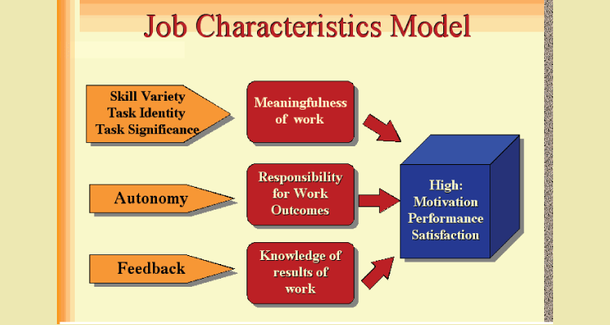
Figure 4: Job Characteristic Model
(Source: Vskill, 2026)
Position 1: CEO
Job description: In the forefront of strategic vision, development and culture of the organisation. Should be an innovator on decision-making, stakeholder involvement and long-term sustainability development.
Job specification (Skill): strategic leadership, data-driven decision-making ability, technological knowledge, industry expertise and strong communication ability with critical thinking.
Design focus: Providing autonomy in decision-making, broad skill variety in strategy development, leadership, innovation and feedback from stakeholders.
Position 2: CFO
Job description: Financial planning management, financial decision-makings, risk analysis, budgeting, development of investment strategies, data-driven decision-making.
Job specification (Skill): Financial background, deep understanding and experiences, analytical, risk management, good know-how in regulation factors, technical know-how in financial software application.
Design focus: Ability in financial analysis and financial strategy development, independence in the financial planning and feedback in the form of financial performance.
Position 3: CTO
Job description: Review and monitor the technological strategies, plan for adopting new technologies, product development, innovative designs, and lead the engineering team.
Job specification (Skill): Technical skills and expertise in hardware and software. Innovation management ability and knowledge, leadership skills, problem-solving ability, critical thinking and collaboration ability (Gary Dessler, 2020).
Design focus: Higher autonomy is provided in technical decision-making, a variety of skills are required for technical assessment, and high task identity is achieved by using the entire product development process.
Position 4: CIO
Job description: Leading the innovation strategy of the organisation and making innovation strategy, new product or service development, creativity and innovation-led culture development within the organisation, continuous improvement and team collaboration.
Job specification (Skill): Strong innovative skills and technical knowledge, innovative mindset, inspirational or motivational ability, creative thinking, analytical skills and cross-functional collaboration.
Job design: High autonomy in innovative decisions, stronger skill variety, continuous feedback through innovative outcomes and high task importance.
Position 5: HR Director
Job description: Leading talent management, HR team management, employee engagement, HRM practices design, HRM strategy development, and organisational development strategy. In charge of overall recruiting and development of the employees.
Job specification (Skill): HR experience, excellent communication skill, high level EQ, leadership skill and change management skill.
Design focus: skill variety during the recruitment and training, culture development, autonomy in developing HR policies and feedback through employee engagement metrics.
Position 6: Head of R&D
Job description: researching ability and new product designing with innovation and follow the current market patterns.
Job specification (Skill): Cooperation and collaboration with CTO and CIO an experience and skill in research, creative thinking and project handling experiences.
Job focus: Higher autonomy and creativity during product development designing, strong task identity in the ideation of products and a high skill variety in innovation.

1.4 Explanation of how these two systems connect to create a performance-driven culture.
To develop a performance-driven culture, it is essential for an HR manager to encourage and motivate employees continuously. 360-degree feedback collection is a highly effective option. It helps to know the current preferences of the employees (Souki and karkoulian, 2025). Understanding the employee preference through feedback collection shows that the company is ready to fulfil the need to get the desired outcome from the employees. 360-degree feedback helps to identify the current training program which required by the employees for better growth and contribution. At the same time Job Characteristics Model helps to identify the current working system which preferred by the employees. Integrating these two models in one workplace develops a highly productive team. As per, Stoermer, Lauring and Selmer, 2022), The Job Characteristics Model successfully meets the psychological needs of the employees. Knowledge-based results designed by the HR manager which ensure that employee job satisfaction rates increase. As per, Souki and karkoulian (2025), A 360-degree feedback collection strategy provides the knowledge that, currently, employees prefer to get autonomy in the workplace. The Job Characteristics Model support to offer autonomy to the employees. Involving the employee in the decision-making procedure is also supported by the Job Characteristics Model (Stoermer, Lauring and Selmer, 2022). From the current feedback analysis, employees prefer to get a position in the decision-making procedure. Sharing the power of the employees increases the responsibility to improve performance.

Part 2: Reflection

2.1 Learning journey
Based on my current learning experience from this module, I am going to share the learning and development approach that I am going to follow further to cultivate a culture of innovation and a growth mindset.
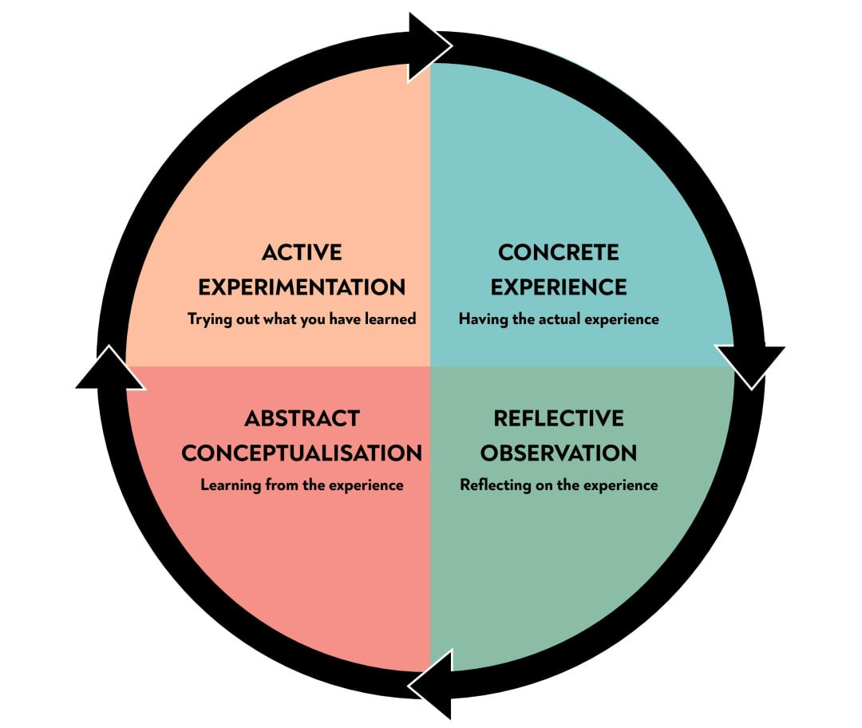
Figure 5: Kolb’s Learning Styles
(Source: McLeod, 2025)

2.1.1. Concrete Experience
This module helps to recognise my current strengths and weaknesses, which I need to improve further to grow in a professional area. This module helps me to act as a mirror which shows where I am currently incapable to get desired job. Increasing self-awareness in the first place is highly essential. I learned that innovation is currently the main priority of the organisation for organisational resilience. For long term growth, innovation and creativity are highly essential. It increases my interest to experiment with several new facts and points. Now my attitude shifts from innovation to learning procedure. This module helps me to learn that now, without the help of innovation and creativity, it is not possible to sustain an organisation in the competitive business market. Every organisation is now developing a digitally integrated working system (Al-Alawi et al., 2021, December). I have started to understand innovative culture, which is now followed by multiple organisations with high prospects in the market. This learning journey is transformative for me. Previously, I preferred to follow traditional working practices, which is time consuming. As the convenient rate of digital technology is high and it is preferred by most of the organisation I have planned to develop this skill in future.

2.1.2. Reflective Observation
This module helps me to develop clear knowledge about the current tools and technologies that are used by the organisation. It helps me to learn that innovation comes with a stable process, which requires a strong IT Infrastructure. Without the help of a strong infrastructure, it is not possible to integrate an advanced system. I also develop curiosity to know about the threats which associate with the use and application of advanced technology. Because I have found that technical glitches can cause a safety concern among the customers (Wicks et al., 2021). Further, I have a plan to engage in the continue upskilling protected to ensure that I am viable enough to work in a digitally integrated working system. A fast-changing environment required to develop strong knowledge about the current system. I will actively seek feedback from colleagues and members regarding the skill improvement procedure. It helps me to refine ideas and strengthen the resilience process. Also, with this, I have decided that I will get engaged in the innovative projects to test my ideas. It is the best practice to identify one flaw.

2.1.3. Abstract Conceptualization
During this module, I get engaged in the concept of innovation and the innovative culture model, which is currently used by the organisation. It helps me to develop a clear perspective about the current organisational culture (Atlassian, 2024). I have identified that innovation encourages experiments and improves organisational process designs. I have noticed that to develop an innovative mindset, it is essential to have strong critical thinking skills, problem-solving ability and decision-making skills. Currently, I am not capable of thinking critically. However, I am interested in developing these skill sets. I have plans to further work in a cross-cultural team, to boost the growth mindset. It helps me to develop diverse ideas which I can utilise in my personal and professional growth.

2.1.4. Active Experimentation
I have a plan to develop the idea that to work in an innovative culture, it is essential to improve the above -mentioned skill, which is lacking. I believe that participating in brainstorming programs can help me to develop this skill in the next 6 months. On a daily basis, I will participate in a brainstorming program. It helps me to propose new insights and ideas for better strategy formulation. Along with this, I have decided that I will improve my technical skills by participating in online classes. There are several online courses available. I will join a free 6 to 12-month course to improve my technical abilities. It helps me to identify the data management, data structuring, and data reporting systems technically. To work in an innovative work culture, developing skills and mind are both important (Atlassian, 2024). I believe that the proposed plan is highly relevant to the market standards.

2.2 Plan to stay relevant
As per, Atlassian (2024), to stay relevant in the job market, it is highly essential to develop technical skills. Without the help of developing technical skills, it is not possible for me to get the desired job roles. AI technology is capable of handling multiple tasks at the same time. As per, Al-Alawi et al. (2021, December), It works in a structured manner and reduces repetitive tasks. To stay relevant in the market, it is essential to develop a creative and original skill set to impress the HR manager of the organisation. From the recruitment strategy of IBM, it can be said that the hr manager of the organisation tests the technical skills of employees (Al-Alawi et al., 2021, December). There is a particular segment in the recruitment procedure related to technical skill sets. Wicks et al. (2021), critically analysis that there are several companies is now following the same strategy to successfully pass the technical skill set. It is important to develop a clear and strong knowledge of technical systems to handle the tasks.
There is a particular procedure to use AI in the market for assistance, not as a replacement. The key to use AI as a collaborative tool to improve the work process is to develop a routine task practice (Atlassian, 2024). I will suggest AI to complete the repetitive task to save my time. It helps me to focus on another important task. As per, Wicks et al. (2021), The employee of amazon company is sharing the insight that they use AI technology for draft reporting, summarising the report and automatic workflows. Following this strategy in my workplace helps me to get the guidance to complete tasks on time in an efficient way. Application of AI technology as a research tool is a highly market-relevant decision. It helps to provide rich insights about the market. Mainly, this strategy is used by marketing companies. The HR manager instructs the employees to use AI for market research, trend analysis and customer behaviour analysis. Expert knowledge on task management can help to achieve this goal.

Reference List
Al-Alawi, A.I., Naureen, M., AlAlawi, E.I. and Al-Hadad, A.A.N., (2021, December). The role of artificial intelligence in recruitment process decision-making. In 2021 International Conference on Decision Aid Sciences and Application (DASA) (pp. 197-203). IEEE.
Atlassian (2024) Objectives and Key Results (OKRs) Guide. Available at: https://www.atlassian.com/team-central/project-planning/okrs⁠ (Accessed: 19 March 2026).
Datalligence AI, (2025). OKR Based performance management. Available at: https://datalligence.ai/blogs/okr-based-performance-management-system/ [Accessed on 20th March 2026]
Gary Dessler (2020) Human Resource Management. 16th edn. Harlow: Pearson Education.
John Doerr (2018) Measure What Matters: How Google, Bono, and the Gates Foundation Rock the World with OKRs. New York: Penguin Random House.
McLeod, s., (2026). Kolb’s Learning Styles and Experiential Learning Cycle. Available at: https://www.simplypsychology.org/learning-kolb.html [Accessed on: 20.3.2026]
Meynhardt, T., Hermann, C. and Bardeli, J., (2024). Connecting value creation for society with work engagement: the relevance of an organization’s public value as an extension of the job characteristics model. Current Psychology, 43(27), pp.23260-23277.
Silva, R. and Santos, G., (2024). Surveying the academic literature on the use of OKR (Objectives and Key Results)–An update. iSys-Journal of Information Systems, 17(1), pp.4-1.
Silva, R.V. and Souza, G.D.S., (2023), May. Surveying the academic literature on the use of okr (objective and key results). In Proceedings of the XIX Brazilian Symposium on Information Systems (pp. 427-434).
Souki, k., aad, s.s. and karkoulian, s., (2025). The impact of 360-degree feedback on innovative behavior within the organization: the mediating role of organizational justice. International journal of organizational analysis, 33(3), pp.584-602.
Stoermer, s., lauring, j. And selmer, j., (2022). Job characteristics and perceived cultural novelty: exploring the consequences for expatriate academics’ job satisfaction. The international journal of human resource management, 33(3), pp.417-443.
Vskills, (2026). Job Characteristics Model. Available at: https://www.vskills.in/certification/blog/job-characteristics-model/ [Accessed on 20th March 2026]
Vuong, T.D.N. and Nguyen, L.T., (2022). The key strategies for measuring employee performance in companies: a systematic review. Sustainability, 14(21), p.14017.
Wicks, a.c., budd, l.p., moorthi, r.a., botha, h. And mead, j., (2021). Automated hiring at amazon. Https://papers.ssrn.com/sol3/delivery.cfm?abstractid=3780423

