Knowledge and Information Management Skills for Workplace
BMSK 5006

Student Name: Mustafizur Rahman
Teacher Name: Dr Md Nazmul Hasan
Student ID: 1711957
Group: 1

Part – 1
1. Explain why the same set of data can be considered as useful information by some and useless data by others. Further, could this useful information be termed as “knowledge”? Why?

What is data?
Data refers to small and distinct pieces of information which can be used, applied and formatted in whatever way necessary (Gitelman, 2013). There are several forms of data and this could involve facts in a person’s mind and texts/numbers on a piece of paper.

Why is data which is useful information to some and useless to others?

The data which is derived from a particular source could contain all kinds of information which some people may understand and others may not. If an individual is unaware of the source of the data and therefore the value and the importance of the data, such an individual would consider the data, whether it is large or small, meaningless (Blackstone, 2010). When data is collected, it is for a particular purpose and is usually used to gain further understanding as well as evidence.

The example which would be used here would be research on cancer patients. If a random individual who is not too particularly familiar which medical terminology may not be able to understand information gathered about cancer patients. For example data collated could be blood type, BMI data, level of antibodies in the body ect. Such information is usually used in the cancer research in order for cancer specialist to formulate diagnosis and work out why majority of cancer patients have become vulnerable to cancer (Du Soleil, 2019). This piece of data which would most likely be on a piece of paper with several data across it including number and phrases, would not be of any interest or value of someone whom is not familiar with this type of research. This particular data has no meaning in that person’s life.

Another example which will be used is in relation to an architecture engineer. Before designing or structuring a new building, the architecture is required to create a drawing of the building which would include data scattered across the page. There may even be high level mathematical calculations. Of course the data presented would be related to the building itself, though for many the data may be understandable but not useful. A person with limited knowledge in this sector work would understand what to do with the data and therefore would not find the data to be useful.
Therefore, the level of importance a person places on a piece of data would vary amongst people. By just seeing numbers and a few phrases will make it very difficult for a random individual to interpret the data and is therefore not valuable for them. However for a person whom has knowledge regarding such data is able to interpret it, will hold such data with great importance as he or she understands to what future application would require this piece of data (Biasiotti and Faro, 2011).

Could this useful information be termed as knowledge?
The little bits of data a person gathers does not solely provide the human mind with adequate information. When various kinds of data, most likely from different sources is collated together in the appropriate and related context, it could formulate information which could prove to be useful to the individual (Ishikawa and Nakagawa, 2013). By having useful information an individual can develop and foster the quality of their knowledge. Therefore useful information which has implications in one’s life whether this be personal or professional, it will ultimately deliver a person with knowledge in a specific field which of course adds on to the previous knowledge a person had regarding the current topic.

2. Describe the ways in which “knowledge” differs from “data” and “information.” Justify your answer with a relevant diagram.

How Knowledge differs from data and information
Data is what forms the primary foundation of information (Vojtáš, 2013). This could be transactions and recordings which have been transferred from a one human to another or even computer machines. This therefore entails that unless a piece of data is not viewed with the meaning it has, it cannot be understood and neither can the purpose of the data be understood just by looking at it. Once data has been given its context only then can the data become information.
The concept of data is extended by information. Information includes the data as well as any other information a person comes into context with related to that data (Wójcik, 2016). Information like data includes symbols which are combined with complex rules and structures. This therefore shows how information can be accessed in a variety of forms such as diagram, writings and charts.
When a piece of information is retained and accepted by a person, it becomes part of an individual’s knowledge (Refaiy, 2009). The information which becomes part of someone’s knowledge is considered to be true and has a valid interpretation. Specific knowledge such as social knowledge develops once the information has been accepted amongst a group of people. Everyone does not necessarily need to accept the knowledge as to the individual or group, the information is sufficient for them. When information is readily available and broadly accepted it becomes common knowledge.

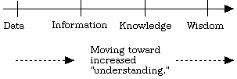
Source:(smith 1999)
3. Does a player in a card game use tacit or explicit knowledge? Explain why. Define and Explain the difference between the two.

Tacit knowledge
Tacit knowledge is the internal part of an individual’s consciousness and is usually attained from associating with others and needs shared or joint activities to be separated for one to another (Refaiy, 2009). It is difficult for an individual to use written or verbal communication for tacit knowledge to be transferred to one person to another. Tacit knowledge involves an individual having skills such as playing an instrument, speaking a language and having basic life skills. so that tacit knowledge can be attained individuals would require to have unique teaching process, long hours of personal contact and dedicated time to improving oneself and reflecting upon it. So that a person can transfer tacit knowledge, the other individual must have a shared experience. In mentoring, tacit knowledge is transferred from tutor to student.

Explicit knowledge
Another type of knowledge is known as explicit knowledge. Compared to tacit knowledge this knowledge can be shared, written done and can easily be comprised somewhere (Rebuschat, 2013). The most basic knowledge is explicit knowledge and the level of accessibility of this kind of data is high. Explicit knowledge is derived from when data is interpreted, organized, structured and processed. In world of knowledge management, explicit knowledge is where knowledge is stored. Examples of explicit knowledge in the context of knowledge management would be the things which surround an individual in the workplace e.g. white sheets and research reports.

What type of knowledge does a card game player use?
Since Tacit and Explicit knowledge have been briefly defined, applying it in the context of a card game is much easier. A player, whom plays a card game, is playing on basis of previous experienced obtained whether this is a few years or days (Wastiau, 2015). This therefore shows that tacit knowledge has a contribution on this. Without the skills and experience a person has performing the game properly would not be successful which Is why knowledge from tacit knowledge is required. Such skills may be difficult for the player to describe and explain to an individual whom is not sharing a similar experience. But when it comes to speaking to a beginner on how to pay a card game, the player would be successful because the person being spoken to and taught is sharing the same experience.
However is can be considered that if the level of experience the player has in the card game varied, then the applied knowledge could change (Learning how to make more effective decisions, 2016). If the player is beginner and does not have any previous experience of playing such a game, he/she would not have any knowledge to comprehend the game. Therefore in this sense the individual learns how to plays cards by attaining explicit knowledge from another person or a instruction manual. Only once the person plays several times can the knowledge used in the game be labelled as tacit knowledge.

4. Consider five decisions you have made today (they could be simple such as taking a turn while driving or even choosing a soda at a convenience store). In each case determine the data, information, or knowledge that were involved in the decision.Five decisions made today
Decision made | Data | Information | Knowledge
Having a shower in the morning | The name is the shampoo and conditioner used. The words on the tap referring to hot or cold. Time of entry in the bathroom. | The information would be related to the data. From the information I had, I knew what products were inside the shampoo and the benefits of using that particular shampoo. By having the data of hot and cold, I derived the information that by turning the tap, I will have either hot or cold water. By entering in the shower with the data of the current time in my mind, I could plan the duration of the shower in order to stay on schedule. | From previous knowledge I know what the outcome would be after having a shower. The shampoo and conditioner will leave my hair nice and smooth and smelling wonderful. This has contributed to believing that these products a perfect for me. From previous knowledge and experience by not keeping a eye on the time, resulted in long showers and getting late for work
Having breakfast | The data derived is the names on each of the products e.g. the brand of the loaf of bread and the labelled tag on the cereal container | By looking at the cereal, I was able to access the information of which cereal I would like to choose. | From previous knowledge I selected the cereal which I though tasted the best.
Shopping at the supermarket | The data which I had was the amount of money I had, the list of items on the shopping list and the number of items for each item | Information is the type of brand of each item which I needed to purchase and the direction of the supermarket, | From my knowledge, I knew my way to the supermarket without a map. Also due to regular visits to the supermarket, where each item was located was stored in my knowledge
Picking up children from school | Data was the time | information was the schools which I had to go pick up the children and times of when each child school finished | From previous knowledge, I knew how to get to the schools and from which area of the school to collect the children from
Preparing dinner | The time and the number of the amount of items which would be required in the dish on the recipe | Information was provided by the instructions given on the recipe sheet | From previous experience of preparing similar food, I knew how the food would turn out.

5. Now consider how those decisions would have been influenced by the lack of pre-existing data, information, or knowledge

Decision 1: Having a shower in the morning
I wouldn’t know what to apply on my hair and without the data of the labels of hot and t may have resulted in me burning myself. Without previous experience and knowledge of time management it was possible to estimate the shower time so that I was not late for work.
Decision 2: Having breakfast
Without the data, information and knowledge available at the time I would not have been able to pick a cereal which was tasty to me and therefore would not have enjoyed my food
Decision 3: Shopping at the supermarket
By not having directions of the supermarket I would not have reached the supermarket in a shorter period of time and without the shopping list I would know what to buy. Also without the data present when purchasing the food would have made it nearly impossible for me to know the prices of the items.
Decision 4: Picking up children from school
Not having information of the location of the schools would mean that I would no be able to pick up the children from school. With the data of the time, I was able to make sure that I go out to pick them up at the right time. Furthermore previous knowledge allowed me to take certain routes to get to the schools.
Decision 5: Preparing dinner
Without information and data given from the recipe, making dinner would be near to impossible. With the data shown on the weighting scale, I could measure the ingredients I needed. Also with previous knowledge of making dinner, I was able to make a delicious dish.

6. You have recently invented a new product. Collect demographic data from a sample population, determine how you would use this data, and convert it into information and possibly knowledge for promoting the product.

Invention of new product
The new product which is being created is a perfume for females which is called ‘Hadstrong’. The information which was gathered enabled the perfect perfume to be made which would suit the needs and expectations for females (Turney, 2010). This was possible from gathering demographic data and a sample of this data will be provided below. With the demographic data which was gathered it was possible for the data to be converted into knowledge and information used for when the item will be promoted.

Does your current fragrance scent last very long? | Yes (75%) | No (25%) | /
Do you spray your perfume on your wrist and neck? | Yes (20%) | No(80%) | /
How much would you pay for a perfume? | Less than £10 (34%) | £11 - £25  (56%) | More than £26 (10%)
What is your age category? | 16 – 30 (64%) | 31-50(20%) | 50+(16%)

From the small sample collated and other questions which was asked it was possible to create the perfect perfume which would most likely result in great sales and popularity amongst the choice of perfume for females. Many females complain that the perfume which they purchase does not stay for long on their skin and neither their clothes. This is a real downside to perfume products because it means that quality is less and the customer therefore much applies more perfume in order to maintain the scent. This therefore, means the consumer must by the product again in a shorter space of time. However the perfume which is being invented does the complete opposite. The chemicals and natural substances used in the perfume will enable the perfume to stay on the skill on the applier as well as they clothes due to attraction of molecules and the change of charges. With specialist working on the perfume will allow this to take place.
Furthermore, many have shown according to the data to not direct their application of the perfume on the wrist but rather other places possibly the entire body with a few sprays. But research suggests that the best way to sustain and obtain the richness and smell of perfume, it should be applied on the wrist and neck. The reason for this is because our pulse points are there. Due to this area of the skin being very warm, the smell will be preserved. Since most people are unaware of this according to the data above, a piece of advice would be provided on the product so that customers become aware of this.
In addition in order to keep a budget on the investment of the perfume finishing out what consumer should prefer to pay for a perfume is essential. According to the data people would like to pay between the price ranges of £11 - £25. This is excellent piece of information because it allows the planning stage of the product to be accurate and within the budget prescribed. Also by applying the common price on the perfume means that customers will not be disappointed by the price.
By asking the age category, it has become possible to create the desired target audience which is between 16 – 30 years of age. Therefore the advertisements made on this perfume would include models within his age category and the platform for marketing will be social media, as social media plays a importing part in the target audience life.
In relation to the advertisement when would be created with this product, the person will be a female, whom will include the several advice mentioned on the bottle, for example spaying the perfume on the wrist and neck. Also the finalised price will be added on the advertisement also. By doing this the target audience would be most likely be interested in product.

References
- Biasiotti, M. and Faro, S. (2011). From information to knowledge. Amsterdam: IOS Press.
- Blackstone, W. (2010). Commentaries on the laws of england, in four books. [Place of publication not identified]: Nabu Press.
- Business knowledge for IT in Islamic finance. (2009). London: Essvale Corp.
- Du Soleil, O. (2019). Excel Data Cleansing. Merritt Island, FL: Holy Macro! Books.
5 Infogineering.net. (2019). The Differences Between Data, Information and Knowledge :: Infogineering - Master Your Information. [online] Available at: http://www.infogineering.net/data-information-knowledge.htm [Accessed 15 Oct. 2019].
- Ishikawa, A. and Nakagawa, J. (2013). An introduction to knowledge information strategy. Singapore: World Scientific.
- Learning how to make more effective decisions. (2016). World Pumps, 2016(12), pp.26-29.
- Rebuschat, P. (2013). Measuring Implicit and Explicit Knowledge in Second Language Research. Language Learning, 63(3), pp.595-626.
- Refaiy, M. (2009). The Effect of Tacit Knowledge Characteristics on Tacit Knowledge Transfer: The Case of the Egyptian Industry. SSRN Electronic Journal.
- S, S. (2019). Difference Between Information and Knowledge (with Comparison Chart) - Key Differences. [online] Key Differences. Available at: https://keydifferences.com/difference-between-information-and-knowledge.html [Accessed 15 Oct. 2019].
- SearchCIO. (2019). What is product development (new product development - NPD)? - Definition from WhatIs.com. [online] Available at: https://www.google.com/amp/s/searchcio.techtarget.com/definition/product-development-or-new-product-development-NPD%3famp=1 [Accessed 15 Oct. 2019].
- Shajahan, S. and Priyadharshini, R. (2004). Management information systems. New Delhi: New Age International (P) Ltd.
- Turney, J. (2010). The invention of race. New Scientist, 208(2784), p.54.
- Vojtáš, P. (2013). Information modelling and knowledge bases XXIV. Amsterdam: IOS Press.
- Wastiau, P. (2015). What Does Learning Prepare for Today? Co-creating Knowledge for Action. European Journal of Education, 50(4), pp.394-399.
- Wójcik, P. (2016). How Creating Shared Value Differs From Corporate Social Responsibility. Journal of Management and Business Administration. Central Europe, 24(2), pp.32-55.

Knowledge and Information Management Skills for Workplace
BMSK 5006

Student Name: Mustafizur Rahman
Teacher Name: Dr Md Nazmul Hasan
Student ID: 1711957
Group: 1

Part – 2 Information System
1. Describe how the overall approach adopted by American Airlines incorporated the basic competitive strategies of cost leadership and product differentiation.

American Airlines and IBM join together with the same idea of Semi-Automatic Business Research Environment acronym of SABRE. The main concept of bringing up this idea was to replace manual process to digitization process. American Airlines applied porter’s generic forces framework tool to enhance their services. According to the statement of Bertozzi (2017), porter’s generic strategies include three different factors, which are ‘cost leadership, differentiation, and focus. The last one is subdivided into two different parts, which are cost focus and differentiation focus. American Airlines uses Cost leadership and product differentiation strategies for developing their competitive marketing strategy.

Figure 1: Porter’s generic strategy
(Source: Hannigan et al., 2015)

Through applying the competitive strategies, American Airlines can try to develop an edge that helps in getting the sales, which ultimately takes the company away from their competitors. Applying cost leadership and differentiation strategy would help the company in increasing their customer base. Researching over uniqueness and developing new idea over services and products can give tough competition to their rivals, so American Airline implies both the strategy to defeat their rivals in share market.

The two porter forces factor implication of American Airlines:

❖ Cost Leadership:

Cost leadership strategy is the process to reduce cost price and increase profit by grabbing consumers while the industry charges average prices. Lowering prices is not always profitable for an organisation as it lowers the annual income of company. American Airlines invented SABRE in the aim of providing high-quality services at lower prices. SABRE is a software tool to calculate baggage weight and tracking bookings which are used for optimizing speed and reliability (Hannigan et al., 2015). This automation system helps American Airline for fast ticket booking and reservation as the customer finds this process comfortable by not waiting over a queue. The main aim of SABRE was to make the reservation process comparatively easier for the company and the customers also. Based on this aim and benefit offered by SABRE, American Airlines decides to include cost leadership strategy, through which the company aims to enhance their profit margin as well as market share, by minimising charges and production cost. The company got success in saving around 30% of the total costing after implementing SABRE in their operations.

❖ Product Differentiation:

Product differentiation strategy is used by marketers to prevent their product for cannibalizing and separates their product from their rival organisation (Hoberg and Phillips, 2016). The differentiation strategy would help the company in differentiating their products or services in various ranges, which creates differences in the product portfolio. American Airlines introduces SABRE for providing reliable and speedy software tool which is different from other Airlines. Cancellation of tickets via messages and telephone calls compelled consumers to opt for only American Airlines. American Airlines provides cheap ticketing within shorter span of time. Therefore, the product differentiation strategy was effective in the growth of the American Airlines business (Jhigh.co.uk, 2019).

2. In what ways did SABRE provide American Airlines with a competitive advantage? Your analysis should refer to concepts related to the strategic use of information systems, for example, entry barriers.
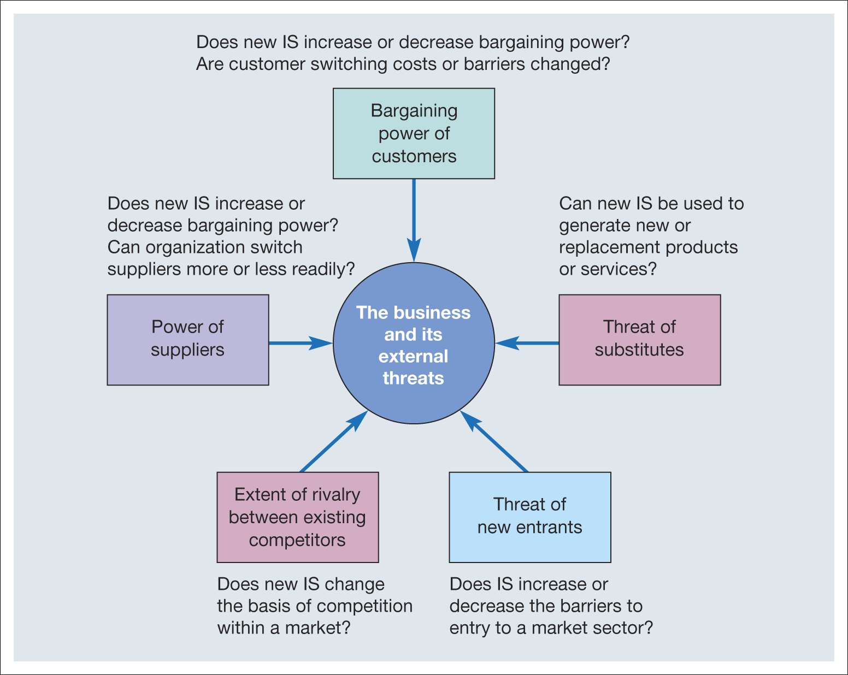

The factors of SABRE provide American Airlines with a competitive advantage.

❖ Comparative Advantage:

The comparative advantage adds uniqueness to their product by competing and comparing the products to the rest of an organisation. This creates a clear persuasion to the consumers to opt for the right services (Bensoussan and Fleisher, 2008).

❖ Threat of new Entrance:

Innovation of SABRE in the market has created threats for the new start up company to enter a market. This technology differs from other organisations, affecting the rivals to restrict the expansion of their business in the market. Therefore the competition increased as American Airlines developed a technology that its Competitive organisations did not have.

❖ Differential Advantage:

Innovating SABRE has added to the uniqueness of the service provided by American Airlines. To increase their target audience a company has to be transformative, irrespective of the latest trends. Transformational changes in their services play an important role in growing customers.

❖ Cost-competitive Advantage:

SABRE gives an advantage over cost-competition. The price of ticket decreasing means the numbers of labourers reduces. The enhancement of SABRE software reduces the dependency on workers and paying wages to workers has become less for American Airlines.

❖ Increasing Customer Loyalty:

The Lowering prices of tickets have earned the trust of American Airlines customers. This created huge business benefits for them, as the new customer became a regular customer of American Airlines (The Hustle, 2018).

Apart from the above, SABRE also provides competitive advantages to the American Airlines through the following ways-
• It helps in understanding the strategies and approaches used by the rival companies.
• Due to the implication of SABRE, the bargaining power of customers becomes lower in case of American Airlines.
• The bargaining power of supplier also becomes lower for American Airlines due to the increasing customer base.
• It reduces the threats of new entrants, as new ventures of start up companies could not implement SABRE at their first operational year.
• The threat of substitute would be medium in this case, as the other established airlines might imitate this tool for making the reservation easy.

3. Although SABRE was undoubtedly successful, American Airlines was not able to maintain its competitive advantage beyond the late 1980s. What factors played a part in the erosion of the company’s lead over its competitors and how did the company react?

During the late 1980s American Airlines introduces “Unlimited AAirpass” strategy to their consumers. The “Unlimited AAirpass” Costs $250k to their consumers allowing them to travel unlimited In the first-class department along with that the addition companion coasted them around 150k.This was the best purchasing ticket price for a 1980s customer. However the unlimited travelling passes failed to provide the million-dollar business with what they has desired, compelling them to revoke the “Unlimited AAirpass”. The American Deregulation Act of 1978 was the main reason for American Airlines to lose pace with their rivals. They’d suffered 76m losses during 1980 due to unnecessary low prices and threatened them to sink in competing with the tough competitors.

The newly elected president Robert Crandall swore to raise American Airlines by implementing different plans. The different plans were to raise capital from their own wealthiest customer base by selling “the ultimate travel park”-an unlimited first-class ticket but lately the customers found out that the marketing strategy and that American Airlines discontinued the pass. They gave free unlimited rides instead of cash back dividends (Nytimes.com. 2019).
Through analysing the market structure and analysis of competitive elements, it can be stated that the leading erosion factors are as follows-

• Since SABRE is one of the technical tool used for ticket booking and reservation, therefore, other rival companies can easily imitate and create some another web applications for these services.
• SABRE for American Airlines is beneficial in static market structures, however, in case of dynamic market structure, the competitive force strategies will not work.
• It can be stated that strategic alliances, value chain of the company, and information system linking would not be properly evaluated through competitive forces (Michaux et al., 2015).

1. Define an information system

Based on the most basic definition of information system, it can be defined that an Information System includes a set of different components, which work together for managing the data processing, storage, and assessment. It performs in different roles, such as supporting the key operations of an organization, like record keeping, decision making, analyzing data, communicating, and so on. Organizations generally apply the information for improving their overall business operations, making strategic decisions and gaining competitive advantages. The organisation generally stores all data of its customers who access their organisation’s sites as registering data, clicking on the link and using cookies. It acts as an interface between external and internal environment (Saylordotorg.github.io, 2019).
The information system is a wide range of applications of Information technologies like the Internet, telecommunication, database, communication models. The application of information system is in various fields like manufacturing, accounting, finance and marketing. For example, suppose a user needs to register in the hospital administration, the hospital administer will retrieve all the database of the consumer. Taking another example, Consider popular TV show is broadcasting and the TV show conducts a voting poll over the live show so the voting and polling process is processed by the Information system. A server is installed inside the TV show to tally voting and polling. The people who cast votes is the external factors and the information system is the server which is tallying the votes and polling and the internal factor is the organisation who invest money on the TV shows. The information systems are managed by the programmers but typically not programming by themselves (Cassidy, 2016).
2. Describe the categories of computer-based information systems, providing relevant business examples for each category identified
The computer-based information systems are important to run an organisation. The business process generally applies computer-based information for accessing the customer’s details and makes it easy for them to approach it again. The following information is the categories of computer-based information system (Jhigh.co.uk, 2019).
• Data processing system
• Management information system
• Decision support system
• Executive information system

❖ Data processing system:
Data processing system allows clerical work by the manual process of an organisation. These are mostly used in commercial purposes.
The system was developed in 1950s and 1960s. The application is mainly helpful for humans in a complex calculation like bank records, billing in shopping malls. They can be referred to as Transaction processing system as it is used mainly in transactional related organisations.
❖ Management information system:
Management information system extracts records and databases from an external and internal source. The Management Information System generally compares data sales figures of an organisation on a monthly and weekly basis comparing the annual profit and production numbers. The MIS data source is extracted from various database accesses such as reports. This technique is less flexible and has a less analytical capability as it comprises mainly of comparisons and summaries over the past data analysis (Balozian et al., 2017).
❖ Decision support system:
Decision support system generally helps in strategic decision making by using various analysis model tools and figures and extracting information through the report. This generally supports management for planning and forecasting to meet goals, keep track of company performance data, acts as an interface of user for asking queries. DSS helps managers to analyse over the business profit as increasing sale causes decrease of cost.DSS are mainly applicable in the ad-hoc, one-off decision which is generally unstructured and irregular. The source of data of DSS is mainly based on is the combination of gathered information of Data Processing System and Management Information System consisting important from external sources.
❖ Executive Information System:
Executive Information System generally assists senior managers to analyse and implement over strategic decisions. The system compares and identifies the array and trends that are common in the market. The system is not used to provide analytical models but to keep track of the changing trends by filtering; compressing and tracking critical data.EIS employs advanced software like high visual and easy to use representation of complex information. The data warehouse is the example of EIS as they drill down the details which are being provided by the information system in different fields. EIS gathers and summarises the internal information of the Management Information system and Decision support system.
❖ Expert System:
Expert system uses artificial technology to improve the decision-making process by combining knowledge of humans, following a set of rules and procedures and drawing interference through it. The expert system is made up of three parts
• Knowledgebase
• Interference engine
• User interface
Knowledgebase- Knowledgebase Contains all the information, data which represents knowledge of experts.
Interference engine-The interface system allows a user to query and enter new knowledge.
Example of Expert system is MYCIN (Naser, 2015).
MYCIN is a software tool developed by Stanford University for diagnosing the infectious disease. The system asks a series of questions to the patients and the physician will diagnose the infectious diseases by responses stored in the system and treatment done by the physician’s recommendations (Naser and El-Najjar, 2016).

3. Explain how computer-based information systems can support managers at each level of an organisation.

The computer-based information support Management at each level of an organisation.
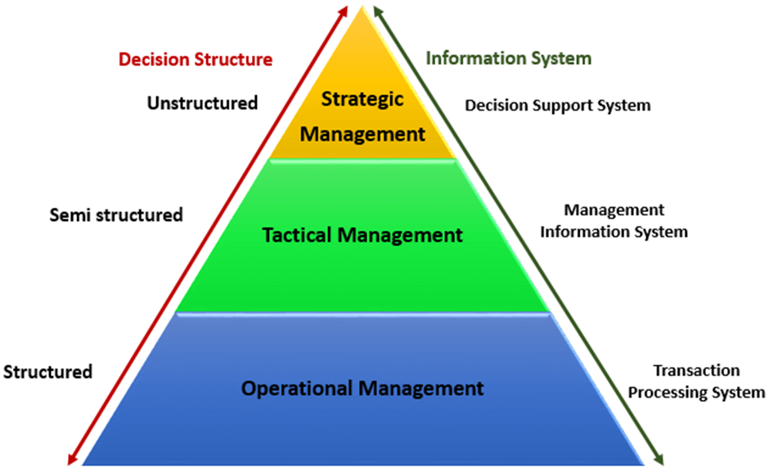
(Source: Figure 1: Pyramid diagrams of organisational levels and information requirement

Understanding the level of an organisation is important to understand how it operated with respect to the organisation. (Guru99.com, 2019)

❖ Operational management:

This management make the structured decision and guiding the rules while making decision. The main function of operational management is to concern over daily transaction like cashiers, customer care staff.
❖ Tactical management:
This management make the semi-structured decision and allowing them to look on the transactional activities like payment activities credit limit. These departments are generally dominated by middle-level managers.
❖ Strategic management:
The operational management is senior-level management and makes the unstructured decision and makes long term planning and decision.

❖ Transaction processing system:

The TPS keep track of all the transactional activities like flight ticketing, payroll system, record daily sales which are done by a low level of an organisation.

❖ Management Information system:

MIS managers monitor the TPS System and keep track of the performance status. The data provided by the system helps managers to take short and long term decision.

❖ Decision support system:

DSS take decision by the senior level of an organisation according to the critical situations and resolving problems. They generally make non-routine decisions. DSS is the input from the internal System (MIS and TPs) and external system.

Overall computer based systems can help organisation in completing several tasks as identified above. In terms of levels of an organisation of managerial roles computer based systems also provide further benefits as discussed below:

The computer-based information system can support the managers in different level, such as-
Entry level- During the entry level, managers can use the information system for learning the different protocols, systems, and operations of an organization. At the very early period, information systems can play the role of a virtual educator to the newly appointed managers.
Mid level – While reached to the mid level, managers start using the information system for storing their work information, schedules of meeting, company reports, documentations of suppliers and clients, and so on. Apart from this, information system also helps in maintaining the time schedule as well as building proper communication network with the subordinates.
Senior level – At the senior level, managers use the information system as an online working portal, through which they can observe the working patterns of the team members or subordinates properly. Additionally, they also keep track of the performance of different members, based on which further assessment and rewarding would be done (Vlahos et al., 2004)

References :
- Balozian, P., Leidner, D. and Warkentin, M. (2017). Managers’ and Employees’ Differing Responses to Security Approaches. Journal of Computer Information Systems, 59(3), pp.197-210.
- Bensoussan, B. and Fleisher, C. (2008). Analysis without paralysis. Upper Saddle River, N.J.: FT Press.
- Bertozzi, F (2017). Porter’s five generic strategies; A case study from the hospitality industry. International Journal For Research In Mechanical & Civil Engineering (ISSN: 2208-2727), 3(2), pp.09-23.
- Hannigan, T.J., Hamilton III, R.D. and Mudambi, R., (2015). Competition and competitiveness in the US airline industry. Competitiveness Review, 25(2), pp.134-155.
- Hoberg, G. and Phillips, G. (2016). Text-based network industries and endogenous product differentiation. Journal of Political Economy, 124(5), pp.1423-1465.
- Hoberg, G. and Phillips, G. (2016). Text-based network industries and endogenous product differentiation. Journal of Political Economy, 124(5), pp.1423-1465.
- Jhigh.co.uk. (2019). Categories of Information Systems. [online] Available at: http://jhigh.co.uk/Using%20Information/13%20Categories%20of%20Informaiton%20Systems.html [Accessed 10 Oct. 2019].
- Michaux, S., Cadiat, A. and Probert, C. (2015). Porter's five forces. [Lieu de publication non identifié]: 50Minutes.
- Naser, S.S.A. (2015). Sl5 Object: Simpler Level 5 Object Expert System Language. International Journal of Soft Computing, Mathematics and Control (IJSCMC), 4(4), pp.25-37
- Naser, S.S.A. (2015). Sl5 Object: Simpler Level 5 Object Expert System Language. International Journal of Soft Computing, Mathematics and Control (IJSCMC), 4(4), pp.25-37.
- Naser, S.S.A. and El-Najjar, A.E.A. (2016). An expert system for nausea and vomiting problems in infants and children.
- Nytimes.com. (2019). How One Computer System Tangled Up Several Airlines. [online] Available at: https://www.nytimes.com/2019/04/29/business/airlines-computer-glitch-sabre.html [Accessed 10 Oct. 2019].
- Saylordotorg.github.io. (2019). What Are Information Systems?. [online] Available at: https://saylordotorg.github.io/text_business-information-systems-design-an-app-for-that/s05-01-what-are-information-systems.html [Accessed 10 Oct. 2019].
- The Hustle. (2018). The men who took 10,000 flights. [online] Available at: https://thehustle.co/aairpass-american-airlines-250k-lifetime-ticket/ [Accessed 10 Oct. 2019].
- Users.cs.cf.ac.uk. (2019). [online] Available at: http://users.cs.cf.ac.uk/Dave.Marshall/AI1/mycin.html [Accessed 10 Oct. 2019].
- Vlahos, G., Ferratt, T. and Knoepfle, G. (2004). The use of computer-based information systems by German managers to support decision making. Information & Management, 41(6), pp.763-779.

