DS 1 Template

My Screenshots/Photos
- Please add 4–6 screenshots or photos of your digital life.
- You can use your phone or laptop.
- For each screenshot, write one or two sentences explaining what it shows.

Screenshot/Photo 1
[Insert Photo/Screenshot below]


[Write what this shows of your digital life]
I use Amazon to order different things for example kitchen cutlery.

Screenshot/Photo 2
[Insert Photo/Screenshot below]

[Write what this shows of your digital life]
I use online Currys to order mobile devices perhaps a laptop

Screenshot/Photo 3

[Insert Photo/Screenshot below]

[Write what this shows of your digital life]
I go to the hospital for monthly checkups or if I have a health issue.

Screenshot/Photo 4
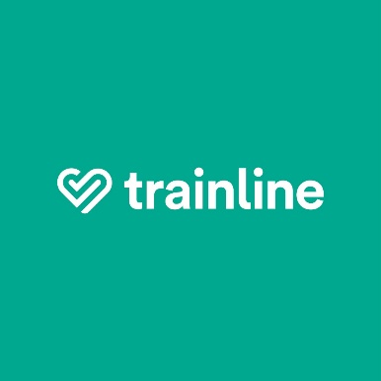
[Insert Photo/Screenshot below]

[Write what this shows of your digital life]
I use trainline to book online tickets to get me to my destinations.

Screenshot/Photo 5
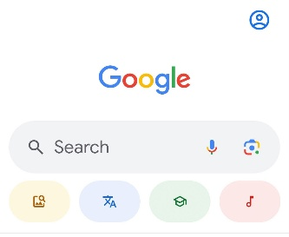
[Insert Photo/Screenshot below]

[Write what this shows of your digital life]
I use Google for research to get all sorts lf information .

Screenshot/Photo 6
[Insert Photo/Screenshot below]

[Write what this shows of your digital life]
I use Youtube to watch my favourite Nigerian shows.

My Short Reflection
- Write 5–8 simple sentences about your digital life.
- You can use the sentence starters below if helpful.
I use digital tools to help me with school and my everyday life .I often use my phone to learn new things such as doing research on Google or youtube about different countries .I feel happy when I learn something new.Sometimes I struggle with new technology,but I try my best to understand how it works.

Sentence starters
- I use digital tools to …
- I feel confident when I …
- I want to improve …
- I often use these tools: …
- I sometimes feel nervous about …
- I hope this module will help me …
- Digital skills are important for me because …
You can write more if you want.

Submission Checklist
Before you submit, please check:
​​​ ☐ I added 4–6 screenshots
☐ I wrote short sentences for each screenshot
☐ I wrote my short reflection
☐ My work is my own
☐ My file opens correctly
​​☐ My file opens correctly

