Report:

Developing a new landscape for customer care

Programme: Master of Business Administration (International Hotel Management)
Module: Strategic Management
Module code: BMMB7013
Lecturer: Dr Jayne Griffith-Parry
Student name: Lola Villard
Student ID: 2114927

Table of Contents

Executive Summary 3
Introduction 3
Main Body 3
1 - Strategic Planning phase 4
a) Feedback analysis 4
b) SWOT analysis 6
c) Conceptualisation and formulation 7
2 – Execution Phase 8
a) Vision and Mission statements 9
b) Guest satisfaction Loyalty 10
c) Pricing and selling strategy 10
d) Sustainability 11
3 – Monitoring phase 13
4 – Improvement phase 14
Recommendations 15
Conclusion 15
Reference list 16
Appendices 20

Executive summary
In this report written for the Managing owner of St Brides Spa Hotel, a decline on customer satisfaction following the reopening post COVID 19 has been highlighted. A thorough analysis of customer feedback, internal and external data has been conducted by the selected team using a 4-phase process including planning, execution, monitoring and improvement. The findings of this process led to the following recommendations.
- Adopt new values and share virion and mission statements externally.
- Develop a new induction training program for new starters.
- Train the teams on effective communication.
- Implement a new loyalty programme.
- Embrace the MrBIV continuous improvement approach.
If implemented accurately, these recommendations will help St Brides Spa Hotel to take a sustainable competitive advantage on its competitors and increase customer satisfaction.

Introduction
This report is written for Mr Andrew Evans, the Managing Director of St Brides Spa Hotel, St Brides Hill, Saundersfoot, Pembrokeshire, SA69 9NH. This 4 star silver AA awarded Hotel is located in the Pembrokeshire Coast National Park. The property (Appendix 1) offers a view over Carmarthen Bay and the village of Saundersfoot. Historically St Brides Spa Hotel opened its doors for the first time in the 1950’s and has been operated as an Event’s Banqueting Hotel for 50 years, before being purchased by its current owner in 2000. It has since been refurbished and a spa has been added. Following this revamp, the business started to focus mainly on leisure guests wanting to get away for a relaxed, stress-free vacation. “St Brides Spa Hotel is an oasis of calm with an award-winning spa, contemporary restaurant and stylish bedrooms. Relaxed, informal luxury. That’s us.” (St Brides Spa Hotel, 2021).
The task of creatively reshaping the organisation’s strategic direction has been given to the newly created emergency project team. Choosing the right team is an important step as Alexandra Hayes (2018) says “Picking the right professionals to build an effective team for a project is more challenging than it looks. It’s a big responsibility and risk because the people you choose are the biggest factor to determine if your project will turn out to be successful. The more skilled and knowledgeable they are, the better your odds of success become.”
The emergency project team consists of;
- The Operations Manager with the role of coordinating and executing the strategic plan.
- The General Manager in charge of making financial and final decisions.
- The Marketing Manager with the role of collection and analysis of data, as well as the external communication of the plan.
- A receptionist taking the role of the colleague representative freshly elected by the operational employees though a majority vote.
- The Human Resources and Training Manager taking responsibility for internal communication and training.
- An administrator to keep track of meeting minutes and various admin tasks.
Decline in overall customer satisfaction and a change in the customer’s behaviours and expectations has been noticed since the hotel reopened its doors and resumed operating at full capacity after the last pandemic related lockdown. With the end goal in mind of developing a new landscape for customer care, four strategic management steps are going to be developed through this report. According to Fred R. David (2008) “Strategic management is the art and science of formulating, implementing and evaluating cross-functional decisions that enable an organization to achieve its objectives”. The main body of this report will be structured in four phases as follows;
- Strategic planning
- Execution
- Monitoring
- Improvement
Each of these phases will be thoroughly explained using concepts, theoretical frameworks, and techniques through the report and will result in findings leading to strategic options available for the owner of St Brides Spa Hotel. Finally, recommendations on the application of these options will be formulated.

1 - Strategic Planning Phase
This is the most important phase of the strategic plan; it is the foundation, the solid base supporting all options and recommendations that will be formulated. Planning is about understanding the current business, collecting past and current data, understanding how successful the business is currently and how it can be improved. It is planning through the most adapted methods, identifying how to do it, when and where do to it and who the main actors will be. Charles W. L. Hill and Steven McShane (2006, p106) explain that planning is a process whereby managers select goals, choose actions to attain those goals, allocate responsibility for implementing actions to specific individuals, measure the success of actions by comparing actual results against the goals, and revise plans accordingly. With the implementation of the emergency project team, clear responsibilities have been allocated to the members. From these responsibilities, each team member will provide an action plan to be implemented, monitored and reviewed.

a) Feedback analysis
To identify and understand how the business is currently performing against the backdrop of the pandemic, the Marketing Manager has been asked to collate and analyse constructive feedback from the Hotel’s website and review sites such as Trip Advisor, Booking.com and Expedia (Appendix 2). The Hotel rating has been assessed online on November 23rd, 2021, and is showing a score of 8.7/10 on Booking.com, 4.5/5 on Trip Advisor and is not rated on Expedia. An example of a constructive review is provided below.
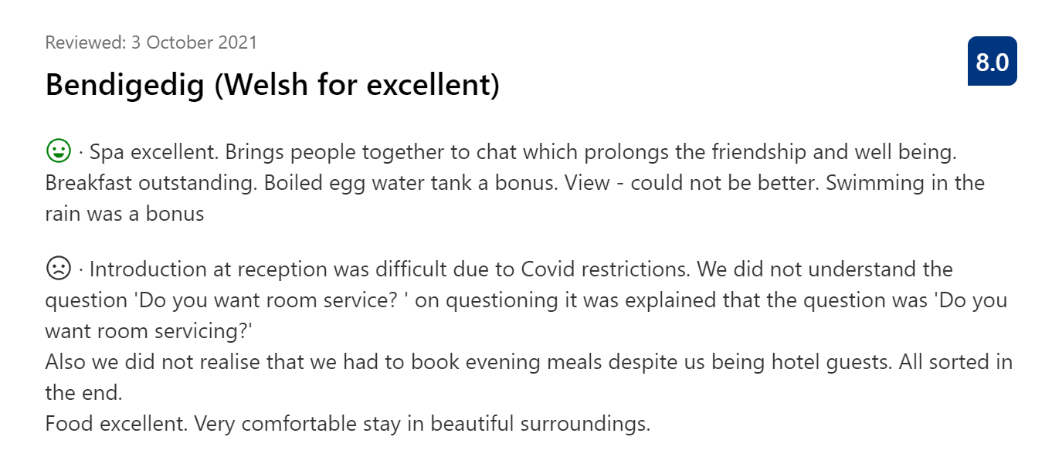
(St Brides Spa Hotel, Saundersfoot, UK, Booking.com, 2021)
Communication is identified to be the issue here, firstly the reception team member didn’t address their question accurately, this could be due to them being a non-English native speaker or lacking training. To rectify these issues, a script could be provided for training purposes. Secondly it seems that communication concerning having to book dinner was not made clear to the guest prior to arrival resulting in a misunderstanding. This could be resolved through further training for the team on the check-in procedure.
Review sites can play an important role in understanding guest’s needs, change in behaviour and expectations. Paul Jones (2016), CEO of LUX hotels says “For me Trip Advisor is huge! It's huge on every level, it's huge because it's so informative. For a general manager it is fantastic, for the team members it's amazing. This is very obvious but how many general managers are using the tool? And how many think that it is a nuisance, and nobody uses it? I think that Trip Advisor has been the single most important change in terms of marketing in the hospitality industry.”
The Marketing Manager has identified two recurring negative feedback topics. The first one is communication, guests stating that they were not informed to book a restaurant table and were disappointed not to be able to dine. Communication concerning room cleaning schedule seems confused, comments concerning the housekeeping team not servicing the room every day are recurring. This is supported by Gibson, (2016) who said “Excellent communication skills can enhance a guests experience as it shows that you are listening to them, valuing their feedback and conveying clear messages. This can lead to customer loyalty, increased business and eventually the hotel becoming more successful.” The second negative feedback topic is the price, it has been identified that guests seem to think that they are paying too much for what they get. Bar drinks and restaurant food are often highlighted in reviews as being too expensive. As shown below, the score on Booking.com concerning value for money is the lowest with 7.5 out of 10. Review of pricing strategies may need to be reconsidered and will be addressed later in this report.
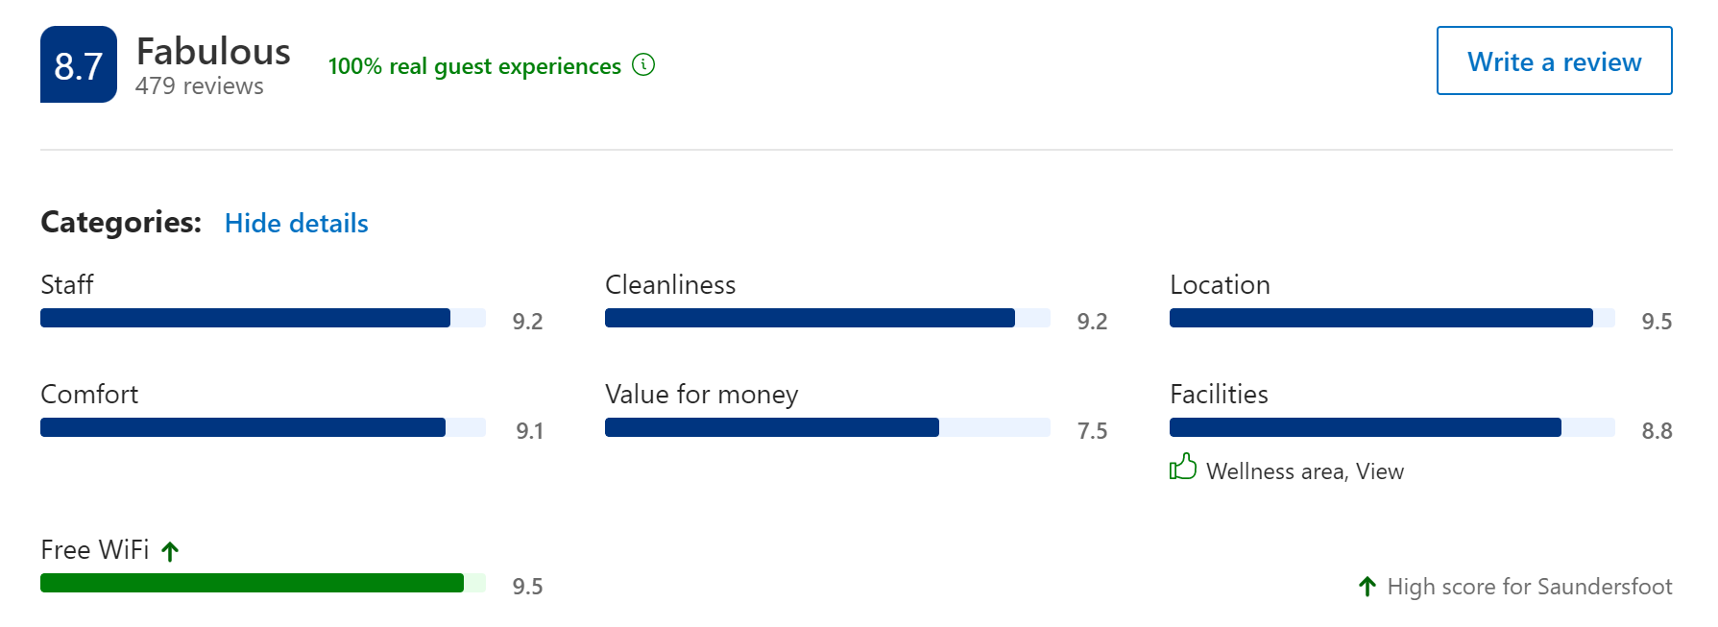
St Brides Spa Hotel, Saundersfoot, UK, booking.com, 2021)

b) SWOT analysis
A board meeting has taken place where the following two methods where discussed the McKinsey 7S model and the SWOT method. It has been decided to use the SWOT method as it would allow, through a brainstorming process, a quicker and more efficient way to analyse a hotel organisation. For Mr Andrew Evans and any reader’s understanding, here is how the two method’s compare. McKinsey 7S model is a tool that analyses firm’s organisational design by looking at the alignment of 7 key internal elements: strategy, structure, systems, shared values, style, staff and skills (Jurevicius, 2021). SWOT analysis is a simple tool that can help analyse what a company does best right now and advise a successful strategy for the future. SWOT can also reveal areas of the business that are holding it back, or that competitors could exploit if not protected. (Mind Tools Content Team, 2019). The Segmentation, Targeting, Positioning (STP) has been included to the analysis, exposing the existing marketing strategy of St Brides Spa Hotel.

STP (Segmentation, Targeting, Positioning)
Segment | Leisure and business travellers
Target Group | Upper class couples and families, business travellers, wedding groups, special occasions, locals.
Positioning | Prime location, luxury
SWOT Analysis
Strength | - Prime location in Pembrokeshire Coast Park and sea view.  - Quality of local products available  - Well established with a good reputation  - Corporate contracts with local oil refineries  - Award winning Spa
Weakness | - Communication procedures  - Sustainability actions  - Low staffing levels  - Training abilities  - Vision, mission and core values not existing
Opportunity | - Improvement on memberships plans, customer loyalty programmes  - Technology upgrade  - Employee retention to ensure better service  - Set higher standards of communication  - Improve online visibility of vision, mission and core values  - Improve and promote sustainability practices
Threats | - COVID-19 pandemic or another viral related pandemic  - Storms damaging the property exposed on the coast  - World’s climate change  - Skills gap in the hotel industry  - Seasonality  - Competitors

The analysis of internal and external factors brings to light six opportunities. Thomas Bush (2016) defines opportunities as a combination of different circumstances at a given time that offer a positive outcome, if taken advantage of. The key word in this definition is ‘circumstances’ because opportunities are said to be external. Unlike with strengths, however hard anyone tries they cannot ‘create’ opportunities, they can only choose how to position themselves to gain maximum benefit from them, or whether or not to grasp for them.

c) Conceptualisation and formulation of the plan
The next step of the planning phase is conceptualisation, consisting of setting our goals and objectives. Goals and objectives have essentially a similar meaning. However, there is potential to distinguish between the two by using goals for long-term planning and objectives for short-term planning. “The goal is to success the deal; the objective is to capture the bridge” (Bohan, 1995).
Short-term objective: to increase customer satisfaction by retraining the team and deliver a higher level of service and communication.
Long-term goals: to increase customer loyalty, being recognised for excellent customer service and green practices.
Implementation is the process that turns strategies and plans into actions to accomplish strategic objectives and goals. Implementing the strategic plan is as important, or even more important, than the strategy. “95% of the typical workforce doesn't understand their organization's strategy.” (Tschammer, 2020) Objectives have been set and strategic decisions have been formulated answering who will be involved, how is it going to be actioned and when it is going to be actioned. This will need to be communicated to the entire team to ensure the success of the plan.

Strategic decisions | WHO?  Department involved | HOW?  Actions | By WHEN?
Review vision and mission statements | General Manager  Operations Manager Marketing Manager | Review vision, mission, and core values. Promote on website and communicate to employees. | Short term  Immediate action
Increase customer satisfaction | All operational departments  HR & Training Manager | Product knowledge and service delivery training including communication. Prior, during and post stays. | Long term  Continuous action
Review F&B pricing and selling strategy | F&B Manager  Operations Manager Marketing Manager | Review costs and profit margins. Market products promoting quality and uniqueness. | Short term  Immediate action
Membership Card for loyal guests | Marketing department  Front of House department | Create/communicate/promote via all different channels | Short term  Immediate action  Long term expected outcomes
Increase sustainable practices | Operations Manager  F&B and Kitchen  Housekeeping team  HR & Training Manager | Apply for green key award  Waste management training  Sustainable practices understanding and training | Short term  Immediate action  Long term continuous action

Five strategic decisions have been formulated, the execution phase can be started immediately and will involve all operational departments; it has been identified that costs will be very limited as most actions will involve managers and employees internally with limited external help. The Operations Manager will lead and supervise the execution with the support of each operational head of department working closely with the marketing and human resources department. In this process it will be important to show unity of the management team to successfully implement changes. “Organizations that excel at implementation foster a leadership style that sets bold aspirations with clear accountability—emphasizing the challenging and supportive dimensions of leadership over the authoritative and consultative qualities that may be effective in other situations. Successful leaders are relentless in pushing and encouraging their reports, while also greasing the wheels through tough decision making.” (Johnston, Lefort, and Tesvic, 2017)

2 – Execution Phase
Pennypacker and Ritchie (2005) explained that the inability of organisations to effectively execute their corporate strategies is one of the major factors limiting their success. Sound execution is critical, a focus on making strategy work results in a healthy organisation. So, if execution is so critically important, why don't more organisations develop a disciplined approach to it? Simply because it's very difficult to do. Turning strategies into reality requires constant investment in management resources. It's particularly difficult in large or more complex organisations, where the distance between those who formulate strategy and those who carry it out can be significant.
In the case of St Brides Spa Hotel, a small organisation, implementing change will involve the management team and their direct reports at first. Directions will be filtered down to the teams through training delivered by the head of department and the HR and Training Manager. But most importantly daily briefings and debriefings, open discussions about constructive and negative feedback followed by actions monitored by the head of department.
a) Vision and Mission statement
During the planning phase a lack of clarity has been identified concerning the aims of the company, the vision, mission, and shared values are not stated on the website. “An effective vision pervades the organisation with a sense of winning and motivates employees at all levels to aim for the same target, while leaving room for individual and team contributions.” (Rothaermel, Frank T, 2017) The only relatable sentence to an objective or a vision on the hotel’s website is in the ‘about us’ section as per the picture below. Due to this finding a new vision, mission statements and core values will need to be created and communicated.
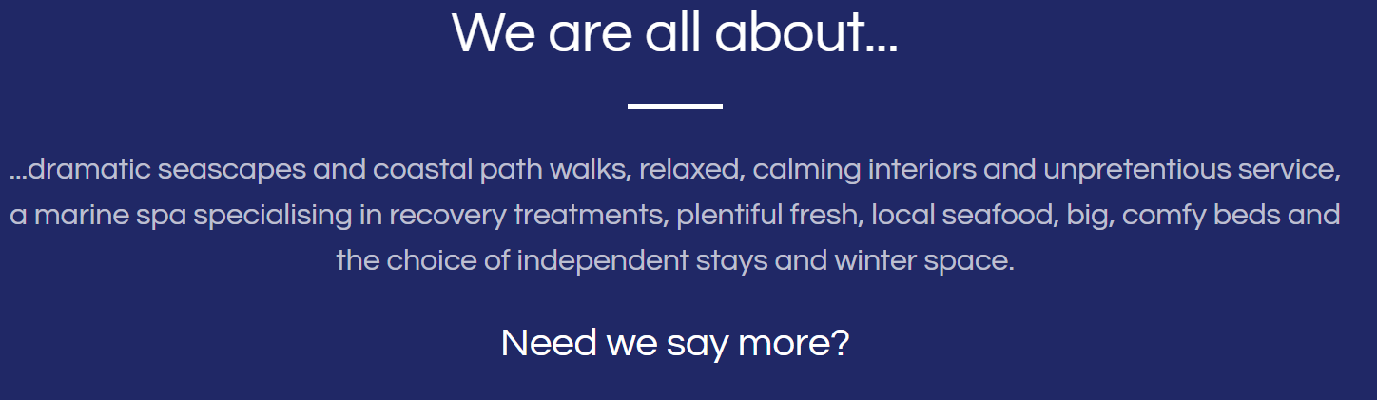
(St Brides Spa Hotel: About Us, 2021)
Proposed mission statement To focus on hospitality by offering an unpretentious and proactive service to consistently exceed our guest’s expectations.
Proposed vision statement To provide our people with the best working environment which in turn will result in optimal service for our guests. To increase profitability of the business by constantly identifying opportunities to reduce costs and increase revenue.
As an example, and for inspiration two different hotels were chosen and their core values reviewed. Hilton’s international core values are “integrity, teamwork, leadership and ownership” (Hilton, 2021). This is shown very clearly when accessing their website. St Bride’s Spa Hotel’s close competitor, Twr y Felin Hotel in St David’s, Pembrokeshire, communicate the core values of “positivity, flexibility, attention to detail, care, pride and passion” (Retreats Group, 2019). A copy of the employee booklet where the core values are shared can be found in Appendix 3.

Proposed Core values
Empowerment: For our colleagues to feel empowered to make decisions in order to exceed expectation of their peers, guests and suppliers.
Care: For the environment, our guests, colleagues, and suppliers. Care for our community and developing an inclusive, non-discriminative against sex, race, colour, ethnic origin, disability, religion sexual orientation, gender, marital status, nationality, age or culture.
Opportunities: For our colleagues to inspire career progression, for our guests to discover and cherish the culture and products that Pembrokeshire has to offer.
Passion: To demonstrate pride in being an ambassador of hospitality and giving our guests a sense of place.
b) Guest satisfaction and loyalty
For Kotler and Armstrong (2006), loyalty is won through delivery of consistent superior customer service, it means providing them with services that are so good such that there is little chance of not meeting their expectations and requirements. Consistency is key according to an article by Jojuli (2021) “The only way you can guarantee your products and service delivery will be the same each time is by ensuring all of your employees maintain the same standards, abide by the same policies and procedures, and use the same processes, practices and systems to perform their jobs at the desired level. Consistency is key to achieve organizational goals.”
Each head of department has been asked to review their procedures and standards to identify gaps. It has been identified that newly appointed employees are not fully aware of procedures and standards, this would be rectified through specific team training. At the same time the HR and Training Manager has been asked to review training matrices and induction processes to ensure new employees are monitored closely in the future.
“Retaining loyal customers for hoteliers is essential and a core factor in keeping the industry in shape and competitive enough to measure itself up to the changing trends of the industry” (Schulz, 2012). The Marketing Manager has been asked to design and implement a membership card for returning guests. The returning guest will have access to a complimentary upgrade to the best room available at the time of booking and a complimentary drink voucher to be used at the bar or restaurant during their stay. The loyalty card will be offered to identified regular guests that have stayed three times or more. This card can be free, as it can be produced in house and distributed solely as an electronic version, involving minimal costs in the process. Hotel groups such as Accor and Marriott offer a membership card, the “Accor Plus” (Hotel Memberships, 2021) and “Club Marriott” (Marriott, 2021), these are purchasable. Fees vary depending on the benefit offered and are generally targeted to business guests. As identified in the STP, St Bride’s Spa Hotel target segment is leisure. As outlined by Schultz (2012), as competition intensifies, hoteliers have learnt to shift their strategies from customer acquisition to customer retention and loyalty, which is only possible with effective customer satisfaction.

c) Pricing and selling strategy
As noted in the planning and analysis phase of this report, value for money seems to be a concern in the eyes of the guests. Bar drink prices are the main concern from the recent reviews, the Food and Beverage Manager and the Operations Manager will be conducting a thorough analysis of each product to highlight the Gross Profit Margin per product. “Profit margin is expressed as a percentage – the higher the percentage the more profitable your bar is. The average gross profit margin for bars and nightclubs is 70 to 80%.” (McCutchen, 2020). Wine pricing needs to be a dynamic, not a static, process to be able to adapt to the ever-changing guest expectations. Data from your POS, distributors, retailers, or online wine resources needs to be used during the decision-making process. (Sommelier Business, 2021)
Often the problem is not the price but the way the product or service is sold to the customer. Let’s remember that every drink has a story from its origin, the ingredients or the person behind the process, the packaging and marketing of the product. Colleen Francis, (2008) explained that top-ranked sales performers don’t sell their products or services based on price. They focus on the value of what they are selling and how it can best meet the needs of the customer. She also said that one question is to be considered ‘What’s in it for the consumer?’
Value for money is relative to each individual and in the Hotel industry it is about expectations. “Your customers want to know what they can expect to gain by choosing your product or service at the price you’re offering.” (Francis, 2008) The highest the price, the highest the expectation. Creating “wow” moments becomes a priority for all hoteliers and underselling as strategy could be more beneficial than over selling. According to Belyth (2019), under-promise and over delivery is key, she said “While setting expectations, it is best to keep it under restrain, though it may seem like a good strategy to have high expectations, in reality it is not, as inability to deliver can cost you dearly”.
Communication plays a massive role when it comes to managing expectations. Whether it is verbal, non-verbal or para-verbal. ‘It is not what you said, it is the way you said it” is a well-known phrase we have all heard and explains how powerful paraverbal communication can be. Communication in the hotel industry is what builds guest’s expectations from the moment they research the hotel or place their first phone call. Due to important measures imposed by the government during the COVD19 pandemic, hotels had to adapt, change and review their procedures in terms of service delivery. This is to ensure maximum safety for their guests. David Straker (2008) explains that everything communicated to a customer will have an impact on how the business is being perceived. Any communication whether it is personal conversations, adverts or a logo will set an idea on the customer’s mind on how much they would be willing to pay for the product or the service. As an example, if a customer visited a hotel and was made to wait on arrival in an untidy area and no acknowledgement of the wait was provided when finally being welcomed, this would be perceived as a poor offering of service. Therefore, the value of the product and service decreases in the customer’s mind leading him to think that is poor value for money compared with the price paid and the underlaying promise made at the time of booking. “The reverse is true as clear communications and positive experience leads to higher price expectation and acceptance.” (Straker, 2008)
Clearer communication procedures could be implemented at St Brides Spa Hotel throughout the whole operational team, focussing at first on the front office department, often described as the heart of the hotel operation and the centre point of internal and external communication (Bardi, 2007). Scripts and checklists will be implemented, combined with new training procedures, and will be monitored by the HR and Training Manager through training matrices.

d) Sustainability
Considering the worldwide effort to protect our planet, sustainability needs to be considered in the strategic management decisions moving forward. Sustainability is made up of three pillars: Economy, society and the environment (Allen, 2021). Gaurav Chawla (2021) explained that sustainability is a lot more than environmental management, it is also about economic progress and social development. Social concerns include, but are not limited to inclusivity, promoting work-life balance, promoting employees’ health and wellbeing, sourcing supplies locally and stimulating entrepreneurship. Laura Fredericks (2020) related this to the hotel industry and explained that sustainable hotels are businesses that significantly reduce their environmental impact through green best-practices in maintenance, services, logistics, products, and supplies. The core elements revolve around reducing waste, saving energy, and cutting down on water usage. Some hotels such as the Green House Hotel (2021) in Bournemouth put sustainability as part of the core experience with their business mantra ‘to spoil the guests without spoiling anything else’.
St Brides Spa Hotel could increase sustainable practices and overall culture by the following:
Join a recognised programme such as the Green Key award which is a voluntary eco-label awarded to more than 3,200 hotels and other establishments in 65 countries. “The Green Key award is the leading standard for excellence in the field of environmental responsibility and sustainable operation within the tourism industry” (Green Key, 2021). To answer the increasing demand of eco-friendly generations such as the millennials and generation Z led by the movement of the Swedish activist Greta Thunberg, being part of a sustainable programme is essential and a free marketing tool for hospitality businesses.
Increasingly, consumers seek out green businesses and pay more for eco-friendly products and services. “One in three consumers prefer sustainable brands, and the travel industry is taking note” (Unilever, 2021). TripAdvisor (2021) for example, has developed its ‘GreenLeaders Programme’ showcasing hotels with environmentally friendly best practices to conscientious travelers. A report entitled ‘Where Sustainable Travel is Headed’ by Booking.com (2018) indicates that the sustainable travel trend continues to increase, with a vast majority of global travelers (87%) stating that they want to travel sustainably, but only 39% confirming that they often or always do so. We could deduct that hotels could offer more sustainable experiences or that they do not advertise their sustainable practices enough. Mack Bhatia (2021) explains that communicating about sustainability goals and actions by sharing positive examples will increase the chances of winning contracts with corporates that have sustainability procurement criteria. It will enable customers to see the hotel’s sustainability values when making their booking selection. Global hotel chain values are a good example of great use of sustainability in their marketing communication. Hilton International (2018) with ‘Travel with Purpose’ has committed to doubling their investment in social impact and cutting their environmental footprint in half by 2030. Marriott International (2019) with ‘Swerve 360 - Doing good in every direction’ has committed to create positive and sustainable impact wherever they do business. Premier Inn (2021) with ‘A Force for Good’ and IHG (2021) with ‘Green engage’ are expressing similar commitments.
Create an Eco Warrior team, employees play a major part in making a hotel sustainable, they are the ones on a daily basis putting the right items in the right bins, increasing or lowering the lighting, turning on and off the heating in the bedrooms and many more little actions that make a hotel more sustainable and save pennies. Fredericks (2020) says that it gives employees a sense of ownership of green strategies, and more commitment to long-term adoption. Chef-restaurateur Arthur Potts Dawson, co-founder and executive head chef/director of London's first eco-friendly training restaurants, the two-AA-rosette Acorn House and the Water House said "By sharing our beliefs with a young, local workforce, we are hoping to spread that message far and wide”.
Sourcing local, eco-friendly products and refillable products are a good example of customer’s understanding and acceptance of change towards sustainability. Single use toiletries were a minimum requirement for 5 star hotels for a long time but it is now acceptable to offer refillable bathroom amenities in 5 star hotel bathrooms. The AA (Automobile Association) and UK tourism boards updated their common quality standards minimum entry requirements to reflect the change in consumer demand towards a more sustainable environment. (AA, 2018, p28)
Hotels can combine efficiency and sustainability in many ways, for example;
- Monitoring the occupancy and putting in place a 2- or 3-night minimum stay to avoid changing and cleaning linen on a daily basis
- The use of light sensors in public areas
- Automatic water flows that reduce the amount of water used for each person flushing the toilets
- Ordering bulk stock to reduce the Co2 emission of transportation
- Gifting old linens to local charities
- Serving breakfast a la carte rather than buffet to avoid wasting half the food each morning
“When hotels ‘go green’ they do less damage to the environment, lower costs, and win goodwill from guests. Sustainability in the business world is essential to achieving growth and satisfying customers”. (Collings, 2021)

3 – Monitoring phase
Whilst implemented, strategies will need to be continuously monitored to track the guest experience by analysing data, both online and direct feedback from guests. David Campbell (2021) the Operations Director of The Coaching Inn Group a hospitality business including 23 properties in the UK explains that if hotels have an intelligence platform showing that 65-70% of their guests are saying that they need to spend money for an upgrade as it looks dated, they need that information so that they can make an informed decision. For instance, if after implementing changes such as introducing water flower reducers on bathroom showers and taps, the feedback indicates that it affects the overall standard and is a subject of complaints. By monitoring consistently, the decision of removing them can be taken quickly and not affect the image of the brand in the long term.
Technology plays a vital role in the collection of data and therefore the experience tracking. The Property Management Systems (PMS) or Customer Relationship Management (CRM) properties can store data effectively against each guest profile explained J. Lynne Fraser (2018), however this will rely on manual input of the data by the team members.
Amanda Moore (2017), senior director of Social & Digital Marketing at Marriott International explains that a chatbot named ChatBotlr has been implemented in the Marriot Mobile App to answer guests queries and track customer experience. She said “What we’ve built is this engagement ecosystem where we want to be available beyond the stay — pre, during and post stay”.
Tracking the guest experience can sound simple but requires a strict schedule and the involvement of the team. Inspired from the Patrick O’Connell (2006) method from ‘The Inn at Little Washington’, training will be offered by the HR and Training Manager to implement a ‘mood tracking’ system, involving rating guest happniess on a scale of 1 to 10. If a guest looks unhappy, he probably is! Employees will be empowered and feel confident to identify the issue and resolve it in timely manner.

4 – Improvement phase
The constant internal evaluation of results following the implementation of changes and adaptation to the constant change of guest’s needs and expectations is an important phase where employees will have to play the first role. Kober (2009) explains that continuous improvement is about empowering and engaging. To create magic, employees should be taught how to find ways to continuously improve the operation.
A few methods such as PDCA or Kaizen have proven themselves efficient in terms of learning and improving opportunities.
Deming’s PDCA (Plan, Do, Check, Act) consists of “the systematic process for gaining valuable learning and knowledge for the continual improvement of a product, process, or service” (The W. Edwards Deming Institute, 2021).
Masaaki Imai (1986) explained that Kaizen is a philosophy that promotes a mindset where small incremental changes create an impact over time. Kaizen’s methodology is about enhancing specific areas in a company by involving top management and employees to initiate everyday changes, knowing that many tiny improvements can yield big results.
St Brides Spa Hotel conducts daily morning meetings and departmental team briefings. To involve the teams the MrBIV system by the Ritz Carlton is suggested. Giving a chance for employees to discuss, review and find solutions of any Mistakes, Revisions, Breakdowns, Inefficiencies and Variations of standards they would have experienced, enhancing the culture of care of the company. (Trajkovski, 2020).

Recommendations
Following the analysis of the operational structure of St Brides Spa Hotel the following recommendations have been formulated.
- Adopt new values, vision and mission statement. It could be beneficial to ask the employees for their input in creating the new values to create a sense of ownership. Promote them by creating a page on the hotel website to share these credentials.

- Develop a new induction training program for new starters to improve long term staff retention. The induction programme will include the introduction to the organisation, its values, culture, people, and acceptable working practises.

- Re-train the teams on effective communication. Getting every employee to know that communication is about sharing information with another person in a manner that will not leave space for the wrong interpretation of this information. It needs to be clear, concise, and provided to the right person, at the right moment. It could be beneficial to provide scripts for newly appointed employees at the front desk.

- Create and implement the loyalty programme. To be offered to identified regular guests for free and distributed only electronically. The loyalty programme could include a complimentary upgrade to the best room available and a complimentary drink voucher.

- Embrace the MrBIV continuous improvement approach by involving employees during the daily meeting to come up with solutions to any mistakes, revisions, breakdowns, inefficiencies, or variations encountered.

Conclusion
This report has identified through four simple steps how to develop a new landscape for customer care in the backdrop of a pandemic. The change in customer expectations and the identified decline in the customer satisfaction through the study of customer feedback has led to review the strategic options available to St Brides Spa Hotel in order that they can take a sustainable advantage over their competitors. The recommended changes will focus on customer service, it will involve recruitment and staff retention with the development of an efficient induction programme. Changes will be implemented internally and rapidly by the Operations Manager making the strategic plan efficient and keeping costs as low as possible. The focus will be ‘people’, employees in one hand embracing the new company culture of care and customers in the other with the development of a guest loyalty programme. By enhancing the service quality standards and improving communication before, during and after the guests stay, value for money should not be of concern any longer and profitability will increase.

References
Allen L. (2021) What Are the Three Pillars of Sustainability? Available at https://www.treehugger.com/what-are-the-three-pillars-of-sustainability-5189295#:~:text=1%20Social%20Sustainability.%20Social%20sustainability%20includes%20environmental%20justice%2C,of%20environmental%20stressors%2C%20such%20as%20greenhouse%20gas%20emissions (Accessed: 29 November 2021).
Automobile Association (2018) ‘Common Quality Standards for Hotels’, p.28.
available at https://www.theaa.com/hotel-services/ratings-and-awards (Accessed: 29 November 2021).
Bardi, A. J. (2007). ‘Hotel front office management’, 4th Edn, Pennsylvania: John Wiley & Sons, Inc.
Belyh, A. (2019) Ways to Effectively Set Management Expectations. Available at https://www.cleverism.com/ways-effectively-set-management-expectations/ (Accessed: 25 November 2021).
Bhatia M. (2021) The importance of communication in sustainability and sustainable strategies. Available at https://www.thesustainability.io/importance-of-sustainability-communication-and-sustainability-strategies (Accessed: 29 November 2021)
Bohan G. P. (1995) ‘Focus the Strategy to Achieve Results’, pp. 89-92.
Booking.com (2021) St Brides Spa Hotel, Saundersfoot – Updated 2021 Price. Available at https://www.booking.com/hotel/gb/stbrideshotel.en-gb.html?aid=330633%3Blabel&#tab-reviews (Accessed: 23 November 2021)
Booking.com (2018) Where Sustainable Travel is Headed in 2018. Available at https://globalnews. booking.com/where-sustainabletravel-is-headed-in-2018/ (Accessed: 29 November 2021)
Bush, T. (2016) SWOT Analysis Opportunities: Definition and Examples. Available at https://pestleanalysis.com/what-is-strategic-planning/ (Accessed: 23 November 2021)
Campbell D. (2021) The Complete Guide to Direct Guest Feedback Available at https://www.guestrevu.com/guide-to-guest-feedback (Accessed: 30 November 2021)
Charles W. L. Hill, Steven McShane (2006) ‘Principles of Management’, p.106
Chawla G. (2021) Why sustainability is key for the future of the hospitality industry. Available at https://www.southwales.ac.uk/courses/ba-hons-hotel-and-hospitality-management/2484/why-sustainability-is-key-for-the-future-of-the-hospitality-industry/ (Accessed: 29 November 2021)
Colling B. (2021) Proud to be green. Available at https://www.linkedin.com/pulse/proud-green-betsy-collings/ (Accessed: 29 November 2021)
David, F.R. (2008) ’Concepts of strategic management’, 13th Edn, London; Pearson plc
Dawson A. P. (2010) A vision for sustainable restaurants [video] Available at https://www.ted.com/talks/arthur_potts_dawson_a_vision_for_sustainable_restaurants (Accessed: 29 November 2021)
Francis, C. (2008) Price isn't the Problem: Sales Strategies: The Sales Leader. Available at https://www.engageselling.com/blog/price-isnt-the-problem/ (Accessed: 25 November 2021)
Fraser J. L. (2018) Why Data Collection is Key to PMS Success. Available at https://www.hoteliermagazine.com/data-collection-key-pms-success/?cn-reloaded=1 (Accessed: 30 November 2021)
Fredericks L. (2020) Sustainable hotel ideas : 25 ways to go green. Available at
https://www.cvent.com/en/blog/hospitality/eco-friendly-hotel ideas#:~:text=Sustainable%20hotels%20are%20businesses%20that%20significantly%20reduce%20their,a%20hotel%20can%20take%20to%20move%20toward%20sustainability (Accessed: 29 November 2021)
Gibson, J. (2016) The importance of effective communication of a hotel manager. Available at https://mooreandsmalley.co.uk/insights/knowledge-post/the-importance-of-effective-communication-of-a-hotel-manager/ (Accessed: 23 November 2021)
Hayes, A. (2018) 10 Tips for Choosing Effective Team Members. Available at https://aboutleaders.com/effective-team-members/#gs.gvumt (accessed 22 November 2021)
Hilton (2021) Learn more about Hilton Culture. Available at https://jobs.hilton.com/us/en/culture (Accessed: 23 November 2021)
Hilton International (2018) Travel with Purpose. Available at https://cr.hilton.com (Accessed: 29 November 2021)
Hotel Memberships (2021) Accor Hotel – Hotel membership. Available at
https://www.hotelmemberships.com/accor-plus/ (Accessed: 25 November 2021)
IHG Hotels and Resorts (2021) IHG Green Engage system. Available at https://www.ihg.com/content/gb/en/support/green-engage (Accessed: 29 November 2021)
Imai M. (1986) ‘Kaizen the key to Japan’s competitive Success’, New York ; McGraw-Hill
Johnston, A. Lefort, F. and Tesvic, J. (2017) Secrets of successful change implementation. Available at https://aboutleaders.com/effective-team-members/#gs.gvumtj (Accessed: 24 November 2021)
Jojuli (2021) Consistency is key to successful business - very important. Available at
https://jojuli.com/consistency-is-key-to-successful-business-very-important/ (Accessed: 25 November 2021)
Jones, P. (2016) TripAdvisor's impact on the hotel industry [video]. Available at https://www.youtube.com/watch?v=Q3eQh6GLIvk (Accessed: 23 November 2021)
Jurevicius, O. (2021) McKinsey 7S Model: The 7S Framework Explained - SM Insight. Available at https://strategicmanagementinsight.com/tools/mckinsey-7s-model-framework/ (Accessed: 22 November 2021)
Kaplan, R.S. and Norton, D.P. (2000) ‘The Strategy-Focused Organization’, Harvard Business School Press
Kober, J. (2009) Making Disney Better Through Continuous Improvement. Available at: https://www.mouseplanet.com/8880/Making_Disney_Better_Through_Continuous_Improvement (Accessed: 01 December 2021)
Kotler, P. and Armstrong, G. (2008) ‘Principles of marketing’,12th Edn, London: Pearson Education Limited
Marriott (2021) The best hotel loyalty program in Asia Pacific. Available at https://myclubmarriott.com/ (Accessed: 25 November 2021)
Marriott International, (2019) Serve 360. Available a https://serve360.marriott.com (Accessed: 29 November 2021)
McCutchen, M. (2020) Average Bar Profit Margins And How To Maximize Yours. Available at https://www.glimpsecorp.com/bar-profit-margins/ (Accessed: 25 November 2021)
Mind tools content team (2019) SWOT Analysis understanding your business, and forming your strategy Available at https://www.mindtools.com/pages/article/newTMC_05.htm (Accessed: 23 November 2021)
Pennypacker, J. S. & Ritchie, P. (2005) ‘The four Ps of strategy execution: integrating portfolio, program, project, and performance management’ Paper presented at PMI® Global Congress 2005, Available at https://www.pmi.org/learning/library/four-ps-strategy-execution-7472 (Accessed: 24 November 2021)
Premier Inn (2021) We’re a Force for Good. Available at
https://www.premierinn.com/gb/en/why/force-for-good.html (Accessed: 29 November 2021)
Retreats Group (2019) ‘Vision, mission, aims, values’, printed booklet, Unpublished
Rothaermel, Frank T (2017) ‘Strategic management’ 3rd Edn, New York: McGraw-Hill Education

Schulz, R.N. (2012) ‘The effects of business image on customer retention in hotels in Eldoret, Kenya.’ Vol.4, No18, DOI 2222-2839

Sommelier Business (2021) Wine Pricing: Strategy, Profitability and Adjustments. Available at https://sommelierbusiness.com/en/articles/menu-intel-1/wine-pricing-strategy-profitability-and-adjustments-14.htm (Accessed: 25 November 2021)
St Brides Spa Hotel (2021) Welcome to St brides Spa Hotel. Available at http://www.stbridesspahotel.com/ (Accessed: 22 November 2021)
St Brides Spa Hotel (2021) St Brides Spa Hotel: About Us. Available at http://www.stbridesspahotel.com/about (Accessed: 23 November 2021)
Straker, D. (2008) Changing minds – Price expectation. Available at http://www.changingminds.org/disciplines/marketing/pricing/price_expectation.htm (Accessed: 25 November 2021)
The Green House Hotel (2021) The greenhouse is the greenest hotel in the UK. Available at https://www.thegreenhousehotel.co.uk/environment/ (Accessed: 29 November 2021)
The W. Edwards Deming Institute (2021) PDSA Cycle, Available at https://deming.org/explore/pdsa/ (Accessed: 30 November 2021)
Trajkovski, R. (2020). Why you need to know Mr. Biv? Available at: https://roberttrajkovski.medium.com/why-you-need-to-know-mr-biv-4c6ebcdaaefd (Accessed: 01 December 2021)
Trip Advisor (2021) ST BRIDES SPA HOTEL - Updated 2021 Prices, Reviews, and Photos. Available at https://www.tripadvisor.co.uk/Hotel_Review-g191268-d194130-Reviews-or5-St_Brides_Spa_Hotel-Saundersfoot_Pembrokeshire_Wales.html (Accessed: 23 November 2021)
Trip Advisor (2021) Green Hotels. Available at https://www.tripadvisor.com/GreenLeaders (Accessed: 29 November 2021)
Tschammer, F. (2020) Why is a strategy formulation important? Available at https://lasvegasfaithcenter.com/why-is-strategy-formulation-important (Accessed: 23 November 2021)
Unilever PLC (2017) Report shows a third of consumers prefer sustainable brands. Available at https://www.unilever.com/news/press-and-media/press-releases/2017/report-shows-a-third-of-consumers-prefer-sustainable-brands/ (Accessed: 29 November 2021)

Appendices

Appendix 1
St Brides Hill, Saundersfoot, Pembrokeshire, SA69 9NH. This 4 star silver AA awarded Hotel is located on the Pembrokeshire Coast National Park
Brochure available at St Brides Spa Hotel Brochure by lucyvw - Flipsnack

Appendix 2
Trip advisor Review example.
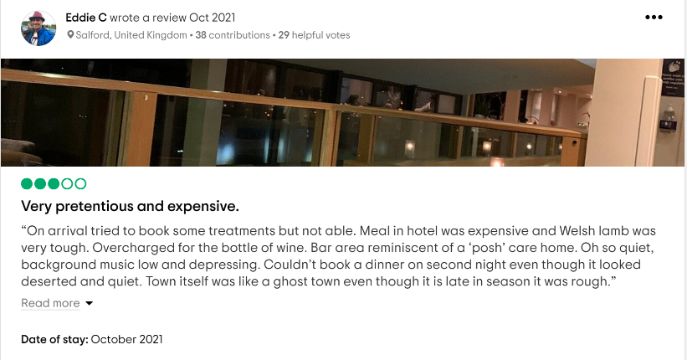

Appendix 3
Retreats group Booklet (Paula Ellis, 2018).


