

School of Engineering

FESTO Cyber Physical System – Goods Dispatch Process Automation Development
Manufacturing, Design & Technology (ACMA5002)

Paul Benbow
2014803
12/06/2022
Table of Contents
1 Introduction 1
2 Methodology 2
3 Conclusions 11
4 Bibliography 13
5 Appendix ‘A’ 15
6 Appendix ‘B’ 19

Table 1, Voice of the customer and Employee 2
Table 2 DFMEA for Concept 1 9
Table 3 DFMEA for Concept 2 9
Table 5 Design Efficiency for Concept 1 9
Table 4 Design efficiency for concept 2 9
Table 6 The Lucas method for evaluating Concept 1 manual handling 10
Table 7 The Lucas method for evaluating Concept 2 manual handling 10
Table 8 The Lucas method for evaluating the difficulty for assembling concept 1 10
Table 9 The Lucas method for evaluating the difficulty for assembling concept 2 10

Introduction
This report will review and utilise the ‘Design for Six Sigma’ (DFSS), methodology to produce two ‘creative design’ solution that will integrate a collaborative robot (Cobot) into a cyber-physical production system. DMADV framework will be followed, this will separate the design process into five phases which will; define the customer’s requirements and design objectives; measure the propriety of design features required to satisfy the customer’s needs; analyse the design priorities to produce ‘critical to quality’ milestones; design the product; verify that the product meets the customer’s needs (Yang & El-Haik, 2009).
Defining the customer’s needs and the design objectives will derive from an understanding of the customers problem and what they will be willing to pay, for a resolution (Mascitelli, 2004). The voice of the customer (VOC) is a principal feature of this phase and can be captured in a variety of different ways such as field reports; questionnaires; discussions (Yang & El-Haik, 2009). This report will use the customer specification (written in the report brief), as the VOC and discussions held with the ‘Cyber-physical Systems’ team at UWTSD for the ‘voice of the employee’ (VOE).
A SIPOC Diagram will used to clearly identify the internal suppliers; inputs; processes; outputs; customers, of the process that the VOC and VOE requires that the design of the product to perform (Ahmed, et al., 2020). The SIPOC will be limited to itemising no more than seven ‘processes’ of the customers functional requirements, this will enable the design team to “brainstorm” effectively.
The design team shall consider the; VOC; VOE; the SIPOC diagram to “brainstorm” and create additional design requirements that might be beneficial to the process. The team will use an Ishikawa diagram for this, with the statement “Failure of automated offloading of finished goods from output station of cyber physical station” to provoke additional design ideas.
The second phase of DMADV will utilise the Quality functional deployment methodology to translate the customers voice along with the attempt to understand the customer’s problem into technical characteristics of the product that is required (Oliveira, et al., 2020).The VOC and the Ishikawa diagram will be used to itemise design requirements in a ‘House of Quality’ matrix (Figure 3). The design team will identify product characteristics that can be controlled by the designer to provide the correct functionality, in the ‘House of Quality’ matrix (Figure 3).
The importance of the relationship between a design requirement and a product characteristic is quantified with a calculation that produces a ‘weight/importance’ score that ranks each design characteristic. Analysis of each ‘weight/importance’ score will identify product characteristics that are critical to quality (CTQ). Each CTQ will be ranked in order of priority, to ensure that the design team remain focused on their objectives.
The ‘Design for excellence’ theory shall be employed during the design phase of DMADV to consider the life cycle of the product from perspectives such as assembly; manufacture; reliability; cost; environment (Mascitelli, 2004). Concepts shall be explored with the use of “solid works” software which will give an understanding of how each concept will interact within the system and provide technical drawings that will detail dimensions and tolerances.
During validation of the design concept, this report will conduct a design failure mode effect analysis (DFMEA). The DFMEA will be an attempt to identify potential failures associated with any proposed product design, this is to ensure that any failures would be resolved before the product would go to mass production.
A review of the ‘Design for excellence’ theory, used during the validation phase of the DMADV framework, which will provide substance for the concept design by demonstrating that the design considers the CTQ’s. A design for assembly exercise will be completed at the validation phase by using ‘Boothroyd & Dewhurst’s method’ for evaluating the design efficiency of the product with consideration to the assembly process. Additional exercises that employ the use of ‘the Lucas method’ for evaluating the difficulty of assembling the product will also be completed.

Methodology
The specification of the product required by the customer, has been detailed within the design brief for this technical report and will be used as the VOC. Additional information provided by the ‘cyber-systems production’ team during a visit to the UWTSD, will be the ‘voice of the employee’. Both have been used to define the design objectives that are listed in Table 1.
Table 1, Voice of the customer and Employee
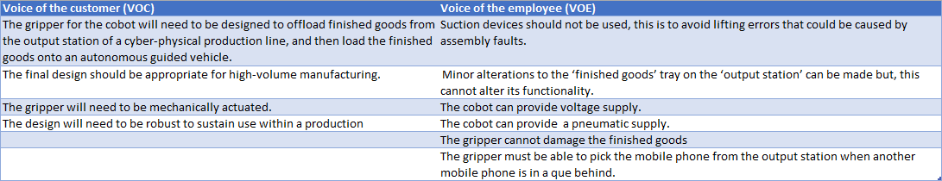
A technical report by Rajamani (2021), promotes the use of an Ishikawa or 6M methodology as a tool for developing a design during the ‘Design’ phase of the DMADV frame work. The report suggests the Ishikawa diagram would benefit a design for manufacturing and assembly process if used in conjunction with a SIPOC diagram.
Suppliers, inputs, processes, outputs and customers are all categorised in a SIPOC diagram which outlines a process that a custom requires. The SIPOC diagram shown in Figure 1 (Brown, 2018), evaluates the functionality of the process the customer requires, this helps the design team to ‘brainstorm’ and create an Ishikawa diagram (Figure 2). Figure 2 (Lucas & Lucas, 2019), shows the potential design failures of a design that maybe used to provide the customer with the required functionality.
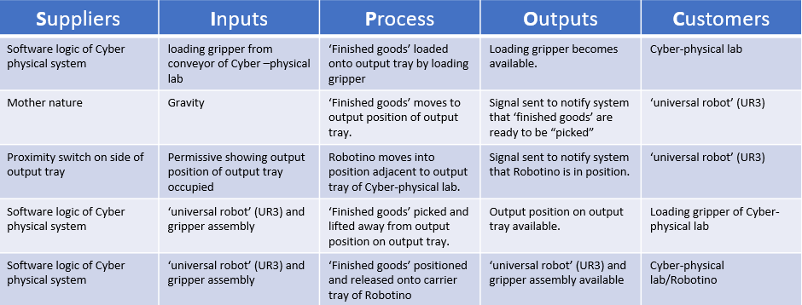
Figure 1, SIPOC of desired design requirements

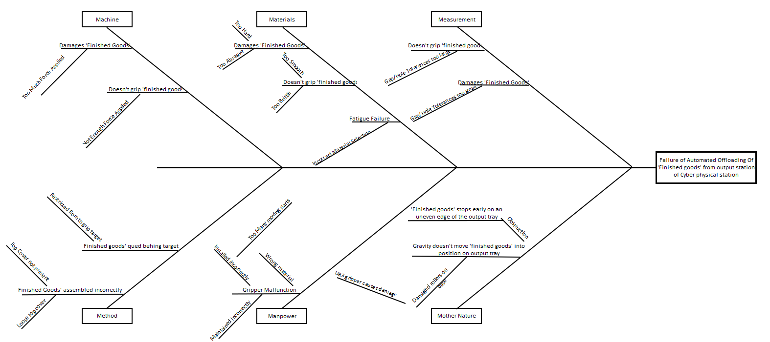
Figure 2, Ishikawa diagram illustrating possible failures of an automated offloading system
When producing a design for a new product it essential that each design criteria is measurable against the functionality the customer requires from the product (Shidpour, et al., 2016). This process will help the design team to remain focus on what is important. A case study of the design of industrial switchgear states that ‘Quality, Functional Deployment’ (QFD) and the ‘Design failure mode effect analysis’ (DFMEA) tools can be used during the ‘measurement’ phase of the DMADV framework (Bidikar, et al., 2021).
Figure 3 show a QFD that considers the voice of the customer and the Ishikawa diagram that were both produced in the ‘define’ phase. The QFD translates the customers’ requirements into product characteristics the design team can control. The ‘importance’ of each of the customers’ requirements are quantified by evaluating how often they are associated with an item of the Ishikawa diagram (Figure 2).
The QFD illustrates the design features that the design team should prioritise, Figure 3 shows that a design should be produced that attends the requirements list in the following order.
- A design that maximises the manufacturing process
- A design that minimises the assembly process
- A design that has integrated intelligence
- A design that selects a flexibly material
- A design that can be dexterous enough to move the queued ‘Finished goods’
- A design that has a material that is smooth
- A design that enables the correct force to be applied
- A design that has accurate tolerances
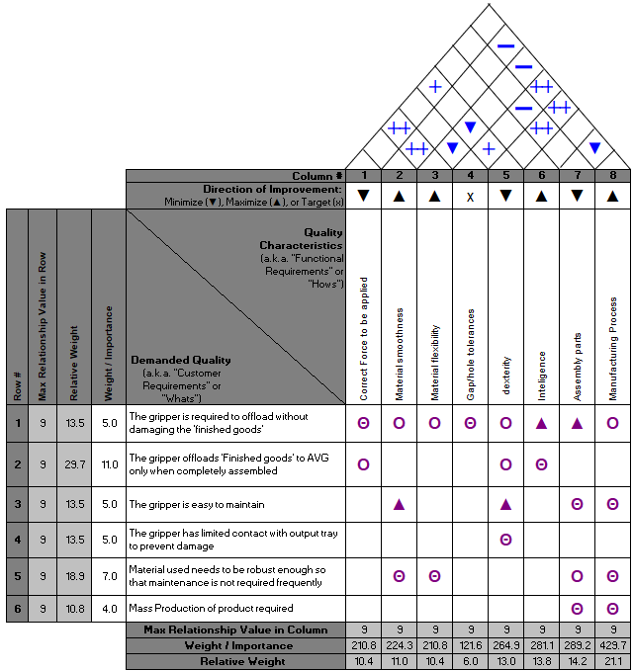
Figure 3 A 'House of Quality' for design of new gripper
Concept 1
Concept 1 (shown in Figure 4 and Figure 5), comprises of four parts that need to be manufactured using four different processes which, might include electronic manufacturing; additive manufacturing; machining & milling; forging; welding.
Part 4 is the ‘finished goods’ gripper this is made from a silicone rubber. The dimensions of the gripper require minimal force to be applied by UR3 to the ‘mobile phone’, the force will distort the silicone rubber enough for the ‘mobile phone’ to fit inside it’s cavity.
The design of the gripper will require poisons ratio to be calculated and remain within tolerance for the silicone rubber to apply enough pressure to the ‘finished goods’ to be able to form a grip but, not too much pressure that it will resist the pulse of air needed when required to release.
The red circle shown on Figure 4 shows an extruded ‘lip’. The intention of the design is to use the UR3 to position the this ‘lip’ between the target ‘mobile phone’ and the ‘mobile phone’ that is queued behind. The UR3 will be programmed to move forwards which will push the queued ‘mobile phone’ back up the ‘output tray’ (shown in Figure 7). Once a gap has been created between the target and the queued ‘mobile phone’ the gripper can be lowered into position (shown in Figure 6). After ‘Robotino’ has lifted the target away, the queued ‘mobile phone’ will roll down the ‘output tray’ ready to be the next ‘finished goods’ to be picked (shown in Figure 8).
Part 3 is a base plate that has been designed to provide rigidity to part 4. The orange box shown in Figure 5 highlights a pneumatic port, there is another on the opposite side of the assembly. It is the intention of this concept to connect a pneumatic supply via a solenoid valve which will deliver a pulse of air onto the ‘top cover’ of the ‘mobile phone’, this will then force the mobile phone from part 4 and onto ‘Robotino’.
Part 2 is a ‘off-the-shelf’ low range load cell it will measure the weight of the ‘mobile phone’ once picked from the ‘output tray’. The UR3 will revert to a datum position when the loadcell weighs the product. If the loadcell detects that the UR3’s payload is too light, then the system can be programmed to send an alert to a team member notifying them of an assembly fault. The ‘mobile phone’ can then be deposited into a ‘reject bin’ and the process can resume.
Part 1 is an adapter plate that allows the Part 2 to be secured with two M2.5mm fixings, four bolts can then be used to secure the fixing plate onto UR3.
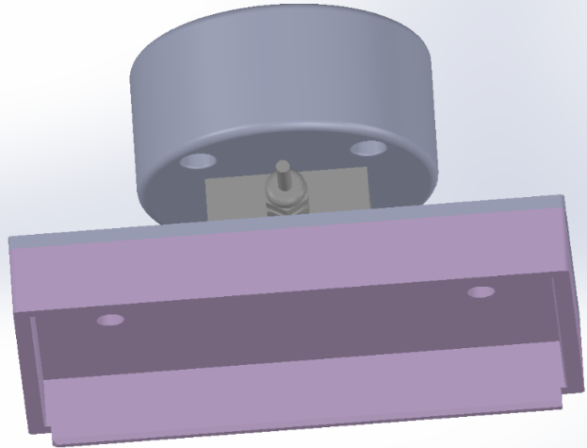
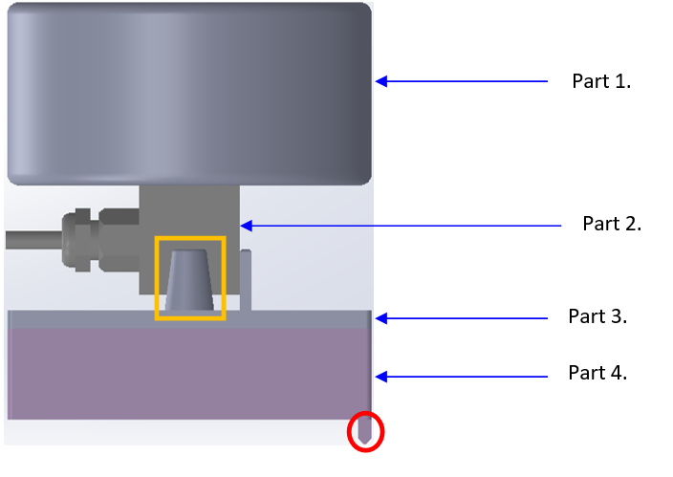

Figure 4 side view of design concept 1
Figure 5, front view of design concept 1

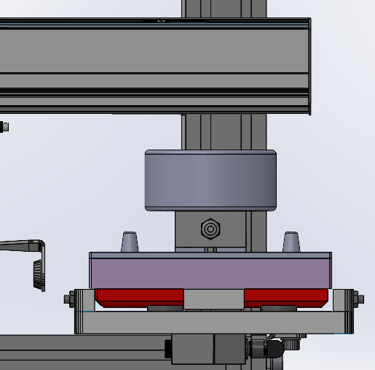
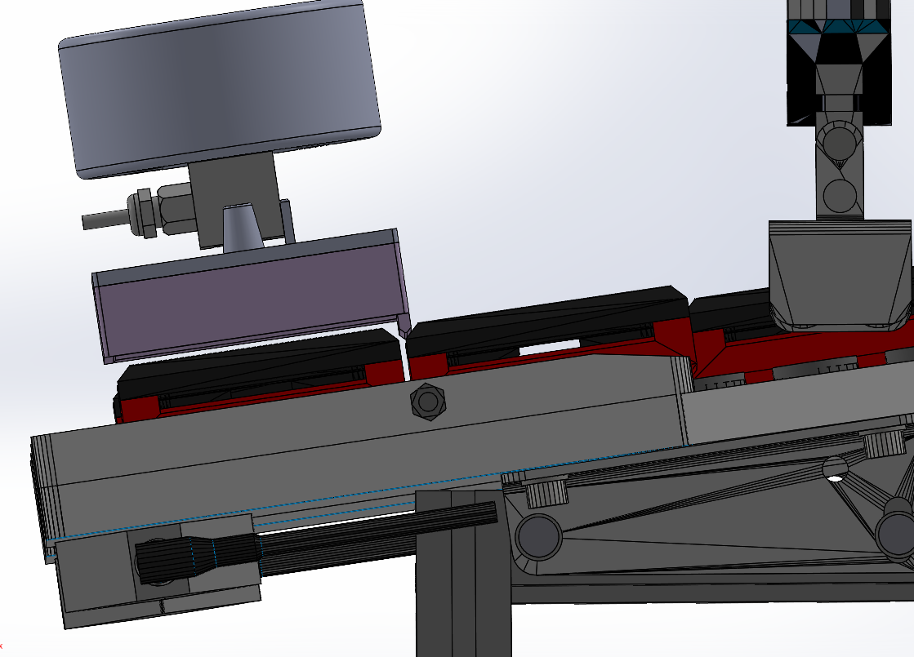
Figure 6 front view of concept 1 picking the mobile phone
Figure 7 side view of concept 1
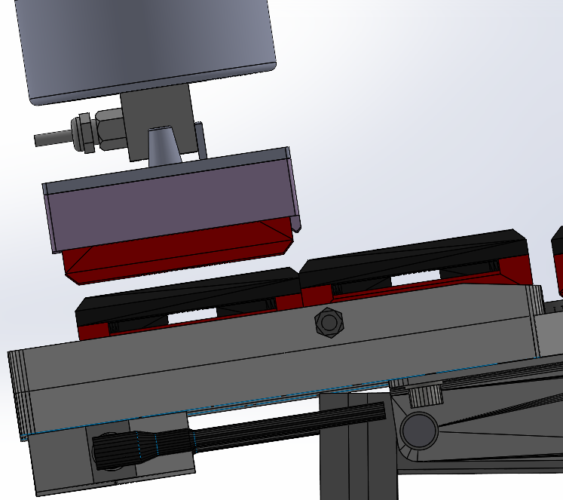
Figure 8 design concept 1 lifting the mobile phone away
Concept 2
This design comprises of 1 part (Figure 9), which will be manufactured with recycled rubber, using laser sintering for 3D printing (Toncheva, et al., 2021). Figure 10 (B2B, 2019), shows a ‘Festo pneumatic gripper’ like that of the one currently being used in conjunction with the UR3 at the cyber-systems workshop.
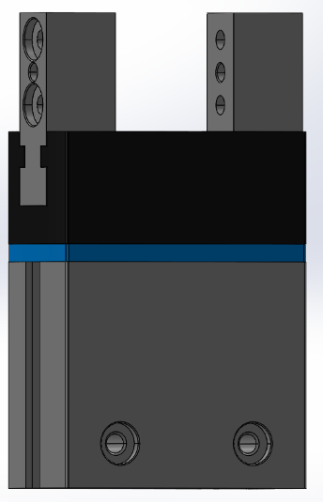
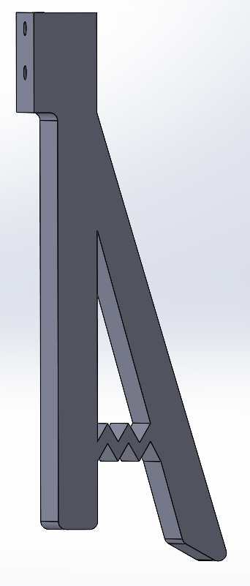
Figure 9 Gripper Finger Figure 10 Festo Pneumatic Gripper

Two gripper fingers will be fixed either side of the pneumatic gripper, each secured with two M3 bolts. The UR3 will be programmed to manoeuvre into position above the target ‘mobile phone’, it will then slowly lower. The longer of the two fingers will gently press against the ‘top cover’ of the queued ‘mobile phone’, pushing it back up the ‘output tray’ towards the ‘CP Lab’ (as shown by the blue arrow in Figure 12). The shorter of the two fingers will lower to a position where it will be able to grip both the ‘base’ and the ‘top cover’ (Figure 11)
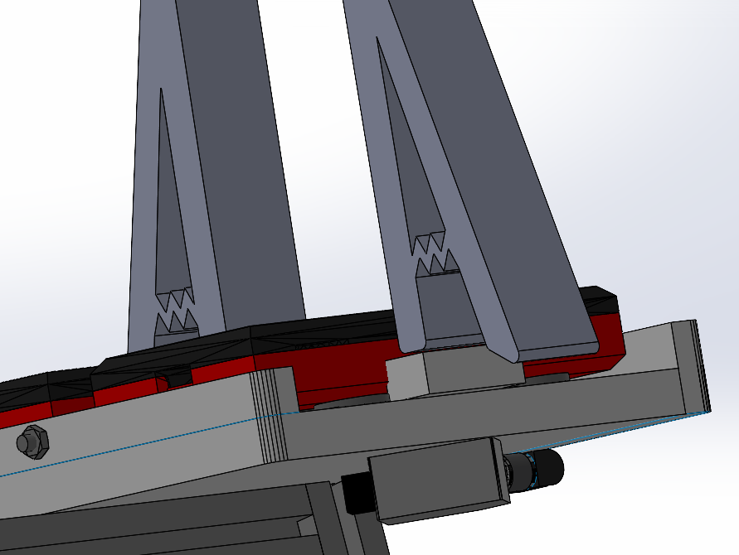
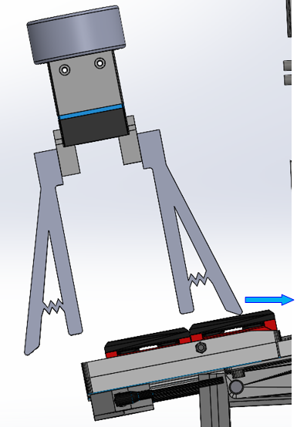
Figure 11 Centre view of gripper fingers
Figure 12 Side view of Gripper fingers

The Festo pneumatic gripper will close, allowing both short fingers to form a grip on the ‘mobile phone’, the UR3 will then lift the ‘mobile phone away’. Once the target has been removed the queued ‘mobile phone’ will be free to roll back down the ‘output tray’ and into position to be picked.
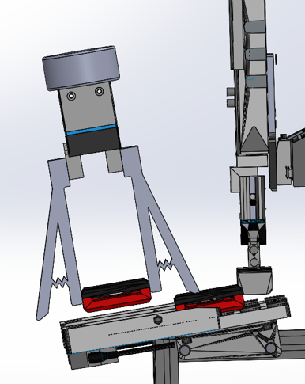
Figure 13 Gripper fingers removing the target 'mobile phone'
Validation of each concept design was completed with the four separate evaluations of both products; A design failure mode effect analysis (DFMEA); the Boothroyd Dewhurst method for analysing design efficiency; the Lucas method for measuring the manual handling required to assemble; the Lucas method for measuring the difficulty of fitting together the separate parts of the assembly.
Table 2 and Table 3 shows the systematic approach for the DFMEA in an attempt of evaluate the potential risk of each concept failing, actions where then created in attempt to stop the failure mode before the concept goes into production (pornpibunsompop, et al., 2011). Attention should be drawn to the difference between the quantity of failures, concept design 1 has nine possible scenarios compared to concept 2 with only three. Possible reasons for this could be the quantity of different parts and the different manufacturing process used.
Table 2 DFMEA for Concept 1
Table 3 DFMEA for Concept 2
Table 5 and Table 4 show the results of the evaluation for design efficiency between both concepts (Culleton, et al., 2017). Concept 1 and concept 2 scored 73% and 100% respectively, the reduced quantity of parts and their essential requirement to the design contributed to concept 2’s score.

Table 5 Design Efficiency for Concept 1
Table 4 Design efficiency for concept 2
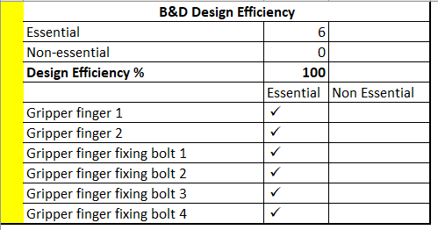
Table 6 and Table 7 detail the results of the ‘The Lucas method’ used to evaluate the manual handling required by the person assembling the product which will give a method to compare and contrast both concepts (Alfadhlani, et al., 2018). Concept 2 was the better design with a manual handling index of 10.6 compared to a manual handling of 20.8 for concept 1. Reasons for the better score would be contributing factors such as reduced quantity of parts; lighter parts; less complexed design of parts.
Table 6 The Lucas method for evaluating Concept 1 manual handling

Table 7 The Lucas method for evaluating Concept 2 manual handling
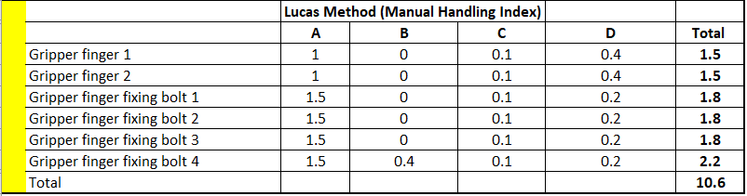
Table 8 and Table 9 show the results from an evaluation of the difficulty level required to assemble each of the concept designs. Concept 2 has the better index of both, the biggest contributor for this would be the reduced number of parts that were light weight.
Table 8 The Lucas method for evaluating the difficulty for assembling concept 1

Table 9 The Lucas method for evaluating the difficulty for assembling concept 2
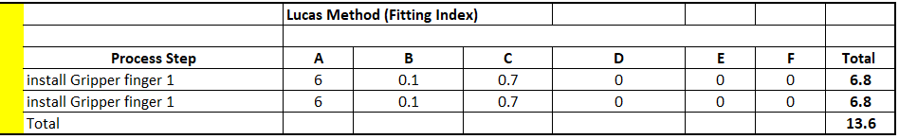

Conclusions
The ‘house of quality’ in Figure 3 shows the priorities associated with the characteristics that need to be incorporated into the design and after consideration both ‘concept design 1’ and ‘concept design 2’ will be able to achieve the majority of the ‘critical to function’ items.
However, the largest priority produced by the ‘house of quality’ was the necessity for the ability for product to be able to be massed produced through the maximisation of manufacturing process, ‘design concept 1’ does not achieve this objective. The ‘design concept 1’ will require multiply materials and skilled trades to produce each individual part. Once produced each part will need to be assembled the results recorded in Table 6 and Table 8 show that in comparison with ‘design concept 2’ this will be twice as difficult. The ‘design concept 2’ has as a simple design that could be massed produced with ‘additive manufacturing’ or ‘injection moulding’ but, it will not provide the intelligence of design concept 2.
The ‘design concept 1’ will be capable of being able to be programmed to enable the ‘Cyber-production system’ to recognise an assembly fault. Once the assembly fault has been identified the system will be able to process the fault and resume its production activities by continuing to the next ‘finished goods’ to be picked. Design concept 2 will not have this facility therefore, at the point of an assembly failure a user or operator will need to interact with the process for production to resume. The interaction between a physical user or operator to resolve such issues, contradicts the theory of a ‘cyber-physical system’ (Sedigh & Hurson, 2012).
The DFMEA on both concept’s indicate the possibility of nine failures arising with ‘design concept 1’ compared to four with ‘design concept 2’. Additional resources are required in both the design phase and the installation/commissioning for ‘design concept 1’ to resolve the faults. In comparison, ‘design concept 2’ will require minimal resources to resolve all failures, in the design phase.
A customer requirement not stipulated by the customer and not scrutinised by the design team was details of the budget constraints. The budget restraints would be instrumental in deciding which concept would be viable for this project. The cost associated with producing ‘design concept 1’ would be considerably more, due to the quantity of specific trades required to manufacture the assemblies multiple parts, and the cost of purchasing the load cell. Design concept 2 could be produced ‘in-house’ at a relatively low cost once the initial purchase of manufacturing equipment has been made.
The customer for this project is the UWTSD therefore, it has been assumed for this report that cost is a priority for the customer. It is for this reason that the design team endorses design concept 2 over design concept 1.

Bibliography
Ahmed, A., Page, J. & Olsen, J., 2020. A comparison of three simulation methodologies for a Lean Six Sigma manufacturing project – a business case study. International Journal Of Lean Six Sigma, 11(3), pp. 405-427.
Alfadhlani, Ari, S. T. M. A., Anas, M. & Toha, I. S., 2018. A Framework for the Development of Automatic DFA Method to Minimize the Number of Components and Assembly Reorientations. Materials Science and Engineering, 319(1), pp. 1-8.
B2B, 2019. B2b.Partcommunity.com. [Online]
Available at: https://b2b.partcommunity.com/3d-cad-models/dhps-parallel-gripper-festo?info=festo%2Fparts%2Fd%2Fdhps%2Fdhps_asmtab.prj&cwid=1383
[Accessed 15 June 2022].
Bidikar, S. G., Rane, B. S. & Potdar, R. P., 2021. Product development using Design for Six Sigma approach: case study in switchgear industry. International Journal of System Assurance Engineering and Management volume , 13(1), pp. 203-230.
Brown, C., 2018. Why and how to employ the SIPOC model. Journal of Business Continuity & Emergency Planning , 12(3), p. 199.
Culleton, M., McGinn, C. & Kelly, k., 2017. Framework for Assessing Robotic Dexterity within Flexible Manufacturing. Journal of inteligent & Robotic Systems, 87(3-4), pp. 507-529.
Lucas, L. & Lucas, T., 2019. Ishikawa diagram applied to identify causes which determines. IOP Conference Series. Materials Science and Engineering, 564(1), p. 4.
Mascitelli, R., 2004. The Lean Design Guidebook. First Edition ed. Northridge: Technology Perspective.
Oliveira, L. M. V. D., Santos, H. F. D. & Costa, J. A. F., 2020. Quality Function Deployment and Analytic Hierarchy Process: A literature review of their joint application. Concurrent Engineering, 28(3), pp. 239-251.
pornpibunsompop, T., charoepon, a. & Pankaew, E., 2011. A Fuzzy Logic Based Rocket Launch Tube's DFMEA. Applied Mechanics and materials, 87(1), p. 119.
Rajamani, M., 2021. Enhancement of 6M Methodology as a Design for Assembly Tool for Developing Effective Aerostructures, United States: SAE International.
Sedigh, S. & Hurson, A., 2012. Chapter one - Introduction and Preface. Advances in computers, Volume 87, pp. 1-6.
Shidpour, H., Da Cunha, C. & Bernard, A., 2016. Group multi-criteria design concept evaluation using combined rough set theory and fuzzy set theory. Expert Systems with Applications, 64(1), pp. 633-644.
SIPOC Diagram Explained. 2018. [Film] Directed by Bzhwen A Kadir. s.l.: Youtube.
Toncheva, A., Brison, L. & Philippe, D., 2021. Recycled Tire Rubber in Additive Manufacturing: Selective Laser Sintering for Polymer-Ground Rubber Composites. Applied Sciences, 11(18), p. 8778.
Yang, K. & El-Haik, B. S., 2009. Design for Six Sigma A road Map for Product Development. Second Edition ed. New York: The Mcgraw-Hill Companies.

Appendix ‘A’
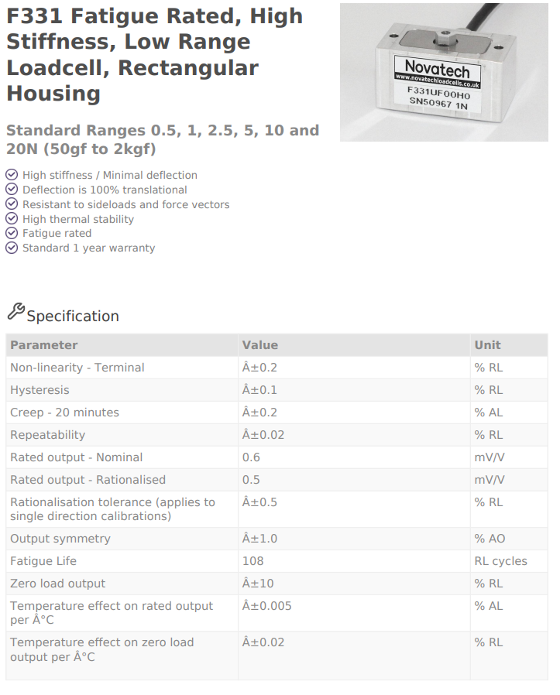
Figure 14, Specification of a low range loadcell.

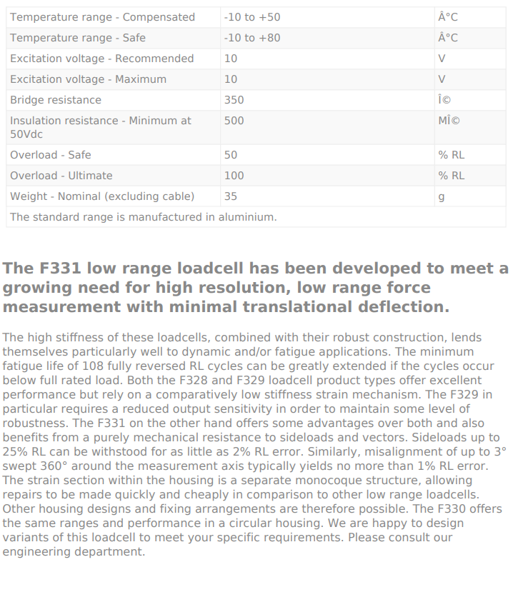

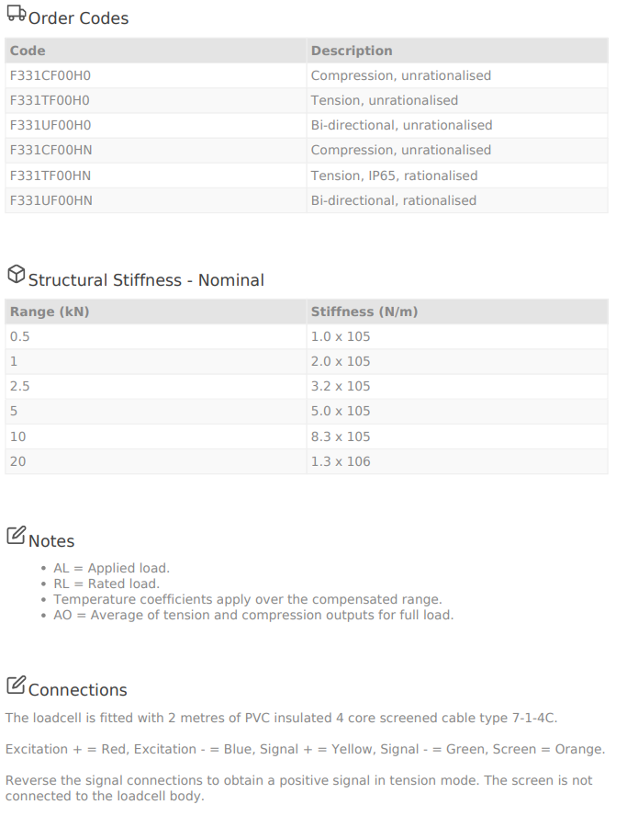

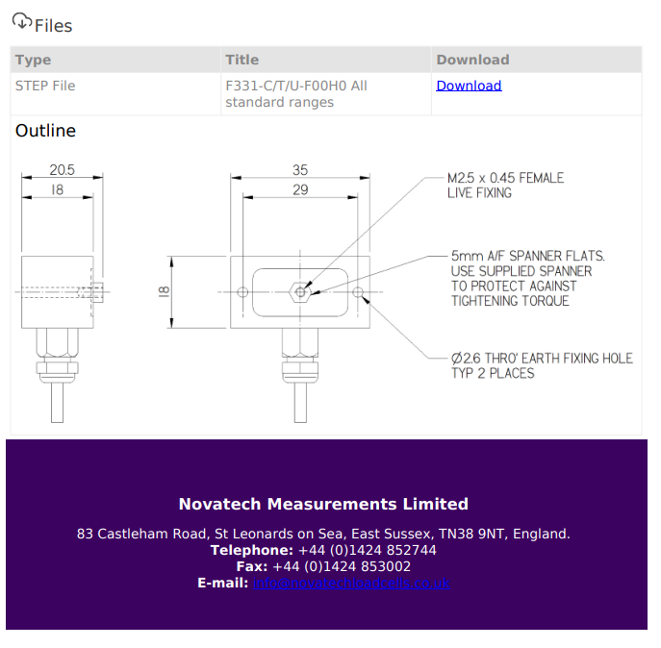

Appendix ‘B’
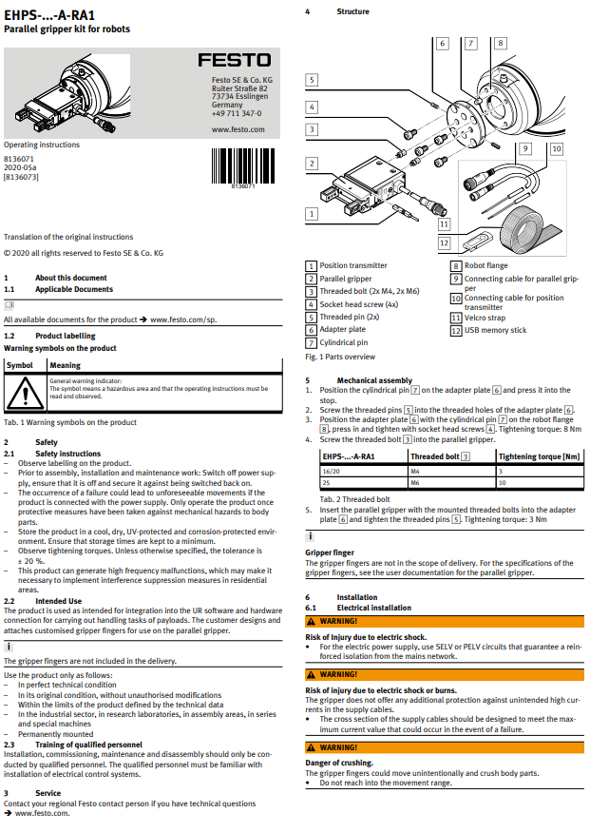
Figure 15 Specification of a Festo parrellel gripper tool


