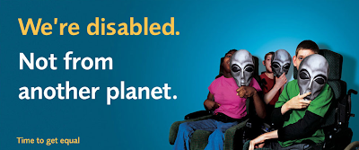
Understanding and preventing the issue
Disablism
Disablism can affect anyone who is living with a disability, hidden or not.
This can happen to anyone with a disability. It can be seen during employment or the interview process when there can appear to be a reluctance to hire an individual with a disability.
There also can be issues with using public transport. There can be a lack of facilities to aid wheelchair access and this can leave individuals frustrated at the lack of support for their condition.
Hidden disabilities are complex when it comes to Disabilism as people may not be aware, they are mistreating the individual by not making adequate adjustments for them. However, this is not a reason for people to get away with telling people their disability isn’t real or the common misconception of calling the individual lazy.
Another area that can experience Disablism is those with mental health disorders. There appears to be a lack of understanding of the issues faced by those suffering with issues such as bipolar disorder and obsessive-compulsive disorder. However there needs to be a higher level of understanding and consideration when assisting individuals with such issues.
Disablism can affect a broad spectrum of individuals and is not isolated to those with visible, physical disabilities.

Who can this affect?

(Seidman, 2019)
Disablism is defined as “discrimination against disabled people”
(Collinsdictionary.com, 2019)
All the information held within this document is placed to enable an individual to discover or realise when they are experiencing discrimination due to their disability and who they can speak to. This also contains information on the acts in place to protect the individual’s rights and to show them that there are policies in place to protect them. This leaflet shows the vast importance of equal rights for those with hidden or visible disabilities and how those supported properly can flourish. There is an important focus on how able-bodied individuals should be treating disabled people equally and that disablism should have been eradicated years ago as knowledge of disabilities developed.

“To find equality for mankind, we must first remove the barriers that have divided us for so long”
(Hensel 2019)

Convention on the Rights of Persons with Disabilities

You are protected under the CRPD nationwide as it is an international human rights treaty. It is in place to ensure countries implement policies and acts that ensure disabled individuals are treated fairly and are able to exercise their human rights equally to those able bodied.
This act helps to prevent and protect individuals from experiencing Disablism as it ensures that disabled people are treated equally and provides a viewpoint that they should have equal rights. Article 28 of the convention also enforces that individuals with disabilities should have full access to appropriate housing and support financially for disability related expenses
You are protected under the equality act if you have “a physical or mental impairment” (Equality act 2010) and this “has a substantial and long-term” (Equality act 2010) effect on their daily life.
Under this act you are protected from discrimination within the workplace and within educational settings. This means employers cannot ask inappropriate questions regarding your disability during the interview process and cannot refuse you employment purely because of your disability.
This also protects you from direct and indirect discrimination. It places focus on employers, and educational providers to ensure that appropriate adjustments are made to enable full access to education and employment for disabled individuals.
Equality act 2010

Acts in place to protect disabled individuals
Signs you are experiencing Disablism

- Being questioned about your disability within the interview and recruitment process.
- Bullying from co-workers due to your disability, this can present as unkind or derogatory remarks.
- Not having access to certain areas of a building if you have a physical disability due to lack of provisions such as ramps.
- Not being considered for extra training or external courses as the employer assumes you will have difficulty accessing the training vicinity.
- No promotion or pay rise due to your disability and the assumption you could not handle new responsibility.
Within WOrk

- Lack of access to public transport such as inaccessible train and bus stations.
- Being refused access to busses despite the legal obligation.
- Derogatory language being used and being talked down to.
- Forced help, individuals assuming their aid is needed.
- A lack of understanding from individuals and the assumption they have the right to question “why are you like this.”
- A severe lacking in accessible accommodation and an unwillingness from landlords to adapt properties.
- A lacking of accessible changing rooms, doorways and ramps for shops.
Within daily life

Professor Stephen Hawking is considered a pillar of the disabled community and appeared to ignore any Disablism thrown at him, not allowing anything to hold him back. He made the scientific community come to the realisation that a disability does not prevent someone being an intelligent individual and began the progress seen today within the disabled community.
Despite his life changing diagnosis of Amyotrophic lateral sclerosis, he went on to continue his work as a professor and researcher creating many literary publications and receiving thirteen honorary degrees throughout his lifetime. He is a symbol of believing in your self-ability and not letting disablism and disability hold you back.
Don’t let disablism hold you back
If you or a family member are experiencing disablism the places below can help you find out more about your rights and can support any next steps.
Support Avenues
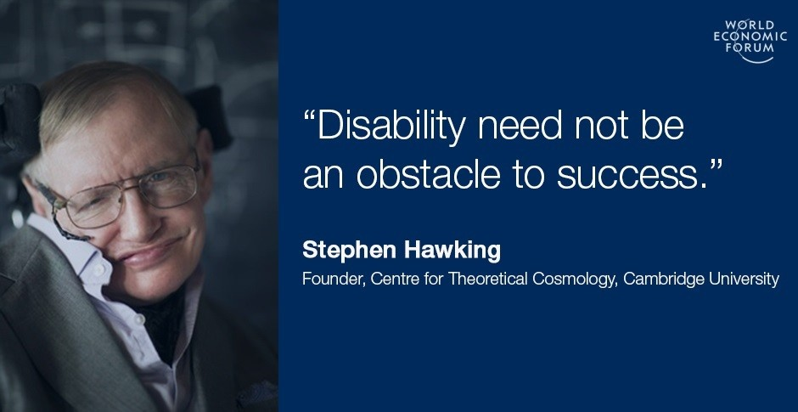
(Stephen Hawking, n.d.)
Disabilities Rights UK: This is a group of disabled individuals who are fighting for equal rights for disabled individuals.
Disability Law Service: This is a charity who provide free legal advice for disabled people to ensure they are receiving appropriate justice and are not having their rights blocked.
Scope: This is another charity that is campaigning for equal rights within society for disabled individuals. They have a wealth of information on their website and cover vast topics relevant to those with or supporting those with disabilities.
Citizens Advice: They provide free advice on many issues and can speak to you in person if you book and appointment with the local Citizens Advice Bureau.

Rationale
This leaflet is designed for the disabled individuals to understand what disablism is and their rights to prevent it from occurring. The purpose of the leaflet is to empower individuals to learn to recognise when they are being mistreated and the avenues they can explore to further fights against the injustices faced by themselves.
This was the chosen topic as it is an area that is constantly in need of improvement. Despite the progression that has been seen with more places becoming disability friendly and employers being unable to discriminate against individuals due to their disability there is still a high level of disablism seen every day. This in part can come across as ignorance as people can indirectly be disablist by not providing appropriate access to facilities such as changing rooms. Direct discrimination can be seen by disabled individuals being bullied and prevented from participating in an event purely due to their disability.
There are many successful individuals within the disabled community and this leaflet highlights at the end that despite disablism, and lack of understanding disabled people can achieve wonderful things.
The is no need for disabled people to feel as though they are less important within their community and there are acts in place to prevent them being mistreated. The Equality Act 2010 and CRPD protects the rights of disabled people nationwide and provides a framework for employers and individuals to understand how the rights should be equal for everyone.
There needs to be an adjustment within society to ensure that disabled people do not suffer from disablism and get to fully enjoy their lives. There is plenty of legislation as outlined above that supports the importance of treating everyone equal.

References
Citizensadvice.org(2019). Home. Available at: www.citizensadvice.org.uk/wales/ [Accessed 17 Nov. 2019].
Collinsdictionary. (2019). Disablism definition and meaning | Collins English Dictionary. Available at: www.collinsdictionary.com/dictionary/english/disablism [Accessed 13 Nov. 2019].
Disability Law Service. (2019). Home | Disability Law Service. [online] Available at: dls.org.uk/ [Accessed 14 Nov. 2019].
Disabilityrightsuk.org. (2019). How we can help | Disability Rights UK. [online] Available at: www.disabilityrightsuk.org/how-we-can-help [Accessed 16 Nov. 2019].
Everydaydisablism.com. (2019). Why?. Available at: www.everydaydisablism.com/why/ [Accessed 19 Nov. 2019].
Hensel, R. (2019). My Quotes:. THE OFFICIAL ROBERT M. HENSEL WEBSITE. Available at:roberthensel.webs.com/myquotes.htm [Accessed 16 Nov. 2019].
Legislation.gov. (2010). Equality Act 2010. Available at: www.legislation.gov.uk/ukpga/2010/15/section/6 [Accessed 14 Nov. 2019].
Ryan, F. (2019). What is life really like for disabled people? The disability diaries reveal all. the Guardian. Available at: www.theguardian.com/inequality/2017/nov/15/whats-life-really-like-for-disabled-peopld-disability-diaries-reveal-all [Accessed 14 Nov. 2019].
Seidman, E. (2019). You know better than to be racist. So why are you disablist?. Love That Max. Available at: www.lovethatmax.com/2012/08/you-know-better-than-to-be-racist-so.html [Accessed 10 Nov. 2019].
Stephen Hawking. (n.d.). About Stephen. Available at: www.hawking.org.uk/about-stephen.html# [Accessed 12 Nov. 2019].
Tomkinson, H. (2018). I get treated differently just because I’m disabled, I’m determined to change that. [Scope's Blog. Available at: blog.scope.org.uk/2018/03/23/i-get-treated-differently-just-because-im-disabled-im-determined-to-change-that/ [Accessed 12 Nov. 2019].
Tuc.org.uk. (2019). Available at: www.tuc.org.uk/sites/default/files/You%20don%27t%20look%20disabled_0.pdf [Accessed 14 Nov. 2019].
Un.org. (2006). Convention on the Rights of Persons with Disabilities (CRPD) | United Nations Enable. Available at: www.un.org/development/desa/disabilities/convention-on-the-rights-of-persons-with-disabilities.html [Accessed 14 Nov. 2019].
World Economic Forum. (2019). Disability is not an obstacle to success. These inspirational leaders prove that. Available at: www.weforum.org/agenda/2016/12/disability-is-not-an-obstacle-to-success-these-inspirational-leaders-prove-that-9bfc2816-a172-4a67-836e-95c1609f63eb/ [Accessed 12 Nov. 2019].

