

ACCA4026
Software Solutions for Business
Component 1

Contents
Task 1 2
1.1 Introduction 3
1.2 Comparative Analysis 3
1.2.1 Ease of Use 3
1.2.2 E-Commerce Features and Scalability 3
1.2.3 Design Flexibility 3
1.2.4 Cost and Value Proposition 4
1.3 Advantages and Limitations 4
1.4 Recommended Choice Based on Business Context 5
Task 2. Mind-map of contemporary software applications 6
2.1 Mind Mapping 6
2.2 Mind Map Creation: Different Software Daily Uses 7
Task 3. Office Applications for creating, storing, presenting, and analysing information/data 8
3.1.1 Microsoft Word 8
3.1.2 Microsoft PowerPoint 9
3.1.2.2 Benefits to Business Operations. 9
3.1.2.3 Limitations 10
3.1.3 Microsoft Excel 10
3.1.4 Microsoft Access 11
3.2.1 Feature 1: IF Function 12
Feature 2: Pivot Table 16
Task 4. Communication and Collaboration applications (Approx. 1000 words). 18
4.1 Communication Application: Microsoft Teams 18
4.2.1 Communication Application – Microsoft Teams (Free Version) 20
4.2.2 Collaboration Application – Trello (Free Plan) 22
References 24

Task 1
Question: Describe two contemporary e-Commerce website builders/software solutions
Answer:

1.1 Introduction
The selection of site builders is among the huge choices available to online shoppers nowadays. Shopify and Wix are two of the popular ones. Shopify was created with the purpose of dealing with e-commerce in mind, and as such, there are numerous features which are suited to allowing you to sell effectively online. Wix, on the other hand, was originally a generic site builder, but it subsequently introduced e-commerce capabilities. Due to the differences in their backgrounds, they have different purposes and capabilities and, thus, would suit different categories of users. [1].

1.2 Comparative Analysis

1.2.1 Ease of Use
Wix is reputed to be user-friendly. It has a drag and drop editor such that anyone can build a site without any technical skill, hence the editor is not only suitable for small business owners but also a beginners in web development. However, Shopify is also friendly, but with a slightly steep curve as compared to Amazon because it is more e-commerce-driven, with its emphasis on inventory management, delivery, and money transfer rather than web design per se. [1].

1.2.2 E-Commerce Features and Scalability

Shopify is good at providing end-to-end services to e-commerce. It makes product listing without limit, sells through social media and has a variety of applications to enhance the product listing functionality [3]. This makes it a very good option for any business that intends to expand and one that requires conducting many sales or one that requires carrying out complicated selling procedures [2]. Although Wix has enhanced its e-commerce services, they remain minimal regarding the large-scale operations and sophisticated functionalities. It is best suited to small stores or stores that require good creative design rather than a lot of sales functionality.

1.2.3 Design Flexibility

Flexibility is where Wix is really strong in regard to design. You can choose a wide range of templates and adjust your layout to your taste, and make it even more personal to your brand. Shopify does have some very professional themes which are e-commerce-minded, but they do not allow flexible design changes. Shopify, however, maximises consistency of look and feel and performance instead of maximum creative licence in terms of layout [5].

1.2.4 Cost and Value Proposition
Wix can be less expensive for small or beginning enterprises to set up their online store. Shopify’s pricing tends to be higher, and when apps, themes and transaction fees are factored in, the total cost may increase significantly as the store grows. (Strauss, L. 2023) Therefore, the decision between them often comes down to current business size, projected growth and available budget. [3]

1.3 Advantages and Limitations
1.3.1 Wix – Advantages: Rapid deployment, minimal technical skill required; strong design freedom; cost-effective for small operations. [1]
1.3.2 Wix – Limitations: Less suited for large inventories or aggressive scaling; may lack advanced selling/fulfilment features found in dedicated e-commerce platforms. [2]
1.3.3 Shopify – Advantages: Built for commerce from the ground up; high scalability; rich app/integration ecosystem; excellent suitability for medium-to-large-scale online retail. [4]
1.3.4 Shopify – Limitations: Higher cost (especially when growing); initial setup and customisation may require greater learning or external support; design freedom is somewhat constrained compared to site-builders focused on design. [2]

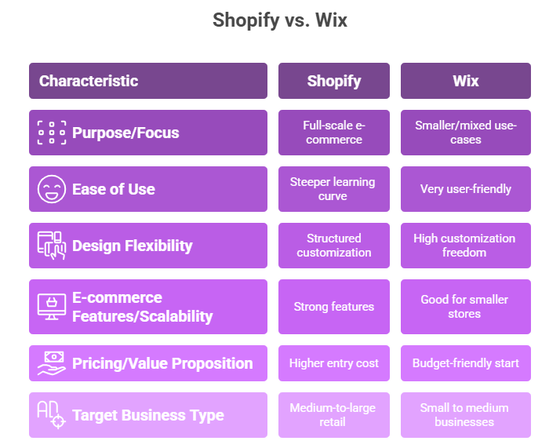
Figure: Difference Between Wix and Shopify

1.4 Recommended Choice Based on Business Context
For a small business or entrepreneur launching a modest online store, especially when prioritising design and budget. Wix is a strong candidate. However, if the business is aimed at scaling up rapidly, selling across channels, managing large inventories or targeting international markets, Shopify is arguably the more suitable platform. [6] The key decision hinges on the business’s immediate requirements and future ambitions.

Task 2. Mind-map of contemporary software applications
Describe mind mapping and explain the benefits of using mind mapping in business operations (approx. 2/3 sources).
Answer:

2.1 Mind Mapping
Mind mapping is a visual-diagramming technique used to organise information around a central concept, from which branches radiate to represent related ideas, sub-topics and connections [7].
According to a learning guide from The University of Adelaide, a mind map can be used for generating ideas, visualising relationships, organising information, problem-solving and decision-making.
2.1.1 Benefits for Business Decision-Making & Operations
2.1.1.1 Structure and Clarity of Complex Information
Mind maps help visualise the “big picture” by showing how different elements of a business decision or operation (e.g., stakeholders, risks, resources, timelines) interrelate. As the article in Business.com explains: “Mind maps are visual aids that organise new information as it relates to a central theme or concept.”
2.1.1.2 Enhanced Creativity and Problem-Solving
The branching structure encourages lateral thinking and exploration of alternative paths, facilitating idea generation beyond linear lists.[8] For example, mind mapping has been shown to improve recall, creativity and problem-solving in educational research.
2.1.1.3 Improved Collaboration & Shared Understanding
In team settings, a mind map acts as a shared visual artefact that participants can contribute to and view together, which enhances alignment and communication.
Working with multiple departments or stakeholders, one can use such a joint visual system in order to facilitate cooperation and interaction.
2.1.1.4 Agility and Adaptability in Operations
The mind maps are inherently dynamic and can be updated, reorganised or even extended in the event of new information being discovered. This is particularly appropriate within the context of the constantly changing business environment, where the nature of operations varies occasionally. The visual component assists in making plans, processes, or decisions more flexible for the teams [9].
Create a mind map of contemporary software applications that are used to support day-to-to to-today business/ Organisation operations.
Answer:

2.2 Mind Map Creation: Different Software Daily Uses
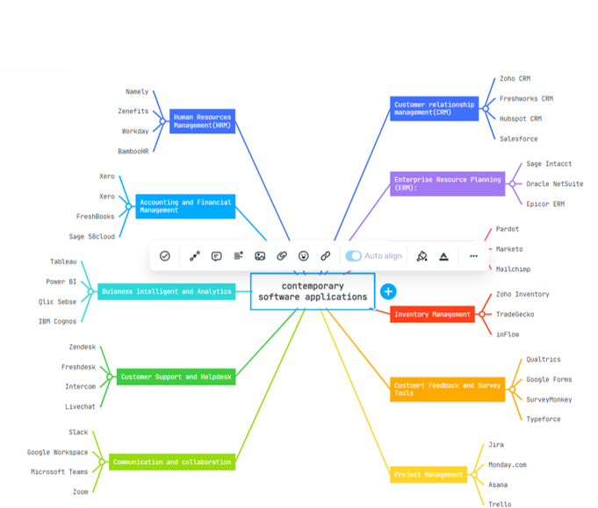

Figure: Mindmap Different Software Tools

Task 3. Office Applications for creating, storing, presenting, and analysing information/data
Explain four office software solutions for business operations (MS Word, MS PowerPoint, MS Excel, and MS Access), highlighting their major features, benefits, and limitations (if there are any). You can use some images in addition to text (approx. 4/5 sources).
Answer:

3.1.1 Microsoft Word


3.1.1.1 Major Features
Richest format word-processing: fonts, styles, headings, reports, and proposal templates, letter templates [12].
Mail-merge: the ability to connect to data sources and send out mail in bulk by means of letters and labels is a personalised business attribute.
Collaboration features. When integrated within a Microsoft 365 environment, the collaboration features include version-tracking, comments, and shared editing.
Document templates and branding: facilitating uniform delivery of any internal/external communication [12].

3.1.1.2 Benefits for Business Operations
- Improves professional communication by letting businesses create standardised, well-formatted documents for clients, stakeholders, and internal use.
- Time efficiency enabled by the use of templates, mail-merge, and collaborative editing reduces the repetition of work. [11]
- Scalability works for small and large organisations, across industries.
- Integration as part of Microsoft 365, which integrates with cloud storage, sharing, and remote access.

3.1.1.3 Limitations
Mainly documents-based, not designed to process lots of data and analyse; that is the domain of Excel. Collaboration may be very limited in cases when different formats are in use or compatibility with the Microsoft ecosystem is lacking. Version control of documents can get cumbersome if teams are large, unless active workflows are in place.

3.1.2 Microsoft PowerPoint


3.1.2.1 Major Features
Developing presentations via slides, text, visuals, charts, and multimedia (audio/video) in business storytelling.
The layouts on the appearance of professional templates, designer recommendations, and visual theme [15].
Presenter features: notes exposure, slide metamorphosis, animations, and integration of multimedia.
Online learning should be able to collaborate and share: real-time co-authoring, cloud storage, export possibilities- PDF, video. [15]

3.1.2.2 Benefits to Business Operations.
●Improves business communication: creating data, ideas, and plans attractively enables obtaining the stakeholders' attention and contributes to decision-making.
●Training, marketing, pitching and presenting to boards: Cross-functional. [13].
However, the intricate information can be presented in the form of slides, with the help of visuals and multimedia.
● Work remotely and work together: the team will be able to build decks actively across geographic locations [15].

3.1.2.3 Limitations
Excessive animation, or any other visual trickery, may ruin, instead of improving, the message. Presentations can also look unprofessional in events where the templates or multimedia apps are not designed in the best way possible. Well-constructed slides have a sense of good design and were created effectively; ill-constructed slides are prone to destroying the message. Though extremely powerful in presentation, PowerPoint is not intended to perform a significant amount of data analytics or database processes. [14].

3.1.3 Microsoft Excel
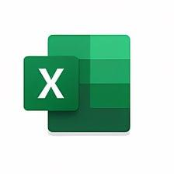

3.1.3.1 Major Features
- Spreadsheet grid: data entry, formulae, functions, charts: rows/ columns. [15].
- Also, there are advanced analytics pivot tables, data modelling, Power Pivot, external-database data import, and business analytics. [16].
- Data visualisation: conditional formatting, charts and graphs to assist in making sense of huge data. [17].
- Integration: Excel can access databases or other applications, e.g., export/import with Access, to more complicated scenarios. [18].
- Business Operation Benefits.
- It allows making data-based decisions; one can analyse sales, costs, forecast and budget using the analytics of Excel.
- Industrial flexibility: all areas of finance, operations, HR, and marketing use spreadsheets to track and analyse.
- Economical: a variety of users have been using spreadsheets; it does not need to be developed or necessary [17]. Scalability for moderate data volumes: With the inclusion of features like Power Pivot and data modelling, Excel can handle significant datasets. [18]

3.1.3.2 Limitations
Excel can struggle with very large databases or highly concurrent multi-user access; that's where Access or a full DBMS comes in. Manual spreadsheets are prone to formula errors, version control issues, lack of audit trails [18]

3.1.4 Microsoft Access
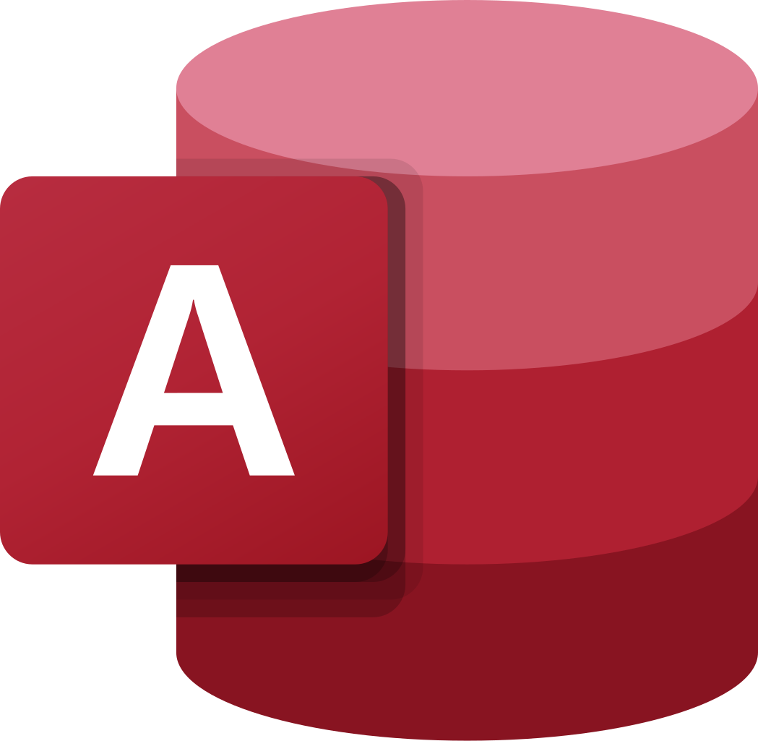

3.1.4.1 Major Features
Relational database management: tables, queries, forms, reports to structure and manage business data. [19]
Rapid application development: templates, graphical interface, VBA (Visual Basic for Applications) automation for custom business solutions.
Integration with other Office tools and data sources: import/export, link to SQL Server, Excel, etc. [18]
Multi-user data entry (within limits), data integrity features, and forms for controlled data input. [21]

3.1.4.2 Benefits for Business Operations
- Structured data management: suitable for businesses needing centralised data storage, relationships, and custom forms (e.g., customer, inventory, sales databases). [20]
- Cost-effective DBMS for small/medium organisations: simpler than full enterprise databases while still offering rich features.
- Automation and customisation potential: forms, macros, reports tailored to business workflows. [18].
- Integration: because it is part of the Office suite, many organisations are already familiar with the interface and can leverage it.

3.1.4.3 Limitations
Access is not designed for very large databases, high concurrency, or enterprise-level workloads. [20] primarily Windows-based; portability and cross-platform issues may arise. Collaboration and version-control features are weaker compared to cloud-native or enterprise DB solutions. Requires database design knowledge for optimal use; misuse may lead to poor performance or inconsistent data.
- Test any two features from the following Mail merge, IF Function, VLOOKUP, Pivot Table, Goal Seek in MS Excel, and document several screenshots with accompanying description to provide evidence of practical use. Note: This task is based on your own practical activities.
Answer:

3.2.1 Feature 1: IF Function
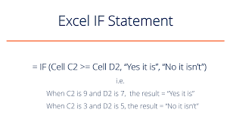
Figure: IF Function
The IF function allows the user to perform a logical test: if a condition is TRUE, then return one value; otherwise, return another.
3.2.1.2 Business scenario example:
Using our UK-based dummy table (from earlier): Suppose you have a Sales Amount (£) column and you wish to assign a “Bonus” label for any salesperson whose sales exceed £100,000, otherwise “No Bonus”.
Table: Dummy Table for Test
Salesperson | Region | Sales Amount (£) | Bonus Status | Employee ID
Olivia Smith | London | £120,000 |  | UK001
James Brown | Manchester | £88,500 |  | UK002
Emma Johnson | Birmingham | £142,000 |  | UK003
William Jones | Glasgow | £95,000 |  | UK004
Sophia Taylor | Leeds | £110,750 |  | UK005
Daniel Evans | Cardiff | £73,200 |  | UK006
Emily Wilson | Edinburgh | £131,400 |  | UK007
Thomas Davis | Bristol | £97,800 |  | UK008
=IF(C2>100000, "Bonus", "No Bonus")

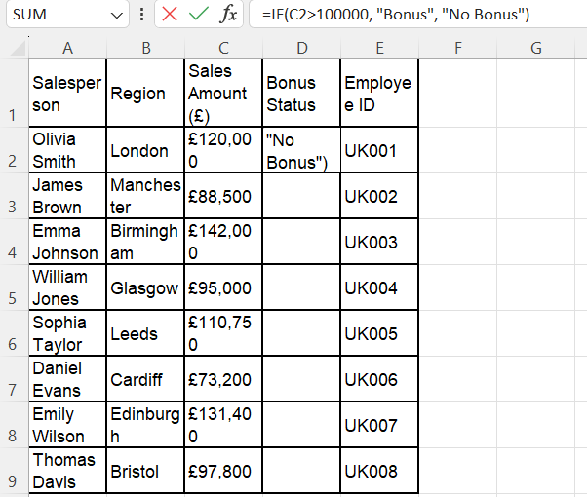
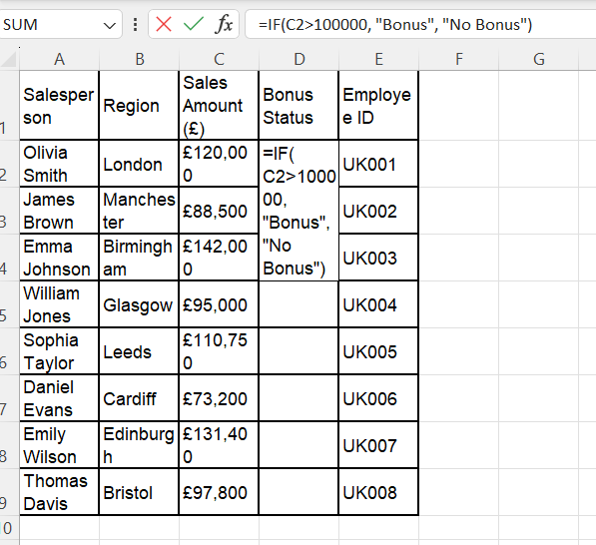
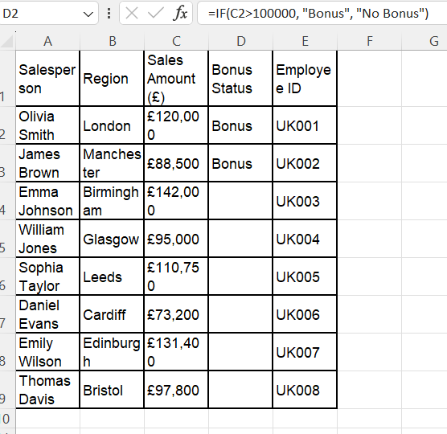
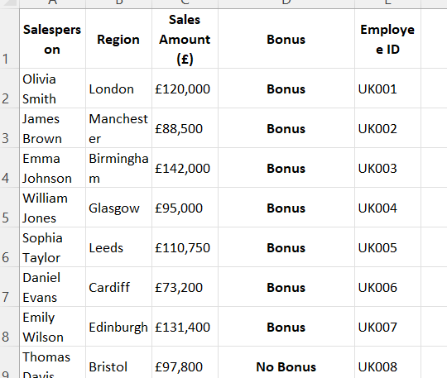

Feature 2: Pivot Table
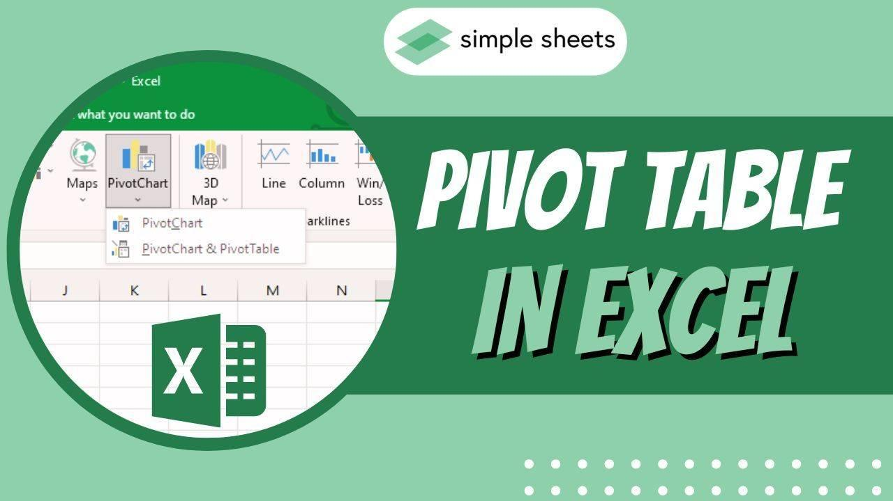
A Pivot Table is a powerful tool in Excel that allows you to summarise, analyse and display large sets of data by dragging and dropping fields into rows, columns, filters, and values.

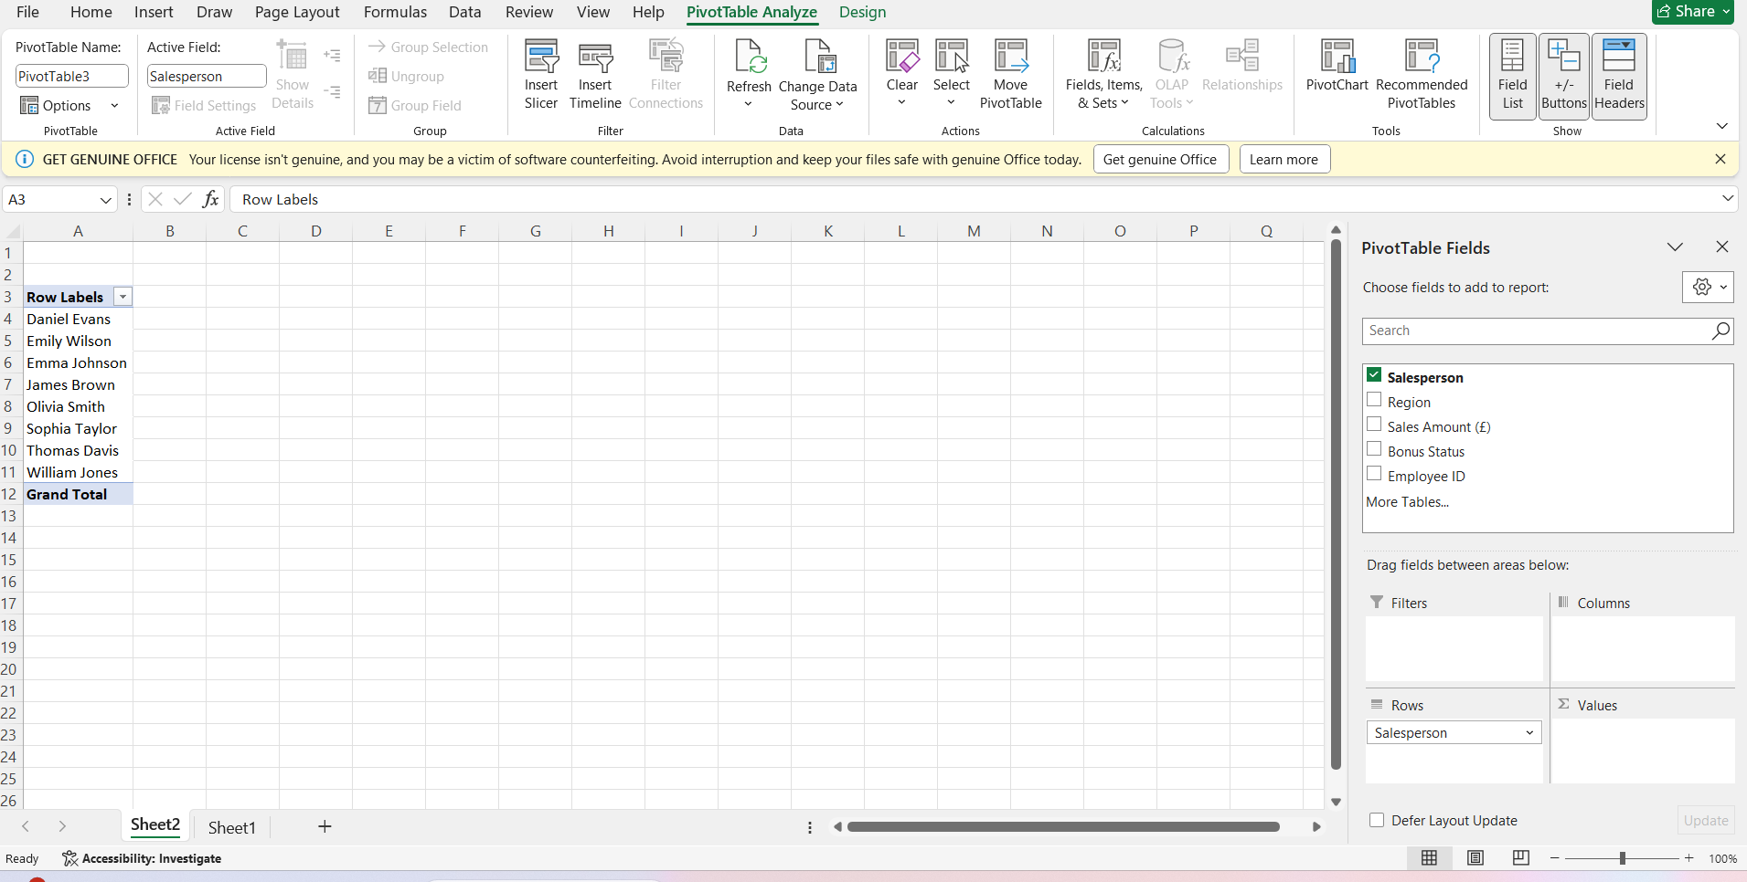

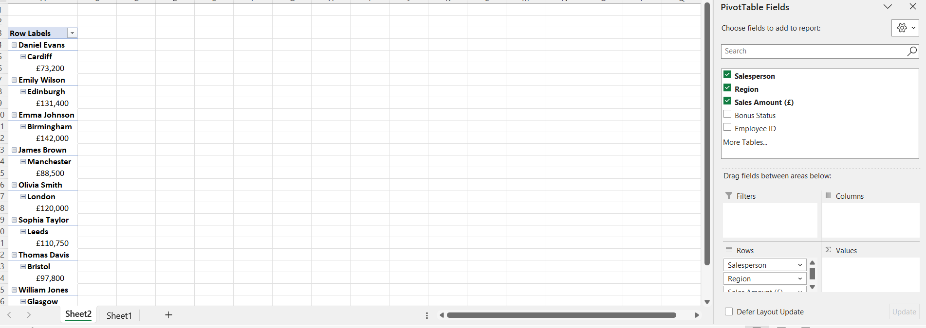
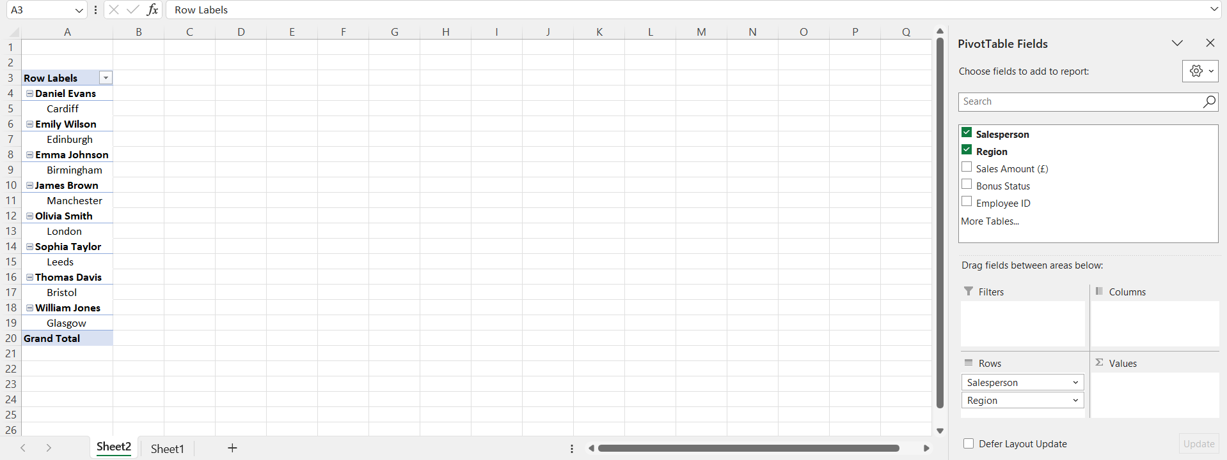

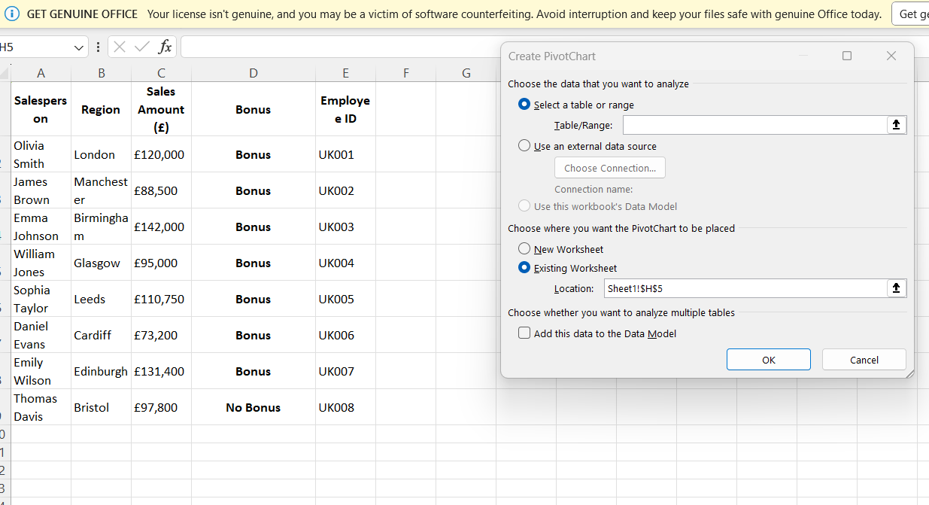

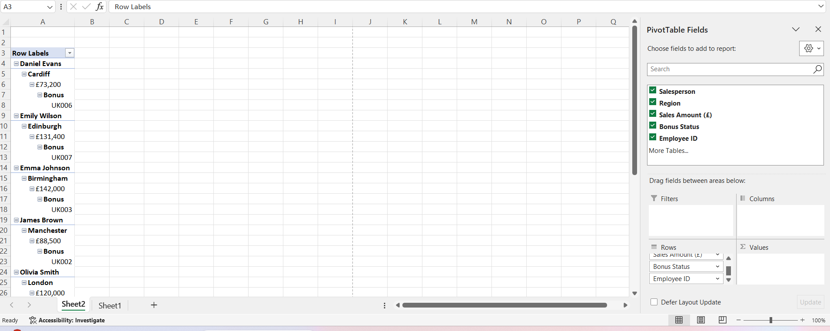
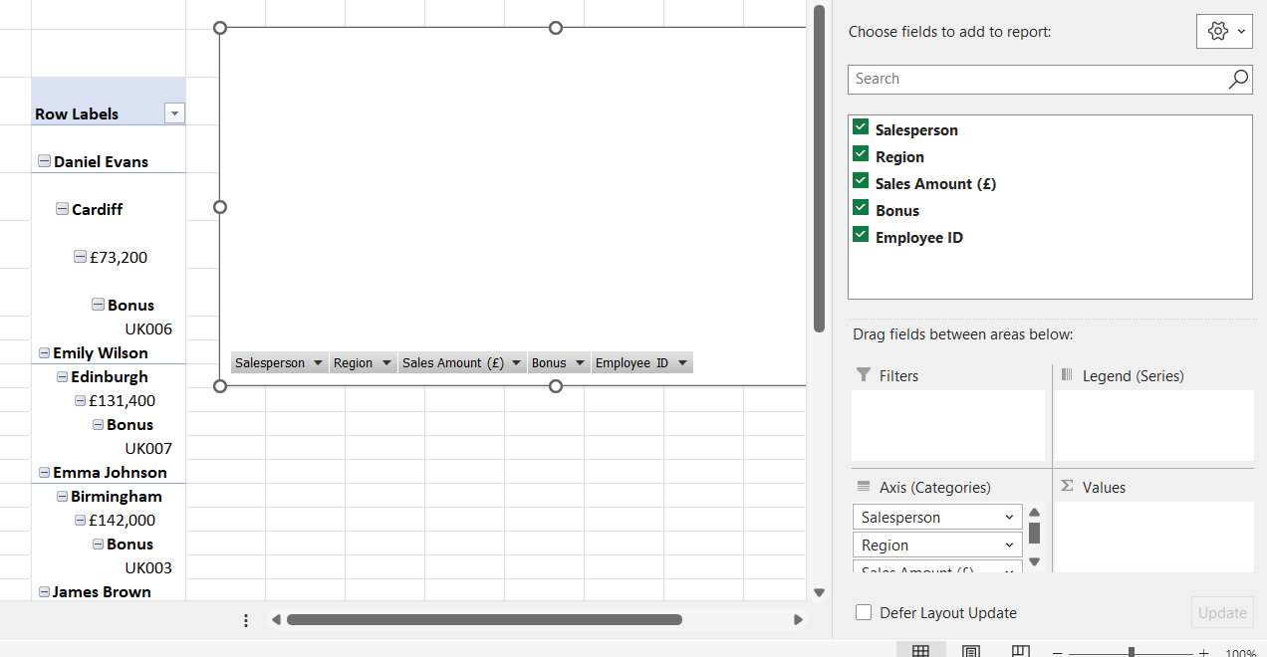

Task 4. Communication and Collaboration applications (Approx. 1000 words).
- Analyse one contemporary Communication and one Online Collaboration Page 4 of 14 applications/tools used frequently in modern business world and document a summary of their key features using written text with some images and relevant citations. (approx. 2/3 sources)

Answer:

Microsoft Teams

4.1 Communication Application: Microsoft Teams


4.1.1 Overview
Microsoft Teams is a cloud-based unified communications platform developed by Microsoft Corporation that combines workplace chat, video meetings, file storage and application integration. According to public documentation, Teams allows users to communicate via text, audio and video, collaborate on files stored in the cloud, integrate with third-party apps and manage tasks within channels and teams. [22]

4.1.2 Key Features
Persistent chat and channels: Teams supports one-to-one and group chats, as well as dedicated ‘teams’ and channels for topic-based discussions. [23] This structure helps keep communication organised rather than dispersed in multiple emails.
Video and audio conferencing: Users can hold video meetings with screen-sharing, voice calls, virtual backgrounds and meeting recordings.
File sharing and collaboration: Integration with Microsoft 365 means files (Word, Excel, PowerPoint) can be shared, co-edited and stored in channel tabs, supporting real-time collaboration [24]
Incorporation of third-party applications: Teams enable teams to sustain workflows in the same ecosystem by combining multiple productivity applications, such as Trello, GitHub, and Planner [25].
Search, command bar and accessibility: The users are able to search files, messages and persons. Through the command bar, they are also able to jump to tasks. It is accessible through desktop and mobile versions [24].

4.1.3 Benefits for Business Operations
Faster communication and reduced siloing: There is more transparency and access to information between teams, and it elevates work through collaboration as conversations occur within channels instead of isolated emails. One article claims that it is through the contemporary communication systems that enable the realisation of connecting groups, simplifying operations in business and ensuring that they remain viable and competitive throughout the digital age [26].
Better remote/hybrid workplace: As remote working continues to grow, remote work platforms such as Teams provide the teams in different geographic locations the opportunity to meet, chat, and work together in real-time as a way of keeping the teams in tune and preserving their culture [25].
Single platform: Teams can bring together chat, meetings, files and apps, enabling customers to work with less tool switching, save time and stay on track with the workflow [26].
Traceability and documentation: The records of chats, files and meetings are archived and searchable, making it transparent and useful in audits, decision-making, as well as knowledge retention.

4.1.4 Limitations
Since it has many features, Teams may need training; also, if not well managed, channels and notifications can be noisy and distracting. The organisations that rely mostly on non-Microsoft tools may face friction in integration or may not exploit the full advantages of the features Teams offers [26]. With many channels, chats, files, and notifications, without strong governance and clear usage protocols, the information may get fragmented and hard to manage. While the free tiers exist, the complete enterprise features require Microsoft 365 licenses, which the smaller organisations may consider limiting in terms of cost.

Microsoft Outlook


4.2 Collaboration Application: Microsoft Outlook
4.2.1 Overview
Microsoft Outlook is an email and personal information management application provided as part of the cloud-based services by Microsoft Corporation. It provides a unified platform for email communication, calendar scheduling, contact management, and task organization. According to Microsoft documentation, Outlook provides functions that enable users to send and receive emails, manage appointments, create tasks and reminders, and share calendars for collaborative work. Thus, it works on desktop, web, and mobile platforms for maintaining connectivity and staying organized from any location. [26]
Outlook is a part of Microsoft 365 and is integrated with Teams, Word, and OneDrive, among others, which enables better workflow efficiency and collaboration for an individual or an organization.

4.2.2 Key Features
Email Management - Outlook allows for a focused inbox, where important emails are prioritized, along with spam filtering, categories, and rules, all combined to organize communication efficiently. [27]
Calendar and Scheduling: Events or meetings can be created, shared, and managed with the integrated calendar feature; invitation sending and viewing of colleagues' availability to minimize scheduling conflicts can also be done.
Task and To-Do Integration: Outlook is integrated with Microsoft To Do, making it possible to create, track, and update tasks directly from their inbox or calendar overview.
Contacts and People Management: Users can store, categorize, and manage contacts. It's easy to send group emails or meeting invites.
Integration with Microsoft 365 and Third-party Apps: Outlook is closely integrated with Microsoft Teams, OneDrive, and SharePoint, whereby email attachments, meeting links, and shared files are accessible right from within the app. It also currently supports integrations with tools like Trello and Zoom. [26]
Cross-platform Access and Security: Outlook is available on Windows, macOS, iOS, Android, and the web with enterprise-grade security, including encryption, multifactor authentication, and phishing protection. [25]
4.2.3 Advantages to Business Operations
Improved communication efficiency: Outlook combines e-mail, a calendar, and contacts into one; thus, everyday correspondence is much easier and requires fewer application changes.
Enhanced scheduling and time management: Shared calendars and meeting invites drive coordination among employees, wherever they may be-whether in-office or working remotely.
Integrated collaboration: The integration of Teams and OneDrive into Outlook allows users to schedule meetings, attach files, and join calls directly from their inbox to facilitate a rapid and continuous workflow. [27]
Professionalism and reliability: Outlook's standardized user interface and sophisticated spam protection supports organizational professionalism, guaranteeing secure communications with customers and partners.
Flexibility and accessibility: Outlook is installed on numerous devices, so staff can check emails, accept meeting invitations, and update tasks from any location for better responsiveness and productivity. [28]
4.2.4 Limitations
Outlook is powerful in regard to communication and collaboration; however, it does come with a few limitations. The UI is complex for a new user because of so many tabs and settings; extensive training may be required for full adoption. Very large inboxes can sometimes make the application slow, especially using older desktop versions.
Also, while Outlook works well within the Microsoft ecosystem, integrating non-Microsoft services may require plugins or manual setup. Storage limits for free plans can further limit users who depend heavily on email attachments or long-term archiving. Lastly, an overdependence on email as the key means of communication reduces real-time collaboration compared to chat-enabled tools like Microsoft Teams. [29]

- Test one feature of a freely available Communication (1) and one feature of a Collaboration (1) application and document several screenshots with brief accompanying description to provide evidence of practical use.
Answer:
Microsoft Teams

4.2.1 Communication Application – Microsoft Teams (Free Version)

4.2.1.1 Feature Tested: Scheduling & Hosting a Meeting (Free Account)

4.2.1.2 Description:
In my test, I used the free version of Teams to schedule a meeting with two participants. Through the meeting interface, I could set a date/time, invite participants via email, and after launching, could share my screen and chat.

4.2.1.3 Business Use Implication:
●Allows fast distance communication and work of team members and even of small budget companies.
●Supplies Replace video meeting, chat and file share with a single-built-in platform.
●Limitations: Free: The free version is limited in terms of time-cap (of 60 minutes), number of participants (and certain advanced features, including recording, larger meeting sizes, etc.).
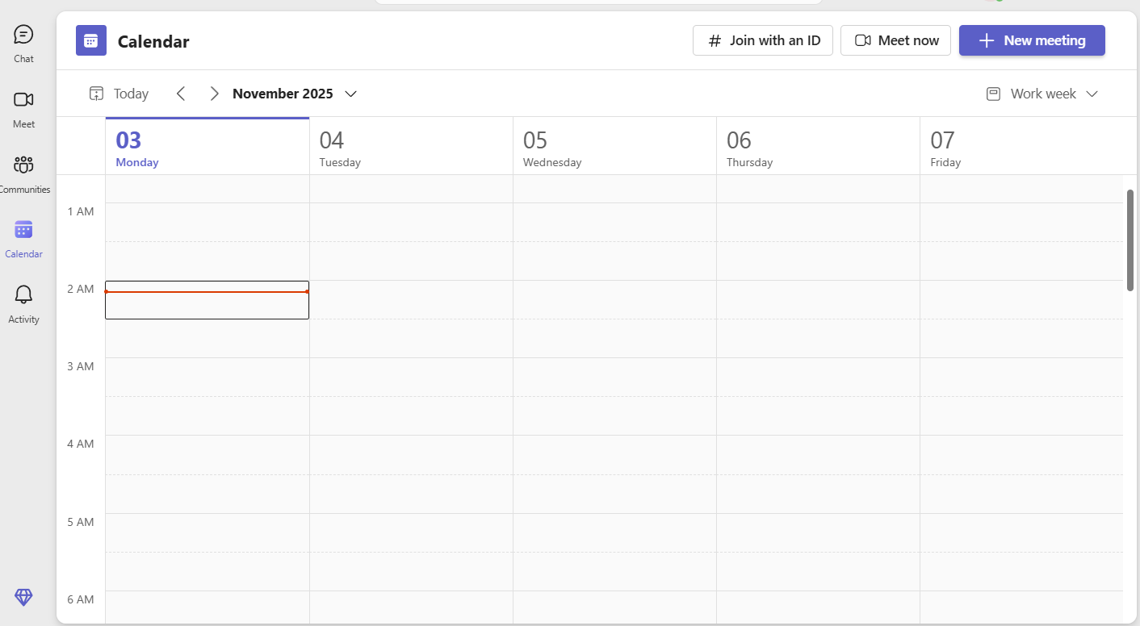

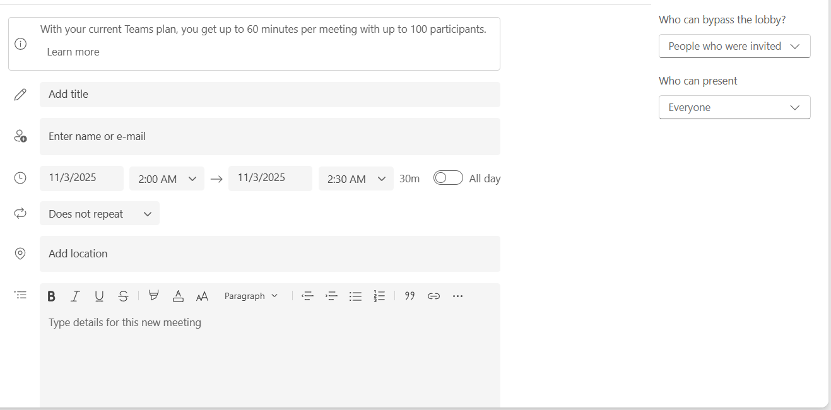
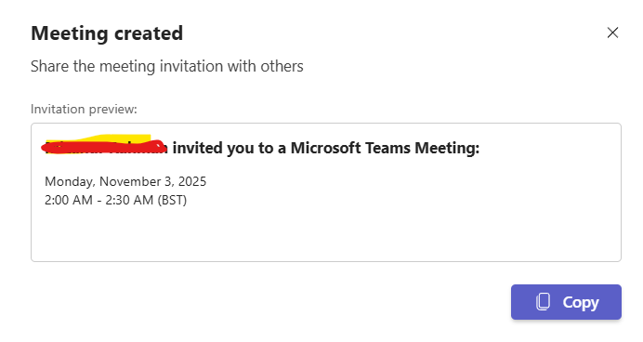
Microsoft Outlook

4.2.2 Collaboration Application – Outlook (Free Plan)

4.2.2.1 Feature Tested: Creating and Managing a Board with Cards (Free Plan)

Description:

In the Outlook web version, I created a new calendar event titled Team Progress Meeting and invited two participants by email. I added the meeting date, time, and an online Teams link. Participants automatically received invitations and could respond with "Accept," "Decline," or "Tentative."

4.2.2.2 Business Use Implication:
- Schedules meetings easily with no outside resources needed.
- All communication and scheduling data is kept on one platform.
- Enhances coordination among teams working across locations and time zones.
- Limitation: The free version lacks some advanced scheduling and integration features available in the business plans of Microsoft 365.= 1 per board in free plan; board limits), which may hinder larger-scale operations.

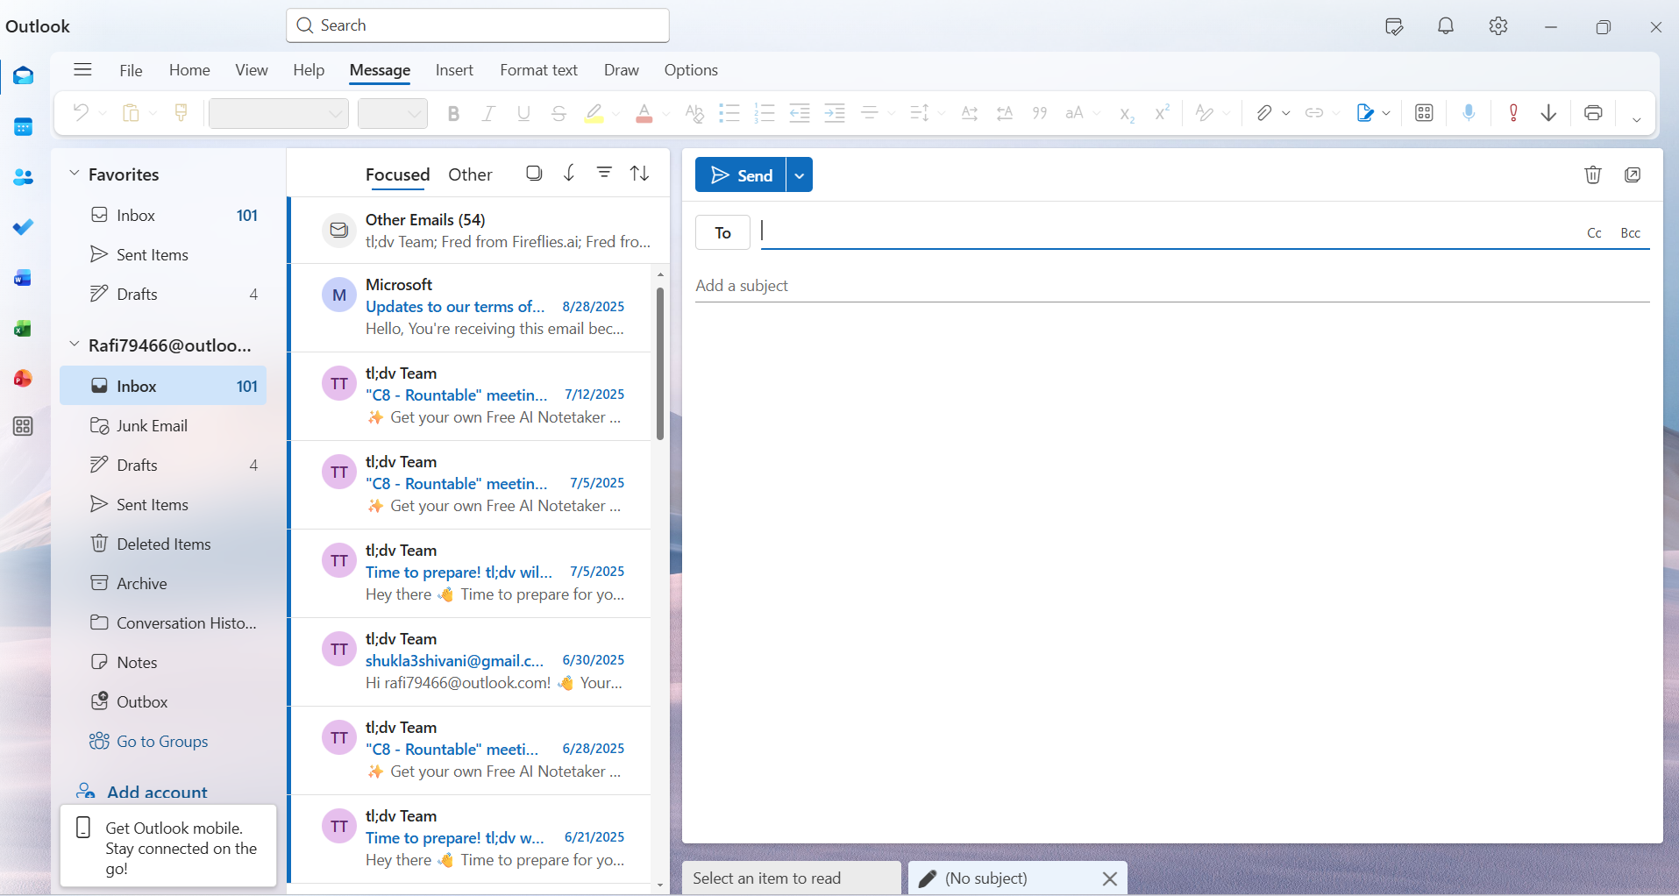
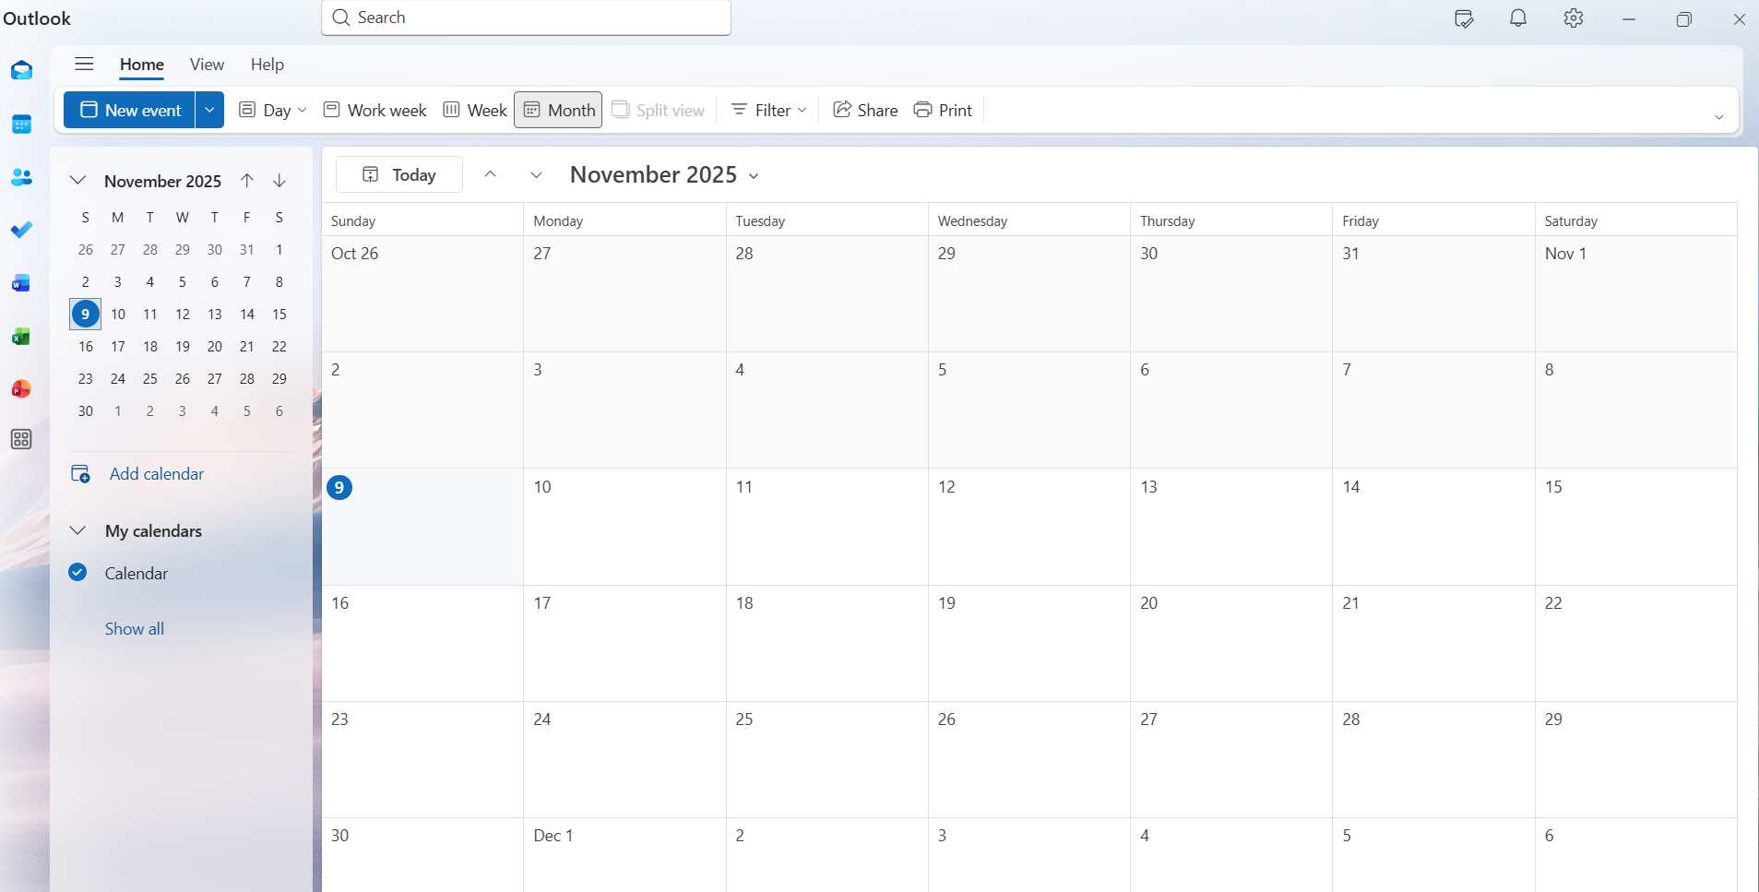
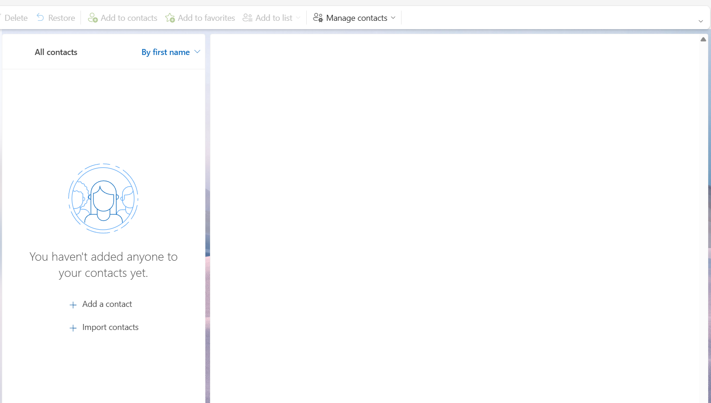

Conclusion
This report discussed how various software tools support contemporary business operations in terms of communication, collaboration, and productivity. Be it Wix vs. Shopify, the testing of Microsoft Office features, exploring Teams and Trello, or mind mapping, it's absolutely clear that the right software depends on the size, needs, and growth goals of a company. Mind mapping nurtures creativity and clarity, while Office applications effectively help to organize, present, and analyze data. Microsoft Teams improves communication, and Microsoft Outlooks allows for teamwork to be more visual and transparent. All these tools taken together demonstrate that technology, if put to good use, can make business smarter, faster, and better connected.

References
12 best business communication software for your teams [2025] (no date) Getguru.com. Available at: https://www.getguru.com/reference/best-business-communication-software?utm_source=chatgpt.com (Accessed: November 2, 2025).
Brandner, R. (2024) “Why mind mapping? 5 key benefits (+ templates),” MeisterTask. Meister, 15 February. Available at: https://www.meistertask.com/blog/why-mind-mapping?utm_source=chatgpt.com (Accessed: November 2, 2025).
Erdem, A. (2017) “Mind maps as a lifelong learning tool,” Universal Journal of Educational Research, 5(12A), pp. 1–7. Available at: https://doi.org/10.13189/ujer.2017.051301.
Finch, C. (2010). Uses of Microsoft Word in business, Techwalla. Available at: https://www.techwalla.com/articles/uses-of-microsoft-word-in-business?utm_source=chatgpt.com (Accessed: November 2, 2025).
Gaza, G. (2024) Communication tools and technologies for modern businesses, Poertner. Available at: https://poertner.com/communication-tools-and-technologies-for-modern-businesses/?utm_source=chatgpt.com (Accessed: November 2, 2025).
How-To Geek. (2023) Beginner’s guide to Microsoft Outlook email and calendar. Available at: https://www.howtogeek.com/guide-to-microsoft-outlook/ (Accessed: 9 November 2025).
Importance of Microsoft Excel in the workplace (with real-world examples) (2025) GeeksforGeeks. Available at: https://www.geeksforgeeks.org/excel/importance-of-microsoft-excel-in-workplace/?utm_source=chatgpt.com (Accessed: November 2, 2025).
Khan, N.A.A. (2025) “Wix vs Shopify for eCommerce: A detailed feature comparison,” Dcastalia Blog, 13 May. Available at: https://dcastalia.com/blog/wix-vs-shopify-for-ecommerce/(Accessed: November 2, 2025).
Lifewire. (2024) Overview of Microsoft Outlook and its key features. Available at: https://www.lifewire.com/what-is-microsoft-outlook-1170741 (Accessed: 9 November 2025).
Microsoft Corporation. (2024) Manage your email and calendar with Microsoft Outlook. Available at: https://www.microsoft.com/en-us/microsoft-365/outlook/email-and-calendar-software-microsoft-outlook (Accessed: 9 November 2025).
Microsoft Corporation. (2025) What is Outlook? Available at: https://support.microsoft.com/en-us/outlook (Accessed: 9 November 2025).
Microsoft.com. Available at: https://techcommunity.microsoft.com/blog/microsoft_365blog/supercharge-your-business-with-microsoft-tools-create-stunning-documents-and-pre/4358025?utm_source=chatgpt.com (Accessed: November 2, 2025).
Microsoft.com. Available at: https://www.microsoft.com/en-us/microsoft-365/business?utm_source=chatgpt.com (Accessed: November 2, 2025).
Nagy, S. and Hajdu, N. (2022) “Consumer acceptance of the use of artificial intelligence in online shopping: evidence from Hungary,” arXiv [econ.GN]. Available at: http://arxiv.org/abs/2301.01277.
Nussbaum, R. (2024) “The ultimate guide to communication software in 2025: Revolutionizing connectivity in the modern workplace,” BuilderComs, 1 December. Available at: https://www.buildercoms.com/post/the-ultimate-guide-to-communication-software-in-2025-revolutionizing-connectivity-in-the-modern-wor?utm_source=chatgpt.com (Accessed: November 2, 2025).
Peek, S. (2019). The benefits of mind mapping for busy professionals, business.com. Available at: https://www.business.com/articles/benefits-of-mind-mapping-for-professionals/?utm_source=chatgpt.com (Accessed: November 2, 2025).
Pros and cons of Microsoft Access (2023) Keypress Software Development Group. Available at: https://keypressgroup.com/article/pros-and-cons-of-microsoft-access/?utm_source=chatgpt.com (Accessed: November 2, 2025).
Raj, A. (2023) Top 12 advanced features of MS Excel in 2025, AlmaBetter. Available at: https://www.almabetter.com/bytes/articles/features-of-ms-excel?utm_source=chatgpt.com (Accessed: November 2, 2025).
Ryan, E. (2018). I’ve tested and reviewed Wix vs Shopify: Which is my winner?, Website Builder Expert. Available at: https://www.websitebuilderexpert.com/ecommerce-website-builders/comparisons/wix-vs-shopify/ (Accessed: November 2, 2025).
Singh, T. (2025) Excel vs access: Which one should you choose?, ScaleupAlly. Available at: https://scaleupally.io/blog/excel-vs-access/?utm_source=chatgpt.com (Accessed: November 2, 2025).
Strauss, L. (2023). Wix vs. Shopify: What’s the best eCommerce platform? [2025], Zapier.com. Zapier. Available at: https://zapier.com/blog/wix-vs-shopify/ (Accessed: November 2, 2025).
TechRadar. (2024) Microsoft Outlook review: email, calendar, and collaboration simplified. Available at: https://www.techradar.com/pro/microsoft-outlook-review (Accessed: 9 November 2025).
The best ways to use Microsoft Word for business (2017) business.com. Available at: https://www.business.com/articles/5-random-things-you-can-create-in-a-microsoft-word-document/?utm_source=chatgpt.com (Accessed: November 2, 2025).
Top 10 features of Microsoft Access (no date) Excelaccessexpert.com. Available at: https://excelaccessexpert.com/blogs/top-10-ms-access-features-for-small-business-2025?utm_source=chatgpt.com (Accessed: November 2, 2025).
Using Access or Excel to manage your data (no date) Microsoft.com. Available at: https://support.microsoft.com/en-us/office/using-access-or-excel-to-manage-your-data-09576147-47d1-4c6f-9312-e825227fcaea?utm_source=chatgpt.com (Accessed: November 2, 2025).
Warnimont, J. (2015) Wix vs Shopify (2024): Which is the Absolute Best?, Ecommerce-platforms.com. E-commerce Platforms. Available at: https://ecommerce-platforms.com/articles/shopify-vs-wix-ecommerce-platform-comparison? (Accessed: November 2, 2025).
Warnimont, J. (2015) Wix vs Shopify (2024): Which is the Absolute Best?, Ecommerce-platforms.com. E-commerce Platforms. Available at: https://ecommerce-platforms.com/articles/shopify-vs-wix-ecommerce-platform-comparison? (Accessed: November 2, 2025).
Why is PowerPoint important in business? (no date) .3g.network. Available at: https://3g.network/knowledgebase/why-is-powerpoint-important-in-business?utm_source=chatgpt.com (Accessed: November 2, 2025).
Wilson, J. (2023) “What is Microsoft PowerPoint used for in the workplace? (the benefits revealed),” Tooling Ant, 14 September. Available at: https://toolingant.com/what-is-microsoft-powerpoint-used-for-in-the-workplace/?utm_source=chatgpt.com (Accessed: November 2, 2025).

