Personality and Memory

Research Methods I
ECPS4003

Abstract

This study aimed to discover the differences between participants with low and ahigh levels of extraversion and their memory recall. A between-subjects design which consisted of thirty-five participants was used. Participants were gathered using the Experiment Management System (EMS) and were asked to complete a memory task on Superlab which used words from the Affective Norms for English Words (Bradley and Lang, 1999) and then a questionnaire via Qualtrics which included the Big Five Inventory (John et al., 1991). An independent samples t-test was used to analyse the data. The hypothesis for this study was rejected as the p value was more than the critical value of .05 and so the null hypothesis was accepted as no significant difference between levels of extraversion and the number of recalled words; t (33) = -.524, p > .05

Literature Review

This study aims to look at personality and memory, specifically differences between levels of extraversion and memory recall. Jung (1921) defines extraversion as “an outward-turning of libido” (p.393). It is an interest outside of oneself and on external stimuli. He also defines introversion as “an inward-turning of libido” (p.415). This means that introverts have a focus within themselves and their own thinking.
Luchetti et al. (2021) studied 71,566 respondents over the age of fifty from twenty- seven countries. Participants were asked ten questions from the Big Five Inventory and were asked to memorise and recall a list of ten words and were scored out of twenty. The study found that people who scored high in extraversion and low in neuroticism recalled more words than those who scored high in neuroticism. This supports the researcher’s hypothesis as they predicted that neuroticism would be a risk to the memory of those who came from poor economic status.
Trotsiouk et al. (2016) studied a group of 59 females who were asked to complete an IQ test and a timed memory test. Three separate t-tests were used to analyse results, which found that despite the female introverts scoring higher than extraverts on the IQ test, the female extraverts completed the memory task in less time with fewer mistakes than the introverts. However, the use of a gynocentric sample could have confounded the results of this study as only female participants were gathered in the sampling process, making it difficult to generalise to all extraverts and introverts.
In a study conducted by Simpson (2007), Eysenck’s Personality Inventory (Eysenck and Sybil, 1964) was used and a memory task which consisted of abstract and concrete words. The results for his study were non-significant and did not support his hypothesis or previous literature, as Simpson predicted that not only would extraverts recall more words, but that more concrete words would be remembered as participants can visualise concrete objects in their mind.
Furthermore, Lieberman (2000) gathered a sample of 28 participants who were asked to complete a memory task in as little time as possible. From the results, it was concluded that introverts had worse working memory than extroverts.
Cox-Fuenzalisa et al. (2006) conducted a study involving thirty participants who were also asked to fill in Eysenck’s Personality Inventory and complete a memory task where they were asked to recall abstract and concrete words. The researchers found that introverts have better long- term memory while extroverts have better short-term memory. Introverts also showed higher levels of cortical arousal than extroverts which “have been associated with optimal storage and retrieval mechanisms”.
Based off the previous literature mentioned above, the hypothesis for this study is that participants who score high levels of extraversion will record significantly more words than those who score low levels of extraversion. The null hypothesis for this study is that there will be no significant difference between high and low levels of extraversion and number of recalled words.

Methodology

Participants
A sample of thirty-five participants were used (20 females, 13 males and 2 nonbinary individuals). The age of participants ranged from 18-69 years old (M=28.97, SD=11.30). Participants were gathered using the Experiment Management System (EMS).
Design
A between subjects design was used for this study. The researcher chose an independent samples t-test (Student, 1908) to explore the differences between memory recall of extraverts and introverts as it is a robust test and easy way of gathering and calculating data. The independent variable for this study was memory recall and the dependent variable was personality groups i.e., introverts and extroverts.
Materials
The materials used was a questionnaire created through Qualtrics that involved the Big Five Inventory developed by John et al. (1991). Questions 1,3,4,6 and 8 denoted whether the participants were extraverted (See Appendix C). A lab setting was used where participants had access to Qualtrics on a laptop and Superlab on a computer. The Superlab immediate recall task (See Appendix B) included a list of ten words chosen from the Affective Norms for English Words (Bradley and Lang, 1991) (See Appendix A). And had a valence score of between 5 and 5.5. These words were fabric, patent, butter, basket, paper, machine, column, engine, doctor and table. One word was displayed on each slide for two seconds each, with a blank slide between each word that lasted less than a second each. The font style of each word was Arial, the font size was 90 and all the words were black in colour to make sure that all the words were clearly visible to participants. Like Luchetti et al.’s (2021) study on the participants from 27 countries, participants were scored out of twenty for the immediate and delayed recall total scores.
Procedure
Firstly, participants were gathered using the Experiment Management System (EMS). Participants who signed up to the study via EMS were then provided with an information sheet (See Appendix D) and asked to complete a consent (See Appendix E) form which highlighted participants’ right to withdraw. They then completed the first part of the memory recall task in order to measure participants’ immediate recall using Superlab on the computer. At the end of the list of words, participants were given thirty seconds to recall as many words from the list as they could. They were then given a laptop and directed to a questionnaire via Qualtrics that measured participants’ levels of extraversion. Again, participants were asked to then recall as many of the words from the first memory task, but without a time limit, in order to measure participants delayed recall. Participants were then debriefed (See Appendix F) and reminded of their right to withdraw from the study, and then thanked for their participation.

Results

An independent samples t-test (Student, 1908) was used to explore differences between high and low levels of extraversion and memory recall. Findings show that nineteen participants scored high in extraversion (M= 9.32, SD=3.59) and sixteen participants scored low in extraversion (M=9.94, SD=3.38) (See Appendix G). The degrees of freedom were 33, the p value was .302 and the t statistic was -.524. The hypothesis for this study was rejected and the null hypothesis was accepted as results from the t-test suggest that there was no significant difference between levels extraversion and memory recall as the p value was more than the critical value: t (33) = -.524, p > .05

Discussion

The hypothesis of this study was rejected as results from the independent samples t-test implied that findings were due to chance as the p value was less than the critical value of .05. Therefore, we cannot conclude that extraverts have better memory recall than introverts.
The questionnaire contained eight questions, but only five of the questions denoted whether the participants were extraverted. It is a possibility that the use of unequal extraversion and introversion questions could have confounded the results of the study and creating unreliable results. The use of a pilot questionnaire would have been useful in this case as this would have allowed the researcher to make amendments to the design of the questionnaire before conducting the real study.
The results support findings by Simpson (2007) as both studies used concrete words which lead to non-significant results. The researcher chose neutral words for this study that wouldn’t provide an emotional response in participants. For example, participants may be more likely to remember a word like ‘beautiful’. Perhaps as both this current study and the work conducted by Simpson (2007) used concrete words which lead to non-significant results in both instances, it might be an idea to explore the effects of other types of words in future research.
Despite using a similar method to Luchetti et al. (2021), the results from this current study did not support that of Luchetti et al’s. The difference in results could be explained by the fact that Luchetti et al. filtered their sample from anyone who had a cognitive impairment, such as dementia, and the researcher from this current study did not. As the sample for this current study consisted of participants whose age ranged from 18-69 years old, it may have been useful if the researcher treated this issue as a confounding variable and controlled it by conducting a questionnaire before the immediate recall task in order to filter through the sample to make sure none of the participants and issues that would affect their memory, that way only reliable and valid data would be collected.
Results from this study do not support that of Trotsiouk et al’s (2016) study as a sample of both males and females were used which could have affected the results. If Trotsiouk et al (2016) found that extraverted females scored higher than introverted females, this is something that future research needs to consider.
In summary, despite the non-significant results received from the independent samples t-test, the researcher has gained insight from past literature which may be helpful in aiding psychologists to conduct similar studies on personality and memory in future, by possibly taking factors such as gender and age into consideration and controlling any confounding variables like diseases that affect cognitive functions, such as dementia. Research into levels of extraversion and memory not only provide more depth into our knowledge of dementia and diseases that affect our thinking but can also assist teachers by providing learning aids to help introverted and extroverted students improve their memory.

References

Bradley, M. M., & Lang, P. J. (1999). Affective norms for English words (ANEW): Instruction manual and affective ratings technical report C-1, the center for research in psychophysiology, University of Florida. 30(1), pp 25-36. https://pdodds.w3.uvm.edu/teaching/courses/2009-08UVM-300/docs/others/everything/bradley1999a.pdf
Cox-Fuenzalida, L., Angie, A., Holloway, S. & Sohl, L. (2006). Extraversion and task performance: A Fresh Look through the Workload History Lens. Journal of Research in Personality, 40, pp 432-439. https://doi.org/10.1016/j.jrp.2005.02.003
Eysenck, H. J., & Sybil, B. G. (1964). An improved short questionnaire for the measurement of extraversion and neuroticism. Life sciences. 3(10), pp 1103–1109. https://doi.org/10.1016/0024-3205(64)90125-0
John, O. P., & Srivastava, S. (1999). The Big-Five trait taxonomy: History, measurement, and theoretical perspectives. In L. A. Pervin & O. P. John (Eds.), Handbook of personality: Theory and research (Vol. 2, pp. 102–138). New York: Guilford Press.
Jung (2016) Personality Types. Routledge. https://doi.org/10.4324/9781315512334
Lieberman, M. D. (2000). Introversion and working memory: Central executive differences. Personality and Individual Differences, 28(3), 479-486. https://doi.org/10.1016/S0191-8869(99)00113-0
Luchetti, M., Terracciano, A., Stephan, Y., Aschwanden, D., & Sutin, A. R. (2021). Personality Traits and Memory: A Multilevel Analysis Across 27 Countries From the Survey of Health, Ageing and Retirement in Europe. Psychological Science, 32(7), 1047–1057. https://doi.org/10.1177/0956797621993101
Simpson, C. (2007). The relationship between extraversion-introversion on memory task performance. The Huron University College Journal of Learning and Motivation, 45(1). https://ojs.lib.uwo.ca/index.php/hucjilm/article/view/7797
Student. (1908). The probable error of a mean. Biometrika. 1-24.
Trotsiouk, N., Klein, J., Kilman, K., Davidson, M., Dodd, D., Aleksandruk, E., Stokes, M., & Cate K. L. (2016). Are introverts smarter than extroverts? University of North Georgia, Department of Psychological Science. 47. https://digitalcommons.northgeorgia.edu/cgi/viewcontent.cgi?article=1592&context=ngresearchconf

Appendices

Appendix A
List of words used in immediate recall task
Words (ANEW; Bradley and Lang, 1999) | Valence score
Fabric | 5.30
Patent | 5.29
Butter | 5.33
Basket | 5.45
Paper | 5.20
Machine | 5.09
Column | 5.17
Engine | 5.20
Doctor | 5.20
Table | 5.22

Appendix B
Superlab immediate recall task
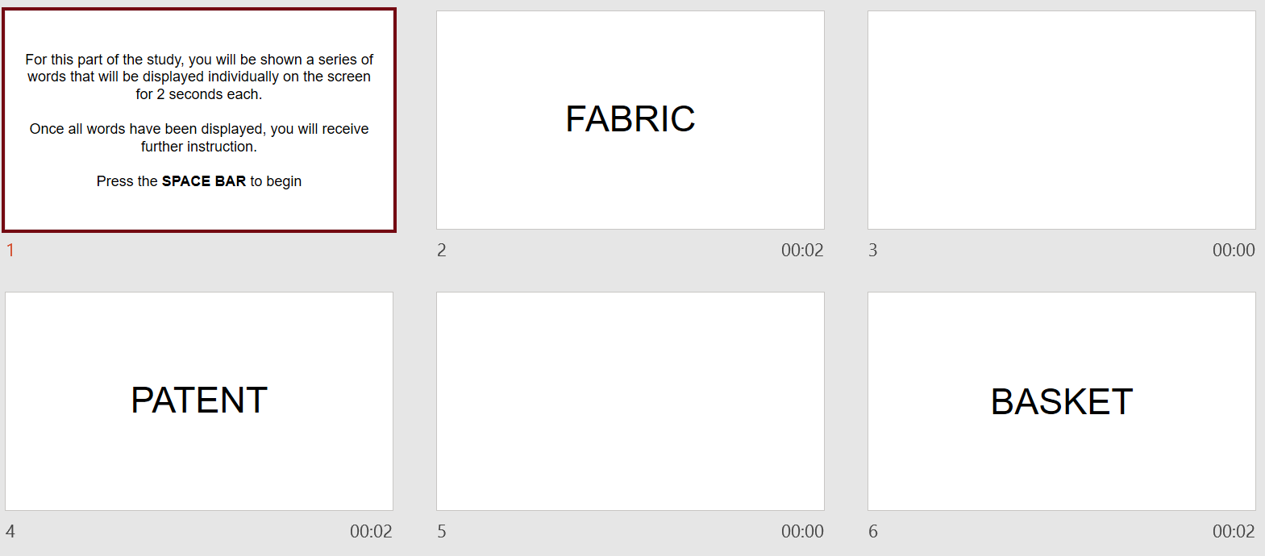
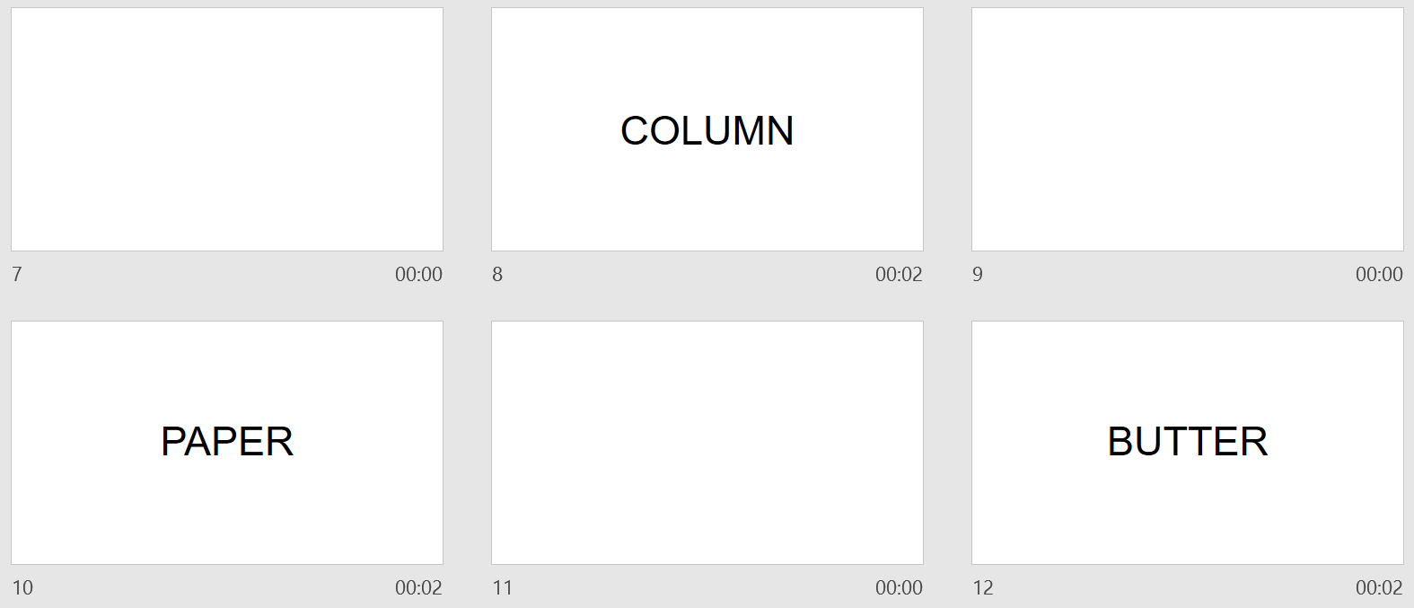
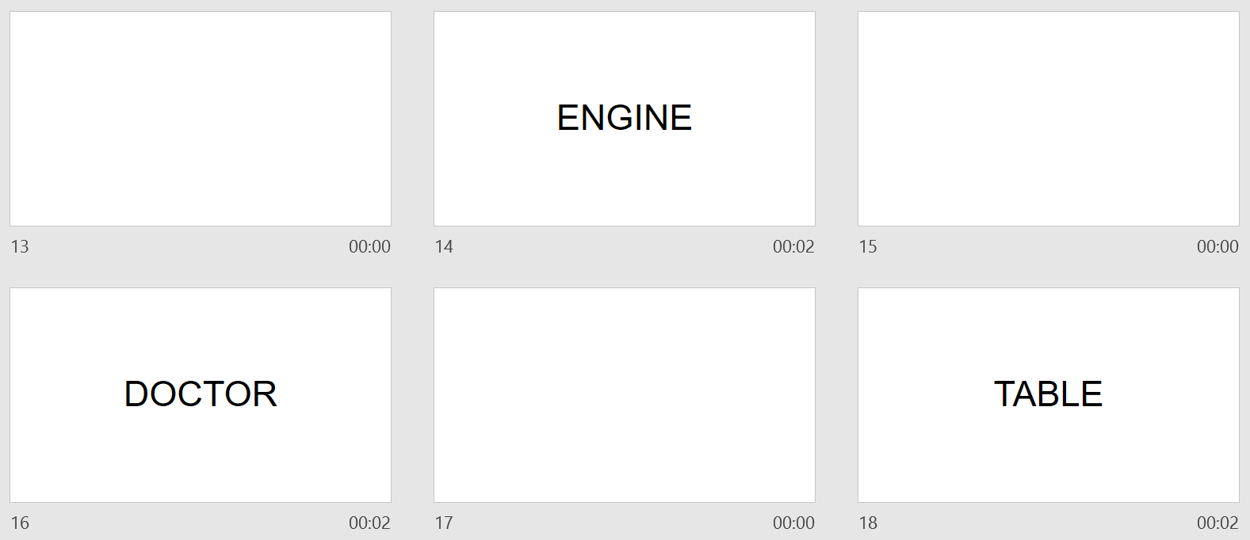
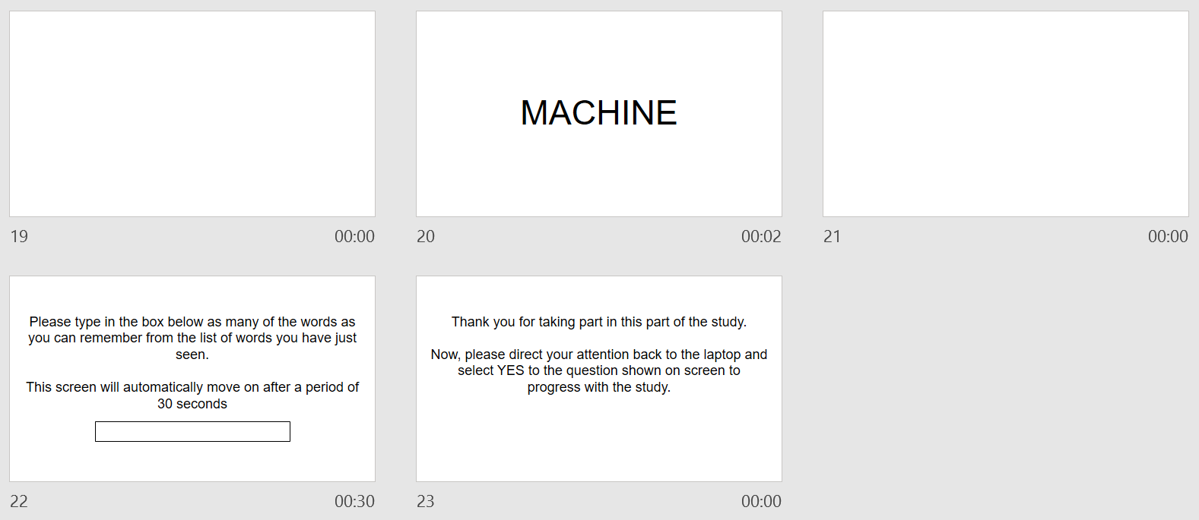

Appendix C
Qualtrics questions
The Big Five Inventory (BFI; John & Srivastava, 1999)

Here are a number of characteristics that may or may not apply to you. For example, do you agree that you are someone who likes to spend time with others? Please write a number next to each statement to indicate the extent to which you agree or disagree with that statement.

Disagree strongly  1 | Disagree  2 | Neither agree nor disagree  3 | Agree  4 | Agree strongly  5

I see Myself as Someone Who...

_____ 1. Is talkative

_____ 2. Is reserved

_____ 3. Is full of energy

_____ 4. Generates a lot of enthusiasm

_____ 5. Tends to be quiet

_____ 6. Has an assertive personality

_____ 7. Is sometimes shy, inhibited

_____ 8. Is outgoing, sociable

Scoring information: R denotes reverse scored items, 1 + 2R + 3 + 4 + 5R + 6 + 7R + 8

Appendix D
Study Information Sheet

Centre for Psychology and Counselling
SA1 Campus

Swansea

This document provides key information regarding the study and provides details about what will be expected of you as a participant. Therefore, please read this information carefully before providing consent to take part.
The purpose of this study is to investigate whether the personality trait of extraversion has an impact on memory recall.
During this study you will be required to do the following:
- Fill in your demographic information of age and gender.
- Complete the Extraversion sub-scale of the Big Five Inventory (John et al., 1991).
  - This is an eight-item questionnaire designed to assess the personality trait of extraversion.
  - Each item has a five-point response option ranging from Disagree strongly to Agree strongly.
  - You should choose which response option best describes your thoughts/feelings in relation to each of the statements presented.
    - Further instructions on how to complete this questionnaire will be presented at the top of the page.
- You will then be required to complete a standard memory recall task via Superlab.
    - Further instructions on how to complete the task will be presented to you.
- At the end of the study, you will be provided with the study debrief.
If you have any questions or concerns about this study, please contact the research supervisor Stacey Coleman on stacey.coleman@uwtsd.ac.uk You can download a copy of this information sheet for your records here: Information Sheet If you feel you want to leave the study, you can do so at any time by informing the researcher. Once the study has ended, you will be asked if you want your data to be saved as part of the study. If you agree, then your data will be anonymised and therefore untraceable to later delete. If you do not wish for your data to be used, please ensure you inform the research before leaving the study. As this study involves the completion of an extraversion questionnaire, if you feel you would not be comfortable answering questions about your extraversion levels, then you are advised not to take part in this study. If you are happy to take part in this study, please ask the researcher for the consent form for the study.
Appendix E
Study Consent Form
Centre for Psychology and Counselling
SA1 Campus
Swansea

I understand that this research study is being carried out by a group of 1st year Psychology Students for the purpose of a module assessment, and that taking part in this study will involve providing details about my age and gender, completing a personality questionnaire, and a memory recall task.
This study will take approximately 20 minutes to complete.
I understand that participation in this study is voluntary and I am free to withdraw my participation at any time during or before the end of the study without giving a reason and without penalty by closing the computer browser.
I understand that once I complete the study, I will not be able to withdraw my data, as it will be anonymised and the researcher will be unable to trace my data back to me.
I am aware that if I have any questions or concerns about the study, I can contact the researcher supervisor, Stacey Coleman at any time before, during, or after the study on stacey.coleman@uwtsd.ac.uk
I understand that the information provided by me will be held confidentially, with a code assigned in place of my name. These data will be stored indefinitely in accordance with the Data Protection Act.
I also understand that at the end of the study I will be provided with a debrief form.
You can download a copy of this consent form by clicking here: Consent Form
Please tick all boxes below to confirm your consent into participating in this study:

I am 18 years of age or over

I understand I can withdraw at any time without penalty by closing the browser

I understand my data will be held confidentially and my identity will remain anonymous

I understand all the above information on this consent form

I consent to taking part in this study

Appendix F
Debrief Form

Centre for Psychology and Counselling
SA1 Campus
Swansea

Study Debrief Sheet
An exploration into the potential differences between individuals high and low in extraversion and memory recall performance

Thank you for taking part in this study.

The purpose of this study is to investigate whether the personality trait of extraversion has an influence on memory recall performance. Specifically, the aim of the study is to examine whether those who report higher levels of extraversion on a self-report personality assessment (the Big Five Inventory, John et al., 1991) will be able to recall more words and therefore have better memory recall.

If you wish to withdraw your data from the study you must close your computer browser now. After this point, your data will become anonymous and it will not be possible to trace it back to you. The data you submit will remain confidential.

If taking part in this study has raised any concerns or if you have any questions about the study, please contact the academic supervisor Stacey Coleman: stacey.coleman@uwtsd.ac.uk

You can download a copy of this debrief sheet for your records by clicking here: Debrief

If you are happy for your data to be included in this study, please click the arrow below to confirm.

Thank you once again for taking time to participate in this study.
BSc Psychology
BSc Psychology and Counselling

University of Wales Trinity Saint David, Swansea
Appendix G
t-test analysis using SPSS


