Organizational Structure and Culture: Tesco PLC

Name : Adrian Calancea
Affiliation : Introduction In The Modern Workplace
Date : 04.05.2020

Introduction
This essay aims at assessing the organisational structure and the culture of the Tesco Company, aiming to identifying the correlations between these and the performance of the organization.
Most often implied and not expressly communicated by employees, corporate culture includes beliefs and behaviours impacting employee and management performance within and outside the company. It is shaped by factors like dress code, treatment of clients and stakeholders, and consumer satisfaction, and it communicates the company’s identity to customers, partners, suppliers and the community.
Organization culture develops over time, reflecting on the character traits encouraged and developed within the organization and facilitating the employment and retention of talented workers and experts into the company. Corporate culture influences the performance and well-being of employees in the workplace An appropriate culture helps the organization to balance between achieving the set goals while ensuring that the welfare of employees is considered.

Introduction to Tesco PLC
Tesco facts
Founded in 1919, Tesco is at this moment the ninth-largest retailer in the world measured by revenues. It has shops in seven countries across Asia and Europe, and is the market leader of groceries in the UK (where it has a market share of around 28.4%).
Tesco boasts over 6,800 shops around the world, serviced by 450,000 employees, and around 80M shopping trips per week at year end 2019. They have businesses in the UK & ROI, including the Booker, as well as in Central Europe (in Poland, the Czech Republic, Hungary and Slovakia) and in Asia (market leader Tesco Lotus in Thailand, as well as in Malaysia, China and India). These translate in impressive figures. Group sales: £56.9bn, as compared to £51.0bn in 2018, with a £2,206m group operating profit, as compared to £1,646m in 2018. The group reports a retail operating cash flow of £2,502m, as compared to £2,773m in 2018, and an operating profit of £2,153m, as compared to £1,839m in 2018. A TESCO dividend was valued at 5.77p per share, as compared to 3.00p per share in 2018.

Organisational structure
Tall structures
In the tall organisational structure, a large chain of command separates an organisation into multiple levels of hierarchy. Tall structures are specific to large organizations, with the key benefits of a tall structure being coordination and efficiency. Within a tall structure, all employees know the exact position they are in and the exact job they have to do. The internal structures and procedures leave little room for interpretation. Goals and objectives are clearly defined so tasks can be performed in time.
At the same time, a tall structures allows for little flexibility, hindering long-term-planning, and creativity, generating excessive dependency of long-term projects on one leader. It produces overburdened management and idle employees. Within a tall structure, any one department can take a long response time to an issue signalled by another department, as communication is difficult. It ensures little coordination between local targets and overall objective and interests. Moreover, poor communication within tall structures causes inadequate competition and poor team spirit, ultimately weakening the moral of the organization.
Flat structures
Successful flat structures work best with smaller companies like start-ups. In the flat organisational structure, middle management, if present, is a minor part of the structure. Thus, the chain of command is direct from executives to staff. Its greatest positive aspects are related to lower management costs and higher responsibility. The lower costs reflect the lower number of managers, which in turn translates in staff needing less direct supervision to be efficient.
A somewhat "groupthink"-based structure, a flat organisation may allow any one department to overlap and blur into another in terms of functions and roles, which can generate confusion. Despite having less bosses overall, workers in a flat structure can have more than one boss. So, a flat structure may improve some aspects of communication while also generating communication problems of its own.
The organizational structure of Tesco
As Tesco is the large size company, its organizational structure is hierarchical, ensuring the smooth functioning and efficiency of the business. The functions are divided into a long chain of commands, with decisional power belonging to apex level members and with roles being clearly defined to avoid confusion. However, after noticing that several management layers per store result in excessive bureaucracy and a decreasing flow of information, Tesco also uses some variation in store organization structures – depending on size, location, and other store-specific factors.

The Board and the Executive Committee
Corporate Governance in Tesco is ensured by the PLC Board and the Executive Committee. The CEO and CFO are members of both. The PLC Board consists of 14 members, of which the non-executive chairman, the senior independent director, the 9 non-executive directors and the group secretary. The Executive Committee has 13 members. There are 5 Chief Officers corresponding to the five functional areas Tesco has delimited (Finance, People, Customers, Operations and Products). There are also 3 regional CEOs (for the UK and ROI, Central Europe and Asia), alongside one for the online operations (Booker) and one for the Tesco Bank operations. All the powers are provided to the CEO - head of the administration, who takes all the major decisions. The executive committee makes decisions ensuring the effective functioning of the company, while also representing the company in the global market.

Flattening the structure
In 2018 Tesco has made changes meant to remove complexity and deliver a simpler, more helpful experience for its employees and customers. 1,700 old roles were replaced with only 900 new broader roles, with the affected employees being supported to find alternative roles within the business wherever that was possible. Tesco removed People Managers in 757 large stores (including all Extra and Superstores, and some large Metro stores) and 7 fulfilment centers, Compliance Managers in 667 large stores and the 7 fulfilment centres, as well as Customer Experience Managers in the largest 226 Extra stores, where line managers were given more direct accountability for customer service, similarly to other Tesco stores. Instead, People Partners, Learning Partners and Colleague Relations Partners roles were created to work across multiple sites throughout distribution, stores and fulfilment, while Colleague Administrators were created to support management teams in large stores and fulfilment centres.
In 2020, Tesco are planning further managerial changes, presumably structured around merging grocery and warehouse together. However, a communication that has gone out to store managers recently explained that store structures haven’t been reviewed in 10 years, and the focus of this experiment is on speeding up decision making and freeing up employees on service and availability. The changes mean that the expectation will be for managers to be on the shop floor, leading by example. However, no large scale change will take place until the trial is completed. Also, the overall headcount won’t reduce as a result of this trial.
A pilot experiment has already been carried out in 12 East Midlands UK stores, with department managers changing to ‘team managers’ and the team leader (supervisor) positions being downgraded to a standard general assistant role.
Sources from inside the affected shops explain that the change is expected to affect Superstore and Extra formats, whereas Metro and Express formats may be excluded, as team leaders here are important. However, deputy store managers are to disappear, in every other format than Metro.
On the other hand, larger Express stores could have 6 managers. The company is also planning on creating extra management roles on nights and training, which are partially going to make up for the lost team leaders. Redundancies have also been offered to the ex-team leaders. However, other managerial roles such as ‘events manager’ are also going to be rationalised.
If the experiment works, it will be rolled out across the business allowing for cost savings and a leaner management structure. It is not yet clear, but managers will most likely have to re-apply for the new roles. Explained as a better experience for customers, the change is expected to free up more staff on the shop floor while allowing the company to spot poorly performing managers more accurately.

Tesco’s Corporate Culture
1. The performance strategy framework: Tesco’s Corporate Steering Wheel
When Sir Terry Leahy became Tesco’s CEO, the management team created a performance management framework which was named the Corporate Steering Wheel because its main purpose was to help steer the organisation to success, through:
- providing a map for the company’s evolution to success,
- outlining the key strategic objectives of the company,
- creating key performance indicators - enabling the organisation to check if it was on track.
Sir Terry intended the Steering Wheel to offer Tesco “a balanced approach towards performance” and to create “a shared language, a shared way of thinking and a common blue print for action,” i.e. a new Tesco culture. Today, every store and every company within the Tesco group has their own Steering Wheel to manage performance. This puts the people on the ground in control. The Steering Wheel has also been translated into different languages to ensure it is used to engage frontline staff in all countries Tesco is operating in.
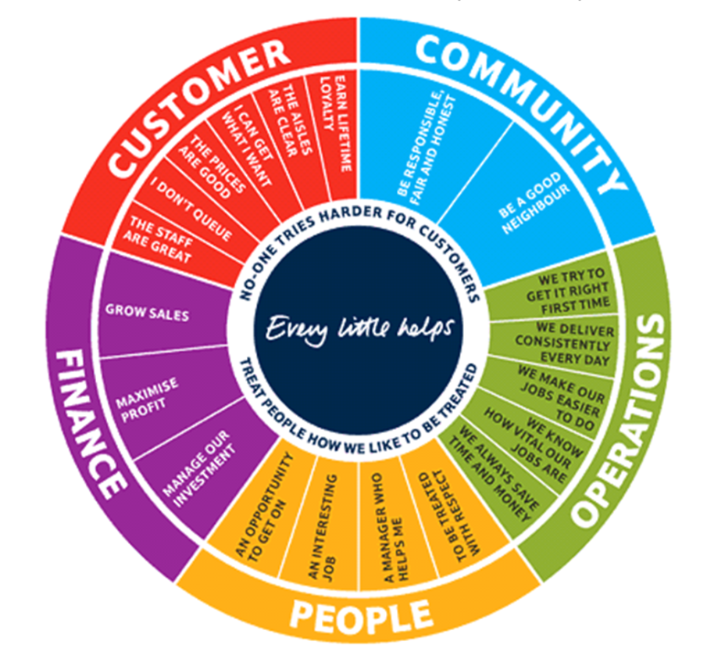
The Corporate Steering Wheel provides strategic focus by communicating what matters the most in a simple and easy to understand one-page framework. It includes 20 corporate objectives across five perspectives. The perspectives are arranged in a circle around the central philosophy of 'Every Little Helps' and the two values of 'No one tries harder for customers' and 'Treat people how I like to be treated'. Because the Steering Wheel captures the key strategic objectives of the company in one easy to understand picture, it is a powerful way of communicating strategy to all staff.
The Financial Perspective is summative and very abstract, stating that increasing sales maximizes profit and manages investments. The Customer Perspective is clearly developed in the wheel. Clear isles where products are available at good prices, together with fast and great service should earn a customer’s lifetime loyalty. From a Community Perspective, the practice of responsibility, fairness and honesty are what makes Tesco a “good neighbour.” From an Operations Perspective, Tesco emphasizes the correlation between delivering quality and saving everybody’s time and money. Tesco people are urged to understand exactly before acting and to act consistently, keeping the jobs simple and knowing that every job is important for the larger perspective on Tesco. From a People Perspective, Tesco reflects on what their employees consider most important: to have an interesting job where one is treated with respect and has a supportive manager and which provides an opportunity to get on.

Making strategy everyone's job
Tesco wanted to establish a culture in which everybody feels responsible for performance. Where staff come up with new ideas and where they are allowed to challenge and improve performance.
When the Steering Wheel was first introduced the company had a number of general meetings to explain the strategy, with Sir Terry conducting these meetings himself to personally engage staff in the stores, explain the strategy face-to-face and give staff the chance to ask questions. Tesco also produced little notes called 'shopping lists' to highlight the key strategic objectives for each perspective. These were handed out and printed as posters for the stores, as reminders about what is important.
Sir Terry wanted everyone in the business to live and understand strategy and be clear about how they can contribute to deliver it.
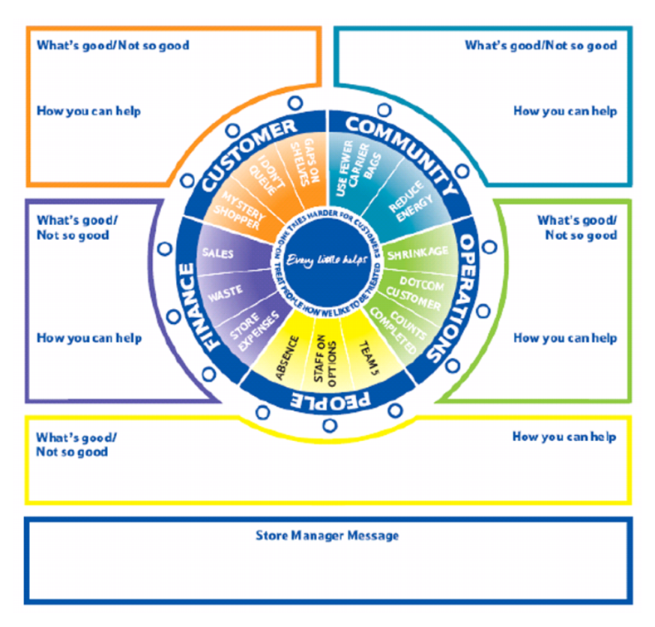
The local Steering Wheel template for stores (see figure below for the store version). is a great tool to engage staff, facilitate a local discussion and capture local challenges. The template asked what is good and not so good for each of the five perspectives and most importantly how individuals can help to improve it. This simple template engages people in strategy execution and makes them think about how they can improve performance. In addition to capturing the ideas of front line staff it allows the store manager to write a message in the bottom field.
Measuring performance - the pragmatic way
Tesco has many performance indicators but as Sir Terry Leahy says "The danger is to look at them in isolation and out of context. We try to put them into context and pay a lot of attention, regular attention, to the indicators that matter the most to our business". Tesco's philosophy is not to answer every conceivable question with their performance data but only those that help to answer the critical and most important questions.

2. Tesco’s core purpose and values
Tesco’s declared core purpose is serving shoppers a little better every day. By delivering customers great products at great value and in the right way for them, Tesco aims at helping them to enjoy a better quality of life and an easier way of living.
Introduced a decade ago to act as guidelines towards growth and success, the values are considered quintessential to Tesco culture, being a set of principles designed to help employees put its core purpose into practice: They ensure that every person at Tesco understands what is important – about how we work together as a team and how customers are at the centre of what we do.
First, Tesco wants its employees to be the hardest workers for their customers. This starts with understanding their customers, colleagues, and communities, to understand what matters to them. Then comes working to make those things better. Tesco employees have tools like the Clubcard data and social media to understand their customers better, and are expected to acting on what they find out by changing and innovating to meet their partners’ needs.
Second, Tesco wants its employers to be first to meet customers’ needs. The Tesco method of ensuring that their employees try their hardest for customers is having their employees feel recognised and rewarded for the work they do together, offering them the opportunity to get on and supporting their development through their careers in the business – an attitude which Tesco summarizes as looking after colleagues in a culture of trust and respect. Tesco urges its employees to treat people how they want to be treated. This age-old idea includes their responsibility to function as of a team, where members share knowledge and experience, and where trust and mutual respect are paramount. Tesco employees are supposed to be attentive, supportive and thankful to all their partners.
Every little help makes a big difference is the practical way in which Tesco employees are expected to serve customers, colleagues and their communities a little better every day. This idea urges Tesco employees to take small daily steps in addressing the issues that concern their customers, colleagues, communities and wider society. This way, employees are reminded that their daily consistency in all the small things they get to do are finally adding up in the big difference that Tesco can make.
Third, Tesco wants its employees to act responsibly for their communities. Tesco has declared its wish to restore trust and transparency in the company through making a positive contribution to the communities where it operates and the bigger global initiatives in which these are involved. The main social issue Tesco stores address is ensuring their customers get quality products from sustainable sources for affordable prices. This is Tesco’s assumed way of making healthy lifestyle choices easier for its customers. Another important social concern is global reduction of food waste to which Tesco has responded by redirecting surplus food to needy beneficiaries.

3. Tesco’s approach to what consumers want: the Clubcard
Data collection and analysis has been crucial to improving the way Tesco runs its business. Tesco’s Clubcard loyalty scheme was introduced in 1994, under the management of Sir Terry Leahy, who firmly believed that customers make the best management consultants and who appreciated the Clubcard’s capability for collecting relevant data to generate competitive advantage. Increasing data input had some Tesco competitors abandoned their loyalty card schemes. However, Tesco handled the problem in a different way, outsourcing data analysis right from the start. Their partner was Dunnhumby, then a data analysis company, who was left to develop approaches of its own. Tesco got to keep their loyalty programme and to buy Dunnhumby at a later time, presently offering data analysis services to brands worldwide. One of the most successful loyalty programmes ever created, the Clubcard now has over 16.5M users, giving Tesco access to detailed transaction data on two thirds of all shopping baskets they process.
Another key role the Clubcard data performs is allowing Tesco to perform smaller-scale experiments before implementing them throughout their store chains, with the programme thus facilitating fact-based decision making at Tesco. Lowering the risk of innovative ideas significantly, the Clubcard acts as a massive laboratory of customer behaviour, letting Tesco know if new product lines, innovative offers and price reductions are efficient.

CONCLUSIONS
Tesco’s approach to managing corporate performance consists of:
1. Keeping the performance framework simple and easy to understand.
2. Facilitating the communication of what mattes the most by creating simple tools (the Local Steering Wheel Template and the Shopping Lists).
3. Engaging everybody in strategy, thus delegate responsibility for performance improvements to everyone in the business.
4. Measuring and regularly reviewing only the performance metrics that really matter.
5. Devising a powerful customer behaviour measuring and tracking tool (the Clubcard) and using it consistently ahead of most.
7. Using data-driven decisions to create a culture where innovations and experiments are valued.

Bibliography
- Davis, S. (2018) Using design principles to deliver the strategy in a new organizational structure. Statistical journal, 3(1), 121-139

- Market watch, (2018). Company spotlight: Tesco. Food, (9)1, 37-52

- Olukemi, D. (2016). Relationship between competitive strategy and construction organization performance, management decision, 9(1), 11-23

- Sabri, Y. (2019). In pursuit of supply chain fit. International journal of logistics management, 30(3), 55-89

- Tamara, L. (2016). The Influence of Organizational Culture on Business Creativity, Innovation and Satisfaction. Management, 5(12), 351-389

- Tor, G. (2019). A new measure of organizational culture for business innovativeness in practice. International journal of the academic business world, 22(1), 56-71

- Yosua, M. (2017). Global Retailers ‘overseas expansion and their financial strategies A study of Tesco and Carrefour. Journal of management studies, 11(2), 35-98

- Potter, Mark (16 February 2011). Tesco to outpace growth at global rivals – study. Reuters. Retrieved 25 February 2020.

- Global Powers of Retailing 2010 (PDF). Deloitte. Archived from the original (PDF) on 9 November 2012. Retrieved 25 February 2020.

- Our businesses. Tesco PLC. Retrieved 20 January 2020.

- Finch, Julia (2 February 2010). "Tesco opens its first zero carbon store". The Guardian. UK. Retrieved 1 September 2020.

- Tesco: How one supermarket came to dominate". BBC News. Retrieved 18 October 2020.

- History". Tesco PLC. Retrieved 28 January 2020.

- Ryle, Sarah (2013). The Making of Tesco: A story of British Shopping. Random House.

