Print Making with Cam 10am – 1.30 – 3.30pm Monday 5th October
Organic Mediterranean Week

This is a process led workshop. The techniques will drive the imagery as much as the trend starting point. Approach with a curious mind!

Be prepared to go beyond the simplistic first impression of the technique to seek depth, richness and valid pattern motifs and starting points.

Printmakers and Designers to research before Monday’s session:
- Louisa Loakes
- Speronella Marsh
- Enid Marx

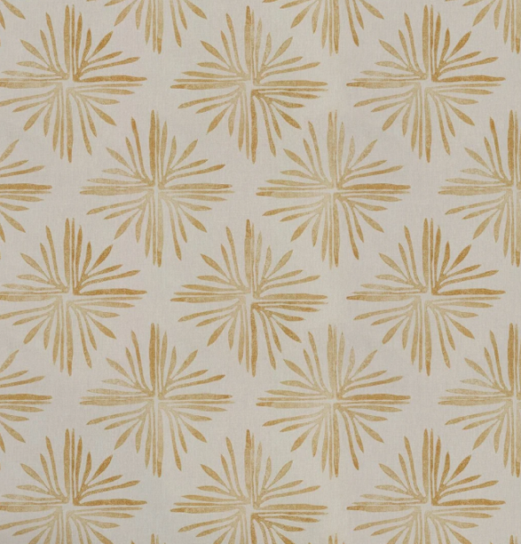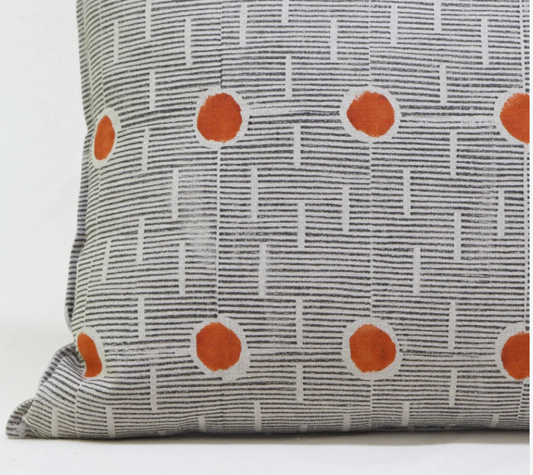

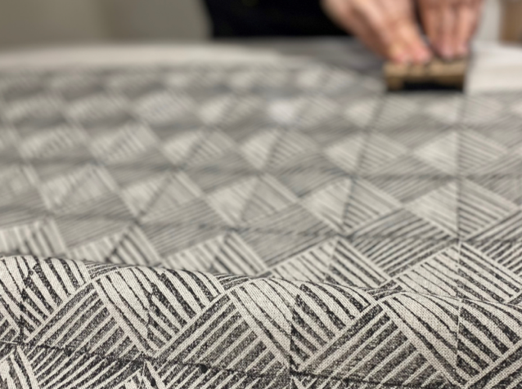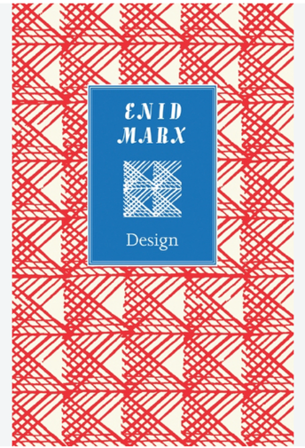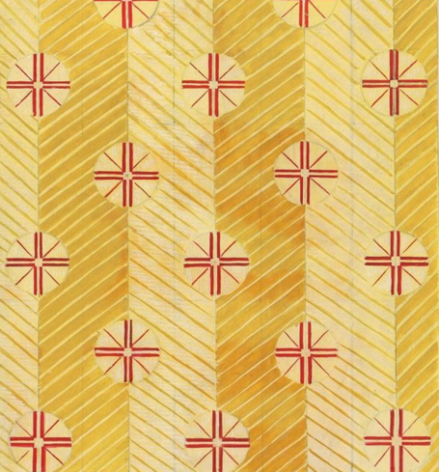

What to bring:
- Varieties of string, twine and rattan to achieve differing marks – see image at bottom of handout for soft geos achieved with rattan (they don’t have to be that complex!!)
- You could plait some lengths of string to have ready to use textures.
- A packet of cheap erasers to carve into

How to Approach:
- Think softened geometry in line with the Organic Mediterranean trend
- Think beyond singular blocks in repeat – how can you combine blocks to create more complex prints – images above give a very clear interaction of two different blocks.
- Use varieties of paper - coloured grounds or brown paper
- Mix colours according to the Design Group Food is Organic Mediterranean theme
- Elevate the process beyond a passive playful activity



