Title Page

Name: George Thomas

Student Number: P149706

Course: BSc Games Development

Module: Indie Games Development

Assignment: Assignment 2

Table of Contents

Introduction 3
Game Description 3
Rules of the Game 3
Scripts 4
Screenshots 7
Evaluation 12
References 14

Introduction

This report will cover the game that was created for this assignment. It will discuss the rules and objectives of the game, as well as discuss the code that was used and screenshots of the working game. Finally there will be an evaluation section, talking about the errors and issues with the game, a reflection on the game and future improvements that could be made.

Game Description

The game is a first person shooter, in which the player must navigate the levels and reach the end point which will take them to the next level. In the level however, there are AI zombie characters which will attack the player to attempt to kill them. The player will earn points for each enemy that is killed. The main goal of the game is to reach the end of the final level with as many points as possible.

Rules of the Game

The player controls the game by using the “W, A, S, D” keys to move, the space bar to jump and the mouse to look around and aim. Pressing left click will shoot and pressing “R” will reload. Much like in most games, the escape key will pause the game and bring up the menu.
The HUD will display the kill count, the ammo count and the player’s health bar. The player starts with health value of 10, and each zombie does 1 damage. The health bar will decrease as you get hit, showing a visual representation of the health but not displaying the actual number. The player will have 30 bullets in their gun and when the clip is empty the gun will automatically reload. The user can also reload at any point by pressing “R”, however they will be unable to shoot while reloading.
The levels are mostly linear but the player is able to move around a small open world area. At the end of each level there is a “token”, which in this case is a giant floating spinning zombie head. When the player touches the token the level will end and the next level will start. The player’s score will carry over but the health will reset back to full. At the end of the final level, the game will display the game over screen and will have a button that will exit the game. This screen will also display if the player loses all health and dies.

Scripts

The Player character and the AI characters use the first person controller script and the AI controller script, respectively, that have been provided by unity’s standard assets.

AI Script – The AI script controls the basic functions of the AI, such as controlling the movement through Navpoints, the AI’s ability to attack, and it also controls the AI’s death.
Character Script – The character script is the parent class for characters in the game, this was initially used but as development progressed, this script has become nearly redundant.
Exit Script – The exit script is a simple script which is responsible only for exiting the game [1].
FPCharacter Script – This script control the animation for the player character. Changing character states based on movement and passing speed into the animator. It also has Enums for the different animation state.
Gun Script – This script is one of the main scripts for the characters, this script controls the ammo and shooting and damage of the gun. The start method passes the ammo to the player manager for later use in the UI. The update method checks two things. Firstly if the user is reloading, if so it will start the reload co-routine, this will reset the ammo after the specific reload time has passed, reload time is defined in in this class. Since there is no animation for reloading, the debug shows that the gun is reloading. The script also checks if the user is shooting. If the player is able to shoot it will call the shoot function. This function plays the muzzle flash effect, and then uses ray casting to check if the gun is aiming at an enemy with the target script attached to it. If this is the case then the target will take damage based on the gun damage. It will then display an impact effect on the target. This uses the objects normal will display an effect facing away from the target [3].

Health – The health script is the health script provided on Moodle, this controls the health for the player.

PauseM Script – This script is used for pausing the game. If the player presses the pause button this will set pause to be the opposite of what it was, for example if true, it will set to false and vice versa. If pause is true then timescale is set to 0, if false it is set to 1 [4].

Player Script – This script is mainly focused on controlling the player’s health. It will pass the updated health to the player manager and also has the die method for when the player dies. This method has an on collision method however it never actually gets triggered so this check is instead done in the zombie attack script.

Save Script – The save script is used to save and load the players position. This script takes the player’s coordinates and stores them in player preferences. The load then takes the stored values and then transforms the player position to those values [2].

Target Script – This script is attached to any target that the gun can destroy, in this case it is only the enemies. The take damage function will subtract the amount of damage from the target’s life when it is hit. If the target’s health is 0 then it will call die which will set the enemies death animation and will destroy the game object. It will also stop the AI so it cannot move after it dies. When the enemy dies the player’s score will increase by 1. There is a bool field called score added which will be set to true if the player has already received a point for killing the enemy. This prevents the score increasing while shooting the dead enemy [3].

UIControl Script – This script controls the UI. It gets the health, score and ammo from the player manager and will display it on the HUD.

Waypoint and Waypoint collection – These scripts control the Nav points of the AI. This script was provided on Moodle.

Zombie Attack Script- This Script is used on the AI characters, it control their attacks. It contains the attack damage of the AI and has the on Trigger Enter function, this checks if the trigger collider attacked to the object is colliding with the player. If it is then it will reduce the player’s health based on the attack damage. If the player’s health is 0 then it will call the players die method.

End Level Scripts – The end level scripts are attached to the end level tokens. They will load a new scene if the player collides with them. There is a different script for each level, the only difference being the scene that it loads. Also the final level end token will unlock the player’s mouse.

Player Manager and singletons – These scripts are provided on Moodle.

Screenshots

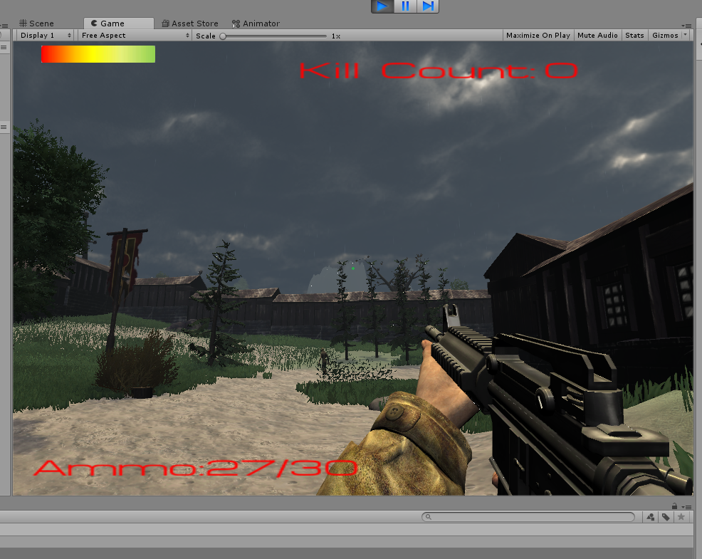

This screenshot shows the HUD and the player’s perspective. There is a health bar, a kill count and an ammo count. There is also a dot in the centre of the screen acting as a reticule.

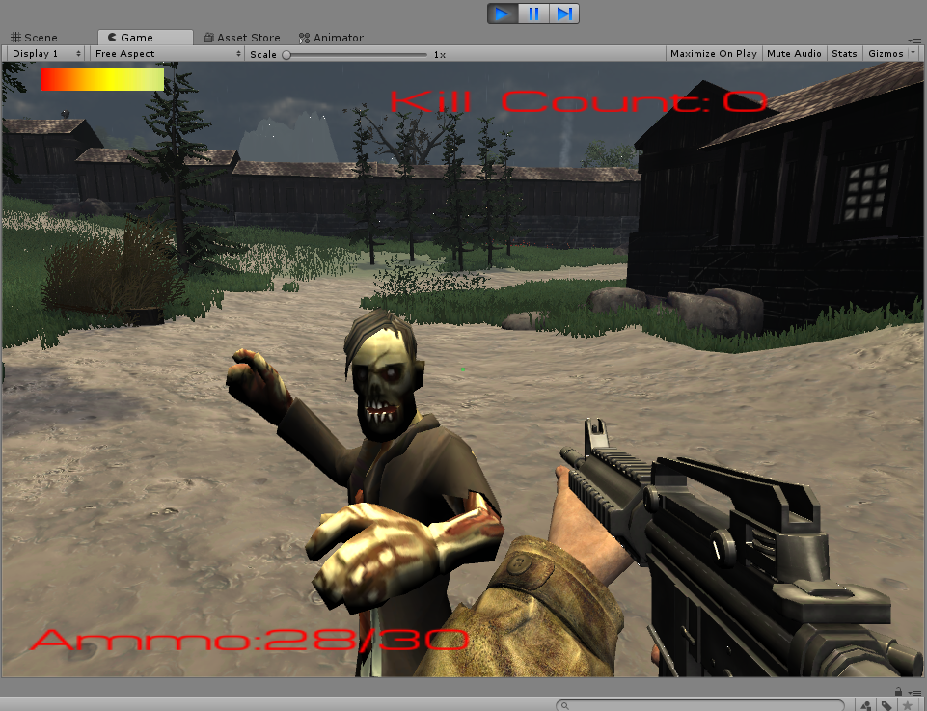
This screenshot shows the AI’s attack animation, it also shows the health bar is working as the health has decreased.

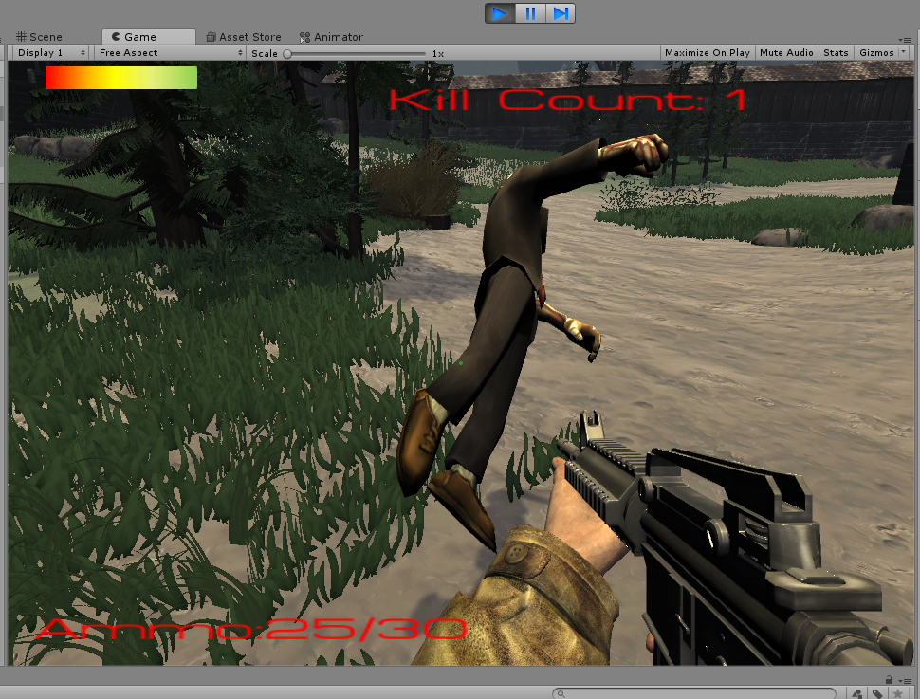
This screenshot shows the death animation for the AI. It also shows the kill count increasing for the kill.

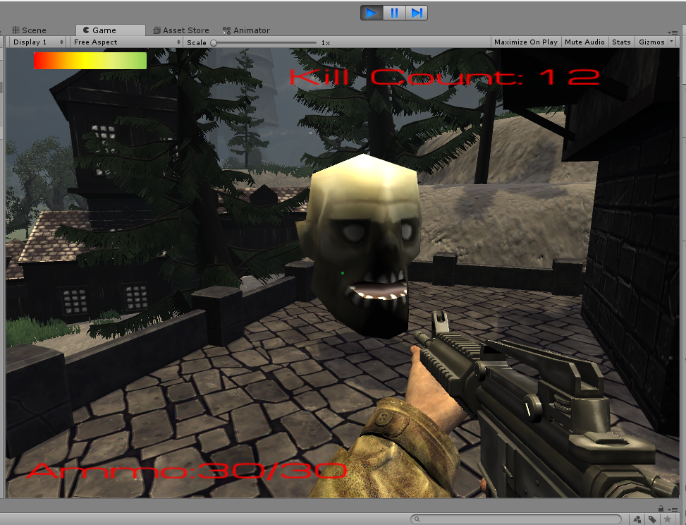
This screenshot shows the end level token.

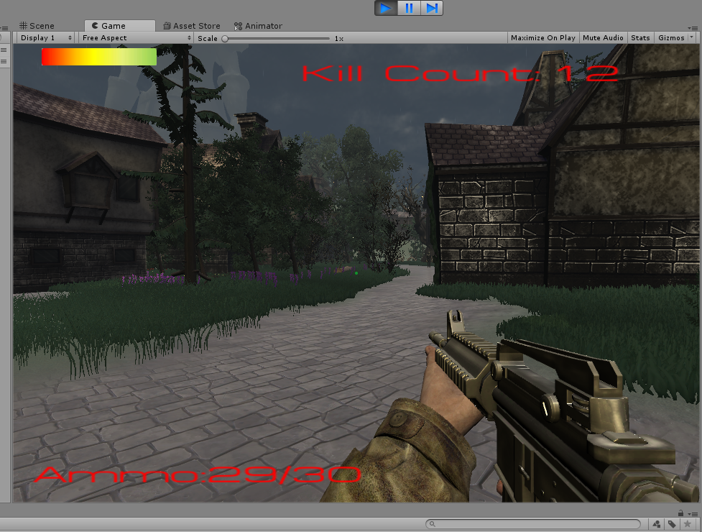
This screenshot shows the next level being loaded after the token is collected, as you can see the kill count remains the same as the last level.

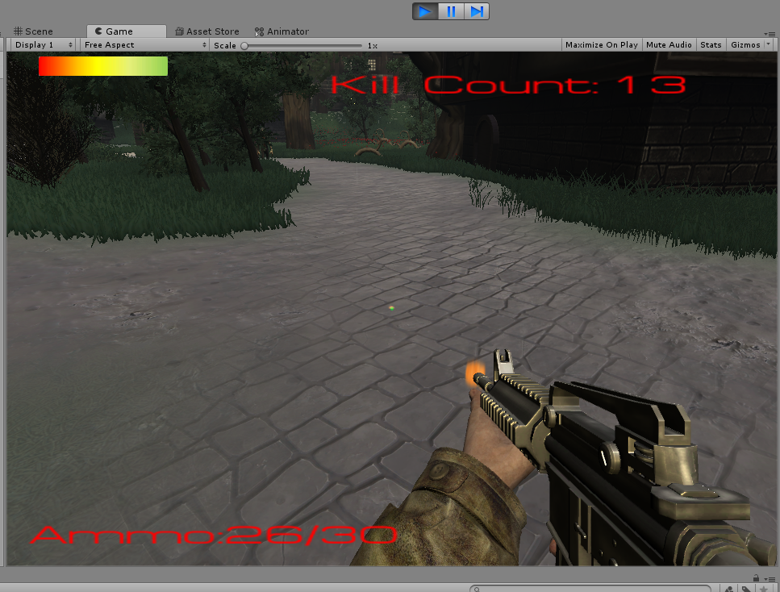
This screen shot shows the muzzle flash and the impact effect of the gun.

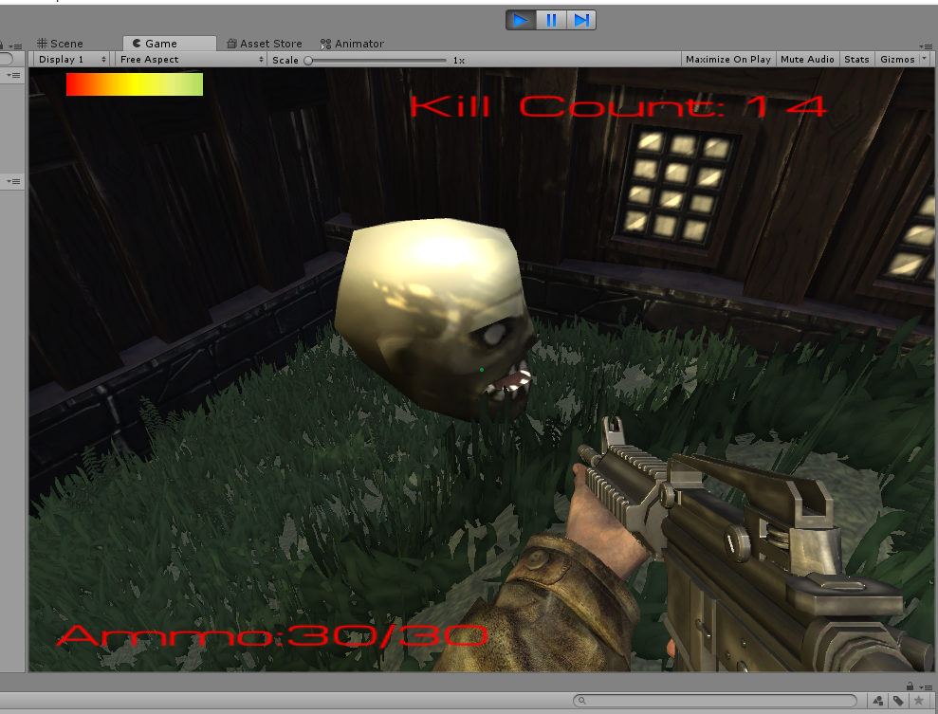
This shows the level 2 end level token.

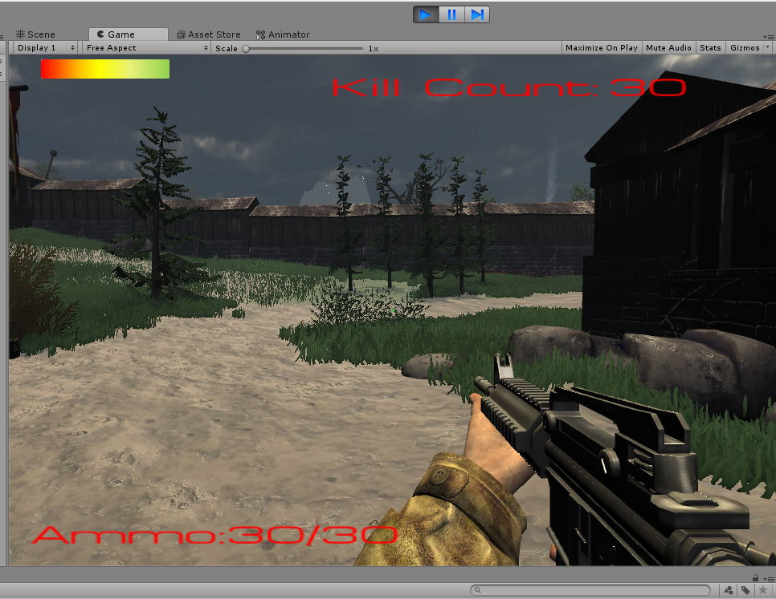
This screenshot shows the third level.

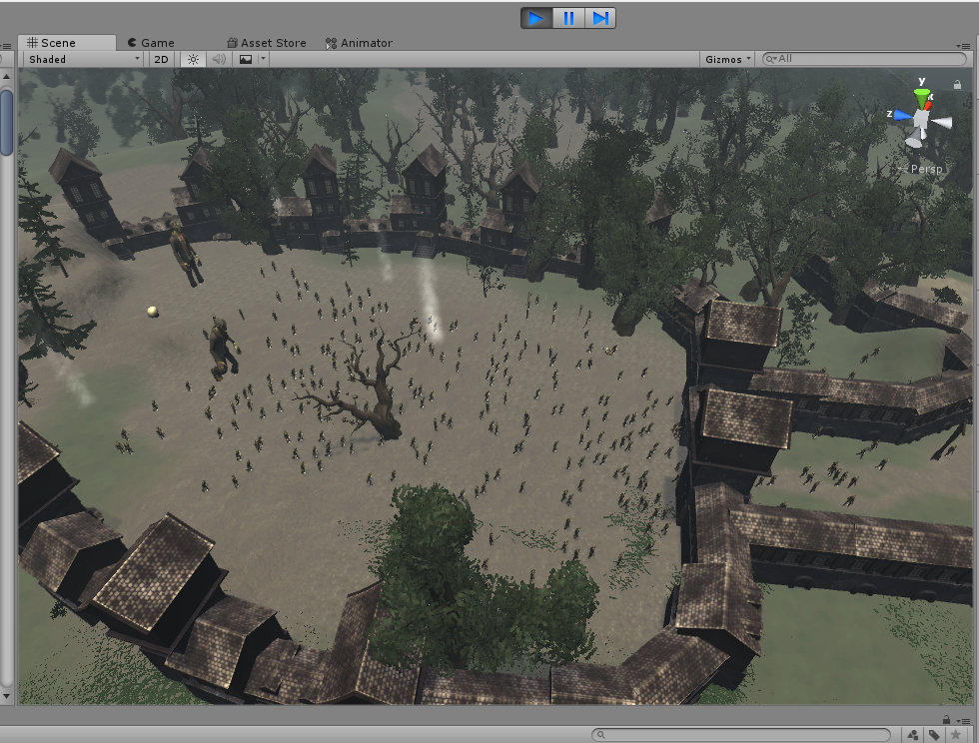
This screenshot shows the third level from above. There are a lot of enemies and 2 large enemies which have significantly more health. This is intended to make the final level more difficult. It also shows the final level token.

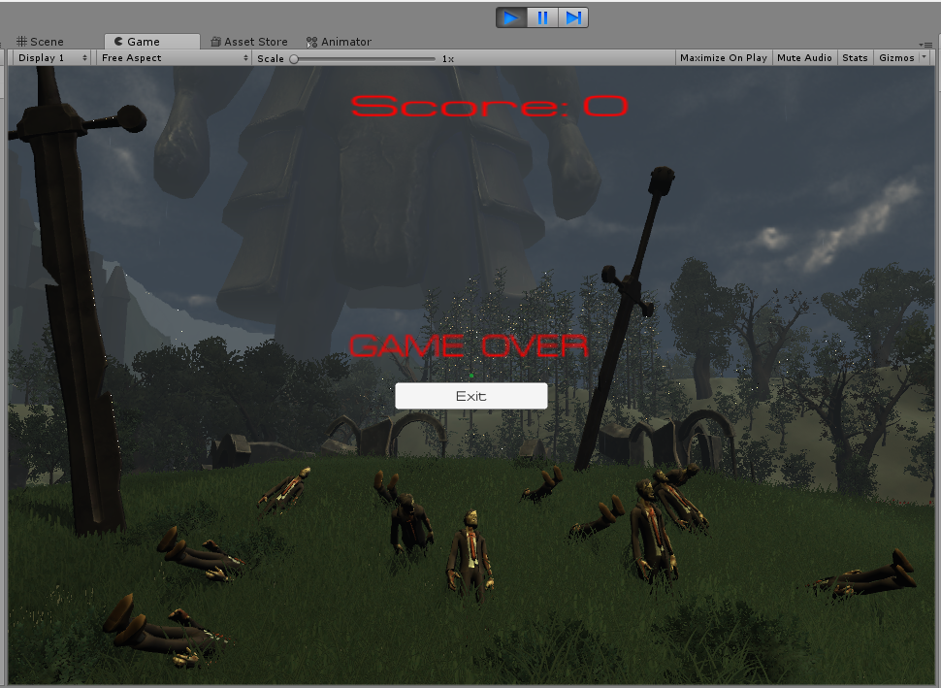
This screenshot shows the end game screen. There is a game over message and an exit button. It also shows the score but it does not carry the player’s score over, even though it has the exact same script as the other scenes, which will carry across the players score.

Evaluation

Player score not carrying over to game over screen – This has no effect on gameplay, however, it would be nice to see score at the end. This is still unfixed.

AI still moving after death – initially, the AI would follow the player while in the death animation or even after the animation had ended. This was a simple fix, the AI just needed to be stopped after they were considered dead.

Low performance final level – The final level can have some performance issues due to the amount of enemies in it. The performance is not too bad and improves over time however it does cause the AI to act strangely, such as moving to the player’s last location rather than following the player. This improves as enemies die. Removing enemies would solve this issue but the final level needs to be difficult and a large amount of enemies certainly provides that.

AI stuttering in spot – some AI would not move and instead “glitch” on the spot. This was because the collider was in the floor and was causing an issue. This is now fixed.

Loading without saving – If the player presses load without saving it will transform the player’s position to the origin. This is unfixed but could be fixed in future by setting default values for the load transform.

This game isn’t the most fun or original game out there, however given the amount of time and limitations, the game is reasonably well made. There are many bugs and a few features that have been left out that could be added. The game;s aesthetics are quite nice to look at however the UI could be improved for adding images for the kill count and ammo count and an icon next to the health bar to make it more obvious that it is the player’s health. The gameplay is very simplistic yet oddly fun to play. It is not a difficult game but can prove to be rather challenging at times.

The game could be improved in future versions by adding animations for the reload and death of the player. It can also be improved by fixing the bugs in the game. Also adding recoil to the weapon would provide more of a challenge and adding a choice of weapons or having a weapon select would be a nice feature. The ability to aim down the sights of the weapon was attempted however nothing came of the attempt, actually implementing this feature would make the game more immersive. Finally a major improvement would be adding more levels to the game.

References

[1] UNITY, “Unity - Scripting API: Application.Quit,” Unity Technologies. [Online]. Available: https://docs.unity3d.com/ScriptReference/Application.Quit.html. [Accessed: 02-May-2018].
[2] sluice, “Saving and Loading Player Position/Rotation etc | Unity Forum.” [Online]. Available: https://forum.unity.com/threads/saving-and-loading-player-position-rotation-etc.328387/. [Accessed: 02-May-2018].
[3] Brackeys, “Shooting with Raycasts - Unity Tutorial - YouTube.” [Online]. Available: https://www.youtube.com/watch?v=THnivyG0Mvo. [Accessed: 02-May-2018].
[4] Chappy, “How to program a pause/unpause button in C#. - Unity Answers.” [Online]. Available: https://answers.unity.com/questions/447142/how-to-program-a-pauseunpause-button-in-c.html. [Accessed: 02-May-2018].

marking criteria and Student FEEDBACK

This section details the assessment criteria. The extent to which these are demonstrated by you determines your mark. The marks available for each criterion are shown. Lecturers will use the space provided to comment on the achievement of the task(s), including those areas in which you have performed well and areas that would benefit from development/improvement.

Common Assessment Criteria Applied (Assignment 2) | Marks available | Marks  awarded
1. Research-informed Literature
Extent of research and/or own reading, selection of credible sources, application of appropriate referencing conventions.
References consulted are appropriate and have been cited appropriately and in a consistent manner. (Grade mark: 60.00%) | 5 | 3
2. Knowledge and Understanding of Subject
Extent of knowledge and understanding of concepts and underlying principles associated with the discipline.
Demonstrates good knowledge of the concepts and principles used to build a game. Good use of property accessor methods, but aim to also use the event system for interaction between game objects. Refactor repeated code into reusable methods or classes. (Grade mark: 62.50%) | 20 | 12.5
3. Analysis
Analysis, evaluation and synthesis; logic, argument and judgement; analytical reflection; organisation of ideas and evidence
A good evaluation and discussion of the challenges faced during implementation has been provided. Recommendations for future improvements are relevant and practical. (Grade mark: 66.67%) | 15 | 10
4. Practical Application and Deployment
Deployment of methods, materials, tools and techniques; application of concepts; formulation of innovative and creative solutions to solve problems.
A very good attempt at a game that has been well thought out. Although, there are some errors when you run the game, the game is still playable and provides a reasonable amount of challenge to the player. See your report for suggested improvements to the script classes. (Grade mark: 71.82%) | 55 | 39.5
5. Skills for Professional Practice
Attributes in professional practice: individual and collaborative working; deployment of appropriate media; presentation and organisation.
The report is of a good standard. See additional comments in your report. (Grade mark: 60.00%) | 5 | 3

Assignment Mark (Assessment marks are subject to ratification at the Exam Board. These comments and marks are to give feedback on module work and are for guidance only until they are confirmed. ) | Late Submission Penalties (tick if appropriate) |  | 68%
 | Up to one week late |  | 68%
 | 1st/2nd/3rd attempt? |  | 68%

