
Module code: BMSW4002
Module Name: Effective Team Work and Communication
Student Number:2027942
Student Name: Mihaela Breazu
Teacher’s name: Lloyd Beharry

Table of Contents
Table of figures 3
Introduction 4
Effective workplace communication 5
Shannon Weaver model of communication 6
Aristotle model of communication 8
Berlo’s S-M-C-R Model 9
Lasswell’s model of communication 11
Poor communication incidence at the workplace 13
Conclusion 14
Reference List 15

Table of figures
Figure 1 Shannon Weaver model of communication 6
Figure 2 Aristotle model of communication 8
Figure 3 Berlo's S-M-C-R Model 9
Figure 4 Lasswell's communication model 11

Introduction
Effective communication plays a crucial role in the workplace as the workplace is the social place where different people from diverse backgrounds works. Therefore, effective communication plays a major part in the workplace for setting up better relations with the team members in the company. Effective communication can include both the verbal and the non-verbal aspects of communication within the workplace. With the help of effective communication, innovations at the workplace can be assured. Further, effective communication helps in the effective making of the team and the effective management at the workplace. Effective communication assures that there must not be any gap between the receiver and the sender during the communication. With the help of an effective team working a positive working environment can be seen in the organisation. For the development of an effective team working in an organisation communication skills plays a crucial role.
In this report, the theories related to effective communication will be discussed briefly. In this report, effective communication strategies will be discussed with the help of several models of communication.

Effective workplace communication
Effective workplace communication can be defined as the communication through which the information and ideas are effectively transferred between the different teams in the organisation (Alyammahi et al., 2020). Effective communication involves both verbal and non-verbal communication. Effective communication between the team members involves the better collaboration of the team members towards the achievement of the goals of the teams in the organisation. Effective communication between the team members and the team leaders assures a better understanding between the team leaders and the team members. There are various ways for effective communication like video conferencing, messaging and e-mail tools. The best way the identification the efficacy of the communication between the team members and the team leaders is to identify the use of effective communication tools. Effective workplace communication plays a crucial role in the development of better relations between the team members and the external clients within the organisation. Effective team communication can be set up with the help of the face to face meetings, by identifying the audience with whom the communication has been made further. Listening to the team members also plays a crucial role in effective communication (Alyammahi et al., 2020).

Shannon Weaver model of communication
It is the mathematical models that involve the six elements of communication. This model is also termed to be the information theory or the Shannon theory of communication. This is the linear model of communication that involves the analyses of the massage and the conversation made between the sender and the receiver (Ali et al., 2021).
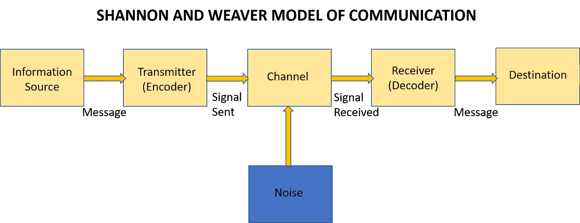
Figure 1 Shannon Weaver model of communication
Source: (Ali et al., 2021)
Sender: It is the first element of this model. In this model, this element is termed to be the source of the information (Ali et al., 2021). The source of the information can be the associated people and the objects through which the communication has been made.
Encoder: It is the second most crucial parameter of this model. This acts as the machine that is responsible for the conversion of the ideas into signals (Ali et al., 2021). In this model, the computers and the telephones are being considered as the encoder or the machine.
Channel: This is the element that acts as the platform for the communication between the receiver and the sender in the communication process. This is the medium of communication through which the communication between the receiver and the sender has been taken place (Yue et al., 2021). This can be divided into two types i.e. the online medium of communication and the offline medium of communication. Further, the verbal and non-verbal medium also acts as the channel of communication between the sender and the receiver.
Noise: It is the element that acts as the interruption between the communication between the receiver and the sender. Noise can be divided into two types i.e. the internal noise and the external noise. The internal noise involves the noise at the point of the sending and the point of the receiving of the message (Yue et al., 2021). The external noise involves the disruption of the messages at the point of the transmission of the messages from the sender to the receiver of the messages.
Decoder: It is the opposite process of the encoding of the message. In this aspect, the message has been decoded by the receiver in the receiving end.
Receiver: This is the final element of the communication process. In this step, the message is finally received by the receiver.
Feedback: It is the final step in the process of communication. In this step, the feedback and the response regarding the communication process have been made (Kuznar and Yager, 2020).

Aristotle model of communication
This model is majorly focused on the speaker and the speech that has been made during the communication process. This model is associated with the three elements of communication. This theory revolves around the speaker’s role in the communication process (Dutton, 2020). These three elements are the ethos, pathos and logos aspects.
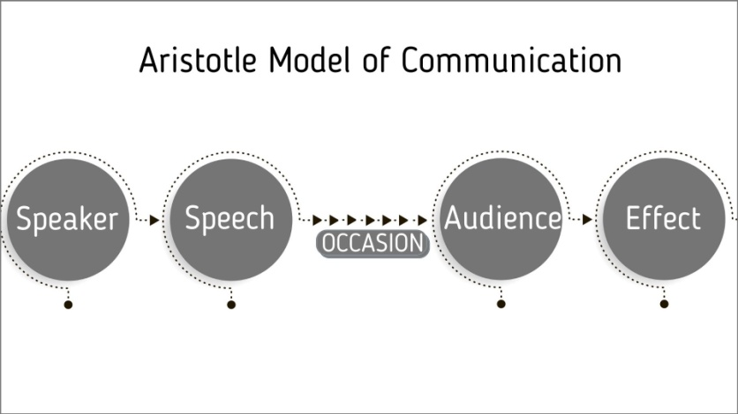
Figure 2 Aristotle model of communication
Source: (Dutton, 2020)
Ethos: It is the element that outlines the ability of the speaker in the communication process. It is the element that outlines the authority, power and creditability of the speaker during the communication process. (Dutton, 2020). This element outlines that the speaker must have appropriate eye contact with the audience is that credibility during the conversation can be maintained.
Pathos: This element involves the importance of the emotional bond while making the communication between the audiences (Dutton, 2020). This element aids the speaker to make prominent contact with the audience through the help of emotions.
Logos: This element gives importance to the logic behind the conversation between the receiver and the speaker (Alshanqiti and Khozium, 2021). In this element, the speaker needs to put effective and relevant evidence while making the conversation with the audience.
There are various criticisms of the models like that this model focuses on the one-way communication between the speaker and the audiences. This model is mostly used in public speaking programmes and therefore it is the restraint of the model (Alshanqiti and Khozium, 2021).

Berlo’s S-M-C-R Model
This is the most prominent model that determines the communication between the receiver and the sender. This model is also term as the SMCR model which is the acronym of the source, message, channel and receiver (Maneerutt, 2021).
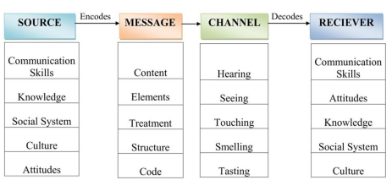
Figure 3 Berlo's S-M-C-R Model
Source: (Maneerutt, 2021)
Source: This is the element where the message to the receiver is being transferred. This is the starting or the originating point of the information. It involves the communication skills, attitudes and knowledge of the sender while making the communication.
Message: This is the element that involves the content or the information that has been sent during the communication process (Maneerutt, 2021). It involves different types of gestures; body language and the language that has been used while making the communicating with the other person.
Channel: This is the medium of communication through which communication has been made among the people. This element involves the description of the five organ senses while making the communication with the different persons.
Receiver: This is the final element of this model that plays a crucial role in making the communication complete from both ends. In this element, the receiver must need to respond effectively to the sender by analysing the message in an effective manner (Maneerutt, 2021).
There are several criticisms associated with the model like the lack of feedback in making the communication. It is the linear model of communication and so the communication cannot be made with more than two people. It is a complex model of communication.

Lasswell’s model of communication
This model identifies the five elements of the conversation. These five elements involve the Who aspect of the conversation in addition to what has been said to the person. Further, this model outlines the conversation that is being happened in different channels (Babaei et al., 2021). In the end, this model identifies the person with which the communication has been made and with what effect this communication has been made is identified in this model.
According to this model, communication has been made for the fulfilment of the three social functions in the organisations. These social functions involve the surveillance, correlation and transmission aspect.
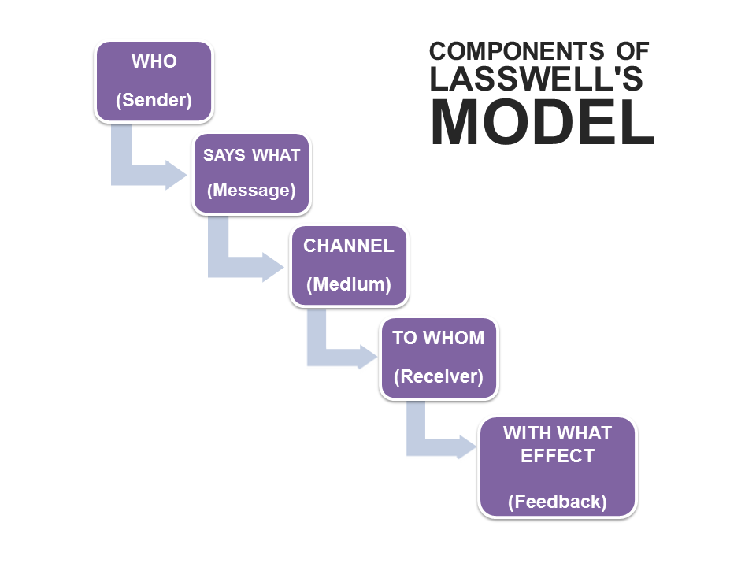
Figure 4 Lasswell's communication model
Source: (Babaei et al., 2021)
Who:
It involves the conversation with the communicator or the source and the sender.
Says what:
It deals with conversation point that has been made between the communicator and the receiver.
In which channel:
This aspect involves the media of the communication between the receiver and the sender (Babaei et al., 2021). This involves the media of the communication between the receiver and the sender.
To whom:
In this aspect, the person or the receiver of the conversation has been taken into the consideration (Babaei et al., 2021).
With what effect:
This is the feedback that has been provided by the receiver to the sender.

Poor communication incidence at the workplace
Poor communication creates tense problems among the employees in the workplace. Due to poor communication, the employees lose the motivation of working effectively (Gamil and Rahman, 2017). The shortage of motivation among the employees is being responsible for the bitter relations between the different employees at the workplace. Poor communication can be defined as the communication in which the flow of information is disrupted harshly. Due to poor communication, the important information at the workplace is not being transmitted to the receiver and misunderstanding regarding the information can be seen (Gamil and Rahman, 2017). Due to the lack of effective communication, the workplace conflicts incidence can also be seen (Matta and Fares, 2021).
Example of poor communication at the workplace:
At the workplace, employee X has to deliver the daily data report to the senior data analytics at 10 am and due to the sudden breakdown of the telephonic communication the employee listens to the delivery time of the report at 5 pm. Due to the lack of efficiency in the telephonic conversation the employee listened to the wrong information about the delivery time. Due to the gap in the telephonic conversation, the conflict between employee X and the senior data analytics officer has been created (Matta and Fares, 2021).
The communication gap between the sender and the receiver end can be cured effectively with the help of Lasswell’s model of communication. With the help of this model, the company needs to first identify the speaker and the efficiency of the information through the speaker's end. As per the above example, the company needs to inculcate the communication effective communication culture between the sender and the receiver (Stevenson, 2020). Further for the online and telephonic conversation, the company needs to make the protocol so that the telephonic conversation can be made much effective in the company. Instead of the telephonic conversation, the company needs to adopt email messaging tools so that the errors in the information delivery can be sorted virtually.
The company needs to focus on the setting of effective communication standards with the help of Lasswell's model of communication. With the help of this model, the company needs to find out the efficient channel for the delivery of the message to the receiver for this the company can set out the standards demands and norms for different mediums of communication (Stevenson, 2020).
After the setting up of the effective communication channels, the company needs to focus on the process of seeking feedbacks from the different employees. With the help of the feedbacks, the company can easily engage the employees in the different works at the workplace.
Conclusion
This report briefly outlines the discussion of the different models for making effective communication at the workplace. This report has involved the discussion of effective communication-making strategies in the workplace. Further, effective communication strategies at the workplace have been discussed with the help of theories and models of communication. In this report the discussion regarding the poor communication incidents have also been discussed.

Reference List
Ali, B.J., Anwar, G., Gardi, B., Jabbar Othman, B., Mahmood Aziz, H., Ali Ahmed, S., Abdalla Hamza, P., Burhan Ismael, N., Sorguli, S. and Sabir, B.Y. (2021). Business Communication Strategies: Analysis of Internal Communication Processes. Ali, BJ, Anwar, G., Gardi, B., Othman, BJ, Aziz, HM, Ahmed, SA, Hamza, PA, Ismael, NB, Sorguli, S., Sabir, BY (2021). Business Communication Strategies: Analysis of Internal Communication Processes. Journal of Humanities and Education Development, 3(3), pp.16-38.
Alshanqiti, A.M. and Khozium, M.O. (2021). Communication Models Comparisons: Tackling Approach for Corporate Communication. Psychology and Education Journal, 58(4), pp.4075-4079.
Alyammahi, A., Alshurideh, M., Al Kurdi, B. and Salloum, S.A. (2020, October). The impacts of communication ethics on workplace decision making and productivity. In International Conference on Advanced Intelligent Systems and Informatics (pp. 488-500). Springer, Cham.
Babaei, P., Ghavidel, S. and RiahiNia, N. (2021). Content Analysis of Infographics with the Theme of Reading Based on the Lasswell's Communication Model. Research on Information Science and Public Libraries, 26(4), pp.629-664.
Dutton, T. (2020). 1.2 The Communication Process. Communication 101 Textbook (Dutton).
Gamil, Y. and Rahman, I.A. (2017). Identification of causes and effects of poor communication in construction industry: A theoretical review. Emerging Science Journal, 1(4), pp.239-247.
Kuznar, L.A. and Yager, M. (2020). The Development of Communication Models, Quick Look. Joint Staff J39, Strategic Multi-layer Assessment Washington, DC United States.
Maneerutt, G. (2021). Miscommunication at the Workplace: Causes and Ways to Improve Internal Communication. AU-GSB e-JOURNAL, 14(2), pp.155-166.
Matta, R. and Fares, R. (2021). The impact of interpersonal workplace conflicts on the long-term success of organisations. EuroMed Journal of Management, 4(1), pp.55-71.
Stevenson, J. (2020). Expertise for the workplace. In Developing vocational expertise (pp. 3-25). Routledge.
Yue, C.A., Men, L.R. and Berger, B.K. (2021). Leaders as communication agents. In Current Trends and Issues in Internal Communication (pp. 19-38). Palgrave Macmillan, Cham.

