Student name: Violeta- Ionela Necsoi
Module Title: International Meetings Management for the Hotel Industry
Programme: BA (Hons) International Hotel Management
Module code: BMIH6007
Module leader: Kathryn Flynn
Assignment 1: Feasibility Plan for an International Meeting

Slide 1: Title
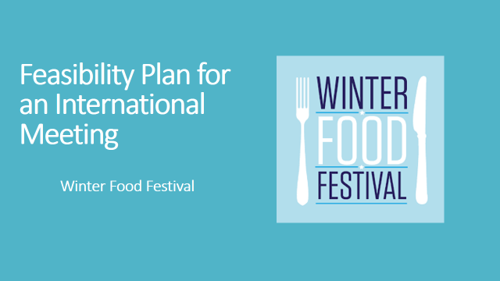

Slide 2: Introduction
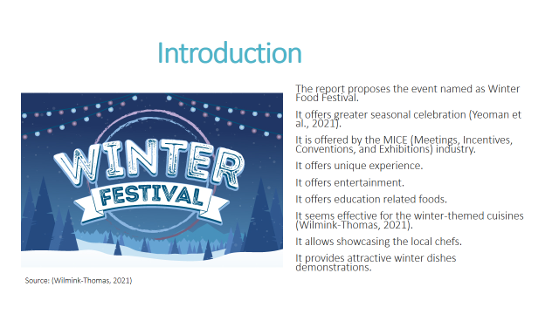
The presentation is based on the proposal of the event named as Winter Food Festival.
It is designed as one of the greater seasonal celebrations offered by the MICE (Meetings, Incentives, Conventions, and Exhibitions) industry.
The festival focuses on the creation of a unique experience.
It allows combination of entertainment, provision of education related foods, and allocated networking opportunities for all the concerned participants in the hospitality industry.
The event seems effective for the winter-themed cuisines.
It allows showcasing the local chefs, measures of culinary delights, and also some attractive winter dishes demonstrations.
Slide 3: Winter Food Festival
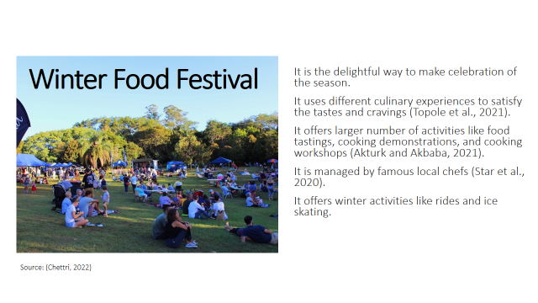
Winter food festivals is one of the delightful ways to make celebration of the season.
It includes different culinary experiences to satisfy the tastes and cravings.
The festival will offer larger number of activities for the attendees such as food tastings, cooking demonstrations, and cooking workshops that will be led by famous local chefs.
There will also be some winter activities like rides and ice skating to make fun in the atmosphere.
Slide 4: Event Content and Context
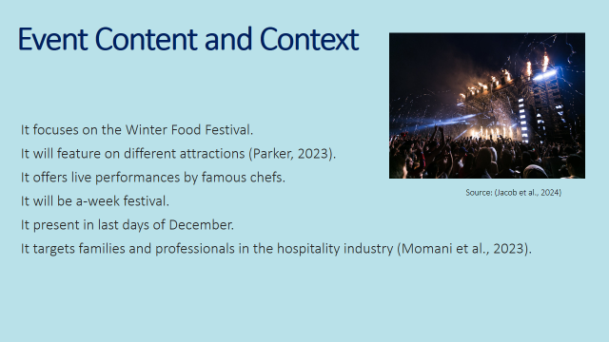
The focus of Winter Food Festival will feature on different attractions such as tasting of different cuisines, winter food market, cooking workshops on the winter-themed crafts, live performances by famous chefs.
Type and nature of the events is a one-week festival that will be held in last days of December. It targets families and professionals within the hospitality industry.
Slide 5: Market Factor
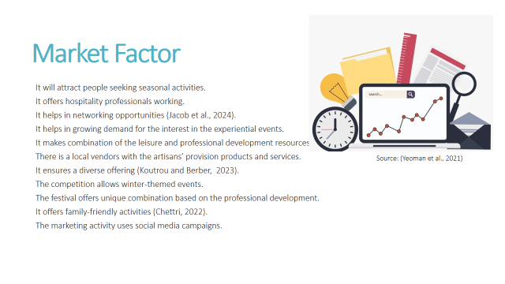
The target market offers attraction to the families looking for the seasonal cooking and food activities.
The event offers hospitality professionals working to the networking opportunities.
There is a growing demand for the interest in the experiential events and combination of the leisure and professional development resources.
There is a local vendors with the artisans’ provision products and services. It ensures a diverse offering.
The competition allows winter-themed events. The festival offers unique combination based on the professional development.
It allows family-friendly activities making it apart.
The marketing activity allows promotion of the social media campaigns. It allows partnerships with the businesses and community system.
Slide 6: Operational Factor
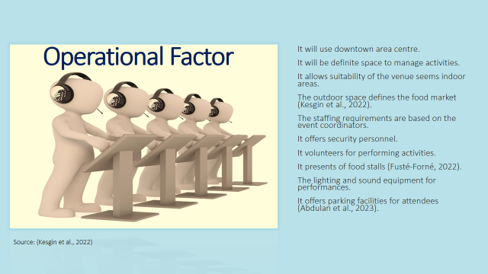
The venue availability allows festival to take place within the downtown area centre that is definite space to manage food and related activities.
Suitability of the venue seems indoor areas for all the workshops.
The outdoor space defines the food market. The staffing requirements are based on the event coordinators, security personnel, and volunteers for performing activities.
The resource allocations allows catering services for all the food stalls.
The lighting and sound equipment are allocated to all the performances individually. Parking facilities will also be provide to all the attendees.
Slide 7: Financial Factors
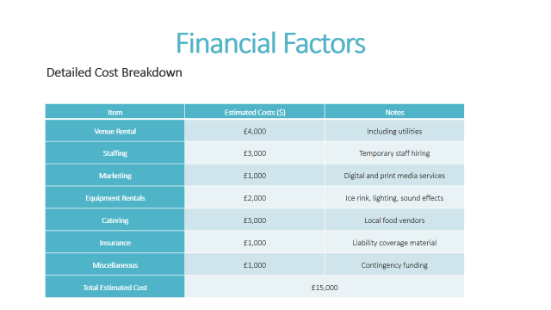

Slide 8: Revenue Stream

Slide 9: Promotional Channels
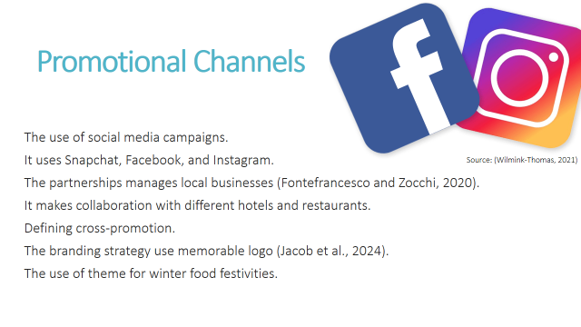The use of social media campaigns will be helpful for targeting families and professionals on the platforms such as Snapchat, Facebook, and Instagram.
The partnerships with local businesses will help in making collaboration with different hotels and restaurants for the management of the cross-promotion.
The branding strategy is based on the creation of a unique logo and making the theme that resonates with successful winter food festivities.
Slide 10: Risk Management Plan
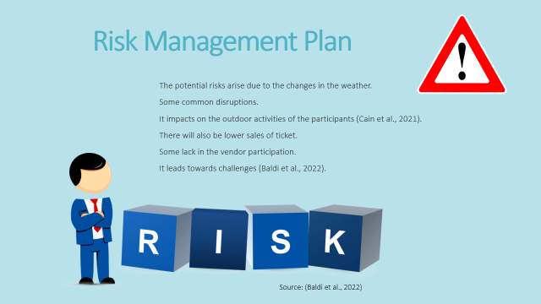
The potential risks arise due to the changes in the weather and related disruptions where the outdoor activities are planned for the participants.
There will also be lower sales of ticket and some lack in the vendor participation that leads towards challenges.
Slide 11: Mitigation Strategies
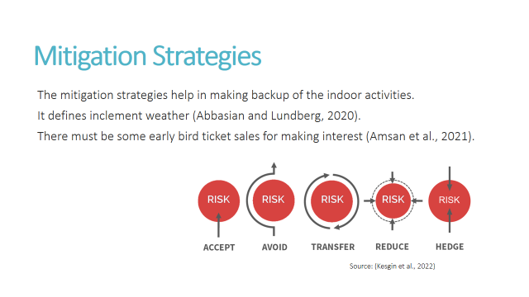
The mitigation strategies help in making backup of the indoor activities in case of facing any kind of inclement weather.
There must be some early bird ticket sales for making interest.
Slide 12: Conclusion
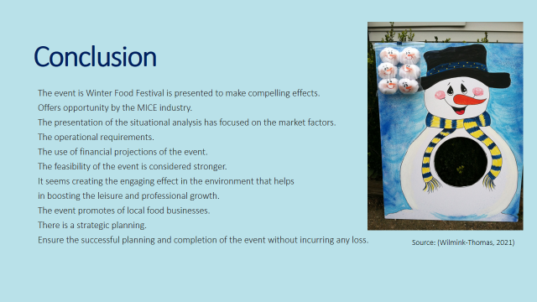
The event named as Winter Food Festival is presented to make compelling effects to the opportunity by the MICE industry.
The presentation of the situational analysis has focused on the market factors, operational requirements, and financial projections of the event.
The feasibility of the event is considered stronger. It seems creating the engaging effect in the environment that helps in boosting the leisure and professional growth.
The event is poised for attracting the diverse audience and make promotion of the local food businesses. There is a strategic planning that ensures the successful planning and completion of the event without incurring any loss.
Slide 13: References
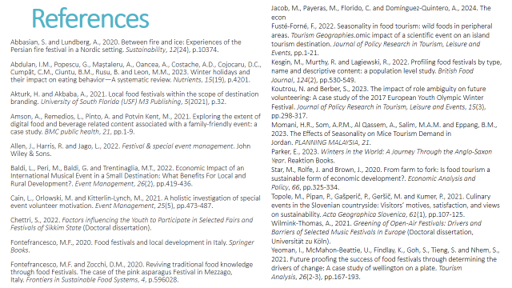
Slide 14: Thank You


