-
Sam Melmoth
1809093
M5X02070

Manufaacturing design & technology
Computer Aided Manufacturing and Design for Additive Manufacturing Technologies

Introduction
The purpose of this report is to review a concept design that has been proposed to function as a gripping tool to carry out several different “pick and place” operations. The report will consider many different factors when reviewing the concept such as materials used, manufacturing processes, design for ease of use and the operational conditions it must be used in. Once any weaknesses in the design have been located, a new revision of the design will be produced to combat these issues. Forming a well suited and capable product for the role.
Factors that we are considering for this scenario are that we are making the part in low numbers and custom made for a robot on our plant in Wall Colmonoy. Consequently, we are not interested in mass producing these parts, this will narrow the production methods that are suitable. The facilities that we have on site are a precision machine shop with lathes, CNC machines and a new metal 3D printer. With this taken into consideration we want to make the components with the resources we have on site, to reduce lead time and manufacturing fees.
Table of Contents
Introduction 1
Body 2
Appraisal of the original design 2
Manufacturing process proposal 5
Design and development work undertaken 10
Manufacturing process design 13
Conclusion 13
Works Cited 13

Body

Appraisal of the original design
The assembly supplied for this project is made from 11 separate parts. These parts have all been designed with no consideration for manufacture or assembly. An FMEA was conducted to find faults with each component. Here is a breakdown of the issues that would arise if the current design were to be made.
Gripers
There are three gripers in total that come together at a point. This point is very small. This is good for precise work and picking up small objects. But if the robot is controlled by hand then it would be very hard to line up such a small point.
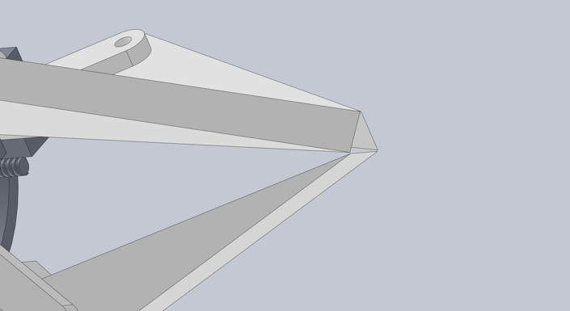
The gripers must exert a sufficient amount of force to lift the component. Due to the small surface area between the gripers and the component this would also increase the amount of force concentrated in one spot on the component, this could be problematic as it could damage the part. The gripers are planned to be made from PVC this will limit markings on the component being lifted in comparison to metal jaws. But will plastic jaws will limit the weight capacity of the griper.
Figure 1(Original gripers)
Joint
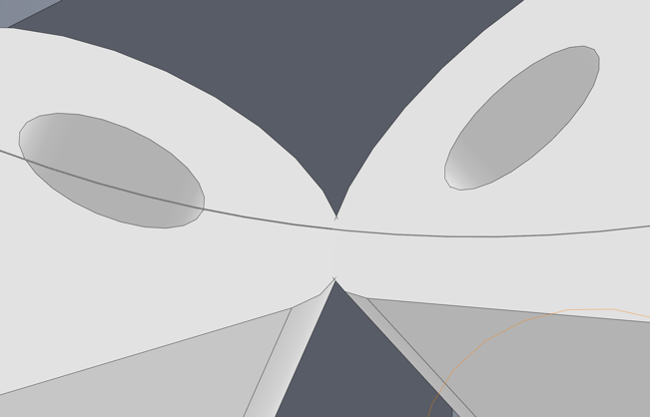
The joints that move the gripers have drilled holes for pivots at either end to attach to the griper arm and the drive plate. These unions aren’t specified and currently would fall apart. There is also a clearance issue with the current design as the joints collide with each other. This collision wouldn’t allow for the joints to be assembled after manufacturing. There is also no tolerance in the design between the PVC joints and the 1060 Alloy drive plate. This would cause friction between the plates and due to the PVC part being softer than the alloy it would wear out quickly. Due to the low quantity of these parts casting would be an expensive method of manufacturing these parts from PVC. Machining also has issues because PVC blunts CNC tools quickly and releases toxic fumes in the form of chlorine gas (Health and Safety Executive, 2020).
Figure 2(Collision between two Joints)
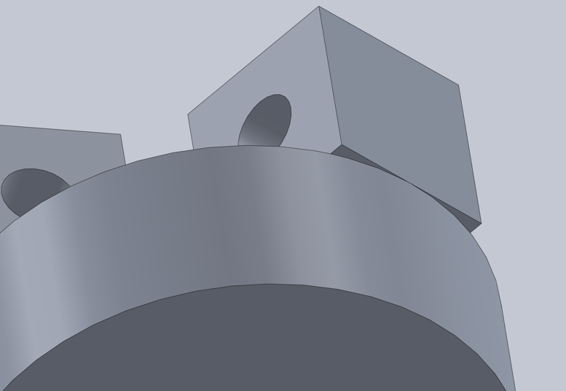
Driveplate
Figure 3(Ragged edges on driveplate)
On the current design there are overhangs where the circular body meets the extrusions that connect to the joints. These overhangs are unnecessary and during operation of the machine would collect dust and dirt making it harder to clean. By removing these ledges and making the whole length of the part cylindrical this would make it easier to machine. Because the CNC would be able to make the part from one solid alloy cylinder instead of having to trim down half of the length, then change orientation to drill the rest of the part.
Worm
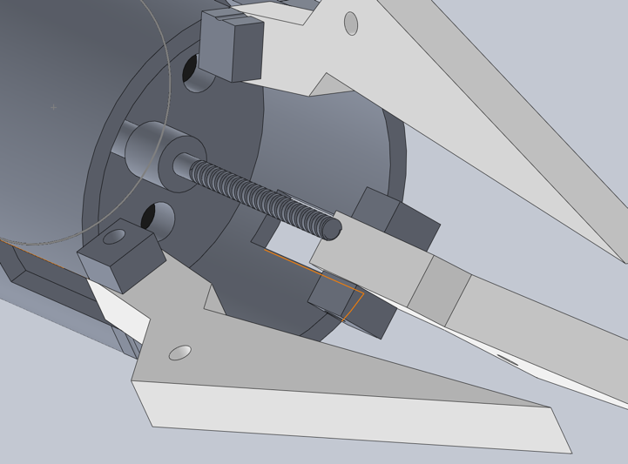
The worm and drive plate are both machined from aluminium alloy as this is a soft metal this would wear down quickly with sustained use on a factory line. It would also be easy to cross thread when assembling the griper assembly. This would require more maintenance. Maintenance causes downtime for the production line and causes delays, this leads to a financially negative effect on the company (S.C. Nwanya, 2017).
Figure 4 (Worm from original CAD model in assembly)
The connection point between the worm and the shaft has no thread and is round this would hinder the shafts capability to transfer rotational force to the worm. The lack of tension applied in the system would mean that the gripper arms could not apply enough force to pick up heavy objects. Once the gripers met the object it would cause the connection between the shaft and the worm to slip.
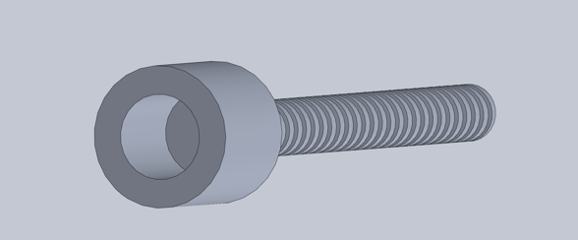
There are also no tolerances applied to the two meeting components. The shaft and the hole are both 3mm. This allows no machining tolerances for the parts and would likely not fit. As there is no vent either the parts would form a vacuum and be impossible to disassemble.
Figure 5 (Original Worm CAD Model)
Cylinder
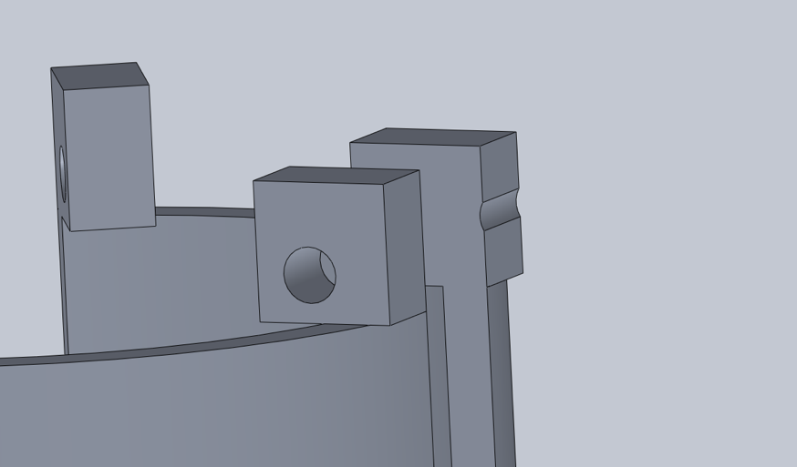
The cylinder is currently made from Aluminium Alloy 1060. There are a few design errors with the current model such as. The joint holes where the griper arm connects to the cylinder are off to the side. This reduces the wall thickness and weakens the part. The holes on either side are also not aliened. This would make the part impossible to assemble after manufacture.
Figure 6 (Error in the alignment of pivot holes)
Some of the features on this model would not be able to be cut out by lathes or CNC machines, such as the overhangs of the pivot points. Therefor this part must be made in a 3D printer. This area is also a weak point in the design. Where the pivot points meet the rest of the cylinder there is a weak point due to the overhang of material. It is also this material that prevents machining on a lathe or CNC. It is also due to the excessive removal of material from the slot in between the two pivot points to make room for the griper arm. This lack of material leads to flexing and a lack of structural strength.

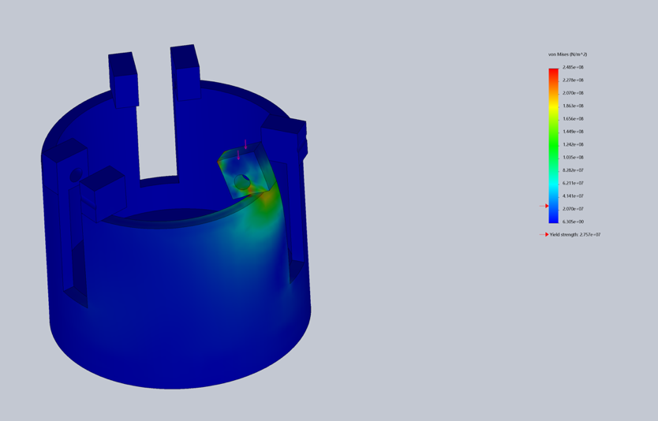
Also, there are no clearances between the cylinder and the shaft that fits through. This lack of clearance would stop the shaft from spinning and driving the griper. It would also wear the shaft down through friction and fatigue the part.
Figure 7 (Stress analysis of original cylinder design)
To connect the cylinder to the motor body there are four bolt holes on the inside of the casing. By positioning the holes in that location, makes it hard for workers to access the bolts to make repairs and conduct maintenance.
Other considerations for improvement are adding radiuses or chamfers to corners to minimise stress points, this also increases health and safety to stop cuts.

Manufacturing process proposal

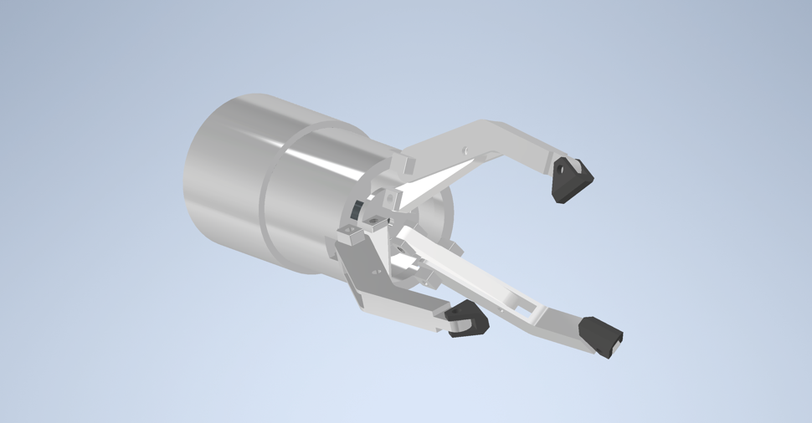
Figure 8 (New proposal griper design)

Piston Housing
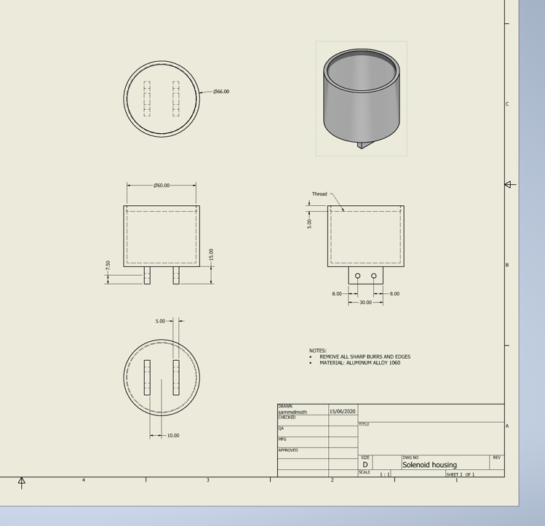
The Piston housing is made from a solid cylinder of 1060 Aluminium alloy. It is then turned down to size and board on a lathe. Next the thread is added to the inside of the open end. Lastly the component is transferred to a 4-axis CNC machine to cut the mounting brackets at the closed end of the component. The choice to use Aluminium is that it is easy to machine, readily available and cheap. The benefits of producing this component on site is that it can be customized to fit onto any robot in the factory. The diameters can also be increased or decreased to fit any piston that is used for the griper.
Figure 9 (Drawing for new piston housing/mount)
Griper Housing
The griper housing will be made from an additive manufacturing compatible aluminium alloy AlSi12. This alloy has a good ratio between yield strength and hardness out of all the aluminium alloys. It is imperative that the housing remains as light as possible so that the weight capacity of the robotic arm is not breached, and the performance of the robot isn’t reduced. Here you can see the performance of the alloy compared to other additive manufacturing powders (Anon., 2019).
Figure 10 (Material chart for additive manufacturing materials)

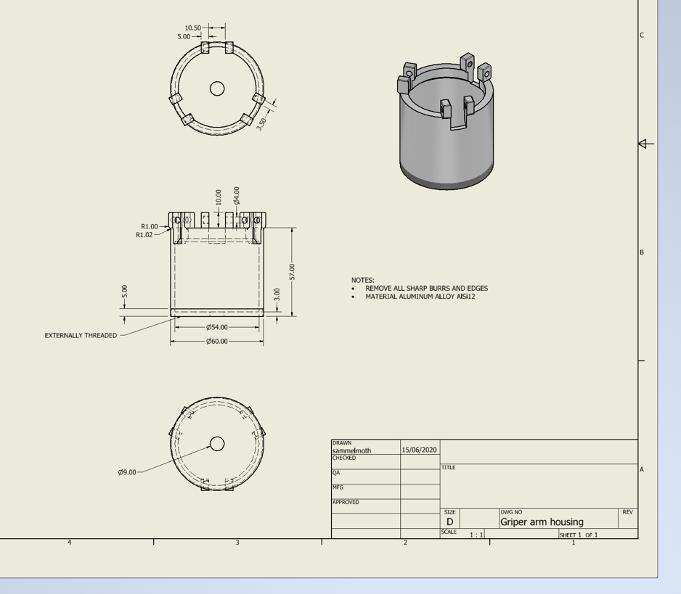
3D printing was chosen as the manufacturing technique for this part due to the overhanging sections on the inner diameter that would be hard to machine on a conventional lathe. As this part is going to be made in small numbers this allows us to use this manufacturing technique cost effectively (David L. Bourell, 2014).
Figure 11 (New griper housing drawing)

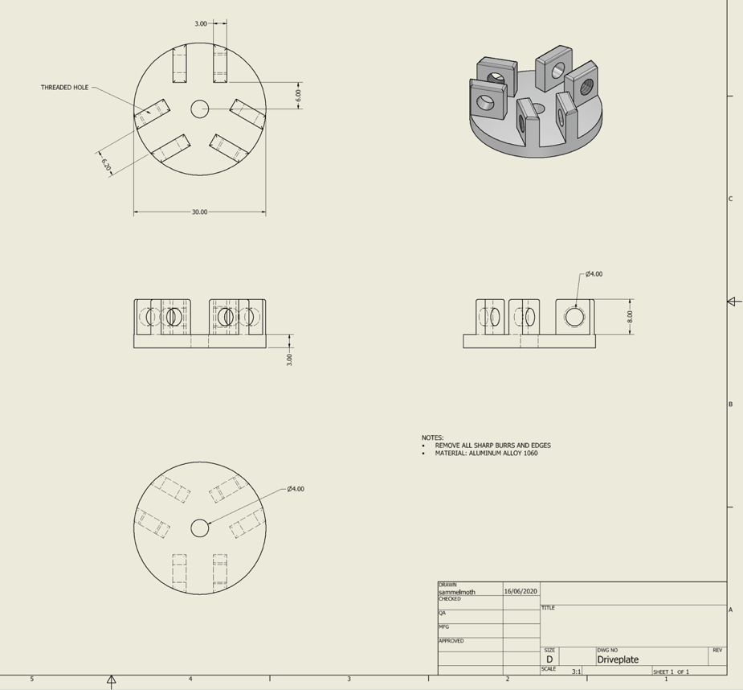
Driveplate
Figure 12 (New driveplate drawing)
The material chosen to construct the driveplate from is Aluminium alloy 1060, this material was chosen for its strength to weight ratio and its resistance to rust (Z.J.Wang, 2018), this allows the griper to be used in a variety of environments. The manufacturing techniques chosen to make this component is CNC machining. Wall Colmonoy have access to 4-axis CNC machines that are able to mill all the features and geometries of the driveplate including the tapping of the holes. Other manufacturing methods such as casting would be much more expensive for a limited production quantity such as this, due to the tooling costs. As well as this, the component would need machining afterwards to add the threads, so machining the whole component is more practical. Also manufacturing by casting would be much more time consuming, once the tooling and design time were considered.

Joints
The joints that connect the gripper arms to the driveplate are going to be made from PVC plastic. The reasoning behind this decision is that this is a weaker material than the metal components around it, and this will be used as a sacrificial component in case an error occurs. This component will fail before damaging any of the other components or the product that is trying to be lifted. As this component is made from plastic it will be manufactured using the 3D printer. This method is better than milling the part on a CNC because milling PVC can blunt end-milling bits rather quickly. It also releases toxic chlorine fumes which are very harmful (Health and Safety Executive, 2020). The 3D printing method also allows replacement parts to be made quickly and cheaply with limited to no waste material.
Figure 13 (New joint drawing)
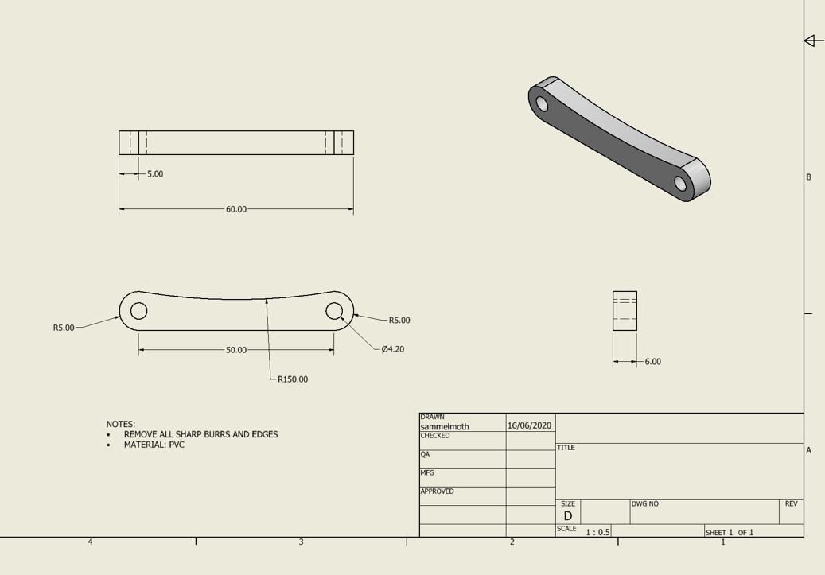

Griper Arms
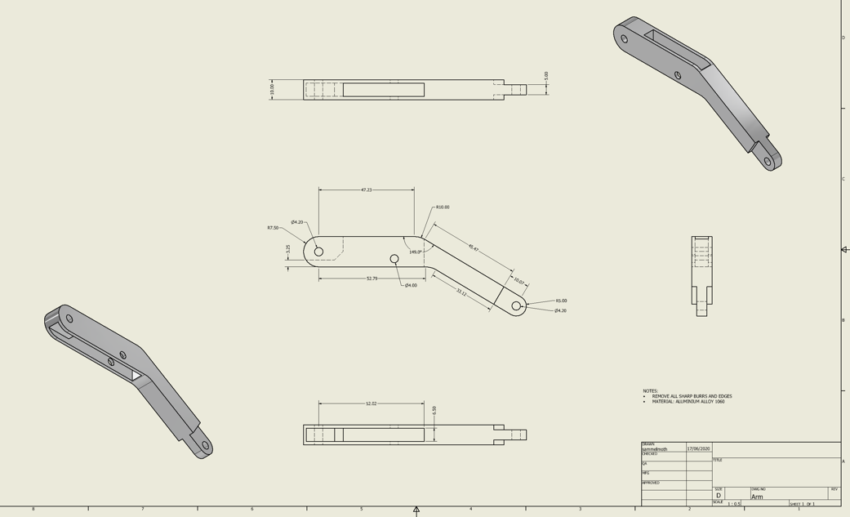
For the Griper Arms construction I decided to keep using Aluminium Alloy 1060 to stay consistent throughout the design. Weight is an even more important of a consideration as you move further away from the pivot as leverage will increase the effect of the weight (Goodwin, 2012). The arms will also be made using CNC machining.
Figure 14 (New griper arms drawing)
Gripers
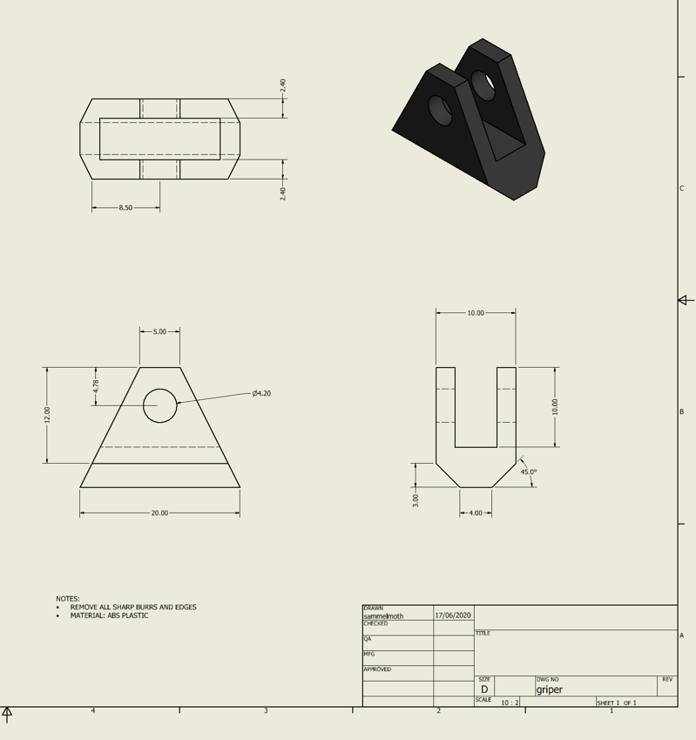
To increase grip on the part the gripers will be made from ABS (S. Perepelkina, 2017). This plastic has a high coefficient of friction, this allows the griper to exert less force on the component which in turn reduces the likelihood of damaging the component. This component will be produced in batches of three by 3D printing. The use of 3D printing for this component is because that 3D printing is the only method of forming this part on site at Wall Colmonoy.
Figure 15 (New griper drawing)

Design and development work undertaken
The new design is based largely on the original but considerations have been made to improve how workers interact with the assembly in operation and how the machinery will be manufactured. Structural considerations were also taken into account.
Piston
Firstly, I made the decision to change the motor of the original design to a piston. The reason for this change is because the energy from the motor must be changed from rotational motion to a forward and back motion by the driveplate thread. This creates more friction and reduces the efficiency of the system. By Changing to a piston, it negates the change of motion creating a more efficient system. By changing to a hydraulic system, it also ties in with the rest of the robot that is on site, as the other joints of the arm are powered by hydraulic pistons. By having hydraulic piston controls it allows for a greater degree of accuracy in how the griper can be used. Pressure gauges can be inserted directly into a hydraulic piston so that the pressure that is being applied to the part can be controlled. Comparatively it is harder and more complicated and less accurate to measure the torque being applied through the motor and the shaft.

Joints moved
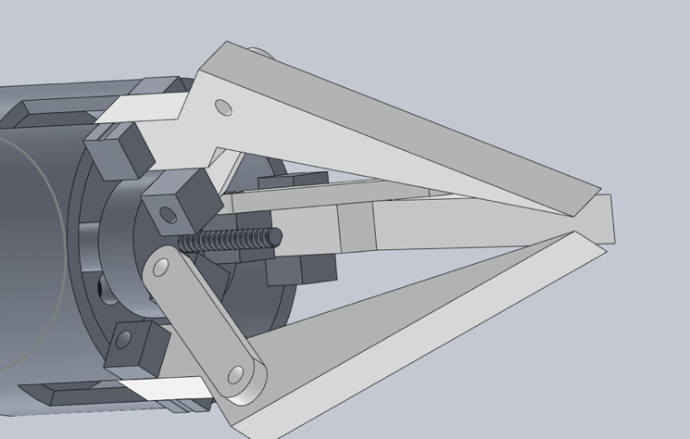
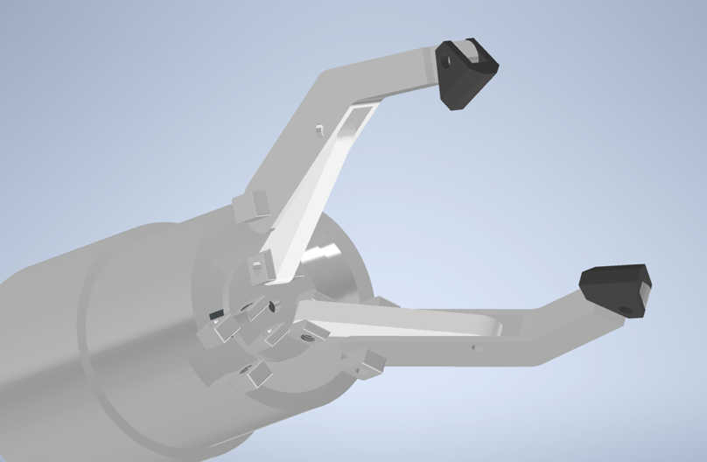
Secondly the joints that connect the drive plate and the griper arms were changed. Before these parts were connected asymmetrically. This was an issue because it caused clearance issues. It also creates unwanted torsion in the mechanism. This can cause increased wear in pivot parts leading to increased maintenance and downtime (Vieroslav Molnár, 2014). The change that was made was done by shelling out the interior of the griper arm for the joint to fit inside and be symmetrical with the arm. This created more space on the drive plate as the joint wasn’t pushed off to the side to accommodate the arm any more. This extra space allowed for an extra extrusion per joint on the driveplate. These extrusions are placed the other side of the joint and have a threaded hole so that nuts would not have to be used to secure the joints in place.
Figure 16 (Original joint positioning)
Figure 17 (New Joint positioning)

Structural change to the housing
Structural changes were also made to the arm housing. This was done due to excessive removal of material down the sides of the housing for clearance for the griper arm. On the new design the slot depths were reduced to increase rigidity and reduce bending at the pivot points. The shape was also changed due to the ability of the 3D printer to make more complex shapes. For example, radiuses were added in to sharp corners on the design. This design choice was made to spread the stress over a greater area. So that the part is less likely to fail. To test the changes made I conducted stress analysis on the parts so that I could compare their performance. Before and after the changes. As we can see from the images bellow the stress analysis conducted before the changes were made, identifies areas of high stress where failures are likely to occur. To limit these stress points fillets were added so that the stress was spread across a larger area. As shown in the image of the stress analysis done after the changes there is a reduction in high stress point and less load on the surrounding area. Both these tests were conducted with the same load on each of 100N this is to maintain an equal comparison and fair test.
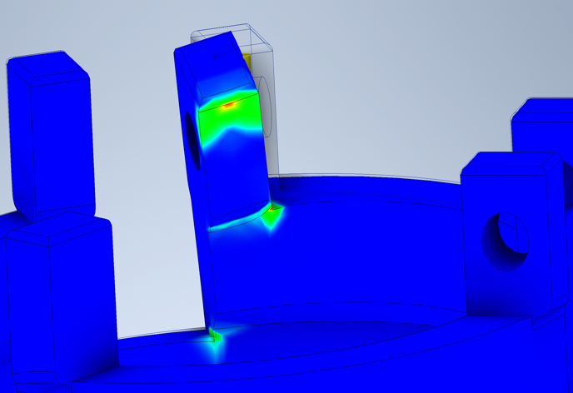
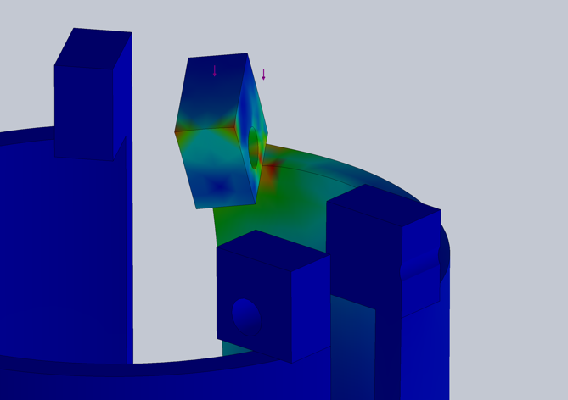
Figure 18 (Revised design stress analysis of pivots)
Figure 19 (Original design stress analysis of pivots)

Threaded connection
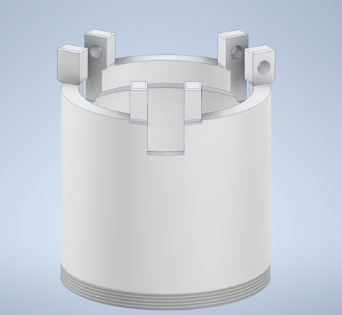
Another modification made to this part was the addition of a thread at the bottom on the external surface. This thread connects to the top of the piston housing. The thread replaces the bolt holes on the inside of the original casing. These holes were difficult to access, making maintenance difficult for employees. To remove this compartment with the new design requires a more accessible bolt to be removed on the drive plate and then the entire assembly can be twisted off the piston housing.
Figure 20 (Threaded connection added to bottom of griper housing)
Changes to joints
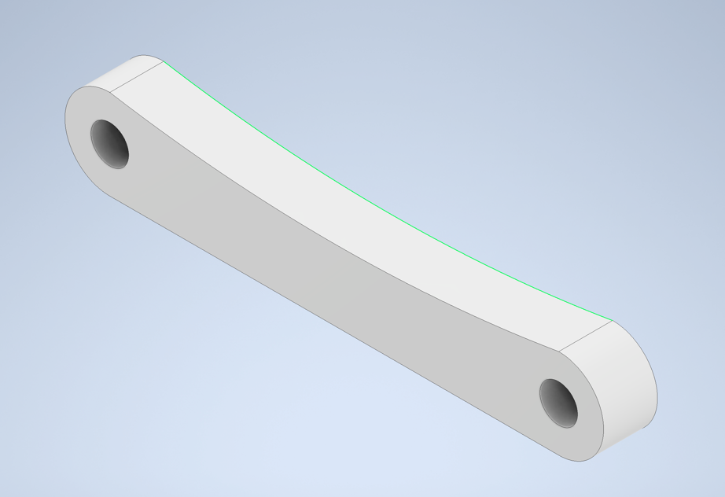
Due to the joints moving to the central position, the shape of the joint had to change to allow clearance during the full motion of the assembly. To create this clearance, I had cut a curve out of the side of the joint that faces the arm. I didn’t cut a curve out of the other side because I didn’t want to compromise the structural integrity of the part.
Figure 21 (New joint design)

New Gripers
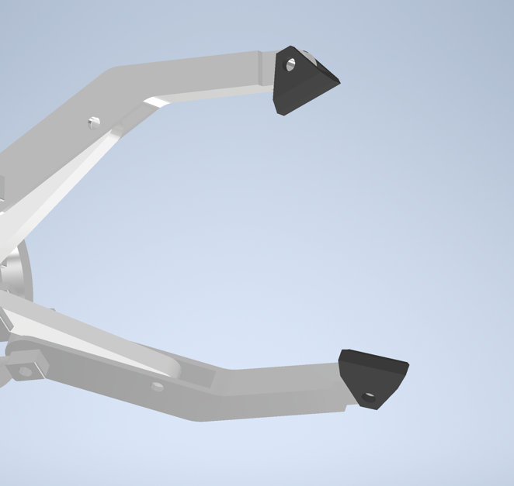
To improve the contact area between the component being lifted and the griper, and make the griper more versatile for more tasks. I added pivoting ABS gripers at the end of the arms. As the griper closes around the component the parts will pivot so that the large face of the griper flattens out over the component. This large surface area increases the grip that the assembly has on the component and stabilizes the part in the jaws so that it cannot spin and fall out. The material also helps due to its high coefficient of friction. This will stop the part from slipping out of the jaws.
Figure 22 (New ABS plastic griper)

Manufacturing process design
Some features that were incorporated into the design to aid maintenance and operation for workers such as; all pivots and bolt required for the construction and assembly of the griper are M4 bolts. This consistency makes maintenance easier for operators, as they do not need to change tools for each bolt. This reduces time for maintenance and operation therefor reducing downtime and saving the company money.
Threads were also added to all pivots and bolt holes so that there is no need for nuts to keep bolts in place. The thinking behind this change was there would be less hardware parts to lose or drop when working on the griper. Another benefit of this feature is that it makes the design sleeker. By having the bolt and nut protrude from the joint would require extra clearance between components to accommodate the nut and allow the spanner to fit around the nut. This makes designs bulkier than they need to be. Also, by having the threads built into the design it makes it easier for mechanics to locate the bolt thread into joints, therefore reducing the likelihood of crossthreding bolts.

Conclusion
To conclude I believe that the changes I have made will benefit the design, usability and manufacturability of the product. Changes that have been made to improve the manufacturability of this product include, Manufacturing methods such as 3D printing for parts that would otherwise have to be cast which would increase manufacturing costs and time due to the low order quantity of the product. Also, by smoothing corners and simplifying features so that CNC machining could be done quicker and easier. Additions of plastic gripers will increase the griper’s versatility as it will be able to grip a wider variety of parts and decrease the likelihood of damaging them by dropping or scratching. Improvements that have been made for product usability and maintainability include the inclusion of threaded holes so that nuts don’t have to be used, more accessible joints between parts and clearances that allow parts to fit properly and move freely.
Now that factors such as manufacturing have been taken into consideration whilst editing the design of the griper, I believe that it can be manufactured and installed with a higher likelihood of success.

Works Cited
Anon., 2019. [Online]
Available at: https://www.metal-am.com/introduction-to-metal-additive-manufacturing-and-3d-printing/
[Accessed 10 June 2020].
David L. Bourell, D. W. R. M. C. L., 2014. The Roadmap for Additive Manufacturing and Its Impact. 3D Printing and Additive Manufacturing, 1(1), pp. 1-92.
Goodwin, D., 2012. CIS009-2, Mechatronics Robotic Arms & Hands. Bedfordshire, Department of Computer Science and Technology University of Bedfordshire.
Health and Safety Executive, 2020. Controlling fume during plastics processing, s.l.: s.n.
S. Perepelkina, P. K. R. P. K. M., 2017. Investigation of Friction Coefficient of Various Polymers Used in Rapid Prototyping Technologies with Different Settings of 3D Printing. Tribology in Industry, 39(4), pp. 519-526.
S.C. Nwanya, J. U. a. O. A., 2017. Optimization of machine downtime in the plastic manufacturing. cogent engineering , 4(1), pp. 1-12.
Vieroslav Molnár, G. F. B. S. M. T. Z. H., 2014. Analysis of asymmetrical effect of tension forces in conveyor belt on the idler roll contact forces in the idler housing. Measurement, 52(1), pp. 22-32.
Z.J.Wang, M. Z. J. W., 2018. Microstructure, texture and mechanical properties of AA 1060 aluminum alloy processed by cryogenic accumulative roll bonding. Materials characterization, 139(1), pp. 269-278.

