
STUDENT NAME: RAMBABU ATLA
STUDENT ID: 2333687
COURSE: M.B.A. INTERNATIONAL BUSINESS
MODUEL: HUMAN CAPITAL MANAGEMENT
LECTURER: DR. GLADIUS DAVID KULOTHUNGAN
SESSION: GROUP 1 JUNE 2024 TERM.

Table of Contents:

1. INTRODUCTION: 3
2. SUPPLY OF NURSES 4
2.1. Internal Factors: 5
2.1.1. Demographic Challenges 5
2.1.2. Educational & Professional Development 5
2.1.3. Attrition factor 6
2.1.4. Regulations and Work Satisfaction 6
2.2. External Factors: 6
2.2.1. Worldwide Hiring 6
2.2.2. Competitive Advantage 6
2.2.3. Brexit impact on healthcare 7
2.3. Shortage of Nurses: 7
2.3.1. Demographics and Medical Services Model 7
2.3.2. Advancements in Technologies 8
2.4. Economic and social factors: 8
2.5. Planning & Workforce Management: 8
3. POSITION ANALYSIS OF DOCTORS IN NHS. 9
3.1. Workload and Stress. 9
3.2. Hiring process and turnover issues. 10
3.3. Working conditions and Job satisfaction. 10
3.4. Emotional and Physical Well-being. 10
3.5. Government & NHS Reforms. 11
3.6. The Opportunities. 11
4. CONCLUSION. 11
5. REFERENCES: 13

Table of Figures:

Figure 1: Growth and the Demand of Health Workers. 3
Figure 2: UK nurses on strike to demand better pay. 4
Figure 3 : Factors affecting the Healthcare sector. 4
Figure 4 : Framework of Continuous Professional Development. 5
Figure 5 : Number of health staff coming from other countries. 7
Figure 6 : Percentage of Overall Patient Satisfaction on NHS. 7
Figure 7 : Number of NHS staff resigned in the year 2022. 9

1. INTRODUCTION:
Human Resource Management seeks to align employee ambitions with the mission of the company, assuring both individuals and overall company objectives are met effectively (Sanghi, 2014). Human capital management is critical in tackling the country's demand for nurses by including planning for strategy, hiring, growth, and the continued employment of nursing workers. Evaluating the internal and external market for human resources in nursing necessitates a multidimensional technique considering diverse attributes.
Within a company, this entails investigating workforce characteristics, turnover rates, and the potential of nursing training institutions. Outside the organization, it requires recognizing the consequences of immigration laws, worldwide rivalry for healthcare experts, and the effects of issues like Brexit, which has mainly affected the healthcare sector in the UK, with all possibilities resulting in mostly adverse effects (Hervey et al., 2021). Brexit increased the NHS staffing crisis, as per new reports it is estimated that more than 51,000 nursing staff are needed (Matthews-king, 2018).
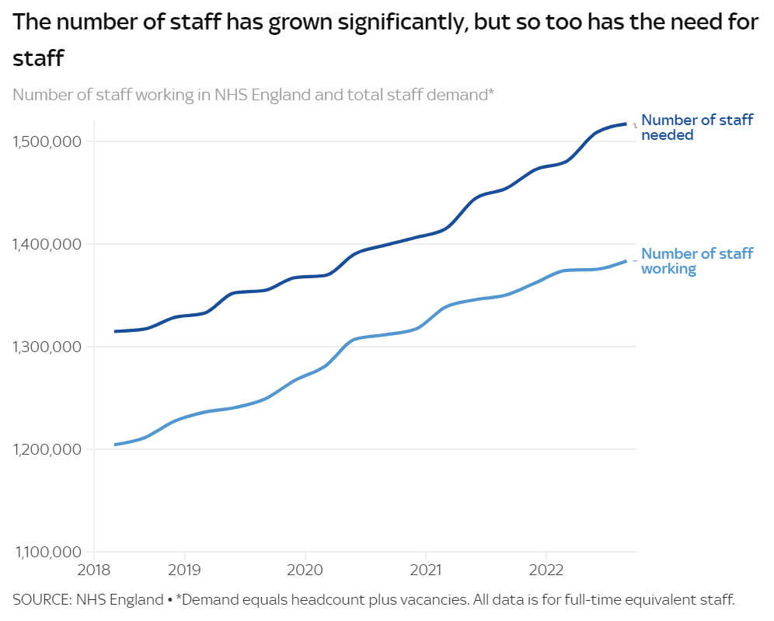
Figure 1: Growth and the Demand of Health Workers.
(Source: NHS England, 2022; Merwe, 2023)

Even though there is a huge improvement in recruiting new staff still there is a big gap in the demand for health workers, on top of that Nurses across the UK were on strike about the pay and the workload and it is the biggest strike in the history of NHS. (BBC News, 2022).


Figure 2: UK nurses on strike to demand better pay.
(Source: Oladeji, 2022).

2. SUPPLY OF NURSES
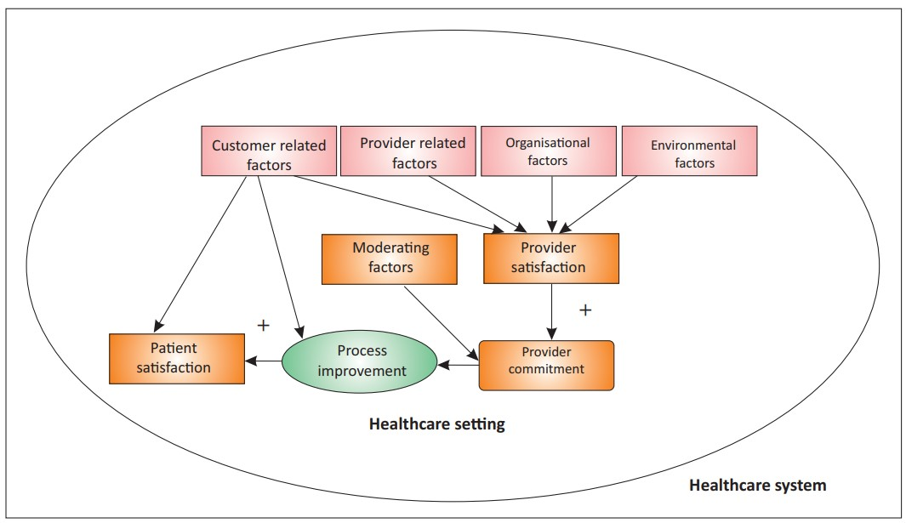
Human Capital Management (HRM) plays an important role across healthcare sectors and other service industries, mainly because customer problems are frequently caused by employees’ efficiency as well as expertise. The stress levels and the job satisfaction of the workforce affect the care and the satisfaction of the patient (Firth, 2001).
Figure 3 : Factors affecting the Healthcare sector.
(Source: Mosadeghrad, 2014)

Effective human resource management is critical to improving the level of service and overall patient satisfaction (Kabene et al., 2006). The NHS workforce statistics show that a growing number of in shortage of staff with more than 41,722 nursing roles unfilled in June (Matthews-king, 2018).

2.1. Internal Factors:

2.1.1. Demographic Challenges
The demographic transformation poses substantial challenges to healthcare systems (Osareme et al., 2024). A declining population frequently results in an increased percentage of retirees, reducing the pool of qualified nurses. In view of these developments, it would seem reasonable to expand the number of NHS beds available; nonetheless, since 2010, the NHS has lost 25,000 acute beds despite the UK's population growth and aging. Currently, there are 2.4 beds per 1,000 persons, compared to 4.8 in the EU. In order to align the UK with this average, an extra 155,000 beds would be needed (Nazarko, 2024).

2.1.2. Educational & Professional Development
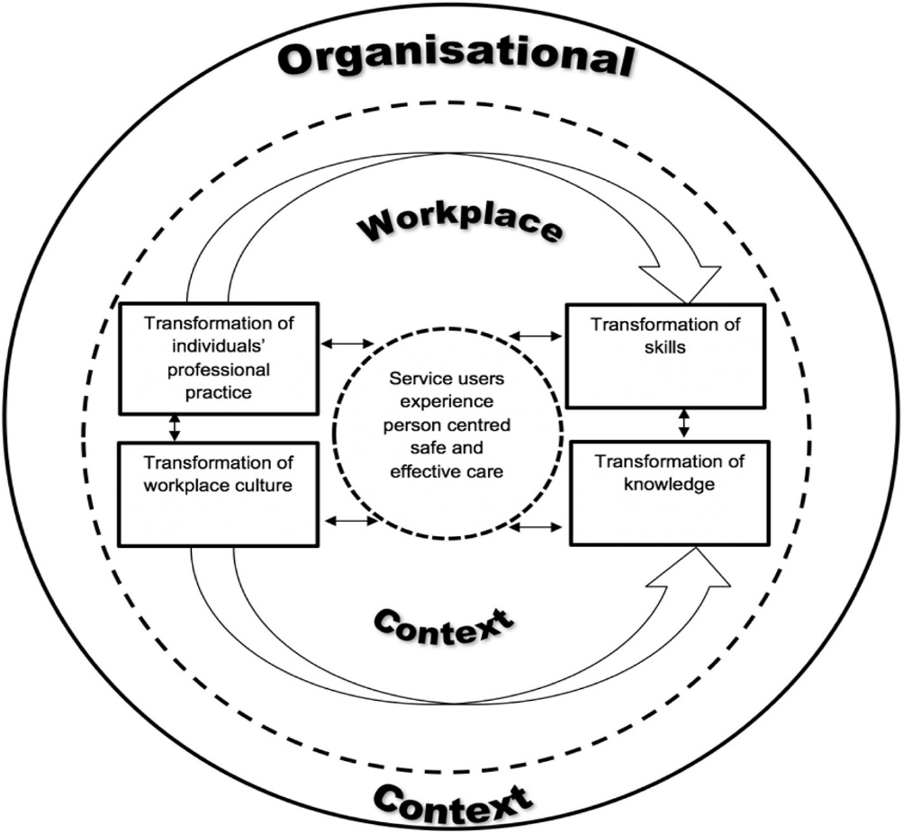
Continuous learning and growth improve diagnostic abilities, increase team effectiveness, lower expenses, and promote consistent patient treatment (Manley et al., 2018), But the availability of educational and professional development has a major effect on the availability of new nurses.
Figure 4 : Framework of Continuous Professional Development.
(Source: Manley et al., 2018)

NHS employees’ access to continuing professional development (CPD) has been consistently underfunded. With £84 million allocated to workforce development in 2018–19, the primary investment in continuing training and development for current employees currently accounts for one-third of the company's value from 2014–15. This is £2 billion less than what it would have been if 2006–07 levels had been maintained (Buchan et al., 2019).

2.1.3. Attrition factor
Attrition-driven scarcity of trained medical workers impedes the healthcare sector’s ability to retain high-quality staff (Paul and Fonceca, 2022). Employee attrition rates are essential in determining the continuing availability of nurses. Analysing predicted retirements allows you to determine how many nurses are likely to quit their positions. High levels of turnover may indicate concerns with job fulfilment, workplace conditions, or advancement in career prospects.

2.1.4. Regulations and Work Satisfaction
The policy making and legislation structure, as well as fulfilment with work and working conditions, have a significant impact on the availability and the continuing supply of competent nurses. Transitions in license requirements, subsidies from the government, immigrant rules, and workplace conditions all influence the staff of nursing. Patient satisfaction, loyalty, and the efficiency of health care sectors are influenced by the quality of services provided (Mosadeghrad, 2014). Burnout is a major problem, causing worries about the general well-being of healthcare personnel (Willard et al., 2019). The NHS is experiencing a rise in demand for nurses, which is fueling rising vacancy rates. But according to our updated analysis, more nurses are opting to leave the NHS, which is making the problem worse. In the last year, almost 34,000 nurses departed the National Health Service (NHS), a 25% rise from the year before. This is not a single or coincidental increase; rather, an evident pattern of people opting to leave is emerging when we examine the data over the course of subsequent quarters (Holmes, 2022).

2.2. External Factors:

2.2.1. Worldwide Hiring
By 2030, estimates show that there will be a substantial need for more than 80 million health workers globally, and as per WHO the current shortage is 18 million (Britnell, 2019).Because of globalization and the increased need for nurses in developed nations, registered nurses now have more options when it comes to where they work and whether to apply overseas. Large-scale international recruitment campaigns of advanced nations and networks of intermediary companies, including recruitment agencies, have aided nurses' desire to go abroad (Pressley et al., 2022).

2.2.2. Competitive Advantage
Substandard medical care can pose medico-legal risk factors affecting patients, employees, and organizations (Bezuidenhout, 2008). The country’s health system’s attractiveness is a major factor in drawing in foreign nurses. The complicated or onerous procedures may discourage hypothetical recruitment; thus, it is also vital that foreign nurses find it easy to have their professional credentials acknowledged in the UK.

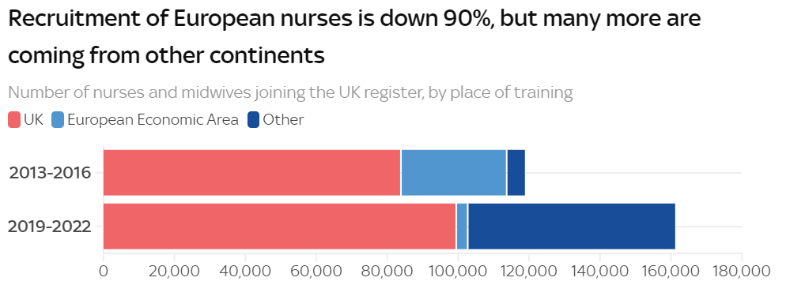
2.2.3. Brexit impact on healthcare
Brexit has exacerbated the shortages, especially in more difficult-to-fill areas like social care nursing, where 2700 positions have already been lost to other EU countries (Matthews-king, 2018). There has been a huge impact on the economy, politics, and the sustainability of NHS after Brexit (McIntosh, and West, 2017). Moreover, the Brexit and post-COVID-19 situations have increased the burden on health workers and exacerbated the preexisting conditions at work (Taylor et al., 2022). The foreign nursing supply, especially from Europe, has been greatly affected by Brexit (Merwe, 2023).

Figure 5 : Number of health staff coming from other countries.
(Source: Merwe, 2023)

According to research, Brexit has made the severe shortage of doctors in critical areas of care in the UK worse and has caused over 4,000 European doctors to decide not to work for the NHS. The revelation coincides with an increasing number of physicians quitting their jobs due to frustration with their excessively demanding work life in the health care. There are 10,582 open positions in the NHS in England alone, according to official statistics (Campbell, 2022) .

2.3. Shortage of Nurses:

2.3.1. Demographics and Medical Services Models
The health care service satisfaction among the patients has drastically decreased after the year 2012 (Morris et al., 2023). The increased need for qualified nurses is being influenced by an aging population and a rise in persistent illnesses that require greater medical treatments. Furthermore, the transition from healthcare provided in hospitals to communities and traditional healthcare contexts needs nurses with specialized capabilities, which influences the overall need for healthcare personnel. The shortage of finance or staffing has a substantial impact on the quality of care provided to patients (Bezuidenhout, 2008).
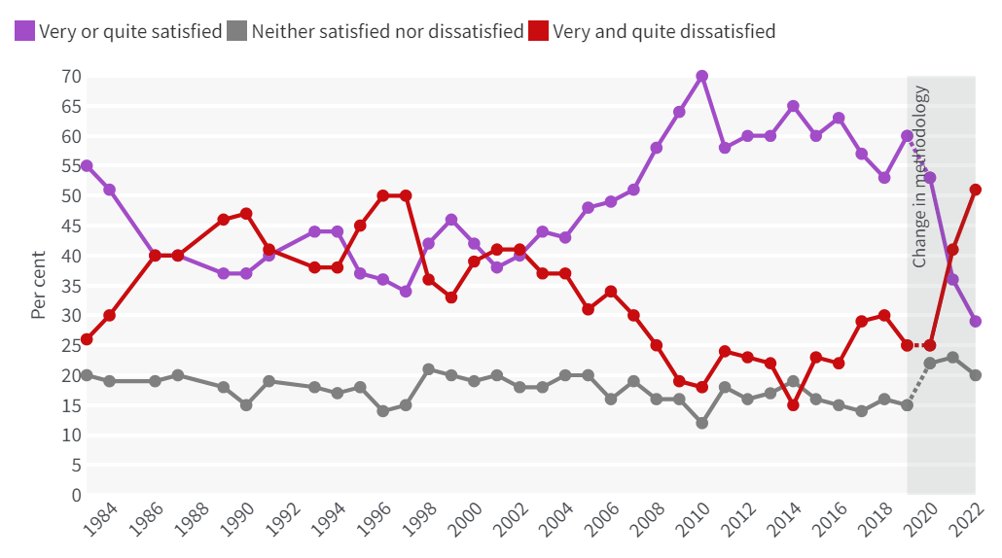
Figure 6 : Percentage of Overall Patient Satisfaction on NHS.
(Source: Morris et al., 2023)

2.3.2. Advancements in technologies
The healthcare sector has changed significantly, and further changes are likely to come in the near future (Ginter, Duncan, and Swayne, 2018). The practitioners with the exact same profession frequently have different qualifications, abilities, and responsibilities (Wood et al., 2020). The demand for certain abilities and careers in healthcare is evolving due to the development of telemedicine and technology for digital health. The requirement for nurse who are skilled in digital technologies will increase as novel developments are more thoroughly incorporated into the healthcare sector, which will impact the demand as well as supply of healthcare workers.

2.4. Economic and social factors:
Societal and financial parameters have an impact on the nursing workforce. Recessions in the economy can restrict employment, and the public's opinion of nursing impacts interest in the profession. Significant funding for labs and teaching spaces is needed to offset the loss of medical educators, particularly considering the additional obstacles caused by Brexit plus COVID-19 (Ginter, Duncan, and Swayne, 2018).

2.5. Planning & Workforce Management:
Strategic planning aids leaders in overcoming shifts and structuring their companies for success (Ginter, Duncan, and Swayne, 2018). A company’s overall performance is improved, and employee engagement is increased through effective HRM (Knies et al., 2024). The solution to workforce problems, and to improve delivery of services in healthcare required collaboration among different orginazations (Mosadeghrad, 2014), like government agencies, academic institutions, medical providers, and professional associations.
The healthcare sector operates in a dynamic and unpredictable environment, and management errors can have a major consequence (Selami, 2023. systematically estimating the demand of nurses depends on a thorough examination that has several aspects, especially learning resources, market circumstances, and larger macroeconomic trends. Healthcare institutions and policymakers must examine both present and possible future demands. To successfully tackle this shortage, solutions should focus on enhancing retention, advancing the educational pipeline, and transforming regulations to suit the rapidly evolving needs of healthcare.

3. POSITION ANALYSIS OF DOCTORS IN NHS.
The workforce issue that the NHS is facing might be catastrophic (Geary, McKee, and Petty-Saphon, 2024). The NHS has faced a wide range of challenges to improve patient care among the financial and workload problems (Ham, Berwick, and Dixon, 2016). A wide range of parameters have an effect on doctors’ position in the UK’s National health services, for instance, demographic trends, legislative changes, and fundamental problems inside the healthcare systems. Heavy Workload, mental well-being, hiring, retention, workplace conditions, and present reforms are the major issues (Hall et al., 2018). The main objective is to present a comprehensive understanding of present situation for NHS doctors, as well as its effects for future generations of medical services in the UK.

3.1. Workload and Stress.
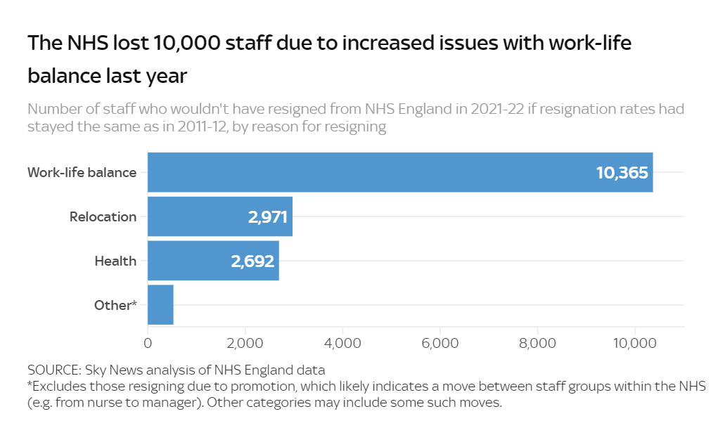
The amount of work increased, workplace conditions became worse, and work-related stress sharply increased in the health sector (Kingma, 2018). Doctors in the NHS are experiencing increased workloads as the population of Britain grows and ages. Increase demands for healthcare services has resulted in more those receiving treatment, imposing further strain on doctors and nurses. Chronic lack of staff exacerbates the organizational structure, forcing current staff members to take on extra responsibilities.
Figure 7 : Number of NHS staff resigned in the year 2022.
(Source: Sky News, 2022)
Doctors' stress and tiredness are exacerbated by lengthy hours at work, which frequently surpass professional boundaries (Faderani et al., 2020). The intricacy of patients, particularly in highly specialized fields, compounds the strain, demanding specialists to keep up to date on today's medical discoveries and medication.
Out of all work sectors in the nation, stress-related sick leave is more common in the National Health Service (NHS) of the United Kingdom than it is elsewhere. Addressing this is crucial since work-related stress affects staff members and the organization, which in turn affects patient care (Ravalier et al., 2020).

3.2. Hiring process and turnover issues.
Organizations should rethink how they train their staff and recruit and recognize their excellence in the service (Britnell, 2019). The NHS experiences significant issues in acquiring and keeping staff. Brexit has decreased the total amount of doctors and nurses from the European Union (EU), aggravating shortfalls and resulting in manpower shortfalls. Confusion over UK immigration regulations and difficult visa procedures has significantly hampered foreign specialists from entering the NHS. Moreover, increased wages and improved working circumstances elsewhere and in the private sector would contribute to making it harder to maintain highly qualified employees in the nation’s healthcare system.

3.3. Working conditions and Job satisfaction.
The NHS’s atmosphere of work remains an important issue of criticism. Doctors regularly cite poor amenities, limited finances, and outdated machinery as obstacles to delivering excellent care. It is very hard to recruit and keep skilled professionals due to inadequate salaries and extremely stressful workplace conditions (Clark, Stewart, and Darlene, 2006). The workload associated with administration also takes up an important part of their time, reducing the treatment of patients. Regardless of these challenges, numerous medical professionals remain dedicated to the NHS because they value public services and have a chance to serve in a sector that provides free care.

3.4. Emotional and Physical Well-being.
To maintain an intense focus on human resources, we must completely evaluate our approach to the issue (Britnell, 2019). Concerns about NHS doctors' emotional and physical well-being have become increasingly common. anxiousness, despair, and exhaustion are frequently brought on by the emotionally taxing nature of treating patients and the extremely stressful atmosphere. Help-seeking stigma, notably in the healthcare industry, often hinders doctors from receiving the care they require. In reaction, both the government and NHS have implemented initiatives like resilience training, support from fellow professionals’ groups, and individual counselling. The employee’s well-being is no longer a secondary factor (Sauerteig et al., 2019), so a culture change is required to put employee well-being first.
Junior doctors' morale has been steadily declining as a result of persistently rising inflation, record-high NHS waiting lists, and widespread staff shortages. Sixty percent of respondents said they had a low or extremely low morale when asked to characterize it. That means that despite having spent years of training for their career, the majority of our respondents arrive at work every day feeling depressed. Even more concerning, 49% of respondents said they had low or very low levels of bodily and mental wellness (The BMA Survey, 2024).

3.5. Government & NHS Reforms.
The political system and the actions of a nation have a big influence on medical facilities and public health (Selami, 2023). In order to speed up access to care, the government has pledged to reduce waiting lists for NHS services. This year's mission is centered around that promise, which will enable us to provide for patients, and we are providing for them. In addition to record spending for elective, urgent and emergency, and primary care, the government has made up to £14.1 billion accessible to health and social care over the next two years to support delivery (GOV UK, 2024).
Revision to regulations at work may result in substantial variations in the rates of retaining employees (Britnell, 2019). The British government initiated steps to improve the NHS's value to foreign medical professionals by streamlining the procedure for obtaining a visa while creating distinct career tracks. The policies to enhance the growth of NHS should promote a positive and encouraging atmosphere at work (Taylor et al., 2022).

3.6. The Opportunities.
Political actions, and changes in demographics will all impact the future growth of NHS doctors. The need for medical care will rise due to a growing elderly population, requiring a more robust and greater workforce. Increasing hiring and retaining talent with attractive remuneration, improved workplace conditions, and robust networks of support are the most important goals. Technological innovations have had a huge impact on the medical industry (Bezuidenhout, 2008). Maintaining investments in infrastructure and technological developments will be essential to keep up with technological advances in medicine.

4. CONCLUSION.
Well-being of staff has a substantial effect on productivity and the performance of any organization (Sauerteig et al., 2019). To make improvements to the healthcare industry and the well-being of medical professionals and nurses, the NHS must prioritize various pressing issues. Promoting educational resources and enhancing the shift from school to professional life can help to overcome shortages of employees.
By reducing the workload can boost the productivity, reduces the turnover and enhances the overall productivity (Sauerteig et al., 2019). Workload difficulties can be reduced by providing facilities and resources, enhancing workplace conditions by hiring additional staff, and utilizing technologies to streamline tasks related to administration. Supporting an active and engaged workplace also requires tackling psychological well-being as well as encouraging a balance between work and private life with profound support networks.

5. REFERENCES:
BBC News (2022) Nurses strike: Biggest nurses’ strike in NHS History announced, BBC News. Available at: https://www.bbc.co.uk/news/live/health-63753197 (Accessed: 08 August 2024).
Bezuidenhout, M.C., 2008. External factors influencing health services management. Introduction to Health Services Management, p.1
Buchan, J. et al. (2019) A critical moment: NHS Staffing Trends, retention and attrition. Available at: https://www.health.org.uk/sites/default/files/upload/publications /2019/A%20 Critical%20Moment_1.pdf.
Clark, P.F., Stewart, J.B. and Clark, D.A., 2006. The globalization of the labour market for health-care professionals. Int'l Lab. Rev., 145, p.37
Campbell, D. (2022) Brexit has worsened shortage of NHS doctors, analysis shows, The Guardian. Available at: https://www.theguardian.com/society/2022/nov/27/brexit-worsened-shortage-nhs-doctors-eu (Accessed: 19 August 2024).
Faderani, R., Monks, M., Peprah, D., Colori, A., Allen, L., Amphlett, A. and Edwards, M., 2020. Improving wellbeing among UK doctors redeployed during the COVID-19 pandemic. Future healthcare journal, 7(3), pp.e71-e76.
Firth-Cozens, J., 2001. Interventions to improve physicians’ well-being and patient care. Social science & medicine, 52(2), pp.215-222. Available at: https://doi.org/10.1016/S0277-9536(00)00221-5.
Geary, U., McKee, M. and Petty-Saphon, K., 2024. Mind the implementation gap: a systems analysis of the NHS Long Term Workforce Plan to increase the number of doctors trained in the UK raises many questions. British medical bulletin, 150(1), pp.1-10.
Ginter, P.M., Duncan, W.J. and Swayne, L.E., 2018. The strategic management of health care organizations. john wiley & sons. Available at: https://doi.org/10.1002/job.396.
GOV UK (2024) The government’s 2023 mandate to NHS England, GOV.UK. Available at: https://www.gov.uk/government/publications/nhs-mandate-2023/the-governments-2023-mandate-to-nhs-england (Accessed: 19 August 2024).
Hall, L.H., Johnson, J., Heyhoe, J., Watt, I., Anderson, K. and O’Connor, D.B., 2018. Strategies to improve general practitioner well-being: findings from a focus group study. Family practice, 35(4), pp.511-516.
Ham, C., Berwick, D. and Dixon, J., 2016. Improving quality in the English NHS. London: The King's Fund.
Hervey, T., Antova, I., Flear, M.L., McHale, J.V., Speakman, E. and Wood, M., 2021. Health “Brexternalities”: The Brexit effect on health and health care outside the United Kingdom. Journal of Health Politics, Policy and Law, 46(1), pp.177-203.
Holmes, J. (2022) The NHS nursing workforce – have the floodgates opened? | The King’s Fund. Available at: https://www.kingsfund.org.uk/insight-and-analysis/blogs/nhs-nursing-workforce (Accessed: 19 August 2024).
Kingma, M., 2018. Nurses on the move: Migration and the global health care economy. Cornell University Press.
Knies, E., Boselie, P., Gould-Williams, J. and Vandenabeele, W., 2024. Strategic human resource management and public sector performance: context matters. The international journal of human resource management, 35(14), pp.2432-2444. Available at: https://doi.org/10.1080/09585192.2017.1407088.
Manley, K., Martin, A., Jackson, C. and Wright, T., 2018. A realist synthesis of effective continuing professional development (CPD): A case study of healthcare practitioners' CPD. Nurse education today, 69, pp.134-141.
Merwe, B.V.D. (2023) NHS Crisis: Why are so many staff leaving the Health Service?, Sky News. Available at: https://news.sky.com/story/nhs-crisis-why-are-so-many-staff-leaving-the-health-service-12812473 (Accessed: 07 August 2024).
McIntosh, B. and West, S., 2017. Brexit: the consequences and impact on the health sector. British journal of healthcare management, 23(4), pp.154-157.
Morris, J. et al. (2023) Public satisfaction with the NHS and Social Care in 2022 | The King’s Fund. Available at: https://www.kingsfund.org.uk/insight-and-analysis/reports/public-satisfaction-nhs-and-social-care-2022.
Mosadeghrad, A.M., 2014. Factors affecting medical service quality. Iranian journal of public health, 43(2), p.210
Nazarko, L. (2024) ‘bed shortages and demographic pressures have led to an unsafe healthcare system’, Nursing Times. Available at: https://www.nursingtimes.net/opinion/bed-shortages-and-demographic-pressures-have-led-to-an-unsafe-healthcare-system/.
NHS England, (2023) NHS choices. Available at: https://www.england.nhs.uk/long-read/nhs-long-term-workforce-plan-2/ (Accessed: 07 August 2024).
Oladeji, M. (2022) UK nurses join wave of strike action to demand better pay, MojiDelano.Com. Available at: https://www.mojidelano.com/2022/12/uk-nurses-join-wave-of-strike-action-to-demand-better-pay/ (Accessed: 08 August 2024).
Osareme, J., Muonde, M., Maduka, C.P., Olorunsogo, T.O. and Omotayo, O., 2024. Demographic shifts and healthcare: A review of aging populations and systemic challenges. International Journal of Science and Research Archive, 11(1), pp.383-395. Available at: https://doi.org/10.30574/ijsra.2024.11.1.0067.
Kabene, S.M., Orchard, C., Howard, J.M., Soriano, M.A. and Leduc, R., 2006. The importance of human resources management in health care: a global context. Human resources for health, 4, pp.1-17
Paul, J.A.L. and Fonceca, C.M., 2022. Attrition and retention practices in healthcare sector: perception of staff nurses during Covid-19 pandemic. Journal of Academia and Industrial Research (JAIR), 11(1), pp.11-15.
Pressley, C. et al. (2022) Global migration and factors that support acculturation and retention of International Nurses: A Systematic Review, International Journal of Nursing Studies Advances. Available at: https://www.sciencedirect.com/science/article/ pii/ S2666142X22000224 (Accessed: 19 August 2024).
Ravalier, J.M., McVicar, A. and Boichat, C. (2020) ‘Work stress in NHS employees: A mixed-methods study’, International Journal of Environmental Research and Public Health, 17(18), p. 6464. doi:10.3390/ijerph17186464.
Sanghi, S., 2014. Human resource management. Vikas Publishing House.
Sauerteig, S.O., Wijesuriya, J., Tuck, M. and Barham-Brown, H., 2019. Doctors’ health and wellbeing: at the heart of the NHS’s mission or still a secondary consideration?. International Review of Psychiatry, 31(7-8), pp.548-554.
Selami, Y., 2023. THE IMPACT OF EXTERNAL ENVIRONMENT FACTORS ON HEALTH INSTITUTIONS. Journal of science. Lyon №, 43, p.13.
Taylor, C., Mattick, K., Carrieri, D., Cox, A. and Maben, J., 2022. ‘The WOW factors’: comparing workforce organization and well-being for doctors, nurses, midwives and paramedics in England. British medical bulletin, 141(1), pp.60-79.
The BMA Survey (2024) A perfect storm of poor conditions and pay, The British Medical Association is the trade union and professional body for doctors in the UK. Available at: https://www.bma.org.uk/news-and-opinion/a-perfect-storm-of-poor-conditions-and-pay (Accessed: 19 August 2024).
Willard-Grace, R., Knox, M., Huang, B., Hammer, H., Kivlahan, C. and Grumbach, K., 2019. Burnout and health care workforce turnover. The Annals of Family Medicine, 17(1), pp.36-41. Available at: https://doi.org/10.1370/afm.2338.
Wood, E., King, R., Robertson, S., Allmark, P., Senek, M., Tod, A. and Ryan, T., 2020. Advanced practice nurses' experiences and well‐being: Baseline demographics from a cohort study. Journal of Nursing Management, 28(4), pp.959-967.

