LCLM 4002- Digital Skills
Task 2- Informative Poster - How to insert a chart in Excel- By Michelle 251295
What is Excel? According to Microsoft, MS Excel is one of the 365 Apps that helps to manage numbers efficiently.(2025)
To use the 365 MS Excel, you should follow the following procedures.
Have a laptop with internet connection. See image below. Then Go to UWTSD HUB sign into moodle (see icon2) then to Office 365 (see icon 3)

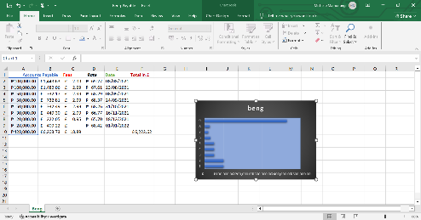
Open your Microsoft 365 then click on Excel. Click on create blank workbook. Then enter the data you want to enter (see image below).
Highlight the data that you want to put in a chart. It must be highlighted to insert a chart.
Ones it is highlighted, click INSERT then choose a chart, you can click on recommended chart for more options to choose from. I chose bar chart then click on OK. Chart will be inserted on your worksheet.
If you want to move the chart, just click on the sides of the chart then it will move. Or if you want to make it smaller or bigger, just click on the corners of the chart.
You can also change the Chart Title by highlighting it first, then click to enter the title that you prefer. There are also ways to change the colours and style of your chart by clicking the on the right side of your chart.
If you want more details, video is attached here. Just click the link below for more information.
how to insert a chart in excel

