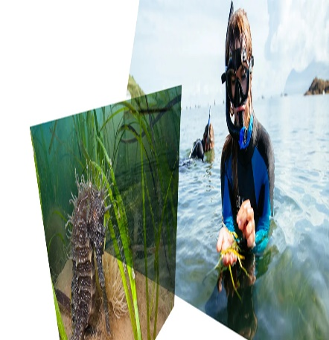
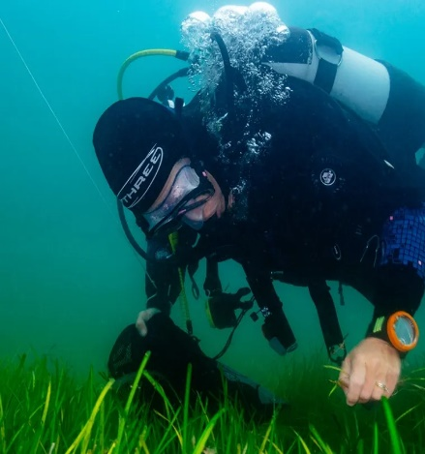
Effective communication:
Informative campaigns involve disseminating information through pamphlets, websites, and social media.
Narrative Techniques: Sharing success stories and personal experiences to motivate others.
Participatory communication entails encouraging community involvement through workshops and seminars.
Media channels:
Social Media: Maintain an active presence on Twitter, Facebook, and Instagram to engage a larger audience.
Local media includes features and articles in newspapers and periodicals that raise regional awareness.
Community Events: Organise meetings and restoration events to encourage direct participation.
Academic publications include study findings that are intended to inform policymakers and practitioners.
Cultural Sensitivity:
Create messages that respect and reflect local cultural norms and values.
Using culturally appropriate language and respecting local traditions to ensure resonance and genuine involvement.

Enhancing Marine Ecosystems: Supporting Seagrass Restoration in Swansea

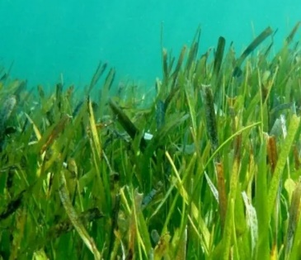
Project Partners:
Swansea University: Leading research and restoration efforts.
Project Seagrass: Providing expertise in seagrass conservation.
Sky Ocean Rescue: Offering logistical support and resources.
Carlsberg: Corporate sponsorship and funding.
WWF-UK: Environmental advocacy and policy support.
UK Government: Regulatory support and policy integration.
Project Scope:
Initial planting of 2-hectare seagrass meadows.
Expansion to North Wales, the Solent, and the Firth of Forth.
Focus on carbon sequestration, coastal protection, and marine biodiversity enhancement.

Theoretical Frameworks:
Social Cognitive Theory: Leveraging observational learning by showcasing successful restoration efforts and role model. Theory of Planned Behaviour: Influencing attitudes, social norms, and perceived control to encourage participation. Community-Based Social Marketing (CBSM): Identifying barriers and benefits to design targeted interventions that make restoration activities accessible and appealing.
Intervention Strategies:
Educational Programs: Conducting workshops and training sessions on restoration techniques and ecosystem benefits. Incentive Programs: Offering rewards such as certificates, public recognition, and tangible benefits for active participation. Enhancing Accessibility: Providing necessary tools, resources, and support to facilitate community involvement in restoration efforts. Creating Social Opportunities: Organizing events that bring community members together, fostering a supportive environment for behavioural change.
Seagrass meadows are important maritime ecosystems that help to sequester carbon, protect coastlines, and support biodiversity. In Swansea, UK, a devoted community is actively working to restore and conserve these critical habitats.
Purpose: This poster discusses the Swansea seagrass restoration project, including its goals, present actions, and the possible role I can play in assisting local community development.

Community Members:
Researchers and Scientists: Conducting studies on seagrass health and ecosystem benefits.
Conservationists: Implementing restoration activities and monitoring progress.
Local Government Bodies: Facilitating policy support and resource allocation.
NGOs and Corporate Partners: Providing funding, resources, and advocacy.
Local Residents: Participating in restoration activities and promoting community awareness.
Inclusivity Efforts:
Engaging diverse ethnicities, socioeconomic classes, ages, and cultural backgrounds.
Promoting participation from youth organizations, indigenous communities, and marginalized groups.

Barriers to Growth in Community Restoration
• Funding Limitations: Consistent and adequate financial support for large-scale projects.
• Resistance to Change: Overcoming scepticism or apathy among community members.
• Logistics Constraints: Managing site selection, planting logistics, and maintenance.
• Knowledge Gaps: Addressing gaps in scientific understanding and restoration methodologies.
• Conflict Resolution Strategies: Open Communication, Collaborative Decision-Making, and Mediation and Facilitation.

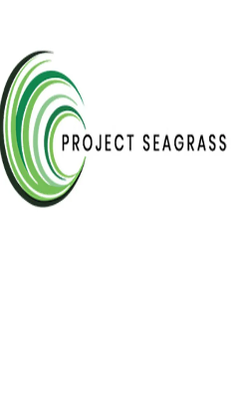
https://www.swansea.ac.uk/research/research-highlights/sustainable-futures-energy-environment/seagrass/
https://www.gov.uk/government/publications/community-development-handbook
https://iosh.com/collections/social-sustainability?msclkid=3e35470f8b6c1495b00b203b7e0955fe
https://www.swansea.ac.uk/press-office/news-events/
American University. (2018). About community-based learning and research. Retrieved from https://www.american.edu/ocl/volunteer/Community-Based-Learning-and-Research.cfm
Barr, S (2008) Environment and Society: Sustainability, Policy and the Citizen, Aldershot, Hamps: Ashgate Publishing.
McKenzie-Mohr, D. (2011). Fostering sustainable behavior: An introduction to community-based social marketing. New Society Publishers. Barton, H [Ed.] (2000) Sustainable Communities: The Potential for Eco-Neighbourhoods London: Earthscan
In conclusion, the seagrass restoration community in Swansea has made significant strides in addressing environmental challenges through collaboration, effective communication, and behavioural change initiatives. Despite facing funding and logistical challenges, their commitment to sustainable development positions them as leaders in marine ecosystem restoration. The insights gained from their success can inform similar global initiatives, emphasizing the importance of collaboration, adaptive management, and diverse funding sources. Ultimately, Swansea's experience highlights the effectiveness of collective action and interdisciplinary approaches in driving meaningful environmental change, offering valuable lessons for future conservation practices worldwide.
Seagrass Restoration Program Assessment Methods Surveys and questionnaires for feedback evaluation. Interviews and focus groups for qualitative insights. Participation metrics tracking engagement levels. Ecological monitoring of seagrass meadows. Biodiversity Success Indicators: Environmental Outcomes: Seagrass meadow health improvement, increased, carbon sequestration. Community Engagement: High participation rates, volunteer retention, active involvement. Feedback Mechanisms: Regular reporting and scientific findings. Feedback Loops: Incorporating community suggestions into projects.

