

Assessment Component 1

Case study - Written Report

Student name: Catia Araujo
Student ID:1916673

Module name: Children, Young People and Families
Module code: (BMHP5004_LON)
Lecturer name: Bianca Sanfilippo
Word count: 2000 Words

TABLE OF CONTENTS
Introduction: 3
Presentation of case study 4
The family 5
The risks factors of vulnerability 6
Case Study: The impact of these factors on the children Health and Wellbeing 7
Analysis 10
Conclusion………………………………………………………………………………………… 11

INTRODUCTION
This report analyses a case study is about troubled families. Furthermore, family facing adversities include family with specific issues such alcohol, drugs, domestic violence and involvement with abusive childhood.
However, in this situation involves two children. The children were not attending school regularly and their behaviour in school was disturbing. These factors make the child vulnerable and can affect mental health problems, behavioural problems such emotional, recognizing danger and irritate.
Vulnerability can be understood as capacity of an individual or group to dealing and resist from the impact of natural or risk (IFRC, 2021). Therefore, is associated in people do not socialize, felt insecure, in risk and other factors. In another words, may also be affect their social group, gender, ethnic, identify or others factors. In this context, there are two children that consider vulnerable in the environment exposed to potential dangerous.

PRESENTATION OF CASE STUDY
The case study is about a family with problems that involves domestic violence, alcohol, drugs and involvement criminal justice. In another words the single mum was an alcoholic, has two children and she had a less good past related to domestic violence. Recently the father of her children died from a drug overdose. Therefore, their children suffer these situations, often were not attending school.
However, the case study report will be identified factors to the risk of vulnerability of the child person and family. Furthermore, will be discuss, evaluate and analyse of the professional interventions of the health and social care agencies and could be involved as the policy and decision.
On the one hand, mum wanted to get her life back under control. The support worker made an assessment and planned a programme to help this family. The family worker decide to help her break alcohol dependency, start setting routines and boundaries for their children.
On the other hand, the family worker support at school that the children do not miss school. After the school has reported behaviour and happier children and also mum feels happy, can able to trust a worker enough and currently she is looking for the employment.

THE FAMILY
The family was located in Stockport, and it was composed by the father, mother and two children. Unfortunately, the children father died.
On the one hand, this family presents the risks factors of vulnerability. The family was facing adversities as the parents had mental health problems, they were involved domestic violence, alcohol, drugs and abusive childhood. This family were in a position of vulnerability, because mum came from an abusive childhood and severe domestic abuse.
On the other hand, their children are living in dangerous circumstances, and they are likely to be scared and in dangerous constantly to stay home. However, these children need to be built relationships up with social workers and to understand can stay at home or need to be care.
According to the NSPCC, many parents are helped, because their children are involved mental health problems and domestic abuse (NSPCC, 2021). Once this parent has mental health problems, often they have depression and many cases this limit them from being able to take care of your children.
Often this depression has been diagnosed such personality disorders and bipolar disorder. Is very worrying, because this depression can affect their family relationships and the impact their children.
Mostly of these adults contact for helping their children with family directly to agency. Overall, this agency is confidential, always able to give feedback and there are many concerns that include: domestic abuse to the police or children services. However, this situation was reported, and they are worried about the safety of the children involved. Furthermore, there are other concerns regarding that parents are trying to hide the children and are still missing schools.
The main impact in relationship with young children is domestic abuse. Some of these children need care of their parents, because need a protect and are vulnerable. (NSPCC,2021). Some of these young people has confusing relationship with parents, because got divorced or they won’t live together anymore and living with concern such a domestic abuse of their parents and them treat with violence.

THE RISKS FACTORS OF VULNERABILITY
Firstly, regarding of the case study I analysed the risks factors of vulnerability with children and family.
In this context, the child is considered vulnerable because, it presents many factors such they need education from school, social services care of these children, living in dangerous circumstances because your mother was an alcoholic and frequently was a meeting place for other drinkers. Moreover, this family has difficult situations which has a big impact in domestic abuse, drugs, alcohol and mental problems.
Secondly, safeguarding children and child protection is a organization to promote and protect children from abuse, maltreatment, prevent about of child development through your growth with safe and effective care. Through your growth, safeguarding should protect these children in schools from abuse and the risks involved in the family environment. As I can on the case study, the mother of these children was a alcoholic came from an abusive childhood and had previously relationship with domestic abuse. Therefore, these children did not go to school which hinders their performance and development in learning. Furthermore, safeguarding in education (NSPCC, 2021) to support the best safeguarding and child protection. It was developed across in UK schools and the evaluation is organised by five steps such a leadership, governance, policies, procedures, can be recognized and responding to child protection and supporting children, families and adults working with children.

CASE STUDY: THE IMPACT OF THESE FACTORS ON THE CHILDREN HEALTH AND WELLBEING
According to the impact of these factors on the children may experience domestic abuse directly such listening the abuse from another room and constantly seeing a parent’s injuries. Furthermore, there are high impact and can have a serious effect on the children behaviour, brain development and overall wellbeing.

Progress turning troubled families’ lives around in Stockport
The chart below shows progress made in Stockport as of March 2014.

Total number of families | 565
Number of families identified as at end of March 2014 | 565
Number of families worked with as at end of March 2014 | 565
Families turned around as at end of February 2014 | 319

According to this chart has a progress of March 2014. Furthermore, these family has a large negative impact of their children, particularly this mum was an alcoholic and recently the father of her children died from drug overdose.
Once these people use this substance are not aware that could affect the health and wellbeing of others, included children. These factors represent a problem the parents abuse alcohol and drug which has been growing 30% of children in the UK (The conversations, 2021). These families with this negative impact are considered problematic and they are not aware their children could be growing up to have problems breathing in the future and may cause stress and conflict at home.
On the other hand, may affect the mental health of everyone that involved in this environment at home, that including cognitive on the children who do not go to school, social positive relationship and economic.
In this case study, I analysed how is mother use of alcohol and drugs impacts on children. I believe that these children involved in this problematic environment of alcohol and drug use will have a big impact on their lives in the future.
However, this mum decides to get her life back under control with the family worker. Never had meeting place for drinkers, she feels happier, able to trust a worker to be honest about her problems and currently she is looking for new job.
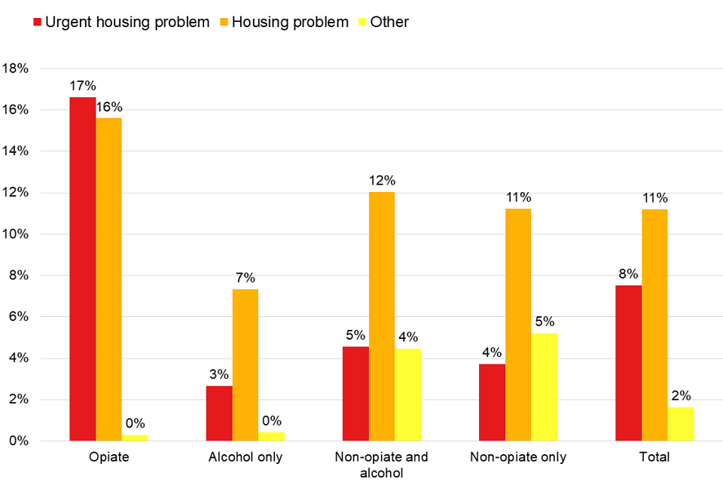
According to the NSPCC, there was a big increase in contacts about mental health problems, alcohol, drugs and domestic abuse. Through this analysis there were contacts to help these families from adults who were concerned about children (NSPCC, 2021), because parent’s use of alcohol or drugs and may affect and stable environment their children. Furthermore, these children are vulnerable in their parents to provide or report this situation.
On the other hand, the main problem in this family environment is the mental health issues. Many parents are diagnosed with mental health issues and could be include depression, anxiety disorders, schizophrenia, bipolar disorder and personality disorders.
However, depends on the circumstances or support they receive as for example financial problems can impact mental health and also the parents can not able work. There are some information to help these parents to recognize with mental health problems, need to support their children and could be included impact on family with mental issues: divorce or separation, unemployment, poor housing, discrimination, lack of social support, domestic abuse and substance misuse.
Additionally, about care for children, some parent’s and carers may need support to the routine of daily life (housework, mealtimes, bedtimes, taking children to school, taking children to medical and dental appointments. There are many children whose parents have mental health issues never had any negative effects, but if parents are not able to support for their family can have an impact on their children wellbeing that include concern about carer condition, caring for other family member and to hard make friends.
Many times, parents with mental health problems and their children are scared and upset this situation, because parents need to go frequently to the hospital.
In terms of substance use alcohol or drugs can cause problems such depression, physical illnesses or accidents. Firstly, alcohol is associate with criminal, domestic abuse and health problems, secondly drug is associate with social problems, mental and psychological illnesses, physical illnesses or legal problems. In England is most common to use cannabis, cocaine and ecstasy. The analysis of this case study reflects a family with economic and poor housing.
According to the Children Act 1989, in this case as seen the mother should be able recognize their responsibilities and should be respected, sustained and children need to develop their own identity (self-confidence and sense of self-worth). Regarding the UNCRC (United Nations Convention on the Rights of the Child) is a human right all children and young people aged 17.

ANALYSIS
In terms the intervention I identify many points of the children that involved risk factors with family at home. The intervention or assessment was based on the working together to safeguard children (2018) which is to promote wellbeing of children.
In another words, children should be live with their families in state care or independently after 18 years old. Children need to be supervised by familiar adults, understand what goes on in the family environment, respected (be treated well), protection against forms abuse and discrimination.

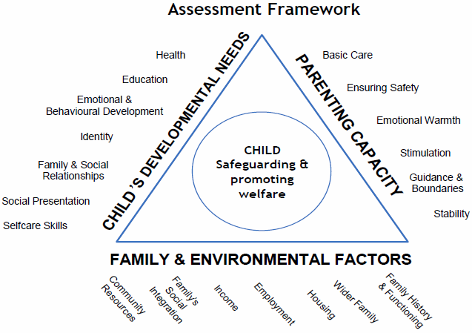
In this case study assessment was based on local organizations and agencies that support emergency problems and provide services to adults with children. Also, they are working with universal services
The practitioners involved special educational (Health and Care Plan), in the school is most important the environment have aware that some cases from mental health issues the children suffer from abuse.

CONCLUSION
In the end I will summarize the key points regarding this report. The report has been about a case study that include problematic family with specific issues such alcohol, drugs, domestic abuse and mental health issues.
In this case study report a single mother with two children and risks factors were identified. Once the risk factors were identified, I would agree the family worker to support these family, because they can be able to plan routines, habits for her and their children.
Lastly, the analysis has been based on local organizations or agency that support emergency problems and provide services to adults with children.

REFERENCES
- Cleaver(2011)Children living in families facing adversity NSPCC helplines report [online ]www.learning.nspcc.org.uk/media/1432/nspcc-families-facing-adversity-helplines-report.pdf (Accessed 20th August 2021)

- Safeguarding and child protection in schools [online] www.learning.nspcc.org.uk/safeguarding-child-protection (Accessed 20th August 2021)

- Safeguarding and child protection self-assessment tool [online] www.learning.nspcc.org.uk/safeguarding-self-assessment-tool (Accessed 20th August 2021)

- Troubled families: Stockport [online] www.gov.uk/government/case-studies/troubled-families-stockport (Accessed 20th August 2021)

- www.theconversation.com/parents- drug-alcohol- and- tobacco-use-negatively-impacts-all-areas-of-child-well-being-new- study-120365 (Accessed 21st August 2021)

- What is vulnerability? [ online] www.ifrc.org/en/what-we-do/disaster-management/about-disasters/what-is-a-disaster/what-is-vulnerability/ (Accessed 21st August 2021)

- Public Health England, National Statistics Adult substance misuse treatment statistics 2018 to 2019; report [online] www.gov.uk/government/statistics/substance-misuse-treatment-for-adults-statistics-2018-to-2019/adult-substance-misuse-treatment-statistics-2018-to-2019-report (Accessed 25th August 2021)

- The Children Act 1989 guidance and regulations; Volume 2 care planning, placement and case review [online] https://assets.publishing.service.gov.uk/government/uploads/system/uploads/attachment_data/file/1000549/The_Children_Act_1989_guidance_and_reg ( Accessed 25th August 2021)

- HM Government Working Together to Safeguard Children [online] https://assets.publishing.service.gov.uk/government/uploads/system/uploads/attachment_data/file/942454/Working_together_to_safeguard_childr ( accessed 25th August 2021)

- Working together www.workingtogetheronline.co.uk ( Accessed 25th August 2021)

