Student name: Anita Madan
Title: Light and Space
Word Count: 1185
Lecturer name: Julia Lockheart
Student number: 1702280

The theme of this exhibition is Light and Space and how it consumes the modern viewer into a new perceptive phenomenon. The exhibition will stimulate the sense of seeing for the modern viewer, as our busy lives are centred around eye and touch coordinated devices. I think we lose the sensational experience of the outside elements and day to day life events as our senses are not being used individually and the experienced is blurred. According to Berger (1972:8) seeing comes before words. We are constantly seeing what’s in front of us and its relation to us. With untainted focus by using our vision which is constantly active and subconsciously moving that allows us to constitute what is present. I will touch upon the artists that were involved in the movement ‘Light and Space’ in the 1960’s to 1970’s in California, Los Angeles. Their main purpose was to create a sensory phenomenon using light, space and scale to create a unique experience, each has produce work that is unique to the materials they used to form mentally dynamic spaces. Some of these artists include James Turrell, Doug Wheeler etc. and I want to look over Olafur Eliasson who has been inspired by this movement.

I felt the theme light and space was truthful to the way this movement can push into the personal boundaries of the viewers perception of the work. It creates a tonne of awe and speechless judgments as it almost feels completely unnatural but still the viewers senses are obliterated by the stunning work in front of their unsuspecting eyes. The main response to this exhibition for me is to have an encounter with the space that is not already in place with our own understanding of area. Just from experiencing an encounter that is non-recognisable to us, we start to process our thoughts. We think about the world around us and are challenged with these new ideas and perspectives. The audience start to see cracks in their ideology of space and question ‘what is real’ Plato (2012:104). This new way of seeing the world is a step forward into a new creative way of thinking and for this encounter to be embedded into our own history of encounters. I think O’Sullivan (2006:1) really picks up on being able to encounter new ideas, this way without pre-judgments of visuals of the work allows a truly genuine response which I feel is lost in today’s viewing of exhibitions and new encounters of objects and spaces etc. This is why this theme and movement is so intriguing to focus on, as all the artists main aim of work was to create a specific experience of light and sensory phenomena within us. The artists could see how having this involvement with the work accumulating the knowledge of the pieces can reinforce open-mindedness.

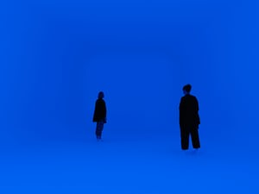
James Turrell, Untitled, 2017

The piece I have chosen to exhibit of James Turrell is from another exhibition called ‘Pharos’ and is a ‘cubed shaped room with changing lights’. The main fascination of Turrell’s work is the investigation into sensory deprivation stemming from his college studies in psychology (2013:97). Sensory deprivation is where the senses have not been stimulated such as sight and touch, for a long period of time. This piece has created a space with no visible edges, it changes the perception of the viewers overwhelming thought of where are they as for many can’t see the familiar shape that is embedded in their knowledge of space. So, for those audiences James Turrell’s work is exceptional as “an anti-dote to closed mindedness” says Wilson (2018). Turrell describes his work as it “is about your seeing, like wordless thought that comes from looking into fire” Turrell (2010). The more you surrender to the space the more fulfilling the experience will be.

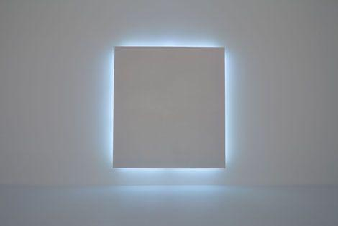
Doug Wheeler, Untitled, 1969

The next artist to enter my exhibition is Doug Wheeler who was a part of the same movement as Turrell and Irwin. His work addresses the same movement of creating a sensory experience with white on white lights to fabricate this idea without explosive colours. It also pushes the knowledge of having an experience without there being a physical object to glorify upon was what I believe was the dynamic change in the way in exhibitions were seen during the 60’s and 70’s. It also changes the approach art was to be perceived in the materials that were being used by this movement, by using materials such as glass neon lights, resin and cast acrylics. In Wheelers work these were some of the materials being used with cutting edge technology at the time.

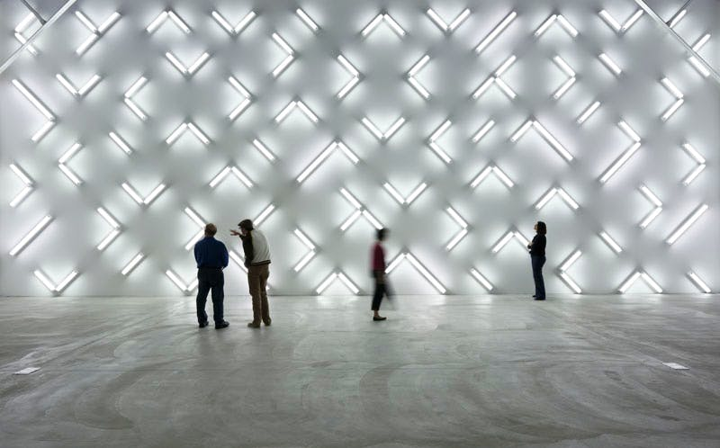
Robert Irwin, Light and Space,2007

Robert Irwin is an intricate component of the movement as he and Turrell were the forerunners of light and space installations. He began with experimental painting trying to capture the illusion of the changing perception of the size of objects. His innovative progression from acrylic paint to acrylic plastic shows his underlining fixture on the use of light as a perceptual phenomenon for the viewer Griffin (2015). His application of materials that come from every day use shows the brilliant language of creating new barriers that challenge the viewers perception of what’s in front of them and confront the goodness of their own sight. The piece of work I have chosen is called ‘Light and Space’ and is made up 115 fluorescent light fixtures, this was named after the movement he and other installation artists had cofounded. This particular piece was placed in an among and an elevator space that was part of a grand hall and it was there to relieve the darkness that loomed over this area. It is mesmerizing as it is layered over different levels and distances of surface that can create ideas in the viewers mind of a hidden message trying to decipher the piece but Irwin says in Newsfield (2012) it “bothers people” and what he really likes about it is that “its neutral” it doesn’t need stories to make it into something for the viewers to grasp, they just have to accept.

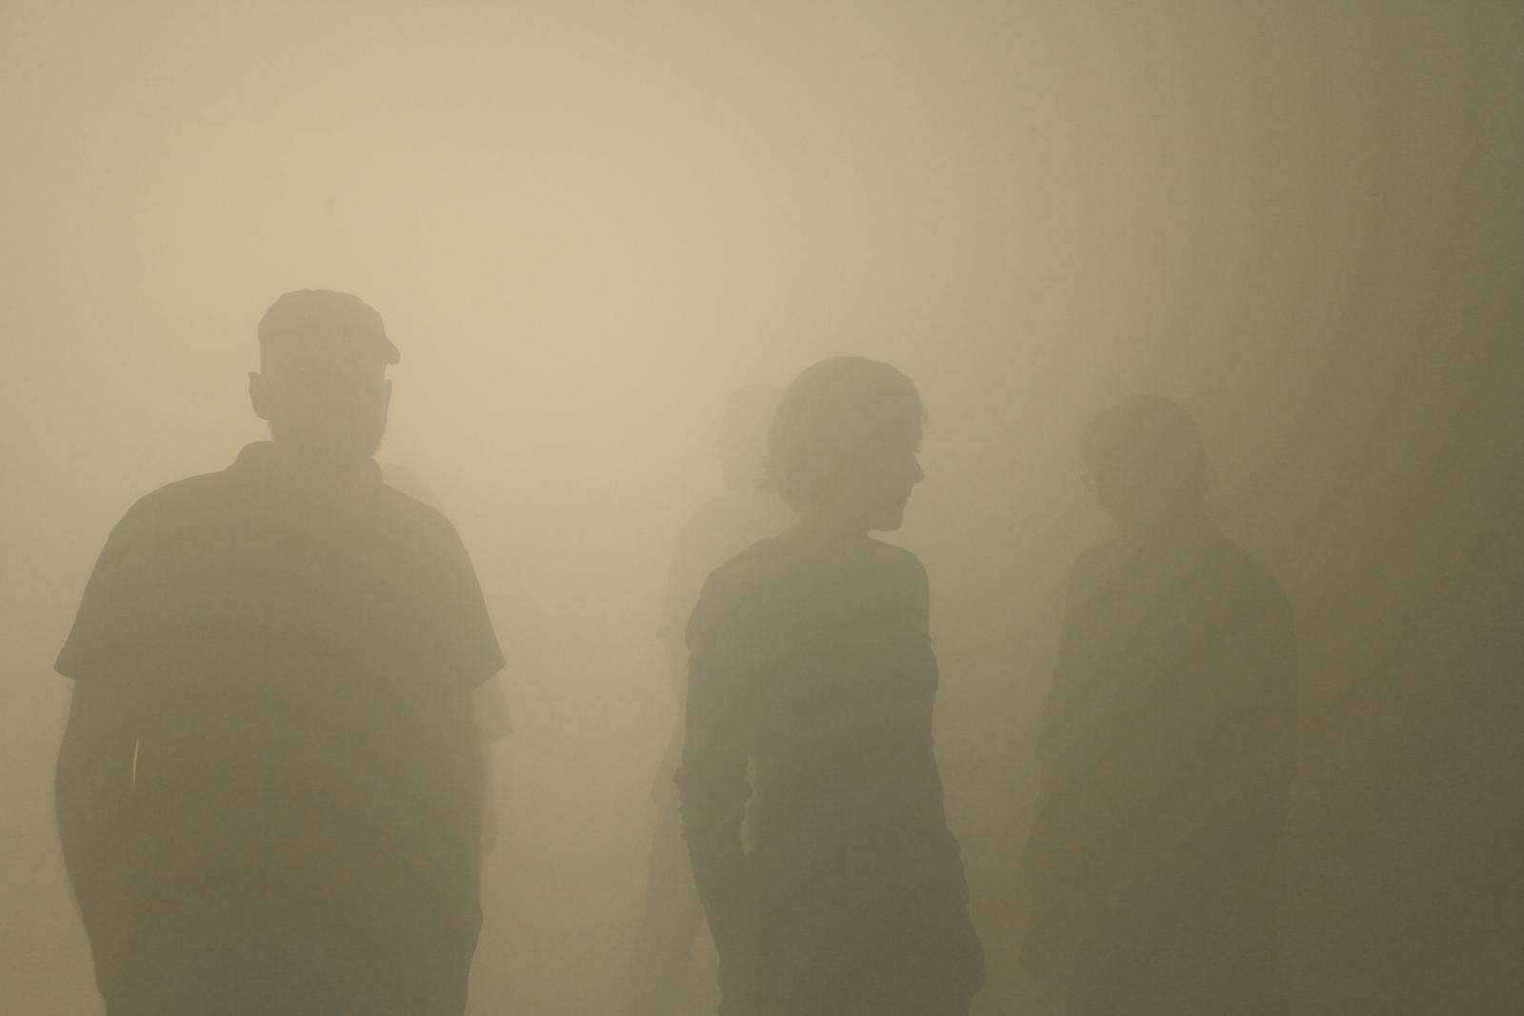
Olafur Eilasson, din blinde passager,2010
I chose Olafur Eliasson as he has a different take on light and space but by still being inspired by the light and space movement of the 60’s and 70’s. He has taken on the use of light and illusion to have the reaction of the audience to use their senses to orientate where they are and how to move through the interactive installation which is called ‘din blinde passager’ which is a long 90 metre tunnel filled densely with fog. On the ceiling, there are a number of fluorescent lights constantly changing colours in a grid form. This piece addresses how a space that is strange and not a safe territory people are familiar with can change the way we try to compile our surroundings. Everything is thrown into the pot, thus creates a disorientated and redefined reality. This is sometimes helpful to feel, as for some it can be a unique utopia that can free the senses and take a step back to feel what’s in front and around them as this is truly being involved within the rare sensory space.

Bibliography
Alican N.F (2012) Rethinking Plato: A Cartesian Quest for the Real Plato. Netherlands: Volume 251

Coghlan. N () Manipulating Light. Available at: http://www.aestheticamagazine.com/manipulating-light/ (Accessed: 7 May 2018)

Delaney.B (2018) Blinded by the light: James Turrell obliterates the senses in stunning new Mona wing. Available at: https://www.theguardian.com/artanddesign/2018/jan/26/blinded-by-the-light-james-turrell-obliterates-the-senses-in-stunning-new-mona-wing (Accessed: 7 May 2018)

Govan et al., 2013. James Turrell: a retrospective,
Griffin. J (2016) Light Years Ahead: Interview with Robert Irwin. Available at: https://www.apollo-magazine.com/apollo-artist-interview-with-robert-irwin/ (Accessed: 7 May 2018)
Keh. P (2016) Force of light: David Zwirner New York hosts Doug Wheeler's 'Encasements'. Available at: https://www.wallpaper.com/art/david-zwirner-hosts-five-of-doug-wheelers-encasements-in-new-york (Accessed: 7 May 2018)
Newfields (2012) a conversation with Robert Irwin on Light and Space III. Available at: https://www.youtube.com/watch?v=JCh8s10f2ws (Accessed: 7 May 2018)

O'Sullivan, S., 2006. Art encounters Deleuze and Guattari: thought beyond representation, Basingstoke: Palgrave Macmillan.
Turrell. J (2010) National Gallery of Australia. Available at: https://nga.gov.au/turrell/ (Accessed: 7 May 2018)

Reference list

Baudrillard, J., 1994. Simulacra and simulation, Ann Arbor: University of Michigan Press.

Wheeler.D.,2010. Primary Atmospheres., David Zwirmer: Steidl, Göttingen, Germany

