

ADAA7000 Coexistent Perspectives Module

Name: Faye Kennedy

Student number: 2103221

Word Count: 3,824

- Please keep all drafts of your essay. You may be asked to produce these as evidence of your writing process.

- Please ensure you follow the AI guidance on the assessment brief and note when and how you are able to use AI.

- Please also note the guidance regarding plagiarism on your assessment brief also refers to referencing the source of your material and that includes the use of AI.

For this assessment,
I confirm that I have not used Generative AI to support me in structuring my submission, including creating a draft argument structure, identifying parts and headings.
I confirm that I have not used Generative AI to create text for my submission.
I confirm that I have not used Generative AI for creative materials, such as images.

Student Signature: ___________

Chosen Question:
Question 5: Design Thinking and Material Practices: How are contemporary practices of design and making reshaping ideas of authorship, agency, and materiality in response to shifting technological, ecological, and philosophical paradigms? Consider how approaches such as speculative design, generative systems, or post-digital craft are contributing to these developments?

Essay Title/Question:
How are contemporary practices of art and design such as generative artificial intelligence (GenAI), reshaping ideas of authorship, agency, labour, and materiality in response to shifting technological and ethical paradigms? Consider how postmodern, post-human and feminist theories influence this.

Abstract:
This essay examines how contemporary art and design practices employing generative artificial intelligence are reshaping ideas of authorship, agency, labour, and materiality in response to shifting technological and ethical paradigms. As GenAI becomes increasingly embedded within creative production, it disrupts traditional understandings of creativity and challenges the notion of the singular human author. In response to these developments, this research investigates how GenAI operates not merely as a technical tool but as an active collaborator within artistic practice.

This discussion is divided into four case studies: The Portrait of Edmond de Belamy (Obvious, 2018), Unsupervised- Machine Hallucinations (Anadol, 2022), Assembly Lines (Chung, 2022) and How not be Seen: A Fucking Didactic Education (Steyerl, 2013). Each work integrates GenAI as a vital component of its material and conceptual process, demonstrating distinct approaches to human-machine collaboration. An exception is made for Steyerl, as although she does not specifically use GenAI, she critiques technological innovation within artistic practice. These case studies are analysed through postmodern theoretical frameworks, drawing on the writings of Lyotard, Barthes, and Benjamin to interrogate the destabilisation of authorship and the redistribution of creative agency. To develop a more well-rounded theoretical understanding of human-machine collaboration, feminist and post-human theories are also engaged, particularly through the analysis of Chung and Steyerl’s practice.

This essay argues that while GenAI challenges established definitions of creativity and authorship, it can be understood as a form of emergent materiality that reconfigures, rather than replaces, artistic labour. Ultimately, the research suggests that GenAI signals a significant shift within contemporary art and design practice, with lasting implications for how creative agency, value, and authorship may be understood in the future.
How are contemporary practices of art and design such as generative artificial intelligence (GenAI), reshaping ideas of authorship, agency, labour, and materiality in response to shifting technological and ethical paradigms? Consider how postmodern, post-human and feminist theories influence this.

This essay investigates how technological innovation, particularly generative artificial intelligence (GenAI) has become increasingly embedded within contemporary art and design practices. It examines both the opportunities and challenges generated by shifting technological and ethical paradigms, and considers how these developments reshape understandings of authorship, agency, labour, and materiality.In this context, a technological paradigm is understood as ‘a societal framework in which technological systems increasingly structure creative production, cognitive processes, and attribution of value’ (Dosi, 1982). Similarly, an ethical paradigm can be understood as ‘a set of prevailing moral frameworks that guide how responsibility, authorship and accountability are evaluated in response to emerging technologies’ (Floridi et al., 2018).

Building on this framework, the essay evaluates how GenAI disrupts and reshapes authorship and materiality within contemporary art practices. It considers GenAI not merely as a tool, but as a form of materiality that actively takes part in creative processes. To contextualise these developments, the discussion draws primarily upon postmodern theory, particularly concepts such as meta-narratives, flux, and Barthes’ Death of the Author, which directly address the destabilisation of singular authorship and fixed meaning. This theoretical grounding is informed by the work of Benjamin, Lyotard, and Barthes. Combined with an analysis of selected contemporary artworks, this approach shows how generative artificial intelligence reshapes authorship and materiality within contemporary creative practice.

While feminist and posthuman theoretical perspectives contribute significantly to ethical debates surrounding generative artificial intelligence—especially in relation to labour, relationality, and agency within contemporary art and design—this research engages with them selectively. This methodological choice reflects the essay’s analytical focus, as postmodern frameworks most directly address the core concerns of authorship and materiality raised by GenAI. The omission of additional theoretical frameworks, such as the simulacrum, the third aesthetic and the Sublime (Grabes, 2008), is therefore not a reflection of their irrelevance, but a considered decision shaped by analytical focus and word count constraints.

On one hand, it can be argued that GenAI has a positive impact on contemporary art and design, particularly through its capacity to enable practitioners to ‘cognitively offload’ (Gerlich, 2025). Cognitive offloading refers to the delegation of ‘data-driven’ and ‘analytical’ tasks to technological systems, allowing individuals to focus on more complex and creative activities (Gerlich, 2025. pp 5-6). In this context, GenAI functions as an assistive agent, rather than a replacement for human authorship, enabling a redistribution of labour within creative processes. This argument is further supported by postmodern theorist Yoshija Walter, who conceptualises AI as bridging the “Cerebral Divide” (Walter, 2025). While the division between left and right brained thinking is widely understood as metaphorical rather than neurologically fixed, it remains a useful framework for describing the perceived division between analytical and creative modes of thought. Thus, AI’s exceptional knowledge of algorithms and data-driven processes (Fry, 2018), positions it as a system capable of undertaking analytical labour. Consequently, as GenAI has been described as ‘automation with intelligence’ (Valishery, 2025), its integration into contemporary creative practice enables artists to ‘cognitively offload’ analytical tasks (Gerlich, 2025), allowing greater focus on creative practice.

On the contrary, while theorists such as Fry and Walter emphasise the analytical strengths of GenAI, they offer limited engagement with whether such systems can be considered creative. Generative artificial intelligence is defined as technology capable of producing text, images, and other outputs based on existing datasets (Valishery, 2025). This ability to generate images aligns more closely with the concept of imagination rather than creativity. The Oxford English Dictionary (Murray, 1884) defines imagination as ‘the faculty or action of forming new ideas, images, or concepts of external objects not present to the senses.’ Whereas creativity is defined as ‘the use of imagination or original ideas to create something’ (Murray, 1884). This distinction suggests that GenAI could be described as imaginative, but its creative stature is still contested due to its lack of originality, as it operates through learned patterns rather than independent invention.

Case Study 1: The Portrait of Edmond De Belamy (Obvious, 2018)

The Portrait of Edmond De Belamy (2018) by the collective Obvious provides a critical example of this tension between imagination, creativity, and authorship with GenAI (See Figure 1, below). The portrait was created using a generative adversarial network trained on 15,000 historical portrait paintings ranging from the fourteenth to the twentieth century (Dupre, 2018). The image depicts a fictional character generated through the collaboration of human and machine processes (Dupre, 2018). While the AI-generated portrait appears novel, its aesthetic qualities are taken from existing artistic conventions, reinforcing the argument that GenAI recombines visual forms rather than originates them.
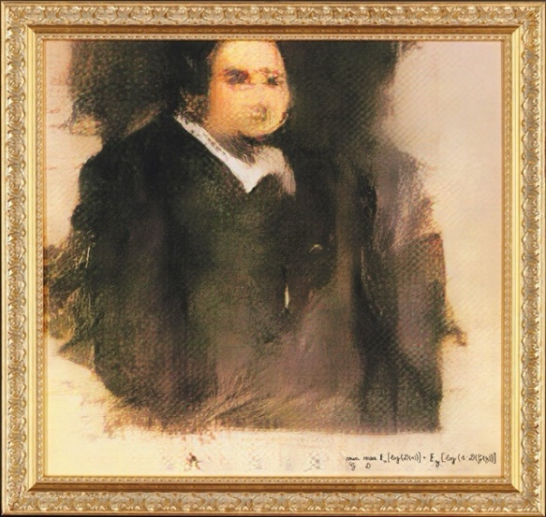

Figure 1. Portrait of Edmond De Belamy, from La Famille de Belamy. (Obvious 2018). [Generative Adversarial Network Print]

Furthermore, The Portrait of Edmond De Belamy (Obvious, 2018) represents a key moment for GenAI within contemporary art and design, particularly in relation to the technological paradigm previously discussed. The artwork was sold at auction for a staggering £337,000 (Jones, 2018), proving the high cultural and economic value attributed to AI-generated works within contemporary society. This auction sale further supports the argument that GenAI is not solely valued for its ‘data-driven processes’ (Fry, 2018) but is increasingly perceived as capable of imaginative output. As the creators stated, ‘portraits provided the best way to illustrate our point… which is that algorithms are able to emulate creativity.’ (Dupre, 2018). Therefore, this work suggests that GenAI can participate in imaginative processes associated with creativity, while also hinting at potential negative implications for creative practitioners.

One such implication, particularly in relation to materiality, is how GenAI blurs authorship. This can be seen in The Portrait of Edmond De Belamy (see Figure 1), which shows how GenAI functions as a form of new materialism within contemporary creative practice. Dupre (2018), describes this portrait as a ‘collaboration between two artists… one human, and one a machine.’ He further speculates that GenAI ‘could become a new medium for art in the foreseeable future.’ (Dupre, 2018). This further emphasises how GenAI is valued within contemporary society.

However, The Portrait of Edmond De Belamy (See Figure 1), raises critical questions of authorship. As Dupre explains, the artwork is a result of both human and machine contribution. Therefore, some may argue that a human artist authored the work, as a person selected and inputted the training that shaped the systems output. Conversely, it could be argued that GenAI generated the portrait, as the human role was limited to instruction, while the AI autonomously produced the image. As a result, this work resists singular authorship and instead exists as a collaborative piece. Notably, no individual artist is credited, but rather the work is described as a ‘Generative Adversarial Network print, on canvas, 2018’ (Dupre, 2018). Dupre further explains that a Generative Adversarial Network or GAN consists of ‘the Generator (AI) on one side, and the Discriminator (human) on the other side’ (Dupre, 2018). The discriminator provided the system with numerous examples of portraits, shaping the AI’s output and resulting in the final image (See Figure 1). Therefore, this case study demonstrates how GenAI reshapes authorship and materiality within contemporary art and design by destabilising singular authorship through a postmodern framework, while responding to shifting technological paradigms.

In addition, post-modernist theorists express an ‘incredulity towards metanarratives’ (Lyotard, 1979. P xxiv). A meta-narrative refers to the dismissal of a singular ‘grand narrative,’ allowing space for multiple ‘small narratives’ or ‘differing viewpoints’ to form (Lyotard, 1979). When applied to generative artificial intelligence, this framework suggests that GenAI cannot be understood as inherently beneficial or harmful to contemporary creative practice, but rather as a technology whose impact is contingent upon individual context and use. For some practitioners, GenAI enables what has been described as ‘creative explosions,’ ‘facilitating new forms of creative expression and experimentation’ (Palfrey and Gasser, 2008, p.112). On the contrary, some argue that AI threatens creative labour by ‘raising concerns regarding job security and professional autonomy’ (Schofield and Sinclair, 2025). These contradictory perspectives, reflect the postmodern condition of contemporary society, in which no singular narrative can adequately define AI’s role within contemporary art and design practices.

Case Study 2: Unsupervised- Machine Hallucinations (Anadol, 2022)

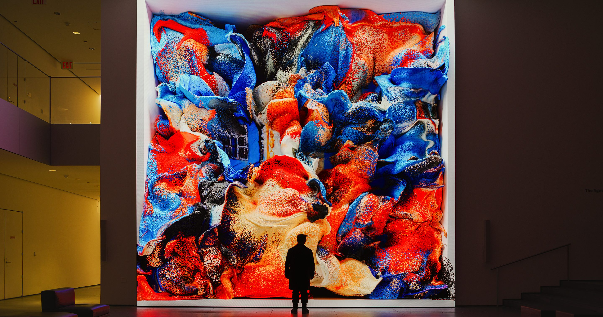
Figure 2. Unsupervised-Machine Hallucinations (Anadol, 2022), The Museum of Modern Art [Digital AI Installation].

Expanding upon this discussion, contemporary visual artist, Refik Anadol exemplifies this postmodern plurality through his use of generative artificial intelligence as a collaborator. This aligns with what Palfrey and Gasser describe as ‘creative explosions’ enabled by digital innovations (2008, p.112). In his work Unsupervised (2022) (See Figure 2, above), Anadol queries what a machine might ‘dream’ after being exposed to the Museum of Modern Art’s collection (Barham, 2025). The artwork is a continuously evolving, software- based installation that uses GenAI to interpret, transform, and generate abstract visual forms derived from over ‘200 years of artistic data within MoMA’s archive’ (Anadol, 2022). During an interview, Anadol imagines ‘a future where a symbiotic relationship with machines will give us new insights, knowledge, and the power to not only challenge but change existing systems’ (Anadol, 2022). This is further supported by the postmodern idea of ‘flux’ where they believe that reality is ‘fragmented, pluralistic and unstable’ (Barthes, 1977). Both statements reflect an emerging technological paradigm within contemporary society, where GenAI’s role is not fixed or neutral, but increasingly evolving within contemporary art practices.

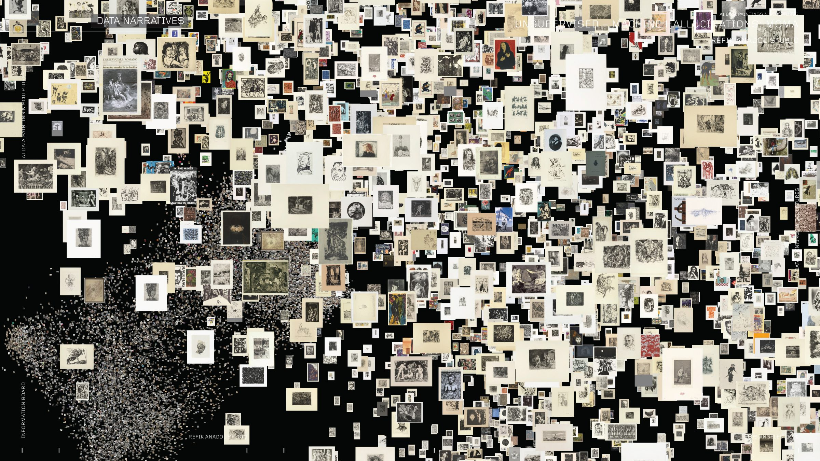
Furthermore, Anadol’s work shows that GenAI is being valued not merely as a tool, but as an active form of new materialism, taking on the role as a collaborator within contemporary art practices. He explicitly names ‘generative AI algorithms, software, hardware, and code’ as a form of materiality within his practice (Anadol, 2022). This reinforces the view of AI as a ‘new medium for art’ (Dupre, 2018). Similarly to The Portrait of Edmond de Belamy (Obvious, 2018), Anadol’s Unsupervised (2022) utilises a generative adversarial network or GAN as a form of materialism to extensively analyse datasets to generate outputs. While The Portrait of Edmond De Belamy analysed approximately 15,000 historical portraits (Dupre, 2018), Anadol’s work draws upon ‘38,000 high-resolution images derived from 138,151 artworks within MoMA’s collection’ (Barham, 2025). Although Anadol employs a more advanced GAN, ‘StyleGAN2-ADA’ (Anadol, 2022) both practitioners demonstrate how generative systems produce visual forms through the recognition and recombination of patterns across large datasets. This supports the view that GenAI appears imaginative through its capacity to mimic and recombine creative processes (Williams, 2025). However, this blurring of creative agency complicates questions of authorship, responsibility, and ownership, raising ethical concerns around creative labour and value within contemporary art and design practices.

Figure 3. Unsupervised-Machine Hallucinations (Anadol, 2022), initial data-sifting stage, The Museum of Modern Art [Digital AI Installation].

Notably, the shared use of GANs in these creative works highlights ethical tensions arising from technological innovation. While GANs are not inherently unethical, their dependence on vast quantities of pre-existing visual data complicates issues of authorship, consent, and creative labour (Grant, 2023). Figure 3 (see above) provides a visual analogy, depicting Anadol’s work at an early stage of data extraction and training. Both case studies raise questions about who receives credit and who remains invisible within AI-driven systems. Although, both case studies can be identified as a form of homage to art history, their use of historical pieces obscure the contributions of the original artists, while creative recognition and economic value are attributed to contemporary practitioners and institutions such as Anadol, Dupre, and Obvious. Consequently, these examples show how generative artificial intelligence reshapes contemporary ideas of authorship and materiality, while foregrounding ethical tensions around labour, ownership, and value within emerging technological and ethical paradigms.

This redistribution of creative agency aligns with postmodern critiques of authorship, particularly Barthes’ concept of The Death of the Author, in which meaning is no longer fixed by a single creator but emerges through systems, processes, and interpretation (Seymor, 1988). Generative artificial intelligence operates within this framework by challenging singular notions of creative authority and reframing authorship as a collaborative process between human input, algorithmic systems, and cultural data. This collaborative potential is exemplified by Geoffrey Hinton, who is often referred to as the ‘Godfather of AI’ (McDonough, 2025). He argues that ‘the combination of authorship will lead to the most extraordinarily successful creative outcomes’ (Alexander Street, 2024). His perspective emphasises that artificial intelligence remains dependent on human intelligence and we must operate collaboratively rather than independently to achieve successful outcomes (Teves, 2026). In combination, the case studies and these perspectives demonstrate how generative artificial intelligence reshapes authorship and materiality within contemporary art and design by rejecting singular creative authority. Thus, foregrounding ethical tensions, and operating within a postmodern technological paradigm.

Case Study 3: Assembly Lines (Chung, 2022)
While Anadol’s work exemplifies postmodern plurality and the destabilisation of singular authorship, postmodern theory offers limited guidance on how ethical responsibility should be negotiated within human–machine collaborations. To address this limitation, post human and feminist perspectives provide a more robust framework, as both foreground relationality, agency, and the recognition of creative labour within technological systems such as GenAI. Feminist theory offers a ‘socially concerned alternative’ to the ‘increased mechanical evolution’ currently afoot in contemporary creative practices (Brodsky, 2021). Within feminist discourse, relationality refers to the critical examination of how artificial intelligence systems interact with, influence, and reshape human relationships within contemporary art and design practices (Browne et al., 2024). Drage et al. (2024, p. 9) further emphasise ethical dilemmas surrounding generative systems, particularly in relation to authorship and responsibility, raising concerns about technology being used in ways creators do not consent to and questioning who should be held accountable when systems are deployed beyond their intended use. These ethical concerns become especially significant when considering AI practices that rely on large-scale, un-consented datasets such as Anadol and Dupre’s works.

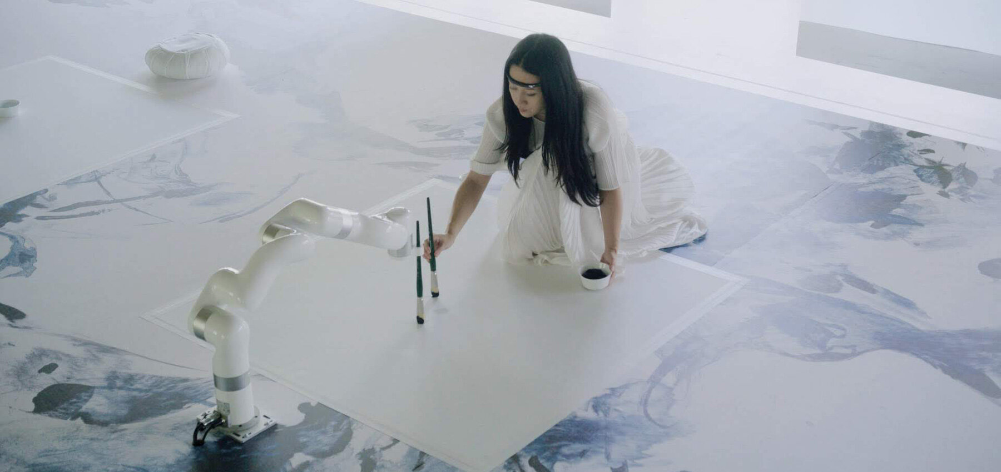
Sougwen Chung’s practice directly responds to these ethical concerns by fundamentally rethinking how AI is positioned within the creative process. In contrast to the GAN-based approaches employed in the earlier case studies, Chung gives artificial intelligence a physical and embodied presence. She positions it as both a collaborator and a form of emergent materiality (see Figure 4). Rather than relying on vast historical datasets, Chung works with her own generative system, D.O.U.G. (Drawing Operations Unit Generation), which is trained exclusively on her personal drawing practice (Chung, 2025). By deliberately limiting the dataset to her own creative labour, Chung directly addresses ethical concerns surrounding consent, ethics and authorship that remain unresolved within many postmodern approaches to AI-generated art. In doing so, her practice aligns with Floridi et al.’s (2018) ethical paradigm, which emphasises responsibility, accountability, and transparency in the evaluation of emerging technologies.

Figure 4. Assembly Lines (Chung, 2022), The Museum of Modern Art [Photograph of Chung’s creative process, taken by Peter Butterworth].
This emphasis on process over product functions as a critical intervention into contemporary debates surrounding authorship and creative labour. Whereas The Portrait of Edmond de Belamy (Obvious, 2018) and Unsupervised – Machine Hallucinations (Anadol, 2022) rely on historical datasets that obscure individual creative contributions, Chung’s methodology renders the conditions of production explicit and overt. Her work is frequently described as performative rather than outcome-driven, with a focus on the act of drawing as a shared event between human and machine (Chung, 2020). This approach reflects a feminist commitment to visibility and ethical responsibility. By equipping D.O.U.G. with a robotic arm and openly acknowledging its role within the drawing process, Chung ensures that creative agency is neither abstracted nor hidden.

Chung’s practice also aligns closely with post human theory, which rejects the notion of the autonomous human creator and instead understands creativity as distributed across networks of bodies, technologies, and materials (Braidotti, 2013). Through the integration of biosensors that translate the artist’s brainwaves into robotic gestures (Chung, 2020), the boundary between human intention and machine execution becomes increasingly porous. Rather than positioning AI as an external tool, Chung demonstrates how creative agency can emerge relationally through sustained collaboration between human and machine. As Hofman (2024) argues, engaging with generative technologies in a proactive and principled manner enables designers and artists to actively shape ethical futures for AI, rather than passively adapting to technological change. Through this integration of feminist and post human principles, Assembly Lines (2022) confirms that generative technologies can reshape authorship, labour, and materiality without reproducing exploitative or extractive models of creativity. Chung’s work thus offers a compelling ethical alternative within contemporary art and design practice, showing that responsibility, consent, and visibility can be embedded within human–machine collaboration rather than treated as secondary concerns.

Case Study 4: How not to be seen: A Fucking Didactic Educational .MOV File (Steyerl, 2013)

On the contrary, Hito Steyerl’s How Not to Be Seen: A Fucking Didactic Educational .MOV File (2013) offers a critical counter-position by interrogating the power structures underpinning digital and algorithmic systems. Although Steyerl does not employ GenAI as a creative tool, her work remains highly relevant to contemporary debates surrounding algorithmic agency, visibility, labour, and ethical responsibility within data-driven cultures. Presented as a satirical instructional video, How Not to Be Seen (Steyerl, 2013) (See Figure 5) explores strategies for becoming invisible in an era defined by surveillance technologies, computational vision, and high-resolution imaging. Through humour, fragmentation, and irony, Steyerl critiques the ways individuals are rendered visible, measurable, and exploitable within technological systems. This approach aligns strongly with postmodern theory, particularly Lyotard’s concept of incredulity toward meta-narratives (1979), as the work resists any singular, authoritative narrative about technological progress. Instead, meaning emerges through a series of contradictory and destabilised instructions, reflecting the fragmented and unstable condition of digital technologies within contemporary art and design.

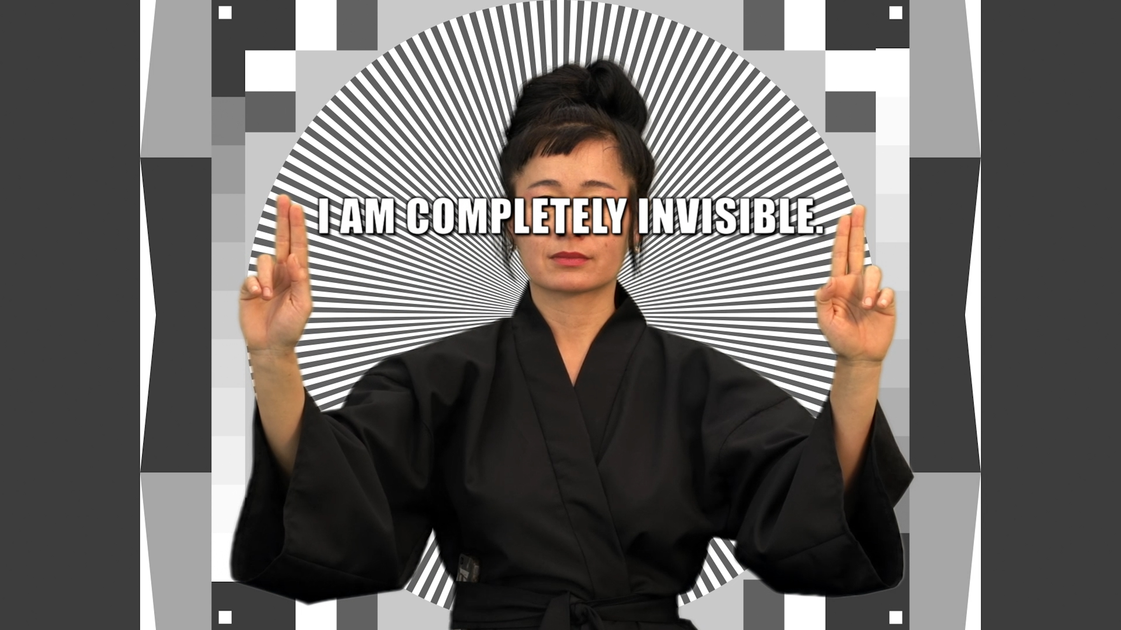
Figure 5. How not to be seen: A Fucking Didactic Educational .MOV File (Steyerl, 2013), Minnesota Street Project [Youtube short film].

When read in relation to contemporary GenAI practices, Steyerl’s work brings ethical questions into focus that are frequently overlooked within optimistic narratives of technological innovation. While artists such as Obvious and Anadol operate within systems that extract and recombine vast datasets to generate new visual forms, How Not to Be Seen (Steyerl, 2013) draws attention to those who remain unseen, uncredited, or rendered invisible by these same systems. From a feminist perspective, this invisibility is not neutral. Browne et al. (2024) argue that algorithmic systems frequently obscure the labour, consent, and agency of individuals whose data underpins computational creativity. Steyerl’s work anticipates these critiques by exposing how visibility itself becomes a site of power, control, and exploitation within digital infrastructures.

Moreover, Steyerl’s refusal to engage directly with AI as a creative collaborator functions as an ethical gesture rather than a technological limitation. In contrast to Chung’s ethical redesign of human–machine collaboration, Steyerl adopts a strategy of resistance, questioning whether participation in algorithmic authorship is truly desirable (Sparks, 2015).This refusal aligns with feminist critiques of technological determinism, which challenge the assumption that innovation must involve adoption rather than critique (Brodsky, 2021). By withholding participation, Steyerl asserts artistic agency through critical distance, demonstrating that authorship can also be exercised through negation and refusal.

From a post human perspective, How Not to Be Seen (Steyerl, 2013) complicates notions of distributed agency by revealing how technological systems do not merely collaborate with humans, but actively structure visibility, value, and exclusion. While post human theory often celebrates the decentring of the human subject (Braidotti, 2013), Steyerl’s work cautions that such decentralisation can obscure accountability when power is diffused across systems. In this sense, her work exposes a limitation within postmodern and post human frameworks. Whilst plurality and distributed agency destabilise singular authorship, they do not inherently resolve ethical responsibility.

In relation to labour, Steyerl’s critique resonates strongly with concerns surrounding creative extraction within GenAI systems. As shown in earlier case studies, AI-generated artworks often rely on historical and contemporary datasets without explicit consent or attribution. Steyerl’s emphasis on invisibility highlights how creative labour becomes abstracted and anonymised within algorithmic processes, raising ethical questions about who benefits from technological innovation and who is erased in the process. This aligns with Floridi et al.’s (2018) ethical paradigm, which stresses the importance of responsibility and accountability in evaluating emerging technologies. Therefore, Steyerl reframes authorship not as collaboration or co-creation, but as critical intervention. By refusing algorithmic visibility, Steyerl exposes the ideological assumptions embedded within data-driven creativity and challenges the power structures that govern digital representation. Within the context of this essay, her work functions as a necessary counterbalance to GenAI-driven practices, demonstrating that contemporary art and design are reshaping authorship, agency, and labour not only through technological adoption, but also through resistance to its ethical implications.

In conclusion, this essay has critically examined how contemporary practices of art and design, particularly those engaging with generative artificial intelligence (GenAI), are reshaping ideas of authorship, agency, labour, and materiality in response to shifting technological and ethical paradigms. Drawing upon postmodern, post human, and feminist theoretical frameworks, it has argued that GenAI does not simply function as a neutral tool within creative practice but actively reconfigures the conditions under which creativity is produced, valued, and attributed.

Through postmodern theory, particularly Barthes’ Death of the Author and Lyotard’s incredulity toward metanarratives, the essay has shown how GenAI destabilises singular authorship and fixed meaning. Case studies such as The Portrait of Edmond de Belamy (Obvious, 2018) and Unsupervised – Machine Hallucinations (Anadol, 2022) exemplified how creative agency becomes distributed across human intention, algorithmic systems, and cultural datasets. In these works, authorship is no longer located in an individual creator, but emerges through collaborative, process-driven systems that reflect a postmodern condition of plurality, flux, and recombination. However, these practices also expose ethical tensions surrounding labour, consent, and visibility, particularly in relation to the large-scale extraction of historical and contemporary creative work.

Post human and feminist perspectives therefore provide a necessary ethical extension to postmodern critiques by highlighting relationality, responsibility, and embodied labour. Chung’s Assembly Lines (2022) offers an alternative model of human–machine collaboration, demonstrating how ethical paradigms can actively shape technological paradigms. By limiting AI training to her own creative labour and making both human and machine agency visible, Chung embeds consent, accountability, and care within the creative process, which is a direct link to feminist ideology. In contrast, Steyerl’s How Not to Be Seen (2013) illustrates the critical power of refusal, exposing how algorithmic systems structure visibility and value. Together, these works demonstrate that ethical agency within contemporary art and design is exercised not only through technological adoption, but also through resistance, consideration and at times, critical distance.

Therefore, contemporary art and design practices reveal that authorship, agency, labour, and materiality are no longer singular or fixed, but distributed across networks of humans, machines, and data. As generative artificial intelligence (GenAI) becomes further embedded within creative practice, ethical responsibility needs to be addressed. Artists and designers are therefore not only reshaping creative production through GenAI but actively shaping the ethical paradigms that will determine how creativity is imagined, valued, and governed in the future.

Bibliography:

Alexander Street (Producer) (2024) The Godfather of AI. [Video] Available at: https://video-alexanderstreet-com.uwtsd.idm.oclc.org/watch/the-godfather-of-ai?utm_campaign=Video&utm_medium=MARC&utm_source=aspresolver (Accessed: 29th December 2025)

Anadol, R. (2022). Refik Anadol on AI, algorithms, and the machine as a witness. Available at: https://www.moma.org/magazine/articles/821 (Accessed: 22nd October 2025)

Bar-Gil, O. (2025). ‘The transformation of artistic creation: from Benjamin’s reproduction to AI generation,’ AI & Society, [Online]. Pp. 6349-5453. DOI:10.1007/s00146-025-02432-5

Barham, M. (2025). Promethean Postmodernity: Creativity in the Age of Digital Intelligence. Deterritorialization, Medium. Available at: https://medium.com/deterritorialization/promethean-postmodernity-0d7a10291a46 (Accessed: 29th December 2025).

Barthes, R. (1977). Image Music Text. London: Fontana Press.

Braidotti, R. (2013). The post-human. Cambridge: Polity Press.

Brodsky, J. K. (2021). Dismantling the Patriarchy, bit by bit: art, feminism, and digital technology. London: Bloomsbury Publishing.

Browne et al., (2024). Feminist AI: Critical Perspectives on Algorithms, Data, and Intelligent Machines. England: Oxford University Press.

Burke, S. (1998). The Death and Return of the Author: Criticism and Subjectivity in Barthes, Foucault, and Derrida. (2nd Edition). Edinburgh: Edinburgh University Press.

Chung, (2020).’Putting the Art in Artificial Intelligence: a conversation with Sougwen Chung. Available at: https://sougwen.com/putting-the-art-in-artificial-intelligence-a-conversation-with-sougwen-chung (Accessed: 2nd January 2026).

Chung, (2025). Sougwen Chung, SPECTRAL (Collaboration with D.O.U.G._5), 2025. Available at: Sougwen Chung, SPECTRAL (Collaboration with D.O.U.G._5), 2025 on Vimeo (Accessed: 17th December 2025)

Dosi, G. (1982). ‘Technological paradigms and technological trajectories: A suggested interpretation of the determinants and directions of technical change,’ Research Policy, volume 11 (Issue 13), pp. 147-162. DOI: 10.1016/0048-7333(82)90016-6

Drage et al., (2024).’Engineers on responsibility: feminist approaches to who’s responsible for ethical AI’, Ethics and Information Technology, 26 (4) pp. 1-13. [Online]. Available at: s10676-023-09739-1 (1).pdf (Accessed: 16th December 2025).

Dupré, H. (2018). Obvious and the interface between art and artificial intelligence. Available at: https://www.christies.com/en/stories/a-collaboration-between-two-artists-one-human-one-a-machine-0cd01f4e232f4279a525a446d60d4cd1 (Accessed: 24th November 2025)

Floridi et al, (2018). ‘AI4People—An Ethical Framework for a Good AI Society: Opportunities, Risks, Principles, and Recommendations’, Minds and Machines, [Online]. Pp 690-707. DOI: 10.1007/s11023-018-9482-5

Fry, H. (2018). Hello world: How to be Human in the Age of the Machine. London: Penguin books.

Gerlich, M. (2025). ‘AI Tools in Society: Impacts on Cognitive Offloading and the Future of Critical Thinking. ‘Societies, (Volume 15, Issue 1), 6. DOI:10.3390/soc15010006

Grant, A. (2023). The Dark Side of AI: Geoffrey Hinton’s Warning. London: Self-Published

Grabes, H. (2008). Making Strange: Beauty, Sublimity, and the (Post)Modern ‘Third Aesthetic.’ Netherlands: Rodopi. (Postmodern Series 42)

Hofman, G. (2024). ‘Towards a Practical Ethics of Generative AI in Creative Production Processes.’ Available at: https://arxiv.org/pdf/2412.03579 (Accessed: 7th January 2026)

House of Fine Art (2023). Sougwen Chung: Relational Gestures. London [House of Fine Art]. London: House of Fine Art.

Jones, J. (2018). A portrait created by AI just sold for $432,000. But is it really art? Available at: https://www.theguardian.com/artanddesign/shortcuts/2018/oct/26/call-that-art-can-a-computer-be-a-painter (Accessed: 20th November 2025)

Kinsella, E. (2018). The First AI-Generated Portrait Ever Sold at Auction Shatters Expectations, Fetching $432,500–43 Times Its Estimate. Available at: The First AI-Generated Portrait Ever Sold at Auction Shatters Expectations, Fetching $432,500—43 Times Its Estimate (Accessed: 14th October 2025).

Lyotard, J.F. (1979). The Postmodern Condition: A Report on Knowledge. (Vol.10). United Kingdom: Manchester University Press.

McDonough, M. (2025). ‘Geoffrey Hinton,’ in Britannica. Available at: https://www.britannica.com/biography/Geoffrey-Hinton (Accessed: 15th October 2025)

Murray, J. (1884). ‘Creativity.’ Oxford: Oxford University Press.

Murray, J. (1884). ‘Imagination.’ Oxford: Oxford University Press.

Palfrey, J and Gasser, U. (2008). Born digital: Understanding the first generation of digital natives. USA: Basic books.

Schofield, B and Sinclair, A. (2025). ‘We’re creatives – this is what AI has done to our jobs.’ Available at: https://www.bbc.co.uk/news/articles/c8e9627w156o (Accessed: 12th October 2025)

Seymor, L. (1988). An Analysis of Roland Barthes’s: The Death of the Author. London: Routledge Publishing.

Sparks, K. (2015). ‘To Cut and To Swipe: Understanding Hito Steyerl Through ‘HOW NOT TO BE SEEN.’ Available at: https://momus.ca/to-cut-and-to-swipe-understanding-hito-steyerl-through-how-not-to-be-seen/ (Accessed 28th October 2025)

Teves, J. (2026). ‘Godfather of AI’ Geoffrey Hinton warns 2026 could see millions of jobs replaced’. Available at: 'Godfather of AI' Geoffrey Hinton warns 2026 could see millions of jobs replaced (Accessed: 7th January 2026)

Valishery, L.S. (2025). Artificial intelligence (AI) worldwide- statistics and facts. Available at: https://www.statista.com/topics/3104/artificial-intelligence-ai-worldwide/?srsltid=AfmBOopvMXBZdpkyiO3x3ShGallT_X-M98kEZFZBSCtljFjoxDIBBBHs#topicOverview (Accessed: 12th November 2025)

Walter, Y. (2025). ‘Generative AI agents as ‘AI artists’: keeping human creativity and bridging the ‘cerebral divide’’. AI & Society: Knowledge, Culture and Communication. (Volume 28, Issue 3), DOI: 10.1007/s00146-025-02493-6

Williams, S. (2025). The Art of Algorithms: Can Machines Create True Art? Exploring AI-Generated Works. United Kingdom: NFT Publishing

List of Figures

Figure 1:
Obvious (2018). The Portrait of Edmond De Belamy, from La Famille de Belamy. [Generative Adversarial Network Print on Canvas in a Gilded Wood Frame]. Available at: https://www.christies.com/lot/lot-edmond-de-belamy-from-la-famille-de-6166184 (Accessed: 18th October 2025).

Figure 2:
Anadol, R. (2022). Unsupervised – Machine Hallucinations. The Museum of Modern Art, New York. [Digital AI Installation]. Available at: https://medium.com/deterritorialization/promethean-postmodernity-0d7a10291a46 (Accessed: 19th October 2025).

Figure 3:
Anadol, R. (2022). Unsupervised – Machine Hallucinations, initial data-sifting, and training stage. The Museum of Modern Art, New York. [Digital AI Installation]. Available at: https://rfc.art/moma-unsupervised (Accessed: 20th October 2025).

Figure 4:
Chung, S. (2022). Assembly Lines. The Museum of Modern Art, New York. Photograph by Peter Butterworth. [Documentation of human–machine collaborative drawing process]. Available at: sougwen chung co-creates with multi-robotics through biosensors (Accessed: 29th December 2025)

Figure 5:
Steyerl, H. (2013). How not to be Seen: A Fucking Didactic Educational. MOV. File. Installation view. Minnesota Street Project, San Francisco. [Video Installation]. Available at: https://minnesotastreetproject.com/exhibitions/1275-minnesota-st/installation-hito-steyerls-how-not-be-seen-fking-didactic-educational (Accessed: 29th December 2025).

