LCMB7012 Banking Financial Management and Financial Market
Student Name: Mohammed Naved Momin
Student I’d:2231710
Lecturer: David Coker
Table of Contents
1. Introduction 2
2. UK based key regulatory frameworks 3
2.1. Financial Services Act 2012 3
2.2. Bank of England and Financial Services Act 2016 4
2.3. Financial Conduct Authority (FCA) 5
2.4. MiFID II (Markets in Financial Instruments Directive II) 6
3. Global key regulatory frameworks 8
3.1. Dodd-Frank Wall Street Reform and Consumer Protection Act (United States) 8
2.2 Basel III Capital and Liquidity Standards (Bank for International Settlements) 9
3.2. European Market Infrastructure Regulation (EMIR) 11
3.3. G20 Pittsburgh Summit Commitments 12
4. Contribution of reforms 13
5. Impact on NatWest 16
6. Conclusion 19
7. References 21

Introduction
During financial crisis of the 2007-08 which known as the subprime mortgage crisis, severe liquidity contraction happened global financial market, especially in the United Kingdom and USA (OBR, 2019). This led the government to make several laws, regulations and changes in banking policies in order to deal with the crisis and preventing similar kind of situation in future. This report will discuss about the post crisis in United Kingdom, how the government dealt with the crisis and worked for established better financing system.
In reaction to the crisis and the ensuing instability in global financial markets, both the United Kingdom as well as the United States took several steps to address the immediate issues while also building a more robust financial system for the future. The impacts of the crisis were most severe in the United Kingdom & United States, resulting in significant changes in banking policies, regulations, and legislation. The crisis' liquidity contraction was characterised by a rapid and significant tightening of credit markets. Financial institutions had trouble obtaining cash, resulting in credit freezes and a loss of faith in the financial system's soundness (Gallagher, et al., 2021). This had a domino effect, resulting in the failure of key financial institutions, government intervention, as well as severe economic consequences.
Policymakers in both the UK and the US implemented new legislation and policy changes to avoid a similar catastrophe from happening in the future, as outlined in this study. Because of the crisis's emphasis on the interdependence of global financial markets, there has been a greater focus on international cooperation and cooperation in regulatory and policy measures. The G20 countries, particularly the United Kingdom & United States, collaborated to address the crisis's core causes, maintain financial stability, and assure effective regulatory standards (Horton, 2021). The fundamental purpose of the regulatory reforms and policy adjustments was to build more strong and robust financial system capable of withstanding future shocks. This entailed not just resolving urgent difficulties, but also developing a framework that fostered responsible lending, greater risk management, as well as greater financial market transparency.

UK based key regulatory frameworks
There are several laws, regulation which was passed by the United Kingdom government post 2008 crisis. Some of these are mentioned below: -

Financial Services Act 2012
This act aims to strengthen the monetary system of the United Kingdom and improve protection for consumers (Legislation.gov.uk, 2012). It formed Prudential Regulation Authority (PRA) as Bank of England subsidiary charged with regulating and overseeing financial services firms and big investment institutions (Wilson, 2012). According to the findings of Figure 1, anomalous returns are mainly reduced following the enactment of Financial Services Act of 2012 (Pham and Ausloos, 2022).
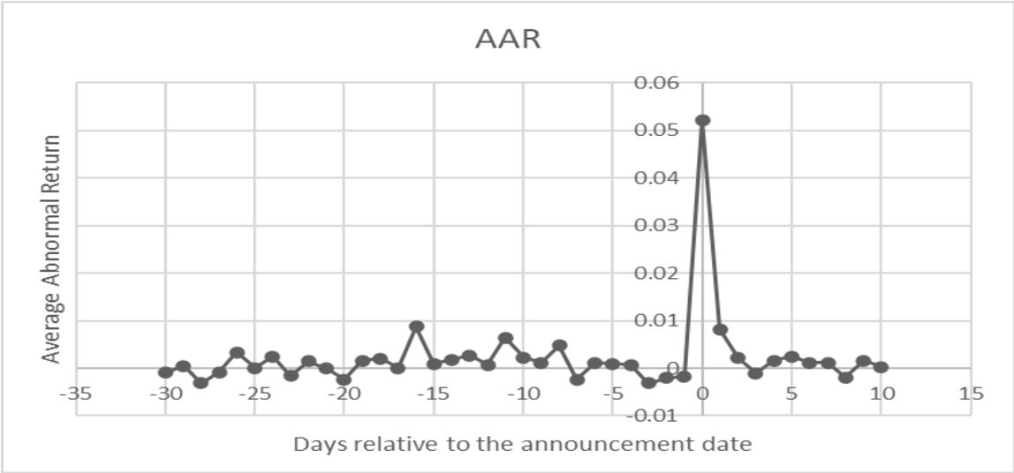
Figure 1- London Stock Exchange
Source- (Pham and Ausloos, 2022).
The formation of Prudential Regulation Authority (PRA) as separate entity of Bank of England was a key component of this legislation. The PRA was given the crucial task of overseeing and regulating financial services corporations and big investment organisations. The PRA's oversight of these firms aims to assure their financial health and resilience, preventing a repeat of the systemic flaws that led the 2008 financial crisis (Authority, 2021). The legislation was a major step towards strengthening UK's financial infrastructure as well as restoring market confidence.
The PRA was given the ability to interfere in the operations of financial institutions as result of Financial Services Act. It might, for example, order a bank to enhance its capital reserves if it believes the organisation is undercapitalized. The PRA could additionally perform stress tests on financial institutions to determine their ability to withstand severe economic situations and ensure they have backup procedures in place (Park and Kim, 2020).

Bank of England and Financial Services Act 2016
This legislation strengthened the regulatory structure for economic stability and the Bank of England's operations. The Act also sought to strengthen the performance of Bank of England as country's central bank as well as financial regulator (Legislation.gov.uk, 2016). The Bank of England responsible for making sure the financial stability, establishing monetary policy, and overseeing financial institutions. In figure 2, the black line represents the Bank of England's base interest rate, averaged throughout every quarter from the beginning of 2004 (Economic Research Council, 2016).
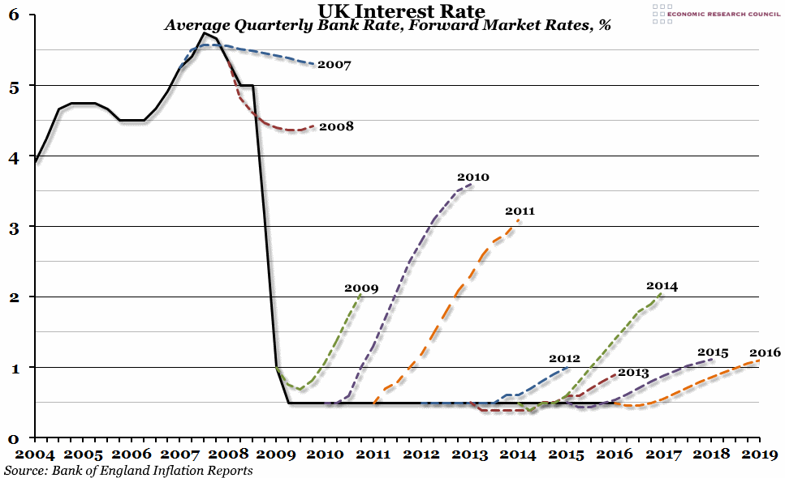
Figure 2- Bank of England Inflation
Source- (Economic Research Council, 2016).
The legislation provided the Bank of England with necessary instruments as well as authority for carrying out the obligations efficiently. As it had formed Prudential Regulation Committee (PRC) in Bank for monitoring the PRA's operations (UK Government, 2016). As the PRC was mainly in charge of supervising as well as monitoring the PRA's operations. The PRC was also formed as internal oversight tool for making sure that PRA's regulatory actions matched with the larger financial stability objectives. It also meant that, as being part of Bank of England, PRC had an ability of monitoring as well as evaluating the PRA's policies as well as actions (Lloyd, 2021). These internal balances as well as check’s structure was mainly designed for avoiding any disproportionate concentration of power as well as ensuring that the regulatory measures were compatible with broader goal of the financial stability.

Financial Conduct Authority (FCA)
The FCA founded as separate regulatory organization from PRA for regulating the financial market behaviour as well as safeguarding the interests of the consumers. As it also focuses on preserving consumer fairness as well as financial market fairness (Kovas, 2015). The FCA was formed in aftermath of crisis to address concerns of market behaviour and consumer protection. Whereas the PRA, which is primarily concerned with safeguarding financial institutions' prudential soundness, the FCA's principal aim is to regulate financial market behaviour and defend consumers' interests. The goal of the FCA includes enforcing fair practises, market integrity, and competition in the financial sector. The FCA was established by the UK in order to improve openness in the markets and avoid consumer abuses that contributed to the 2008 financial crisis. Figure 3 highlights, Retail investments as well as retail lending have the greatest amend/withdrawal rates, accounting for 90% of our interactions with permitted entities (Financial Conduct Authority, 2023).
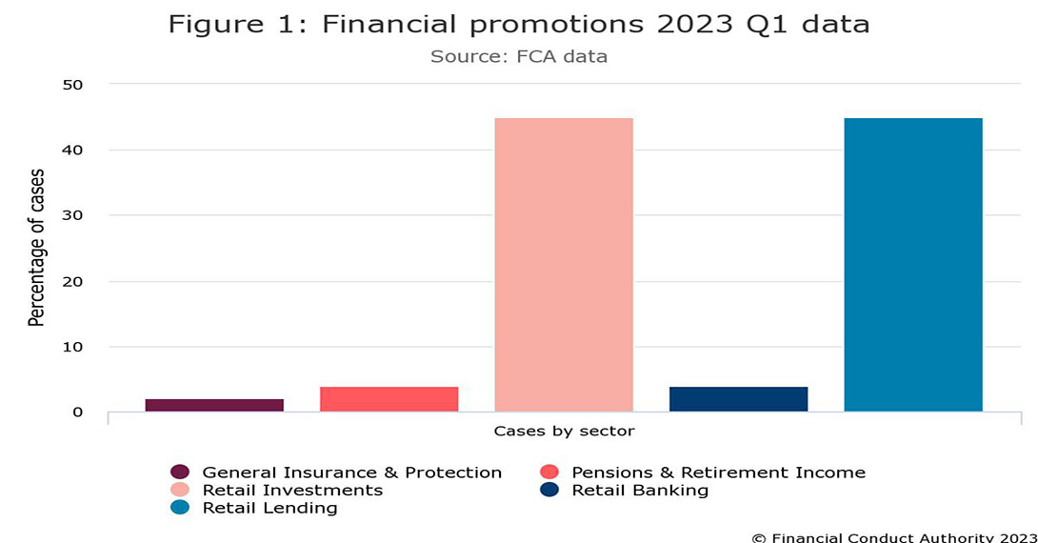
Figure 3- Financial Promotions
Source- (Financial Conduct Authority, 2023).
The FCA's regulatory strategy considers the changing environment of the financial technology (fintech) as well as innovation. It strives to balance the advantages of innovation with the dangers of possible hazards, creating a welcoming atmosphere for novel financial services and products while ensuring they meet regulatory requirements. By tackling financial industry misbehaviour and reckless behaviour, the FCA helps to reduce systemic risks that might lead to another financial catastrophe. Its restrictions and monitoring operate as a deterrent to practises that might destabilise the whole financial system (Anago, 2023). Aside from consumer protection, the FCA sought to improve the integrity of financial markets. It established laws and regulations to combat market manipulation, insider trading, and various other acts that might threaten financial markets' fairness and efficiency. This aided in restoring investor trust and preventing scenarios in which some individuals may take advantage of the system for personal benefit (Anago, 2023).

MiFID II (Markets in Financial Instruments Directive II)
While not unique to the United Kingdom, MiFID II is a European Union directive that was enacted in the United Kingdom with the goal of increasing transparency and strengthening safeguards for investors in financial markets (European Commission, 2023). MiFID II, enacted to promote openness and investor safety in financial markets, required full information disclosure, particularly for complex financial instruments. This directive further increased laws regulating investment services and operations, with the goal of providing better information to investors and mitigating possible market abuses. Although not unique to the United Kingdom, adoption of the MiFID II corresponded to the country's aim to promoting a more transparent and responsible financial industry (Marano, 2021).
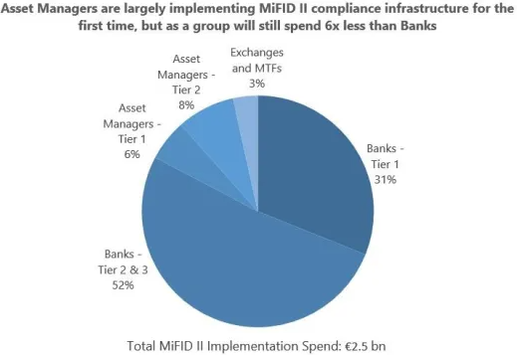
Figure 4implementation of MIFID II
Source- (Prajapati, 2018).
MiFID II was an EU legislation, but its influence stretched beyond its boundaries. Regardless of their home jurisdiction, many multinational financial organisations operating in the EU must alter their practises to meet the directive's standards. This extraterritorial effect spurred more regulatory and practise harmonisation across international financial markets. Figure 4 shows, banks are likely to bear around 80% of the cost burden. Each of the top banks will be required to spend more than €40 million. Managers of assets will have to create MiFID II infrastructure from the ground up. Their overall costs are projected to reach around €350 million (Prajapati, 2018).
Overall, the regulatory adjustments implemented in the UK following the financial crisis intended to reduce the excessively risk-taking behaviour that had led to the catastrophe. While these measures limited banks' operations, their primary goal was to improve financial stability, protect customers, and encourage a more accountable and responsible financial sector. In addition, the Basel III framework-imposed liquidity rules, which obliged banks to keep enough liquid assets on hand to satisfy short-term obligations. This lowered banks' reliance on short-term funding sources, causing them to be more resistant to liquidity disruptions (Zetzsche and Anker-Sørensen, 2022).

Global key regulatory frameworks
Several nations and international agencies established a variety of laws, rules, and agreements in reaction to 2008 global financial crisis in order to address challenges that led to the crisis and to avert a similar disaster from occurring in the future. Some of the significant actions undertaken by global financial system stakeholders include:

Dodd-Frank Wall Street Reform & Consumer Protection Act (United States)
Dodd-Frank was enacted in 2010 and brought significant modifications to regulations aimed at strengthening financial stability and safeguarding consumers. It formed the Consumer Financial Protection Bureau (CFPB), strengthened financial institution monitoring, increased transparency in the trading of derivatives, and compelled banks to undertake stress testing (Evanoff and Moeller, 2014). It prohibited exclusive trading by banks via the Volcker Rule, which tries to prevent banks participating in speculative trading activity that might jeopardize their stability. By restricting such high-risk operations, the act limits the possibility for excessive risk-taking, which can destabilize financial institutions as well as the broader economy (Zhao, 2023). The Dodd-Frank Act contains provisions that safeguard whistleblowers who expose violations of securities regulations to Securities and Exchange Commission (SEC). Whistleblowers are compensated and protected from reprisal, encouraging anyone with inside understanding of fraudulent or unethical conduct to come out. This leads to the early discovery of misconduct and develops an accountability culture throughout the financial industry. Figure 5 shows, although the Great Recession's wounds are undoubtedly still visible, the U.S. economy has been slowly recovering since the financial crisis ended and Dodd-Frank was passed (Center for American Progress, 2017).
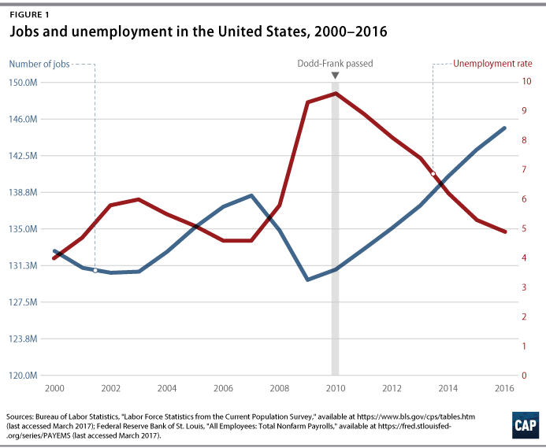
Figure 5- Dodd-Frank enactment in US
Source- (Center for American Progress, 2017).
The Consumer Financial Protection Bureau (CFPB) was one of the Dodd-Frank Act's significant creations. This organisation was entrusted with protecting consumers from exploitative financial practises, guaranteeing accurate financial product disclosures, as well as enforcing consumer financial goods and services rules (DOLMA, 2023). The CFPB was crucial in combating abusive lending practises and giving consumers with the data they needed to make sound financial decisions. While the Dodd-Frank Act was limited to the United States, its impact was seen throughout the world owing to the interconnected structure of the financial sector. International financial institutions as well as regulatory organisations frequently looked to the United States as a regulatory reform model (Bureau, 2022). The Dodd-Frank Act's concepts and methods sparked debate and change in various nations and areas.
2.2 Basel III Capital and Liquidity Standards (Bank for International Settlements)
With Basel III, the Basel Committee on the Banking Supervision implemented a series of changes to increase bank resilience. Higher demands for capital, stronger risk management methods, and larger liquidity buffers were among the improvements (Bank for International Settlements, 2017).
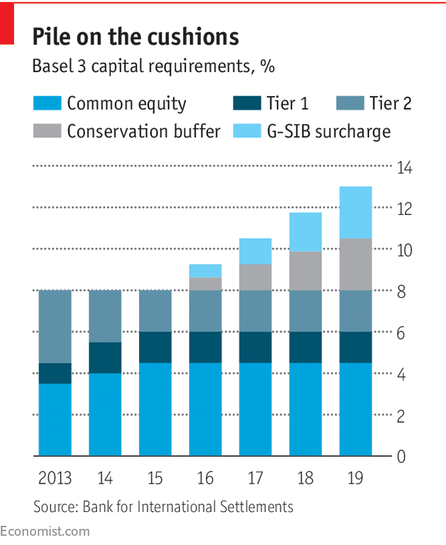
Figure 6- Basel III requirements
Source- (The Economist, 2017).
Basel III increased the bare minimum capital requirements for banks substantially. It mandated common equity Tier 1 (CET1) capital, emphasising need of high-quality, readily available capital. CET1 capital is made up mostly of common stock and retained profits. Banks were obligated to maintain a larger CET1 capital ratio than before, which served as a cushion against unexpected losses. Basel III established the countercyclical capital buffer to deal with the issue of pro-cyclicality in loans and risk-taking (Mustary, 2021). This buffer required banks to accrue greater capital during years of economic prosperity in order to serve as a cushion during periods of economic depression. The size of this buffer changed according to the status of the national economy.
Basel III imposed stricter liquidity restrictions. Banks were obliged to maintain a higher liquidity buffer, ensuring that they had enough high-quality liquid assets to satisfy short-term commitments during stressful periods. To analyse a bank's liquidity risk management, Liquidity Coverage Ratio (LCR) as well as Net Stable Funding Ratio (NSFR) were created (Abboud, et al., 2021). Basel III included a leverage ratio to the risk-weighted capital ratios. This ratio compared bank's capital to entire assets without taking risk weights into account. Its goal was to limit excessive borrowing in the financial system by establishing a minimum capital requirement regardless of asset riskiness.

European Market Infrastructure Regulation (EMIR)
EMIR, which has been implemented in the European Union, aims to improve transparency, and decrease risks in the market for derivatives. It mandated central clearing of some derivatives and enhanced reporting requirements (Aditya, 2013). The absence of full disclosure in the derivatives market was one of the major flaws exposed by the financial crisis. Prior to EMIR, many derivative transactions were handled over the counter (OTC), that is, directly between the two parties rather than through a centralised exchange. Because of the lack of transparency, regulators, investors, and even the parties engaged in the transactions found it difficult to assess the total market exposure and associated hazards. EMIR improve transparency by using derivative transactions which to be reported to the trading repositories (Meier, et al., 2023). Trade repositories are central platforms that record all derivative transactions, giving regulators and market players with a full view of trading activity. This criterion enables regulators to monitor and analyses market patterns, identify possible hazards, and take appropriate action in a timely manner.
The central clearing requirement of the certain standardised derivatives contracts which was one of fundamental components of the EMIR. Certain kinds of derivatives, especially those that are frequently traded and standardised, were mandated to be processed through central counterparties (CCPs) under this requirement. Central clearing requires a third party (the CCP) standing among the two parties to a deal, becoming the counterparty to both and thereby lowering counterparty risk (Feenan, et al., 2021). This approach aims to improve derivatives market stability by lowering the chance of one of the parties engaged in a deal defaulting. The adoption of EMIR resulted in a large rise in the reporting requirements of derivatives transactions. In accordance with the European Securities and Markets Authority (ESMA), over 80 million transactions were recorded on a weekly basis under EMIR as of 2019 (European Securities and Markets Authority, 2023). This degree of reporting contributes to increased openness and regulation of the derivatives market.

G20 Pittsburgh Summit Commitments
G20 leaders pledged to improve the global banking system in 2009. Among these were initiatives to strengthen regulation, promote global collaboration, increase transparency, and set tougher capital and liquidity rules for banks. Figure 7 shows, the projected increase exceeds both the trend as well as potential of the pre-crisis period and is complemented by a sharp drop in unemployment (International Monetary Fund, 2023).
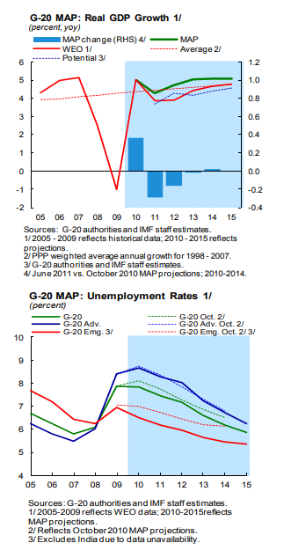
Figure 7- G20 Pittsburgh commitment
Source- (International Monetary Fund, 2023).
The G20 recognised the global financial system's interdependence and the necessity for concerted action to solve its difficulties. As a result, officials pledged to strengthen international cooperation among regulatory bodies and financial institutions. This coordinated strategy attempted to guarantee that regulatory requirements were consistent across jurisdictions and that financial companies could not avoid rules by transferring operations to less stringent nations. The implementation of stricter capital and liquidity standards for banks was one of the most major undertakings (Tadas, 2023). The G20 recognised that banks were vulnerable throughout the crisis due to a lack of liquidity and capital buffers. The agreements intended to guarantee that banks had enough capital to withstand losses and enough liquidity to weather market volatility. These methods were aimed to improve bank resilience and lower the danger of systemic failure.
Recognising the significance of liquidity as well as capital buffers in protecting financial institutions from unanticipated shocks, the G20 commitment emphasised the establishment of greater capital requirements and stringent liquidity controls. This included the establishment of the Basel III framework, which significantly boosted banks' a minimum amount of capital as well imposed larger liquidity buffers. The G20 vow to restructure the global banking system indicated a shared resolve to avoid future financial crises and preserve the global economy. Initiatives implemented in response to this pledge, like as the Basel III framework and greater regulatory monitoring, have made a significant contribution to the financial system's resilience and stability (Rayner, 2021).
The Bank which is for International Settlements' Basel Committee on the Banking Supervision created the Basel III framework, which considerably increased capital requirements for banks and imposed new liquidity norms. The Financial Stability Board (FSB) estimates that by 2019, all G20 countries will have adopted the Basel III framework for capital and liquidity rules. Regulatory agencies in many G20 nations strengthened oversight and surveillance of financial institutions to guarantee compliance with summit pledges (Lapin, 2021).

Contribution of reforms
Following the 2008 financial crisis, the changes to laws and regulations adopted played a vital influence in changing financial system as well as the activities of various financial institutions. These improvements were intended to improve financial stability, handling of risks, transparency, and consumer protection. The Enhanced Capital as well as Liquidity Requirements (Basel III) framework, for example, established greater capital and liquidity rules for the banks. In accordance with the Bank for International Settlements (BIS), banks' worldwide common equity Tier 1 (CET1) capital had expanded considerably during the 2008 financial crisis. The CET1 capital ratio, which calculates high-quality capital as a proportion of risk-weighted assets, acts as a loss buffer. Banks' susceptibility to financial shocks has gotten better as a result of greater capitalisation. Banks must now maintain higher levels of capital to cover future losses and liquid assets to resist short-term liquidity challenges (Csengoi and Ayadi, 2023). As a result, banks have become more resistant to financial shocks, lowering the possibility of a broad banking disaster. Also, regulations such as EMIR and MiFID II have established steps to improve transparency and risk management in financial markets. For example, EMIR's need for central clearing of some futures has decreased counterparty risk and strengthened the derivatives market. Furthermore, the transparency standards of MiFID II have boosted market visibility as well as decreased the risk of market abuse. Centralized derivatives clearing and prohibitions on proprietary trading (Volcker Rule) have minimized systemic risks and possible conflicts of interest, leading to a more secure financial climate (Thakor, 2018).
Consumer interests have also been prioritised in reforms. This dedication is exemplified by the establishment of regulatory entities like Consumer Financial Protection Bureau (CFPB) in United States as well as the Financial Conduct Authority (FCA) in United Kingdom, which monitor financial market behaviour and assure consumer protection. These organisations enforce regulations that prohibit predatory lending, deceptive advertising, and other types of consumer abuses. In accordance with the Financial Stability Board (FSB), global systemically important institutions' (G-SIBs') total loss-absorbing capacity (TLAC) has improved significantly by 2019 (SoRelle, 2020). TLAC assesses banks' ability to withstand losses while avoiding taxpayer-funded bailouts. As of 2021, big U.S. banks subjected to the Volcker Rule (part of the Dodd-Frank Act) have drastically curtailed their proprietary trading activity, minimising conflicts of interest and lowering possible hazards connected with proprietary trading, according to the Federal Reserve.
Furthermore, G20 commitments have improved supervisory cooperation between governments and banking organizations. Global collaboration among authorities and central banks has enhanced information sharing, collaboration, and regulatory norm alignment. This has aided in the prevention of arbitrage in regulations and the reduction of cross-border hazards (Beker, 2021). Collectively, these changes and laws have contributed to the establishment of a more strong, transparent, and responsible financial system. Collaboration among regulatory bodies has resulted in better harmonization of regulatory norms across jurisdictions. For example, governments have broadly accepted the Basel III framework for capital and liquidity rules, resulting in a more uniform worldwide regulatory framework. This alignment decreases the possibility of regulatory loopholes being exploited by financial institutions in order to engage in dangerous activity (Beker, 2021). The Financial Stability Board (FSB) & the Basel Committee on the Banking Supervision have aided international coordination in reform implementation. By 2020, the FSB will have built channels for exchanging data on supervisory and regulatory concerns, helping to a more uniform regulatory approach across jurisdictions.
However, there are considerable downsides, and financial institutions have paid enormous compliance costs resulted implementation of these changes. Banks have had to devote significant resources to meeting capital requirements, improving reporting capabilities, and adapting to new laws and regulations. Stricter capital and liquidity regulations, especially during economic downturns, could restrict banks' capacity to lend. This might have an influence on economic growth as well as profitability of financial institutions, which may find it difficult to match regulatory compliance requirements with commercial objectives (Kumar, 2020). The regulatory environment has gotten more complicated as a result of the numerous reforms implemented by various countries. This complication can cause misunderstanding, particularly for organisations that operate across borders, and increase operational risks. Some opponents claim that strict rules would impede financial innovation. Due to the higher risk and expense involved, stringent compliance standards and capital limits may dissuade banks from investing in new ventures. Regulatory changes might have unforeseen repercussions. Strict rules, for example, might force some activities into less-regulated areas, thus introducing new dangers that are not well-monitored (Zetzsche, et al., 2020). While changes were intended to produce a more cohesive and robust financial system, diverse implementation, and interpretation of legislation in various jurisdictions might lead to fragmented markets, limiting the efficacy of international coordination.
According to the FSB's yearly reports, the proportion of global systemically significant banks' (G-SIBs') cross-border claims has declined since the 2008 financial crisis. This decrease indicates that regulatory initiatives have helped to reduce cross-border risks and possible dangers linked with interconnectivity. While challenges and risks continue, the adjustments adopted in aftermath of 2008 financial crisis attempted to prevent a repeat of crisis and foster a healthier and more stable financial landscape for both financial institutions and the economy (Bottineau, et al., 2022).

Impact on NatWest
Considering the regulations formed in UK post financial crisis 2007, NatWest, like any other banks, have focused on increasing their capital and liquidity buffers to meet the requirements set by Basel III. Basel III emphasizes improving quality & quantity of a bank's capital. Banks must maintain a greater amount of the common equity Tier 1 (CET1) capital, a particularly loss-absorbing kind of capital (PLC, 2020). During times of financial hardship, this capital absorb losses. To reach the specified minimum levels, NatWest and other banks must enhance their CET1 capital ratios. This could impact their lending practices and investment strategies as they need to maintain higher levels of capital to absorb potential losses (RBS, 2015). NatWest's lending practises and investment strategies were influenced by the necessity of maintaining higher levels of capital and liquidity. With tougher capital requirements, banks had to commit more money to lending activities, potentially affecting loan availability and conditions.
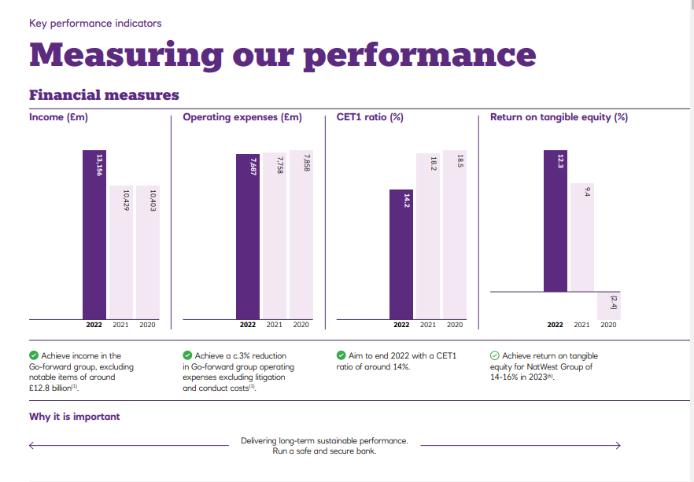
Figure 8- NatWest Finance Measures
Source- (NatWest Group, 2023).
Basel III also imposed strict liquidity rules on banks to make sure that they have enough liquid assets for withstanding short-term funding constraints. The Liquidity Coverage Ratio (LCR) mainly requires the banks to have enough high-quality liquid assets which can readily be transformed into the cash for covering the net cash withdrawals throughout 30-day stress period. This regulation is intended to keep banks from experiencing a liquidity crisis amid market disruptions (Gerba and Katsoulis, 2022). In order to comply with the LCR, banks, including NatWest, must change their balance sheets and funding arrangements. Compliance with Basel III has necessitated considerable changes in the operations, risk management practises, and capital allocation strategies of banks such as NatWest (NatWest Group, 2023).
Another essential feature of Basel III is the leverage ratio. It limits the amount of leverage a bank may use in relation to its capital. This policy aims to discourage high levels of risk and to guarantee that banks maintain a minimum amount of capital to support their operations (Piffer, 2023). To meet the leverage ratio requirements, banks have had to control their balance sheets as well as risk exposures. Basel III also altered how banks assess and handle counterparty and market risk. These modifications are intended to improve risk management practises and better reflect possible losses associated with these sorts of hazards (Healy, 2019). To fulfil regulatory obligations and improve overall resilience, increasing liquidity and capital buffers has been a focus. This has frequently entailed acquiring extra funds, revising lending practises, and rethinking corporate plans.
NatWest, like other banks, has had to improve its risk management practises, such as stress testing and rigorous risk assessments. This may have influenced the bank's risk appetite as well as strategic decisions, since they must assure their ability to endure numerous economic situations (Healy, 2019). NatWest's risk assessment may lead to the re-evaluation of business areas judged excessively hazardous, integrating their operations with regulatory standards, and enhancing overall resilience. The consumer protection and transparency regulations may have changed NatWest's approach to client contacts, demanding better disclosures and equitable treatment. NatWest would have to guarantee that its goods and services comply with the FCA or CFPB's requirements. For example, when selling financial products to consumers, NatWest must guarantee that the information presented is clear and understandable, and that no deceptive assertions are made (Chapelle, 2019). The harmonisation of regulatory norms across countries may have an influence on NatWest's operations. It may have to negotiate the diverse interpretations of these reforms in the nations where it operates. NatWest may need to execute various compliance measures in different locations due to varied legislative interpretations, which might generate to operational complexity. As a prominent UK bank, NatWest is likely to have taken extensive efforts to comply with these requirements due to the possible legal, financial, as well as reputational ramifications of non-compliance. It is in their best interests to ensure that these reforms be followed in order to avoid penalties, safeguard their clients, and retain market trust (Wewege and Thomsett, 2019).
According to Howard Davies (Royal Bank of Scotland Chairman), government tries to strengthen regulated financial system, as well as banks and the insurers. In which the Capital is stronger, as well as the failure incidence should be reduced, if it cannot be eliminated. The Regulators have the stronger political support as well as self-assurance (NatWest Group, 2023). NatWest emphasised asset quality enhancement in response to laws and lessons learnt during the crisis. This entailed minimising risk concentration by broadening its portfolio and perhaps quitting some riskier portfolios. This plan intended to improve the bank's overall asset stability and minimise its exposure to economic downturns. Currently, considering the business model of NatWest, it is completely focused on net interest income. Also, NatWest has made focus on enhancing the asset quality to reduce the risk concentration and the exit portfolios which are driven by RCR disposals strategy (RBS, 2015). In accordance with RBS's 2015 Annual Report, the firm took steps to improve its financial situation, includes raising capital through share issue and divesting non-core assets. This is consistent with the overall industry trend of banks bolstering their capital holdings in order to fulfil regulatory obligations.

Conclusion
Finally, the global financial crisis of 2008 triggered substantial regulatory measures aimed at minimising systemic risks and building a safer financial landscape. The United Kingdom as well as global financial institutions both responded with a slew of legislation, rules, and agreements aimed at addressing the underlying causes of the crisis and improving financial resilience. In UK, regulatory authorities like Prudential Regulation Authority (PRA) and Financial Conduct Authority (FCA) they were formed for safeguarding stability of the financial institutions as well as defending the interests of the consumers. The PRA establishment enabled more specialised approach for prudential oversight, whereas FCA are mainly focused on the market conduct and the consumer protection. Various Reforms like MiFID II as well as Dodd-Frank which increase the openness in the financial markets, which is allowing investors in making more informed decisions. It also emphasis on the openness which was intended of reducing the abusive market practises as well as increasing the responsible financing, and eventually strengthening the market integrity.
For improving the financial institutions' as well as risk management skills and regulatory procedures such as stress testing as well as capital adequacy requirements, which is illustrated by Basel III. It is important to guarantee that the banks were able to undergo economic shocks as well as avoid liquidity and the solvency crises which has been occurred during 2008 financial crisis. Various Reforms like establishment of the Consumer Financial Protection Bureau in the US as well as increased the consumer protection regulations in UK seek of prohibiting the predatory lending practises as well as misleading the financial products, and assuring the customers' equitable treatment. While all the changes were mainly intended in increasing the reliability of financial system, which also provided problems to the financial institutions. Stricter rules and compliance requirements raised operational difficulties and expenses, which might influence lending practises and profitability.

References
Abboud, A., Duncan, E., Horvath, A., Iercosan, D.A., Loudis, B., Martinez, F., Mooney, T., Ranish, B., Wang, K., Warusawitharana, M. and Wix, C., 2021. COVID-19 as a stress test: assessing the bank regulatory framework. https://papers.ssrn.com/sol3/papers.cfm?abstract_id=3965801
Aditya, P.D., 2013. European Markets Infrastructure Regulation (EMIR) and Dodd-Frank Wall Street Reform and Consumer Protection Act (DFA): A New Revolution of OTC Derivatives Towards Transparency. Available at SSRN 2314998.
Anago, J.C., 2023. Addressing FinTech Regulatory Gap Through Regulatory Co-Opetition Theory: A Meta-Analysis Study. https://ijisrt.com/assets/upload/files/IJISRT23JUN516.pdf
Authority, P.R., 2021. Climate-related financial risk management and the role of capital requirements. Bank of England. https://www.bankofengland.co.uk/-/media/boe/files/prudential-regulation/publication/2021/%E2%80%8Coctober/climate-change-adaptation-report-2021.pdf
Bank for International Settlements, 2017. Basel III: international regulatory framework for banks. [online] Bis.org. Available at: https://www.bis.org/bcbs/basel3.htm [Accessed 7 August 2023].
Beker, V.A., 2021. Preventing the next financial crisis. Taylor & Francis.
Bottineau, I., Coffinet, J. and Le Meur, C., 2022. Large French banking groups are increasingly concentrating their international activities in the euro area. Bulletin de la Banque de France, (241). https://particuliers.banque-france.fr/sites/default/files/medias/documents/822240_bdf241-4_en_grands_groupes_vfinale.pdf
Bureau, C.F.P., 2022. Background on Small Businesses. https://www.urban.org/sites/default/files/publication/105315/urban-public-comment-letter-on-section-1071-small-business-lending-data-collection_1.pdf
Center for American Progress, 2017. The Importance of Dodd-Frank, in 6 Charts. [Online] Available at: https://www.americanprogress.org/article/importance-dodd-frank-6-charts/ [Accessed 10 Aug 2023].
Chapelle, A., 2019. Operational risk management: Best practices in the financial services industry. John Wiley & Sons.
Csengoi, A.H. and Ayadi, N., 2023. Banks' Adjustments to Basel III Capital Requirements: Empirical research on a sample of 359 banks between 2015 and 2021. https://www.diva-portal.org/smash/record.jsf?pid=diva2%3A1765296&dswid=1371
DOLMA, Ö., 2023. Cybersecurity Whistleblower Protection: A Comparison of the US and the EU Approaches. Pamukkale Üniversitesi İşletme Araştırmaları Dergisi, 10(2), pp.615-631. https://dergipark.org.tr/en/pub/piar/issue/78771/1281937
Economic Research Council, 2016. Chart of the Week: Week 10, 2016: UK Interest Rate. [Online] Available at: https://ercouncil.org/2016/chart-of-the-week-week-10-2016-uk-interest-rate/ [accessed 10 August 2023].
European Commission, 2023. Markets in Financial Instruments Directive II. [online] finance.ec.europa.eu. Available at: https://finance.ec.europa.eu/regulation-and-supervision/financial-services-legislation/implementing-and-delegated-acts/markets-financial-instruments-directive-ii_en [Accessed 7 August 2023].
European Securities and Markets Authority, 2023. 2022 Report on Quality and Use of Transaction Data. [Online] Available at: https://www.esma.europa.eu/sites/default/files/2023-04/ESMA74-427-719_2022_Report_on_Quality_and_Use_of_Transaction_Data.pdf [Accessed 10 August 2023].
Evanoff, D.D. and Moeller, W.F. eds., 2014. Dodd-Frank Wall Street reform and consumer protection act: purpose, critique, implementation status and policy issues (Vol. 2). World Scientific.
Feenan, S., Heller, D., Lipton, A., Morini, M., Ram, R., Sams, R., Swanson, T., Yong, S. and Zalles, D.B., 2021. Decentralized financial market infrastructures: Evolution from intermediated structures to decentralized structures for financial agreements. The Journal of FinTech, 1(02), p.2150002. https://www.worldscientific.com/doi/abs/10.1142/S2705109921500024
Financial Conduct Authority, 2023. Financial promotions quarterly data 2023 Q1. [Online] Available at: https://www.fca.org.uk/data/financial-promotions-quarterly-data-2023-q1 [Accessed 10 August 2023].
Gallagher, K.P., Gao, H., Kring, W.N., Ocampo, J.A. and Volz, U., 2021. Safety first: Expanding the global financial safety net in response to COVID‐19. Global Policy, 12(1), pp.140-148. https://onlinelibrary.wiley.com/doi/full/10.1111/1758-5899.12871
Gerba, E. and Katsoulis, P., 2022. The repo market under Basel III. Available at SSRN 4394454. https://papers.ssrn.com/sol3/papers.cfm?abstract_id=4394454
Healy, J., 2019. Breaking the Banks: What went wrong with Australian banking?. Simon and Schuster.
Horton, R., 2021. The COVID-19 catastrophe: What's gone wrong and how to stop it happening again. John Wiley & Sons.
International Monetary Fund, 2023. G—20 MUTUAL ASSESSMENT PROCES: FROM PITTSBURGH TO CANNES——IMF UMBRELLA REPORT. [Online] Available at: https://www.imf.org/external/np/g20/pdf/map2011/umbrella.pdf [Accessed 10 August 2023].
Kovas, A., 2015. Understanding the financial conduct authority: a guide for senior managers. Troubador Publishing Ltd.
Kumar, S., 2020. Cost of Remittance: A Priority Area for G20 Member Countries. https://ris.org.in/sites/default/files/Publication/DP-281-Dr-Sushil-Kumar.pdf
Lapin, M.I.X., 2021. EXPOSÉ OF THE DISSERTATION. https://ssc-rechtswissenschaften.univie.ac.at/fileadmin/user_upload/s_rechtswissenschaft_neu/Neu/Doktorat_Expose/Expose1/Voelkerrecht/The_Impact_of_Margin_Requirements_for_Non-Centrally_Cleared_Derivatives.pdf
Legislation.gov.uk. 2012. Financial Services Act 2012. [Online] Available at: https://www.legislation.gov.uk/ukpga/2012/21/contents/enacted [accessed 10 August 2023].
Legislation.gov.uk. 2016. Bank of England and Financial Services Act 2016. [Online] Available at: https://www.legislation.gov.uk/ukpga/2016/14/contents/enacted [accessed 10 August 2023].
Lloyd, J., 2021. Impacts of a new harmonised regulatory index on a small open–economy DSGE model of UK regulation (Doctoral dissertation, Cardiff University). https://orca.cardiff.ac.uk/id/eprint/145518/
Marano, P., 2021. The Contribution of Product Oversight and Governance (POG) to the Single Market: a set of organisational rules for business conduct. Insurance distribution directive: a legal analysis, pp.55-74. https://library.oapen.org/bitstream/handle/20.500.12657/43280/2021_Book_InsuranceDistributionDirective.pdf?sequence=1#page=66
Meier, H.B., Marthinsen, J.E., Gantenbein, P.A. and Weber, S.S., 2023. Swiss Derivative Markets. In Swiss Finance: Banking, Finance, and Digitalization (pp. 501-526). Cham: Springer International Publishing. https://link.springer.com/chapter/10.1007/978-3-031-23194-0_10
Mustary, T., 2021. Implementation of Basel III accords in Mutual Trust Bank: risk based capital adequacy ratios requirement of Bangladesh Bank. https://dspace.bracu.ac.bd/xmlui/handle/10361/16232
NatWest Group, 2023. NatWest Group plc 2022 Annual Report and Accounts. [Online] Available at: https://investors.natwestgroup.com/~/media/Files/R/RBS-IR-V2/results-center/17022023/nwg-annual-report-and-accounts.pdf [Accessed 10 August 2023].
NatWest Group, 2023. Chairman Howard Davies looks back at the financial crisis. [online] www.natwestgroup.com. Available at: https://www.natwestgroup.com/news-and-insights/feature-content/our-updates/2011-2020/chairman_howard_davies_looks_back_at_the_financial_crisis.html [Accessed 7 August 2023].
OBR, 2019. The Government’s regulatory response to the financial crisis - Office for Budget Responsibility. [online] Office for Budget Responsibility. Available at: https://obr.uk/box/the-governments-regulatory-response-to-the-financial-crisis/ [Accessed 7 August 2023].
Park, H. and Kim, J.D., 2020. Transition towards green banking: role of financial regulators and financial institutions. Asian Journal of Sustainability and Social Responsibility, 5(1), pp.1-25. https://link.springer.com/article/10.1186/s41180-020-00034-3
Pham, R. and Ausloos, M., 2022. Insider trading in the run‐up to merger announcements. Before and after the UK's Financial Services Act 2012. International Journal of Finance & Economics, 27(3), pp.3373-3385. https://onlinelibrary.wiley.com/doi/full/10.1002/ijfe.2325
Piffer, M., 2023. Banks’ Leverage Evolution: The Case of Commercial Banks. Mathematics, 11(13), p.2860. https://www.mdpi.com/2227-7390/11/13/2860
PLC, M.B., 2020. COVID-19. Change, 31, p.31. https://uploads4.craft.co/uploads/source/document/894144/51db08d7dcfe5da3.pdf
Prajapati, N., 2018. MIFID-II 101. [Online] Available at: https://pirimidtech.com/mifid-ii-101/ [Accessed 10 August 2023].
Rayner, T., 2021. Keeping it in the ground? Assessing global governance for fossil-fuel supply reduction. Earth System Governance, 8, p.100061. https://www.sciencedirect.com/science/article/pii/S2589811620300203
RBS, 2015. Building a strong, simple, fair bank. [online] RBS. Available at: https://investors.natwestgroup.com/~/media/Files/R/RBS-IR-V2/results-center/ara-final-2015.pdf [Accessed 7 August 2023].
SoRelle, M.E., 2020. Democracy Declined: The Failed Politics of Consumer Financial Protection. University of Chicago Press.
Tadas, G.A., 2023. G20 initiatives in infrastructure investment & finance: Progress & shortfalls. RIS Discussion Paper Series.(August 2023). New Delhi: India. Research and Information System for Developing Countries. Retrieved from https://ris. org. in/sites/default/files/Publication/DP-276-Dr-GA-Tadas. pdf. https://ris.org.in/sites/default/files/Publication/DP-276-Dr-GA-Tadas.pdf
Thakor, A.V., 2018. The Economic Consequences of Regulatory Protection & Extraterritorial Reach. SSRN Electronic Journal. [online] https://doi.org/10.2139/ssrn.3176049
The Economist, 2017. Basel 3, an international capital-adequacy standard, is unloved but much needed. [Online] Available at: https://www.economist.com/special-report/2017/05/04/basel-3-an-international-capital-adequacy-standard-is-unloved-but-much-needed [Accessed 10 August 2023].
UK Government, 2016. Bank of England and Financial Services Act 2016. [online] Legislation.gov.uk. Available at: https://www.legislation.gov.uk/ukpga/2016/14/contents/enacted [Accessed 7 August 2023].
Wewege, L. and Thomsett, M.C., 2019. The digital banking revolution: how fintech companies are transforming the retail banking industry through disruptive financial innovation. Walter de Gruyter GmbH & Co KG.
Wilson, T.A., 2012. Supporting social enterprises to support vulnerable consumers: the example of community development finance institutions and financial exclusion. Journal of consumer policy, 35, pp.197-213.
Zetzsche, D.A. and Anker-Sørensen, L., 2022. Regulating sustainable finance in the dark. European Business Organization Law Review, 23(1), pp.47-85. https://link.springer.com/article/10.1007/s40804-021-00237-9
Zetzsche, D.A., Arner, D.W. and Buckley, R.P., 2020. Decentralized finance (defi). Journal of Financial Regulation, 6, pp.172-203. https://papers.ssrn.com/sol3/Papers.cfm?abstract_id=3539194
Zhao, Y., 2023. The Price of Risk: Exploring the Impact of the 2008 Global Financial Crisis. Highlights in Business, Economics and Management, 15, pp.175-181. https://drpress.org/ojs/index.php/HBEM/article/view/9337

