LECTURER NAME: SYED JAFFERY
  professional careeer development  Module code: BMSW4005-LON | FARZANA SHARMIN

Everyone should want to develop their professional career because without dreams people cannot achieve anything in life Nowadays nothing coming by automatically that’s why we need to work hard to gain somethings.
Professional career development is a plan to develop my professional life and how can I make it successful. Before I develop my career, I have to choose right path, for example now I am working in a nursery school as a cover assistant but my intention is to become teacher, for that what should I have to do I need to find out than start to my journey. When I started a voluntary job in my local school for complete my EYFS level 2, I realized that I would love to work with children and my future career would be as a teacher, where I can demonstrate my skill, knowledge and good manner where I have been learnt from my mother in a very positive way. I believe that I can give most important aspect to my student to get more educated, inspired, and motivated.
In order to fulfil my dreams, I have to continue my studies and working hard and get something in my life.
INTERVIEW FOR GETTING A JOB
In my thoughts interview means when someone apply for his /her career than the organisation arranges for an interview to know about the persons and how is the skills and experienced in that field.
In week 10, while I am studying in university online class, me and my class mate was practicing how can we do any interview and what question they will be asked; for that I have prepared some question and practice in front of many and get some idea from YouTube video, wrote different kind of aspect and made notes, these all things made me more confidence, anything can be improving by practicing and confidence.
When my turn come up me and my classmate ask so many questions which we were answering by our knowledge and experiences. We have been done our interview at least more than 15 minutes and after that we were satisfied with each other. My interview was as a teaching job because I am currently related with that so some of the question was job related and it’s really easy to answering by my experiences, on the other hand my partner was not ready for that question which one I going to ask but she covered it very smartly. Overall, we did really well in my opinion.
Now my I am going to discuss about my SWOT analysis and how can I improve.
SWOT ANALYSIS MYSELF
Basically, this SWOT analysis techniques used by any individual persons to understand about their strength, weakness opportunity and threats, depended on the ability. I am aware that every person has different strengths and weakness. For purpose of the assignment my personal SWOT will be based few different things such as:
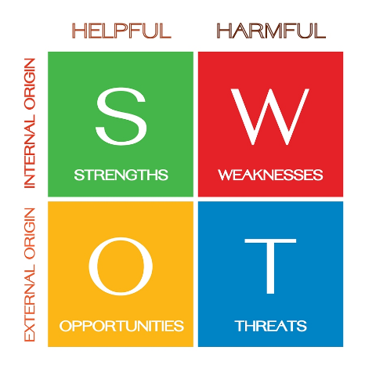
‌

STRENGTHS WHAT I HAVE
- Currently studying in university at level 4 it is big strengths for me as after a big gap, I have been started a study and want to achieved a great qualification.
- I have many experiences in different field such as retail and childcare receptionist, and now cover assistant as a practitioner in school.
- I think it is easy for me to learn something new.
- I am not scared to take challenges.
- Have good responsibility and organised skills,
- I know different languages which can help people who cannot speak English, such as Bengali, Italian, Hindi which can help to communicate with a variety of people.
- Also, I am very hard working and reliable person and always success in the work place
(UKEssays.com, 2020)

MY WEAKNESS
- I am not very good at public speaking, basically front of crowded place.
- Very shy do not want to ask for any help to anyone.
- I can’t speak English fluently which can cause some problems with communicating.
- More improve my writing skill
- Sometimes feeling low confidence basically nervous.

OPPORTUNITY

Making a list for my strengths gave me more confidence and now I am thinking that I want to take all of these strengths to make me progress to next year and I want to take this opportunity to complete my level 5 and level 6. After that I will get opportunity to find a good job and become a successful person what I really to want to achieve.

MY THREATS

Everyone should have dreams to gain something in life. In order to develop my career, I have to finish my university degree first. I am really conscious about public speaking in front of people and it has to be need overcome and that’s why I need to make more presentation practice as much as I can; on the other hand, English language is bit barrier to develop my career so I have to must develop my language skill, and I understand that if I continue my reading skill it could be better.

MY GOALS

Looking at where I am currently is giving me more focus to my future path, for myself I have done some short-term goals and what is my long-term goals, and I believe that it would be more helpful to reach my career. A personal development plan will help me guide to my goal and provide me with the necessary skills to take on any challenges.
For this assignment I have consider several steps to setting my goals
Short terms
Step 1: finish my level 4 study.
Step 2: at least finish 2 story books.
Step 3: more active to learn somethings new.
Step 4: improve English language as much as I can.

Long terms
Step 1: find a good job which one is my dreams
Step 2: search different agency to apply for job such as LinkedIn, indeed total job etc.
Step 3: become more positive and gain more skills and experiences.

Now I am going to discuss about SMART goals:
Sometimes I feel that where I am working now it is not enough for me because I working hard there and not getting anything, so I decided that I will change my job position and develop my professional career, for that I have to choose SMART goals which can develop my path,
SMART GOALS
Goals shows me my destination but I make my own path. This inspires and motivates me to continue and keep working hard however they need to be realistic; SMART.
“The trouble with not having a goal is that you can spend your life running up and down the field and never score –Bill Copeland”.
(Corporate Finance Institute, 2020)
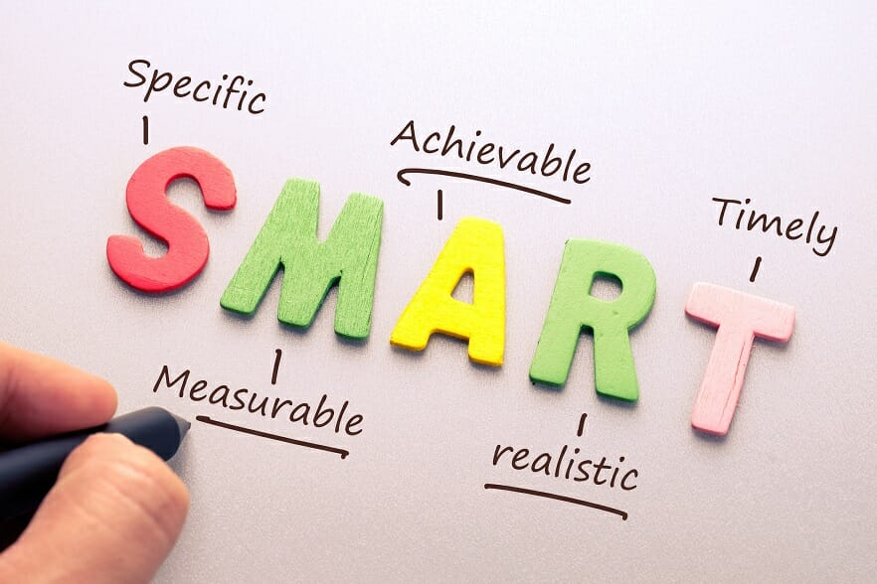

My goals must be simple and realistic for me to achieve it or else it will demotivate me and I will not want to carry on. Before anything, I need to ask myself why I chose this career?
For e.g. I currently work in a nursery, but I want to become a teacher in a few years, so one of my specific goals may be to gain more knowledge and experience in this role.
MEASURABLE
Measuring my objectives is important, I can easily find out my capability and progress for that, for example in my career I can measure my skills how much I gain, and if I do any training it would be help me more to progress my professional
ACHIEVABLE
When I want to do something, I want to set my mind on it and get it done. This means that it is important to make sure that I can actually achieve them within my time period and make sure I gain more skills and experience to be more successful.
RELEVANT
These steps showing me how my goals valuable for me, basically everyone needs support to achieve somethings, for that I need to remain calm and slowly going forward. to develop my career goals, I need the right qualifications, and understand about myself about how I can be the right person for this position.
TIME MANAGEMENT
It is also very important goals in everybody`s life, without time binding not able to success, for that I have to fixed my goals that means within 2 years I will become a good teacher and for this position whatever need to achieve I will do.
These SMART tools find lots of beneficial my life, now I can set my tools and looking forward it, it gives me more clarity to focus my career.
REFLECTING MYSELF
According to Gibbs module, it is really helpful to develop any one`s career. This cycle demonstrated to me that there are different experiences at the workplace and that I will meet different people and children everyday so I found that everyone’s thought is unique; basically, everyone’s character is different so it gives me lots of new experiences, and meet different team members and working with them are getting new learning as well.
This model helped me to analyse events and how I should properly and calmly overcome and deal with the situation and if my reaction was poor, what could I do to improve it next time.
Gibbs model teach that repeat my experiences over and over again, it depends on some situations such as description, feelings, action plan, evaluation analysis and conclusion. Now I am going to be discussing a bit about this:


(The University of Edinburgh, 2020)
DESCRIPTION
Sometimes description is really helpful based on the experience, in the work place what happened is described means situation comes out and learning through that situation which means I end up learning more skills and how to overcome situations.

Some really good questions to ask myself:
- What was the incident
- Where did the incident happen and when?
- What was the outcome of the situation and did that outcome satisfy you?
- any one present that time, cause for witness.

FEELINGS
Sometimes in the workplace showing feelings is very important, because children are very sensitive, they always want love and attention. For example, in the playground children were playing and suddenly one fall down and start crying, so that time I need to express my feelings and sort out the problem if its minor, feeling proud when the children are happy.
EVALUATION
Everyone has good or bad experiences in the work place, comes through by experience and handle the problem is a great solution by reflecting on it in your own time and how the situation could be sorted out better. E.g., if the child fell down then I act really quickly, that’s a positive case because I quickly helped them.
ANALYSIS
When somethings solve in the workplace and repeat and analysis about that situation that means finding ways to solve the situation more efficiently and quickly. E.g., see how hurt the child is after falling over and if they are hurt.
(The University of Edinburgh, 2020)
ACTION PLAN
This is where the person thinks about what they do next to prevent something like this from happening again in the future and what kind of skill is needed. E.g., I would have to fill out a form about the child being hurt and make sure what I could do better next time to be better preparation for the children. I could carry few band aids.
After the Gibb’s model, I thought it was really helpful to developing my personal career and life.
I should reflect on it and think about what I have learnt from it and what else I could have done to make the outcome more positive for all the people that were included. E.g., I would reflect about this and make sure I was paying more attention to my surroundings and how this would develop my personal career.
Now I am going to complete my professional career development assessment, it is a great opportunity to revise my past. in my whole journey and my worked place description gave me more confidence that what I am being, here I was reflecting what could I do better to focus my goals, every one should know that “time does not wait for none” so I am quite satisfied for myself because the majority things I have done and continuously I am focusing to develop my career.
As I am mention before that my future career would be a good teacher so for that I have to do postgraduate teacher training course and I need to work towards qualified teacher status, and need to involved school experiences which one I am currently doing.
(Education.gov.uk, 2021)

References
Mindtools.com. (2016). SMART Goals: – How to Make Your Goals Achievable. [online] Available at: https://www.mindtools.com/pages/article/smart-goals.htm [Accessed 13 Apr. 2021].
UKEssays.com. (2020). Personal and Professional Development Assignment for International Business. [online] Available at: https://www.ukessays.com/essays/personal-development/personal-and-professional-development-assignment-for-international-business.php [Accessed 14 Apr. 2021].
The University of Edinburgh. (2020). Gibbs’ Reflective Cycle. [online] Available at: https://www.ed.ac.uk/reflection/reflectors-toolkit/reflecting-on-experience/gibbs-reflective-cycle [Accessed 16 Apr. 2021].
‌Corporate Finance Institute (2020). SMART Goal. [online] Corporate Finance Institute. Available at: https://corporatefinanceinstitute.com/resources/knowledge/other/smart-goal/ [Accessed 18 Apr. 2021].
‌ Investopedia. (2021). How SWOT (Strength, Weakness, Opportunity, and Threat) Analysis Works. [online] Available at: https://www.investopedia.com/terms/s/swot.asp [Accessed 18 Apr. 2021].
‌ Education.gov.uk. (2021). Get Into Teaching: Steps to become a teacher. [online] Available at: https://getintoteaching.education.gov.uk/steps-to-become-a-teacher [Accessed 18 Apr. 2021].
‌

‌

‌

