

Programme: Master of Business Administration
Module: Marketing Management
Module code: LCMB7024
Lecturer: Sinan He
Assignment Title: Marketing Environment Analysis

Title: Marketing Environment Analysis and Strategic Growth Strategy for BHP's Transition towards a Lower Carbon Business Model

Student name: Divyang Ashvinbhai Kaklotar
Student ID number: 2536588
Word Count: 2620
Date of Submission: 23 July2026
Executive Summary
This report aims to analyse the factors of the external marketing environment in relation to BHP's future shift towards low carbon products and to suggest an appropriate growth strategy. The natural, political and legal environments are identified as the drivers of customer expectations, compliance to regulations and competitive positioning. The Ansoff Matrix suggests that product development is the most appropriate strategy for BHP, as it makes the most of the company's existing capabilities while also helping to advance the decarbonisation goals. Successful long-term competitive advantage requires innovation, trust of stakeholders and good sustainability implementation, the report concludes.

Table of Contents
Introduction 4
Task 1: Marketing Environment Analysis 4
1.1 Introduction to the Marketing Environment Analysis 4
1.2 Overview of BHP's Low Carbon Transition 4
1.3 External Marketing Environment Actor 1: Natural Environment 5
1.2.1 Climate Change and Decarbonisation Pressures 5
1.2.2 Resource Scarcity and Environmental Sustainability 5
1.2.3 Changing Customer and Stakeholder Expectations for Lower Carbon Products 6
1.2.4 Critical Evaluation of the Natural Environment 6
1.3 External Marketing Environment Actor 2: Political and Legal Environment 7
1.3.1 Environmental Regulations and Climate Policies to Lower Carbon Products 7
1.3.2 Critical Evaluation of Political and Legal Influences 7
1.4 Synthesis of External Marketing Environment Actors 7
Task 2: Strategic Growth and Competitive Positioning 8
2.1 Introduction and Linking the Environmental Analysis to Strategic Growth 8
2.2 Critical Evaluation of Growth Strategies Using the Ansoff Matrix 8
2.2.1 Overview of the Ansoff Matrix 8
2.2.2 Market Penetration 9
2.2.3 Market Development 9
2.2.4 Product Development 10
2.2.5 Diversification 10
2.3 Proposed Strategic Growth Approach for the Transition to a Lower Carbon Business Model 10
2.3.1 Strategic Justification 10
2.3.2 Implementation in BHP's Lower Carbon Transition 10
2.3.3 Risks and Strategic Challenges 11
2.4 Achieving Competitive Advantage During the Lower Carbon Transition 11
2.4.1 Differentiation Strategy 11
2.4.2 Long-Term Competitive Position 11
2.5 Critical Summary of the Strategic Recommendation 12
Task 3: Critical Reflection on AI Usage 12
3.1 Introduction 12
3.2 Tool Disclosure 12
3.3 Critical Evaluation of AI Output 13
3.4 Contribution Analysis 13
3.5 Ethical and Professional Reflection 13
3.6 Reflective Conclusion 13
Conclusion 14
References 15

List of Figures
Figure 1: Operational GHG emissions 7
Figure 2: Production of copper by BHP worldwide 8
Figure 3: Ansoff Matrix 10
Figure 4: BHP approach to sustainability 13

Introduction
The international mining industry is under rising pressure to lower its carbon emissions while securing long-term competitiveness (Hodge et al., 2022). This report discusses the impact of external marketing factors on the BHP’s move towards lower carbon products, puts forward an Ansoff Matrix growth strategy and assesses sustainable competitive advantage.

Task 1: Marketing Environment Analysis

1.1 Introduction to the Marketing Environment Analysis
External marketing environment influences mining firms’ adaptation mechanisms to climate change and stakeholders’ expectations (Antonio et al., 2025). In FY2025, BHP, being the world’s largest mining firm, released 46.8 billion into the economy, while minimizing its operational Scope1 and 2 GHG for 5% compared to FY2024 (BHP, 2026). Such indicators highlight that environmental performances have become integral to the firm’s long-term competitiveness, requiring environmental stewardship to precede regulatory compliance. This is why natural, political and legal environment analysis is relevant for assessing BHP’s comparative advantage in a lower-carbon market.

1.2 Overview of BHP's Low Carbon Transition
BHP allows low-carbon production from renewables, decarbonisation programs and partnerships in support of a low carbon position for sustainable steel making (BHP, 2024a). BHP has pledged Scope 1 and 2 emissions reduction of 30% and a FY2020 neutral baseline by FY2030 (BHP, 2024b). These measures will make BHP competitive by providing a growing demand for more lower carbon responsibly mined products. Strategic factors meaningful to value of sustainability in long term include customer demand, competition, decarbonisation costs and critical minerals impacts (Zhang, 2025). Thus, BHP sustainability transition is a strategy opportunity and potential competitive threat.
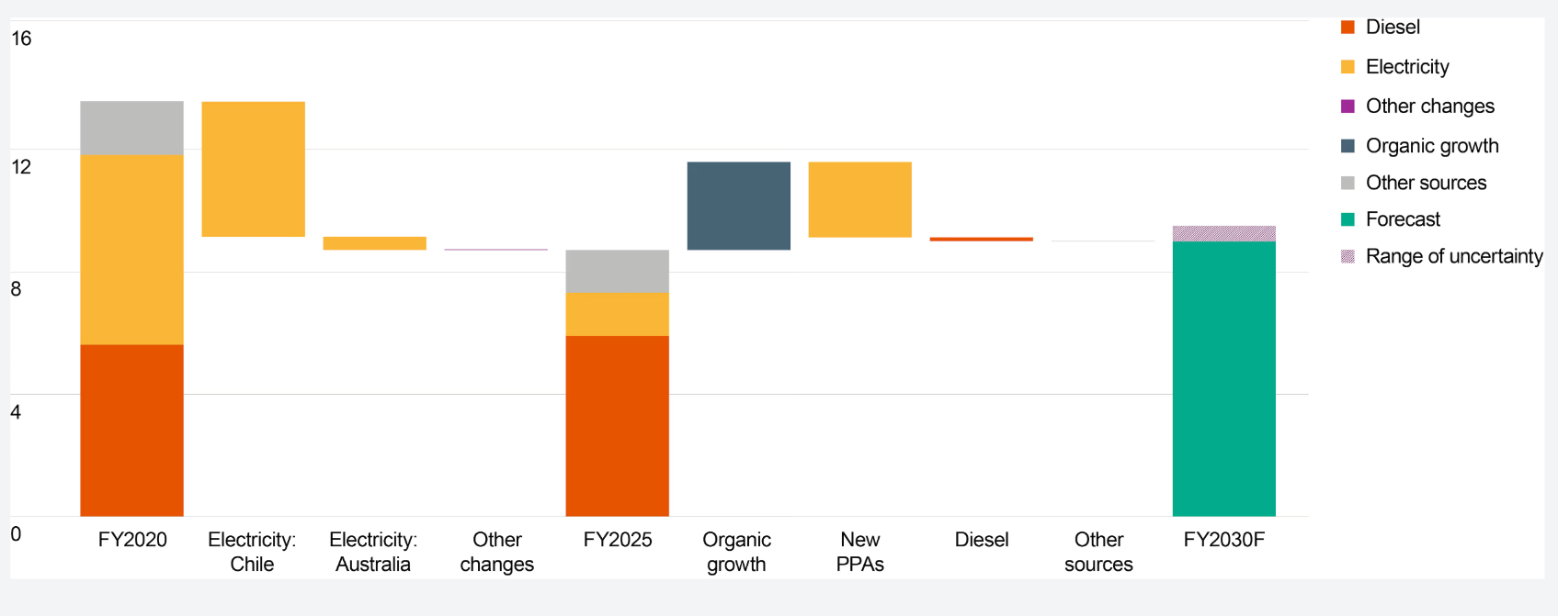

Figure 1: Operational GHG emissions
(Source: (BHP, 2024b)

1.3 External Marketing Environment Actor 1: Natural Environment

1.2.1 Climate Change and Decarbonisation Pressures
Climate change is an external factor that impacts BHP's strategy, marketing position, and stakeholder relationship, as noted by Wright and Nyberg (2024). The challenge for BHP is for regulators, investors and consumers to put a greater focus on the company to make sure it cuts emissions from all activities and throughout its supply chain. BHP now on FY2025 operational GHG emissions reduction with a plan to cut emissions in scope 1 and scope 2 by 5% from FY2025 base-line by FY2030 (BHP, 2026). These measures allow BHP’s customers to cut supply chain emissions and promote its climate ambitions and sustainability commitments. The strategy depends on technology development, investment and customers’ willingness to buy what contain lower carbon commodities.

1.2.2 Resource Scarcity and Environmental Sustainability
Resource scarcity can also be problematic by limiting water sources and the protection of biodiversity and land use management (Dinar, 2024). BHP produced 2.02M tonnes of copper in FY2025, compared to approximately 1.87M metric tons in FY2024, driven by increased transition mineral demand as well as the environmental responsibility in FY2025 (Sasu, 2025). Sustainable mining can improve resilience while heightening conflicts with global communities, indigenous peoples and environmental agencies (Ford et al., 2020). The process of regulatory approval could be further restrictive. In consequence, BHP would need to reconcile between transition mineral demand and environmental concerns to maintain its social licence.
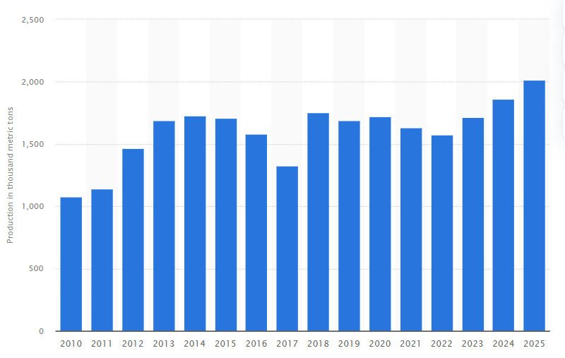

Figure 2: Production of copper by BHP worldwide
(Source: Sasu, 2025)

1.2.3 Changing Customer and Stakeholder Expectations for Lower Carbon Products
Shifting stakeholder expectations mean that lower carbon performance is a strategic market requirement to ensure BHP’s long-term profitability. Industrial customers are demanding lower carbon commodities. Investors prefer strong ESG performance and climate risk management (Foerster and Spencer, 2023). The production of steel accounts for 7% of all energy-related Co emissions, 2.6 gigatonnes of carbon dioxide (Gt CO2) emissions annually, which is rising the pressure on lower-emission raw materials (IEA, 2020). In addition, when governments are actively regulating abatement, local community is in favour of responsible business practice. BHP estimates that more than 70% of its Scope 3 carbon emissions are associated with the production of steel and lists the benefits of collaborating with customers to achieve decarbonisation targets (BHP, 2024a). BHP has committed to spend US$4billion on climate programs and has set Scope 1 and 2 emission reduction targets of 30% by FY2030 (BHP, 2024c). These commitments may increase customer confidence in the market and provide market differentiation.

1.2.4 Critical Evaluation of the Natural Environment
The Natural Environment provides a broad set of strategic opportunities and conundrums for the BHP lower-carbon transition. BHP intends to achieve 30% lower Scope 1 and 2 emissions by FY2030 while maintaining a FY2025 Copper output of two million tonnes (BHP, 2026). Yet elevated mineral production to enable electrification has implications of exacerbated environmental effects and sustainability paradox. BHP strategy enhances company reputation, customer interests, and differentiation through moderate decarbonisation and diligent resource employment.

1.3 External Marketing Environment Actor 2: Political and Legal Environment

1.3.1 Environmental Regulations and Climate Policies to Lower Carbon Products
Environmental standards and climate policies influence BHP’s lower carbon transition, competitiveness and customer expectations. Such as more stringent government regulation of emissions targets, carbon pricing, climate reporting and the EU Union Carbon Border Adjustment Mechanism (CBAM) and increasing pressures on pollution-intensive supply chains (Pan and Liu, 2024). BHP has committed to reach net zero operating GHG emissions by 2050 and a 30% cut in Scope 1 and 2 emissions by FY 2030 (Reuters, 2023). However, the costs of transition will be higher due to regulatory variations, but Brazilian miner Vale will be investing up to 13bn reais ($2.56 billion) in decarbonisation attempts to stay competitive (Reuters, 2026). While popular, greener commodities may enhance customer reliance and help in meeting emissions objectives, affordability issue of the sustainability premiums could create radiances among customers. BHP needs to consider the cost of eco-conformance versus that of maintaining competitiveness and environmental leadership to clubber market differentiation.

1.3.2 Critical Evaluation of Political and Legal Influences
Legal and political factors pose both strategic opportunities and challenges for BHP’s lower-carbon transition. BHP’s climate spending of US$4 billion is indicative of regulatory impacts driving strategic environmental decisions in the longer term FY2022-FY2030 (BHP, 2024c), against competitors like Rio Tinto spending around $5–6 billion in decarbonisation initiatives (Rio Tinto, 2022). This creates elevated competitive pressure for BHP to maintain differentiation in its market. Moreover, industrial buyers have been demanding lower-carbon suppliers, they have been unwilling to compensate for the sustainability price premiums. Therefore, implying regulatory adaptation drives brand credibility, customer relationship and strategic advantage

1.4 Synthesis of External Marketing Environment Actors
The natural environment is pushing BHP to transition to a lower carbon business due to demand from customers, Climate investments and increasing regulation. However, through ensuring compliance and presenting stakeholder pressure, the Political and Legal environment is hastening this transition. Although BHP’s minerals are aiding in decarbonisation worldwide, the increased extraction process adds to the social and environmental issues facing the business. However, BHP’s sustainability must be enhanced through innovation, transparency and partnerships as rivals are able to imitate this to diminish BHP’s long-term advantage.

Task 2: Strategic Growth and Competitive Positioning

2.1 Introduction and Linking the Environmental Analysis to Strategic Growth
Environmental pressures indicate that BHP’s lower carbon transition is driven by climate change, regulation, stakeholder pressure and competition from Rio Tinto and Vale. BHP’s knowledge of copper and nickel helps BHP develop lower-carbon products through an Ansoff Matrix product development approach. Market penetration and market development offer increment growth, but product development better fits BHP’s capabilities than diversification.

2.2 Critical Evaluation of Growth Strategies Using the Ansoff Matrix

2.2.1 Overview of the Ansoff Matrix
Ansoff Matrix assesses four growth options including market penetration, market development, product development and diversification (Hanlon, 2021). However, for BHP it offers a clear tool for consideration of lower-carbon pathways of growth. The current model however misses the complexity of sustainability, regulation, stakeholder response and the environment and so facilitates extra strategic judgment in the mining decision.
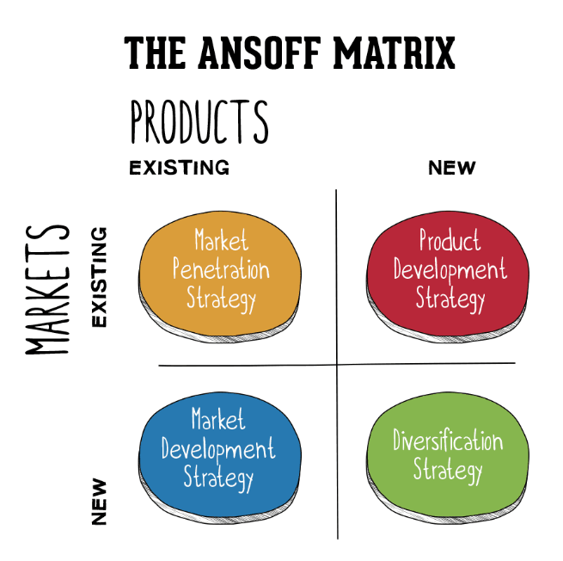

Figure 3: Ansoff Matrix
(Source: Hanlon, 2021)

2.2.2 Market Penetration
Market penetration involves the expansion of sales of an existing product in existing markets (Harahap et al., 2024). For BHP, it might ensure stability but offers little distinction in a lower-carbon economy. However, reducing emissions, finding efficiencies and using cleaner operation technologies may promote the BHP’s viability and competitiveness. Nevertheless, this will not differentiate BHP effectively in a rising lower carbon commodities market.

2.2.3 Market Development
Market development is about using existing products in new markets. BHP may find it attractive to enter the renewable energy markets with its transition minerals. Success would be perceived if customers prioritize lower-carbon sourcing over price (Cano et al., 2023). However, due to the varying regulation and market acceptance, these markets may not provide as much growth as expected for BHP.

2.2.4 Product Development
Product development is about the launch of new products for existing markets. It relates to BHP’s strategy of lower-carbon transition well, since the development of lower-carbon commodities can facilitate the approach toward target customers’ emission reduction target. This will boost BHP’s competitive positioning and stakeholder trust. It also depends on technological capability, reverse and investment level and customers’ value of lower-carbon product.

2.2.5 Diversification
Diversification allows BHP to introduce new products to renewable energy and low-carbon technology markets. However, it also involves higher uncertainties and risks with limited experience and significant investment and uncertain returns (He et al., 2025). Relative to other alternative strategies, BHP can lose focus of its core competencies and add further complexity to strategic decision making. As an alternative to diversification strategy, Product development is the most appropriate strategic option because it builds on BHP’s existing capabilities, creates lower-carbon value and enhances competitiveness.

2.3 Proposed Strategic Growth Approach for the Transition to a Lower Carbon Business Model

2.3.1 Strategic Justification
Product development is well-aligned for BHP as enhanced copper and nickel capabilities underpins BHP’s growth in transition minerals to support renewable energy and electrification. BHP can offer lower carbon products that build from existing brands and infrastructure and customer relationships. Compared to diversification, a product development approach minimizes strategic risk and enhances differentiation but management of competitive advantage depends on continuous innovation, tangible sustainability indicators and generating customer benefits.

2.3.2 Implementation in BHP's Lower Carbon Transition
Product development will be key for BHP to develop in carbon mitigation, and could be driven by investments in renewable energy sources, emissions-reduction technology, and low-carbon operations. BHP climate strategy predicts investing US$4 billion by FY2030 and achieve net-zero operational emissions by 2050 (BHP, 2024c). BHP could use electrification, renewable power and open carbon accounting which would make a supplier of trustworthy natural resources.

2.3.3 Risks and Strategic Challenges
There are an investment cost risk, technological risk, competence pressure, and stakeholders' pressure because of BHP's focus on the environment. To address these issues, BHP needs to build up the deepening of technology alliances, listen more to its community and investor pressure and establish more transparent communication for its focus on the environment. Additionally, it should focus more on investments having a higher possibility to reduce emissions thereby boosting its resource-based performance (Wu et al, 2023). In conclusion, BHP should find a way of combining environmental commitments with strong commercial performance.

2.4 Achieving Competitive Advantage During the Lower Carbon Transition

2.4.1 Differentiation Strategy
BHP can stand out on supply; supply to be less-carbon-intensive commodities capable of enabling customers to spend less on supply chain emissions. BHP’s future-facing minerals position is helped as copper production is forecasted to be up 9% in FY2024, the highest in 15 year (BHP, 2025). BHP should differentiate through tangible environmental performance, transparent reporting and sustainability partnership with customers. This can secure customer relationships, community uplift, bolster reputation and reduce commodity competition.

2.4.2 Long-Term Competitive Position
Over the long-term, BHP’s competitive advantage relies on the combination of decarbonisation strategies with growth. By FY 2050, BHP aims to reduce its Scope 1 and 2 operational emissions by 30%, and to achieve net zero operational emissions by the same year (BHP 2026). These pledges promote continued investor interaction and influence on relationships with and access to customers due to purchasing. However, BHP needs to concentrate on innovating, technology implementation and maintaining stakeholder relationships to ensure an advantage as other multinationals follow.
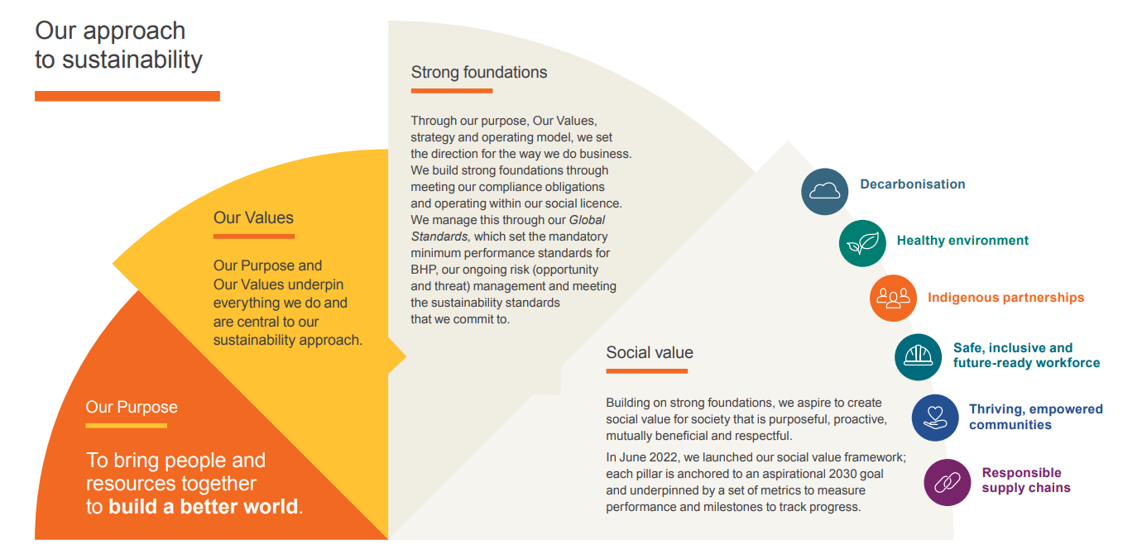

Figure 4: BHP approach to sustainability
(Source: BHP, 2026)

2.5 Critical Summary of the Strategic Recommendation
According to Ansoff analysis, product development seems the most appropriate strategy for BHP to make use of its existing resources and potential sustainability opportunities. It delivers customer value, but does not involve the high risk of diversification strategies. Moving into lower carbon commodities, investing in innovation and developing stakeholder confidence are all ways that BHP can be competitive for long term. Overall, product development appears the most promising in this context.

Task 3: Critical Reflection on AI Usage

3.1 Introduction
This report was enabled with the help of AI, which improved the quality of marketing analysis, increased the efficiency of analytical work, and organized information. At the same time, I acknowledge that my strategic judgment, critical analysis and ethical responsibility is necessary to ensure that I remain in a position of accuracy and academic integrity when dealing with AI.

3.2 Tool Disclosure
In preparing this report, I received support from the AI service ChatGPT. I used the AI to help me review report structure, generate initial ideas, source alternative language and identify potential line of analysis on BHP’s marketing environment and strategic growth. I used the AI for support in organisation and review, not as substitute for my own analysis. As per the university AI use acknowledgement, I have disclosed use of AI and remain responsible for content, evidence and critical appraisal.

3.3 Critical Evaluation of AI Output
While AI contributed to the faster generation of my report, I knew I could not rely on its output without a thorough scrutiny of my report because it could deliver untrustworthy, outdated and unsubstantiated data. For instance, during the mining company’s sustainability analysis, AI generated broad statements that needed to have been cross-checked before being used (Corrigan and Ikonnikova, 2024). I confirmed the accuracy of the information by consulting reputable sources such as BHP publications, scholarly articles, and journals. I also examined the strategic recommendations reached by the AI system to get a better sense of what meanings would be suitable for the Ansoff Matrix range for BHP. Hence, developed AI was utilized as supportive method rather than replacement of my own decision.

3.4 Contribution Analysis
AI was used in the initial brainstorming, structure refinement, and clarity of written expression. The analysis and interpretation of evidence as well as strategic decision making, however, was a product of my own judgment. I looked at BHP's skills, moving difficulties, rivals and opportunities to pick product development as the treatment strategy to be followed. AI did arrange ideas, but my strategic decision making, taking care of stakeholders, and competitive analysis were still important. Thus, the final arguments and conclusions are a product of my own academic thought.

3.5 Ethical and Professional Reflection
AI tools should be utilized in a moral, ethical, and transparent manner and should follow professional responsibilities. I know that there can be a little flesh in the recommendation of data using AI, there can be some bias, there can be incomplete information, there can be issues of privacy. That's why I used AI wisely, by checking the facts, respecting academic honesty and basing my final marketing choices on my own judgment. The use of AI is important in maintaining the integrity and reliability of the profession.

3.6 Reflective Conclusion
This experience has drawn out the meaning of responsible utilization of AI for me. I will employ AI to improve marketing efficiency and my critical judgement, ethical awareness, and professional responsibility, in future marketing decision-making.

Conclusion
In conclusion, the lower carbon transition of BHP needs strategic adaptation to changes from the environment, regulations and stakeholders. New product development gives the strongest growth driver to BHP through capabilities utilization and customer value creation. However, ongoing innovation, credibility and stakeholder management will remain fundamental in grasping a lasting competitive edge.

References
Antonio, N., Marika, I., Christian, F. and Chiara Pia, S. (2025) ‘How stakeholder engagement drives environmental innovation to Mitigate climate change: Evidence from European small caps’, Business strategy and the environment. Available at: https://doi.org/10.1002/bse.70101
BHP (2026) BHP annual report 2025. Available at: https://www.bhp.com/-/media/documents/investors/annual-reports/2025/250819_bhpannualreport2025.pdf (Accessed 19 July 2026).
BHP (2025) BHP financial results for the year ended 30 June 2024. Available at: https://www.bhp.com/-/media/documents/media/reports-and-presentations/2024/240827_bhpresultsfortheyearended30june2024.pdf (Accessed 19 July 2026).
BHP (2024a) Steelmaking decarbonisation. Available at: https://www.bhp.com/news/bhp-insights/2025/12/steelmaking-decarbonisation (Accessed 19 July 2026).
BHP (2024b) Operational GHG emissions (scopes 1 and 2 emissions from our operated assets). Available at: https://www.bhp.com/sustainability/climate-change/operational-ghg-emissions (Accessed 19 July 2026).
BHP (2024c) Climate transition action PLAN 2024 bringing people and resources together to build a better world. Available at: https://www.bhp.com/-/media/documents/investors/annual-reports/2024/240827_bhpclimatetransitionactionplan2024.pdf (Accessed 19 July 2026).
Cano, J.A., Allec, A., Campo, E.A. and Fernández, S.A. (2023) ‘Sustainable business models of E-Marketplaces: An analysis from the consumer perspective’, Journal of Open innovation, 9(3), pp.100121–100121. Available at: https://doi.org/10.1016/j.joitmc.2023.100121
Corrigan, C.C. and Ikonnikova, S.A. (2024) ‘A review of the use of AI in the mining industry: Insights and ethical considerations for Multi-Objective optimization’, The extractive industries and society, 17, pp.101440–101440. Available at: https://doi.org/10.1016/j.exis.2024.101440
Dinar, A. (2024) ‘Challenges to Water resource management: The role of Economic and modeling approaches’, Water, 16(4), pp.610–610. Available at: https://doi.org/10.3390/w16040610
Foerster, A. and Spencer, M. (2023) ‘Corporate net zero pledges: A triumph of private climate regulation or more greenwash’, Griffith law review, 32(1), pp.1–33. Available at: https://doi.org/10.1080/10383441.2023.2210450
Ford, J.D., King, N., Galappaththi, E.K., Pearce, T., McDowell, G. and Harper, S.L. (2020) ‘The resilience of Indigenous peoples to environmental change’, One earth, 2(6), pp.532–543. Available at: https://doi.org/10.1016/j.oneear.2020.05.014
Hanlon, A. (2021) The ansoff model. Available at: https://www.smartinsights.com/marketing-planning/create-a-marketing-plan/ansoff-model/ (Accessed 19 July 2026).
Harahap, M.A.D., Soemitra, A. and Rahma, T.I.F. (2024) ‘Market penetration strategy by increasing firm competitiveness’, Golden ratio of Marketing and applied psychology of business, 5(1), pp.44–52. Available at: https://doi.org/10.52970/grmapb.v5i1.712.
He, Y., Li, W., Tan, X. and Sun, Y. (2025) ‘Economic policy uncertainty, digital transformation, and bank systemic risk’, International Review of Economics & Finance, 102, p.104309. Available at: https://doi.org/10.1016/j.iref.2025.104309.
Hodge, R.A., Ericsson, M., Löf, O., Löf, A. and Semkowich, P. (2022) ‘The global mining industry: Corporate profile, complexity, and change’, Mineral economics, 35. Available at: https://doi.org/10.1007/s13563-022-00343-1
IEA (2020) Iron and steel technology roadmap – analysis. Available at: https://www.iea.org/reports/iron-and-steel-technology-roadmap (Accessed 19 July 2026).
Pan, X. and Liu, S. (2024) ‘The development, changes and responses of the european union carbon border adjustment mechanism in the context of global energy transition’, World development sustainability, 4, pp.100148–100148. Available at: https://doi.org/10.1016/j.wds.2024.100148
Reuters (2023) BHP says path to achieving Net-Zero carbon emissions “Non-Linear.” Available at: https://www.reuters.com/sustainability/bhp-aims-reduce-emissions-least-30-by-2030-2023-06-21/ (Accessed 19 July 2026).
Reuters (2026) Brazil's Vale plans to invest $2.6 billion in decarbonization initiatives. Available at: https://www.reuters.com/business/energy/brazils-vale-plans-invest-26-billion-decarbonization-initiatives-2026-06-15/ (Accessed 19 July 2026).
Rio Tinto (2022) Climate change. Available at: https://www.riotinto.com/en/sustainability/climate-change (Accessed 19 July 2026).
Sasu, D.D. (2025) BHP’s production of copper 2010-2025. Available at: https://www.statista.com/statistics/274231/bhp-copper-production-volume/?srsltid=afmboooek3mrmbpd5lsalupx0ersixogiiwbjfvx9fj1frbinx8aypsk (Accessed 19 July 2026).
Wright, C. and Nyberg, D. (2024) ‘Corporations and climate change: An overview’, WIREs climate change, 15(6). Available at: https://doi.org/10.1002/wcc.919
Wu, G., Xu, L. and Cai, Y. (2023) ‘The impact of Green finance on carbon emission efficiency’, Heliyon, 10(1), pp.e23803-e23803. Available at: https://doi.org/10.1016/j.heliyon.2023.e23803
Zhang, H. (2025) ‘Resilience of critical transition minerals supply chain in the context of strategic rivalry: Implications for the national policy and regulatory frameworks’, Journal of Energy & Natural Resources Law, pp.1–27. Available at: https://doi.org/10.1080/02646811.2025.2495920

