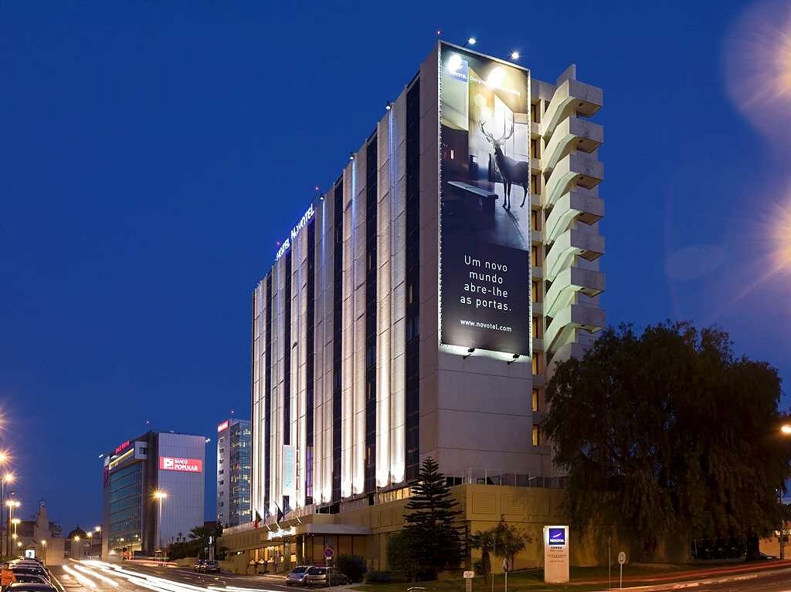
Module: BMIH6005
Student’s Name:
Student’s ID:

D
Delivered On: June 03, 2023
Report By: Unique Consultancy Services
Client’s Name: Maximiano Pestana, GM at Combo Midscale Accor Lisboa- Novotel & Mercure
Consultancy Report on Novotel Lisboa Hotel
Organisational Consultancy
Students Name: Md Forhad Hossain
Student Id: 1706033
Lecturers name: Julia Ault

Table of Contents
Executive Summary 2
Introduction 5
Scope & Analysis 6
Overview of the Hotel 6
Recent Feedbacks 7
PESTEL Analysis 7
SWOT Analysis 9
Main Body 12
Problem Tree Analysis 12
Analysis of the Problems & their Solutions 14
Findings & Results 19
TOWS Analysis 19
Area of Improvement 21
Infrastructural Issues 21
Service-Related Issues 21
Employee management Issues 22
Action Plan 23
Recommendations 26
Conclusion 27
References 28
Appendices 35

Executive Summary
Novotel Lisboa Hotel, located in Central Lisbon, Portugal is situated near the Gulbenkien Foundation and only 500 metres from Lisbon Zoo and is close to the nearest metro station, bus station and airport. It offers a comfortable stay to the guests and offers up to 2 children (under 16 years) stay free there (Hotel.com, 2023). This hotel is famous for its international and Portuguese cuisine served at the restaurant. The breakfast is famous among tourists and very positively reviewed (Expedia.com, 2023). Being a child-friendly hotel, it mainly attracts parents with their small children to stay here. Despite having modern amenities and great food items, this hotel has been facing low guest incoming recently. To identify the problems and to solve them, Unique Consultancy Services have been appointed. Upon being chosen for this purpose, a general survey has been performed and guests’ reviews have been analysed based on different booking websites e.g. booking.com, expedia.com, tripadvisor.com etc.
The key problems of this hotel are mostly related to infrastructure and service related. Being close to the airport has its cons, such as extreme sound pollution, which is prominent to the guest because of the inadequate noise cancellation system. Additionally, the faulty air conditioning, old & stained carpet and covers, slow Wi-Fi, employee issues, pricing for car parking, small lifts, front desk management etc. are some of the main issues that the hotel is facing. But before moving to the extensive analysis of the problems and probable solutions, some analytical tools E.g. PESTEL and SWOT analysis have been performed (Buye, 2021). As per the PESTEL analysis, economic uncertainty, increased unemployment, increased costs etc. have reduced the tourist flow to the hotel. Though the economy is projected to recover soon, the increasing challenges regarding human resources management, technology advancement, legal bindings etc. might cause deterred business activities (Julião et Al. 2020).
The hotel’s core strengths, opportunities, threats and weaknesses have been identified by the SWOT analysis (Mccollum, 2021). This has further been utilised as per the internal outlook of the hotel through TOWS analysis. The impact of Covid-19 is still prevalent within the hotel, especially for the staff management. There is a need for skilled workers for the front-desk, housekeeping, restaurant and car parking (Immaneni et al. 2021). The necessity of change has been acknowledged initially via problem tree analysis that has pointed out the core issues of the hotel, which are to be solved. It has been seen that, if the problems are not solved within 03 months (approximately), then the hotel might face serious repercussions, as the relationship management is very unprofessional. So. Based on the importance of the situation and its ability to be resolved, the problems and their solutions have been ranked, which are as follows:
- Changing the parking costs and reducing them to £13/ £14 per day
- Re-establishing and enhancing Wi-Fi facilities and increasing speed to 100Mbps
- Identifying and fixing all the broken USB ports, changing the wiring system to introduce new charging points near the beds
- Detecting the faulty A/C and replacing or repairing them within 03 months
- Installing a noise cancellation system, especially for the roadside rooms
- Providing relationship managers with exclusive training on customer management and front-desk management to reduce booking-related problems and negative reviews
- Changing the broken furniture and fixtures E.g. springs of sofa bed and old windows in many rooms
- Ensuring proper cleaning and regular housekeeping maintenance
- Installing two new lifts and gym equipment within three months
- Recruiting two new chefs and 03 other restaurant employees to help guests get faster service and warmer foods for breakfast, lunch and dinner
One alarming situation regarding the hotel is that there is no relationship manager appointed who actively replies to the bad and good reviews on the websites (Teixeira et al. 2022). This is a big chance to retain current customers and attract new ones. So, the hotel needs to take steps regarding this. Employee disengagement might be an issue for the problems in housekeeping (De Moura, 2021). So a summer party has been planned to take place at the last week of May 2023. Most of the problems are related to infrastructural and appliance-related. So, after making sure that all proposed steps have been taken care of, it can be said that customers will be happy again (Silva et al. 2021). Following is the action plan along with estimated costs and time frame:
No. | Problem | Solution | Date of Completion | Planned Budget*
1 | Noise from airports and roads | Installing high-quality noise-cancellation devices | 31/08/2023
  £11,500
2. | Costly car parking | Increasing parking space and reducing car parking charge to £13/ £14 per day | 17/06/2023
  £5,800
3. | Malfunctioning A/C | Repairing the faulty A/C and installing new ones | 31/07/2023 | £122,000
4. | Small lifts | Installing two new lifts | 31/07/2023 | £116,000
5. | Slow Wi-Fi speed, broken USB ports & charging points | Changing wiring for the charging points and USB, increasing Wi-Fi speed | 27/06/2023 | £29,000
6. | Broken furniture and fixtures | Buying new sofa beds and changing worn-out fittings | 31/07/2023 | £75,000
7. | Gym service | Adding 02 new equipment | 31/08/2023 | £81,000
8. | Housekeeping & food service | Revising the work plan and recruiting 5 new restaurant employees | 30/06/2023 | £60,000
9. | Cleanliness | Creating a new checklist and cleaning plan | 17/06/2023 | £18,000
10. | Staff Training | Staff training sessions, workshops and Party | Party on  30/06/2023 | £40,000
This three-month-long plan is costly because of the installation costs of lifts, A/Cs, furniture, gym facilities etc. But these costs will prove to be fruitful, as they will make the hotel to be modernised and comfortable. Though the hotel is currently focusing on family travellers, after these refurbishments, it will be able to target a broader segment E.g. business and solo travellers to the hotel and gain more profit. So, keeping the summer season and increasing flow of tourists in mind, the hotel should start following the plan readily.

Introduction
Offering an ideal stay for business and leisure travellers, Novotel Lisboa Hotel serves as a complete package of transportation, accommodation and culinary experience (Booking.com, 2023). This hotel is famous for its extensive breakfast buffet choices while offering spacious rooms, a fitness centre, an outdoor pool, free Wi-Fi etc. The nearby attractions are also easily accessible due to its location at Av. José Malhoa 1-1A, Campolide, 1099-051 Lisbon, Portugal. This hotel is just a 5-minute walk from the nearest metro station and only 500 yards away from the Lisbon Zoo and Gulbenkien Foundation (Accor.com, 2023). This hotel holds a 4 rating on TripAdvisor, an 8 rating for facilities on Hotel.com and a 7.7 rating on Hotel.com denoting its emphasis on serving customers to ensure their comfort and satisfaction. Despite having several positive aspects, the hotel sometimes fails to live up to the expectation of the customers regarding some issues, e.g. noise cancellation issues, cleanliness, staff behaviour, furniture and fixtures, gym facilities and connectivity & car parking issues etc. Unique Consultancy Services have been appointed as the consultant to identify the major issues regarding the hotel’s services to ensure customer satisfaction. Based on the website reviews from customers and employee feedback, this report will identify every aspect that is bringing a negative impact on the customers. At first, macro-environmental analysis such as PESTEL analysis will be done to learn about the hotel’s external environment (Severo et al. 2021). Then SWOT and TOWS analyses will help to pinpoint the nature of positive and negative internal resources of the hotel to solve the current problems and search for prospects. Moreover, it will use a decision tree model to identify the problem and find the solution (Chang et al. 2023). These models and tools will help to create a set of activities to be performed to ensure the loyalty of existing customers while attracting new ones.

Scope & Analysis

Overview of the Hotel
Novotel Lisboa is a 4-star hotel under the Accor Group. This hotel is famous for its location and amenities as it is only 5 miles away from the airport, a 2-minutes walk away from the nearest bus stand and only a 10-minutes walk away from the metro station (Kayak.com, 2023). This hotel offers 249 air-conditioned and spacious rooms, including 150 rooms for non-smokers. It is also convenient for business meetings with 10 meeting rooms and the hotel’s catering system.
Property Amenities
The hotel has paid parking spot in the hotel surroundings, a pool, a bar, a fitness centre and free newspaper and Wi-Fi. One major positive factor of this hotel service is that- it is pet friendly and has a good number of rooms for smokers. Family orientation is one of the main strategies of its business, so there are kids’ play area, kids club and kid-friendly buffet (Easyjet.com, 2023).
Food
The breakfast buffet is one of the most positively reviewed services of Novotel Lisboa Hotel. Though the service is a bit slow, the customers have often expressed their contentment because of the food items. The menu is a blend of Portuguese and Continental items, which help the customers, explore more of the local cuisine.
Business-related Facilities
There are 10 meeting rooms of different sizes for different purposes- from small meetings to large conferences (Accor.com, 2023). It has a concierge facility, parking garage and in-house catering and decoration team for smooth business event arrangement. As it is very close to the nearest bus, metro stations and airports, event attendees find it easier to come to the hotel.

Recent Feedbacks
Though Novotel Lisboa has been in service for many years and has frequent visits from visitors, these days, it has been failing to increase loyal customers. Based on the reviews given on several hotels booking websites, such as booking.com, expedia.com. Tripadvisor.com etc., it has been found that, the main issues lies regarding noise cancellation, slow Wi-Fi, poor gym facilities, slow front desk and housekeeping, cold foods etc. Some of those reviews are shown in the appendices. All the positive and negative aspects listed above can be used as scopes for further improvement (Costa & Costa, 2019).

PESTEL Analysis
PESTEL analysis serves as a tool to analyse the macro environment of an industry of a certain area (Achinas et al. 2019). The country where the hotel of discussion is situated can have an impact on the performance of the hotel. As a part of the Accor group, Novotel Lisboa is also affected by several macro-environmental issues in Portugal. Following is the analysis:
P | Political | - Stable political condition (Breda et al. 2020)  - Being a part of the EU and Schengen area member attracts more tourists  - Leading party’s emphasis on steady fiscal policy (Gumiel, 2023)  - Change in travel policy due to Covid-19
E | Economic | - Increased economic challenges due to Ukraine-Russia War and Covid-19  - Increase in expected GDP to £280 billion in 2023, £20 billion higher than in 2022 (Tradingeconomics, 2023)  - Lower tourist visits from European countries  - A historic high inflation rate of 8.1% in 2022, which is expected to lower by 2% in 2023 (Europa.eu, 2023)  - Increasing unemployment (Fonseca & McGarrigle, 2019)  - Exchange rate fluctuations of Euro and GBP
S | Social | - A good blend of the different migrant populations working in the hotel industry (Rauhut, 2021)  - Increasing living cost lessens the Portuguese tourists to visit and stay at hotel  - Rising unemployment and poverty (Rodrigues & Franco, 2020)
T | Technological | - Internet accessibility to 84% of the population (Sousa et al. 2023)  - Increased use of mobile apps, websites etc. to book hotels in Portugal (Alotaibi, 2020)  - Use of Accor All mobile app by Accor Group  - Need for more ICT innovation in Portugal (Padeiro et al. 2021)
E | Environmental | - Natural resources that can be utilised to attract more tourists  - The increased importance of sustainability (Ferreira et al. 2021)  - Reduction of wastage and increase of recycling and reusing  - Usage of green energy and reduction of carbon footprint (Salazar, 2020)
L | Legal | - Compliance with labour and environmental laws  - Inadequate hospitality staff availability  - Covid-19 related health safety measurements (Hameed et al. 2021)
Portugal’s economy has been facing a significant turn since 2020. Due to covid-19 pandemic, the economy country took a hit, and the hospitality sector was among the worst sufferers (Estevão et al. 2022). Though the country has been recovering from the downturn, the GDP growth rate of 2023 is estimated at 1.6%, which is significantly low (Europa.eu, 2023). The travel restrictions have been reduced and many tourists have been visiting Portugal these days. Novotel Lisboa has also seen a rise in guest booking at the hotel.
The political situation in Portugal is stable and is predicted to remain so which is favourable for the growth of tourism. The focus on keeping a stable monetary and fiscal policy is expected to improve economic growth (Venter, 2020). The unemployment rate in 2023 is still on the rise, indicating that many people are actively seeking jobs. This can be an opportunity for the hospitality sector to employ more people here (Coelho et al. 2020). As a part of the Accor group, Novotel Lisboa also faced problems regarding trained staff availability.
The impact of technological advancement cannot be denied. 78% of hoteliers expect to increase their tech budget to double in 2024 (Alemar, 2023). Novotel Lisboa also uses Accor All as a way to get bookings. Additionally, it uses several booking websites and websites to attract people. People holding Accor Points can easily book an Accor hotel, get an upgrade or get other help via these points (Denysenko & Breus, 2020). Additionally, the management team via system software is doing staff management.

SWOT Analysis
This analysis comprises the internal and external resources of a company based on which it can strengthen its position in the market and easily identify the threats and make strategies to avoid them (Chennana, 2020). Following is the SWOT analysis of Novotel Lisboa Hotel:
Strengths  - Situated near the metro station, bus stand and only 5miles distance from the airport  - Located at the heart of Lisbon  - Have 249 air-conditioned rooms, including smoking & non-smoking rooms  - Family-friendly, dining, playing and entertainment services for kids  - Having a pet-accepting policy  - Easy for business travellers as they have all-inclusive business event arrangement capabilities (Gurbisic et al. 2022) | Weaknesses  - Costly car-parking facilities  - Small outdoor pool, inadequate gym facilities  - Room cleanliness (Stained bed sheet, pillow covers etc.)  - Malfunctioning air conditions, USB ports  - Loud noises from the nearby airport  - Slow connectivity of Wi-Fi  - Staff behaviour at the reception (Triatmanto et al. 2019)
Opportunities  - Delicious breakfast buffet  - Big rooms with good views  - Conference facilities including decoration and catering  - Outside taxi rank  - Social media marketing for promotion (Magano & Cunha, 2020)  - Noise cancellation tools installation | Threats  - Nearby Hotels: Corinthia Lisbon, Hotel Lis-Baixa, Lisboa Carmo Hotel (Tripadvisor.com, 2023)  - Potential competitors- summer cottages, Airbnb, less-expensive hotels  - Reduced number of tourists due to the Ukraine- Russia war  - The increased cost of resources
Strengths- The best feature of Novotel Lisboa is its location. Guests find it easy to come here, as it is only 5 minutes' walking distance from the nearest bus stop and metro station. Additionally, the great choice of breakfast food, child-friendly behaviour and facilities has made the hotel a desired staying solution for parents with kids.
Weaknesses- The front desk operation is slow, and the employees working there are not knowledgeable enough about technologies such as E-wallets (Mota Veiga et al. 2022). Additionally, it has loud sounds coming from the nearby airport and the roads. Almost all the poor and terrible ratings on Tripadvisor.com show that customers frequently faced two problems- super slow Wi-Fi and malfunctioning or broken A/C.
Opportunities- The already existing breakfast menu is a big deal for the guests. The hotel can use it for promoting their restaurant food. There are around 39 other hotels within 300 metres, making people easily dine in those places. Additionally, child-friendliness is a great convenience for young parents, so it can also be promoted via social media marketing (Fernandes et al. 2022).
Threats- Covid-19 has hit the hospitality industry hard and Novotel Lisboa is no exception. Additionally, changed labour laws and immigration policies have made it tougher for hoteliers to find suitable employees (Lopes et al. 2021). So, finding more friendly and tech-savvy employees is quite tough in this situation.

Main Body
Novotel Lisboa acts as one of the best 10 mid-range hotels in Lisbon, Portugal and is widely popular amongst parents with kids. Despite its excellent breakfast buffet, outdoor pools, and good event arrangement facilities, the hotel faces serious issues regarding the front desk, check-in system, noise cancellation and furniture, fixtures and electronic appliances.

Problem Tree Analysis
The problem tree works as a planning tool to map the root cause of the core problem that an entity is facing and the impact that will be created by the root causes (Romanocsky et al. 2018). This is an anatomy of the cause-and-effect relationship helping the consultants find out the most important problems. Following is the problem tree analysis of Novotel Lisboa:
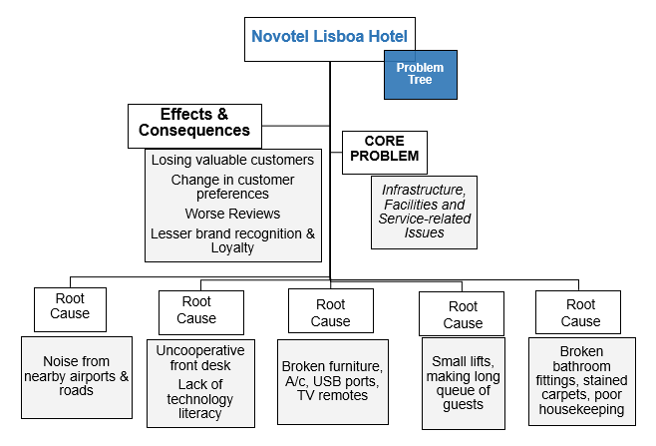
Figure 01: Problem Tree of Novotel Lisboa Hotel
Source: Author’s Creation
Core Problem- The main problem of Novotel Lisboa can be divided broadly into three issues- infrastructural, facilities and service-related. The incompetence to make a proper balance in these sectors has made customers face problems while staying here.
Root Cause- Under the core issues, the root causes of the problem can be identified as shown above. These are the basis of the analysis done in this report. Most of the service-related problems can be solved by proper grooming and training sessions (Viseu et al. 2020). Additionally, infrastructural and service issues can be solved by installing new amenities, appliances and by doing refurbishment. The root causes are as follows:
- Slow front-desk services
- Uncooperative employees at front desk
- Costly parking space
- Small lifts and long queues before them
- Old and faulty air-conditioning system, no USB charging port in many rooms, non-working TV remotes
- Stained curtains, carpets, shower curtains
- Moulded washroom fittings
- Faulty furniture- broken springs of sofas, cracked windows, small windows in some rooms making them darker
- Slow or non-connective Wi-Fi
- Small pool area
- Loud noise from roads and nearby airport
- Inadequate Gym Facilities
Effect- In case the problems are not handled properly, the effect can be drastic (Sanabria-Díaz et al. 2021). Many of the reviewers, who hold platinum or gold Accor status, have already shared their willingness to be a part of the Group’s services. This is an alarming situation where customer retention is at stake. So, the problems need to be solved immediately.

Analysis of the Problems & their Solutions
Noise Issues
The hotel is located on the way to Lisbon airport. While it is a good deal for the guests who like to arrive at a hotel fast, it irritates all because of the flying aeroplanes coming across 300/400 feet above the hotel. Moreover, the front-side rooms also suffer from traffic noise from the streets. These noises denote that the noise cancellation tools of the hotel are not operating properly.
Solution
- Installation of noise-cancelling devices, noise dampening wall panels (Jablonska, 2020)
- Checking the windows of each room, whether any of them are broken, making the windows soundproof
- Introducing padding on the walls to cancel noise
Car Parking Issues
Car parking cost is £2 per hour, which is costly for the guests. Additionally, the car parking rates are not mentioned properly on the booking websites, where it is listed that car parking at this hotel is £11 per day, while it is £11 per exit (tripadvisor.com, 2023). So, it becomes hard for tourists travelling in their cars to come and exit the car park as frequently as they need. Some guests also mentioned that the employee at the car parking was unprofessional.
Solution
- Revising the car parking charging policy
- Making a revised cost for the facility E.g. £13/ £14 per day
- Training the respective employees/ replacing them

Hotel Equipment Issues
The lifts of the hotel are small and slow, which makes the guests wait in a long queue to get on them. Most of the air conditions are either broken or malfunctioning. The USB ports are working in 100 rooms only, the others are not working. Many of the reviewers also have commented that they want charging ports near their beds. In some rooms, TV remotes are not working.
Solution
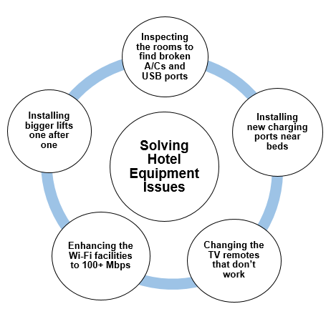
Figure 02: Solution of Hotel Equipment Issues
Source: Author’s Creation
Ensuring customer comfort and satisfaction is the most important aim of the hotels (Veloso et al. 2021). Novotel Lisboa is advertised as a fully air-conditioned hotel. So, guests expect to get a cosy staying experience here. The faulty A/Cs are needed to be fixed within one (01) month so that no other customer feels discomfort. It is to be kept in mind that many of the guests of this hotel are parents with small kids. So, maintaining a proper temperature at the hotel is important (Tiago et al. 2020). Additionally, the long queue is a big negative side of the hotel. To change this, the four lifts of the hotel should be changed one after one, so that guests do not face problems. Lift changing needs to be done at a time when the hotel has the least people to come. The other set-ups like USB ports, TV remotes and charging points need to be changed and installed within two months as wearing tends to take time.
Housekeeping Issues
Though the employees of the hotel are appreciated for their services, Some problems are remaining mostly related to the pool cleaning, bathroom cleaning and stained curtain & bed covers. Many of the guests have found an inadequate number of tea bags, sugar sachets and coffee sachets. The bathroom appliances are worn out in many rooms- broken showerheads, dirty shower curtains and moulded walls in some rooms make the problem apparent. The sofa beds’ springs are broken in some rooms, which need to be changed within 01 month.
Solutions
- Training the housekeeping staff and arranging feedback sessions with them
- Setting up a list of rooms that need bathroom refurbishment
- Changing the broken sofa beds within 01 month
- Changing mouldy bathroom tiles
- Changing the stained curtains, sofa and bed-covers
- Ensuring that enough tea bags, coffee and sugar sachets are available on arrival

Employee Management
The employees of Novotel Lisboa are mostly reviewed as friendly and cooperative. The main problem lies with the front desk and housekeeping area. The front desk sometimes takes a long time to confirm a reservation, making journey-exhausted guests wait longer. Moreover, the hotel policy requires to show a physical debit/credit card, while many people nowadays use e-cards. The non-acceptance policy of e-cards creates a problem for the guests. Guest relationship management is also faulty as many of the negative reviews of websites are kept unattended (Sá et al. 2022).
Solution
- Enquiring employees of their motivations and needs
- Giving training to the front-desk employees
- Making the cleaning schedule of housekeeping staff more frequent
- Making the review responses more readily available
- Recruiting more front-desk and parking staff
- Changing the card acceptance policy
Facilities in Gym and Pool Area
The gym has a very small area having only four instruments. Two of them are not functioning. So, these machines are needed to be changed immediately with a refurbishment plan in mind. The pool area is small and cannot accommodate the large number of guests at the hotel. The pool staffs need to be more frequent to clean the overall changing room and pool surroundings.
Food Service
Though the breakfast service is good, the buffet system is slow and takes time to serve. So, people who need to leave early cannot enjoy the breakfast buffet. The staffs at the restaurant are friendly and the ambience of the restaurant is nice. So, customers have mostly given positive reviews regarding the food service. But according to some reviews, the breakfast items are served cold and the dinner is not available in the room. The bar is the only place where dinner is served. So, these issues need to be changed. Appointing 2 more chefs at the restaurant may make the cooking faster ensuring hot food is served.
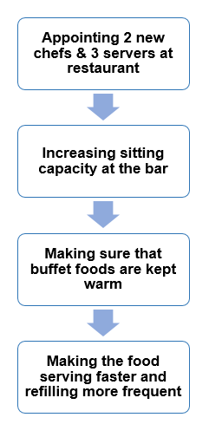
Figure 03: Solutions regarding Food Service Issues
Source: Author’s Creation

Findings & Results
Novotel Lisboa is renowned for its service, and extensive focus on serving families with kids, breakfast buffets and so on but still faces some problems regarding its infrastructure, human resources and services. To solve the issues, Unique Consultancy Services has already pointed out some core issues and their impact as well as their solutions.

TOWS Analysis
TOWS analysis is a planning tool that uses SWOT analysis and helps to look at the external factors that might pose threats and opportunities (Momin, 2021). For creating action plans, TOWS offer better resources than SWOT.

Internal Factors | External Factors
Internal Factors |  | Opportunities | Threats
Internal Factors | Strengths | S/O (Strengths & Opportunities)  - Making the Breakfast Buffet the best food choice (Serving warm food early and refilling it)  - Utilising the location benefit by making the rooms soundproof  - Promoting the hotel as kid-friendly | S/T (Strengths & Threats)  - Diversifying the target market from family-oriented to all types of guests  - Making the full air-conditioning promotion real by installing and repairing A/Cs
Internal Factors | Weaknesses | W/O (Weaknesses & Opportunities)  - Revising car-parking facilities  - Installing new gym equipment  - Ensuring faster Wi-Fi connectivity | W/T (Weaknesses & Threats)  - Staff management at reception and housekeeping  - Priority to cancel noises
Here, the most important strategies are in S/O and W/T categories (Tonoli, 2021). In S/O category, the strengths of Novotel Lisboa have been used to maximise the opportunities. The main inspiration of the above strategy is to utilise the already existing opportunities as strengths. That is why Novotel should use its kid-friendliness as a marketing point to attract more families (Lopes et al. 2021). Additionally, using their much-appreciated breakfast buffet as a key resource, they can attract food enthusiasts. One thing that can be strength, as well as a threat, is its position near the airport. E.g. If they fail to reduce the noise faced by the guests, they will get irritated, resulting in more negative reviews. On the other hand, by making proper use of noise reduction tools, they can utilise the convenience of their location easily.
Though the family-targeted business has proven to be a good business point for Novotel Lisboa, it has ignored other segments of the market E.g. business event attendees, solo travellers etc. So, apart from the families, this hotel should diversify its target market. Changing the threats to strengths is a tough job (Wilke et al. 2019). The hotel will be able to do so by following this report’s guideline to change all faulty furniture and appliances within 01 month.
The human resources of the hotel are acting as a weakness for the overall operation of the hotel (Costa et al. 2021). The front desk acts as the mood setter for the guests. They get negative first impressions due to delays in the check-in process and the lack of digital knowledge of the employees. Giving proper direction to the staff, and amending the current service rules will help to achieve guests’ satisfaction.

Area of Improvement
Following is the summary of the key issues identified in the previous chapter:

Infrastructural Issues
Particulars | Solutions
Loud noises from the airport and roads | Installation of noise-cancelling devices, dampening wall panels, paddings etc. within 2 months
Small lifts | Installation of bigger lifts. Changing 02 of the 04 existing lifts one by one
Air-conditioning system | Is one of the priorities Needs to be checked and replaced within 02 months
Broken springs of sofa bed | All the worn-out sofa beds will be replaced with new and more convenient ones
Broken USB ports and charging sockets | All the USB ports will be changed within 15 days, while new charging sockets will be installed within 3 months

The most prioritised issues to be addressed and solved are noise cancellation, malfunctioning A/Cs and broken sofa beds. As people are most frequently pointing out these problems, these are of the highest importance to solve. If deemed necessary, the authority may also change the existing TVs and install new (bigger) ones for further customer satisfaction.

Service-Related Issues
Particulars | Solutions
Slow Wi-Fi | Ensuring 100Mbps speed of Wi-Fi and connectivity on every floor of the hotel
Housekeeping | Maintaining a clear work chart, supervised by the higher authority so that housekeeping is done at least thrice a day
Changing the banging doors | Doors that have spring-related issues must be changed within 02 months. Some windows are not free to open & need to be freed
Regular cleaning of the room | Changing the stained bed covers, sofa covers
Washroom cleaning | Regular washroom cleaning, changing the mouldy fittings within 02 months
Gym service | Changing the faulty gym equipment within 03 months and including at least 2 new gym instrument
Pool cleaning services | The outdoor pool and changing area must be cleaned every 30 minutes
The change of stained bed covers, sofa covers, curtains and carpets can be done in the least amount of time. The cleaning/ housekeeping manager should assign one supervisor for each floor of housekeeping so that guests can easily find them when needed (Magalhães et al. 2023). Additionally, the gym and pool facilities are to be revised readily as many people love to spend time at the pool during this summer season. Moreover, the most important factor under this point is to change the Wi-Fi so that people can easily remain connected via the Internet.

Employee management Issues
Particulars | Solutions
Car parking | Reducing car parking cost to £13/ £14 per day
Front desk | Ensuring proper training of the employees about e-cards, e-payment policies etc.
Food services | Recruiting 02 new chefs and 03 new servers at the restaurants
Staff feedback session, annual summer event etc. | Collecting insights about employee motivation and boost their enthusiasm for work (Santos & Moreira, 2021)
The employees of Novotel Lisboa have opined themselves to be happy and engaged in the work. The reviewers also expressed happiness about the cooperation of the staff in most of the cases. The front office staff should get a technology-knowledge-boosting workshop within two months so that they can handle the booking and welcome more smoothly (António & Rita, 2021).

Action Plan
The issue identified from previous discussions regarding guest relationship management (online & offline), car parking, reception, gym and pool facilities, housekeeping, food serving, appliance and furniture setting etc. is listed below with their probable solution and approximate cost calculation:
No. | Problem | Solution | Desired  Outcome | Time Needed | Date of Completion | Planned Budget*
1 | Unbearable noise from the road and nearby Lisbon Airport | Selecting the road-side rooms for heavier sound blocks and other rooms for adequate noise cancellation | Less irritated guests, insurance of comfortable stay, positive reviews | 03 months | 31/08/2023
  £11,500
2. | Costly car parking | Increasing parking space and reducing car parking charge to €13/ €14 per day | Ensuring more convenience for the guests | 15 days | 17/06/2023
  £5,800
3. | A/C replacement and repairing | Repairing the faulty A/C and installing new ones where needed | Comfort, the convenience of the guests | 02 months | 31/07/2023 | £122,000
4. | New Lift Installation | Installing two new lifts | Reduce the waiting period for the guests | 03 months | 31/07/2023 | £116,000
5. | Wi-Fi speed, broken USB ports & charging points | Changing wiring for the charging points and USB, increasing Wi-Fi speed | Greater connectivity with customers  Ensuring brand loyalty | 25 days | 27/06/2023 | £29,000
6. | Broken furniture and fixtures | Buying new sofa beds and changing mouldy and worn-out fittings | Reducing the negative reviews and making staying experience more comfortable | 02 months | 31/07/2023 | £75,000
7. | Gym service | Adding 02 new gym equipment | Making health enthusiasts contented | 03 months | 31/08/2023 | £81,000
8. | Housekeeping & food service | Revising the work plan and recruiting 5 new restaurant employees | Ensuring that guests can get warm and delicious food faster, can get housekeeping readily available | 01 month | 30/06/2023 | £60,000
9. | Cleanliness | Creating a new checklist and cleaning plan | Helping people enjoy the clean pool, gym and room | 15 days | 17/06/2023 | £18,000
10. | Staff Training | Increasing staff motivation and capabilities | Developing service quality of staff | Annual summer party | 30/06/2023 | £40,000
*Note: All currencies are calculated in Euro (€) and all the figures are estimated values.

Recommendations
The report has already pointed out several positive and negative aspects of Novotel Lisboa Hotel. These aspects hold a significant impact in using them for future development as shown by the TOWS analysis (Kulshrestha & Puri, 2017). Though the findings have shown several problem-resolving measurements, it is still important to rank all those solutions as per their importance. The following tasks have been sorted according to their priorities to be done:
- Changing the parking policies and reducing the parking charges. It will be better if the parking lot can be expanded, but the current parking facility is also good enough.
- Re-establishing the Wi-Fi facility and increasing the speed to it up to 100Mbps and making central Wi-Fi available on every floor, hotel lobby, rooms, pool and gym.
- Identifying the rooms with broken USB and mobile charging points, changing the TV remotes as soon as possible (within 25 days)
- Changing the A/C and broken springs of sofa beds. Searching for faulty fittings, broken basins, and mouldy corners and repairing those.
- Ensuring good quality noise cancellation tools instalment (especially in the roadside and lower-floored rooms). Maintaining good quality sound insulation in all the rooms.
- Installing two new bigger lifts for the guests’ convenience.
- Appointing two new chefs for a new menu and swift food preparation while hiring three new employees at the restaurant to serve the guests properly.
- Adopting new worksheets for pool cleaning and housekeeping. Hiring three new employees in that department.
- Introducing employee evaluation systems and staff training sessions regarding technology usage.
- Overall, ensuring a positive environment is present at the hotel that makes employees engaged and enthusiastic.

Conclusion
Unique Consultancy Services has been appointed to identify the problems and prospects of the current situation of Novotel Lisboa Hotel. This hotel has been in business for many years and has got an excellent reputation for its location, family-friendliness, kids’ convenience, delicious breakfast buffet etc. After being appointed, data have been gathered from secondary resources like reviews on booking websites and one-to-one interviews with customers and the management team. To get a broader idea of the organisational environment, PESTEL and SWOT analyses have been performed. It has been seen that the economy of Portugal is recovering from the slump of covid-19 and is creating a positive impact on the hotel sector of Portugal. Additionally, the SWOT analysis showed that the hotel has numerous resources to take advantage of and get rid of the problematic scenarios faced now.
The key problems are separated into several sectors but can be listed under three broad categories- infrastructural, service-related and employee management. It has been seen that noise is a very big issue for the guests, as many of them complained about it. Additionally, slow Wi-Fi, worn-out furniture, malfunctioning A/Cs, slow and cold food serving, absence of housekeeping on time, costly car parks etc. are some of the major problems, which need to be solved right away. This report has ranked all these issues and has laid out solutions and strategies to be adopted within the set time. New A/C and lifts will be installed, broken USB ports will be changed and new charging ports will be installed beside the beds for the convenience of the customers. Changing car parking charges will not take much time, so it is on the initial priority list. The employees are another crucial part who are responsible for the delivery of the service. Housekeeping and front-desk management should adopt new strategies, like re-scheduling, more supervising and employee training to enhance the capabilities of the employees while increasing customer satisfaction. All the solutions provided along with the estimated costs can be used properly after taking a look at the TOWS analysis, which denotes the most important strategies to take advantage of. By following the proposed plans within the stipulated time frame, as well as managing employees, the hotel will be back on track in no time and will serve a bigger segment of people.

References
Accor.com, (2023) Novotel Lisboa Available at: https://all.accor.com/hotel/0784/index.en.shtml?utm_campaign=seo+maps&utm_medium=seo+maps&utm_source=google+Maps (Accessed: 01 June, 2023)
Achinas, S., Horjus, J., Achinas, V., & Euverink, G. J. W. (2019). ‘A PESTLE analysis of biofuels energy industry in Europe’. In Sustainability, 11(21), 5981.
Agoda.com, (2023) Novotel Lisboa Available at: https://www.agoda.com/novotel-lisboa_4/hotel/lisbon-pt.html?cid=1844104 (Accessed: 01 June, 2023)
Alemar, S. (2023) 70+ Hotel Statistics You Need to Know in 2023 Available at: https://www.canarytechnologies.com/post/hotel-statistics (Accessed: 01 June, 2023)
Alotaibi, E. (2020). ‘Application of machine learning in the hotel industry: a critical review’. In Journal of Association of Arab Universities for Tourism and Hospitality, 18(3), 78-96.
António, N., and Rita, P. (2021). ‘COVID-19: The catalyst for digital transformation in the hospitality industry?’ In. Tourism & Management Studies, 17(2), 41-46.
Booking.com, (2023) Novotel Lisboa Available at: https://www.booking.com/hotel/pt/novotel-lisboa.en-gb.html?aid=356980&label= 0&keep_landing=1&sb_price_type=total&type=total&#tab-main (Accessed: 02 June, 2023)
Breda, Z., Panyik, E., and Costa, C. (2020). ‘Internationalization of the hotel industry: evidence from Portugal’. In Public Policy, 5(2), 81-96.
Buye, R. (2021). ‘Critical examination of the PESTEL Analysis Model.’ In Project: Action Research for Development.
Chang, V., Liu, L., Xu, Q., Li, T., and Hsu, C. H. (2023). ‘An improved model for sentiment analysis on luxury hotel review’ In. Expert Systems, 40(2), e12580
Chennana, R. R. (2020). Achieving Sustainable in Hotel Industry by Introducing More Environmentally Friendly Eco-Tourism Practices and Promotion Green Consumers and Tourism (Doctoral dissertation, Instituto Politecnico de Leiria (Portugal)).
Coelho, I. L., Sousa-Uva, M., Pina, N., Marques, S., Matias-Dias, C., and Rodrigues, A. P. (2020). ‘Economic crisis in Portugal: Trajectory of the incidence of depression and correlation with unemployment’ In Acta Médica Portuguesa.
Costa, N., Oliveira, C. M., and Oliveira, I. (2021). ‘The role and relevance of human resource management and its practices in the portuguese hotel industry’. In Tourism and hospitality management, 27(2), 407-427.
Costa, V., and Costa, C. (2019). ‘Competitiveness and business performance in the Portuguese hotel industry’. In Proceedings of the 2nd International Conference on Tourism Research (ICTR 2019) (pp. 28-36).
Denysenko, M., and Breus, S. (2020). ‘Hotel business management in modern business conditions’. In Economic strategies for the development of society.
Easyjet.com, (2023) Novotel Lisboa Available at: https://www.easyjet.com/en/holidays/portugal/lisbon/lisbon-city/novotel-lisboa (Accessed: 01 June, 2023)
Estevão, C., Duarte, P., Cabral, A., Campón-Cerro, A. M., and Yuliati, U. (2022). ‘Factors Affecting Portuguese and Spanish Hotel Guests’ Safety Perception Under COVID-19: Insights for the Development of Personalized Hotel Offers’. In Tourism Entrepreneurship in Portugal and Spain: Competitive Landscapes and Innovative Business Models (pp. 263-282). Cham: Springer International Publishing.
Europa.eu (2023) Economic Forecast for Portugal Available at: https://economy-finance.ec.europa.eu/economic-surveillance-eu-economies/portugal/economic-forecast-portugal_en (Accessed: 01 June, 2023)
Fernandes, J. F., Maguire, K., and Santos, L. L. (2022, May). ‘An Examination of the Sustainable and Green Practices of Portuguese Hotels’. In International Conference on Tourism Research (Vol. 15, No. 1, pp. 581-587).
Ferreira, S., Pereira, O., and Simoes, C. (2021). ‘Environmental Sustainability in the Hotel Industry: A Perspective from Eco Hotel Managers in Portugal’. In International Journal of Marketing Communication and New Media, 150-170.
Fonseca, M. L., and McGarrigle, J. (2019). ‘Immigration and policy: new challenges after the economic crisis in Portugal’ In. Impacts of the recent economic crisis (2008-2009) on international migration.
Grubisic, A., Santic, N., and Grubisic, D. (2022). ‘INNOVATIONS AND INCLUSIVITY IN TOURISM-PORTUGAL CASE STUDY’. In Economic and Social Development: Book of Proceedings, 104-113.
Gumiel, A. (2023) What issues will shape the Portuguese political agenda in 2023? Available at: https://www.vincesconsulting.com/en/what-issues-will-shape-the-portuguese-political-agenda-in-2023/ (Accessed: 01 June, 2023)
Hameed, N., Mahomed, R., and Carvalho, I. (2021). ‘Measures to be implemented in the hotel buffets during the COVID-19 pandemic’. In Anatolia, 32(1), 172-175.
Hotel.com, (2023) Novotel Lisboa Available at: https://novotellisboahotel.com-hotel.com/ (Accessed: 01 June, 2023)
Immaneni, K. M., Sailaja, V. N., and Naga, V. (2021). ‘A review of HR practices and employee retention in hospitality industry’. In European Journal of Molecular and Clinical Medicine, 7(7), 6698-6704.
Jablonska, J., and Trocka-Leszczynska, E. (2020). ‘Ergonomics of sound in a hotel environment’. In Advances in Human Factors in Architecture, Sustainable Urban Planning and Infrastructure: Proceedings of the AHFE 2019 International Conference on Human Factors in Architecture, Sustainable Urban Planning and Infrastructure, July 24-28, 2019, Washington DC, USA 10 (pp. 57-65). Springer International Publishing.
Julião, J., Gaspar, M., and Alemão, C. (2020). ‘Consumers' perceptions of circular economy in the hotel industry: evidence from Portugal’. In International journal of integrated supply management, 13(2-3), 192-209.
Kayak.com, (2023) Novotel Lisboa Available at: https://www.kayak.com/Lisbon-Hotels-Novotel-Lisboa.74907.ksp (Accessed: 01 June, 2023)
Kulshrestha, S., and Puri, P. (2017). ‘Tows analysis for strategic choice of business opportunity and sustainable growth of small businesses’ In Pacific Business Review International, 10(5), 144-152.
Lopes, A. S., Sargento, A., and Carreira, P. (2021). ‘Vulnerability to COVID-19 unemployment in the Portuguese tourism and hospitality industry’. In International Journal of Contemporary Hospitality Management.
Lopes, J. M., Oliveira, M., Lopes, J., and Zaman, U. (2021). ‘Networks, innovation and knowledge transfer in tourism industry: An empirical study of SMEs in Portugal’. In Social Sciences, 10(5), 159.
Magalhães, C., Araújo, A., and Andrés Marques, I. (2023). ‘Hotel workers’ perceptions on soft and hard skills in Porto, Portugal’ In Journal of Human Resources in Hospitality and Tourism, 22(1), 49-70.
Magano, J., and Cunha, M. N. (2020). ‘Digital marketing impact on tourism in Portugal: A quantitative study’. In African Journal of Hospitality, Tourism and Leisure, 9(1), 1-19.
Mccollum, P. D. (2021). Navigating the Consumer Electronics Retail Market in Portugal Throughout the Covid-19 Pandemic: Worten’s Strategic Response: A Strategy Case Study (Doctoral dissertation, Universidade Catolica Portugesa (Portugal)).
Momin. A (2021) TOWS Analysis: The Framework and How it Works in 4 Steps Available at: https://pestleanalysis.com/tows-analysis/ (Accessed: 02 June, 2023)
Mota Veiga, P., Fernandes, C., and Ambrósio, F. (2022). ‘Knowledge spillover, knowledge management and innovation of the Portuguese hotel industry in times of crisis’. In Journal of Hospitality and Tourism Insights.
Padeiro, M., Bueno-Larraz, B., and Freitas, Â. (2021). ‘Local governments' use of social media during the COVID-19 pandemic: The case of Portugal’. In Government information quarterly, 38(4), 101620.
Rauhut, D. (2021). Heading for a'Better Life'? Why Swedes Move to Portugal.
Rodrigues, M., and Franco, M. (2020). ‘Measuring the urban sustainable development in cities through a Composite Index: The case of Portugal’. In Sustainable Development, 28(4), 507-520.
Romanovsky, V. L., Zagrebina, E. I., Nikandrova, M. V., Gorina, L. N., Zimina, L. A., and Afanasiev, V. M. (2018). Using The Method Of «Tree Structure» For An Analysis Of The Impact On The Environment. www. mjltm. com info@ mjltm. org, 227.
Sá, S., Costa, E., Borges, I., Mota, C., Leite, S., and Noronha, A. R. (2022). ‘Online Guest Reviews Reputation: Its Importance in a Pandemic Crisis’. In Advances in Tourism, Technology and Systems (pp. 525-535). Springer, Singapore.
Salazar, C. G. (2020). Future of Revenue Management and Marketing in Portuguese Hospitality Industry (Doctoral dissertation, ISCTE-Instituto Universitario de Lisboa (Portugal)).
Sanabria-Díaz, J. M., Aguiar-Quintana, T., and Araujo-Cabrera, Y. (2021). ‘Public strategies to rescue the hospitality industry following the impact of COVID-19: A case study of the European Union’. In International Journal of Hospitality Management, 97, 102988.
Santos, N., and Moreira, C. O. (2021). ‘Uncertainty and expectations in Portugal's tourism activities. Impacts of COVID-19’. In Research in Globalization, 3, 100071.
Severo, E. A., De Guimarães, J. C. F., and Dellarmelin, M. L. (2021). Impact of the COVID-19 pandemic on environmental awareness, sustainable consumption and social responsibility: Evidence from generations in Brazil and Portugal. Journal of cleaner production, 286, 124947.
Silva, M., Melo, A., Melo, C., and Vasconcelos, S. (2021). The COVID-19 Aftermath: A Multidimensional Study on Hospitality Managers' Perceptions. In International Conference on Tourism Research (pp. 501-XVI). Academic Conferences International Limited.
Simonsen. J. (2019) Why and how to reduce noise in hotel rooms Available at: https://www.rockwool.com/group/advice-and-inspiration/blog/why-and-how-to-reduce-noise-in-hotel-rooms/ (Accessed: 02 June, 2023)
Sousa, L., Freitas, J., Pinto, M., Lemos, D., and Tavares, J. (2023). ‘Influence of Social Media Use Among Older Adults in Portugal’. In Activities, Adaptation and Aging, 1-17.
Teixeira, P., Eusébio, C., and Teixeira, L. (2022). ‘How diverse is hotel website accessibility? A study in the central region of Portugal using web diagnostic tools’. In Tourism and Hospitality Research, 22(2), 180-195.
Tiago, F., Borges-Tiago, T., and Couto, J. (2020). Human resources role in hospitality service quality. In Strategic Innovative Marketing and Tourism: 8th ICSIMAT, Northern Aegean, Greece, 2019 (pp. 81-89). Springer International Publishing.
Tonoli. C.S. (2021) SWOT or TOWS? Both of them! Available at: https://www.linkedin.com/pulse/swot-tows-both-them-c%C3%A9sar-augusto-tonoli (Accessed: 01 June, 2023)
Tradingeconomics.com (2023) Portugal Indicators Available at: https://tradingeconomics.com/portugal/indicators (Accessed: 01 June, 2023)
Triatmanto, B., Wahyuni, N., and Respati, H. (2019). Continual human resources empowerment through human capital and commitment for the organizational performance in hospitality industry. Quality Acses to Sucses, 20(173), 84-91.
Tripadvisor.com (2023) Lisbon Hotels: 4 Star Available at: https://www.tripadvisor.com/SmartDeals-g189158-zft9566-Lisbon_Lisbon_District_Central_Portugal-Hotel-Deals.html (Accessed: 01 June, 2023)
Trivago.com, (2023) Novotel Lisboa Available at: https://ar.trivago.com/en-145/oar/hotel-novotel-lisboa-lisbon?search=100-34749 (Accessed: 02 June, 2023)
Veloso, C. M., Magalhães, D., Sousa, B. B., Walter, C. E., and Valeri, M. (2021). Encouraging consumer loyalty: the role of family business in hospitality. Journal of Family Business Management, (ahead-of-print).
Venter, Z. (2020). ‘The interaction between conventional monetary policy and financial stability: Chile, Colombia, Japan, Portugal and the UK’. In Comparative Economic Studies, 62(3), 521-554.
Viseu, J., Pinto, P., Borralha, S., and de Jesus, S. N. (2020). ‘Role of individual and organizational variables as predictors of job satisfaction among hotel employees’. In Tourism and Hospitality Research, 20(4), 466-480.
Wilke, E. P., Costa, B. K., Freire, O. B. D. L., and Ferreira, M. P. (2019). ‘Interorganizational cooperation in tourist destination: Building performance in the hotel industry’. In Tourism Management, 72, 340-351.

Appendices
- Positive Reviews
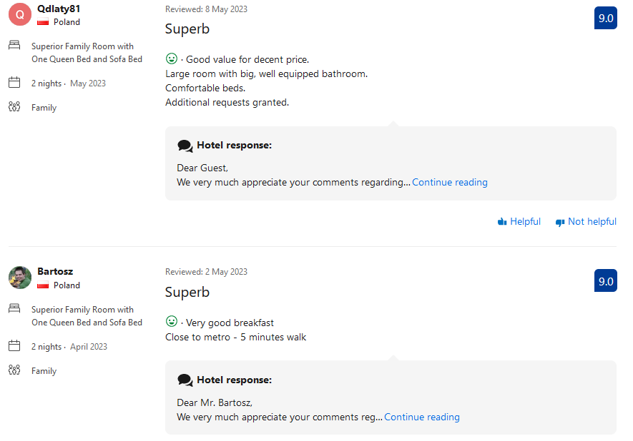
Source: Booking.com, (2023) Novotel Lisboa Available at: https://www.booking.com/hotel/pt/novotel-lisboa.en-gb.html#tab-reviews (Accessed: 03 June, 2023)
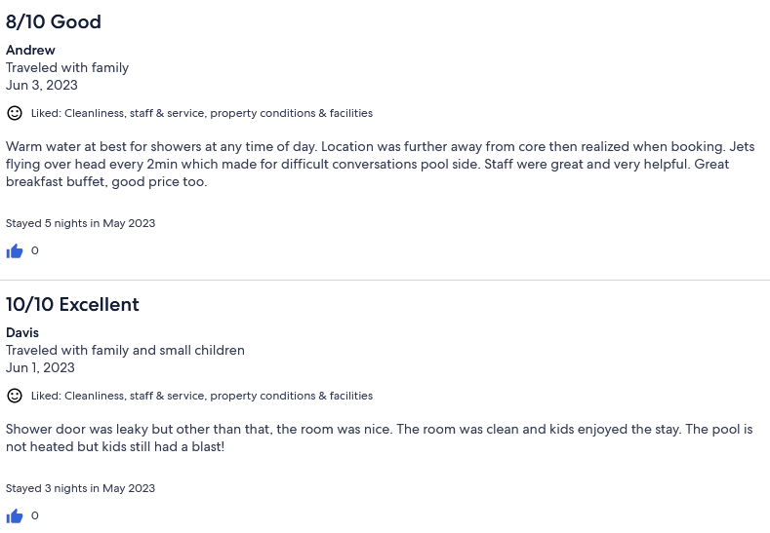
Source: Expedia.com, (2023) Novotel Lisboa Available at: https://www.expedia.com/Lisbon-District-Hotels-Novotel-Lisboa.h23808.Hotel-Information?pwaDialog=summary-reviews-property-summary-1 (Accessed: 03 June, 2023)

- Negative Reviews
2.1 Broken A/C, Noise, Slow Wi-Fi, Faulty furniture
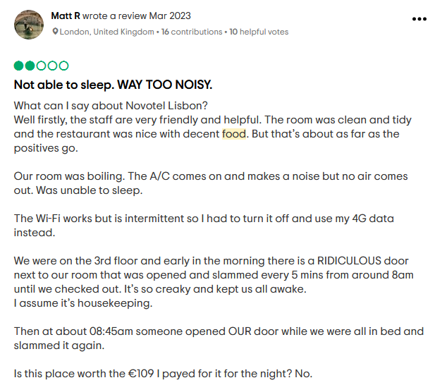

2.2 Front Desk Management
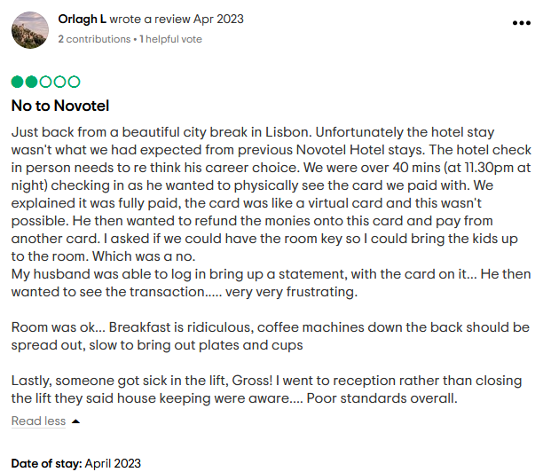

2.2 No Wi-Fi, Shabby Carpet & No USB points, NO Reply from Management
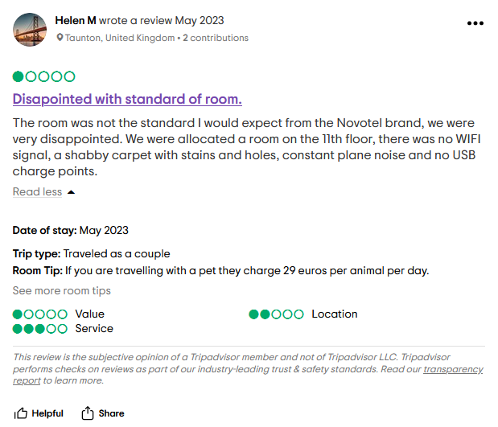
Source: Tripadvisor.com, (2023) Novotel Lisboa Available at: https://www.tripadvisor.com/Hotel_Review-g189158-d206897-Reviews-Novotel_Lisboa-Lisbon_Lisbon_District_Central_Portugal.html (Accessed: 02 June, 2023)
2.4 Parking Issues, Housekeeping
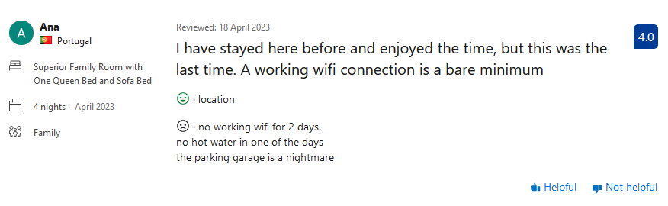
Source: Booking.com, (2023) Novotel Lisboa Available at: https://www.booking.com/hotel/pt/novotel-lisboa.en-gb.html#tab-reviews (Accessed: 02 June, 2023)

