Name:__Luke Colwill_______________________________

Student Number: 2528776
__________________________________________________________

WORKSHEET 3 – TESTING (Chickens)

- Original code:
eggslaid = input('dayslaying:-')
cakesneeded = input("cakesneeded:-")

sum = float(eggslaid) / (2)

print (f" Possible cakes capacity = {sum:.0f}")

Code Testing

For each test below, run your code and enter the values provided. Provide a screenshot of what happened when the programme ran. Did the programme behave correctly or did it do something unexpected? Fill in a box for each test below. You should present 8 separate boxes, 1 for each test. (Note: the first box is provided as a template)

Normal food
i. 4 days (should be 4 eggs = 2 cakes)
ii. 9 days (should be 9 eggs = 4 cakes)
iii. -3 days (no cakes or error handled)
iv. 10000 days (program should catch the error – many of these eggs would be bad!)

Superfood
v. 4 days (should be 6 eggs = 3 cakes)
vi. 5 days (should be 7 eggs = 3 cakes)
vii. 1 days (should be 1 egg = 0 cakes)

Test your menu
viii. What happens if you enter “3”?

Test:
Normal food i) 4 days

Screenshot(s) of output:
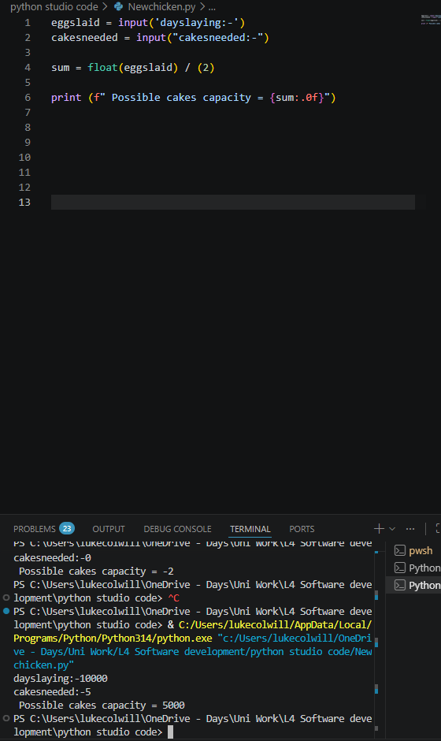
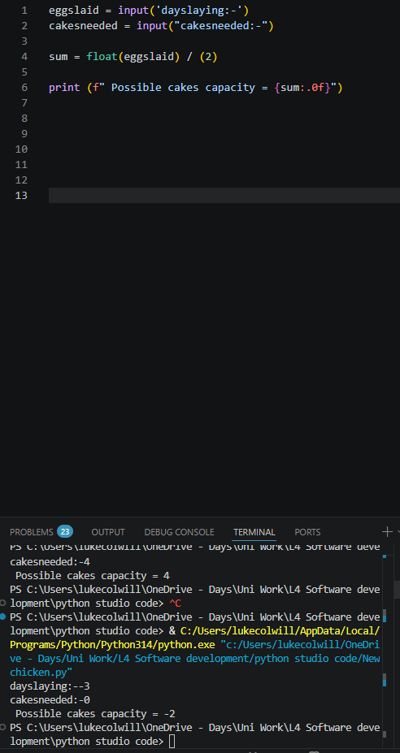

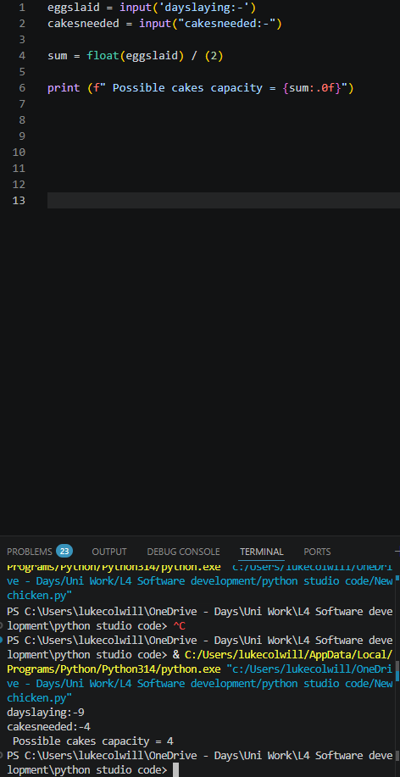
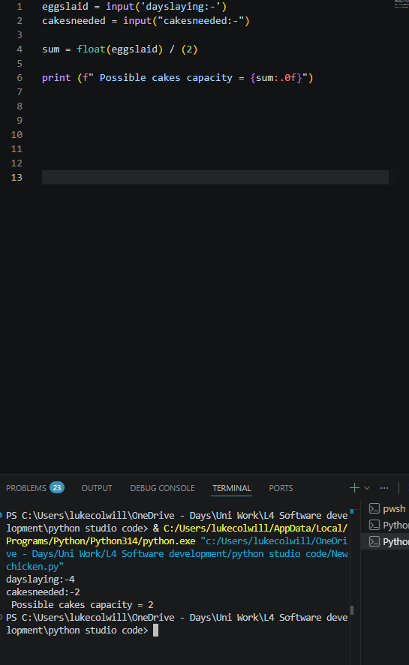
Result: Did the program behave as expected ie syntactically and logically correct?
YES/NO (delete as appropriate)

If NO, what problems were encountered and why? Suggest how things could be improved.

(Copy and paste box above for each of the rest of the tests)

- Consider the results of the above tests and revisit your original code in order to address the tests that failed. (Note: you may not be able to solve all of the problems that were originally encountered, but solve as many as you can.)

Paste your full revised code here :

eggslaid = input('dayslaying:-')
cakesneeded = input("cakesneeded:-")

sum = float(eggslaid) / (2)

if sum < 100:
print("Error the eggs would be bad")

if sum > 0:
print ("error")

print (f" Possible cakes capacity = {sum:.0f}")

