
Community Engagement
Assessment 2
JOY LILIAN ATUNROSE, ID: 1708230 | 5/3/18 | MODULE: SBUS4102

Table of Contents
Introduction 3
- Nature and purpose of reflective practice 4
- Detailed reflection on personal experience of what is learnt throughout the activity 5
- Reflection on the relationship between relevant theory and experience 6
- Examples of key issues encountered during the role play activities 7
Conclusion 8
References 9

Introduction
Every of us are living in a society where lots of other people are living too. This gathering of living peoples is known as community. While living in a community, we need to learn the ways of living according to the norms and cultures of the community. In order to live in the community learning the norms is important and this learning is basically called self-management so that the individual can adapt with the traditions of the community. Personal development is also a part of self-management but personal development is more profession oriented issue. While working on the personal development the person also needs to work for the development of communication, team work, leading and others skills. This particular writing is basically describes the issues that are related to self-management and personal development.

Nature and purpose of reflective
Practice
Reflective practices are the implementations of different reflection models by which individuals can execute their self- management and personal development so that they can perform their job duties and responsibilities more efficiently. That means to do the perf01mances better than before in the workplace reflection models are the roadmap to the individuals who want to develop their performance in professional life. Brockbank and McGill (2007) said that basically reflective practices help the learner to understand the criteria's of their works success, understand the intensity of their efficiency of the works and finally understand where the development are required for developing the performance in future. Effective reflection practice helps the learner to understand himself and also understand the shortcoming of him in his workplace. At the same time reflective practices teaches the learner how to transfer their skills to their workplace so that the organizations they are working can be benefitted from their practices and the persons get proper recognition in their professional career. The past theories suggest that several reflection theories have been developed in the last century that enabled the professionals to develop their performances in workplace. One of the most popular reflection models is John's model 1995.
According to John's model it is suggested that the professionals can have better understanding of their professional works by sharing their working activities and the issues he wants to learn with the colleagues because reflection model cannot define everything so precisely that mentors or colleagues can do. In this model John emphasized that the learner needs to learn first and then those learning should be implemented in the workplace as soon as possible so that it can be realized whether the person can implement the learning or not. If not then it can be said that the learning is not effective enough that will enable the person with some development due to the reflection applied. Leonard (2002) suggests that a learner can realize his thinking capacities and situation handling capacities using the reflective model and after knowing these things the person can easily understand the scopes of improvement in his skills and capabilities John's reflective model is basically described from five dimensions such as aesthetic, personal, ethics related, empirical and situational reflection.
Reflection models perform several purposes or the person's professional development that enables the person to understand his works better and perform better than before. A proper

reflective often enhances the critical thinking ability of the person about decision making and personal developments. Basically reflective practices help the learner to understand the criteria' s of their works success, understand the intensity of their efficiency of the works and finally understand where the development are required for developing the performance in future. Effective reflection practice helps the learner to understand himself and also understand the shortcoming of him in his workplace. Whenever the reflection is followed by the person, he always to evaluate him and also try to understand if his performance is developed than before. Schon (2000) said that reflective practice enables the person to evaluate his own performance and compare that with the past performances and realize the differences. Along with other capabilities reflective practice helps the learners in proper self-management and personal development ensuring their growths of intellectual property that eventually results their academic and professional achievements. At the same time reflective practices teaches the learner how to transfer their skills to their workplace so that the organizations they are working can be benefitted from their practices and the persons get proper recognition in their professional career. Most importantly a proper and effective reflective practice enables the person to realize his own thinking properly that helps to take effective decisions. Due to this efficiency these persons can easily the complex situations in their workplaces and perform better than others as they are quite
Efficient in complex decision making.

, Dec.
L.
a,.l
ea!
re fl ec ti on on pers on al

experience of what is learnt thro ! i:, O u t
the act i vi : y
According to the module requirement all the reflective learning and the personal experience should be discussed here along with the activity chosen. In order to complete the part A of this assignment Facial Working learning was selected. On that portion of the assignment a plan of reflection learning on Facial Service was presented. The experiences of that learning and my personal experience on facial services are discussed below.
There are different types of works and facial is a service oriented profession. While learning the profession firstly I understood my strengths and weaknesses on this profession. According to Seichner and Liston (2006) at first I learned to perform my self-evaluation properly so that I can

easily identify as the scopes of improvements in my skills. While learning I understood that I was nothing but a novice on that profession and because of that I had to learn from the beginning to be an expert of this profession. That's why at the very beginning I learn the name and uses of different facial instruments and ingredients that should be used for better facial and customer satisfaction. Then I knew different facial ingredients like face wash and other popular branded products. After that I learned to prepare the face packs that will enhance the quality of facial services. While working on facials I have also learned about preparing customized facials for different skins. We know that people's skin differs and for the different skins different types of facials should be applied. Then I started working on the outlet and started implementing my learning while doing the facials of different customers. After doing my practices there for two week I realized that I was able to implement my reflective learning on my professional life. Then I worked there for two more months and gather some real life experience on my facial profession.

Reflection on the relationship
be t ween rel evant theory and experience
According to the discussion on reflective practices in the first portion of this paper we have come to know several issues about the learning. Those theoretical issues will be compared here and the relationship of those theories with my real life experiences will be discussed in the following paragraph.
In the very beginning it is describe that reflective practice helps the person or learner to identify his shortcomings in the workplace. In case of my real life experience in working as a facial service provider I experienced that at first I had to identify my own learning needs by evaluating myself. So this experience has a direct relationship with the theories.
According to Taylor (2010) the theories suggest that the learner can easily prepare personal development plan when he has his own evaluation paper. Along with this the person can easily decide the scopes of learning. While working in real life after my evaluation I understood that needed to learn the facial process and ingredients firs and then I needed to learn preparing face masks for different types of skins. That means the theories have relationship in this case too.

The theories of reflective practices also suggest that the learner will be able to handle complex situation and make effective decisions in complex situations. This statement is also applied in my professional experience because while working in the outlet I had to do the facials of different persons and the skin nature of those peoples were not same. In some cases I had to prepare customized face masks for several persons and after those facials I experienced that the face masks were perfectly matching those skin natures. That means in a complex situation I was able to take proper decisions.
According to Sicora (2017) the discussions on reflective theories it is suggested that the learner of reflective practices will be able to work efficiently than before and the person will also be able to transfer his skills in the workplace that will make him more professions. While working as a facial service provider I realized that after the learning I was able to do the facials confidently and properly than before and my customers had no objection about my work. So I was working efficiently than before. At the same time I was implementing my skills while working for my organization that was making the customers satisfied about the services and the organizations popularity was increasing. That means I was successfully transferring my skills for my workplace. So, it is clear that the theories of reflective practices and my experience in real life working have direct relationship.

Examples of during the role
key issues encountered play activities

The recent discussion already presented that I was playing the role of a facial service provider and I had to learn several thing about facials for doing my works properly. While doing my work a facial expert I faced a lot of situations where I had to take decisions of preparing face masks for customers. Now I would like to mention one situation where I was very successful and another situation where I was not that much successful and need further improvements.
Let's start with the situation where I was successful and the customer was really satisfied. There was a customer with an oily skin and she was never satisfied with the facials before. But the last time she had an encounter with me and I did her last facial. After listening to her, according to Rushton and Suter (2012) suggestions I asked her if I could make a customized facial for her skin by mixing some ingredients. She agreed and I made the face pack and applied to her skin. After

the facial she was so happy and satisfied and I realized that my customized face pack did the job effectively.
Then I met another mid aged woman who had skin allergies and due to that she asked me to make a face pack for her but after preparing the pack and applying that she expressed that it was increasing her allergy. That means there was some problem in that face pack. That's why I think I need further improvement in skin oriented face pack preparation.

Conclusion
Effective reflection practice helps the learner to understand himself and also understand the shortcoming of him in his workplace. At the same time reflective practices teaches the learner how to transfer their skills to their workplace so that the organizations they are working can be benefitted from their practices and the persons get proper recognition in their professional career.
Reflective practice enables the person to evaluate his own performance and compare that with the past performances and realize the differences. Along with other capabilities reflective practice helps the learners in proper self-management and personal development ensuring their growths of intellectual property that eventually results their academic and professional achievements. At the same time reflective practices teaches the learner how to transfer their skills to their workplace so that the organizations they are working can be benefitted from their practices and the persons get proper recognition in their professional career. Most importantly a proper and effective reflective practice enables the person to realize his own thinking properly that helps to take effective decisions.

Reference s
Brock, A. (2015). The early years reflective practice handbook. London: Routledge.

Brockbank, A. and McGill, I. (2007). Facilitating reflective learning in higher education. Maidenhead, England: McGraw Hill/Society for Research into Higher Education and Open University Press.
Bruce, L. (2013). Reflective Practice For Social Workers. Open University Press. Leonard, D. (2002). Learning theories, A to S. Westport, Conn.: Oryx Press.
Rushton, I. and Suter, M. (2012). Reflective Practice For Teaching In Lifelong Learning. Maidenhead: McGraw-Hill Education.
Schon, D. (2000). Educating the reflective practitioner. San Francisco: Jossey-Bass. Sicora, A. (2017). Reflective practice. Bristol: Policy Press.
Taylor, B. (2010). Reflective practice. Maidenhead: Open University Press. Seichner, K. and Liston, D. (2006). Reflective teaching.


Activity:
 | Poor | OK | Good | Excellent
Introduction
(Explanation)
Presentation (practical demonstration)
Conclusion
(how well can you carry out the activity?)
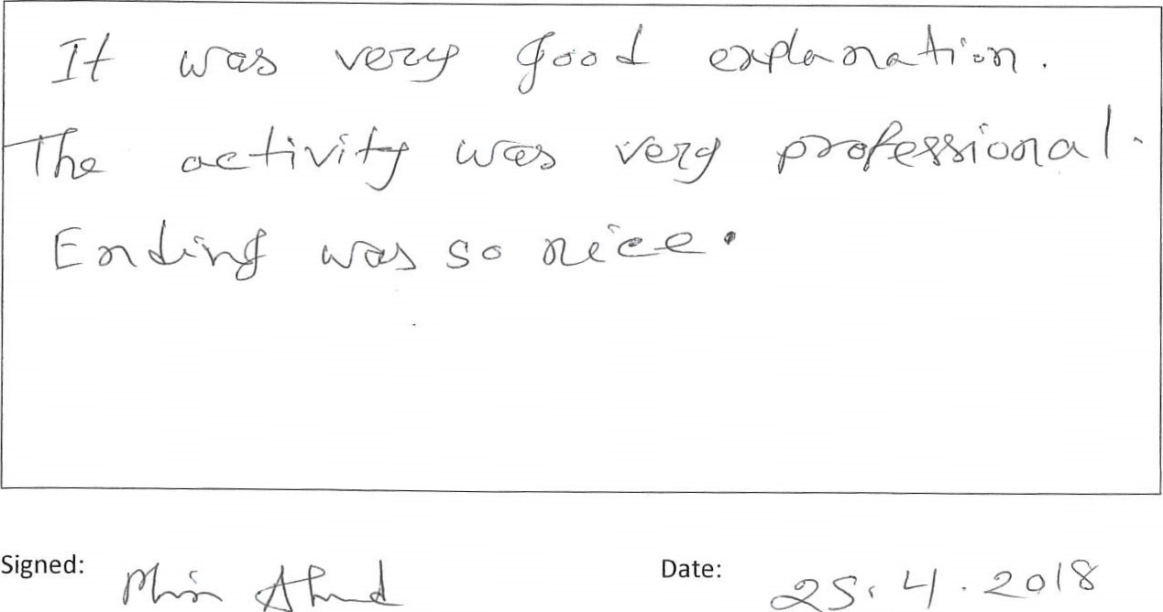
Any
other
comments
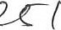oh )

Activity: 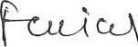
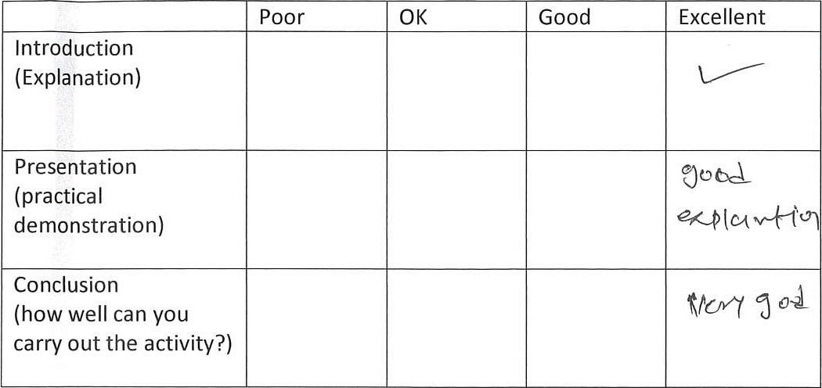
Any other comments
She | tells | 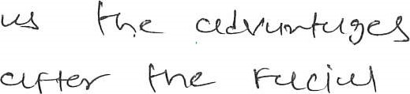 One
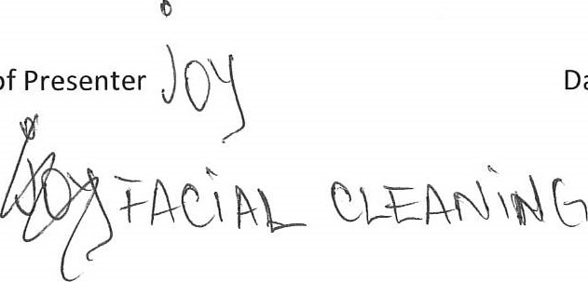
25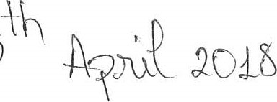
Activity:
 | Poor | OK | Good | Excellent
Introduction
(Explanation)
Presentation (practical demonstration)
Conclusion
(how well can you carry out the activity?)
Any other comments
S\JV | 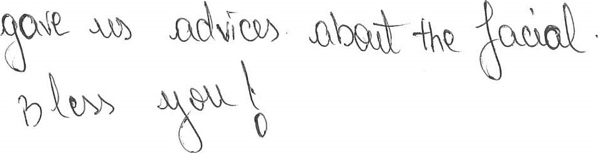  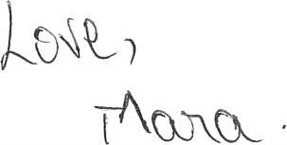
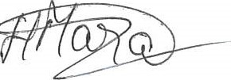 25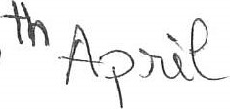 2(OLb

SBIJS
Peer
Name 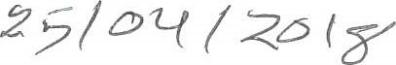
Activity: 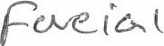
 | Poor | OK | Good | Excellent
Introduction
(Explanation)
Presentation (practical demonstration)
Conclusion
(how well can you carry out the activity?)
Any other comments
She’s very | 
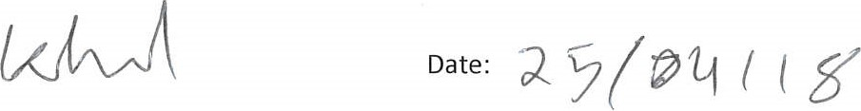
SBUS

Peer

Name 
Activity:
C-kQ-,C 
 | 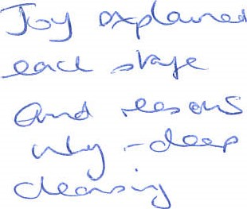
   | Poor | OK | Good | Excellent
  Introduction
  (Explanation)
  Presentation (practical demonstration)
  Conclusion
  (how well can you carry out the activity?)
Any other comments
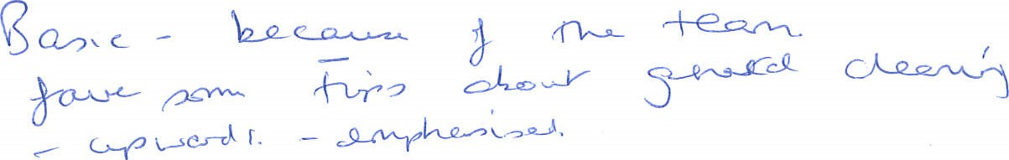




SBUS

Peer
Name e
Activity:
 | Poor | OK | Good | Excellent
Introduction  (Explanation) |  |  |  | 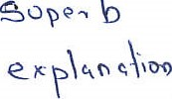  10
Presentation (practical demonstration) |  |  |  | 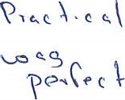
Conclusion  (how well can you carry out the activity?) |  |  |  | 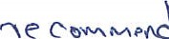
Any other comments


