NSEDA Assignment C
Your narrative should:
1.Explain why cobalt-60 is suitable for use in industrial sterilization facilities.
2.Explain why very high activities are needed for the sterilization of medical items.
3.Determine the source activity on the day on the incident.
4.Estimate, by hand calculation, the dose rate at 2 m from the cobalt source and interpret your result in the context of the incident. You may use a point source calculation but comment on the applicability of this.
5.Assuming a 1000-fold dose reduction factor for each 90-degree maze bend, verify the dose rate at the maze entrance using a hand calculation based upon the measured dose rate values given.
6.Explain how the geometry of the maze and the technician’s movements could result in the recorded dose based on a plausible scenario consistent with the measured dose rates.
7. Discuss any health implications from the radiation exposure in this incident.
8. Discuss the incident in the context of UK radiological protection legislation (IRR17).
9. Evaluate the event against ONR Safety Assessment Principle EKP.5 Defence in Depth and two other SAPs of your choice
10.Propose proportionate improvements, justified on ALARP grounds, that would reduce the likelihood or consequences of a similar event.
.

Incident Dossier C: Incident at [Redacted], Warrington
Facility: High-Dose Gamma Irradiator (Continuous Flow)
Location: Warrington, UK
Date of Incident: 02 November 2024
The Radioactive Source
⁶⁰Co.
Total Activity: 185 PBq certified on 14 June 2022.
Physical Form: Double-encapsulated stainless steel "pencils" (Grade C-188) mounted in a vertical planar rack.
During normal operation, products are conveyed around the source rack within the irradiation cell.
The distance from the source rack to the product irradiation position is approximately 2 m.
Storage: The source rack is stored in a 5 m deep deionised water pool when in the "Safe" position.
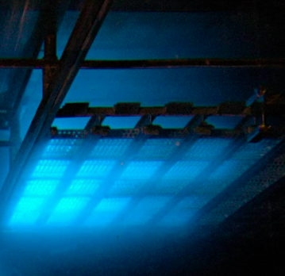

The System
The Hoist: A cable-and-winch system lifts the source rack from the pool into the irradiation cell.
The Conveyor: A "tote box" system moves palletised medical surgical kits around the source.
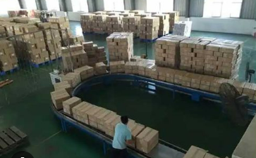
Shielding and Safety
Lead filled steel baffles reduce the radiation dose in directions away from the irradiation area.
The irradiation cell is surrounded by 1.5 m thick barytes concrete. Entrance is by a 6 m double-legged maze with a corridor width of 1.5 m with access controlled by a heavy-duty door attached to an interlock system which prevents the door from opening unless the source is in the shielding pool.
The Incident 02 Nov 2024
During a shift change, a snapped drive chain on the conveyor caused a "Tote Jam." The operator initiated an emergency stop.
The winch motor de-energised, but the source rack became snagged on a bent guide rail 1.5 metres above the water surface.
The "Source Shielded" green light on the control desk is triggered by a limit switch at the bottom of the pool. Because the light remained red, the PLC (Programmable Logic Controller) maintained the "Cell Lock" sequence which prevented the opening of the door to the maze.
The maintenance technician arrived and determined that there was a jam inside the irradiation cell.
Because the winch cable tension indicator showed ‘slack’, and similar indicator faults had occurred previously, the supervisor believed that the source rack had probably reached the pool despite the persistent red “Source Not Shielded” indication.
Following discussion, and in order to investigate and clear the conveyor jam, the maintenance technician used his override key to allow the interlocked door to open to access the maze.
The maintenance technician entered the maze. While inside, the illuminated warning sign “Radiation – Danger of Death” remained active. This sign is linked to the gamma monitor inside the irradiation chamber and operates independently of the door interlock system.
The maintenance technician retreated to consult with the supervisor.
The supervisor picked up a portable gamma dose rate meter and it showed below 1 µSvh⁻¹ at the maze doorway but approached 1 mSvh⁻¹ at the nearest maze bend. The supervisor then called the RPA.
The maintenance technician now said he was experiencing feelings of nausea.
Dosimetry
The maintenance technician’s TLD was sent for emergency reading by the ADS who gave a dose of 27.1 mSv and contacted the HSE.
The supervisor’s TLD read 0.1 mSv.
Post Incident Review
The RPA investigated the incident, interviewing the maintenance technician and the supervisor
The maintenance technician stated that entry into the maze lasted ‘only a few moments’.
However, the supervisor subsequently estimated that the technician could have been inside the maze for at least two minutes.
Using a remote measurement, the RPA looked at the output of the gamma detector mounted near the first bend of the maze proximate to the source and it read ~850 mSvh⁻¹ from scattered radiation.
This was consistent with the apparatus handbook which stated the dose rate at the maze entrance remains below 2.5 µSvh⁻¹ with the cobalt source exposed.

Irradiator System
Heavy duty interlocked door
Conveyor
Illuminated Warning Sign
Plan View- not to scale
Gamma
detector
Irradiation
Zone
6 m
Pool for collimated radioactive source
Walls are 1.5 m thick barytes concrete
Lead/steel
Baffle

