DS 1 Template

My Screenshots/Photos
- Please add 4–6 screenshots or photos of your digital life.
- You can use your phone or laptop.
- For each screenshot, write one or two sentences explaining what it shows.

Screenshot/Photo 1
[Insert Photo/Screenshot below]
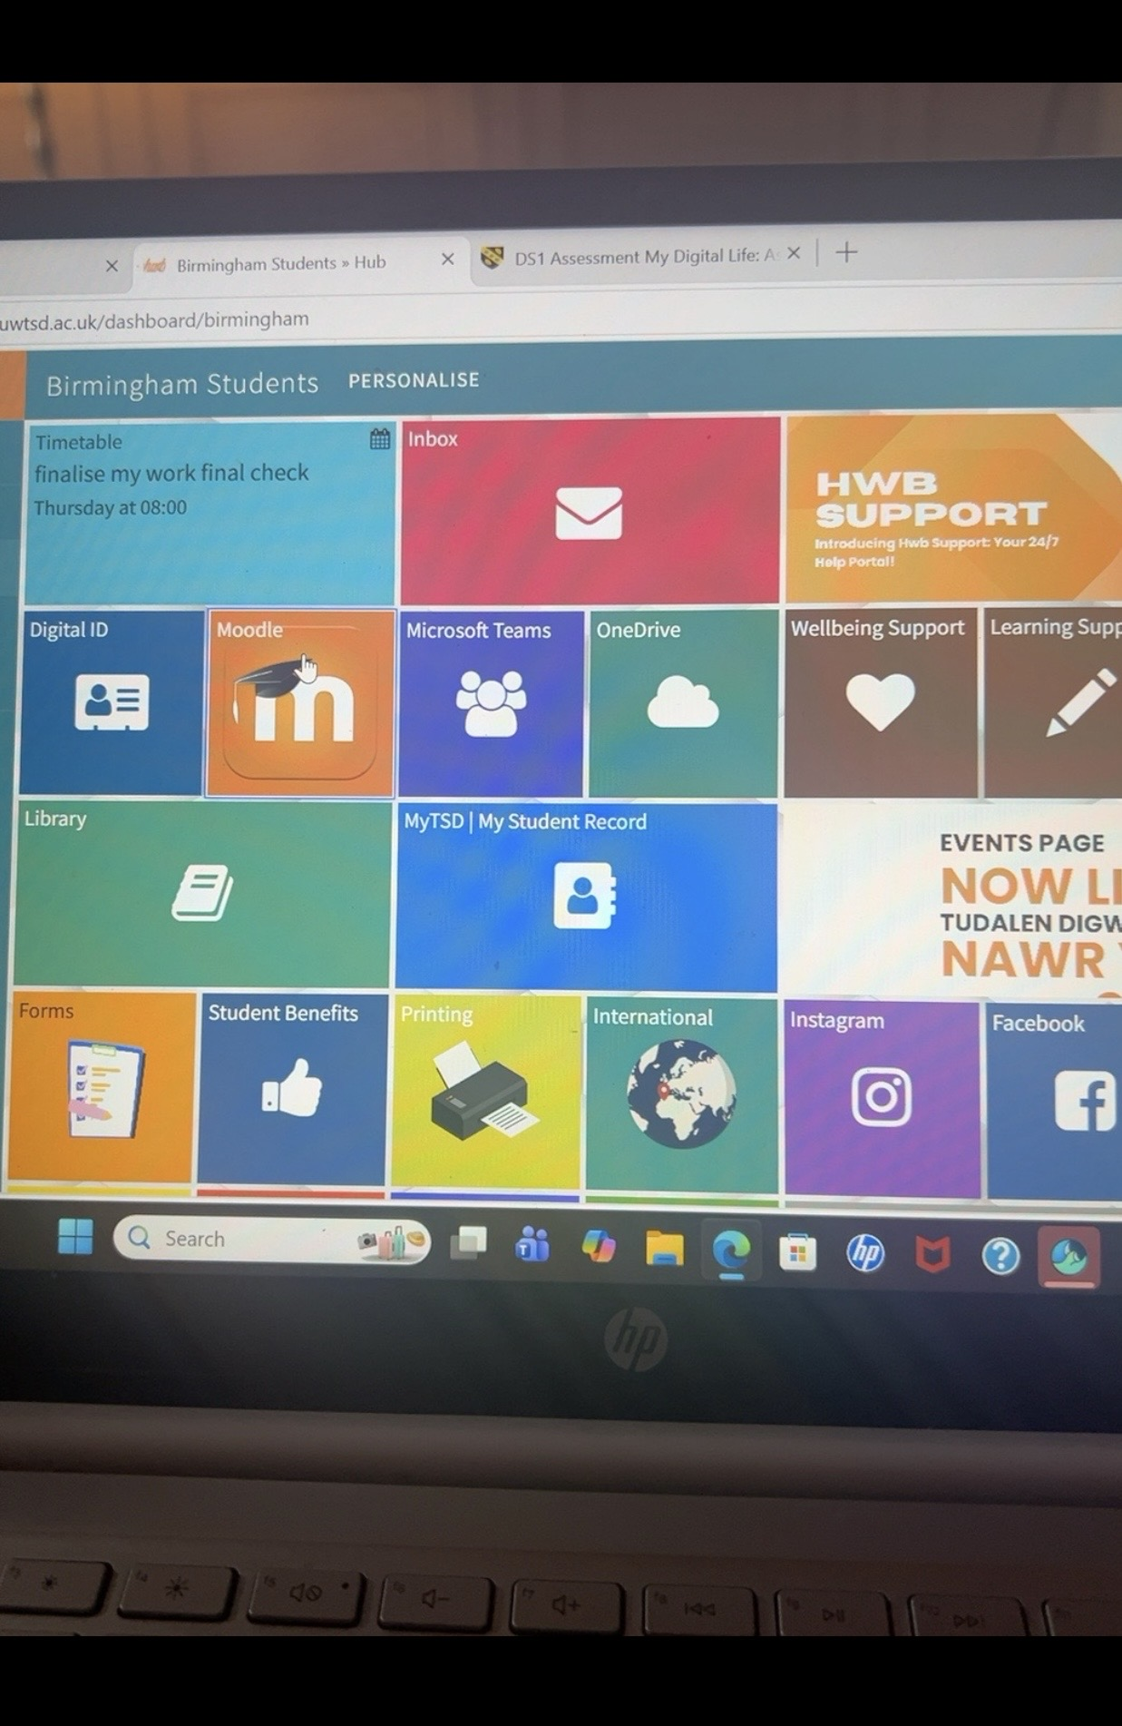
THE HUB
This screen shot shows the hub that us students use at university to access our university services. I can access my one drive, Moodle and Microsoft this helps me manage my university work.

Screenshot/Photo 2
[Insert Photo/Screenshot below]
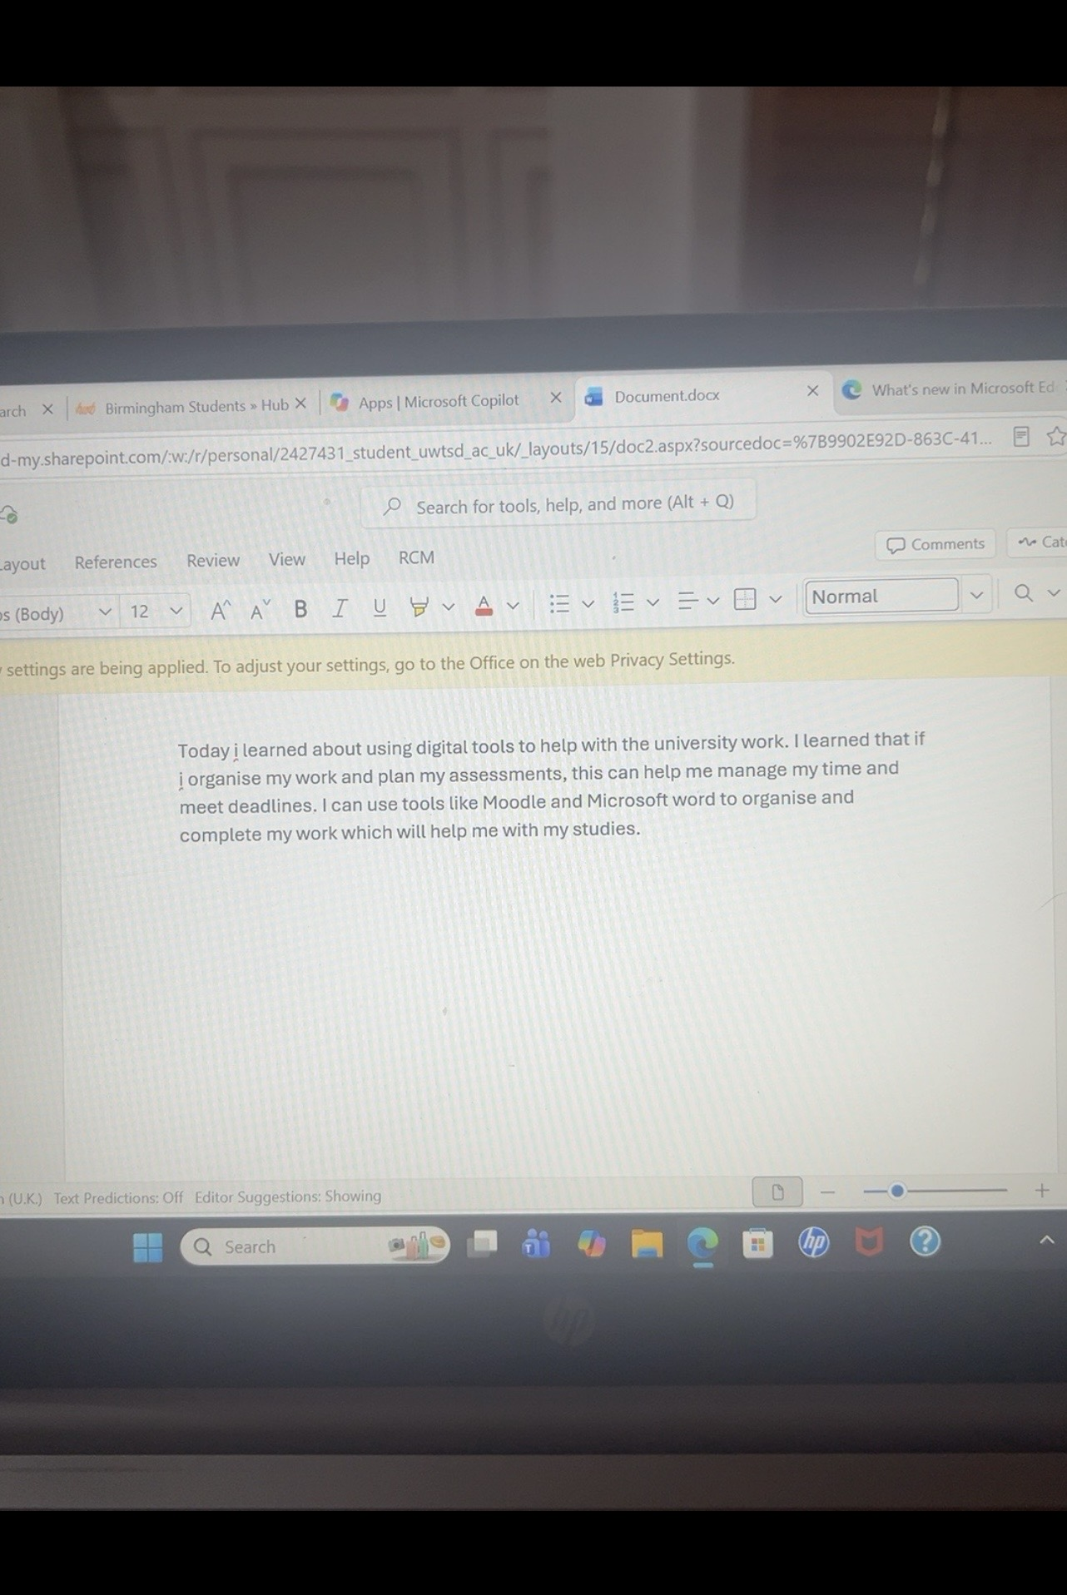
MICROSOFT WORD
This screen shot shows me using Microsoft word to create and edit my university work.I use word to organise my written work and help me to complete assessments.

Screenshot/Photo 3
[Insert Photo/Screenshot below]
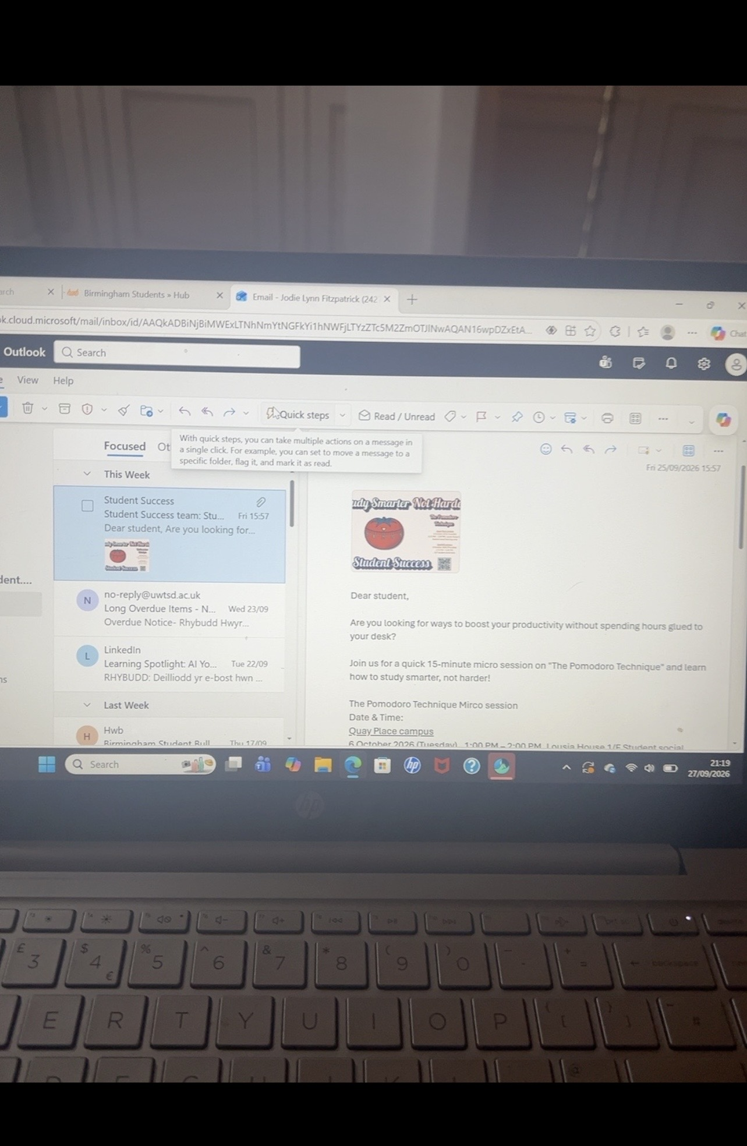
OUT LOOK EMAILS
This screen shot show that I can use emails for digital communication with my university. I use this to receive relevant information and messages about all my studies.

Screenshot/Photo 4
[Insert Photo/Screenshot below]
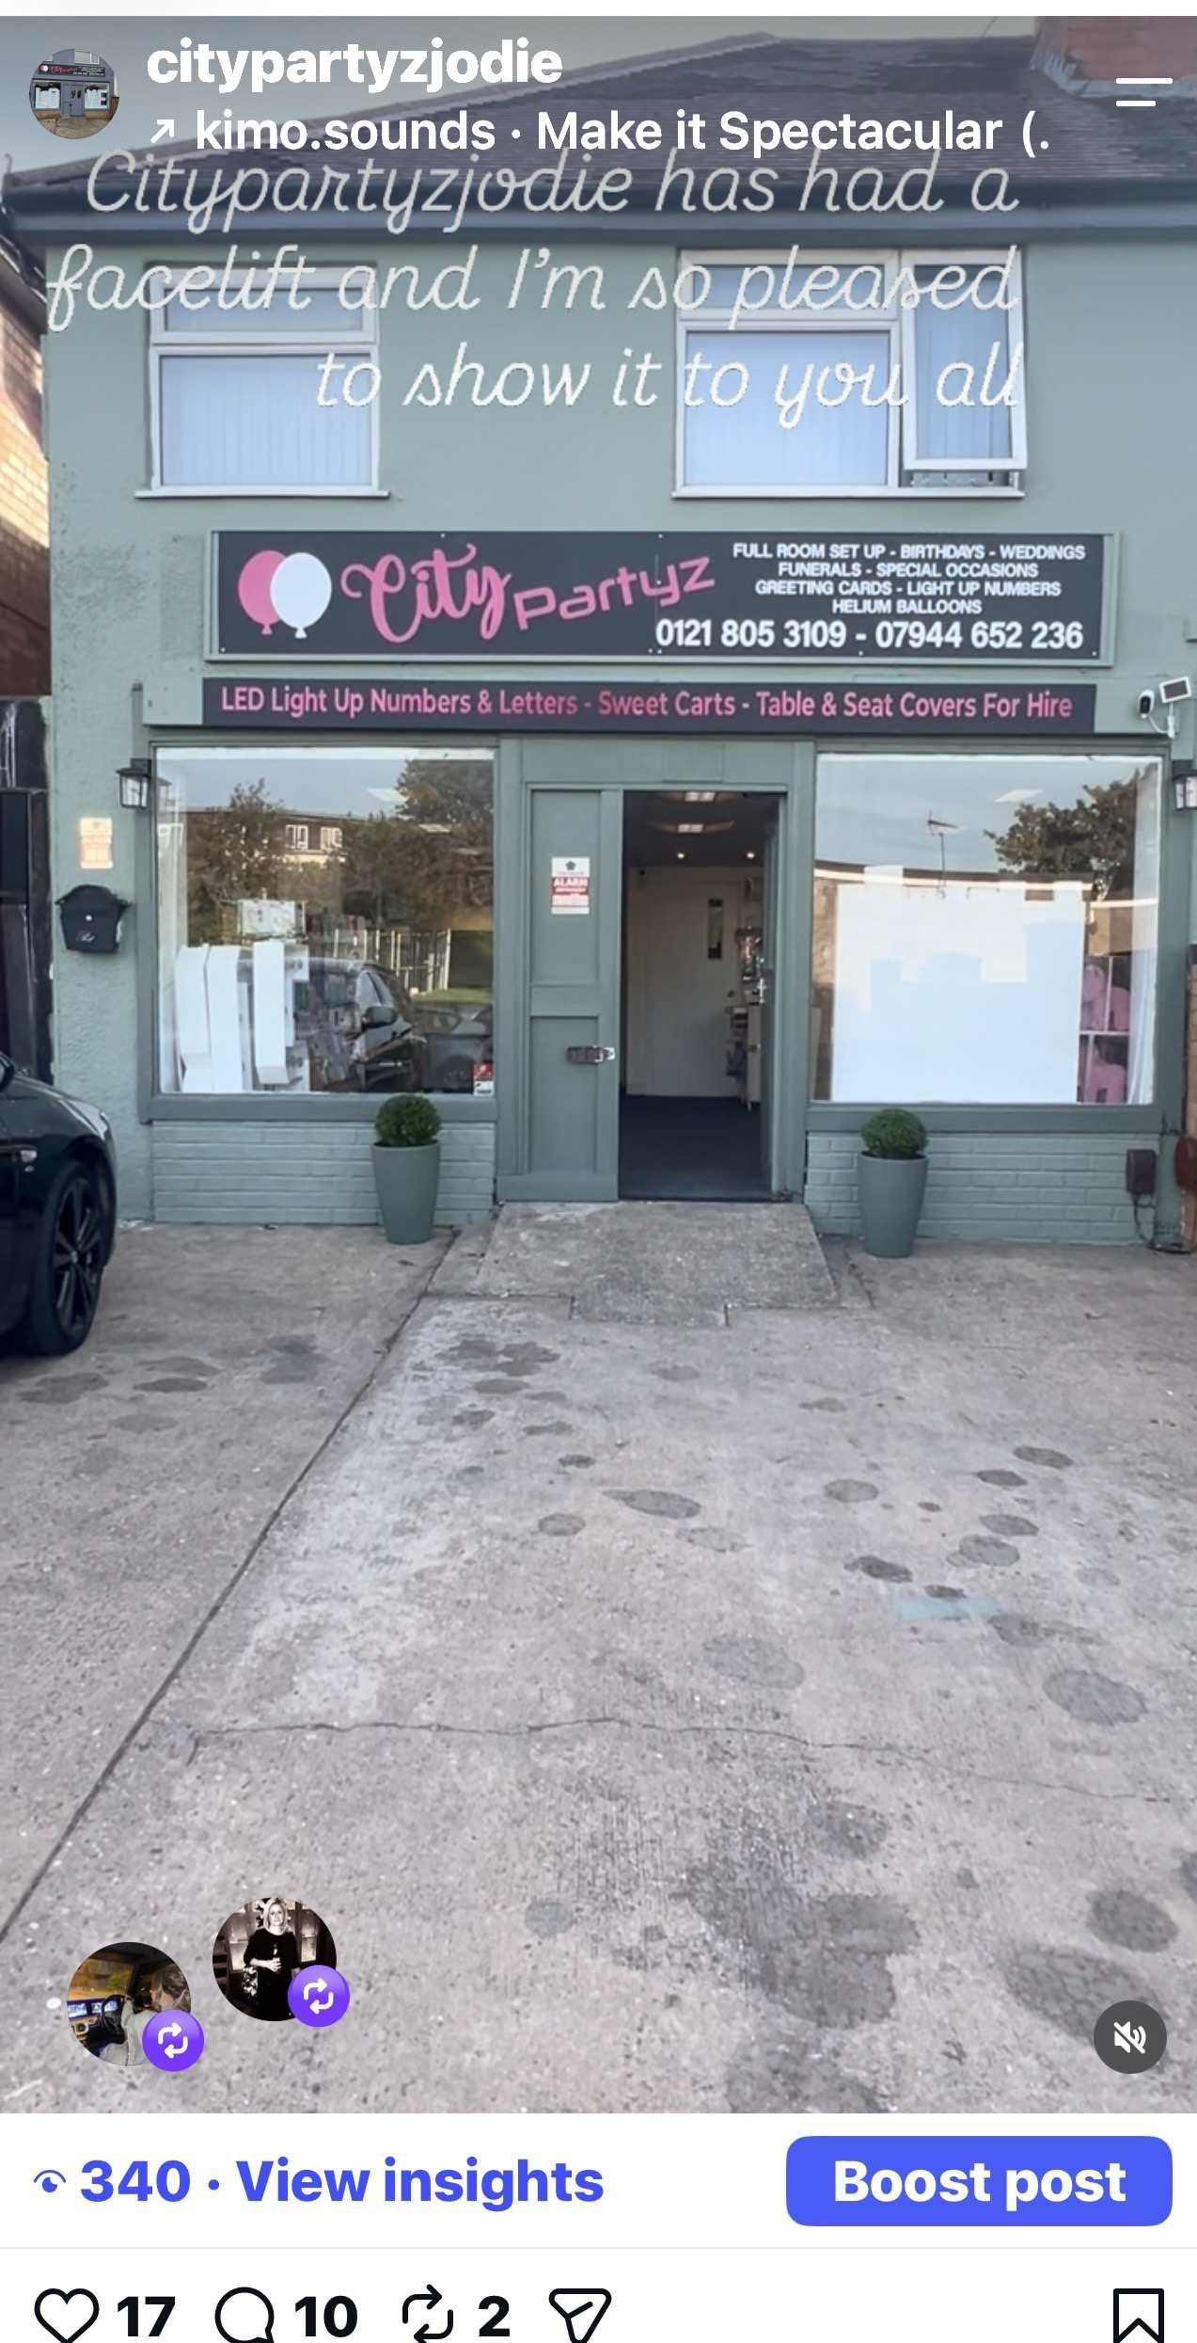
INSTAGRAM
This is showing that I can and do use Instagram to promote my business. I can also use this to advertise and showcase my products and services on social media.

Screenshot/Photo 5
[Insert Photo/Screenshot below]
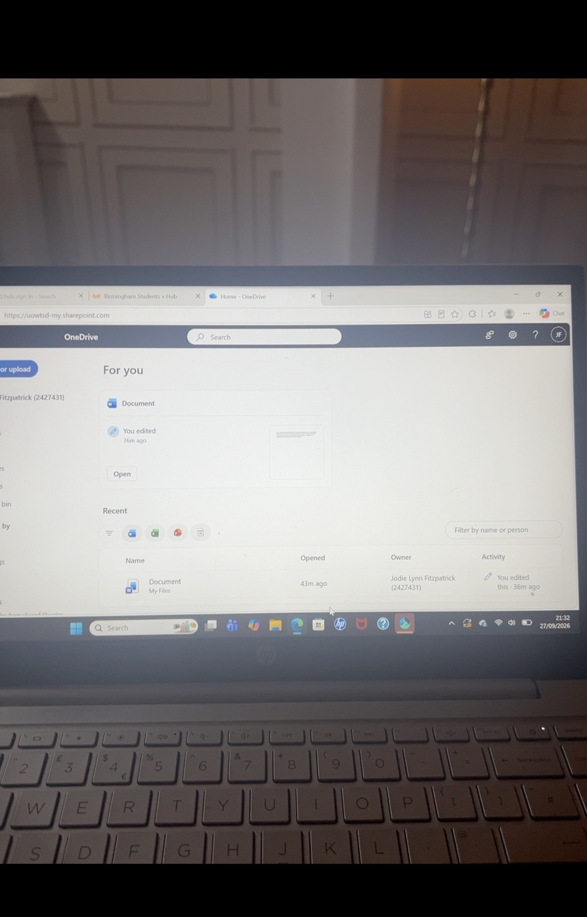
ONE DRIVE
This screen shot shows me using One drive to store and access my documents for university. This allows me to save my work and can get it from different devices which helps me keep all work organised together on line.

Screenshot/Photo 6
[Insert Photo/Screenshot below]
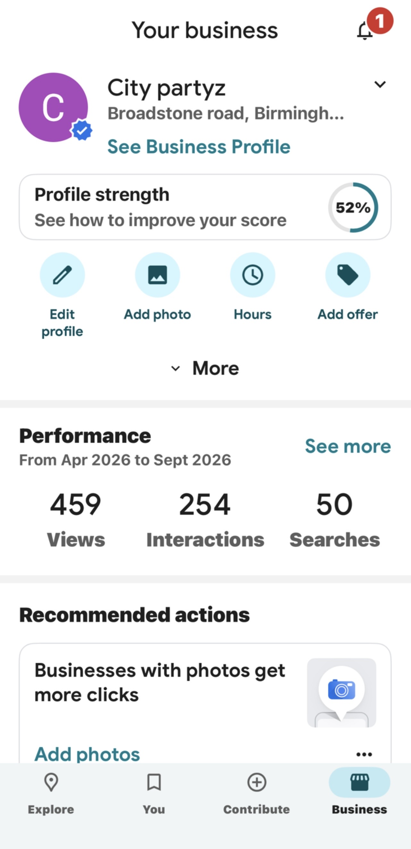
GOOGLE BUSINESS
This screen shot shows me using google business which is online, I do use this to keep up to date with all my interaction with the public, This also allows people to find where I am located and see what products I have to purchase from the shop.

My Short Reflection
- Write 5–8 simple sentences about your digital life.
- You can use the sentence starters below if helpful.
I use digital tools for my university work, My business and everyday life. This is a mixture of Microsoft word, email, Google business profile and Moodle.
I do feel confident when using social media like Facebook and Instagram to promote my business. I’m also feeling confident when using Moodle now.
I do feel nervous when using new tools on the lap top as this is something I haven’t used before but I’m very excited to keep learning.
I do feel that I need to improve my Microsoft word skills as I know this will help me progress in my course.
I do hope this whole experience with in the university course will help me be more digital confident.

Sentence starters
- I use digital tools to …
- I feel confident when I …
- I want to improve …
- I often use these tools: …
- I sometimes feel nervous about …
- I hope this module will help me …
- Digital skills are important for me because …
You can write more if you want.

Submission Checklist
Before you submit, please check:
​​​ ☒ I added 4–6 screenshots
☒ I wrote short sentences for each screenshot
☒ I wrote my short reflection
☒ My work is my own
☒ My file opens correctly
​​☒ My file opens correctly

