ACCA5033 – Changemakers: creativity and value creation
Ashley Rees 2009258

Table of Contents
1. Introduction 2
2. Task 1 3
3. Task 2 4
4. Task 3 5
5. Appendix 6

Introduction

Please click the web view link to open in a browser, click the Task Name to open in OneNote.

https://uowtsd-my.sharepoint.com/:o:/g/personal/2009258_student_uwtsd_ac_uk/EsmBysEEECJGs0a_Gk8YclEBKSuZ_bMRgy387rS6h2PPsA?e=mlhBVW

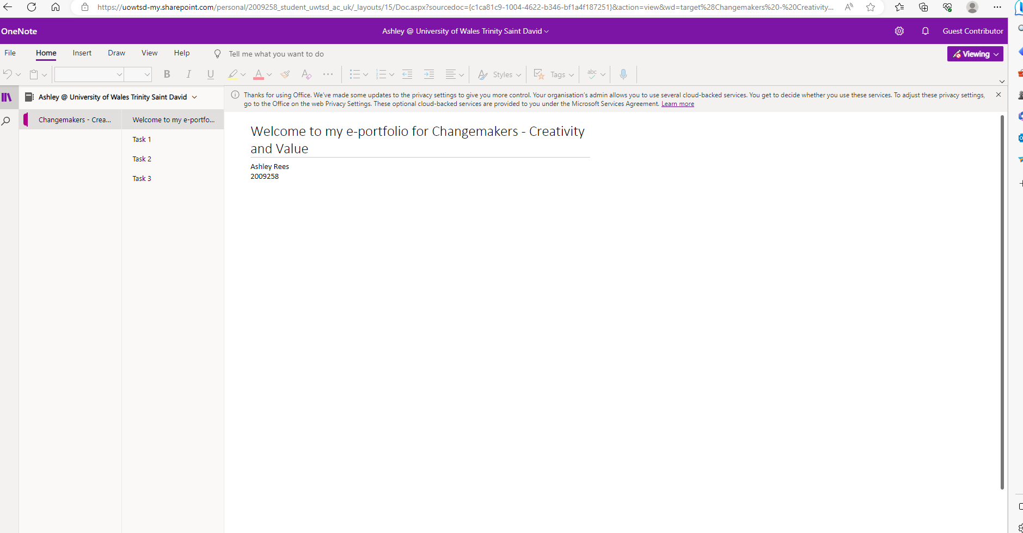

Task 1

https://uowtsd-my.sharepoint.com/personal/2009258_student_uwtsd_ac_uk/_layouts/OneNote.aspx?id=%2Fpersonal%2F2009258_student_uwtsd_ac_uk%2FDocuments%2FAshley%20%40%20University%20of%20Wales%20Trinity%20Saint%20David&wd=target%28Task%201.one%7C1260BCE8-A1E9-4FE7-8F48-DA1DFB14194D%2FTask%201%7C9B625876-3F14-463E-95D7-C1D1511F19B9%2F%29

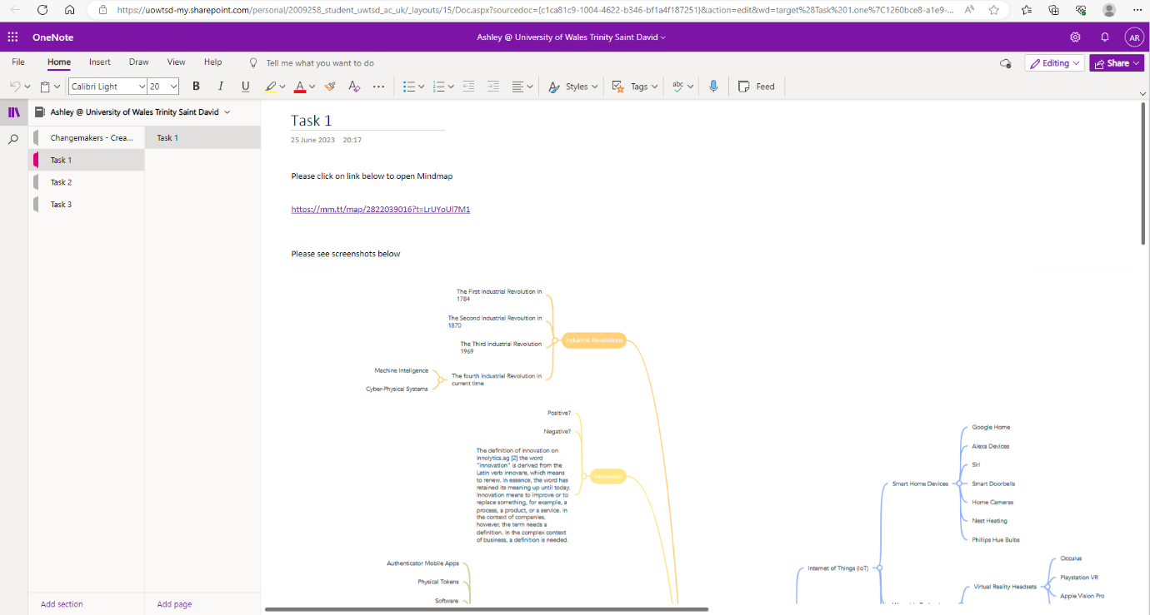

Task 2

https://uowtsd-my.sharepoint.com/personal/2009258_student_uwtsd_ac_uk/_layouts/OneNote.aspx?id=%2Fpersonal%2F2009258_student_uwtsd_ac_uk%2FDocuments%2FAshley%20%40%20University%20of%20Wales%20Trinity%20Saint%20David&wd=target%28Task%202.one%7C4143CDBC-B4ED-4052-ACAA-BF9C44D06E4C%2FTask%202%7CCE21DFD0-F158-4A54-8BD5-F8D9EE8DD114%2F%29
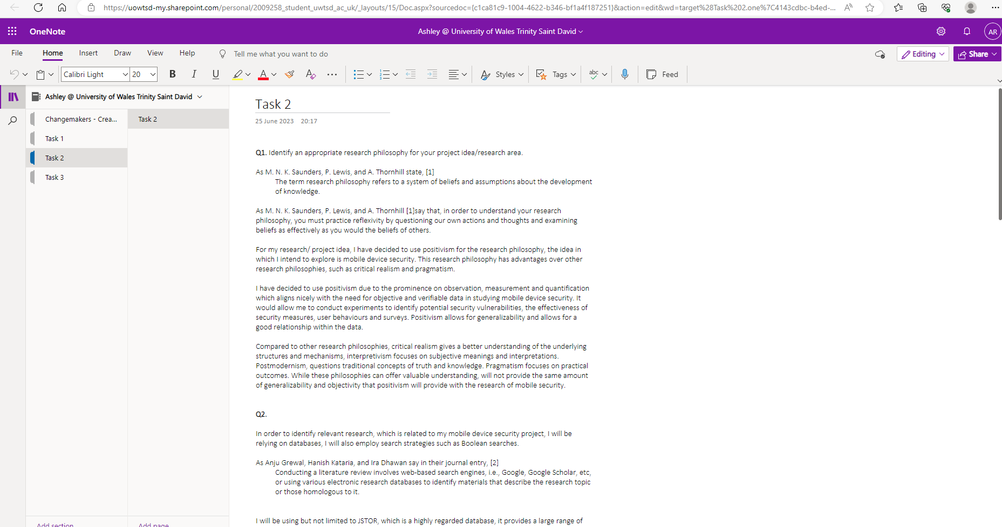

Task 3

https://uowtsd-my.sharepoint.com/personal/2009258_student_uwtsd_ac_uk/_layouts/OneNote.aspx?id=%2Fpersonal%2F2009258_student_uwtsd_ac_uk%2FDocuments%2FAshley%20%40%20University%20of%20Wales%20Trinity%20Saint%20David&wd=target%28Task%203.one%7C480A167E-0449-4806-B5C4-6F70C381C739%2F%29

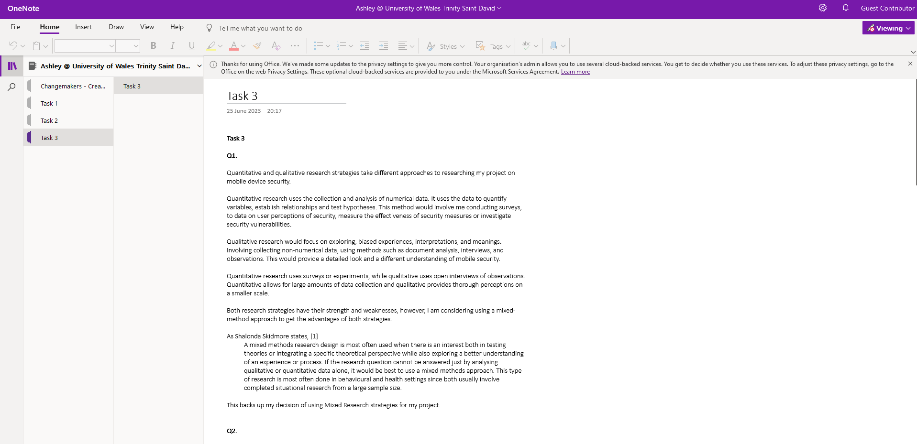

Appendix

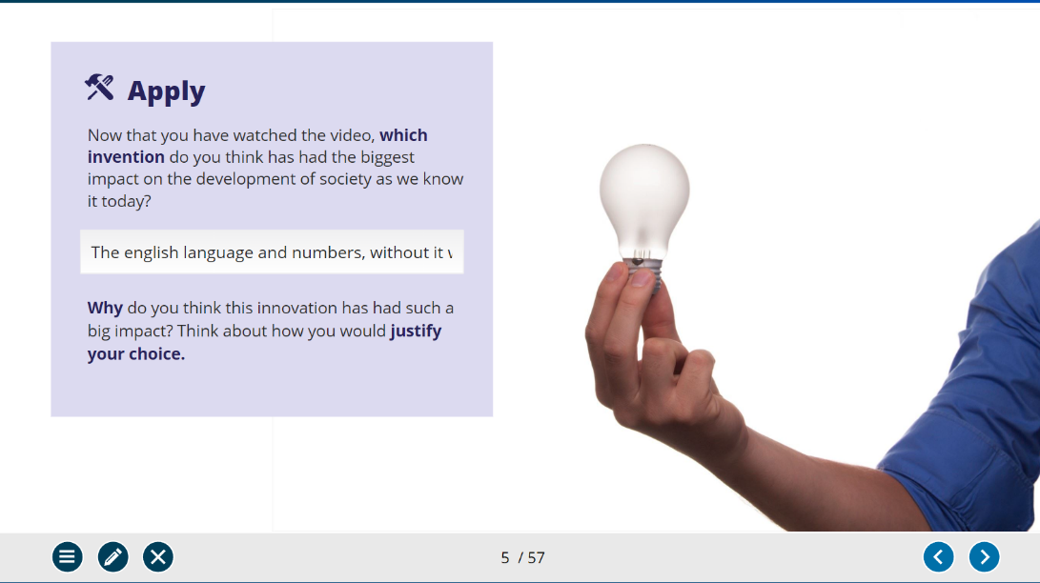
Appendix 1

Appendix 2
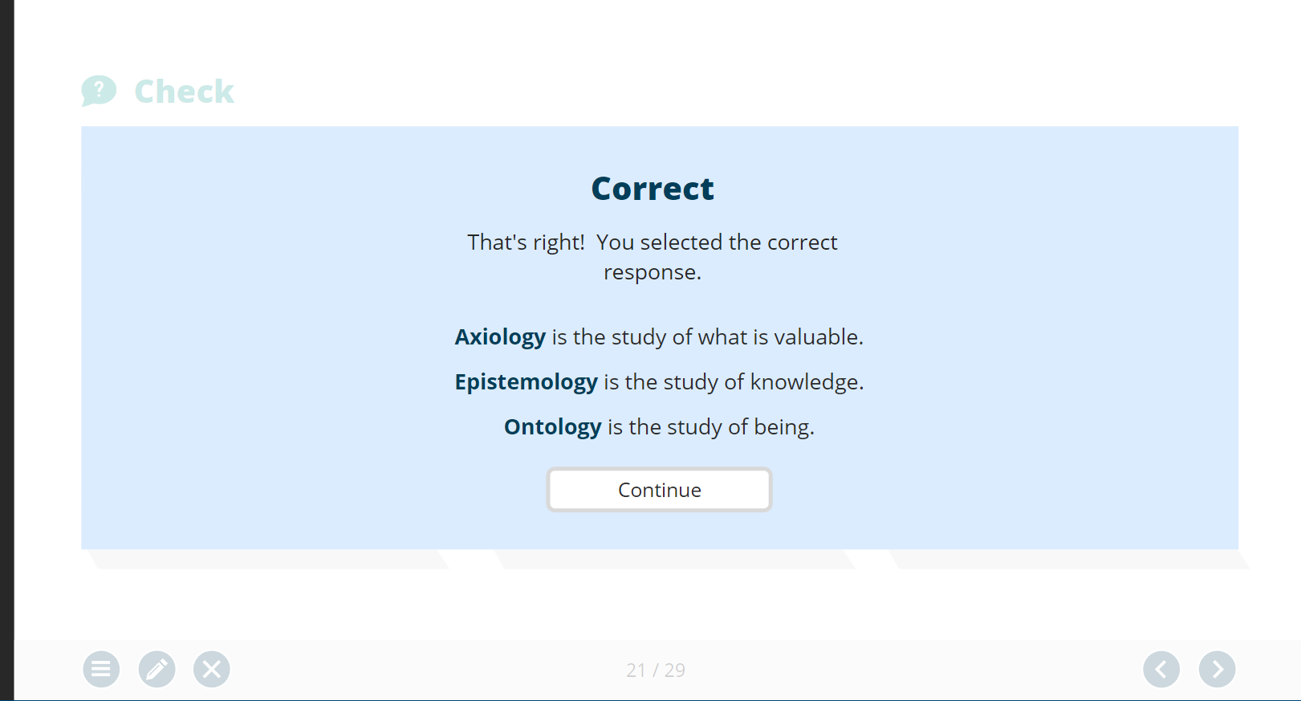

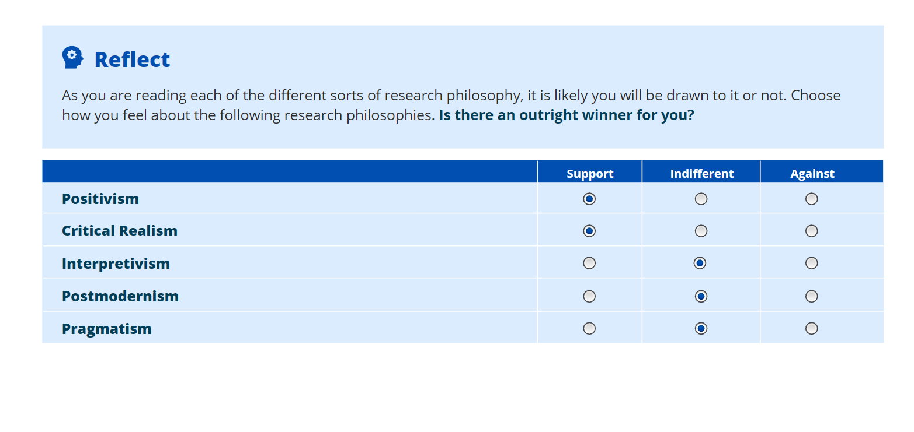
Appendix 3

Appendix 4
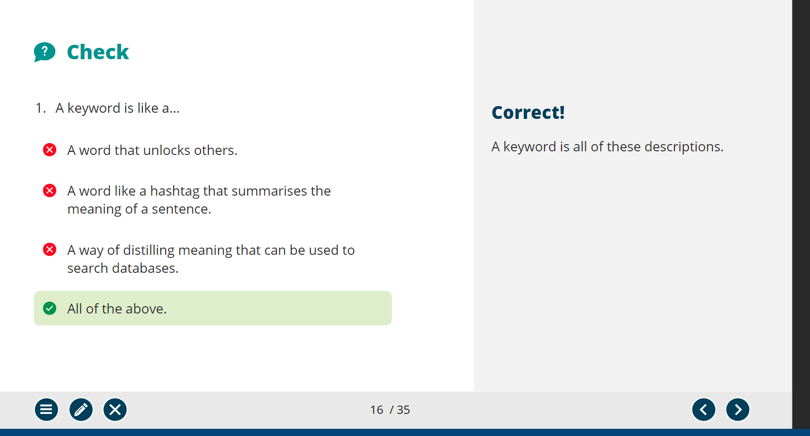

Appendix 5
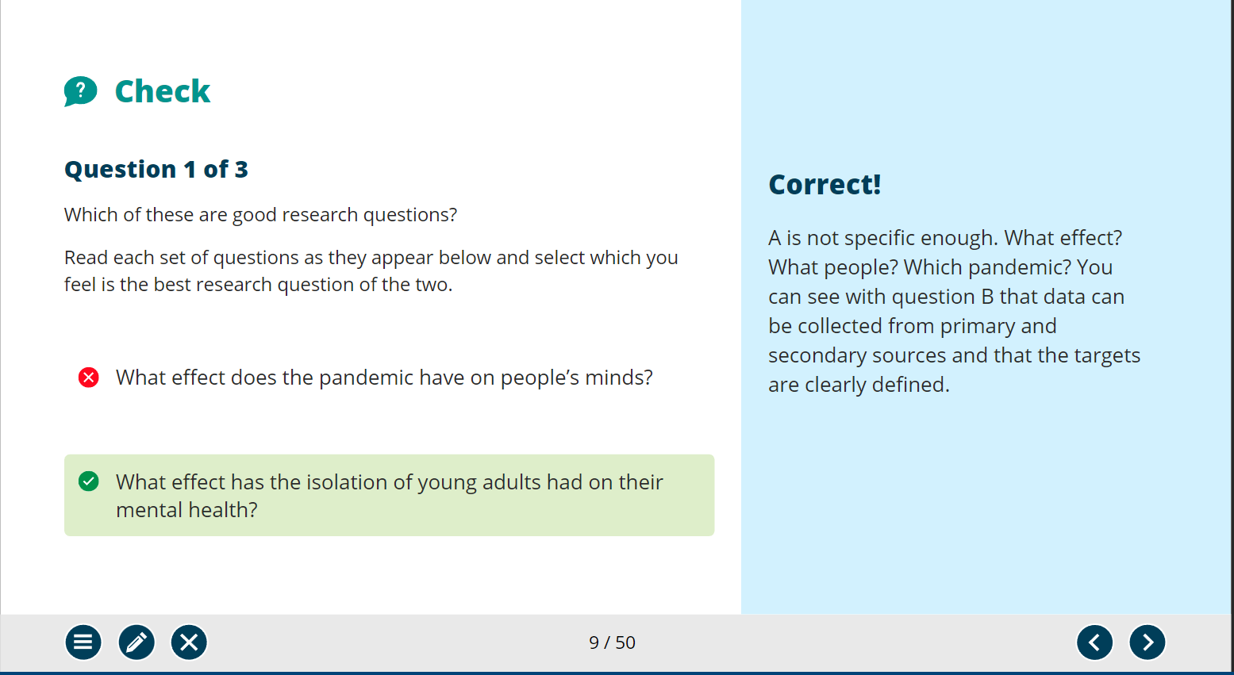

Appendix 6

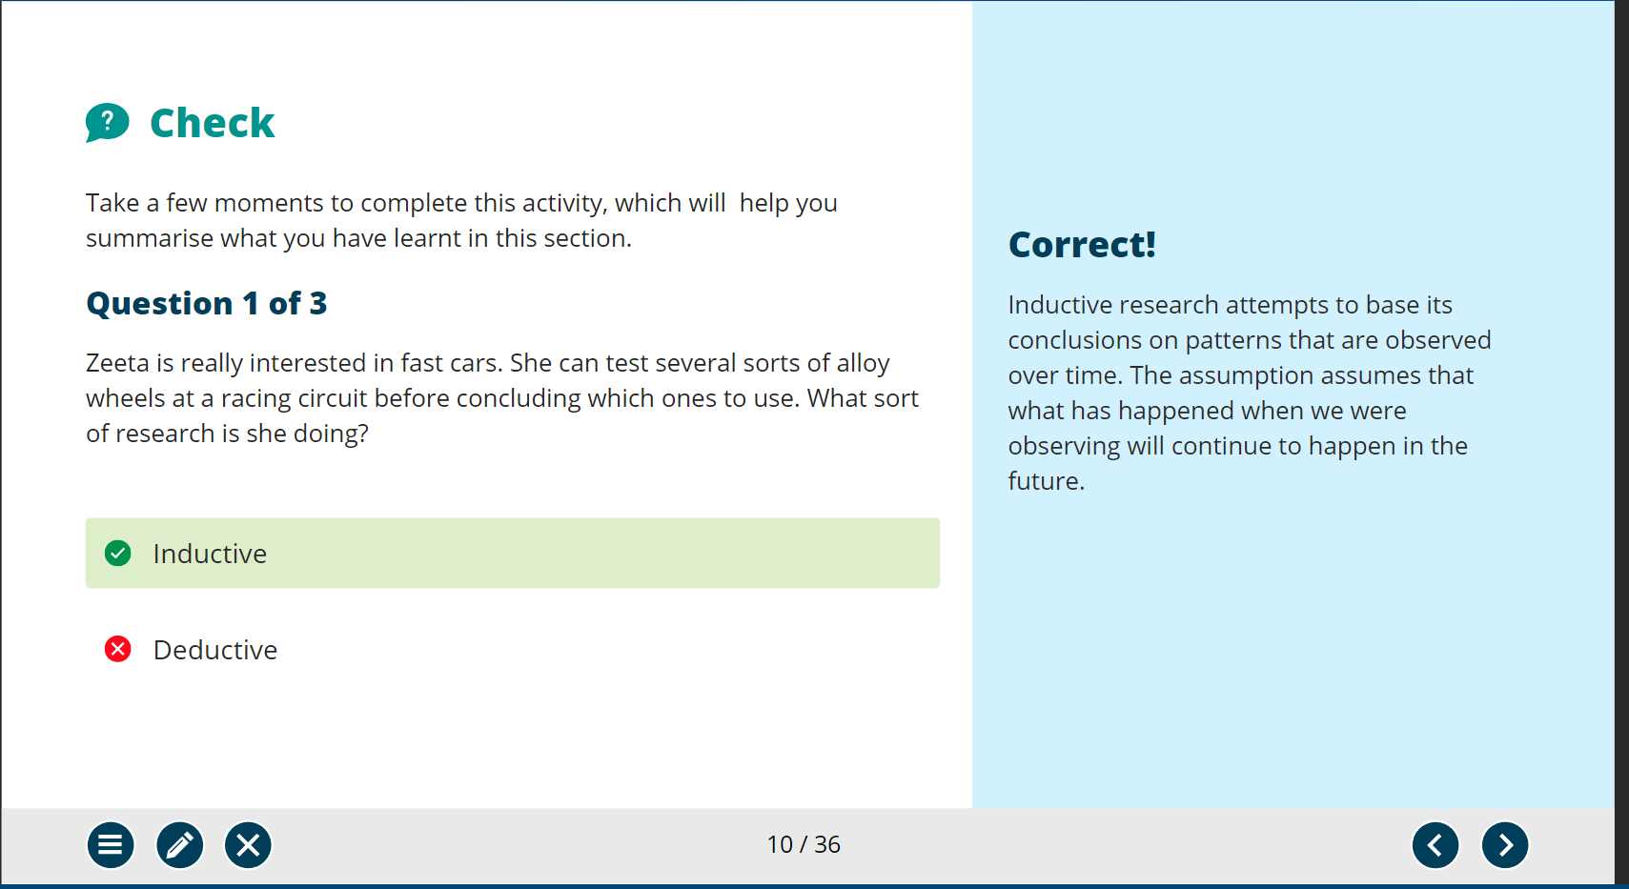

Appendix 7

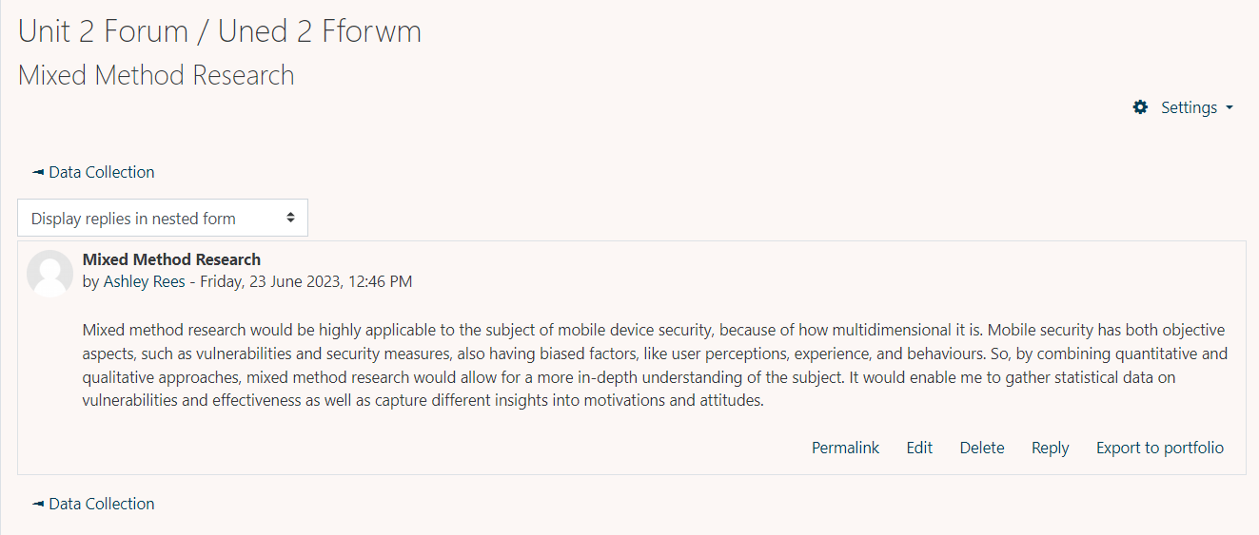

Appendix 8

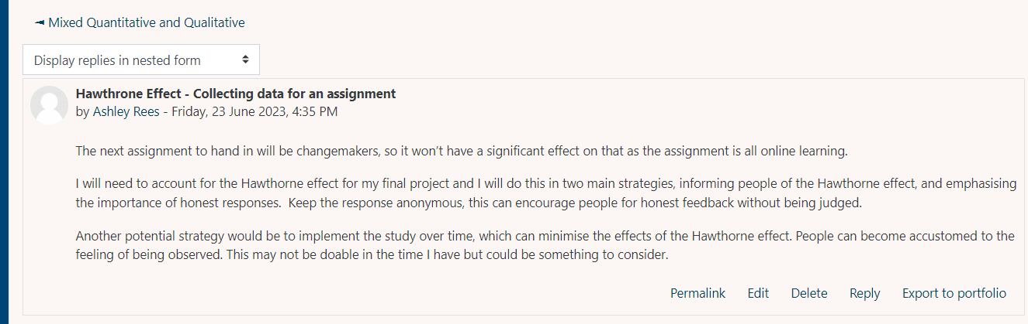

Appendix 9

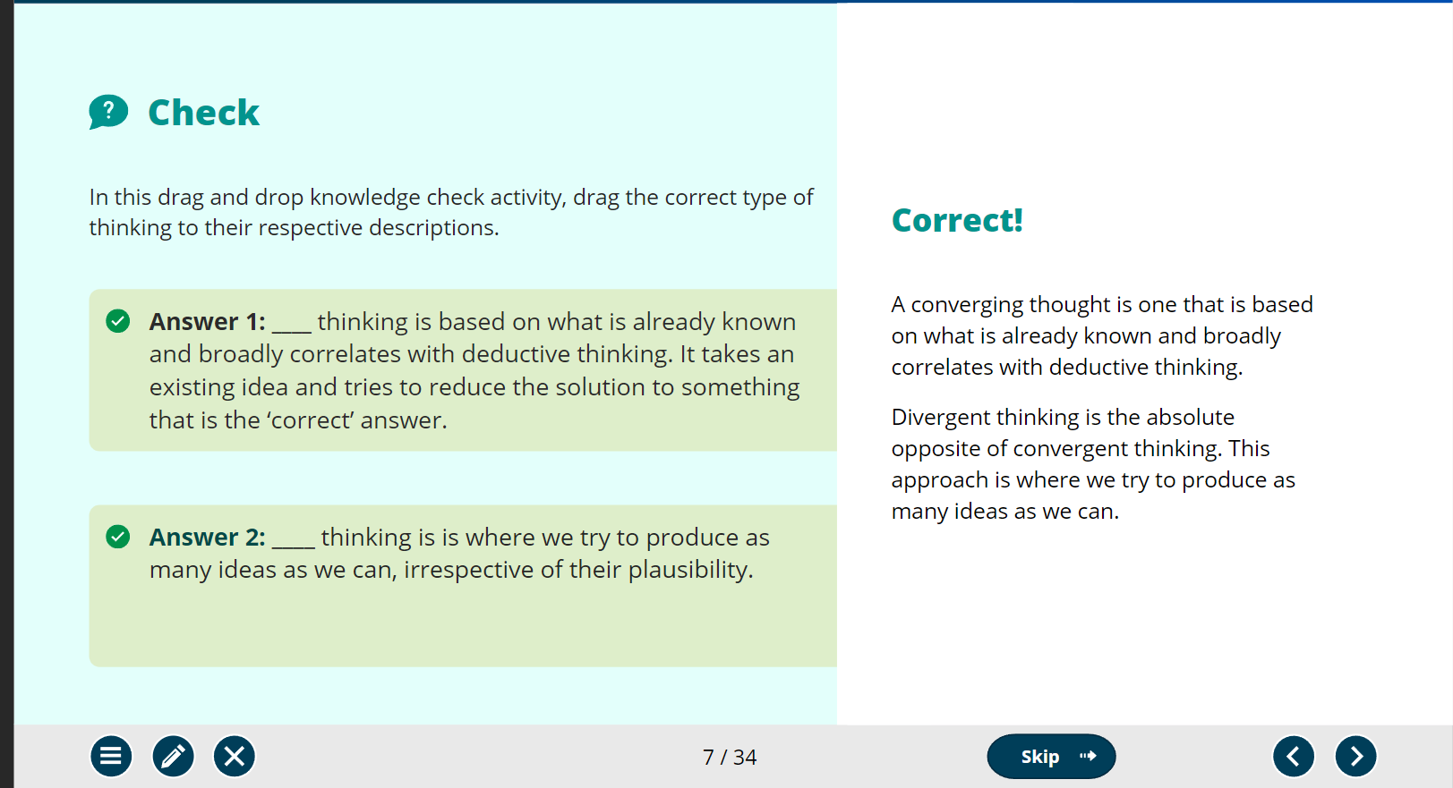

Appendix 10



