

Land Rover
Marketing Management Assignment-2

Name : Naveen Avulannagari ReddeppaReddy
Student ID : 2213721
Name of Lecturer : Tushara Balendran
Module Name : Marketing Management
Module code : LCM7001
Assignment Title : Assignment-2

Table of content

1. Introduction……………………………………………………………………………………………2
2. Background of the organization.……………………………………………………………..2
3. PESTLE…………………………………………………………………………………………………….3
4. Porter Five Forces……………………………………………………………………………………5
5. SWOT Analysis………………………………………………………………………………………..6
6. Segmentation Targeting Positioning………………………………………………………..7
7. Marketing mix strategy of 4p’s…………………………………………………………………8
8. ANSOFF Matrix of Land Rover………………………………………………………………….8
9. Recommendations…………………………………………………………………………………..9
10.Conclusion…………………………………………………………………………………………….10
11.References…………………………………………………………………………………………….11

1.Introduction
The ongoing project is about the Land Rover, it’s a multinational company, will examine the impacts of internal and external factors' effects on land drifters and how they affect the relationship and detailed analysis, detailed explanation of the association of Land Rover company, porters 5 forces model stating these forces are high or low or Medium, SWOT analysis stating the companies strength weakness , opportunities and threats of organization , including segmentation, targeting, positioning and related to the company , 4Ps model relating to company and also recommended feature marketing strategies for Land Rover
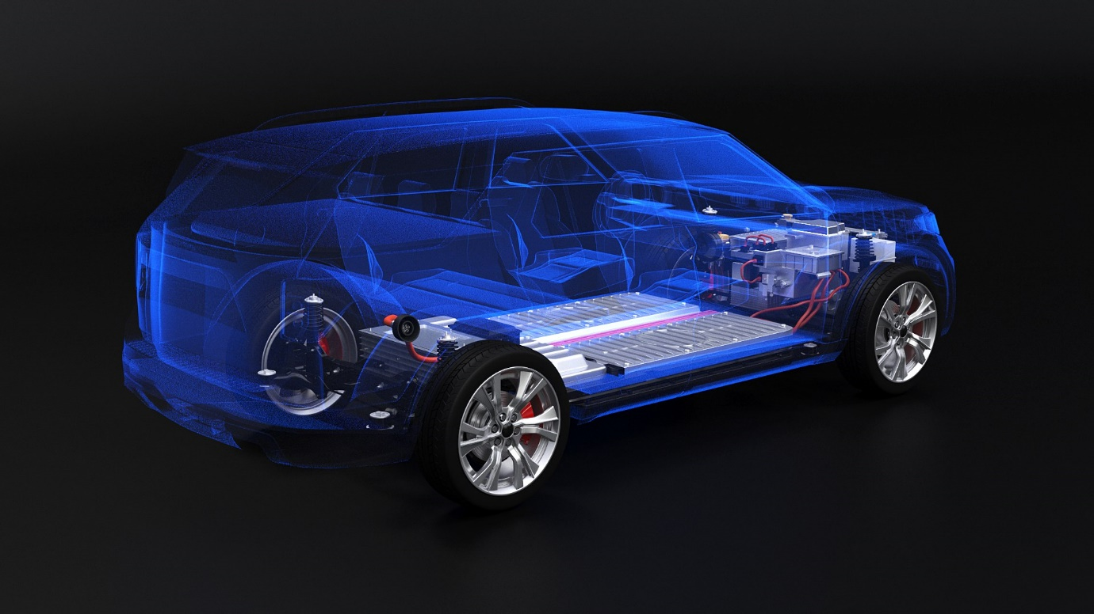
Source: Tata Motors.com

2.Background of organization

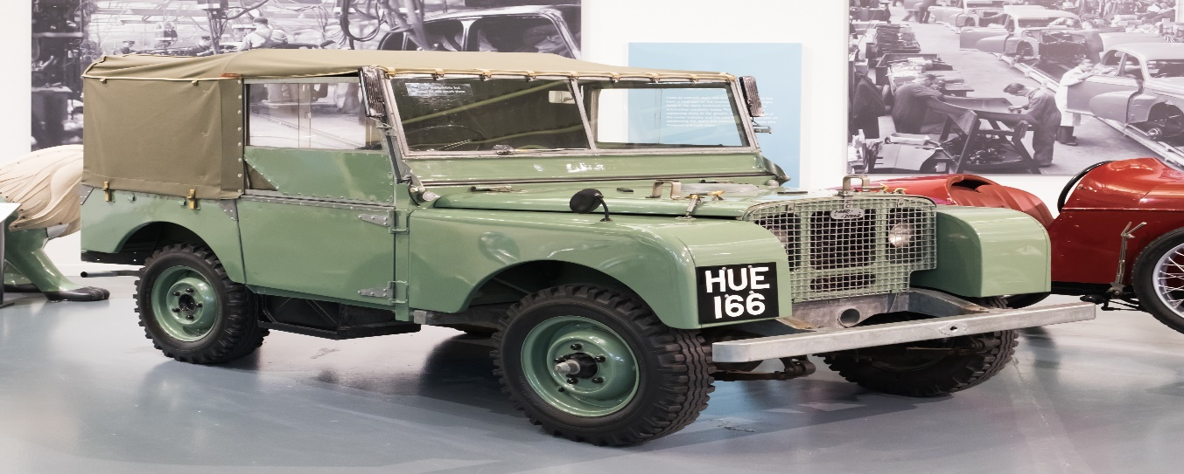
Luxury SUVs and off-road vehicles are Land Rover's two main product lines. Land Rover is a British manufacturer. The company's headquarters are in Gaydon, Warwickshire, England, where it was established in 1948. A little background on Land Rover is provided below:
The Rover Company, which initially made bicycles and motorcycles before switching to the manufacture of cars in the early 1900s, was the parent company of Land Rover. After the 1948 launch of the first Land Rover, the company quickly established a reputation for building tough, dependable cars that were ideal for off-road use. Land Rover split out into its own firm in 1978. BMW eventually acquired it in 1994, and Tata Motors later in 2008.
Range of Products: The Range Rover, Range Rover Sport, Range Rover Velar, Discovery, and Defender are just a few of Land Rover's upscale SUVs and off-road vehicles. The firm is renowned for its dedication to creating vehicles that blend comfort and elegance with durability and off-road prowess.
Land Rover is a global brand with a presence in more than 100 nations. The business has factories in the UK, India, Brazil, and China, and it sells its goods through a global network of distributors and retailers.
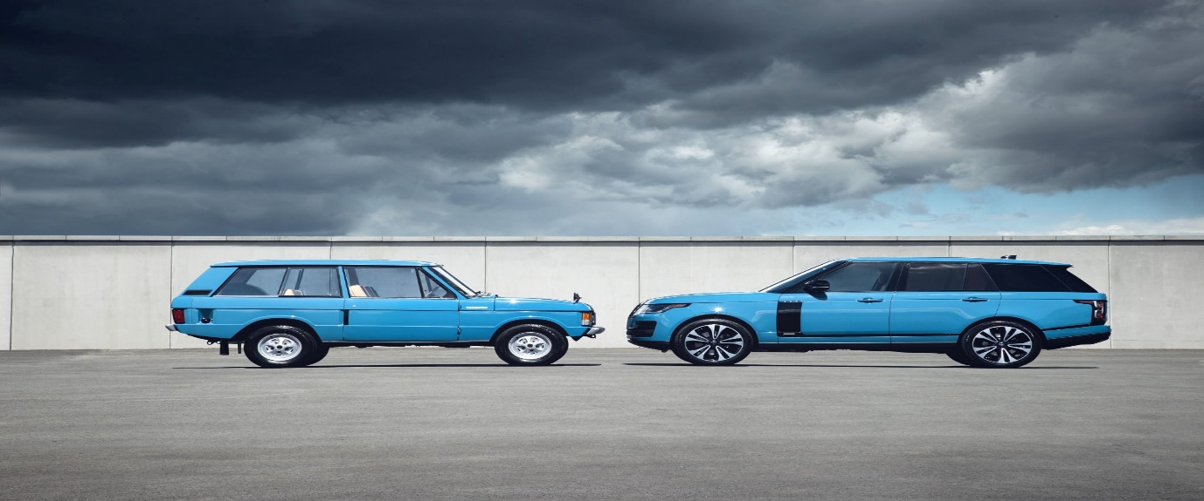
Source: Land Rover.com

Now it’s one of the leading Luxury brands in the world Market. (Ref-Author Martin, R. (2014). The Official Story of Land Rover. The History Press)
3. PESTLE
Summary of pestle factor many changes in governmental decisions that have an impact on Jaguar Land Rover and the automotive industry in the UK.
POLITICAL
Government laws on import and export, taxes, and standards for emissions and fuel efficiency are only a few examples of the political issues that affect Land Rover. The business has international operations, thus political unrest and shifting governmental priorities could have an effect.
The POLITICAL FACTORS ARE UNFAVOURABLE: Because the political will affect the sales of the Land Rover marketing because of their country rules and regulations because of their norms will affect the sales.
ECONOMICAL
The Economical factor affected the Land Rover is very expensive normal peoples can’t afford the vehicles cost, and also downfall of millage fuel cost also increasing day by day. few peoples only liking the vehicles because of their financial stability, the state of the world economy may have an impact on Land Rover's sales and profitability. The demand for the company's goods can be impacted by a variety of variables, including GDP growth, inflation, interest rates, and consumer spending trends.
Economical is an unfavourable of the Land Rover
Social
Products from Land Rover are frequently linked to specific lifestyles and socioeconomic classes. Demand for the company's products may be impacted by consumer choices and attitudes towards luxury SUVs and off-road vehicles. Land Rover's sales may also be impacted by demographic issues including ageing populations and shifting consumer habits.
Social factor is favourable.
Technology
This factor is in Land Rover modern new technologies of the market like newly Tesla introduces Electric vehicles EV. Auto pilot system need to update the land Rover feature to their vehicles and also many advanced upgradations need to build in manufacturing industry of Land Rover
Technology factor is favourable of the Land Rover
LEGAL
This factor of Land Rover embraces an overwhelming technique is to protect its legal brand and licences must and should follow the rules and regulations of their particular country then also the government will allow them into their markets to publish goods with effectively.
Legal factor is unfavourable

ENVIRONMENT
The products made by Land Rover have a big effect on the environment, especially in terms of emissions and fuel economy. The corporation has put in place a number of steps to lessen its environmental impact and abide by rules pertaining to emissions and fuel economy.
Source: steel, R. (2012). A brand-new era. Marketing week, 35(25),20-21

4.Porter Five Forces

Threats of New Entrants
For every organization the capital Prerequisites of business is high, it is very hard to set up new organization until the research of the market fluctuations, Due to high expenses associated with research and development and significant capital consumption, new constants are threatened. a less powerful industry
Threats of New entrants of the porter five forces is High.
Threats of substitutes
It requires more high calibre however much more costly of the substitutes, creating inside business of Land Rover is the creating firms and sell with lower prices than substitutes with good satisfactory quality and also it implies of the danger of substitutes items is powerless inside the business.
Threats of Substitutes is medium.
Industry Rivalry
For the Land Rover opponents is few of other’s rivalry because it’s the finest organization and the Land Rover works significantly isolated and also standard consistency of the company parts is well usage long lasting of the future, these makes the company conflict among exist firms are duplicate forces inside of the business. The Land Rover makes the opposition among existing firms are more weak forces inside of business.
Industry Rivalry is high.
Bargaining Power of suppliers
The inside of Land Rover suppliers doesn’t bargain in the industry. because if they are bargaining more substitutes of suppliers is there in the market. every suppliers have their internal agreement of the industry. This make negotiating intensive.
Bargaining Power of Suppliers is High

Bargaining of the Buyers
Due to the presence of competing luxury SUV companies, Land Rover consumers have a lot of negotiating leverage. However, the company can retain customers and maintain market share thanks to Land Rover's strong brand reputation and customer loyalty.
Bargaining of Buyers is high
Source: Porter, M. E. (2008). The five competitive forces that shape strategy. Harvard Business Review, 86(1), 78-93.
5.SWOT Analysis
STRENGTH
Strength of the Land Rover is convenience and comfort of seat interior design, its provide versatility with comfortable seats, options and many features, its part of TATA MOTORS their main strength is security and safety they won’t compromise about security is main agenda giving to the public
WEAKNESS
High prices: The comparatively high cost of Land Rover's products may limit the company's attractiveness to consumers who are concerned about cost.
dependence on a small number of markets: Due to its reliance on a small number of crucial markets, including China and the United States, Land Rover is at risk from geopolitical and economic concerns.
Environmental impact: Land Rover's vehicles have a considerable environmental impact, especially in terms of fuel economy and emissions, which may limit their attractiveness to buyers who are environmentally sensitive.
OPPORTUNITIES
Land Rover expanding to the global marketing and increasing their manufacturing units in overseas improve car quality and also integration part should be added some advance features, technology advancement.
- Growing demand for luxury SUVs,
- Electric vehicles,
- Emerging markets
TREATS
Uncertainty in the economy: Uncertainty in the economy might affect demand for luxury items, especially Land Rover's products.
Growing competition: Land Rover is up against both newcomers to the market and established premium SUV competitors.
Changing consumer tastes: The demand for Land Rover's products may be impacted by changes in consumer tastes and attitudes towards luxury items. (Ref-Land Rover. (2023). about Land Rover)

Advantages of SWOT ANALYSIS
- SWOT analysis helps Land Rover in identifying its strengths so that they can build on them to obtain a competitive edge.
- SWOT analysis assists Land Rover in identifying its areas for improvement, which can then be addressed to enhance overall performance.
- Opportunities: SWOT analysis helps Land Rover in locating potential new business ventures that may be explored in order to expand the company.
- Threat identification: SWOT analysis helps Land Rover in identifying potential business threats that can be avoided or minimised.
- Simple and straightforward to apply, SWOT analysis is a tool that Land Rover may employ without requiring substantial training.
Disadvantages
- Subjective: SWOT analysis relies on subjective judgements and is susceptible to prejudice, which can produce unreliable conclusions.
- Limited scope: A SWOT analysis may have a limited scope because it only takes into account internal and external aspects that are pertinent to the organisation.
- Lack of prioritisation: Because the discovered factors are not given a priority in the SWOT analysis, it is difficult to decide which ones should be addressed first.
- SWOT analysis does not offer any practical solutions; it just identifies the issues affecting the company.
- Can take time: SWOT analysis can take time, particularly if Land Rover needs to collect and analyse a lot of data.
Source: Akinyomi, O. J., & Abereijo, I. O. (2016). An evaluation of SWOT analysis.
6.Segmentation Targeting Positioning
A marketing strategy known as segmentation, targeting, and positioning (STP) aids businesses in identifying and concentrating on certain client segments. Here are some ways Land Rover might promote its products using STP:
Segmentation: Land Rover could divide its target market into several categories using a variety of segmentation bases. Geographical, demographic, psychographic, and behavioural characteristics may be part of these bases. For instance, Land Rover might divide its market by focusing on rich city dwellers who enjoy outdoor activities and adventure.
Targeting: After determining which target categories to concentrate on, Land Rover can create marketing plans that will entice those consumers. Depending on its objectives and available resources, Land Rover might employ a range of targeting tactics, including concentrated targeting, differentiated targeting, or undifferentiated targeting.
Its selective targeting groups, it won’t be targeting all class of group peoples main target is upper classes.
Positioning: Finally, Land Rover wants to establish a favourable image of its goods among the people who will buy them. This entails creating a distinctive value proposition that sets its products apart from rivals and emphasises the major advantages for clients. For instance, Land Rover may present their SUVs as high-end, tough automobiles that combine luxury and off-road prowess.
(Ref- Kotler, P., K.L. (2015).Marketing management (15th ed.).person)
7.Marketing mix strategy of 4p’s
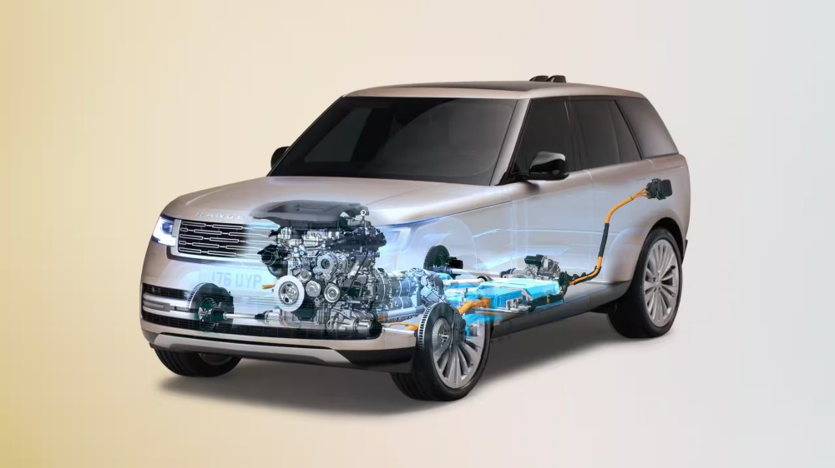
Source: Land Rover motors .com
Product
The product of Land Rover more focussed on wide range of vehicles and high tech contemporary vehicles. They have more products coming in the market. wide range SUV and four wheelers, the list of Land Rover vehicles is.
DEFENDER,
RANGE ROVER SPORT,
FREELANDER etc.
Company as given high competition in vehicle market with their design and technology of the vehicles
Place
With a significant presence in important countries like the United States, China, and Europe, Land Rover sells its goods through a network of dealerships and authorised merchants all over the world. For the convenience of its consumers, the business also provides online sales and delivery choices.
Price
Land Rover's products are relatively pricey compared to other SUV brands, reflecting the high quality and luxury of its vehicles. The business targets customers who prioritise performance and luxury over price and positions its products as high-end and unique by employing a premium pricing strategy.
Promotions
Especially Land Rover doesn’t depend on any promotions because its brand name itself sufficient to promotions. Land Rover is Premium vehicles manufacturing once the customers attracted to brand they always choose on brand collections.
In addition to social media and television and print advertising, Land Rover also sponsors events and sports teams to spread the word about its products.
8.ANSOFF Matrix of Land Rover
Located in the UK, Jaguar Land Rover Limited is a manufacturer of automobiles. The company's main office is in Whitley, Coventry. The business creates, produces, and markets automobiles under the Jaguar and Land Rover brands. This firm produces high-end and sporty automobiles. Despite having a lengthy history on their own, Jaguar and Land Rover joined to form Jaguar Land Rover in 2008. Later, Tata Motors of India purchased the business and designated it as a subsidiary. The business is renowned for its cutting-edge and distinctive designs that provide luxury, class, and a variety of features within the automobiles. According to Jaguar Land Rover (2019), the business sold 174,560 Jaguar vehicles and 439,749 Land Rover vehicles in 2018. More than 43000 people worked for the company in 2018, which had a 25.8 billion pound revenue (Jaguar Land Rover, 2018).
Market penetration
Land Rover might concentrate on boosting the sales of its current models in its present markets. This can entail boosting advertising, providing specials or discounts, or extending its distribution networks. By collaborating with premium car shops, Land Rover might, for instance, concentrate on boosting sales of its Range Rover model in the United States.
Market development
Additionally, Land Rover could look into new markets for its current products. This can entail broadening its geographic scope by entering new nations or focusing on new clientele. By joining together with regional dealerships, for instance, or by launching a marketing campaign aimed at affluent Chinese buyers, Land Rover may break into the Chinese market.
Product Development
In order to better serve its current markets, Land Rover may concentrate on creating new goods. This can entail establishing new product lines or making new versions of its current automobiles. For instance, Land Rover might create a new range of electric SUVs to appeal to buyers who are concerned about the environment.
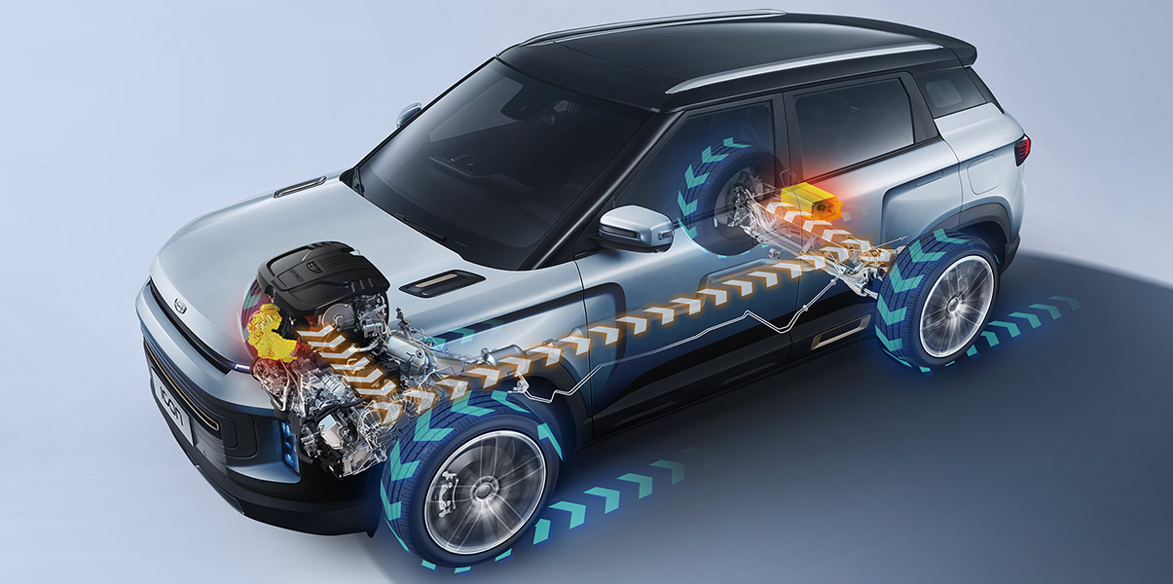
Source: Land Rover.com
Diversification
Land Rover might now investigate entirely new markets and merchandise. This can entail breaking into a totally new industry or introducing a brand-new product line unrelated to its current products. For instance, Land Rover might introduce a line of opulent yachts or private aircraft.
Source: Ansoff, H.I. (1957). Strategies for diversification
9. Recommendations
I will recommend to Land Rover company to introduced off road trucks to carries the heavy loads.
in all conditions of roads. it will be more useful to the consumers. the Land Rover has good.
engine performance technology which have same implements to the heavy trucks it will increase
more sales in the production and also one of the finest heavy vehicles manufacturing list.
- To draw in budget-conscious customers, broaden the company's product line up to include cheap SUV models.
- Focus on further decreasing the environmental impact of its products, such as by improving the SUVs' fuel efficiency, and publicise these initiatives to appeal to buyers who care about the environment.
- Increase the number of online sales and delivery alternatives as part of channel diversification to better serve clients who choose to buy cars online.
- Increased demand for luxury SUVs can be found in rising nations like India and Brazil.
- To keep ahead of the competition in fields like vehicle electrification and autonomous driving technology, collaborate with IT businesses.
10.Conclusion
In conclusion, Land Rover is a high-end SUV manufacturer with a solid reputation for superior quality and off-road prowess. To appeal to customers who are concerned about the environment, the company offers a variety of vehicles with various features and abilities, including electric and hybrid models. To maintain its competitiveness in fields like vehicle electrification and autonomous driving technology, Land Rover makes significant investments in research and development. However, the company faces difficulties due to the high cost of its goods and the negative environmental effects of its vehicles. Land Rover can increase its presence in developing areas and keep innovating in response to shifting consumer tastes and market trends by leveraging its strong brand reputation, devoted customer base, and rising demand for premium SUVs.
However, the conclusion of the Land Rover is made more of opportunities available. they were mostly invested in Indian and Chinese automotive market and also investing more research and development of new technologies of hybrid cars. More eco friendly customers who will generate more revenue for the company

References

- Ansoff, H.I (1957). strategies for diversification. Harvard Business Review,35(5),113-124
- Capon, C (2009) understanding business environment and some internet sources like
- Kotler, P., K.L. (2015). Marketing management (15th ed.). person
- And some others google websites like
- https://www.marketing91.com/marketing-strategy-land-rover/
- Jaguar Land Rover, 2016
- https://www.tatamotors.com/wp-content/uploads/2018/07/27060927/jlr-annual-report-2017-18.pdf (accessed 2023 April 25)
- steel, R. (2012). A brand-new era. Marketing week, 35(25),20-21

